Backoff Algorithm in UMTS-LTE and IEEE 802.16 Systems
In UMTS-LTE and IEEE802.16 system, terminals transmit a random access code by contention to obtain an uplink data transmission and backoff if the their retransmissions if the contention results in a collision. After successful random access, they can transmit uplink bandwidth request message using the uplink resource assigned by the base station. Thus, an efficient collision resolution algorithm leads to better system access performance.
UMTS-LTE and IEEE802.16 use uniform backoff algorithm(BEB) and uniform backoff algorithm(UB) with retry limits respectively as collision resolution. Aside from setting different retry limit, these two systems also distinguish services from each other with different priorities thus different backoff parameters are used.
In UMTS- LTE and IEEE 802.16 system, multipackets can be accepted in the same channelin the presence of multiple-access interference (MAI). In UMTS-LTE there can be F random access channels in the frequency domain within one access period, among which an accessing terminal may randomly select one. At the same time, a terminal picks one of P RAPs and transmits it in the selected random access channel. If the same RAP is transmitted by more than one terminal over the same random access channel, a code collision occurs, or if the transmitted RAP is not acknowledged by the BS within a certain time window, it is also considered collision, and this condition may occur due to the transmitted RAP not being successfully decoded under severe MAI.

This algorithm assumes that a BS tracks all the RAPs, so that in every slot it can determine the number of RAPs not transmitted 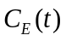and RAPs received 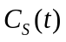, so that the number of RAPs not successfully transmitted 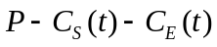. And according to the existing Bayesian algorithm in multidimensional packet reservation multiple access, BS can decide current terminals number 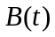 then figure out the best retransmission probability 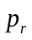 by
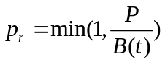
R is the number of RAPs. And this algorithm uses 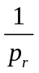to approximate 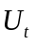, i.e.. Window size of current slot. So that

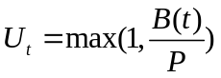.
Thus can be broadcast to terminals before the next slot.

