算 法

1. 确定区域：长三角、珠三角、京津冀

我国一共有19各城市群（国务院）

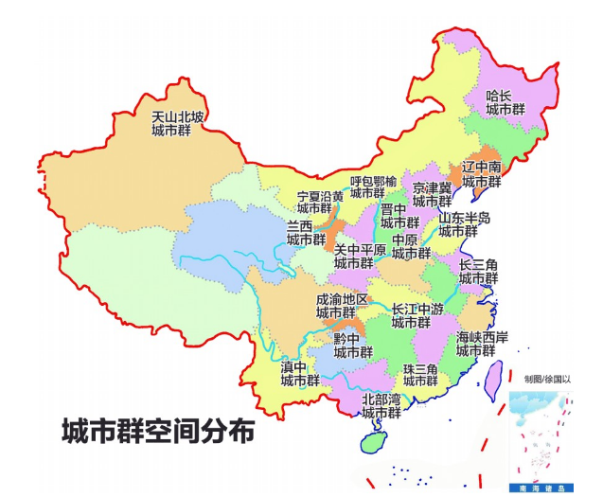

1. 【输出1：行政区域地图】确定邻里关系：每个地区包含哪几个城市（从百城房价中找到对应城市的房价）

长三角：上海市，

江苏省的南京、无锡、常州、苏州、南通、盐城、扬州、镇江、泰州，

浙江省的杭州、宁波、嘉兴、湖州、绍兴、金华、舟山、台州，

安徽省的合肥、芜湖、马鞍山、铜陵、安庆、滁州、池州、宣城

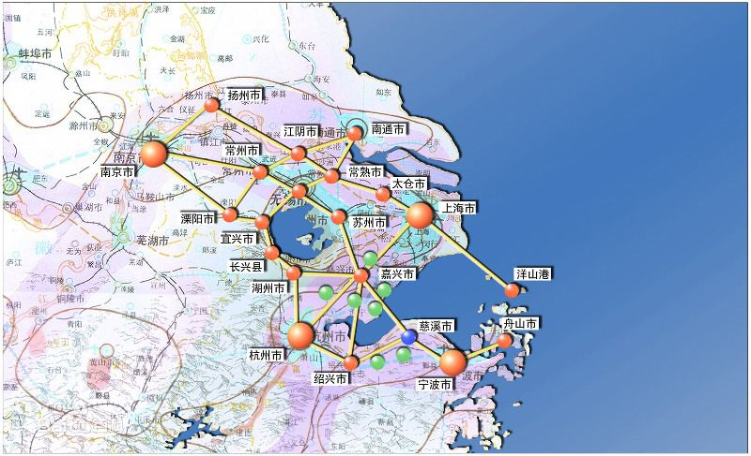

珠三角：广州、深圳 、佛山、东莞、中山、珠海、江门、肇庆、惠州

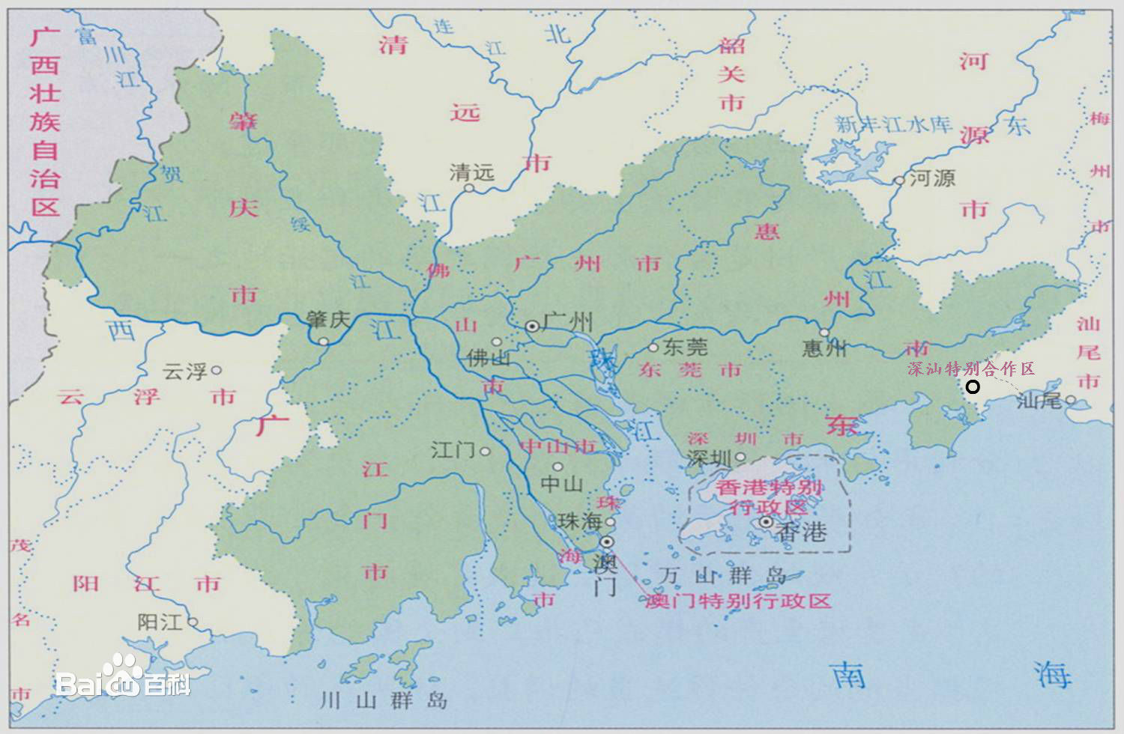

京津冀：北京、天津，

河北的石家庄、保定、张家口、秦皇岛、唐山、廊坊、邢台、邯郸、衡水、沧州、承德、安阳

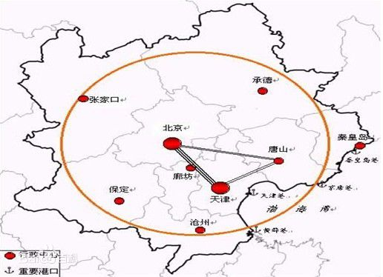

【输出:2】邻里关系表：

|  |  |
| --- | --- |
| 城市 | 邻居 |
| 上海 | 苏州、嘉兴、南通 |
| 南京 | 镇江、扬州、 常州、滁州、马鞍山、宣州 |
| 无锡 | 苏州、常州、泰州、湖州、宣城 |
| 常州 | 苏州、泰州、湖州、宣城 |
| 苏州 | 上海、嘉兴、湖州、无锡、南京、泰州 |
| 南通 | 上海、苏州、泰州、盐城 |
| 盐城 | 连云港、泰州、扬州、淮安、南通 |
| 扬州 | 盐城、淮安、滁州、南京、镇江、泰州 |
| 镇江 | 泰州、南京、常州、扬州 |
| 泰州 | 盐城、扬州、镇江、常州、无锡、苏州、南通 |
| 杭州 | 嘉兴、湖州、宣城、黄山、绍兴、金华、衢州 |
| 宁波 | 舟山、绍兴、台州 |
| 嘉兴 | 上海、苏州、湖州、杭州 |
| 湖州 | 嘉兴、杭州、宣城、无锡、苏州 |
| 绍兴 | 宁波、泰州、金华、杭州 |
| 金华 | 绍兴、杭州、衢州、丽水、台州 |
| 舟山 | 宁波 |
| 台州 | 宁波、绍兴、金华、丽水、温州 |
| 合肥 | 滁州、淮南、安庆、刘安、巢湖 |
| 芜湖 | 宣城、池州、巢湖、马鞍山、铜陵 |
| 马鞍山 | 芜湖、巢湖、南京、宣城 |
| 铜陵 | 池州、安庆、巢湖、芜湖 |
| 安庆 | 铜陵、池州、九江、黄冈、六安、合肥、巢湖 |
| 滁州 | 淮安、南京、扬州、巢湖、合肥、淮南、蚌埠、宿迁 |
| 池州 | 芜湖、安庆、九江、铜陵、宣城、黄山、景德镇、上饶 |
| 宣城 | 湖州、杭州、黄山、池州、芜湖、马鞍山、南京、常州、无锡 |

计算各城市之间距离dij (找坐标，算距离)

|  |  |  |  |  |  |  |  |  |  |  |  |  |  |  |  |  |  |  |  |  |  |  |  |  |  |  |
| --- | --- | --- | --- | --- | --- | --- | --- | --- | --- | --- | --- | --- | --- | --- | --- | --- | --- | --- | --- | --- | --- | --- | --- | --- | --- | --- |
|  | 上海 | 南京 | 无锡 | 常州 | 苏州 | 南通 | 盐城 | 扬州 | 镇江 | 泰州 | 杭州 | 宁波 | 嘉兴 | 湖州 | 绍兴 | 金华 | 舟山 | 台州 | 合肥 | 芜湖 | 马鞍山 | 铜陵 | 安庆 | 滁州 | 池州 | 宣城 |
| 上海 |  |  |  |  |  |  |  |  |  |  |  |  |  |  |  |  |  |  |  |  |  |  |  |  |  |  |
| 南京 |  |  |  |  |  |  |  |  |  |  |  |  |  |  |  |  |  |  |  |  |  |  |  |  |  |  |
| 无锡 |  |  |  |  |  |  |  |  |  |  |  |  |  |  |  |  |  |  |  |  |  |  |  |  |  |  |
| 常州 |  |  |  |  |  |  |  |  |  |  |  |  |  |  |  |  |  |  |  |  |  |  |  |  |  |  |
| 苏州 |  |  |  |  |  |  |  |  |  |  |  |  |  |  |  |  |  |  |  |  |  |  |  |  |  |  |
| 南通 |  |  |  |  |  |  |  |  |  |  |  |  |  |  |  |  |  |  |  |  |  |  |  |  |  |  |
| 盐城 |  |  |  |  |  |  |  |  |  |  |  |  |  |  |  |  |  |  |  |  |  |  |  |  |  |  |
| 扬州 |  |  |  |  |  |  |  |  |  |  |  |  |  |  |  |  |  |  |  |  |  |  |  |  |  |  |
| 镇江 |  |  |  |  |  |  |  |  |  |  |  |  |  |  |  |  |  |  |  |  |  |  |  |  |  |  |
| 泰州 |  |  |  |  |  |  |  |  |  |  |  |  |  |  |  |  |  |  |  |  |  |  |  |  |  |  |
| 杭州 |  |  |  |  |  |  |  |  |  |  |  |  |  |  |  |  |  |  |  |  |  |  |  |  |  |  |
| 宁波 |  |  |  |  |  |  |  |  |  |  |  |  |  |  |  |  |  |  |  |  |  |  |  |  |  |  |
| 嘉兴 |  |  |  |  |  |  |  |  |  |  |  |  |  |  |  |  |  |  |  |  |  |  |  |  |  |  |
| 湖州 |  |  |  |  |  |  |  |  |  |  |  |  |  |  |  |  |  |  |  |  |  |  |  |  |  |  |
| 绍兴 |  |  |  |  |  |  |  |  |  |  |  |  |  |  |  |  |  |  |  |  |  |  |  |  |  |  |
| 金华 |  |  |  |  |  |  |  |  |  |  |  |  |  |  |  |  |  |  |  |  |  |  |  |  |  |  |
| 舟山 |  |  |  |  |  |  |  |  |  |  |  |  |  |  |  |  |  |  |  |  |  |  |  |  |  |  |
| 台州 |  |  |  |  |  |  |  |  |  |  |  |  |  |  |  |  |  |  |  |  |  |  |  |  |  |  |
| 合肥 |  |  |  |  |  |  |  |  |  |  |  |  |  |  |  |  |  |  |  |  |  |  |  |  |  |  |
| 芜湖 |  |  |  |  |  |  |  |  |  |  |  |  |  |  |  |  |  |  |  |  |  |  |  |  |  |  |
| 马鞍山 |  |  |  |  |  |  |  |  |  |  |  |  |  |  |  |  |  |  |  |  |  |  |  |  |  |  |
| 铜陵 |  |  |  |  |  |  |  |  |  |  |  |  |  |  |  |  |  |  |  |  |  |  |  |  |  |  |
| 安庆 |  |  |  |  |  |  |  |  |  |  |  |  |  |  |  |  |  |  |  |  |  |  |  |  |  |  |
| 滁州 |  |  |  |  |  |  |  |  |  |  |  |  |  |  |  |  |  |  |  |  |  |  |  |  |  |  |
| 池州 |  |  |  |  |  |  |  |  |  |  |  |  |  |  |  |  |  |  |  |  |  |  |  |  |  |  |
| 宣城 |  |  |  |  |  |  |  |  |  |  |  |  |  |  |  |  |  |  |  |  |  |  |  |  |  |  |

计算Sij矩阵=1/dij

|  |  |  |  |  |  |  |  |  |  |  |  |  |  |  |  |  |  |  |  |  |  |  |  |  |  |  |  |
| --- | --- | --- | --- | --- | --- | --- | --- | --- | --- | --- | --- | --- | --- | --- | --- | --- | --- | --- | --- | --- | --- | --- | --- | --- | --- | --- | --- |
|  |  |  |  |  |  |  |  |  |  |  |  |  |  |  |  |  |  |  |  |  |  |  |  |  |  |  |  |
|  |  |  |  |  |  |  |  |  |  |  |  |  |  |  |  |  |  |  |  |  |  |  |  |  |  |  |  |
|  |  |  |  |  |  |  |  |  |  |  |  |  |  |  |  |  |  |  |  |  |  |  |  |  |  |  |  |
|  |  |  |  |  |  |  |  |  |  |  |  |  |  |  |  |  |  |  |  |  |  |  |  |  |  |  |  |
|  |  |  |  |  |  |  |  |  |  |  |  |  |  |  |  |  |  |  |  |  |  |  |  |  |  |  |  |
|  |  |  |  |  |  |  |  |  |  |  |  |  |  |  |  |  |  |  |  |  |  |  |  |  |  |  |  |
|  |  |  |  |  |  |  |  |  |  |  |  |  |  |  |  |  |  |  |  |  |  |  |  |  |  |  |  |
|  |  |  |  |  |  |  |  |  |  |  |  |  |  |  |  |  |  |  |  |  |  |  |  |  |  |  |  |
|  |  |  |  |  |  |  |  |  |  |  |  |  |  |  |  |  |  |  |  |  |  |  |  |  |  |  |  |
|  |  |  |  |  |  |  |  |  |  |  |  |  |  |  |  |  |  |  |  |  |  |  |  |  |  |  |  |
|  |  |  |  |  |  |  |  |  |  |  |  |  |  |  |  |  |  |  |  |  |  |  |  |  |  |  |  |
|  |  |  |  |  |  |  |  |  |  |  |  |  |  |  |  |  |  |  |  |  |  |  |  |  |  |  |  |
|  |  |  |  |  |  |  |  |  |  |  |  |  |  |  |  |  |  |  |  |  |  |  |  |  |  |  |  |
|  |  |  |  |  |  |  |  |  |  |  |  |  |  |  |  |  |  |  |  |  |  |  |  |  |  |  |  |
|  |  |  |  |  |  |  |  |  |  |  |  |  |  |  |  |  |  |  |  |  |  |  |  |  |  |  |  |
|  |  |  |  |  |  |  |  |  |  |  |  |  |  |  |  |  |  |  |  |  |  |  |  |  |  |  |  |
|  |  |  |  |  |  |  |  |  |  |  |  |  |  |  |  |  |  |  |  |  |  |  |  |  |  |  |  |
|  |  |  |  |  |  |  |  |  |  |  |  |  |  |  |  |  |  |  |  |  |  |  |  |  |  |  |  |
|  |  |  |  |  |  |  |  |  |  |  |  |  |  |  |  |  |  |  |  |  |  |  |  |  |  |  |  |
|  |  |  |  |  |  |  |  |  |  |  |  |  |  |  |  |  |  |  |  |  |  |  |  |  |  |  |  |
|  |  |  |  |  |  |  |  |  |  |  |  |  |  |  |  |  |  |  |  |  |  |  |  |  |  |  |  |
|  |  |  |  |  |  |  |  |  |  |  |  |  |  |  |  |  |  |  |  |  |  |  |  |  |  |  |  |
|  |  |  |  |  |  |  |  |  |  |  |  |  |  |  |  |  |  |  |  |  |  |  |  |  |  |  |  |
|  |  |  |  |  |  |  |  |  |  |  |  |  |  |  |  |  |  |  |  |  |  |  |  |  |  |  |  |
|  |  |  |  |  |  |  |  |  |  |  |  |  |  |  |  |  |  |  |  |  |  |  |  |  |  |  |  |
|  |  |  |  |  |  |  |  |  |  |  |  |  |  |  |  |  |  |  |  |  |  |  |  |  |  |  |  |
|  |  |  |  |  |  |  |  |  |  |  |  |  |  |  |  |  |  |  |  |  |  |  |  |  |  |  |  |

由此计算

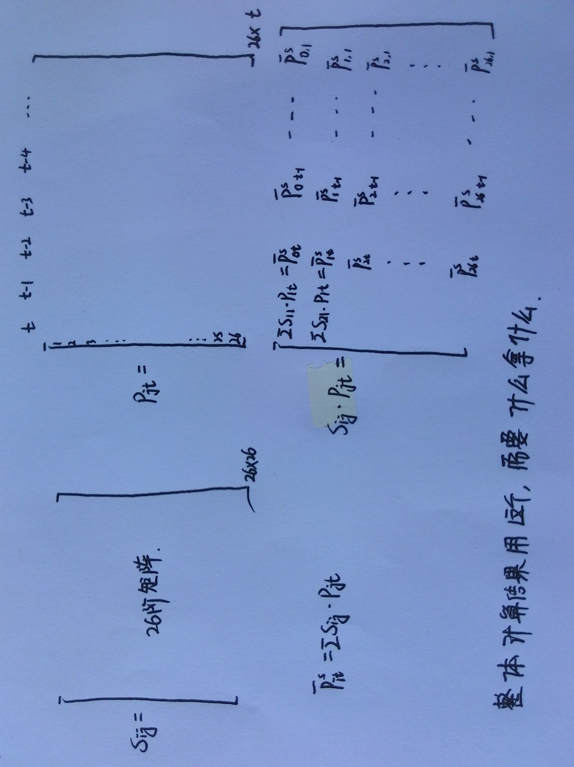

1. 【输出3】房价走势图

由Pij画出每个地区的房价走势图（画在一张图里面，像论文里面的图1）

由△Pij画出每个地区的房价变动走势图（画在一张图里面）

1. 【输出4】协整检验（Johansen检验i与0之间的协整关系）

（协整检验必须有方向，必须为（1，-1），论文里用LR统计量，我们考虑用格兰杰因果关系检验）

Table7 没做没看懂

1. 参数估计

滞后阶数需要自己根据每个式子的预测的MSE试出来

（）+

估计得到，，，，，并由此计算

（）+（）++

分别对i=1,2…N做N个回归，得到各系数，，，，，，

【输出5】将得到的系数整理为下面的形式：

|  |  |  |  |  |  |  |  |  |  |  |
| --- | --- | --- | --- | --- | --- | --- | --- | --- | --- | --- |
|  |  |  | 先把每一个系数都求出来  自身滞后的影响 | 先把每一个系数都求出来  邻居滞后的影响 | 先把每一个系数都求出来  伦敦滞后的影响 | 伦敦当期的影响 | Wu-休斯曼检验的结果 | 实际滞后阶数的说明 |  |  |
| 地区 | EC1( | ) |  |  |  |  | Wu-  Hausman  statistics |  |  |  |
| 北京0 |  |  |  |  |  |  |  |  |  |  |
| 城市1 |  |  |  |  |  |  |  |  |  |  |
| 城市2 |  |  |  |  |  |  |  |  |  |  |
| 城市3 |  |  |  |  |  |  |  |  |  |  |
| …… |  |  |  |  |  |  |  |  |  |  |

1. Wu-Husman检验，看△P0t是否外生

公式：

（）+

用上面的式子计算 ，代入下式，得到该回归中的t值（顺便标记显著性），填入上表。（希望不拒绝原假设）

（）+（）++

1. 【输出6】中心区域的选择：尝试把每一个城市做一次中心区域，做Wu-Husman检验，看△Pit是否外生，以判断其是否可以做一个 “中心区域”。检验的统计量结果填入下表中（记得标记显著性）。做法同5所写。

|  |  |  |  |  |  |
| --- | --- | --- | --- | --- | --- |
| 假设的中心区域 | 北京 | 河北 | 沧州 | …… |  |
| 北京 | —— |  |  |  |  |
| 河北 |  | —— |  |  |  |
| 沧州 |  |  | —— |  |  |
| ……. |  |  |  | …… |  |

结果分析：xxx适合做中心区域，xxx也有潜力，其他地区并不适合。

【输出7】，形成一个矩阵如下：

|  |  |  |  |  |  |
| --- | --- | --- | --- | --- | --- |
|  |  |  |  |  | …… |
| 1 |  |  |  |  |  |
| 2 |  |  |  |  |  |
| 3 |  |  |  |  |  |
| …… |  |  |  |  |  |

计算每个的方差，可形成协差阵:（红色部分直接令为0）

|  |  |  |  |  |  |
| --- | --- | --- | --- | --- | --- |
|  |  |  |  |  | …… |
| 0 |  |  |  |  |  |
| 1 |  |  |  |  |  |
| 2 |  |  |  |  |  |
| 3 |  |  |  |  |  |
| …… |  |  |  |  | …… |

【输出8】计算矩阵R

由自回归系数，，计算矩阵，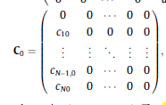

由矩阵，计算矩阵R

R =

【输出9】计算矩阵

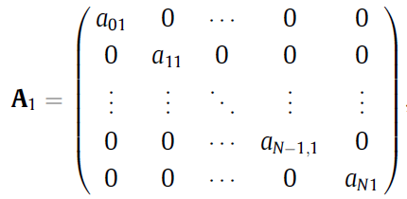 A2，A3，,……Al

 , S由上面手写那张图得到。

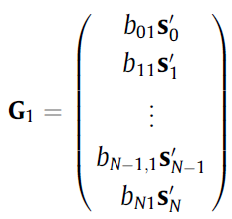 G2，G3，……Gl

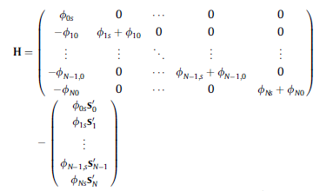











，







1. 【输出10】做脉冲响应

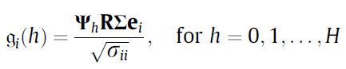

其中，ei 表示向量，均为（N+1）x 1 阶向量

|  |  |  |  |
| --- | --- | --- | --- |
| e0 | e1 | e2 | …… |
| 1 | 0 | 0 |  |
| 0 | 1 | 0 |  |
| 0 | 0 | 1 |  |
| 0 | 0 | 0 |  |
| 0 | 0 | 0 |  |
| 0 | 0 | 0 |  |
|  |  |  |  |

由上式得到i地区在不同h时刻的脉冲值，做成表格存起来。

|  |  |  |  |  |  |
| --- | --- | --- | --- | --- | --- |
|  | 0地区 | 1 | 2 | 3 | …… |
| 0时刻 |  |  |  |  |  |
| 1 |  |  |  |  |  |
| 2 |  |  |  |  |  |
| …… |  |  |  |  |  |

分别不同城市单个的脉冲响应（按列画平滑后的线图）

总体不同城市的脉冲响应（将多条线合在一张图中）；

时空二维展示（将上图画为surface图）

空间的脉冲响应（每一个h是一条线，横轴按距离中心城市的远近排列）

时空对比 （一条时间线，一条空间线，放一起看一下）

1. 加入北京市房价的影响

上海房价与北京房价的时序图

做以下回归：

（）+（）+

（）+（）++

得出回归系数填入下表：

|  |  |  |  |  |  |  |  |  |  |  |
| --- | --- | --- | --- | --- | --- | --- | --- | --- | --- | --- |
|  |  |  | 先把每一个系数都求出来  自身滞后的影响 | 先把每一个系数都求出来  邻居滞后的影响 | 先把每一个系数都求出来  上海滞后的影响 | 上海当期的影响 | Wu-休斯曼检验的结果 | 实际滞后阶数的说明 |  |  |
| 地区 | EC1( | ) |  |  |  |  | Wu-  Hausman  statistics |  |  |  |
| 北京0 |  |  |  |  |  |  |  |  |  |  |
| 上海 |  |  |  |  |  |  |  |  |  |  |
| 城市1 |  |  |  |  |  |  |  |  |  |  |
| 城市2 |  |  |  |  |  |  |  |  |  |  |
| 城市3 |  |  |  |  |  |  |  |  |  |  |
| …… |  |  |  |  |  |  |  |  |  |  |

检验上海对北京周边地区的影响是直接的还是通过北京而影响，将结果制成下面的表格。

A 北京当期房价变化对北京及周边地区影响的显著性F值

（）+（）++

B 北京当期房价不变对北京及周边地区影响的显著性F值

（）+（）++

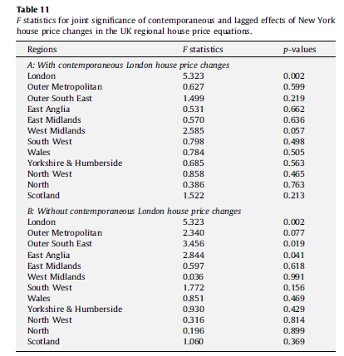

结论：北京房价当期变化，加入上海，对北京显著，但对周边地区不显著。

去除当期北京房价，加入上海，对北京和周边地区均显著。

只通过北京来影响

【输出11】，形成一个矩阵如下：

|  |  |  |  |  |  |  |
| --- | --- | --- | --- | --- | --- | --- |
|  |  |  |  |  |  | …… |
| 1 |  |  |  |  |  |  |
| 2 |  |  |  |  |  |  |
| 3 |  |  |  |  |  |  |
| …… |  |  |  |  |  |  |

计算每个的方差，可形成协差阵:（红色部分直接令为0）

|  |  |  |  |  |  |  |
| --- | --- | --- | --- | --- | --- | --- |
|  | NY |  |  |  |  | …… |
| NY |  | 0 | 0 | 0 | 0 |  |
| 0 | 0 |  |  |  |  |  |
| 1 | 0 |  |  |  |  |  |
| 2 | 0 |  |  |  |  |  |
| 3 | 0 |  |  |  |  |  |
| …… |  |  |  |  |  | …… |

【输出12】计算矩阵R

由自回归系数，，计算矩阵，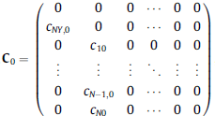

由矩阵，计算矩阵R

R =

【输出13】计算矩阵

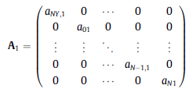 A2，A3，,……Al

 , S由上面手写那张图得到。

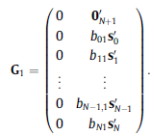 G2，G3，……Gl

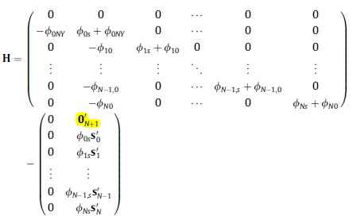











，







1. 【输出14】做脉冲响应



其中，ei 表示向量，均为（N+2）x 1 阶向量

|  |  |  |  |
| --- | --- | --- | --- |
| e0 | e1 | e2 | …… |
| 1 | 0 | 0 |  |
| 0 | 1 | 0 |  |
| 0 | 0 | 1 |  |
| 0 | 0 | 0 |  |
| 0 | 0 | 0 |  |
| 0 | 0 | 0 |  |
|  |  |  |  |

由上式得到i地区在不同h时刻的脉冲值，做成表格存起来。

|  |  |  |  |  |  |  |
| --- | --- | --- | --- | --- | --- | --- |
|  | NY | 0地区 | 1 | 2 | 3 | …… |
| 0时刻 |  |  |  |  |  |  |
| 1 |  |  |  |  |  |  |
| 2 |  |  |  |  |  |  |
| …… |  |  |  |  |  |  |

北京1单位冲击对周边的影响（分地点、合起来）

上海1单位冲击对周边的影响（分地点，合起来）

1. 加入深圳市房价的影响

重复工作

1. 结论

北京市中心区域

具有长期影响趋势

北京在当期对其他地区有影响，其他地区的滞后期影响北京

上海房价对北京有影响，对北京其他地方无影响

冲击随地区的衰减比随时间衰减慢