* 1. **Project Background**

Tourism, being one of Malaysia’s major income revenue sector, has been going strong for decades in the industry. Malaysia has come far in improving and utilizing its strength as the major tourist hotspot in southeast Asia, emphasizing on the multicultural aspect of the country to provide tourist a mix of what Asia has to offer, all in one place.

However, many local tourism service providers operating autonomously have minimal or not at all any form of standardized safety guidelines or protocols in practice. Main reasons being:

1. No provision from the ministry

2. Lacks of funding to enforce any safety standard

One particular observation can be made are among local nautical tourist service provider (island hopping, boat rental) among the many islands in Malaysia. The way these local’s provider operates are with bare minimum safety measure (life jackets, on-board emergency buoy), which deals only with on-incident measure. However, little emphasize are made in handling the post-crisis action among these local service providers, which mostly involves Search-and-Rescue operation. These operations are hindered by the fact that there is no systematic standards or technology employed by these locals to ensure

The project proposes a solution to assist the post-incident SAR operation by equipping the local tourist boat service provider with a cross-platform system (mobile device) that serve as a real-time transmitter for footprints of the whereabout of the boat driver to the dashboard (on-shore device). The driver does this by starting a tracking session on his mobile device, in which the device will ping the dashboard at a set interval amount of time. Abrupt termination of the sessions denotes a possible emergency or incidents happening to the driver, in which the system will alert the system administrator / responder for further action.

* 1. **Problem Statement**

**Lacks of tracking system for local tourism boats service**

Boats used in nautical tourism (island hopping, boat rentals) lacks post-incident safety measure, namely a tracking system that is capable of relaying their location to a remote monitor. This hinders Search-and-Rescue operation in case of incidents and emergency such as equipment failure and capsizes. Some deaths in these related incidents are caused by delay of the responder team to reach to the incident area, which mainly caused by no prior information on the whereabouts of the vessels.

* 1. **Project Objective**

This project aims to achieve these two main objectives, which is:

1. **To provide a live tracking system for service tourist boats**

The system proposed aim to allow user to ping their location to the system at a set interval of time in order to give “footprints” to the system. Users do this by using a smart device on their end as a signal transmitter that pings the system continuously. The system then records the ping location, interval and timestamp, maps it onto a map to provide pathway view for responders and system monitor / administrator.

1. **To provide estimation of plausible searching range to assist SAR operation**   
   In case of emergency, the system can perform analysis based on the last received footprints of the device, duration between the timestamp and current time, and environmental variation (weather and wind, water current) to provide the responders and system monitor an estimate for an effective search radius and perimeter
   1. **Project Scope**

**User scope**

|  |  |
| --- | --- |
| Registration and login | Users are able to register their information and credentials, and able to login using such credentials. |
| Start and stop tracking session | Users are able to start and stop tracking their location while onboard a vessel, transmitting their location and timestamps over the duration of the trip |
| Edit, Update and Delete Credentials (user) | Users are able to edit and update any changes to their account information and credentials, or remove their account entirely from the system. |
| View tracking history | Users are able to view their previous trips’ history (pathway, duration, distance travelled). |

**Administrator / monitor scope**

|  |  |
| --- | --- |
| View current sessions | System admin is able to view currently ongoing sessions on a live-updated map |
| Edit, update and delete credentials (admin) | System admin is able to make changes to other user account information and credentials, or remove the accounts entirely from the system. |

**System scope**

|  |  |
| --- | --- |
| Receive and store tracking footprints | The system is able to receive transmitted footprints and store them in a dedicated database for recalls |
| Display footprints mapping | The system is able to map the received footprints on a map to be displayed to the system administrator / user |
| Session termination alert | The system is able to alert the system administrator of any current user that terminates its tracking session manually or involuntarily |
| Generate plausible search perimeter | The system is able to analyse current weather and time elapsed since last received footprint and generate a plausible search radius to assist for a Search-and-Rescue operation |

* 1. **Review on existing system**

Comparison made on two of currently similar system related to the subject of this project finds that while the current systems in place cover the general security measure requirement, some niche sector are not covered. Within the project context, the tourist boat service provider. The boat tracking system shows the most similarity with the currently in use Vessel Traffic Service, where the purpose of the VTS is to monitor vessels in local water continuously. However, VTS is only applicable to large vessels that are registered under the system. The proposed Boat Tracking System covers this redundancy by instead of registering the vessel, it requires the personnel in charge of piloting the vessel to register instead, and the system tracks the device carried by the personnel (Mobile Device), not a specialized onboard GPS tracker device.

**System 1 – Google’s Find My Device**

This system employed by Google serves as an emergency device tracker that is able to locate any registered mobile to a pinpoint precision. The system employs both GPS and internet connection to maintain transmission between the devices and the system. The system allows for the user to ring, lock or even wipe out the data on their device remotely. 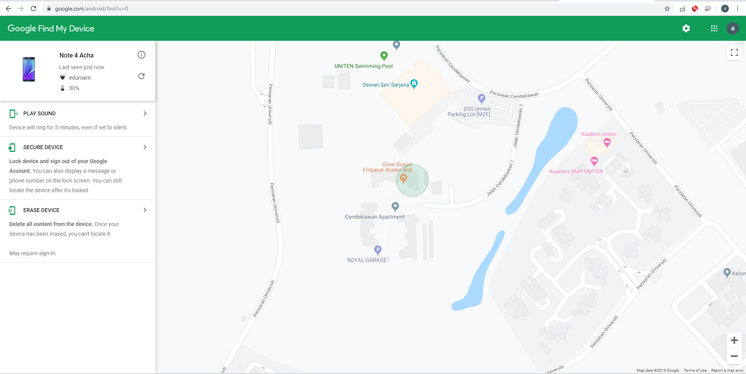

**System 2 – Vessel Traffic Service (VTS)**

VTS is an integrated vessel monitoring multi-system mainly purposed for controlling and managing pathway of vessels in deep sea and shallow waters near harbours. The system provides live tracking of registered vessels under the system, which allows the user to see pathways of the vessels, the vessel information, its origin and destination,

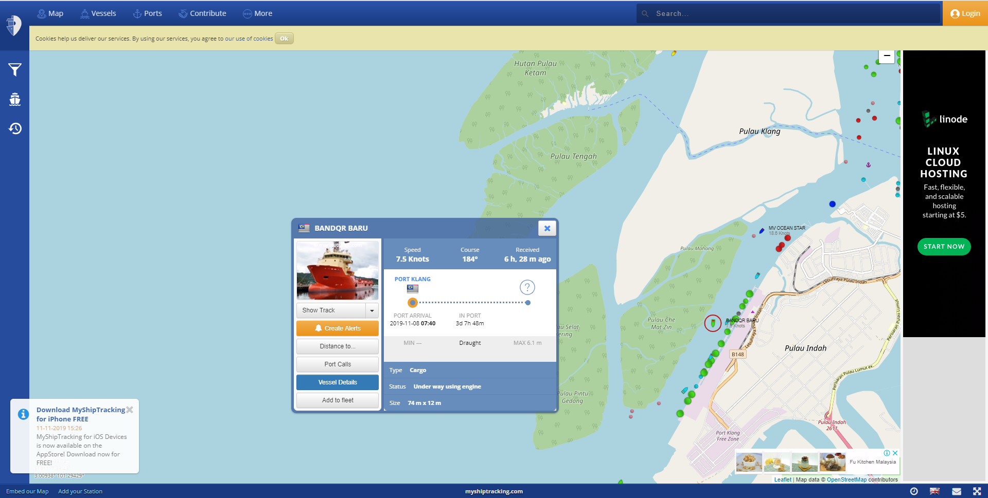

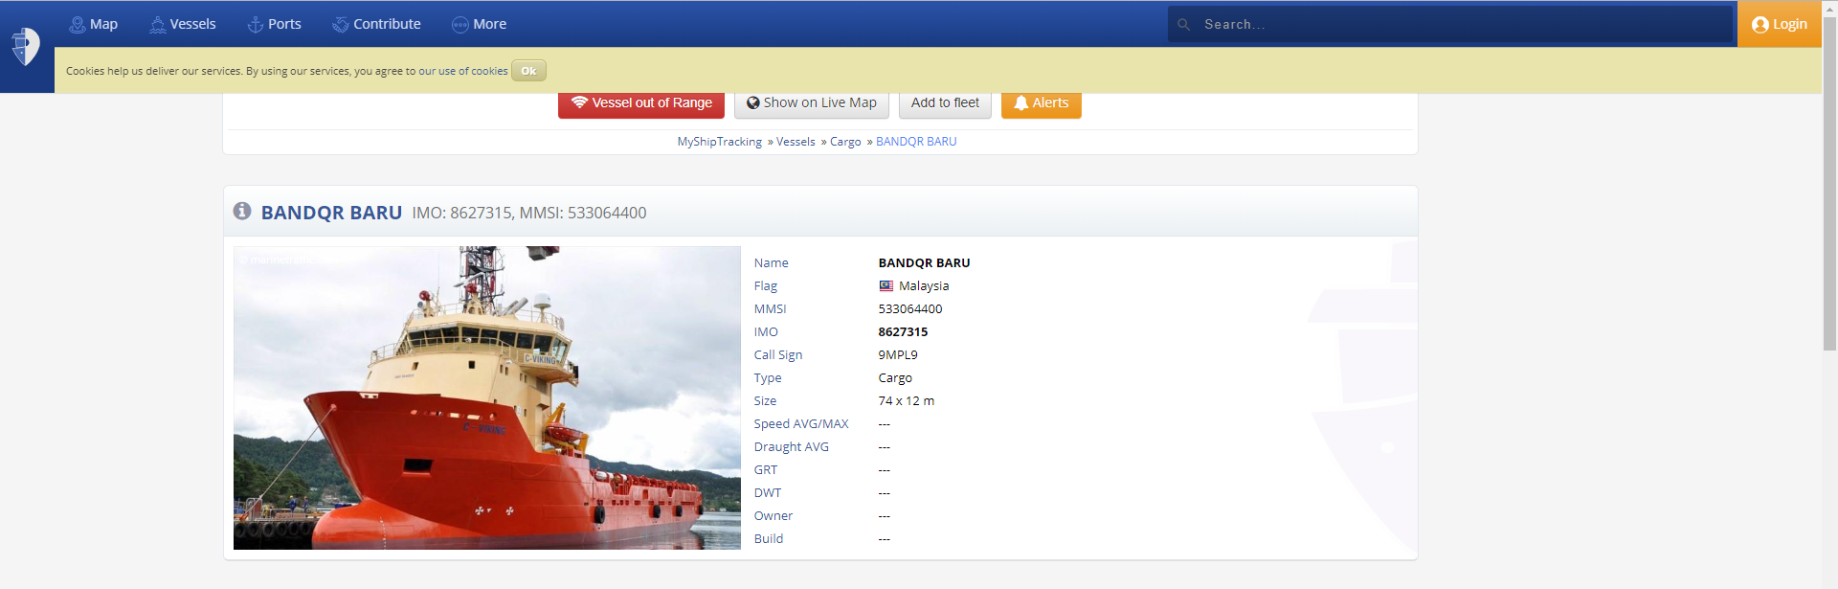

* 1. **Finding Analysis**

|  |  |  |  |
| --- | --- | --- | --- |
| Feature / System | Google Find My Device | Vessel Traffic Service | Boat Tracking System |
| GPS tracking capability | Yes | Yes | Yes |
| Pathway visualization | No | Yes | Yes |
| Direct user notification (noise alert, text) | Yes | No | No |
| Show user / device details | Yes | Yes | Yes |

**Requirement Analysis**

**3.1 Requirement Elicitation**

The requirement gathering process was conducted by two methodology; Interview and Observation.

### Elicitation Technique(s)

1. Interview

A 3-phase interview session with the operation officer in charge at National Disaster Management Agency (NADMA) was conducted to give better understanding of how maritime-related search-and-rescue operations are done, the procedures outlines and authorities involved in such operation.

1. Observation

Observation of sea-going small vessels are conducted in two local piers;

1. Bagan Datoh fisherman pier, Perak
2. Kuah Commercial pier, Langkawi, Perak

The sea-going vessels are mostly comprised of fishermen’s and tourist boats. The observation sub-activity includes;

1. On-board device inspection
2. Protocol and procedures for voyages
3. Safety measures in place for both the captain and passengers on-board

**3.2 Result and Discussion**

The interview was conducted in a 2-phase interview session with the staffs at National Disaster Management Agency (NADMA).

The first phase consists of a general presentation and small tour of the facility around NADMA, explaining regarding what is NADMA and their roles and relations in handling incidents (specifically in context with shallow-sea related incidents).

The second phase comprises of small interviews with the staffs and operatives, with a short debriefing afterwards. The following outcome is obtained from the questions posed:

|  |
| --- |
| 1. Protocol / General outline for Search-and-Rescue mission on shallow waters / shores |
|  |
| 1. Chain of command & parties involved in case of SAR of above operation |
| Maritime SAR usually divided into two distinct jurisdictions over which party is responsible to conduct the ;   1. Below 9 nautical miles from the shore (shallow water): Fire and Rescue Department (Jabatan Bomba dan Penyelamat). 2. Above 9 nautical miles from the shore (deep water): Malaysian Maritime Enforcement Agency (formerly known as Malaysian Cost Guard). |
| 1. Typical time taken between an incident actually happening and its detection to be confirmed |
| Varying, as some sea-going vessels has emergency beacon equipped and some private and individual vessel are poorly equipped.  Time between incident report to confirmation could range between 5 to 30 minutes. |
| 1. Typical response time taken between upon incident confirmation to the rescue team to reach the vessel (inclusive of search / analysis phase) |
| Varies as the time taken to confirm the incident taking place during “search” phase and the capability of the rescue team to reach the site during the “rescue” phase greatly affects the overall response time for the whole operation. |
| 1. Current countermeasures / security policy in place for shallow water / shoreline vessels |
| 1. Increase of jurisdiction coverage by both Fire & Maritime Department 2. Joint operation with Royal Malaysian Navy in incidents that may pose threats to national security (capsizes outside of Malaysian boundaries, pirate attacks, intrusion) 3. Establishment and expansion of Special Malaysia Disaster Assistance and Rescue Team (SMART) as an elite secondary operatives for any SAR missions conducted both in Malaysia and internationally. |
| 1. Classification of any sea-going vessels (and protocols for rescue mission of these groupings) |
| Vessels are not classified in any specific classification, but the size and possible number of on-board crews determine the size of the operation and resources needed to |
| 1. Connection coverage around shallow waters / shores (2G, 3G, 4G, GPS) |
| Malaysia has not yet implemented 5g commercially, and while 4G connection are scarce around the shore, peninsular Malaysia enjoy clear coverage for 3G along the shoreline (especially around the west coast) and limited coverage in the shallow water near the shore. |
| 1. Factors contributing to failed SAR operations |
| SAR operations usually do not have “fail / success” status assigned to them, unlike a military / threat neutralization operations where objectives are |
| 1. Any automation / digitalization improvement to the whole SAR protocol in general |
|  |
| 1. Problems faced by the SAR team in routine operations |
| 1. Limited resources and manpower 2. Lack of knowledge of during-incident best course of action among the individuals affected 3. Changing and uncertain environment and terrain 4. Lack of precautions and safety measures |

Observation on the local piers found that most individually operated tourist boats has no tracking mechanism of any sort installed, and the safety measure installed were minimal to adequate;

1. Life jackets for every tourist onboard
2. 2 dated buoys
3. Handwritten voyage log & schedule

Upon further inspection, the boat driver of the vessels do not have formal maritime safety training, which many bodies and organization consider essential to boating.

Clearly the lack of any tracking system onboard the vessel means in case of emergency, the rescuer team will be hard-pressed to pinpoint the location for Maritime SAR Operation. This