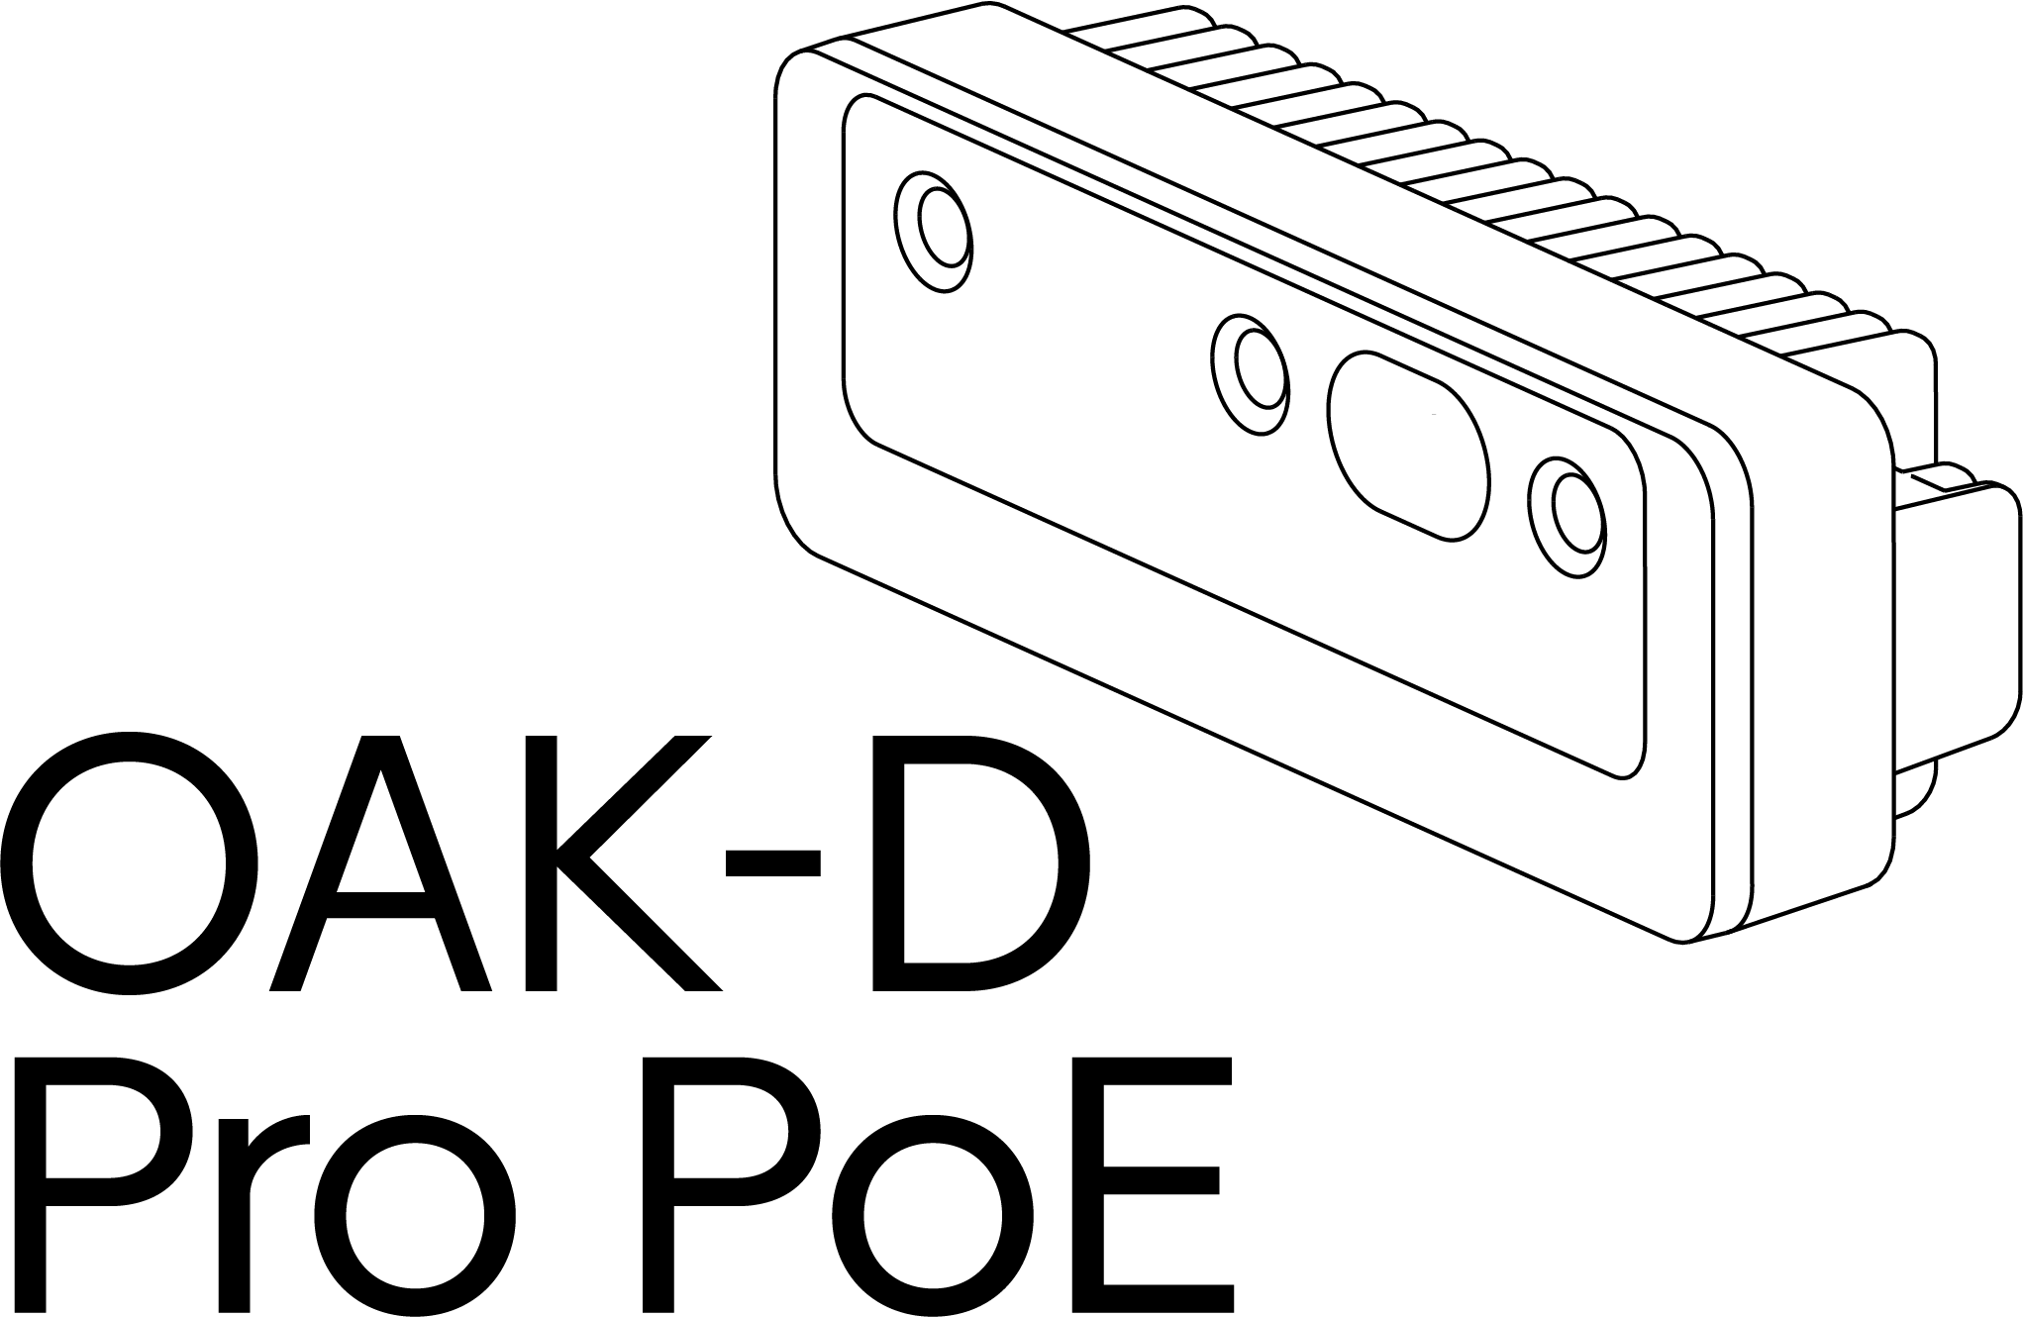

Product name: OAK-D Pro PoE
Board: NG9097
Variants: Auto-Focus (AF), Fixed-Focus (FF)
Part numbers: OAK-D Pro PoE AF: A00569, OAK-D Pro PoE FF: A00570

Table of Contents

Table of Contents 2
Description 3
Specifications 3
Features 4
Electrical Characteristics 4
Absolute Maximum Rating 4
Recommended Operating Conditions 4
Camera Sensors Characteristics 5
Center Color Camera 5
Stereo Vision Grayscale Camera 5
Active Illumination 6
IR Dot Projector 6
IR Flood Illumination LED 6
Inertial Measurement Unit (IMU) 7
Auxiliary Interface 7
USB 7
GPIO 7
FSYNC 7
STROBE 8
5V 8
Connectors 8
Mechanical Information 10
Certification statement 11
Cautionary Statement 11
Support and Resources 11
Revision History 12

Description

The Luxonis OAK-D Pro PoE is an AI Edge vision system driven by the RVC2 VPU. The system is powered with Power over Ethernet (PoE). OAK-D Pro PoE has three onboard cameras which implement stereo and RGB vision, piped directly into the RVC2 VPU for depth and AI processing. The data is then output to a host via a Gigabit Ethernet connection using an M12 X-coded connector.
In addition to stereo cameras, the OAK-D Pro PoE also features IR active illumination in the form of a laser dot projector. It actively illuminates the camera field of view area using 4700 laser dots. The OAK-D Pro PoE also features an IR LED flood light to help in low-light situations. The device has an auxiliary M8 connector that provides USB and GPIO capability to control external devices.
The device has a range of applications and is recommended for robotics, automation, manufacturing, navigation, and surveillance.

Specifications

- RVC2 VPU
- 256/512/1024MBit QSPI NOR Flash
- 32Kb I2C EEPROM
- Gigabit Ethernet + PoE power
- 2x 2-lane MIPI connects OV9282 1MP global shutter cameras with no IR filter
- 1x center 4-lane MIPI connects IMX378 12 MP color rolling shutter camera
- Active IR stereo
- IR Laser dot projector (Belago 1.1)
- IR Flood LED light (SFH 4725AS)
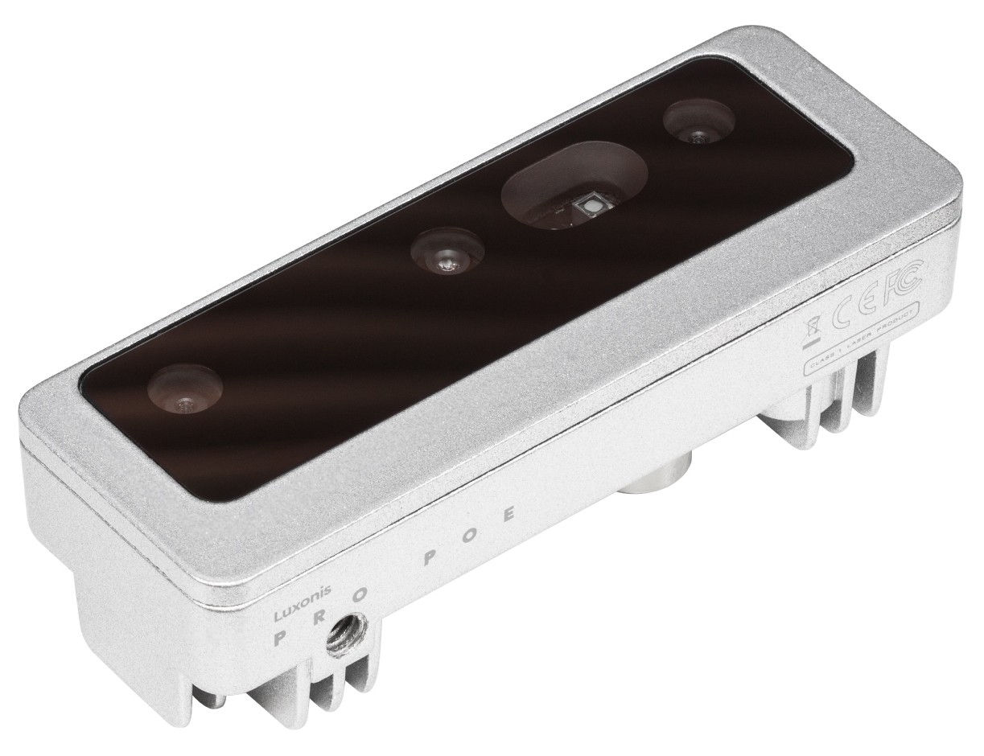
- VESA-spec (7.5cm, M4) set of mounting holes on the back of the unit
- ¼ -20 tripod mount on the bottom of the unit
- IP65 rated
- Dimensions: 111x40x31.3mm
- Weight: 184g

Figure 1 – OAK-D Pro PoE

Features

- 4 TOPS of processing power (1.4 TOPS for AI)
- Run any AI model, even custom architectured/built ones
- Encoding: H.264, H.265, MJPEG - 4K/30FPS, 1080P/60FPS
- Computer vision: warp/dewarp, resize, crop, edge detection, feature tracking
- Stereo depth perception at 120 FPS with filtering
- Object tracking: 2D and 3D tracking

Electrical Characteristics

Absolute Maximum Rating ¹
SYMBOL | RATING | MIN | MAX | UNIT
V_{POE} | 802.3af, Class3 input supply voltage range.⁽²⁾ | 37 | 57 | V
V_{BUSIN} | USB input supply voltage range.⁽³⁾ | 3.5 | 5.5 | V
I_{VBUS} | Maximum input current requirement |  | 2 | A
T_{stq} | Ambient temperature | 0 | 60 | C
Table 1 - Absolute Maximum Rating

Recommended Operating Conditions
SYMBOL | RATING | MIN | TYP | MAX | UNIT
V_{POE} | PoE input voltage range⁽²⁾ | 37 |  | 57 | V
V_{BUSIN} | VBUS input supply voltage |  | 5V | 5.25 | V
V_{io-imax} | Maximum input voltage for GPIO pins |  |  | 5.5 | V
V_{io-omax} | Maximum output voltage for GPIO pins |  |  | 3.3 | V
P | Power consumption requirement | 4 | 6 | 7.5 | W
P_{IDLE} | VBUS idle power draw (Myriad X booted) |  | 2.5 |  | W
T_{A} | Ambient operating temperature |  |  | 50 | °C
Table 2 - Recommended Operating Conditions
- Stresses beyond those listed under Absolute Maximum Ratings may cause permanent damage to the device. These are stress ratings only, which do not imply functional operation of the device at these or any other conditions beyond those indicated under Recommended Operating Conditions. Exposure to absolute-maximum-rated conditions for extended periods may affect device reliability.
- Power supply designed according to 802.3af (802.3at Type 1) standard.
- According to industry standard Universal Serial Bus (USB) specifications.

Camera Sensors Characteristics

Center Color Camera
The color sensor on the stereo depth module and the color image provide texture information. Usages for the texture information include overlay on a depth image to create a color point cloud and overlay on a 3D model for reconstruction.
Parameter | Auto-Focus | Fixed-Focus
Image sensor | IMX378 | IMX378
Active pixels | 4056x3040@60fps | 4056x3040@60fps
Output video format | RAW12/10/8 | RAW12/10/8
Focus type | Auto Focus 8cm - ∞ | Fixed Focus 50cm- ∞
FOV (D/H/V) | 78°/66°/54 | 81°/69°/55°
Shutter Type | Rolling shutter | Rolling shutter
IR sensitive | No | No
Table 3 - Center color camera specifications

Stereo Vision Grayscale Camera

Stereo cameras compare the features and based on the disparity determines the distance/depth of the object tracked on by the product. It also provides the depth map in color and the raw depth map in grayscale.
Parameter | Value
Image sensor | OV9282
Active pixels | 1280x800@120FPS
Output video format | 8/10-bit RAW
Focus type | Fixed Focus 19.6cm - ∞
FOV | 89.5°
Shutter Type | Global shutter
IR sensitive | Yes
Table 4 - Grayscale camera specifications

Active Illumination

IR dot projector

OAK-D Pro PoE doesn’t include an IR filter on mono cameras (production version will have notch IR filters at 940nm), which allows only visible light and IR light from illumination LED/laser dot projector to the camera.
The laser dot projector projects 4700 dots in front of the device, which helps with disparity matching, especially for low-visual-interest surfaces (blank surfaces with little to no texture), such as a wall or floor. A technique that we use is called ASV - conventional active stereo vision - as stereo matching is performed on the device the same way as on OAK-D (passive stereo). The projector meets the CLASS 1 specification, meaning no harm can be done to the human skin or eye with the laser source.

Parameter | Value
Projector | Dot-Pattern Infrared Illuminator
Projector type | VCSEL (vertical cavity surface emitting laser)
Wavelength | 940nm
Control | Using strobe signal from the left stereo camera (PWM)
Compliance | Class 1, IEC 60825-1:2014 Edition 3
FOI (Field of illumination) | HFOI: 61°+/-4°, VFOI: 78°+/-4°
Table 5 - IR dot projector specifications

IR flood illumination LED

Blanket IR LED illumination allows perceiving low-light and no-light environments. You can run your AI/CV processes on frames that are illuminated by the IR LED. Note that the color camera doesn’t perceive IR light, so you need to use a mono camera stream for your AI/CV processes.
Parameter | Value
Projector | IR Light Emitting Diode
Wavelength | 940 nm
Control | Using strobe signal from the left stereo camera (PWM)
Compliance | IEC 62471:2006
FOI (Field of illumination) | FOI: 80°
Table 6 - IR flood illumination LED specifications

Inertial Measurement Unit (IMU)

OAK-D Pro PoE integrates a 9-Axis (Acceleration, Gyroscope, and magnetometer) BNO086 inertial measurement unit. MotionEngine 9-Axis and 6-Axis Sensor Fusion provide raw, calibrated sensor orientation data for more accurate heading and orientation.
Note! A limited number of units were produced with BMI270. Contact support@luxonis.com for more information.

Auxiliary Interface

USB
The device supports USB 2.0 interface used as a host to control external devices. Optionally this interface is used to reprogram the OAK-D-PRO-POE device (AUX GPIO 3V3 needs to be pulled high during boot up in this case)

GPIO
AUX GPIO 3V3 – General purpose input output pin. This pin is used to put the device into USB boot by pulling this pin high with a 10k resistor during startup. Also, this pin is multiplexed with the Strobe functionality.

FSYNC
Frame synchronization signal for cameras. This pin is optically isolated (refer to the implementation below).
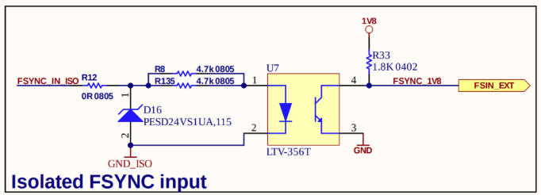
Figure 2 - Isolated FSYNC input

STROBE
Strobe signal for controlling external lights. This pin is optically isolated (refer to the implementation below)
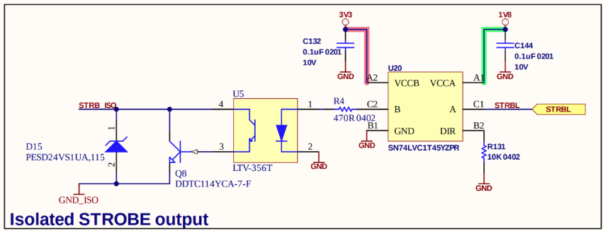
Figure 3 - Isolated FSYNC output

5V
This pin is used for sourcing 5V power to accessory devices connected to the M8 connector. If trying to boot the device in USB boot mode, this pin can also sink current.

Connectors

OAK-D Pro PoE features an M12 connector for connecting to the host via Ethernet and providing power and an M8 auxiliary connector.

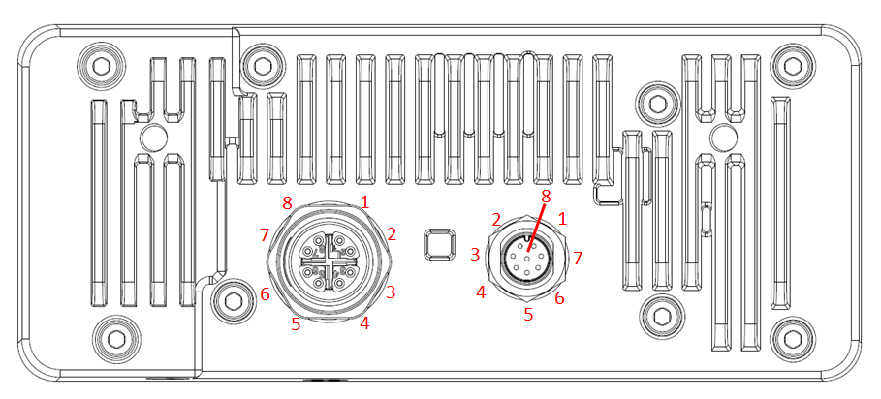
Figure 4 - Camera connectors

Pin | Ethernet M12 connector, X-Coded, Female | Auxiliary M8 connector, A-Coded, Female
1 | Ethernet MX0+ | AUX GPIO 3V3
2 | Ethernet MX0- | FSYNC ISO
3 | Ethernet MX1+ | USB+
4 | Ethernet MX1- | USB-
5 | Ethernet MX3+ | 5V
6 | Ethernet MX3- | Strobe ISO
7 | Ethernet MX2+ | Isolated GND
8 | Ethernet MX2- | GND
Table 7 - Connectors pins

Mechanical Information

The following information is the most current data available for the designated device. This data is subject to change without notice. Refer to Revision History for the change log.
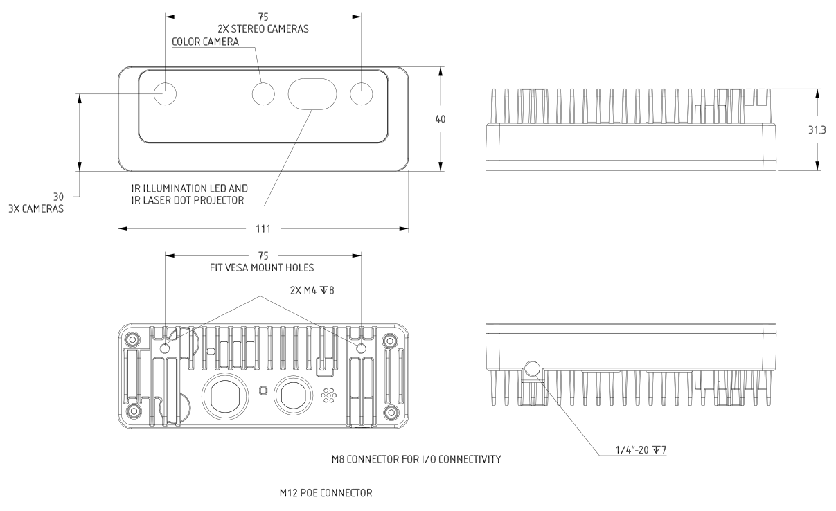
Figure 5 – OAK-D Pro PoE Mechanical measurements

Certification statement

This product is internationally classified as a Class 1 Laser Product under the EN/IEC 60825-1, Edition 3 (2014).
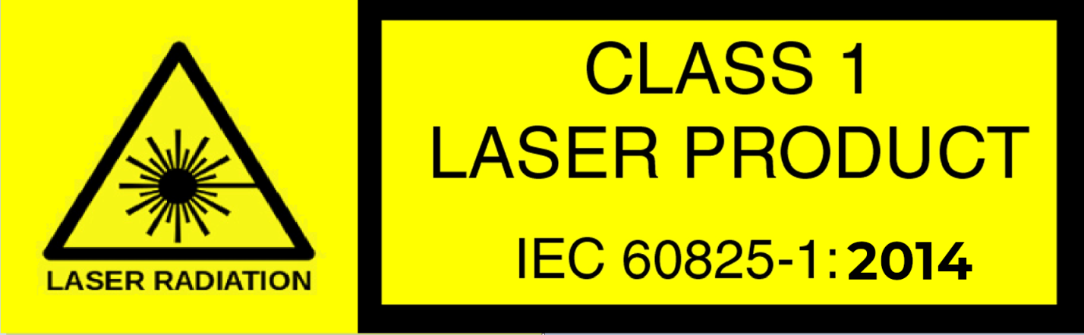

Cautionary Statement

- Do not power on the product if any external damage is observed.
- Do not attempt to open any portion of this laser product.
- Invisible laser radiation when open. Avoid direct exposure to the beam.
- There are no user-serviceable parts with this laser product.
- Modification or service of the stereo module, specifically the infrared projector, may cause the emissions to exceed Class 1.
- No magnifying optical elements, such as eye loupes and magnifiers, are allowed.
- Do not try to update camera firmware that is not officially released for specific camera modules and revision.

Support and Resources

If you have any issues with the device, please contact support@luxonis.com.
Documentation: docs.luxonis.com

Revision History

Rev. 2, December 19th, 2022
- IP rating updated (from IP67 to IP65)
- IMU variant used in production
- Divided RGB camera specifications (Auto and Fixed-focus)
- Added title page
- Updated device photo (Figure 1)
- Added figures and tables numbering
- Updated text formatting, spelling, grammar, and punctuation

