# Zookeeper集群配置

1. 安装需求
   1. 操作系统:Linux发行版,比如ubuntu或者centos的稳定版
   2. Java:1.6或者1.7版本.
   3. 所在目录的读写执行权限,集群机器之间ssh无密码登陆(可选)
2. 安装步骤
   1. 从官网下载压缩包(不选择源码包,由于网络原因,编译安装容易出问题而且比较慢),<http://mirrors.cnnic.cn/apache/zookeeper/zookeeper-3.4.6/zookeeper-3.4.6.tar.gz>.解压到/home/hadoop/another/zookeeper-3.4.6,以后一$ZOOKEEPER_HOME代指这一地址.
   2. 切换到$ZOOKEEPER_HOME/conf目录下,编辑zoo_sample.cfg文件,添加集群节点信息,同时指定日志文件位置.保存为zoo.cfg.

dataDir=/home/hadoop/secondary/zookeeper

server.1=10.100.2.92:2888:3888

server.2=10.100.2.93:2888:3888

server.3=10.100.2.94:2888:3888

* 1. 关闭集群节点上的防火墙--service iptables stop.将集群中所有节点的路由信息加入到各节点的/etc/hosts文件中,格式为ip 主机名.主机名可以通过hostname命令查看到.
  2. 使用monit管理监控集群中的节点.
     1. 从网上下载monit的源代码压缩包,解压,编译安装.
     2. 再~/.monitrc中添加以下代码

Check process supervisor with pidfile /home/hadoop//supervisor.pid

start program = "/etc/init.d/zookeeper start"

stop program = "/etc/init.d/zookeeper stop"

* + 1. 其中/etc/init.d/z的代码比较长放在附件中
  1. 将zookeeper目录拷贝到集群各节点的$ZOOKEEPER_HOME目录,拷贝~/.monitrc到各节点的相同目录,安装monit
  2. 编写zookeeper集群的控制启动脚本(见附件zkEx).

1. 测试
   1. 集群主节点(nimbus所在的节点)上调用启动脚本命令 -- zkEx start.
   2. 登陆zookeeper集群节点检查状态 -- echo “ruok” | nc 10.100.2.92 2181.如果正常则返回imok. 将上面的ip地址换成其他节点的ip测试其他节点是否正常工作.
2. FAQ
   1. Zookeeper日志的清理.使用系统自带的cron工具定时清理--
      1. 输入crontab -e.
      2. 在出现的文本文件中输入一下语句.此命令每周一12点定时清理产生的日志.另外,需要本证命令中用到的jar包再$ZOOKEEPER_HOME/lib目录中存在.

0 12 * * 1 cd /home/hadoop/zookeeper-3.4.5/lib;java -cp zookeeper-3.4.5.jar:slf4j-log4j.jar:slf4j-api-1.6.1.jar:log4j.jar:conf org.apache.zookeeper.server.PurgeTxnLog /home/hadoop/another/zookeeper -n 5

* 1. Zookeeper个节点之间的通信超时时间很短,建议将节点部署到同一个机架,或同一个网段内.各节点关闭交换缓存(swap),不要在节点上运行其他高负荷的任务以免节点超时.

# Storm集群配置

1. 安装需求
   1. 操作系统:Linux发行版,比如ubuntu或者centos的稳定发型版
   2. Java:1.6或者1.7版本.
   3. Python 2.6.6
   4. 所在目录的读写执行权限,集群机器之间ssh无密码登陆(可选)
   5. Zookeeper集群
2. 安装步骤
   1. 从官网下载稳定版的压缩包,比如:[http://www.apache.org/dyn/closer.cgi/incubator/storm/apache-storm-0.9.2-incubating/apache-storm-0.9.2-incubating-src.tar下载之后将,将文件解压至制定的目录,这里使用/home/hadoop/another/storm-0.9.0.1,后面再使用到此目录时以$STORM_HOME指代.](http://www.apache.org/dyn/closer.cgi/incubator/storm/apache-storm-0.9.2-incubating/apache-storm-0.9.2-incubating-src.tar.gz)
   2. [设置配置文件:切换到$STORM_HOME/conf目录下,编辑storm.yaml文件,指定storm的集群机器为:](http://www.apache.org/dyn/closer.cgi/incubator/storm/apache-storm-0.9.2-incubating/apache-storm-0.9.2-incubating-src.tar.gz)

[nimbus.host:"10.100.50.163"](http://www.apache.org/dyn/closer.cgi/incubator/storm/apache-storm-0.9.2-incubating/apache-storm-0.9.2-incubating-src.tar.gz)

[storm.zookeeper.servers:](http://www.apache.org/dyn/closer.cgi/incubator/storm/apache-storm-0.9.2-incubating/apache-storm-0.9.2-incubating-src.tar.gz)

[- "10.100.2.67"](http://www.apache.org/dyn/closer.cgi/incubator/storm/apache-storm-0.9.2-incubating/apache-storm-0.9.2-incubating-src.tar.gz)

[- "10.100.2.93"](http://www.apache.org/dyn/closer.cgi/incubator/storm/apache-storm-0.9.2-incubating/apache-storm-0.9.2-incubating-src.tar.gz)

[- "10.100.2.92"](http://www.apache.org/dyn/closer.cgi/incubator/storm/apache-storm-0.9.2-incubating/apache-storm-0.9.2-incubating-src.tar.gz)

[启用drpc服务器:(对外端口为3772,可选)](http://www.apache.org/dyn/closer.cgi/incubator/storm/apache-storm-0.9.2-incubating/apache-storm-0.9.2-incubating-src.tar.gz)

[drpc.servers:](http://www.apache.org/dyn/closer.cgi/incubator/storm/apache-storm-0.9.2-incubating/apache-storm-0.9.2-incubating-src.tar.gz)

[- "10.100.2.92"](http://www.apache.org/dyn/closer.cgi/incubator/storm/apache-storm-0.9.2-incubating/apache-storm-0.9.2-incubating-src.tar.gz)

[- "10.100.2.93"](http://www.apache.org/dyn/closer.cgi/incubator/storm/apache-storm-0.9.2-incubating/apache-storm-0.9.2-incubating-src.tar.gz)

[启用日志服务器,方便再网页端查看日志:(可选)](http://www.apache.org/dyn/closer.cgi/incubator/storm/apache-storm-0.9.2-incubating/apache-storm-0.9.2-incubating-src.tar.gz)

[logviewer.port: 10001](http://www.apache.org/dyn/closer.cgi/incubator/storm/apache-storm-0.9.2-incubating/apache-storm-0.9.2-incubating-src.tar.gz)

[logviewer.childopts: "-Xmx128m"](http://www.apache.org/dyn/closer.cgi/incubator/storm/apache-storm-0.9.2-incubating/apache-storm-0.9.2-incubating-src.tar.gz)

[logviewer.appender.name: "A1"](http://www.apache.org/dyn/closer.cgi/incubator/storm/apache-storm-0.9.2-incubating/apache-storm-0.9.2-incubating-src.tar.gz)

* 1. [使storm集群加载额外的jar包避免jar包的版本冲突.修改storm的启动脚本--切换到$STORM_HOME/bin,修改启动文件storm中的get_classpath函数为](http://www.apache.org/dyn/closer.cgi/incubator/storm/apache-storm-0.9.2-incubating/apache-storm-0.9.2-incubating-src.tar.gz)

[def get_classpath(extrajars):](http://www.apache.org/dyn/closer.cgi/incubator/storm/apache-storm-0.9.2-incubating/apache-storm-0.9.2-incubating-src.tar.gz)

[ret = get_jars_full(STORM_DIR)](http://www.apache.org/dyn/closer.cgi/incubator/storm/apache-storm-0.9.2-incubating/apache-storm-0.9.2-incubating-src.tar.gz)

[ret.extend(get_jars_full(STORM_DIR + "/lib"))](http://www.apache.org/dyn/closer.cgi/incubator/storm/apache-storm-0.9.2-incubating/apache-storm-0.9.2-incubating-src.tar.gz)

[ret.extend(get_jars_full(STORM_DIR + "/extendlib"))](http://www.apache.org/dyn/closer.cgi/incubator/storm/apache-storm-0.9.2-incubating/apache-storm-0.9.2-incubating-src.tar.gz)

[ret.extend(extrajars)](http://www.apache.org/dyn/closer.cgi/incubator/storm/apache-storm-0.9.2-incubating/apache-storm-0.9.2-incubating-src.tar.gz)

[return normclasspath(":".join(ret))](http://www.apache.org/dyn/closer.cgi/incubator/storm/apache-storm-0.9.2-incubating/apache-storm-0.9.2-incubating-src.tar.gz)

* 1. [使用monit监控管理storm的各个进程,重启意外关闭的进程.](http://www.apache.org/dyn/closer.cgi/incubator/storm/apache-storm-0.9.2-incubating/apache-storm-0.9.2-incubating-src.tar.gz)
     1. [从网上下载monit的源代码压缩包,解压,编译安装.](http://www.apache.org/dyn/closer.cgi/incubator/storm/apache-storm-0.9.2-incubating/apache-storm-0.9.2-incubating-src.tar.gz)
     2. [再~/.monitrc中添加以下代码](http://www.apache.org/dyn/closer.cgi/incubator/storm/apache-storm-0.9.2-incubating/apache-storm-0.9.2-incubating-src.tar.gz)

[Check process supervisor with pidfile /home/hadoop/another/storm/supervisor.pid](http://www.apache.org/dyn/closer.cgi/incubator/storm/apache-storm-0.9.2-incubating/apache-storm-0.9.2-incubating-src.tar.gz)

[start program = "/etc/init.d/supervisor start"](http://www.apache.org/dyn/closer.cgi/incubator/storm/apache-storm-0.9.2-incubating/apache-storm-0.9.2-incubating-src.tar.gz)

[stop program = "/etc/init.d/supervisor stop"](http://www.apache.org/dyn/closer.cgi/incubator/storm/apache-storm-0.9.2-incubating/apache-storm-0.9.2-incubating-src.tar.gz)

* + 1. [其中/etc/init.d/supervisor的代码比较长放在附件中](http://www.apache.org/dyn/closer.cgi/incubator/storm/apache-storm-0.9.2-incubating/apache-storm-0.9.2-incubating-src.tar.gz)
  1. [拷贝$STORM_HOME目录到集群的每台节点相同的路径,在节点上安装monit程序,拷贝~/.monitrc文件到各个节点相同的路径.](http://www.apache.org/dyn/closer.cgi/incubator/storm/apache-storm-0.9.2-incubating/apache-storm-0.9.2-incubating-src.tar.gz)
  2. [编写控制集群启动关闭的脚本(见附件stormEx,可选).脚本的启动方式为ubuntu下启动方式,如果在其他的linux发行版上运行,需要改为对应的启动模式.](http://www.apache.org/dyn/closer.cgi/incubator/storm/apache-storm-0.9.2-incubating/apache-storm-0.9.2-incubating-src.tar.gz)
  3. [以上的步骤a-c为必须,e-g是为了方便集群管理所做的,如果忽略e-g的话,可以选择登陆到集群上的各个节点手动控制.](http://www.apache.org/dyn/closer.cgi/incubator/storm/apache-storm-0.9.2-incubating/apache-storm-0.9.2-incubating-src.tar.gz)

1. [测试](http://www.apache.org/dyn/closer.cgi/incubator/storm/apache-storm-0.9.2-incubating/apache-storm-0.9.2-incubating-src.tar.gz)
   1. [集群主节点(nimbus所在的节点)上调用启动脚本命令-- stromEx start.](http://www.apache.org/dyn/closer.cgi/incubator/storm/apache-storm-0.9.2-incubating/apache-storm-0.9.2-incubating-src.tar.gz)
   2. [打开浏览器,输入nimbus节点的ip地址,端口号为8080.如图所示:](http://www.apache.org/dyn/closer.cgi/incubator/storm/apache-storm-0.9.2-incubating/apache-storm-0.9.2-incubating-src.tar.gz)

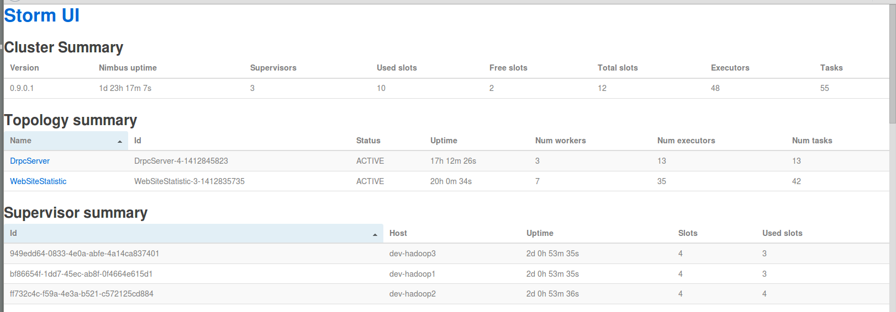

* 1. [Supervisor summary一栏显示集群显示的工作节点数量应与配置的节点数一致.Cluster Summary一栏中的Total slots数量是节点数的4倍.](http://www.apache.org/dyn/closer.cgi/incubator/storm/apache-storm-0.9.2-incubating/apache-storm-0.9.2-incubating-src.tar.gz)
  2. [任务的提交,在任意节点的~/.storm/目录中添加添加storm.yaml文件,在文件中指定nimbus节点的位置,比如:](http://www.apache.org/dyn/closer.cgi/incubator/storm/apache-storm-0.9.2-incubating/apache-storm-0.9.2-incubating-src.tar.gz)

[nimbus.host:”10.100.50.163”](http://www.apache.org/dyn/closer.cgi/incubator/storm/apache-storm-0.9.2-incubating/apache-storm-0.9.2-incubating-src.tar.gz)

[输入命令 storm jar $JAR_POSITION $CLASSPATH后,就能再网页端的Topology Summary一栏看到提交的任务.](http://www.apache.org/dyn/closer.cgi/incubator/storm/apache-storm-0.9.2-incubating/apache-storm-0.9.2-incubating-src.tar.gz)

* 1. [以命令行的方式查看集群状态.登陆到任意节点,切换到$STORM_HOME/bin目录,输入storm list,返回显示连接到nimbus说明该节点以加入集群.](http://www.apache.org/dyn/closer.cgi/incubator/storm/apache-storm-0.9.2-incubating/apache-storm-0.9.2-incubating-src.tar.gz)

1. [FAQ](http://www.apache.org/dyn/closer.cgi/incubator/storm/apache-storm-0.9.2-incubating/apache-storm-0.9.2-incubating-src.tar.gz)
   1. [不要在storm目录下放置不必要的jar包,这样做可能会引起该节点无法启动,或者能启动但无法提供slot进行计算.引起主要原因是由于jar包的版本冲突.](http://www.apache.org/dyn/closer.cgi/incubator/storm/apache-storm-0.9.2-incubating/apache-storm-0.9.2-incubating-src.tar.gz)
   2. [Storm集群上的工作节点在意外关闭后,该节点上的工作进程会迁移到其他节点上,当关闭的节点恢复后不会分配之前的任务.在编写程序时要考虑到这一点.](http://www.apache.org/dyn/closer.cgi/incubator/storm/apache-storm-0.9.2-incubating/apache-storm-0.9.2-incubating-src.tar.gz)

# hadoop2.0集群配置

1. 安装需求:
2. 操作系统:Linux 64位发行版,比如ubuntu或者centos的稳定发行版Java:1.6或者1.7版本.
3. 所在目录的读写执行权限,集群机器之间ssh无密码登陆
4. Zookeeper集群
5. 安装步骤:
   1. 为集群上的各节点设置无密码登陆.
      1. ssh-keygen -t rsa 一路enter到完成.
      2. 切换到~/.ssh目录下,id_rsa与id_rsa.pub就是第一步命令生成的文件.执行cat ip_rsa.pub >> authorized_keys
      3. 编辑/etc/ssh/sshd_config,添加以下文本

RSAAuthentication yes

PubkeyAuthentication yes

AuthorizedKeysFile .ssh/authorized_keys

* + 1. service sshd restart .重启ssh服务
    2. ssh localhost .如果没有提示输入密码,则说明成功.
    3. ~/.ssh目录的权限必须为700,authorized_keys文件的权限最好也设置为600.
  1. 下载hadoop2.0版本的压缩包,地址为http://mirror.bit.edu.cn/apache/hadoop/common/hadoop-2.2.0/hadoop-2.2.0.tar.gz. 解压缩文件到/home/hadoop/secondary目录,以$HADOOP_HOME指代.切换到$HADOOP_HOME/etc/hadoop目录.
     1. 编辑core-site.xml文件.插入一下文本

<configuration>

<property>

<name>hadoop.tmp.dir</name>

<!--- hadoop临时目录 -->

<value>/home/hadoop/secondary/hadoop-2.2.0/tmp</value>

<description>A base for other temporary directories.</description>

</property>

<property>

<name>io.file.buffer.size</name>

<value>102400</value>

</property>

<property>

<name>fs.defaultFS</name>

<!--hadoop主节点的热备份集群,需要有zookeeper -->

<value>hdfs://mycluster</value>

</property>

<property>

<name>ha.zookeeper.quorum</name>

<!--存储hadoop主节点热备份机器信息的zookeeper集群各节点地址 -->

<value>10.100.2.92:2181,10.100.2.93:2181,10.100.2.94:2181</value>

</property>

</configuration>

* + 1. 编辑hdfs-site.xml文件(只有部分的代码,具体见附件)  
       具体见附件.

<configuration>

<property>

<name>dfs.nameservices</name>

<value>mycluster</value>

<description>hadoop主节点的位置</description>

</property>

<property>

<name>dfs.ha.namenodes.mycluster</name>

<value>nn2</value>

<description>hadoop主节点热备份声明</description>

</property>

<property>

<name>dfs.namenode.rpc-address.mycluster.nn2</name>

<value>10.100.2.94:8020</value>

</property>

<!-- Configurations for Namenode -->

<property>

<name>dfs.namenode.name.dir</name>

<value>/home/hadoop/secondary/namenode</value>

</property>

<property>

<name>dfs.namenode.handler.count</name>

<value>10</value>

<description>The number of server threads for the namenode.

</description>

</property>

<property>

<name>dfs.replication</name>

<value>3</value>

</property>

<property>

<name>dfs.blocksize</name>

<value>256m</value>

</property>

<!-- Configurations for DataNode -->

<property>

<name>dfs.datanode.data.dir</name>

<value>/home/hadoop/datanode/secondary/datanode</value>

</property>

</configuration>

* + 1. 添加一下文本到yarn-site.xml(只有部分代码,具体见附件)

<configuration>

<property>

<name>yarn.resourcemanager.hostname</name>

<value>10.100.50.163</value>

</property>

<property>

<name>yarn.resourcemanager.scheduler.class</name>

<value>org.apache.hadoop.yarn.server.resourcemanager.scheduler.capacity.CapacityScheduler</value>

<description>CapacityScheduler, FairScheduler</description>

</property>

<property>

<name>yarn.nodemanager.vmem-check-enabled</name>

<value>false</value>

<description>Whether virtual memory limits will be enforced for containers.</description>

</property>

<property>

<name>yarn.scheduler.maximum-allocation-mb</name>

<value>8192</value>

<description>The maximum allocation for every container request at the RM, in MBs</description>

</property>

</configuration>

* 1. 编辑hadoop-env.sh文件,添加一下代码,再slaves文件中加入个节ip地址.

export JAVA_HOME=/usr/java

* 1. 将$HAOOP_HOME文件夹分发到各节点的相同目录.
  2. 在主节点(这dfs.namenode.rpc-address.mycluster.nn2指定的地址--10.100.2.94)执行格式化,命令如下.这样dfs.namenode.name.dir指定的文件加会被格式化,之前存在的数据会被清除,这点需要注意.

hdfs namenode -format

1. 测试:
   1. 切换到$HADOOP_HOME/sbin目录,执行bash start-dfs.sh(注:如果系统使用的是ubuntu不要通过./start-dfs.sh的形式执行脚本任务).这样hadoop的hdfs已经启动完毕.可以通过页面查看,地址为dfs.namenode.http-address.mycluster.nn2变量所指定,这里是10.100.2.94:7103,其中livenode一栏必须与集群配置的节点数一致,否则通过日志排错.

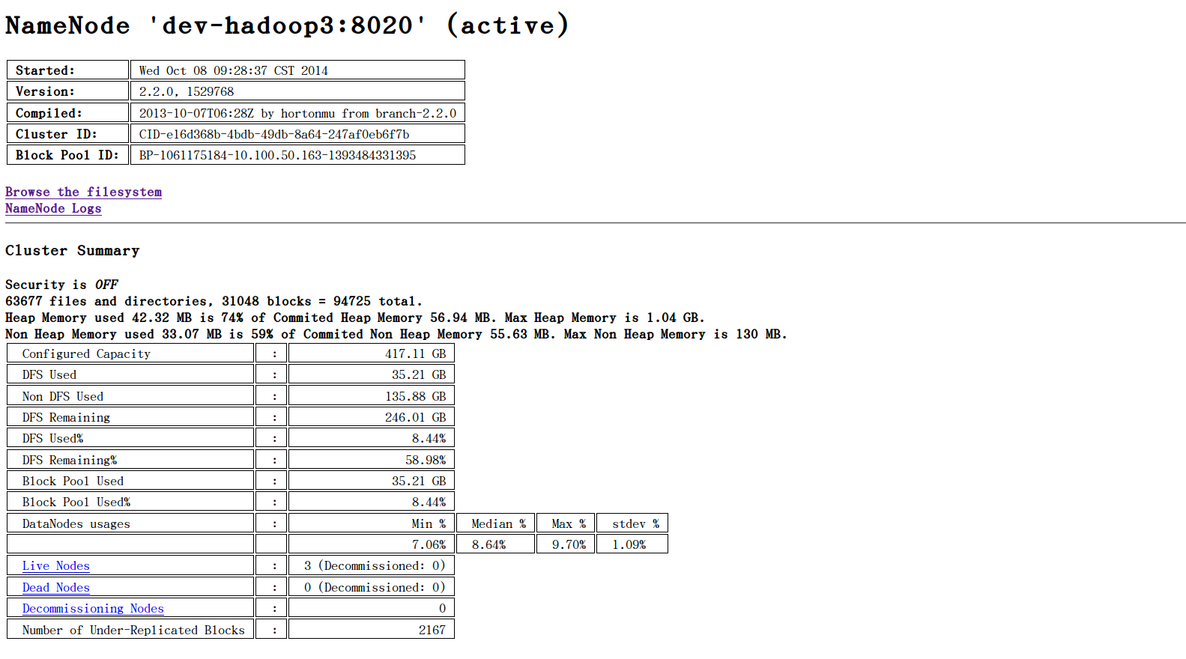

* 1. 切换到$HADOOP_HOME/sbin目录,执行bash start-yarn.sh(注:如果系统使用的是ubuntu不要通过./start-dfs.sh的形式执行脚本任务)启动mapreduce任务集群,访问yarn.resourcemanager.hostname变量指定地址的8088端口查看启动是否成功,这里的地址是10.100.50.163:8088,界面如下图.activenodes 列的数量要与集群的节点数一致.

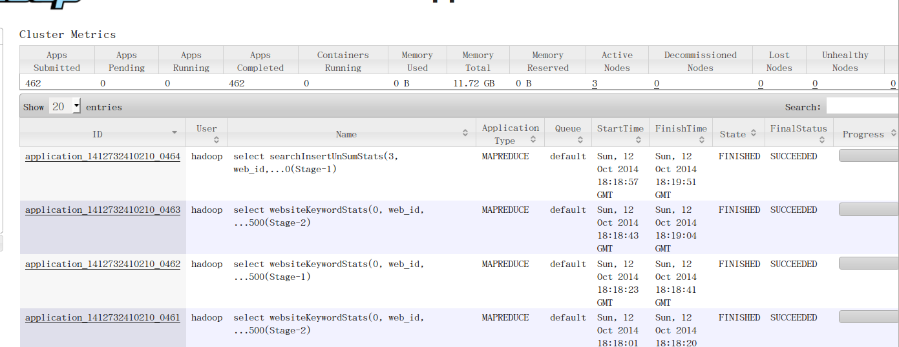

* 1. 选取任意一个文件text.txt复制到hadoop集群.

hadoop fs -put text.txt /

查看复制结果

hadoop fs -ls /

1. FAQ:
   1. dfs.replication 变量指定的值需要小于等于集群节点数,否则存储会失败.
   2. 最好将节点的ip:主机名信息写入到其他节点的hosts文件中.防止由于域名解析失败导致的错误.

# hbase集群配置

1. 安装需求
   1. 操作系统:Linux 64位发行版,比如ubuntu或者centos的稳定发行版Java:1.6或者1.7版本.
   2. 所在目录的读写执行权限,集群机器之间ssh无密码登陆
   3. Zookeeper集群(可选)
   4. Hadoop集群
   5. 管理员用户权限
2. 安装步骤
   1. 设置打开最大文件句柄的数量:
      1. 以管理员权限编辑/etc/security/limits.conf文件
      2. 添加文本,其中hadoop为实际用户名

hadoop - nofile 32768

hadoop soft/hard noproc 32000

* + 1. 系统为ubuntu的话,以管理员权限编辑/etc/pam.d/common-session,添加文本

session required pam_limit.so

* + 1. 注销重新登陆使配置生效.
  1. 下载安装hbase-0.96.2压缩包,下载地址为:apache.fayea.com/apache-mirror/hbase/hbase-0.96.2/hbase-0.96.2-hadoop2-bin.tar.gz .解压到/home/hadoop/secondary/hbase-0.96.2-hadoop-2目录下,以后以$HBASE_HOME变量指代.
  2. 切换到$HBASE_HOME/conf目录.
     1. 编辑hbase_env.sh,添加修改一下代码,/usr/java路径修改会实际的java所在的路径

export JAVA_HOME=/usr/java/

export HBASE_MANAGES_ZK=false

* + 1. 编辑hbase-site.xml,添加以下代码

<configuration>

<property>

<name>hbase.rootdir</name>

<value>hdfs://mycluster/hbase</value>

</property>

<property>

<name>hbase.zookeeper.quorum</name>

<value>10.100.2.92,10.100.2.93,10.100.2.67</value>

</property>

<property>

<name>hbase.cluster.distributed</name>

<value>true</value>

</property>

</configuration>

* 1. 编辑regionservers文件,加入集群各节点的ip地址,一行一个.
  2. 分发hbase目录到集群节点的相同位置.

1. 测试
   1. 启动hbase集群.在集群任意节点上输入

start-hbase.sh

* 1. 通过网页端查看hbase集群状态.在主节点的位置上通过浏览器打开10.100.50.163:60010,这里10.100.50.163的地址替换为实际的主节点ip地址.

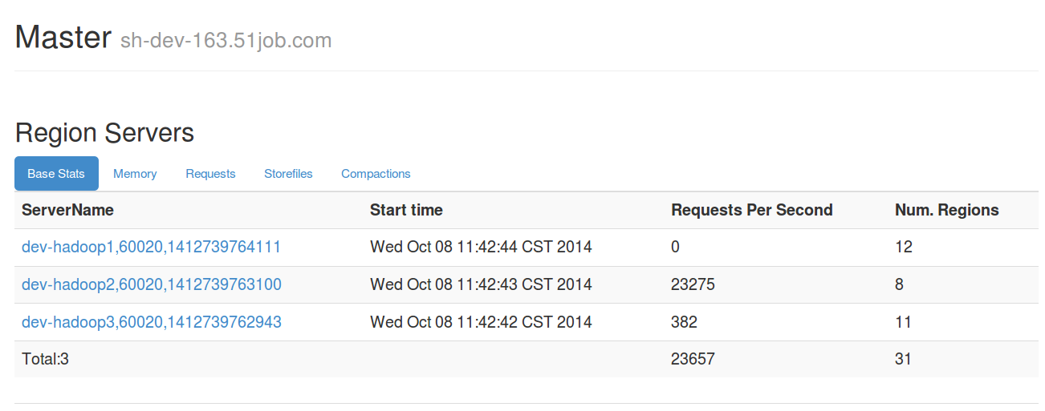

再region servers显示的地址需要与集群节点一一对应.

* 1. 通过hbase shell命令创建表,验证集群能否正常工作

1.hbase shell (打开hbase的shell交互程序)

2.create “testTable”,”columnsfamily”(创建名为testTable的表,列族为columnsfamily)

3list(查看创建表是否成功)

1. FAQ
   1. 这里使用的是对应于hadoop2.0的hbase程序,需要首先安装hadoop2.0.
   2. 不要混用hadoop2.0与hadoop1.0的jar包,之前有这样的bug.目前的0.96.2也不是稳定版本,依然会存在类似的bug.