**Reflection note**

Java is a programming language that use in software development.

First, we can code java using any text editor. Examples are notepad, visual studio code and Notepad ++ etc. After the coding, we can save file using .java extension. Then we can use cmd or command prompt to compile java file and run the file.

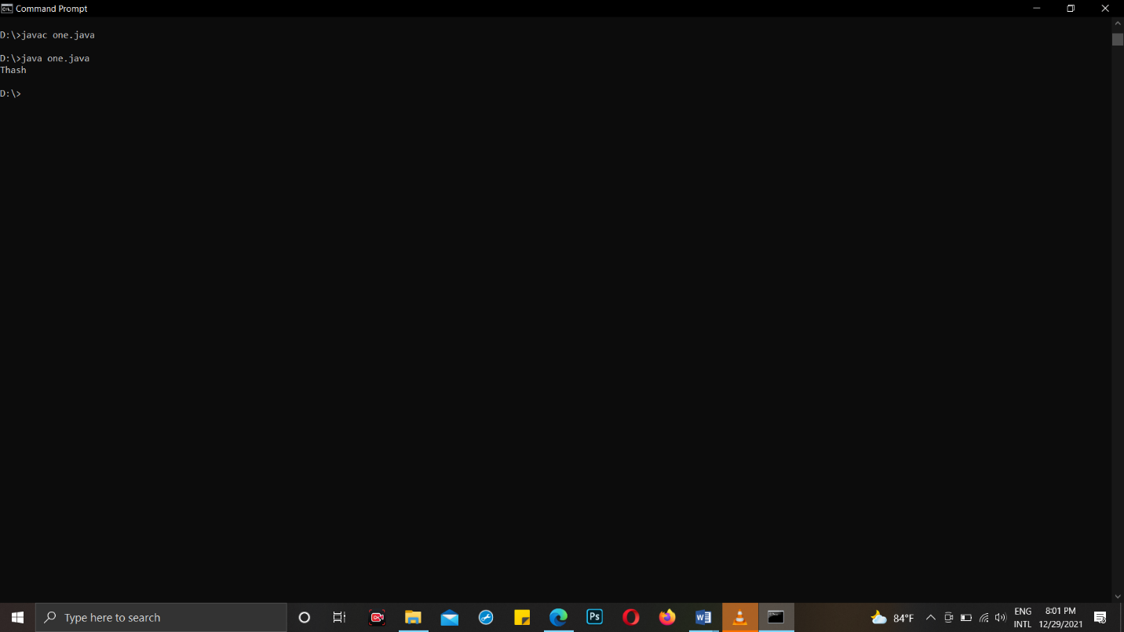

Before we start to develop a system, we have to identify basic things. The user is the main part of the system.

I think we can use any kind of language to coding but first we get to know about what are things user want.

First, we can write instructions in standard way. Like when we type class name we must type first letter as a Capital letter. If we use standard way to type, instructions we can get standard output either.

Example:-

public class Hello{

    public static void main(String args[]){

System.out.println("Welcome bootcamp");

}

}

After that user want to store some data in the class and get output. We can use memory of the computer to use store the data. We have placeholder in memory called Variable.

**Variable Declaration**

Variable declaration means creating a variable. When we create variables, we have to explain datatype. Because of that we can only type that kind of data for the variables. If we want, we can add value for the variables also.

Variable name

Ex :

Data type

int a;

String b = “Hello”;

Value

When we declare variables, we get to know about the data types.

* Data type

There two main datatypes. They are Basic primitive data type and Non-primitive data type.

Premitive datatype can decalare only one value or basic types. They are byte, short, int, long, Float, double, Char and Boolean.

* Name

Name should be meaningful name.

Ex :- accountNumber

* Value

Value should same with data type. Before you add value you must take care about the data type.

Example for java codes using data types.

public class Hello{

    public static void main(String args[]){

        String greet="Hello";

        System.out.println(greet);

}

}

Now we can get to know about how to get data from the user.

We can use Scanner class for that. When we use Scanner we have to import java.util.Scanner.

Example 01:-

import java.util.Scanner;

public class Add {

    public static void main (String args[]){

          // variable declaration

          int a;  // this will create a placeholder in the memory to hold the name

          int b;

        int c;

          Scanner input = new Scanner(System.in);  // to get an input through the command line

          System.out.print("Enter First number : ");

          a = input.nextInt();

          System.out.print("Enter Seconde Number : ");

          b = input.nextInt();

                  c=a+b;

          System.out.print("Total is :" + c);

      }

}