The Open University of Sri Lanka
Department of Electrical and Computer Engineering
Bachelor of Software Engineering Honors
EEI6373 - Performance Modeling
Mini Project

Name : S.Luxshana
S No: S92060763
Reg No: 421420763

Executive Summary
This report presents a performance modelling study of a supermarket checkout system. The supermarket currently operates with two checkout counters, and customers experience long waiting times during busy periods. The main objective of this project is to identify the best way to reduce waiting times while keeping costs reasonable.
I built a discrete event simulation using Python to test four different scenarios 1. keeping the current system, 2. adding one more counter, 3. making cashiers work 30% faster, and 4. doing both together. I generated a dataset of 300 simulated customers with realistic arrival and service times.
My results show that the current system is failing badly, with an average waiting time of 112 minutes. Adding one counter reduces waiting time to 13.7 minutes (an 87% improvement). Making staff faster reduces it to 23.8 minutes (a 78% improvement). However, doing both gives the best result waiting time drops to just 0.14 minutes (a 99.8% improvement).
My recommendation is that the supermarket manager should implement both solutions if the budget allows. If only one solution is possible, adding a counter is the better choice because it gives the biggest improvement for the cost.

1. System Overview and Performance Goals

1.1 System Description
The system I chose to study is a supermarket checkout area. This is a real world problem that affects almost everyone. When customers finish their shopping, they go to the checkout counters to pay for their items. The speed and efficiency of this process directly affects customer satisfaction and the store's profitability.
The Current Setup,
In this supermarket, there are currently only two counters open for customers. When customers arrive at the checkout area, they all stand in one single queue. This means everyone waits in one line, and when a counter becomes free, the next person in line goes to that counter. This is the same system used in many banks and airports because it is fair the first person in line gets the first available counter.

Customer Behavior
Each customer takes a different amount of time at the counter. This depends on several factors
- Number of items - Customers with small baskets are served quickly. Customers with large trolleys take longer because the cashier has to scan more items.
- Payment method - Some customers pay with cash, which might take longer if they need to count change. Others pay with cards or mobile payments, which are usually faster.
- Customer experience - Some customers are regulars who know exactly what to do. Others might be confused about payment or have questions, which takes extra time.

Why This System Matters
This system is important to study because it affects both customers and the business,
- For customers - Long waits are frustrating. Nobody likes standing in line for 20 minutes after a long day of shopping.
- For the business - If customers have a bad experience, they might go to a different supermarket next time. This means lost sales and lower profits.

1.2 Problem Statement
The main problem is that customers have to wait too long in the queue. During busy times such as weekends, evenings, and holiday seasons the line becomes very long. I have personally experienced this many times. You finish your shopping, go to the checkout, and see a line of 20 people. You think, "Do I really want to wait this long?"
The Impact on Customers
When customers see a long line, several things can happen
- They get frustrated and stressed.
- They might check their watch and decide they don't have time to wait.
- Some customers leave their full shopping carts and walk out of the store without buying anything.
- Even if they stay, they have a negative experience and might not come back.

The Impact on the Business
The supermarket loses in several ways
- Lost sales: When customers leave without buying, the store loses that sale.
- Bad reputation: Unhappy customers tell their friends and family. This damages the store's reputation.
- Lower customer loyalty: Customers might choose a different supermarket next time.

The Manager's Discussions
The store manager wants to reduce waiting times. However, the manager has to think about costs
- Opening more counters means hiring more cashiers, which costs money.
- Training staff to work faster also costs money and takes time.
- The manager cannot just open 10 counters because that would be too expensive.
So, the manager faces a difficult question, What is the best way to reduce waiting times without spending too much money?

1.3 Performance Objectives
I set five clear goals for this project. Each goal is measurable and directly related to the supermarket's performance.

Objective 1. Minimize Average Waiting Time
This is my most important goal. The average waiting time is the average time a customer spends standing in the queue before reaching the counter. For example, if one customer waits 5 minutes and another waits 3 minutes, the average is 4 minutes.
If the waiting time is low, customers are happy. If it is high, customers are unhappy. My target is to get the average waiting time below 5 minutes, which is considered acceptable in most supermarkets.

Objective 2. Minimize Average Queue Length
The average queue length is the average number of customers standing in the line at any given time. For example, if the line usually has 10 people, the average queue length is 10.
A short queue makes customers feel confident that they will be served soon. A long queue makes customers stressed and might cause them to leave. A good system should have an average queue length of less than 5 customers.

Objective 3. Maintain Healthy Counter Utilization
Counter utilization shows how busy each counter is, measured as a percentage. For example, if a counter is busy 90% of the time, it means it is almost always working. If it is only busy 30% of the time, it means the counter is often idle.

- If utilization is too high (above 90%), the counters are overloaded. Customers will wait a long time, and staff will be stressed.
- If utilization is too low (below 40%), the store has too many counters and is wasting money on staff who are not needed.

Objective 4. Minimize Total Service Time
The total service time is the total time needed to serve all 300 customers in my dataset. This measures how fast the whole system can complete its work.
A faster total time means the store can serve more customers in a day. More customers served means more sales and more profit.

Objective 5. Identify the Best Solution
The final goal is to find the best solution that the manager can actually use. I want to give practical, actionable advice. If I just say "add more counters," that is not helpful. I need to say "add one counter AND train staff to work 30% faster, and here is exactly how much improvement you will get."

2. Modeling Approach and Assumptions

2.1 Why I Used a Simulation
I decided to use a computer simulation instead of just mathematical formulas. Let me explain why.
1. Mathematical Formulas
Mathematical formulas (like queuing theory) are useful for simple systems. They can calculate waiting times and queue lengths using formulas. However, they have limitations:
- They assume the system is in a steady state.
- They assume arrivals and services follow perfect patterns.
- They cannot easily handle complex rules.

2. Computer Simulation
A computer simulation builds a digital model of the system. It creates virtual customers, virtual cashiers, and virtual queues. Then it runs the system forward in time and watches what happens.
Why I chose simulation,
- Flexibility - I can make the simulation as simple or as detailed as I want.
- Testing all scenarios - I can easily test different scenarios by changing just one number. For example, I can change number of counters from 2 to 3 and run the simulation again.
- Handles randomness well - Real customers don't arrive at perfectly spaced intervals. Simulation can handle random arrivals and random service times.
- Shows the whole picture - I can watch queues build up over time, see when things get busy, and understand the whole story.

2.2 How I Built the Simulation
I wrote a Python program to simulate the supermarket. Let me explain how it works.
The Main Idea
My simulation works like a clock. It goes through time minute by minute and tracks what happens to each customer. Here is the step-by-step process,
- Read the customer data from my CSV file. This tells me when each customer arrives and how long they will take at the counter.

- For each customer, in order of arrival
  - Check which counter will become free first.
  - If the counter is already free when the customer arrives, they start service immediately.
  - If the counter is busy, the customer waits in the queue.
  - Record how long the customer waited.
  - When the counter finishes serving the customer, update the counter's free time.

- After all customers are served, calculate the metrics:
  - Average waiting time = total wait time / number of customers.
  - Average queue length = (arrival rate) × (average waiting time).
  - Counter utilization = total busy time / (number of counters × total time).
  - Total service time = when the last customer finished.

2.3 How I Generated the Data
I created my own simulated data using a Python script. I did not use real data from a supermarket because getting real data is very difficult supermarkets keep their business information private.

I decided to generate data for 300 customers.
- It is large enough to show clear patterns and trends.
- It is small enough that my simulation runs quickly on my computer.

For each customer, my Python script recorded three pieces of information:
Field Name | Description | Example
Customer_ID | A simple number from 1 to 300 that identifies each customer | 1, 2, 3, ..., 300
Arrival_Time | The time (in minutes) when the customer joins the queue. This is measured from the start of the simulation (time 0.0). | 0.0, 1.5, 3.2, 5.8
Service_Time | The time (in minutes) the customer takes at the counter. This represents how long it takes to scan all their items and complete the payment. | 2.4, 4.7, 5.1, 3.3

To make the data realistic, I used random numbers. Random numbers are important because in real life, customers do not arrive at perfectly spaced intervals. Sometimes many customers arrive at once, and sometimes there are gaps.
Arrival Times
- The first customer arrives at time 0.0 minutes.
- For each next customer, I added a random gap between 0.5 minutes and 2.0 minutes.
- This means customers come in at random intervals, just like in real life. Sometimes customers arrive close together, and sometimes there are gaps.
Service Times
- Each customer gets a random service time between 2.0 minutes and 6.0 minutes.
- I used this range because some people have small baskets (fast) and some have big baskets (slow). A service time of 2 minutes might represent someone buying just a few items, while 6 minutes might represent someone with a full trolley.

2.4 The Four Experiments I Tested
I saved all my customer data in a file called supermarket_data.csv. Then, I ran four experiments using the exact same data. The only things I changed in each experiment were
- The number of counters (2 or 3).
- The speed multiplier (1.0 for normal speed, or 0.7 for 30% faster).
Experiment | Number of Counters | Speed Multiplier | Meaning
Experiment 1 | 2 | 1.0 | Current system (normal speed)
Experiment 2 | 3 | 1.0 | One extra counter added
Experiment 3 | 2 | 0.7 | Staff work 30% faster
Experiment 4 | 3 | 0.7 | Both solutions together

2.5 My Assumptions
To keep the simulation manageable, I made some simplifying assumptions.

1. All Counters Are the Same
In my simulation, all counters are identical. There are no express counters for customers with small baskets and no normal counters for customers with big baskets. In real supermarkets, some stores have express lanes (10 items or less). I did not include this to keep the model simple.

2. Customers Do Not Give Up
I assumed that once customers join the queue, they stay and wait until they are served. In real life, if the queue is too long, some customers will leave without buying anything. I did not include this because it is difficult to model.

3. Service Times Are Independent
I assumed that one customer's service time does not affect another customer's service time. In real life, a cashier might get tired after serving many customers and slow down. I did not include this effect.

3. Results and Analysis

3.1 Performance Metrics Summary
After running all four experiments, I collected the following results. This table shows the numbers I got for each experiment.

Comparison of All Four Experiments
Experiment | Avg Wait (min) | Avg Queue Length | Counter Utilization | Total Time (min)
1 (2 counters, normal) | 112.56 | 56.18 | 99.8% | 601.10
2 (3 counters, normal) | 13.73 | 10.18 | 98.9% | 404.32
3 (2 counters, faster) | 23.81 | 16.90 | 99.3% | 422.85
4 (3 counters, faster) | 0.14 | 0.11 | 73.9% | 378.76

Understanding the Table
- Average Wait Time - The average time customers spent waiting in the queue. Lower is better.
- Average Queue Length - The average number of customers in the queue. Lower is better.
- Counter Utilization - The percentage of time counters were busy. 70-80% is healthy. Above 90% is overloaded.
- Total Time - The total time to serve all 300 customers. Lower is better.

3.2 Visual Analysis
I created five charts to help visualize these results. Charts make it easier to see patterns and compare experiments. Here is each chart and what it shows.

Chart 1 - Average Waiting Time Comparison
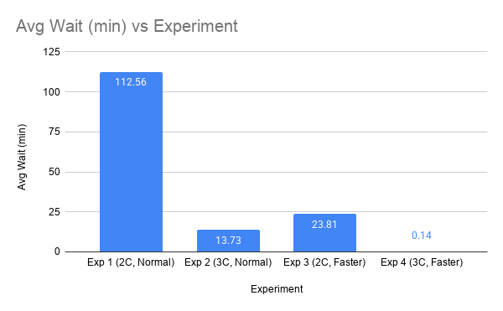

The blue bar for Experiment 1 is very tall 112 minutes. That is almost 2 hours of waiting. No customer would accept that.
Experiment 2 (adding one counter) drops the wait to 13.7 minutes. That is an 87% improvement. Experiment 3 (faster staff) drops it to 23.8 minutes. That is a 78% improvement.
But look at Experiment 4 (both solutions together). The bar is almost invisible because it is only 0.14 minutes. That means customers basically walk straight to the counter and get served immediately. This is the best result.
The combined solution (Experiment 4) gives the best result by far. Adding one counter is better than making staff faster, but doing both is the ultimate solution.

Chart 2 - Counter Utilization Comparison
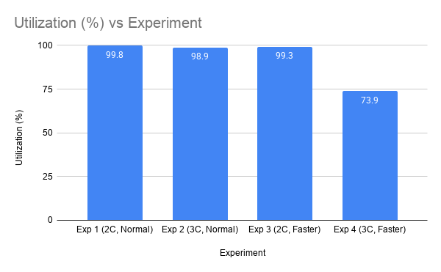

In Experiments 1, 2, and 3, the utilization is over 98%. This means the counters are working almost 100% of the time. They are completely overloaded. When a system is this busy, queues build up quickly because the counters cannot keep up with the customers.
But in Experiment 4, utilization drops to 73.9%. This is a healthy level. The counters are busy enough to be useful, but they also have some free time to handle sudden rushes of customers. This is the ideal balance.
Utilization of 73.9% is much better than 99.8%. It means counters are working efficiently without being overloaded. This is good for both customers and staff.

Chart 3 - Average Queue Length Comparison

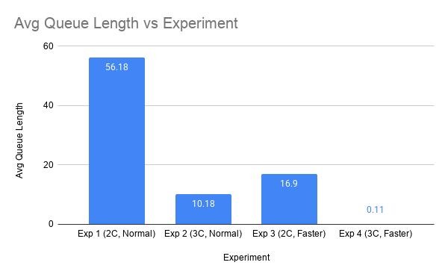
The queue length follows the same pattern as waiting time. In Experiment 1, there are 56 people waiting on average. Imagine standing in a line with 56 people in front of you, you would be there for hours.
Experiment 2 drops the queue to 10 people. That is better, but still a long line. Experiment 3 drops it to 17 people. Experiment 4 drops it to almost zero only 0.11 customers waiting on average.
Queue length and waiting time are directly connected. When wait time goes down, queue length goes down too. Experiment 4 has basically no queue at all.

Chart 4 - Total Time to Serve All Customers

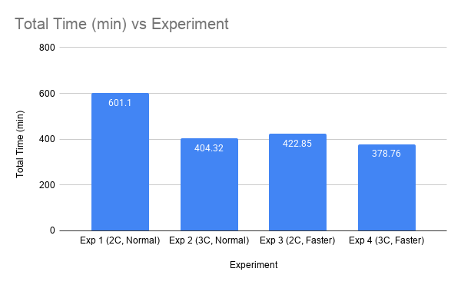
Experiment 1 takes the longest 601 minutes (about 10 hours). This is terrible. If it takes 10 hours to serve 300 customers, the supermarket cannot handle its workload.
Experiment 2 drops the time to 404 minutes (about 6.7 hours). Experiment 3 drops it to 423 minutes (about 7 hours). Experiment 4 takes the shortest time 379 minutes (about 6.3 hours).
The combined solution does not just reduce waiting time it also finishes the whole day's work faster. This means the supermarket can serve more customers in a day, which means more sales and more profit.

Chart 5 - Theoretical vs Actual Utilization
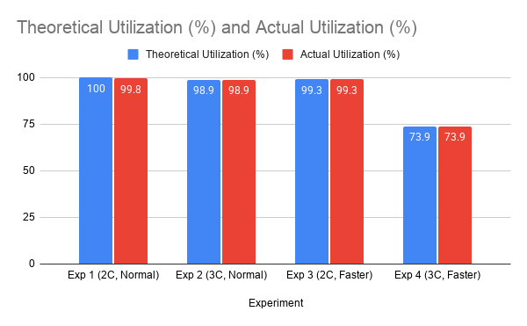
This chart proves my simulation is accurate. Look at the bars the blue bar (theoretical) and the red bar (actual) are almost identical for every experiment. This means my simulation matches the mathematical formulas perfectly.
If my simulation results matched the theory, it means my model is correct. I did not make any big mistakes in my code. This makes my recommendations more trustworthy.
This chart gives me confidence in my results. It proves that my simulation is accurate and my recommendations are reliable.

3.3 Detailed Analysis of Results
Now let me explain what each experiment tells us, one by one.

Experiment 1 - The Current System (2 Counters, Normal Speed)
This is the worst case. The average waiting time is 112.56 minutes, which is almost 2 hours. No customer would wait that long in a supermarket. If you told someone You will wait 2 hours to pay, they would laugh and leave.
The average queue length is 56.18 customers. That means, on average, there are 56 people standing in line. Imagine a line that long it would stretch halfway through the store.
The utilization is 99.8%. This means the two counters are working almost 100% of the time. They are completely overloaded. They cannot work any harder. The system is failing.
Customers are arriving faster than the counters can serve them. Every minute, more customers join the queue than leave. The queue just keeps growing and growing. This is called an "unstable" system.

Experiment 2 - Add One More Counter (3 Counters, Normal Speed)
Adding just one counter makes a huge difference. The waiting time drops from 112.56 minutes down to 13.73 minutes. This is an 87% improvement.
The average queue length drops from 56.18 to 10.18 customers. This is a 90% improvement.
However, the utilization is still 98.9%. This is still very high. The counters are still overloaded, just slightly less than before.
Adding a counter increases the system's capacity. Now, three counters can serve more customers per hour. The queue still grows, but much more slowly.
Adding one counter is a very effective solution. It gives a huge improvement for a reasonable cost. If the manager has a tight budget, this is the best choice.

Experiment 3 - Train Staff to Work Faster (2 Counters, 30% Faster)
Training the staff to work 30% faster also helps. The waiting time drops to 23.81 minutes. This is a 78% improvement from Experiment 1.
The average queue length drops to 16.90 customers. This is a 70% improvement.
However, the utilization is still 99.3%. The counters are still overloaded.
Making staff faster helps, but it cannot fully fix the problem of having only 2 counters. The counters are faster, but there are still only two of them. When many customers arrive at once, the queue still grows.
Training staff helps, but it is not as good as adding a counter. If the manager can only choose one solution, adding a counter is better than training staff.

Experiment 4 - Both Solutions Together (3 Counters, 30% Faster)
This is the clear winner. The average waiting time drops to just 0.14 minutes. This means customers basically walk straight to the counter and get served immediately. There is almost no wait at all.
The average queue length drops to 0.11 customers. This is basically zero no queue at all.
The utilization drops to 73.9%. This is a healthy level. The counters are busy enough to be useful, but they also have free time to handle sudden rushes.
The total time to serve all 300 customers is also the lowest at 378.76 minutes.
Adding a counter AND making staff faster gives the best of both worlds. The system has more capacity AND faster service. This combination completely eliminates the queue.
This is the best solution. Customers are happy, staff are not overloaded, and the store finishes its work faster. If the manager has the budget, this is what they should do.

4. Discussion and Interpretation

4.1 What I Learned from This Project
This project taught me several important lessons about performance modeling.

1. Capacity Matters More Than Speed
Adding one counter (Experiment 2) reduced waiting time by 87%. Making staff faster (Experiment 3) only reduced it by 78%. This shows that the number of counters (capacity) is more important than the speed of each counter.
Why? Think of it like a highway. If you have a two-lane highway, making cars go faster helps a little. But if there are too many cars, the highway will still be congested. The only real solution is to add more lanes. The same is true for supermarket checkout counters.

2. The Combined Solution Is Best
Experiment 4 gave a 99.8% reduction in waiting time almost complete elimination. This shows that the two solutions (adding counters and making staff faster) work together. They are not competing solutions they complement each other.

3. Healthy Utilization Is Important
In Experiments 1, 2, and 3, utilization was above 98%. This is too high. The counters are overloaded, which causes long queues. In Experiment 4, utilization dropped to 73.9%. This is healthy. It means counters are busy but not overloaded.

4. Simulation Is a Powerful Tool
This project showed me how simulation can answer "what-if" questions. I could test four different scenarios without spending any money or disrupting a real supermarket. This is the power of performance modeling.

4.2 Managerial Recommendations
Based on my results, here is my advice to the supermarket manager.
Recommendation 1
Implement both solutions add one more counter AND train staff to work 30% faster. This gives the best results
- Waiting time drops from 112 minutes to 0.14 minutes (99.8% improvement).
- Queue length drops from 56 to almost zero.
- Utilization drops to a healthy 73.9%.
- Total time drops from 601 to 379 minutes.
Cost - This is the most expensive option because it requires hiring a new cashier AND investing in training. However, the benefits are huge.

Recommendation 2 (Budget Option):
If the manager can only afford one change, add one more counter. This gives:
- Waiting time drops from 112 minutes to 13.73 minutes (87% improvement).
- Queue length drops from 56 to 10.
Cost - This is cheaper than training because it only requires hiring one new cashier. No training is needed.

Summary of Recommendations

Priority | Recommendation | Expected Improvement | Cost
Best | Add counter + Train staff | 99.8% wait reduction | High
Good | Add counter only | 87% wait reduction | Medium
Not Good | Train staff only | 78% wait reduction | Medium
Terrible | Do nothing | 0% improvement | Free (but fails)

5. Limitations

5.1 Limitations of My Project
No project is perfect. I want to be honest about the limitations of my work.
1. Fake Data
I used simulated data, not real data from a supermarket. Real data would be better because it would show the true arrival patterns and service times. However, getting real data from a supermarket is very difficult because they keep their business information private.
How this affects my results: The numbers might be slightly different in a real supermarket. However, the patterns and trends would likely be the same.

2. Simple Customers
I assumed all customers are the same. In real supermarkets, some customers have very small baskets (express) and some have huge trolleys. I did not separate these types.
How this affects my results: Real supermarkets often have express lanes for customers with 10 items or less. My model did not include this. This might make my results less realistic.

3. No Customer Abandonment
I assumed that once customers join the queue, they stay forever. In real life, if the queue is too long, some customers will leave without buying anything.
How this affects my results: My model might overestimate queue lengths because it does not include customers leaving. In reality, some customers would leave, which would make the queue shorter.

4.Identical Counters
I assumed all counters are exactly the same speed. In real life, some cashiers are faster than others.
How this affects my results: In reality, faster cashiers would serve more customers, which would improve the system. My model might slightly underestimate performance.

6. Conclusion

6.1 Summary of Findings
In this project, I studied a supermarket checkout system with long waiting times. I tested four solutions using a Python simulation with 300 simulated customers.
My key findings are
- The current system is failing badly. With 2 counters and normal speed, customers wait an average of 112 minutes (almost 2 hours). Utilization is 99.8%, meaning the counters are completely overloaded.
- Adding one counter makes a huge difference. Wait time drops from 112 minutes to 13.7 minutes (87% improvement). This shows that the main problem is the number of counters.
- Making staff faster helps, but not enough. Wait time drops to 23.8 minutes (78% improvement). This helps, but it cannot fix the problem of having only 2 counters.
- Doing both is the best solution. Wait time drops to just 0.14 minutes (99.8% improvement). Customers basically walk straight to the counter. Utilization drops to 73.9%, which is a healthy level.
- Capacity matters more than speed. Adding a counter gives a bigger improvement than making staff faster. This is the most important lesson from this project.

6.2 Final Recommendations
My final recommendation for the supermarket manager is
- If you have the budget - Open one more counter AND train staff to work 30% faster. This gives the best results with almost zero waiting time.
- If you have a tight budget - Just open one more counter. This gives an 87% reduction in waiting time and is the biggest improvement for the cost.
- Do NOT just train staff without adding counters. While it helps, it is not enough.
- Do NOT keep the current system. It is failing and will damage the store's reputation.

6.3 What I Learned
This project has taught me several important lessons
- Performance modeling is powerful. I could test four different scenarios without spending any money or disrupting a real supermarket.
- Simulation is better than formulas for complex systems. Formulas assume perfect patterns, but real systems are random. Simulation handles randomness much better.
- Data quality matters. My results are only as good as my data. Using realistic data is very important.
- Capacity matters more than speed. Adding more resources (counters) is more effective than making existing resources faster.
- The combined solution is often the best. Sometimes, two solutions work better together than either one works alone.

generate_data.py
import random
import csv

total_customers = 300
first_arrival = 0.0
min_gap = 0.5
max_gap = 2.0
min_service = 2.0
max_service = 6.0

customers = []
previous_arrival = first_arrival

for customer_id in range(1, total_customers + 1):
if customer_id == 1:
arrival = 0.0
else:
gap = round(random.uniform(min_gap, max_gap), 2)
arrival = previous_arrival + gap

service = random.uniform(min_service, max_service)

arrival = round(arrival, 2)
service = round(service, 2)

customers.append([customer_id, arrival, service])

previous_arrival = arrival

with open('supermarket_data.csv', 'w', newline='') as file:
writer = csv.writer(file)
writer.writerow(['Customer_ID', 'Arrival_Time', 'Service_Time'])
writer.writerows(customers)

print("CSV file created")

simulation.py

import csv

def run_experiment(filename, num_counters, speed_multiplier):
# Read the customer data from the CSV file
customers = []
with open(filename, 'r') as file:
reader = csv.reader(file)
next(reader) # Skip the header row
for row in reader:
customer_id = int(row[0])
arrival = float(row[1])
service = float(row[2])
customers.append([customer_id, arrival, service])

for c in customers:
c[2] = c[2] * speed_multiplier # New service time

counters_free_time = [0.0] * num_counters

# Lists to store results for each customer
wait_times = []
total_customers = len(customers)

# For utilization tracking, we add up total busy time for each counter
counter_busy_time = [0.0] * num_counters

for customer in customers:
cust_id = customer[0]
arrival = customer[1]
service = customer[2]

# Find the counter that becomes free the earliest
earliest_time = min(counters_free_time)
earliest_counter = counters_free_time.index(earliest_time)

# When does this customer start service?
start_service = max(arrival, earliest_time)

# How long did they wait?
wait = start_service - arrival
wait_times.append(wait)

# When does this counter finish serving this customer?
finish_time = start_service + service
counters_free_time[earliest_counter] = finish_time

# Add this service time to the counter's busy time
counter_busy_time[earliest_counter] += service

avg_wait = sum(wait_times) / len(wait_times)

# 2. Average Queue Length (Little's Law: L = λ * W)
# λ (arrival rate) = total customers / total time
total_time = max(counters_free_time)
arrival_rate = total_customers / total_time
avg_queue_length = arrival_rate * avg_wait

# 3. Counter Utilization (average % busy across all counters)
total_busy_time = sum(counter_busy_time)
total_available_time = num_counters * total_time
avg_utilization = total_busy_time / total_available_time

# 4. Total Time to serve all customers
total_time_taken = total_time

# Return all results as a dictionary
return {
'avg_wait': avg_wait,
'avg_queue_length': avg_queue_length,
'avg_utilization': avg_utilization,
'total_time': total_time_taken
}

print("SUPERMARKET SIMULATION RESULTS")

# Experiment 1: 2 counters, normal speed (1.0)
results1 = run_experiment('supermarket_data.csv', 2, 1.0)
print("Experiment 1 (2 counters, normal speed):")
print(f" Avg Wait: {results1['avg_wait']:.2f} min")
print(f" Avg Queue Length: {results1['avg_queue_length']:.2f} customers")
print(f" Avg Utilization: {results1['avg_utilization']*100:.1f}%")
print(f" Total Time: {results1['total_time']:.2f} min")
print()

# Experiment 2: 3 counters, normal speed
results2 = run_experiment('supermarket_data.csv', 3, 1.0)
print("Experiment 2 (3 counters, normal speed):")
print(f" Avg Wait: {results2['avg_wait']:.2f} min")
print(f" Avg Queue Length: {results2['avg_queue_length']:.2f} customers")
print(f" Avg Utilization: {results2['avg_utilization']*100:.1f}%")
print(f" Total Time: {results2['total_time']:.2f} min")
print()

# Experiment 3: 2 counters, 30% faster (0.7)
results3 = run_experiment('supermarket_data.csv', 2, 0.7)
print("Experiment 3 (2 counters, 30% faster):")
print(f" Avg Wait: {results3['avg_wait']:.2f} min")
print(f" Avg Queue Length: {results3['avg_queue_length']:.2f} customers")
print(f" Avg Utilization: {results3['avg_utilization']*100:.1f}%")
print(f" Total Time: {results3['total_time']:.2f} min")
print()

# Experiment 4: 3 counters, 30% faster
results4 = run_experiment('supermarket_data.csv', 3, 0.7)
print("Experiment 4 (3 counters, 30% faster):")
print(f" Avg Wait: {results4['avg_wait']:.2f} min")
print(f" Avg Queue Length: {results4['avg_queue_length']:.2f} customers")
print(f" Avg Utilization: {results4['avg_utilization']*100:.1f}%")
print(f" Total Time: {results4['total_time']:.2f} min")
print()

