Does generative AI help small, imbalanced clinical tables? A benchmark of interpolation, GAN, VAE and diffusion-based synthetic data for polycystic ovary syndrome prediction
[Author Name 1]¹*, [Author Name 2]¹, [Author Name 3]²
¹ Department of [Department], Faculty of [Faculty], University of Sri Jayewardenepura, Nugegoda, Sri Lanka
² [Affiliation 2, city, country]
*Corresponding author. E-mail: [corresponding.author@email]; ORCID: [0000-0000-0000-0000]
Abstract
Generative models are increasingly used to rebalance small clinical datasets, but their benefit on real patients is rarely tested against a no-augmentation baseline. We benchmarked eight synthetic-data generators for polycystic ovary syndrome (PCOS) prediction: SMOTE, ADASYN, Borderline-SMOTE, CTGAN (two independent fits), TVAE, and compact re-implementations of denoising diffusion (TabDDPM-lite) and latent diffusion (TabSyn-lite). We used a clinical cohort (n = 541; 177 PCOS) and a lifestyle questionnaire cohort (n = 172; 38 PCOS). Over three stratified 75:25 splits, generators were fitted on training data only, minority rows were synthesised to balance the classes, and logistic regression, random forest and XGBoost were tested on held-out real patients. Fidelity (Kolmogorov–Smirnov, total variation distance, correlation error) and privacy (distance to closest record) were measured. On the clinical cohort, no generator improved on no augmentation (F1 0.833 ± 0.022; ROC-AUC 0.946). The best, TVAE, differed by +0.002 [95% CI −0.013, 0.018], and SMOTE reduced F1 by 0.022. On the questionnaire cohort, TabDDPM-lite achieved the highest F1 (0.732 vs 0.686) and recall (0.765 vs 0.630), but its gain [−0.024, 0.116] lay within split-to-split variability. Interpolation oversamplers and one CTGAN fit lowered F1 by 0.08–0.10. Latent diffusion reproduced marginals most faithfully (TVD 0.041–0.051), and the two CTGAN fits differed as much as the generator families did. Synthetic augmentation is not a default remedy for class imbalance in small PCOS datasets. Diffusion models are the most promising option when positive cases are scarce, but any gain must be shown against an unaugmented baseline on real test data.
Keywords Polycystic ovary syndrome · Generative artificial intelligence · Synthetic data · Tabular diffusion models · CTGAN · Class imbalance · SMOTE

1 Introduction
Polycystic ovary syndrome (PCOS) is the most common endocrine disorder of women of reproductive age, affecting about 6–10% of women depending on the diagnostic criteria [1]. It combines ovulatory dysfunction, hyperandrogenism and polycystic ovarian morphology, and it carries reproductive, metabolic and psychological consequences [2, 3]. Because many women remain undiagnosed, machine learning (ML) on routinely collected clinical and lifestyle variables has attracted considerable interest as a screening aid. Recent systematic reviews, however, note that most PCOS ML studies rely on small, single-source datasets, often the same public 541-patient clinical dataset [4], with limited external validation [5, 6].
Small PCOS datasets are also imbalanced: PCOS cases make up roughly one-fifth to one-third of records. The most common response in the PCOS literature is synthetic minority oversampling, using SMOTE or one of its variants [7–11]. Generative artificial intelligence now offers far richer alternatives. Conditional generative adversarial networks (GANs) [12, 13], variational autoencoders (VAEs) [12] and, most recently, denoising diffusion models [14, 15] can learn the joint distribution of mixed-type tables and sample new records from it. Synthetic data are widely promoted in medicine for augmentation, privacy-preserving sharing and simulation [16, 17].
Three concerns temper this enthusiasm. First, class-imbalance corrections do not necessarily improve clinical prediction models. In logistic regression, random under- and oversampling and SMOTE degraded calibration without improving discrimination [18]. Second, evaluation of synthetic health data is fragmented: reviews find no universally accepted metric [19], and fidelity, utility and privacy can pull in different directions [20, 21]. Third, synthetic data do not automatically protect privacy [22]. For PCOS in particular, no study has compared classical oversamplers with GAN, VAE and diffusion generators under the same protocol, on real held-out patients, against a no-augmentation baseline.
This paper addresses that gap. Our contributions are:
- A controlled benchmark of eight generators from five families — interpolation (SMOTE, ADASYN, Borderline-SMOTE), GAN (CTGAN, fitted twice independently), VAE (TVAE), diffusion (TabDDPM-lite) and latent diffusion (TabSyn-lite) — on two PCOS cohorts of different size and nature: a clinical cohort and a lifestyle questionnaire cohort.
- A train-on-real-plus-synthetic, test-on-real protocol with three repeated stratified splits and three downstream classifiers (logistic regression, random forest, XGBoost), in which each generator is fitted on training data only and every metric is computed on real held-out patients.
- A joint assessment of utility (six classification metrics and paired differences from the unaugmented baseline), fidelity (Kolmogorov–Smirnov statistic, total variation distance, correlation error), privacy (distance to closest record) and computational cost.
- Evidence that the benefit of augmentation depends on the dataset: no generator improved clinical-cohort prediction, whereas diffusion-based generators were the only ones to improve the small questionnaire cohort, with the gain still inside split-to-split variability. Two independent CTGAN fits differed by as much as the generator families did.
Section 2 reviews related work. Section 3 describes the data, generators and evaluation protocol. Section 4 reports the results, Section 5 discusses their implications and limitations, and Section 6 concludes.

2 Related work
This section reviews 21 studies in four groups: deep generative models for tabular data, the generation and evaluation of synthetic health records, class-imbalance correction in clinical prediction, and oversampling in PCOS ML. Table 1 summarises them.

2.1 Deep generative models for tabular data
Choi et al. introduced medGAN, which combines an autoencoder with a GAN to generate high-dimensional, discrete electronic health records while limiting disclosure risk [23]. Xu et al. identified the main obstacles to modelling tabular data with GANs — mixed data types, multimodal continuous columns and imbalanced categorical columns. They proposed CTGAN, which uses mode-specific normalisation and a conditional generator trained by sampling, together with TVAE, a VAE counterpart; both outperformed Bayesian-network baselines on most benchmarks [12]. CTAB-GAN extended the conditional GAN with information and classification losses and explicit handling of mixed and long-tailed variables, improving downstream accuracy by up to 17% over earlier synthesisers [24]. CTAB-GAN+ added a Wasserstein loss with gradient penalty, improved encoders and differentially private training, and reported F1-scores at least 21.9% higher than competing methods [13].
Diffusion models have recently overtaken GANs on many tabular benchmarks. TabDDPM applies Gaussian diffusion to numerical features and multinomial diffusion to categorical features, and it outperformed GAN and VAE baselines across a broad benchmark [14]. STaSy trains score-based models with self-paced learning and fine-tuning, and improved task utility and diversity over seven baselines on 15 datasets [25]. TabSyn first learns a VAE latent space for mixed-type rows and then trains a score-based diffusion model within it, which reduced distributional error substantially while being faster than TabDDPM [15]. GReaT takes a different route, serialising rows as text and fine-tuning a pretrained language model to generate them [26]. Nearly all of these evaluations used large public benchmarks with thousands of rows, rather than clinical tables with a few hundred patients.

2.2 Synthetic health data: generation and evaluation
Yale et al. proposed HealthGAN and evaluated synthetic health data jointly for utility, resemblance and privacy. Their method offered stronger privacy than five baselines at comparable utility [27]. Goncalves et al. compared several generation methods, from probabilistic models to a medGAN variant, on cancer-registry data using a broad battery of utility and disclosure metrics, and found that the relative merits of the methods depended on the metric used [28]. A systematic review of 34 studies on synthetic tabular health records concluded that there is no universal method or metric for evaluating and benchmarking generators [19]. Alaa et al. introduced sample-level metrics — α-precision, β-recall and authenticity — that separate fidelity, diversity and privacy [20]. Synthcity provides a common framework for benchmarking tabular generators across these dimensions [21]. On privacy, Stadler et al. showed that synthetic data either failed to prevent inference attacks or lost utility, with no reliably better trade-off than traditional anonymisation [22]. Parise et al. generated synthetic records from only 238 COVID-19 patients with CTGAN under expert guidance and reported high resemblance [29]; this illustrates growing interest in small-sample clinical synthesis. Commentaries emphasise both the promise of synthetic data and the risks of bias amplification and re-identification [16, 17].

2.3 Class imbalance correction in clinical prediction
SMOTE [30] and its many variants remain the dominant response to class imbalance. A 15-year review catalogued more than 85 extensions and highlighted open problems with small disjuncts, noise and high dimensionality [31]. In a clinical setting, van den Goorbergh et al. showed that random under- and oversampling and SMOTE produced systematically overestimated risks in logistic-regression models without improving discrimination. They advised against imbalance correction when calibrated risk estimates are needed [18]. These findings motivate testing augmentation against an unaugmented baseline, rather than assuming that it helps.

2.4 Oversampling in PCOS machine learning
In PCOS studies, oversampling is usually treated as a routine preprocessing step. Elmannai et al. combined SMOTEENN with feature selection and stacking on the 541-patient clinical dataset and reported 100% accuracy [7]. Khanna et al. used Borderline-SMOTE with stacked ensembles and deep networks, reaching 98% accuracy [8]. Moral et al. used SMOTE-Tomek with grey-wolf feature selection and boosting to reach 97.42% accuracy [9]. Ahmad et al. applied SMOTE before training lightweight CNN and LSTM models and reported 96.59% accuracy [10]. Nsugbe balanced the dataset to 728 samples with SMOTE before comparing classical classifiers [11]. None of these studies isolated the effect of oversampling by comparing against a no-augmentation baseline. Several applied it before splitting the data, a sequence that can leak synthetic neighbours of test patients into training [32]. To our knowledge, deep generative models (GAN, VAE, diffusion) had not been benchmarked for PCOS tabular data.
Table 1 Summary of the reviewed studies
Ref. | Focus / data | Method | Key finding (as reported)
[23] | Discrete EHR | medGAN (autoencoder + GAN) | Realistic synthetic patient records with limited disclosure risk
[12] | Tabular benchmarks | CTGAN, TVAE | Outperformed Bayesian-network synthesisers on most datasets
[24] | Tabular benchmarks | CTAB-GAN | Up to 17% higher downstream accuracy than prior synthesisers
[13] | Tabular benchmarks | CTAB-GAN+ (WGAN-GP, DP) | F1 at least 21.9% higher than competitors; DP guarantees
[14] | Tabular benchmarks | TabDDPM (Gaussian + multinomial diffusion) | Outperformed GAN and VAE generators
[25] | 15 tabular datasets | STaSy (score-based) | Better task utility and diversity than 7 baselines
[15] | Tabular benchmarks | TabSyn (VAE + latent diffusion) | Large reduction in distributional error; faster than TabDDPM
[26] | Tabular benchmarks | GReaT (language model) | Realistic rows by text serialisation
[27] | Health records | HealthGAN; utility/privacy metrics | Better privacy than 5 baselines at similar utility
[28] | Cancer registry data | Probabilistic models vs medGAN variant | Relative merit depended on the metric
[19] | Review (34 studies) | Systematic review | No universal generation method or evaluation metric
[20] | Benchmarks incl. clinical | α-precision, β-recall, authenticity | Sample-level fidelity, diversity and privacy audit
[22] | Health and census data | Privacy attacks on synthetic data | No reliable privacy–utility gain over anonymisation
[21] | Multiple modalities | Synthcity framework | Standardised benchmarking of generators
[29] | COVID-19 patients (238) | Expert-guided CTGAN | High resemblance from a small clinical sample
[31] | Review | SMOTE and extensions | Open problems: noise, small disjuncts, dimensionality
[18] | Clinical risk models | Under/oversampling, SMOTE with LR | Worse calibration; no gain in discrimination
[7] | PCOS clinical (541) | SMOTEENN + stacking | 100% accuracy (no unaugmented baseline)
[8] | PCOS clinical (541) | Borderline-SMOTE + stacking/DNN | 98% accuracy
[9] | PCOS clinical (541) | SMOTE-Tomek + boosting | 97.42% accuracy
[10] | PCOS clinical (458) | SMOTE + CNN/LSTM | 96.59% accuracy
DP differential privacy; EHR electronic health records; LR logistic regression; WGAN-GP Wasserstein GAN with gradient penalty.
Two gaps motivate the present study. Deep tabular generators have been validated mainly on large public benchmarks, and their value for clinical tables with a few hundred patients and a small minority class is unclear. In PCOS research, meanwhile, oversampling is routine, but its contribution has not been separated from that of the classifier, and GAN-, VAE- and diffusion-based augmentation has not been compared with classical interpolation under a single protocol.

3 Materials and methods
Fig. 1 summarises the benchmarking workflow. All generators and classifiers were fitted on real training rows only, and every utility metric was computed on held-out real patients.
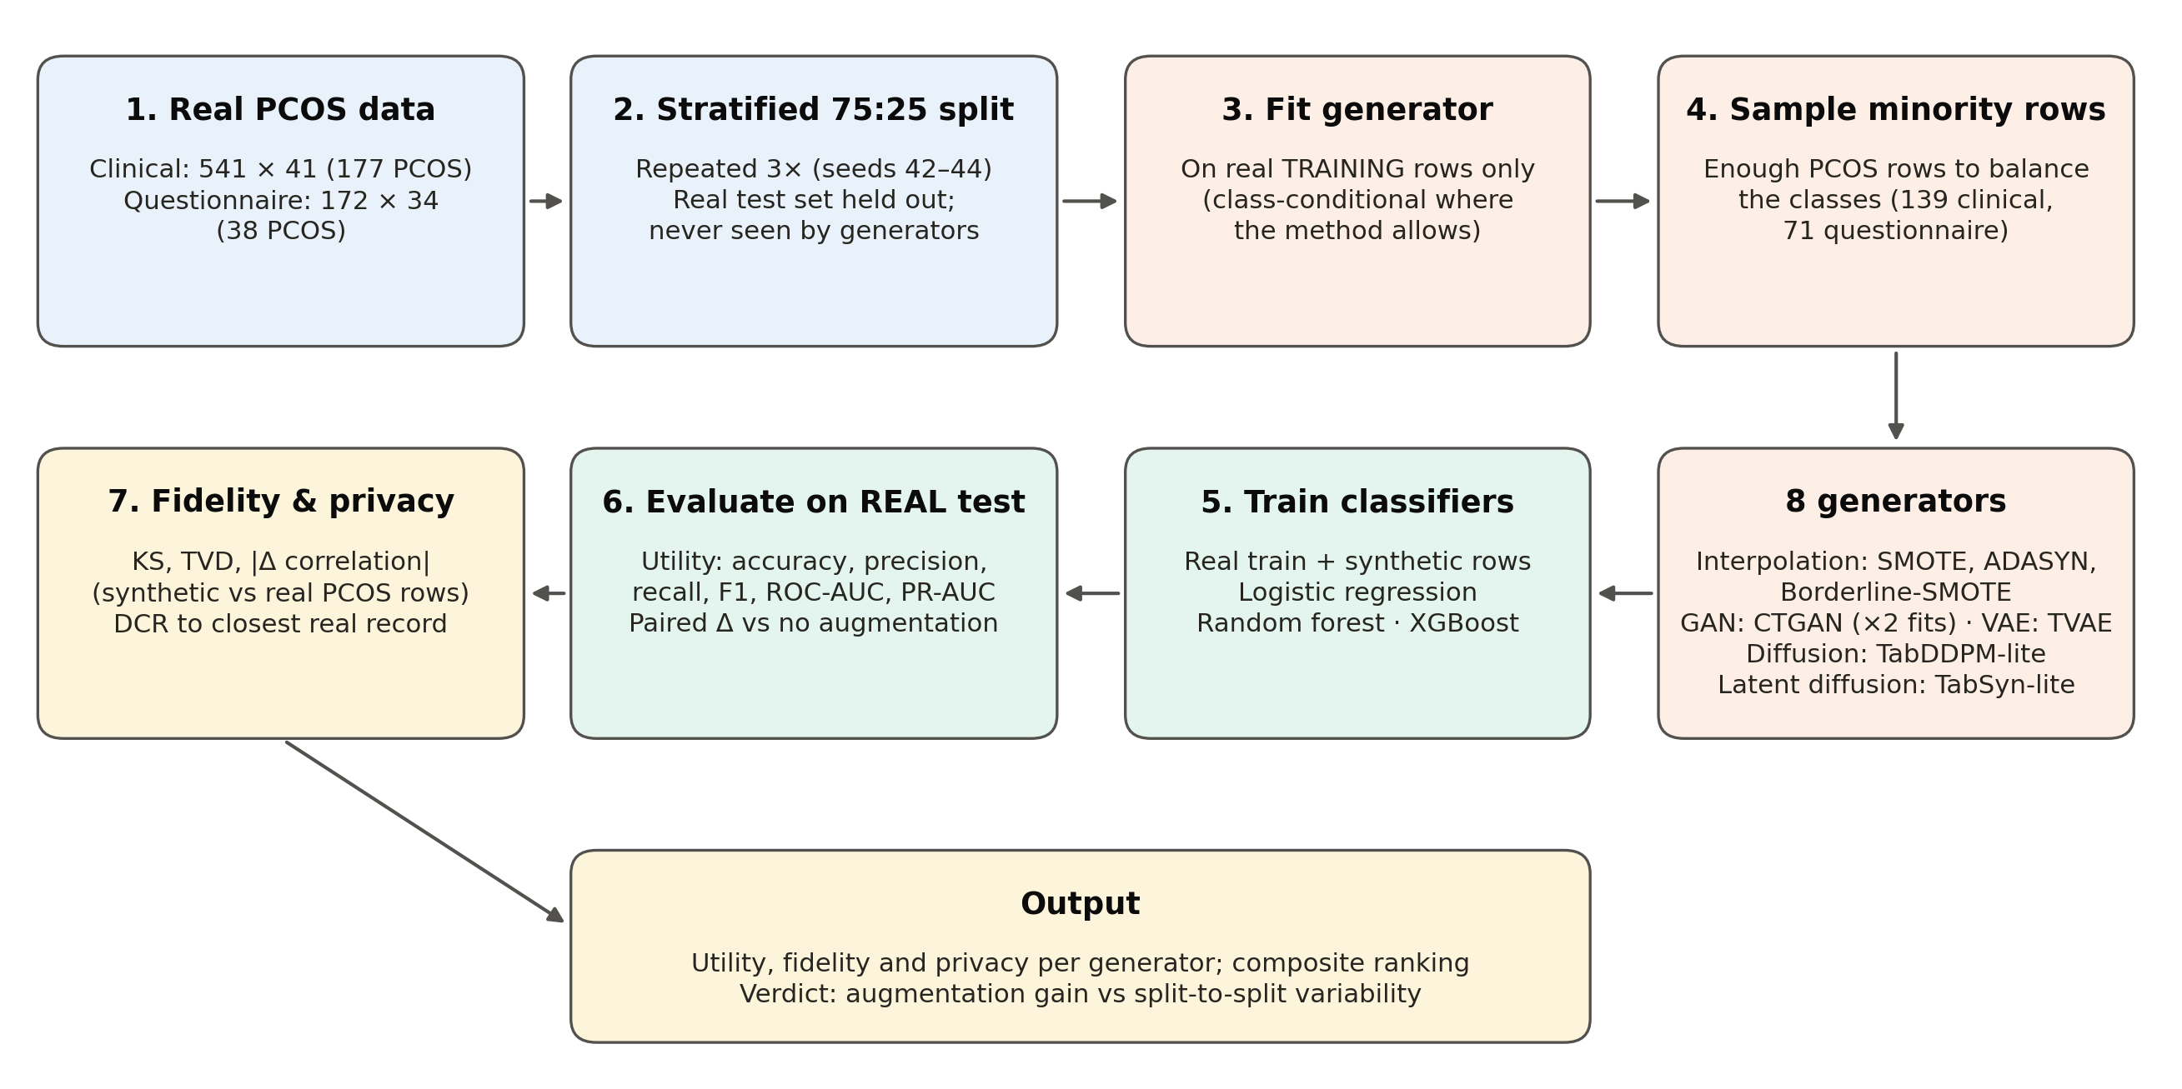
Fig. 1 Benchmarking workflow. For each of three repeated stratified splits, each generator is fitted on the real training set, synthetic PCOS rows are added until the classes are balanced, and three classifiers trained on the augmented data are evaluated on the untouched real test set. Fidelity and privacy are computed on the synthetic rows.

3.1 Datasets
Clinical cohort. The first dataset is a publicly available PCOS dataset collected from hospitals in Kerala, India [4]. It contains 541 women (177 with PCOS; 32.7%) and 41 predictors after removal of identifier columns (serial number, patient file number) and an empty trailing column. The predictors cover anthropometry, vital signs, menstrual history, clinical signs, lifestyle, hormonal assays (FSH, LH, AMH, TSH, prolactin, vitamin D3, progesterone, β-HCG) and ultrasound follicle measurements. The target is "PCOS (Y/N)". Two malformed values (a stray letter in AMH and a double decimal point in II β-HCG) were coerced to missing, and the handful of missing values (fewer than five cells) were imputed with column medians. Predictors with at most two distinct values, together with blood group, were treated as categorical, and the remaining predictors as continuous.
Questionnaire cohort. The second dataset is a publicly available lifestyle and dietary questionnaire [source and citation to be added by the authors]. After removal of one respondent with an ambiguous answer to the diagnosis question, it contains 172 women (38 with PCOS; 22.1%) and 34 predictors, covering anthropometry, self-reported menstrual irregularity and hyperandrogenism, mental health and stress, exercise and sleep habits, and food-frequency items. The column "PCOS_Medication" was removed because it is only defined after diagnosis and would leak the label. Ordered categorical answers (age band, exercise frequency and duration, sleep hours, perceived exercise benefit) were mapped to integers that preserve their order, and other text variables were integer-coded. Binary and text-derived columns were treated as categorical.
Table 2 Characteristics of the two cohorts and of each repeated split
Characteristic | Clinical cohort | Questionnaire cohort
Participants (PCOS / non-PCOS) | 541 (177 / 364) | 172 (38 / 134)
PCOS prevalence | 32.7% | 22.1%
Predictors | 41 | 34
Training rows per split (PCOS / non-PCOS) | 405 (133 / 272) | 129 (29 / 100)
Test rows per split (PCOS / non-PCOS) | 136 (44 / 92) | 43 (9 / 34)
Synthetic PCOS rows generated per split | 139 | 71
Minority-to-majority ratio after augmentation | 1 : 1 | 1 : 1

3.2 Experimental protocol
Each cohort was split three times into stratified 75:25 training and test sets (random seeds 42, 43 and 44). For each split, the number of synthetic rows needed to balance the training classes was computed as n_needed = n₀ − n₁ (139 clinical, 71 questionnaire). Each generator was then fitted on the real training rows and asked for n_needed synthetic PCOS rows. For the class-conditional deep generators, the label was supplied as a conditioning column and sampling was restricted to the PCOS class. The synthetic rows were appended to the real training rows with label 1. Three classifiers were trained on the augmented set and evaluated on the untouched real test set: logistic regression (standardised inputs, L2 penalty), random forest [33] (400 trees) and XGBoost [34] (400 trees, maximum depth 4, learning rate 0.08, row and column subsampling 0.9). The unaugmented baseline trained the same classifiers on the real training set alone. All classifiers used default settings and a 0.5 decision threshold, so that differences reflect the training data rather than tuning. Each generator therefore yields 9 utility observations (3 splits × 3 classifiers).

3.3 Generators

3.3.1 Interpolation oversamplers
SMOTE [30] creates a synthetic minority sample on the line segment between a minority sample and one of its k nearest minority neighbours:
$x_{new} = x_{i} + λ\left(x_{nn} − x_{i}\right), λ ∼ U(0, 1)$ (1)
ADASYN [35] allocates more synthetic samples to minority points that are harder to learn. For each minority point, rᵢ = Δᵢ/K, where Δᵢ is the number of majority points among its K nearest neighbours; the normalised values determine gᵢ, the number of samples generated around point i, out of G in total:
$g_{i} = G · \frac{r_{i}}{∑_{j} r_{j}}, r_{i} = \frac{Δ_{i}}{K}$ (2)
Borderline-SMOTE [36] interpolates only from minority points near the class boundary. For all three, k = min(5, n_min − 1), and interpolated values of categorical columns were rounded to the nearest valid code. The imbalanced-learn implementations were used [37]. ADASYN chooses its own sample count, so it produced 130 rather than 139 rows in one clinical split.

3.3.2 GAN: CTGAN
Generative adversarial networks [38] train a generator G and a discriminator D in a minimax game:
$\min_{G} \max_{D} 𝔼_{x∼p_data}\left[log D(x)\right] + 𝔼_{z∼p(z)}\left[log\left(1 − D(G(z))\right)\right]$ (3)
CTGAN [12] adapts this to tables. Continuous columns receive mode-specific normalisation with a variational Gaussian mixture, a conditional vector with training-by-sampling handles imbalanced categorical columns, and training uses a Wasserstein loss with gradient penalty. We used the ctgan library (version 0.12.1) for 300 epochs, with the class label as an additional discrete column. Synthetic rows were sampled in batches, and those labelled PCOS were kept until n_needed rows had been collected. We had also planned to include CTAB-GAN+ [13], but it is distributed only as a research repository that was not available in the execution environment. The pipeline therefore substituted a second, independent CTGAN fit with identical settings and labelled it explicitly as a fallback. We report this second fit as CTGAN (2nd fit). Although no CTAB-GAN+ result is available, it gives a direct measure of how much a single GAN's results vary between training runs.

3.3.3 VAE: TVAE
Variational autoencoders [39] learn an encoder q(z∣x) and a decoder p(x∣z) by maximising a lower bound on the data likelihood:
$ℒ_{VAE} = 𝔼_{q(z∣x)}\left[log p(x∣z)\right] − β · KL\left(q(z∣x) ∥ p(z)\right)$ (4)
TVAE [12] applies the same column transformations as CTGAN inside a VAE. It was trained for 300 epochs with the label as a discrete column and sampled in the same way as CTGAN.

3.3.4 Diffusion: TabDDPM-lite
Denoising diffusion probabilistic models [40] corrupt data with Gaussian noise over T steps and learn to reverse the process. The forward process has the closed form
$x_{t} = \sqrt{ᾱ_{t}} x_{0} + \sqrt{1 − ᾱ_{t}} ε, ε ∼ 𝒩(0, I)$ (5)
and a network ε_θ is trained to predict the injected noise:
$ℒ_{diff} = 𝔼_{t, x₀, ε}{‖ε − ε_{θ}\left(x_{t}, t, y\right)‖}^{2}$ (6)
Following the TabDDPM recipe [14], we implemented a compact class-conditional variant ("TabDDPM-lite"). Continuous columns were quantile-transformed to a standard normal distribution. Categorical columns were one-hot encoded and diffused in the same Gaussian space, unlike the multinomial diffusion of the original. The denoiser was a three-hidden-layer MLP (256 units, SiLU activations) conditioned on a 64-dimensional sinusoidal timestep embedding and a 64-dimensional label embedding. We used T = 200 steps with the cosine noise schedule of Nichol and Dhariwal [41]:
$ᾱ_{t} = \frac{f(t)}{f(0)}, f(t) = \cos^{2}\left(\frac{t/T + s}{1 + s} · \frac{π}{2}\right), s = 0.008$ (7)
Training ran for 4,000 steps (AdamW, learning rate 10⁻³, weight decay 10⁻⁵, batch size up to 256) on all training rows, with the class label as the condition. New rows were drawn by ancestral sampling with the label fixed to PCOS. The predicted clean sample was clamped to [−4, 4] at every step, which prevented the variance inflation we otherwise observed on small tables. Samples were mapped back to the data space by the inverse quantile transform and, for categorical columns, the arg-max of the one-hot block.

3.3.5 Latent diffusion: TabSyn-lite
TabSyn [15] applies diffusion in the latent space of a VAE, following the latent-diffusion principle [42]. Our compact variant ("TabSyn-lite") first trains a class-conditional VAE (two 256-unit encoder layers, a 16-dimensional latent space, a 16-dimensional label embedding) for 1,500 steps with a small KL weight (β = 10⁻³) to keep reconstructions sharp. The latent codes of the training rows are standardised, and a diffusion model with the same denoiser and schedule as TabDDPM-lite is trained in this 16-dimensional space for 4,000 steps. Sampling draws PCOS-conditioned latent codes and decodes them with the label fixed to PCOS. The original TabSyn uses a transformer-based VAE and score-based diffusion; ours is a lightweight approximation of the same design.

3.4 Evaluation

3.4.1 Utility
For every generator, classifier and split, we computed accuracy, precision, recall (sensitivity), F1-score, ROC-AUC and PR-AUC (average precision) on the real test set. PR-AUC is more informative than ROC-AUC under class imbalance [43]. To isolate the effect of augmentation, we formed paired differences between each generator and the unaugmented baseline for the same split and classifier (9 pairs per generator). For each difference we report the mean, a t-based 95% confidence interval, a two-sided Wilcoxon signed-rank p-value and the number of pairs in which the generator was better. Because the 9 pairs share splits and training data, they are not fully independent, and these statistics are descriptive rather than confirmatory.

3.4.2 Fidelity
Fidelity compared the synthetic rows with the real PCOS training rows of the same split. For each continuous column j, we computed the two-sample Kolmogorov–Smirnov statistic between the empirical distribution functions:
${KS}_{j} = \max_{v} \left(∣F_{j}^{real}(v) − F_{j}^{syn}(v)∣\right)$ (8)
For each categorical column, we computed the total variation distance between the category frequencies:
${TVD}_{j} = \frac{1}{2} ∑_{c} ∣p_{j}^{real}(c) − p_{j}^{syn}(c)∣$ (9)
Dependence structure was summarised by the mean absolute difference between the real and synthetic Pearson correlation matrices over all d columns:
$CorrDiff = \frac{1}{d^{2}} ∑_{k,l} ∣ρ_{kl}^{real} − ρ_{kl}^{syn}∣$ (10)

3.4.3 Privacy and cost
As a simple memorisation check, the distance to closest record (DCR) was computed after standardising all columns on the real training set. For each synthetic row s̃ⱼ, we took the Euclidean distance to its nearest real training row r̃ᵢ, and we report the median over synthetic rows:
$DCR = {median}_{j} \min_{i} ‖{s̃}_{j} − {r̃}_{i}‖_{2}$ (11)
Values near zero would indicate copying of real patients. We also recorded the time needed to fit each generator and draw the synthetic rows. All models ran on CPU in Google Colab.

3.4.4 Composite score
To summarise the three dimensions, each metric was min–max normalised across generators within a cohort (indicated by a tilde), with error metrics inverted. The components were combined with weights of 60% utility, 30% fidelity and 10% privacy:
$S = 0.35 ũ_{F1} + 0.15 ũ_{AUC} + 0.10 ũ_{PR} + 0.12 \left(1 − {k̃}_{KS}\right) + 0.09 \left(1 − {k̃}_{TVD}\right) + 0.09 \left(1 − {k̃}_{CD}\right) + 0.10 {d̃}_{DCR}$ (12)
DCR was capped at twice its median, so that generators receive no extra credit once they are clearly not copying records. The unaugmented baseline has no synthetic rows, so it was assigned the median fidelity and privacy scores. The composite is a relative ranking within a cohort, and its weights are a design choice. We therefore present it as a summary alongside the individual metrics, not as a replacement for them.

4 Results

4.1 Downstream utility
Table 3 and Fig. 2 report utility on the real test sets, averaged over the three splits and three classifiers. On the clinical cohort, the unaugmented baseline achieved F1 0.833 ± 0.022, ROC-AUC 0.946 and PR-AUC 0.924. TVAE (0.835 ± 0.018), TabSyn-lite (0.831), CTGAN (0.830) and Borderline-SMOTE (0.822) came close, while SMOTE (0.811), ADASYN (0.814) and CTGAN (2nd fit) (0.807) fell below the baseline. ROC-AUC varied by only 0.006 across all nine configurations (0.940–0.946), so augmentation did not change the ranking ability of the classifiers.
Table 3 Utility on real held-out test data (mean over 3 splits × 3 classifiers; F1 and ROC-AUC as mean ± SD), ranked by F1
Generator | Family | Accuracy | Precision | Recall | F1 | ROC-AUC | PR-AUC
Clinical cohort
TVAE | VAE | 0.896 | 0.863 | 0.813 | 0.835 ± 0.018 | 0.946 ± 0.020 | 0.923
No augmentation | – | 0.899 | 0.898 | 0.780 | 0.833 ± 0.022 | 0.946 ± 0.018 | 0.924
TabSyn-lite | Latent diffusion | 0.889 | 0.823 | 0.841 | 0.831 ± 0.029 | 0.944 ± 0.017 | 0.923
CTGAN | GAN | 0.891 | 0.847 | 0.816 | 0.830 ± 0.025 | 0.941 ± 0.012 | 0.918
Borderline-SMOTE | Interpolation | 0.886 | 0.824 | 0.826 | 0.822 ± 0.035 | 0.942 ± 0.021 | 0.911
TabDDPM-lite | Diffusion | 0.881 | 0.802 | 0.841 | 0.821 ± 0.020 | 0.945 ± 0.015 | 0.918
ADASYN | Interpolation | 0.879 | 0.809 | 0.823 | 0.814 ± 0.024 | 0.942 ± 0.021 | 0.912
SMOTE | Interpolation | 0.878 | 0.814 | 0.813 | 0.811 ± 0.028 | 0.940 ± 0.023 | 0.910
CTGAN (2nd fit) | GAN | 0.881 | 0.851 | 0.770 | 0.807 ± 0.039 | 0.943 ± 0.026 | 0.915
Questionnaire cohort
TabDDPM-lite | Diffusion | 0.881 | 0.704 | 0.765 | 0.732 ± 0.093 | 0.897 ± 0.054 | 0.797
TabSyn-lite | Latent diffusion | 0.884 | 0.755 | 0.679 | 0.705 ± 0.120 | 0.877 ± 0.071 | 0.771
No augmentation | – | 0.884 | 0.800 | 0.630 | 0.686 ± 0.146 | 0.882 ± 0.073 | 0.775
CTGAN | GAN | 0.863 | 0.692 | 0.691 | 0.676 ± 0.174 | 0.864 ± 0.071 | 0.717
TVAE | VAE | 0.845 | 0.631 | 0.642 | 0.624 ± 0.154 | 0.866 ± 0.099 | 0.687
SMOTE | Interpolation | 0.829 | 0.592 | 0.642 | 0.602 ± 0.115 | 0.845 ± 0.071 | 0.671
CTGAN (2nd fit) | GAN | 0.837 | 0.630 | 0.593 | 0.597 ± 0.154 | 0.822 ± 0.089 | 0.665
ADASYN | Interpolation | 0.822 | 0.593 | 0.630 | 0.596 ± 0.134 | 0.834 ± 0.086 | 0.669
Borderline-SMOTE | Interpolation | 0.824 | 0.588 | 0.605 | 0.590 ± 0.115 | 0.840 ± 0.079 | 0.676

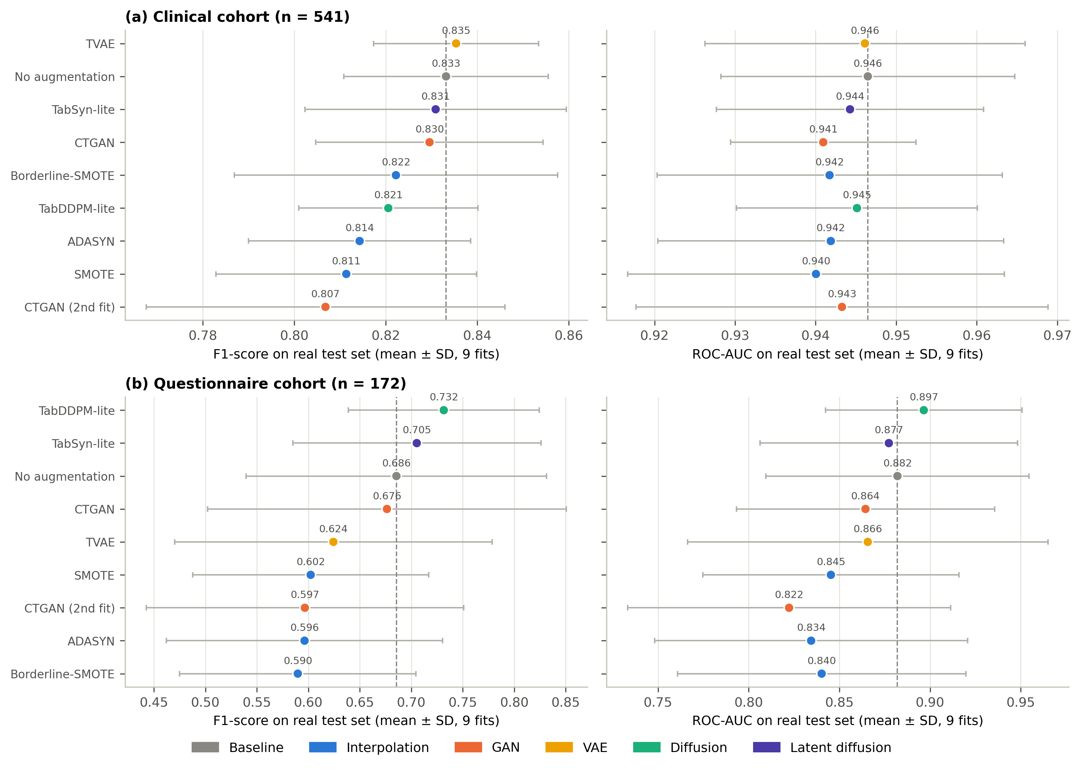
Fig. 2 F1-score and ROC-AUC on real held-out test data (mean ± SD over 3 splits × 3 classifiers) for (a) the clinical cohort and (b) the questionnaire cohort. The dashed line marks the unaugmented baseline
Augmentation did change the operating point. On the clinical cohort, every generator except CTGAN (2nd fit) raised recall above the baseline (0.780), reaching 0.841 for TabDDPM-lite and TabSyn-lite. Precision fell correspondingly, from 0.898 to between 0.802 and 0.863. In other words, adding synthetic PCOS rows shifted the classifiers' decision boundary towards predicting PCOS rather than improving how well they separated the classes. This matches the effect of imbalance corrections described by van den Goorbergh et al. [18].
On the questionnaire cohort, the picture differed. TabDDPM-lite achieved the highest F1 (0.732 ± 0.093), recall (0.765), ROC-AUC (0.897) and PR-AUC (0.797), ahead of TabSyn-lite (F1 0.705) and the baseline (0.686 ± 0.146). All other generators performed worse than the baseline. The three interpolation oversamplers lowered F1 to 0.590–0.602, with precision falling from 0.800 to about 0.59, and TVAE lowered it to 0.624. Fold-to-fold variability was much larger than on the clinical cohort (F1 SD 0.09–0.17), reflecting only nine PCOS cases in each test set.

4.2 Paired comparison with no augmentation
Table 4 and Fig. 3 isolate the effect of augmentation using paired differences. On the clinical cohort, no generator improved F1 meaningfully. The best, TVAE, differed from the baseline by +0.002 [95% CI −0.013, 0.018], and TabSyn-lite by −0.002. SMOTE reduced F1 by 0.022 [−0.040, −0.003], losing in 8 of 9 paired comparisons (p = 0.039), and CTGAN (2nd fit) reduced it by 0.026. ROC-AUC differences were all within −0.006 to 0.000.
Table 4 Paired differences from the unaugmented baseline (same split and classifier; n = 9 pairs per generator)
Cohort | Generator | ΔF1 [95% CI] | p (F1) | Wins | ΔRecall | ΔPrecision | ΔROC-AUC (p)
Clinical | TVAE | +0.002 [−0.013, +0.018] | 0.910 | 4/9 | +0.033 | −0.035 | −0.000 (p = 0.652)
 | TabSyn-lite | −0.002 [−0.032, +0.028] | 0.820 | 5/9 | +0.061 | −0.075 | −0.002 (p = 0.359)
 | CTGAN | −0.004 [−0.028, +0.020] | 0.734 | 5/9 | +0.035 | −0.052 | −0.006 (p = 0.195)
 | Borderline-SMOTE | −0.011 [−0.036, +0.014] | 0.359 | 3/9 | +0.045 | −0.074 | −0.005 (p = 0.203)
 | TabDDPM-lite | −0.013 [−0.035, +0.010] | 0.359 | 4/9 | +0.061 | −0.096 | −0.001 (p = 0.652)
 | ADASYN | −0.019 [−0.038, +0.001] | 0.074 | 3/9 | +0.043 | −0.089 | −0.005 (p = 0.105)
 | SMOTE | −0.022 [−0.040, −0.003] | 0.039 | 1/9 | +0.033 | −0.084 | −0.006 (p = 0.074)
 | CTGAN (2nd fit) | −0.026 [−0.050, −0.002] | 0.055 | 1/9 | −0.010 | −0.047 | −0.003 (p = 0.496)
Questionnaire | TabDDPM-lite | +0.046 [−0.024, +0.116] | 0.102 | 5/9 | +0.136 | −0.095 | +0.015 (p = 0.301)
 | TabSyn-lite | +0.020 [−0.030, +0.070] | 0.438 | 4/9 | +0.049 | −0.044 | −0.005 (p = 0.547)
 | CTGAN | −0.009 [−0.087, +0.068] | 0.945 | 4/9 | +0.062 | −0.108 | −0.018 (p = 0.164)
 | TVAE | −0.061 [−0.100, −0.022] | 0.016 | 1/9 | +0.012 | −0.168 | −0.016 (p = 0.551)
 | SMOTE | −0.083 [−0.178, +0.011] | 0.098 | 2/9 | +0.012 | −0.208 | −0.037 (p = 0.051)
 | CTGAN (2nd fit) | −0.089 [−0.150, −0.028] | 0.008 | 0/9 | −0.037 | −0.169 | −0.060 (p = 0.004)
 | ADASYN | −0.089 [−0.156, −0.022] | 0.020 | 1/9 | +0.000 | −0.207 | −0.048 (p = 0.020)
 | Borderline-SMOTE | −0.096 [−0.181, −0.010] | 0.027 | 1/9 | −0.025 | −0.211 | −0.042 (p = 0.008)
p-values are from two-sided Wilcoxon signed-rank tests; "Wins" is the number of pairs in which the generator had a higher F1 than the baseline. Because pairs share splits, these statistics are descriptive.
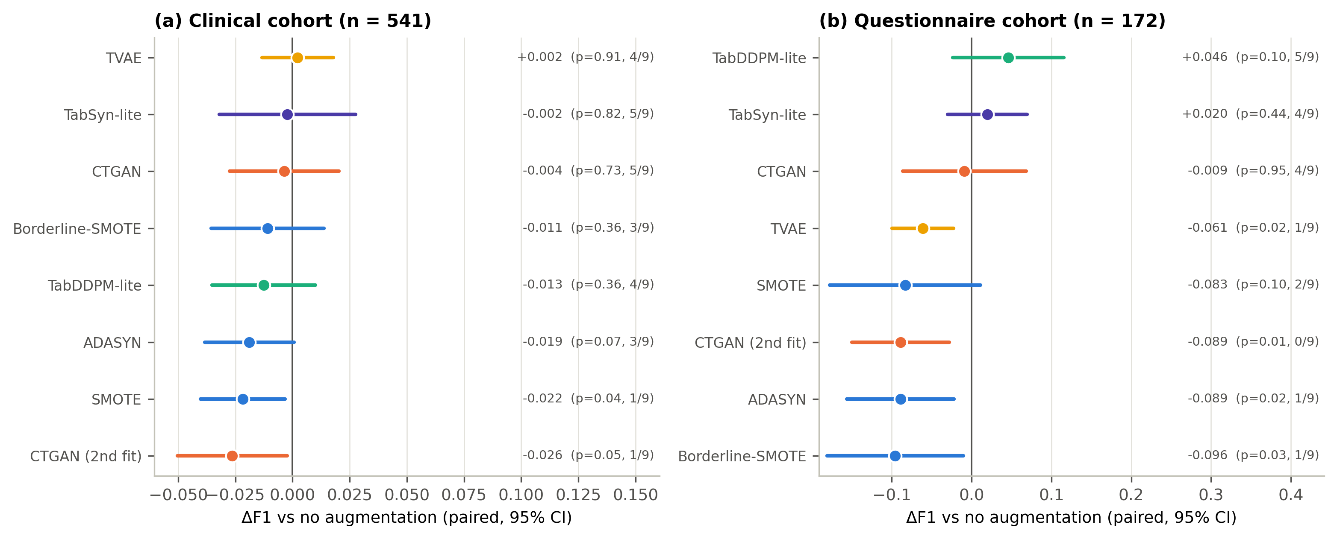
Fig. 3 Paired F1 difference from no augmentation (mean and 95% CI over 3 splits × 3 classifiers) for (a) the clinical cohort and (b) the questionnaire cohort. Labels give the mean difference, the Wilcoxon p-value and the number of pairs in which the generator was better
On the questionnaire cohort, the two diffusion-based generators were the only ones with a positive mean effect. For TabDDPM-lite it was +0.046 [−0.024, 0.116] (p = 0.10; better in 5 of 9 pairs), driven by a recall gain of 0.136, and for TabSyn-lite +0.020 [−0.030, 0.070]. Neither interval excluded zero. In contrast, four generators significantly lowered F1: Borderline-SMOTE (−0.096, p = 0.027), ADASYN (−0.089, p = 0.020), CTGAN (2nd fit) (−0.089, p = 0.008; worse in all 9 pairs) and TVAE (−0.061, p = 0.016). Borderline-SMOTE, ADASYN and CTGAN (2nd fit) also reduced ROC-AUC, by 0.042–0.060.
Fig. 4 breaks the results down by classifier. On the clinical cohort, XGBoost without augmentation gave the best single configuration (F1 0.854), and no generator improved it. Random forest gained slightly from TabSyn-lite (0.839 vs 0.830) and TVAE (0.834). On the questionnaire cohort, TabDDPM-lite improved all three classifiers, most strongly logistic regression (0.693 vs 0.637) and random forest (0.777 vs 0.707). The interpolation oversamplers hurt logistic regression and XGBoost most.
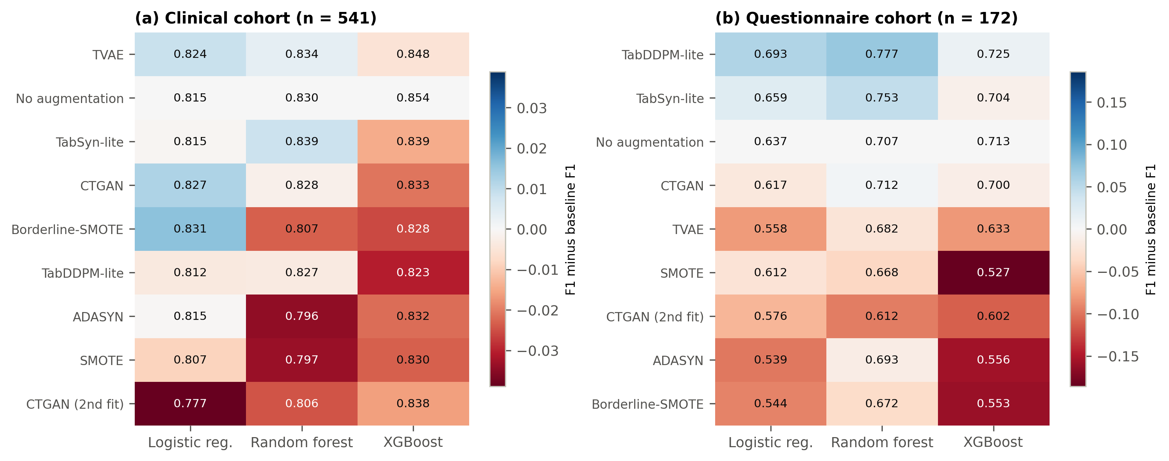
Fig. 4 Mean F1 per generator and classifier (averaged over 3 splits) for (a) the clinical cohort and (b) the questionnaire cohort. Cell colour shows the difference from the unaugmented baseline of the same classifier (blue better, red worse)
The ROC curves of the first split (Fig. 5) confirm that the curves of all generators overlap closely with the baseline on the clinical cohort. On the questionnaire cohort they are more dispersed, and the ordering varies across classifiers.
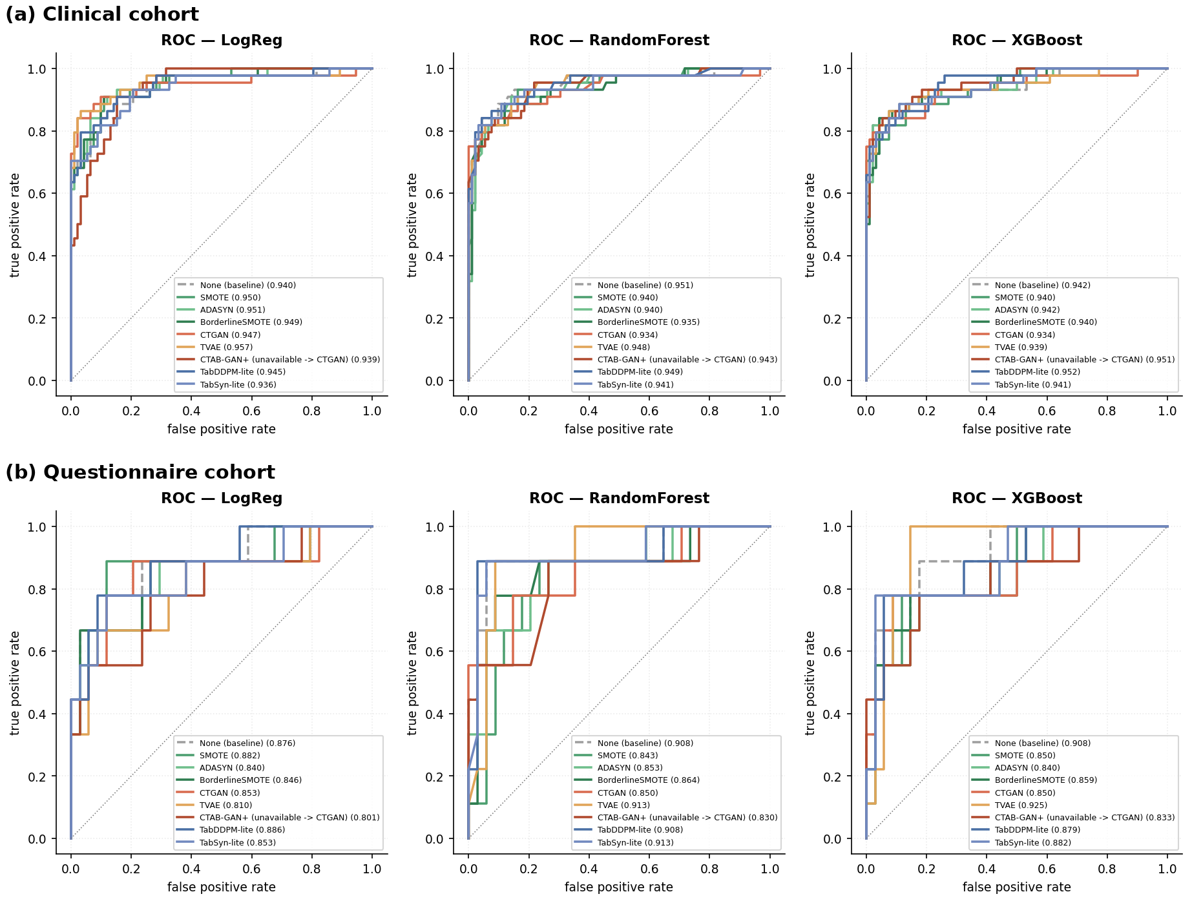
Fig. 5 ROC curves on the real test set of the first split (seed 42) for logistic regression, random forest and XGBoost: (a) clinical cohort; (b) questionnaire cohort. The legend entry "CTAB-GAN+ (unavailable -> CTGAN)" is the second, independent CTGAN fit (Section 3.3.2)

4.3 Fidelity and privacy
Table 5 and Fig. 6 summarise fidelity and privacy. The two diffusion-based generators reproduced categorical marginals far better than all others. TabSyn-lite achieved TVD 0.051 (clinical) and 0.041 (questionnaire), and TabDDPM-lite 0.083 and 0.088, whereas the other generators ranged from 0.159 to 0.271. On continuous marginals, the interpolation oversamplers and both diffusion models had similar Kolmogorov–Smirnov statistics on the clinical cohort (0.130–0.143). On the questionnaire cohort, TabSyn-lite was clearly best (0.133). Both CTGAN fits had the largest KS statistics (0.343 and 0.372 on the clinical cohort). This means CTGAN reproduced category frequencies reasonably but distorted continuous variables such as hormone levels and follicle counts. Correlation structure was best preserved by the interpolation oversamplers on the clinical cohort (0.062–0.078) and by TabSyn-lite on the questionnaire cohort (0.088); the GAN and VAE generators were worst (0.118–0.204).
Table 5 Fidelity of synthetic PCOS rows to real PCOS training rows, and privacy (mean ± SD over 3 splits), ordered by TVD
Cohort | Generator | KS ↓ | TVD ↓ | |Δ correlation| ↓ | Median DCR ↑
Clinical | TabSyn-lite | 0.136 ± 0.008 | 0.051 ± 0.013 | 0.085 ± 0.006 | 3.84 ± 0.27
 | TabDDPM-lite | 0.143 ± 0.014 | 0.083 ± 0.035 | 0.085 ± 0.004 | 5.19 ± 0.34
 | CTGAN | 0.343 ± 0.019 | 0.165 ± 0.019 | 0.118 ± 0.003 | 6.83 ± 0.17
 | CTGAN (2nd fit) | 0.372 ± 0.005 | 0.174 ± 0.017 | 0.121 ± 0.001 | 6.48 ± 0.35
 | SMOTE | 0.130 ± 0.008 | 0.186 ± 0.011 | 0.073 ± 0.008 | 3.13 ± 0.13
 | Borderline-SMOTE | 0.143 ± 0.011 | 0.188 ± 0.027 | 0.078 ± 0.005 | 3.16 ± 0.15
 | ADASYN | 0.137 ± 0.003 | 0.197 ± 0.009 | 0.062 ± 0.006 | 3.17 ± 0.03
 | TVAE | 0.239 ± 0.003 | 0.271 ± 0.021 | 0.120 ± 0.007 | 4.41 ± 0.08
Questionnaire | TabSyn-lite | 0.133 ± 0.011 | 0.041 ± 0.009 | 0.088 ± 0.007 | 2.30 ± 0.43
 | TabDDPM-lite | 0.220 ± 0.011 | 0.088 ± 0.017 | 0.146 ± 0.003 | 5.24 ± 0.03
 | CTGAN | 0.235 ± 0.007 | 0.159 ± 0.005 | 0.200 ± 0.003 | 6.22 ± 0.03
 | ADASYN | 0.161 ± 0.010 | 0.164 ± 0.009 | 0.093 ± 0.011 | 3.85 ± 0.06
 | CTGAN (2nd fit) | 0.243 ± 0.053 | 0.165 ± 0.014 | 0.204 ± 0.004 | 6.15 ± 0.39
 | SMOTE | 0.175 ± 0.015 | 0.172 ± 0.024 | 0.123 ± 0.011 | 3.80 ± 0.20
 | Borderline-SMOTE | 0.178 ± 0.005 | 0.176 ± 0.004 | 0.114 ± 0.005 | 3.79 ± 0.05
 | TVAE | 0.231 ± 0.007 | 0.185 ± 0.015 | 0.177 ± 0.021 | 4.08 ± 0.13
KS mean Kolmogorov–Smirnov statistic over continuous columns; TVD mean total variation distance over categorical columns; DCR distance to closest real training record in standardised feature space.
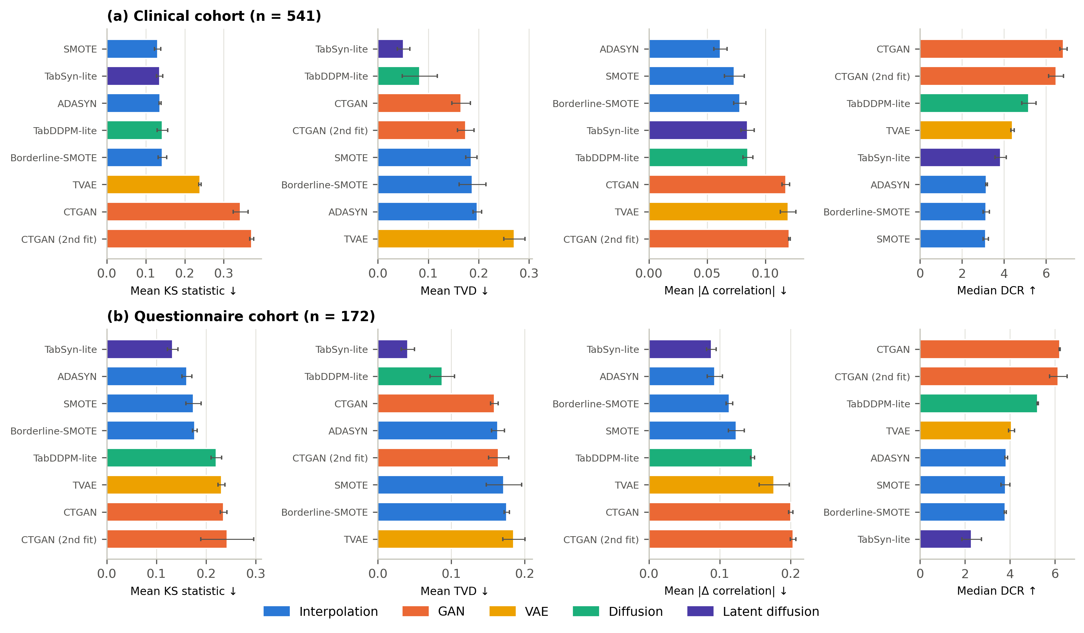
Fig. 6 Fidelity (KS, TVD, correlation error; lower is better) and privacy (median DCR; higher means less copying) of each generator for (a) the clinical cohort and (b) the questionnaire cohort (mean ± SD over 3 splits)
Visual checks agree with these metrics (Fig. 7). In a principal-component projection of the first split, the SMOTE-family and diffusion samples overlap the real PCOS patients. The CTGAN samples form a displaced cloud, and the TVAE samples cluster tightly around the centre of the real distribution — the characteristic under-dispersion of VAEs. The correlation-error maps (Fig. 8) show that TVAE produced several constant synthetic columns (white bands with undefined correlation) and that CTGAN had the largest errors. On the questionnaire cohort, TabDDPM-lite over-represented the modal answer of several ordinal food-frequency and exercise items (Fig. 9). It captured the dominant response pattern but not the tails.
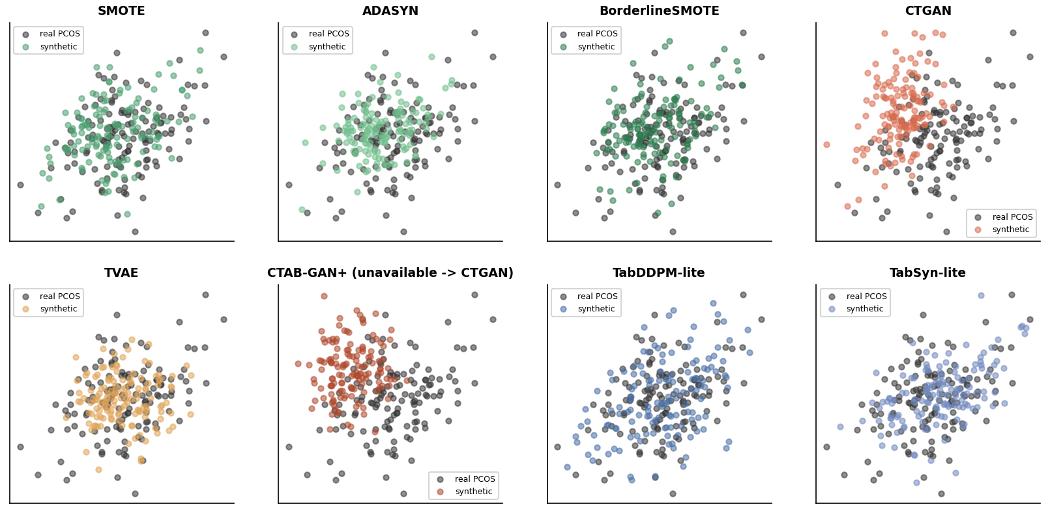
Fig. 7 Real PCOS training rows (grey) and synthetic rows (colour) projected onto the first two principal components of the real training set (clinical cohort, first split). The panel "CTAB-GAN+ (unavailable -> CTGAN)" shows the second CTGAN fit
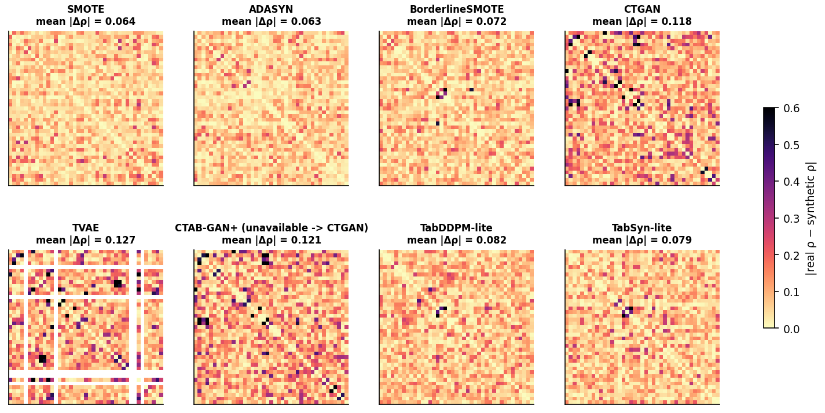
Fig. 8 Absolute difference between real and synthetic correlation matrices (clinical cohort, first split); lighter is better. White bands mark synthetic columns with no variance. The panel "CTAB-GAN+ (unavailable -> CTGAN)" shows the second CTGAN fit
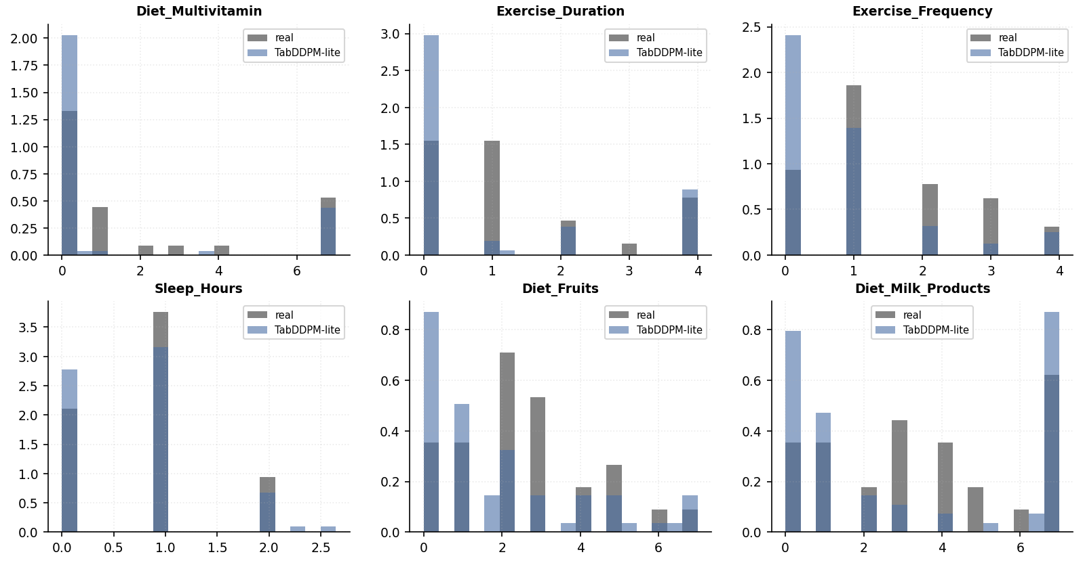
Fig. 9 Marginal distributions of six questionnaire items for real PCOS respondents and TabDDPM-lite samples (first split)
No generator reproduced real records. The median DCR was at least 2.3 standard-deviation units for every generator. It was highest for the two CTGAN fits (6.2–6.8), consistent with their lower fidelity, and lowest for TabSyn-lite on the questionnaire cohort (2.30). The interpolation oversamplers had median DCRs of 3.1–3.8. This does not mean they protect privacy: every SMOTE sample lies on a segment between two real patients, which DCR alone does not reveal. Fig. 10 plots the relation between marginal fidelity and utility gain. On both cohorts, the generators that improved or preserved F1 had low-to-moderate KS statistics, whereas CTGAN (2nd fit) combined the poorest fidelity with one of the largest utility losses. Fidelity alone did not predict utility, however: the SMOTE family was as faithful as TabDDPM-lite on continuous marginals yet consistently reduced F1.
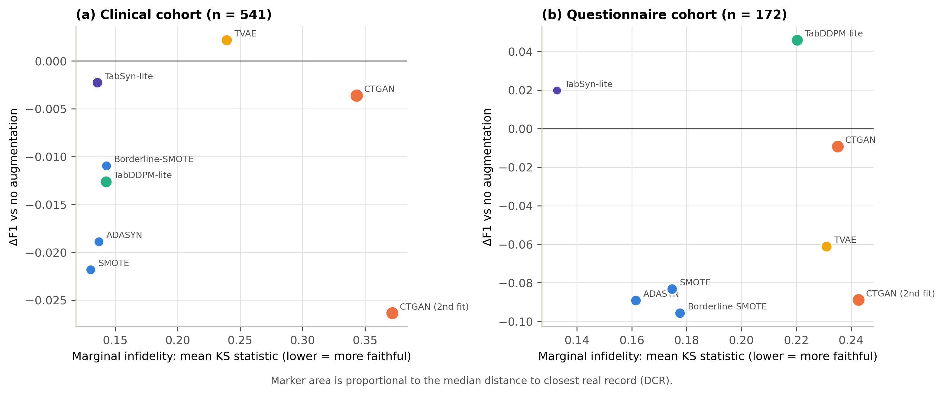
Fig. 10 Relation between marginal infidelity (mean KS statistic) and utility gain (paired ΔF1) for (a) the clinical cohort and (b) the questionnaire cohort. Marker area is proportional to the median DCR

4.4 Run-to-run variability of CTGAN
Because CTAB-GAN+ was unavailable, CTGAN was fitted twice per split with identical settings. The two fits differed substantially. On the clinical cohort, F1 was 0.830 versus 0.807 and recall 0.816 versus 0.770; on the questionnaire cohort, F1 was 0.676 versus 0.597 and ROC-AUC 0.864 versus 0.822. The first fit was indistinguishable from the baseline on the questionnaire cohort (ΔF1 −0.009), whereas the second was worse in all nine pairs. The two fits ranked 5th and 9th on the clinical composite score and 4th and 9th on the questionnaire composite. A single GAN run is therefore not a reliable estimate of a GAN's value on small clinical tables, and differences between generators of a similar size should be interpreted with caution unless several training runs are averaged.

4.5 Composite ranking and computational cost
Fig. 11 shows the composite ranking. On the clinical cohort, the unaugmented baseline ranked first (0.819), followed by TabSyn-lite (0.763), TVAE (0.685) and TabDDPM-lite (0.643). On the questionnaire cohort, TabDDPM-lite (0.805) and TabSyn-lite (0.777) ranked above the baseline (0.620), and all other generators ranked below it. The gap between the top two was 0.056 on the clinical cohort and 0.028 on the questionnaire cohort, so those orderings are not robust.
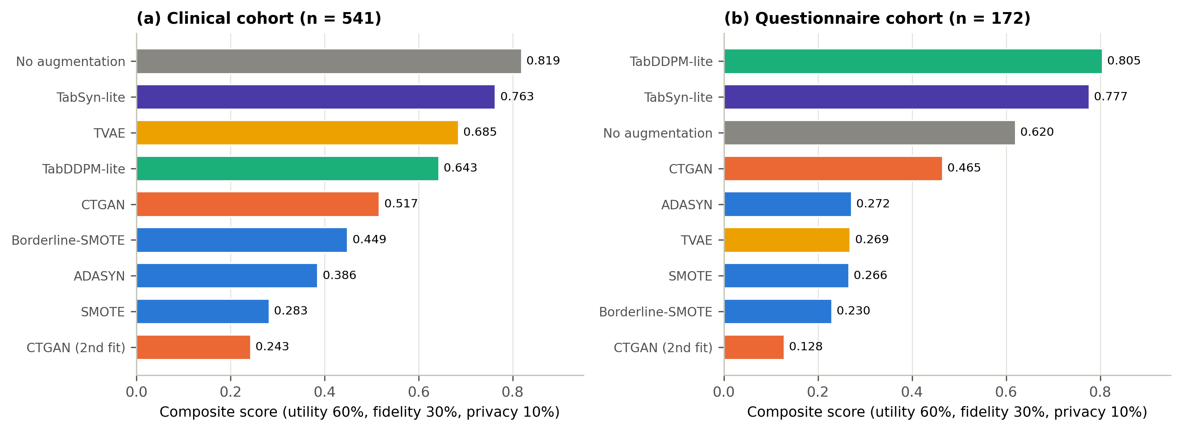
Fig. 11 Composite score (60% utility, 30% fidelity, 10% privacy; min–max normalised within each cohort) for (a) the clinical cohort and (b) the questionnaire cohort. The baseline receives the median fidelity and privacy scores
Computational cost differed by two orders of magnitude (Fig. 12). The interpolation oversamplers ran in under one second. TVAE needed 8–17 s per split, TabDDPM-lite 28–42 s, TabSyn-lite 38–53 s and CTGAN 39–50 s on a CPU. The deep generators are therefore affordable at this scale, but their cost has to be justified by a measurable gain, which occurred only on the smaller cohort.
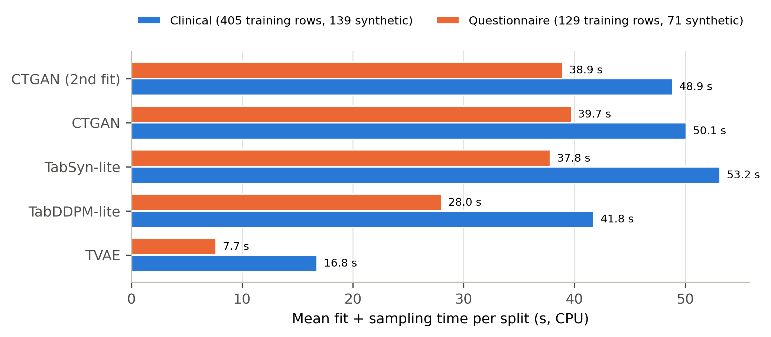
Fig. 12 Mean time to fit each deep generator and sample the synthetic rows, per split (CPU). SMOTE, ADASYN and Borderline-SMOTE took under one second and are omitted

5 Discussion

5.1 Principal findings
This benchmark tested whether modern generative AI improves PCOS prediction when used to rebalance small tabular datasets. There are three main findings. First, on the clinical cohort, augmentation did not help. With 405 training rows, a one-to-two class ratio and strong predictors such as follicle counts and hyperandrogenic signs, the classifiers already had enough minority examples, and synthetic rows mainly traded precision for recall. Second, on the small questionnaire cohort, diffusion-based generation was the only approach with a positive effect. TabDDPM-lite raised F1 by 0.046 and recall by 0.136, and TabSyn-lite raised F1 by 0.020, whereas classical oversamplers, TVAE and one CTGAN fit made prediction significantly worse. Third, the gains were small relative to the uncertainty. The best improvement lay within split-to-split variability, and two fits of the same GAN differed as much as different generator families did.

5.2 Why diffusion helped where interpolation hurt
The questionnaire cohort had only 29 PCOS respondents per training split, described mostly by ordinal and binary answers. Interpolation oversamplers create points between existing minority samples. With few, discrete-valued neighbours, SMOTE-type samples cluster near real respondents, and after rounding they reproduce combinations that occur in both classes. This lowered precision from 0.80 to about 0.59 without increasing recall, consistent with known weaknesses of SMOTE for small disjuncts and noisy minority classes [31]. The conditional diffusion models, by contrast, were trained on all training rows with the class as a condition. They could therefore exploit structure shared between the classes and generate PCOS rows that match the category frequencies of real respondents, reflected in their low TVD. The price was reduced diversity: TabDDPM-lite concentrated mass on modal answers (Fig. 9), which may explain why its recall gain was large but uneven across splits.
These results agree with benchmark evidence that diffusion models outperform GANs and VAEs on tabular data [14, 15, 25], and they extend it to a setting two orders of magnitude smaller than typical benchmarks. They also qualify it: on the larger clinical cohort, even the best-fidelity diffusion samples did not improve prediction. This is consistent with the observation that imbalance corrections change the operating point rather than discrimination [18]. When a model can be recalibrated or its threshold adjusted, simply moving the decision threshold on unaugmented data may achieve the same recall–precision trade-off at no cost.

5.3 Implications for PCOS machine learning
SMOTE-type oversampling is used routinely in PCOS ML, and several studies report accuracies of 96–100% on the 541-patient clinical dataset [7–10]. In our train-on-augmented, test-on-real protocol, the same oversamplers did not improve F1 and sometimes reduced it, even when fitted on training data only. This suggests that oversampling is unlikely to be the source of those high accuracies. Where it is applied before splitting, it may instead inflate them by leaking synthetic neighbours of test patients into training [32]. We recommend that PCOS studies (i) apply augmentation strictly within training data, (ii) always report an unaugmented baseline with the same classifier, (iii) report recall and precision alongside accuracy, because augmentation mainly shifts the operating point, and (iv) average over several splits and, for GANs, several training runs. These practices align with current reporting guidance for clinical prediction models [44].

5.4 Fidelity, utility and privacy are distinct
The three evaluation dimensions did not coincide. The SMOTE family was among the most faithful generators on continuous marginals and correlations, yet it reduced utility. CTGAN had the highest DCR, suggesting the least copying, but also the lowest fidelity. Its "privacy" partly reflected poor modelling rather than genuine protection. TabSyn-lite combined the best marginal fidelity with the lowest DCR on the questionnaire cohort, the usual tension between realism and disclosure risk [20, 22]. A single composite score hides these trade-offs, and its ranking depends on the chosen weights. We therefore recommend reporting utility, fidelity and privacy separately, as in Tables 3–5 and as advocated by evaluation frameworks [19–21].

5.5 Limitations
This study has several limitations. (i) Both cohorts are small and single-source; the questionnaire cohort has only 38 PCOS cases, so each test set contains nine positives, and utility estimates are imprecise. (ii) Only three repeated splits were used, and the 9 paired comparisons per generator share splits, so the confidence intervals and p-values are descriptive. More repeats (for example, repeated cross-validation) and several generator seeds would give firmer conclusions. (iii) TabDDPM-lite and TabSyn-lite are compact re-implementations, not the official code. They use Gaussian diffusion on one-hot categories and a small MLP-based VAE, and the official models may perform differently. (iv) CTAB-GAN+ could not be run; its slot was filled by a second CTGAN fit, which we report transparently. (v) Generators and classifiers were used with fixed hyper-parameters and a 0.5 threshold; neither the generators nor the operating threshold were tuned, and calibration was not assessed. (vi) Median imputation of the few missing clinical values used medians from the whole dataset before splitting. With fewer than five missing cells, the effect is negligible, but fitting imputation within the training data would be preferable. (vii) DCR is only a coarse memorisation indicator; membership- and attribute-inference attacks were not evaluated, and no generator was trained with differential privacy. (viii) The questionnaire dataset's provenance and diagnostic criteria are not documented in detail, and its labels are self-reported.

6 Conclusion
We benchmarked eight synthetic-data generators — interpolation, GAN, VAE, diffusion and latent diffusion — for rebalancing two PCOS datasets under a protocol that fits generators on training data only and tests on real patients. On a 541-patient clinical cohort, no generator improved F1 over training on real data alone (0.833), and SMOTE reduced it. On a 172-respondent questionnaire cohort, the diffusion-based generators were the only ones to improve prediction. TabDDPM-lite gave the highest F1 (0.732 vs 0.686) and recall (0.765 vs 0.630), but the gain remained within split-to-split variability, while classical oversamplers, TVAE and one CTGAN fit reduced F1 by 0.06–0.10. Latent diffusion produced the most faithful synthetic records, and two fits of the same GAN differed as much as distinct generator families. Generative augmentation is therefore not a default remedy for class imbalance in PCOS prediction. It should be applied only within training data, compared against an unaugmented baseline, and evaluated separately for utility, fidelity and privacy. Diffusion models are the most promising option when minority cases are scarce. Future work should use official diffusion implementations and multiple seeds, add membership-inference and differential-privacy analyses, and validate on larger, multi-centre PCOS cohorts.

Declarations
Funding [The authors declare that no funds, grants or other support were received during the preparation of this manuscript. — edit if applicable]
Competing interests The authors have no relevant financial or non-financial interests to disclose.
Ethics approval This study used only publicly available, de-identified secondary data. No new data were collected from human participants, and ethical approval was therefore not required. [Confirm with your institutional ethics committee if required by the target journal.]
Consent to participate / publish Not applicable (secondary analysis of anonymised public data).
Data availability The clinical dataset is publicly available on Kaggle [4]. The questionnaire dataset is publicly available at [URL to be added by the authors]. Synthetic datasets generated during the study are available from the corresponding author on reasonable request.
Code availability The complete benchmarking code (Python; scikit-learn [45], imbalanced-learn, ctgan, PyTorch [46], XGBoost) is available at [GitHub/Zenodo URL to be added by the authors].
Author contributions [Author 1]: conceptualisation, methodology, software, formal analysis, writing – original draft. [Author 2]: validation, writing – review and editing. [Author 3]: supervision, writing – review and editing. All authors read and approved the final manuscript. [Edit to reflect actual contributions.]

References
1. Bozdag G, Mumusoglu S, Zengin D, Karabulut E, Yildiz BO (2016) The prevalence and phenotypic features of polycystic ovary syndrome: a systematic review and meta-analysis. Hum Reprod 31(12):2841–2855. https://doi.org/10.1093/humrep/dew218
2. Azziz R, Carmina E, Chen Z, Dunaif A, Laven JSE, Legro RS, et al (2016) Polycystic ovary syndrome. Nat Rev Dis Primers 2:16057. https://doi.org/10.1038/nrdp.2016.57
3. Teede HJ, Tay CT, Laven J, Dokras A, Moran LJ, et al (2023) Recommendations from the 2023 international evidence-based guideline for the assessment and management of polycystic ovary syndrome. Hum Reprod 38(9):1655–1679. https://doi.org/10.1093/humrep/dead156
4. Kottarathil P (2020) Polycystic ovary syndrome (PCOS) [dataset]. Kaggle. https://www.kaggle.com/datasets/prasoonkottarathil/polycystic-ovary-syndrome-pcos. Accessed [date to be added by the authors]
5. Barrera FJ, Brown EDL, Rojo A, Obeso J, Plata H, Lincango EP, et al (2023) Application of machine learning and artificial intelligence in the diagnosis and classification of polycystic ovarian syndrome: a systematic review. Front Endocrinol 14:1106625. https://doi.org/10.3389/fendo.2023.1106625
6. Ghaderzadeh M, Garavand A, Salehnasab C (2025) Artificial intelligence in polycystic ovary syndrome: a systematic review of diagnostic and predictive applications. BMC Med Inform Decis Mak 25:427. https://doi.org/10.1186/s12911-025-03255-6
7. Elmannai H, El-Rashidy N, Mashal I, Alohali MA, Farag S, El-Sappagh S, Saleh H (2023) Polycystic ovary syndrome detection machine learning model based on optimized feature selection and explainable artificial intelligence. Diagnostics 13(8):1506. https://doi.org/10.3390/diagnostics13081506
8. Khanna VV, Chadaga K, Sampathila N, Prabhu S, Bhandage V, Hegde GK (2023) A distinctive explainable machine learning framework for detection of polycystic ovary syndrome. Appl Syst Innov 6(2):32. https://doi.org/10.3390/asi6020032
9. Moral P, Mustafi D, Sahana SK (2024) PODBoost: an explainable AI model for polycystic ovarian syndrome detection using grey wolf-based feature selection approach. Neural Comput Appl 36(30):18627–18644. https://doi.org/10.1007/s00521-024-10171-9
10. Ahmad R, Maghrabi LA, Khaja IA, Maghrabi LA, Ahmad M (2024) SMOTE-based automated PCOS prediction using lightweight deep learning models. Diagnostics 14(19):2225. https://doi.org/10.3390/diagnostics14192225
11. Nsugbe E (2023) An artificial intelligence-based decision support system for early diagnosis of polycystic ovaries syndrome. Healthc Anal 3:100164. https://doi.org/10.1016/j.health.2023.100164
12. Xu L, Skoularidou M, Cuesta-Infante A, Veeramachaneni K (2019) Modeling tabular data using conditional GAN. In: Advances in Neural Information Processing Systems 32 (NeurIPS 2019), pp 7335–7345
13. Zhao Z, Kunar A, Birke R, Van der Scheer H, Chen LY (2024) CTAB-GAN+: enhancing tabular data synthesis. Front Big Data 6:1296508. https://doi.org/10.3389/fdata.2023.1296508
14. Kotelnikov A, Baranchuk D, Rubachev I, Babenko A (2023) TabDDPM: modelling tabular data with diffusion models. In: Proc 40th International Conference on Machine Learning, PMLR 202:17564–17579
15. Zhang H, Zhang J, Srinivasan B, Shen Z, Qin X, Faloutsos C, Rangwala H, Karypis G (2024) Mixed-type tabular data synthesis with score-based diffusion in latent space. In: International Conference on Learning Representations (ICLR 2024). https://arxiv.org/abs/2310.09656
16. Chen RJ, Lu MY, Chen TY, Williamson DFK, Mahmood F (2021) Synthetic data in machine learning for medicine and healthcare. Nat Biomed Eng 5:493–497. https://doi.org/10.1038/s41551-021-00751-8
17. Giuffrè M, Shung DL (2023) Harnessing the power of synthetic data in healthcare: innovation, application, and privacy. npj Digit Med 6:186. https://doi.org/10.1038/s41746-023-00927-3
18. van den Goorbergh R, van Smeden M, Timmerman D, Van Calster B (2022) The harm of class imbalance corrections for risk prediction models: illustration and simulation using logistic regression. J Am Med Inform Assoc 29(9):1525–1534. https://doi.org/10.1093/jamia/ocac093
19. Hernandez M, Epelde G, Alberdi A, Cilla R, Rankin D (2022) Synthetic data generation for tabular health records: a systematic review. Neurocomputing 493:28–45. https://doi.org/10.1016/j.neucom.2022.04.053
20. Alaa A, van Breugel B, Saveliev ES, van der Schaar M (2022) How faithful is your synthetic data? Sample-level metrics for evaluating and auditing generative models. In: Proc 39th International Conference on Machine Learning, PMLR 162:290–306
21. Qian Z, Davis R, van der Schaar M (2023) Synthcity: a benchmark framework for diverse use cases of tabular synthetic data. In: Advances in Neural Information Processing Systems 36 (Datasets and Benchmarks Track)
22. Stadler T, Oprisanu B, Troncoso C (2022) Synthetic data – anonymisation groundhog day. In: Proc 31st USENIX Security Symposium, pp 1451–1468
23. Choi E, Biswal S, Malin B, Duke J, Stewart WF, Sun J (2017) Generating multi-label discrete patient records using generative adversarial networks. In: Proc 2nd Machine Learning for Healthcare Conference, PMLR 68:286–305
24. Zhao Z, Kunar A, Birke R, Chen LY (2021) CTAB-GAN: effective table data synthesizing. In: Proc 13th Asian Conference on Machine Learning, PMLR 157:97–112
25. Kim J, Lee C, Park N (2023) STaSy: score-based tabular data synthesis. In: International Conference on Learning Representations (ICLR 2023). https://openreview.net/forum?id=1mNssCWt_v
26. Borisov V, Sessler K, Leemann T, Pawelczyk M, Kasneci G (2023) Language models are realistic tabular data generators. In: International Conference on Learning Representations (ICLR 2023). https://arxiv.org/abs/2210.06280
27. Yale A, Dash S, Dutta R, Guyon I, Pavao A, Bennett KP (2020) Generation and evaluation of privacy preserving synthetic health data. Neurocomputing 416:244–255. https://doi.org/10.1016/j.neucom.2019.12.136
28. Goncalves A, Ray P, Soper B, Stevens J, Coyle L, Sales AP (2020) Generation and evaluation of synthetic patient data. BMC Med Res Methodol 20:108. https://doi.org/10.1186/s12874-020-00977-1
29. Parise O, Kronenberger R, Parise G, de Asmundis C, Gelsomino S, La Meir M (2025) CTGAN-driven synthetic data generation: a multidisciplinary, expert-guided approach (TIMA). Comput Methods Programs Biomed 259:108523. https://doi.org/10.1016/j.cmpb.2024.108523
30. Chawla NV, Bowyer KW, Hall LO, Kegelmeyer WP (2002) SMOTE: synthetic minority over-sampling technique. J Artif Intell Res 16:321–357. https://doi.org/10.1613/jair.953
31. Fernández A, García S, Herrera F, Chawla NV (2018) SMOTE for learning from imbalanced data: progress and challenges, marking the 15-year anniversary. J Artif Intell Res 61:863–905. https://doi.org/10.1613/jair.1.11192
32. Kapoor S, Narayanan A (2023) Leakage and the reproducibility crisis in machine-learning-based science. Patterns 4(9):100804. https://doi.org/10.1016/j.patter.2023.100804
33. Breiman L (2001) Random forests. Mach Learn 45(1):5–32. https://doi.org/10.1023/A:1010933404324
34. Chen T, Guestrin C (2016) XGBoost: a scalable tree boosting system. In: Proc 22nd ACM SIGKDD International Conference on Knowledge Discovery and Data Mining, pp 785–794. https://doi.org/10.1145/2939672.2939785
35. He H, Bai Y, Garcia EA, Li S (2008) ADASYN: adaptive synthetic sampling approach for imbalanced learning. In: 2008 IEEE International Joint Conference on Neural Networks, pp 1322–1328. https://doi.org/10.1109/IJCNN.2008.4633969
36. Han H, Wang WY, Mao BH (2005) Borderline-SMOTE: a new over-sampling method in imbalanced data sets learning. In: Advances in Intelligent Computing (ICIC 2005), Lecture Notes in Computer Science 3644. Springer, Berlin, pp 878–887. https://doi.org/10.1007/11538059_91
37. Lemaître G, Nogueira F, Aridas CK (2017) Imbalanced-learn: a Python toolbox to tackle the curse of imbalanced datasets in machine learning. J Mach Learn Res 18(17):1–5
38. Goodfellow I, Pouget-Abadie J, Mirza M, Xu B, Warde-Farley D, Ozair S, Courville A, Bengio Y (2014) Generative adversarial nets. In: Advances in Neural Information Processing Systems 27 (NIPS 2014), pp 2672–2680
39. Kingma DP, Welling M (2014) Auto-encoding variational Bayes. In: International Conference on Learning Representations (ICLR 2014). https://arxiv.org/abs/1312.6114
40. Ho J, Jain A, Abbeel P (2020) Denoising diffusion probabilistic models. In: Advances in Neural Information Processing Systems 33 (NeurIPS 2020), pp 6840–6851
41. Nichol AQ, Dhariwal P (2021) Improved denoising diffusion probabilistic models. In: Proc 38th International Conference on Machine Learning, PMLR 139:8162–8171
42. Rombach R, Blattmann A, Lorenz D, Esser P, Ommer B (2022) High-resolution image synthesis with latent diffusion models. In: Proc IEEE/CVF Conference on Computer Vision and Pattern Recognition (CVPR), pp 10684–10695. https://doi.org/10.1109/CVPR52688.2022.01042
43. Saito T, Rehmsmeier M (2015) The precision-recall plot is more informative than the ROC plot when evaluating binary classifiers on imbalanced datasets. PLoS ONE 10(3):e0118432. https://doi.org/10.1371/journal.pone.0118432
44. Collins GS, Moons KGM, Dhiman P, Riley RD, Beam AL, et al (2024) TRIPOD+AI statement: updated guidance for reporting clinical prediction models that use regression or machine learning methods. BMJ 385:e078378. https://doi.org/10.1136/bmj-2023-078378
45. Pedregosa F, Varoquaux G, Gramfort A, Michel V, Thirion B, Grisel O, et al (2011) Scikit-learn: machine learning in Python. J Mach Learn Res 12:2825–2830
46. Paszke A, Gross S, Massa F, Lerer A, Bradbury J, Chanan G, et al (2019) PyTorch: an imperative style, high-performance deep learning library. In: Advances in Neural Information Processing Systems 32 (NeurIPS 2019), pp 8024–8035

