**Title of the Extended Abstract**

(Font size 14, bold and centered. Word limit is 20. Capitalize the first word of the title and proper nouns only. Do not capitalize the rest. Scientific names should follow the rules of scientific nomenclature and be italicized.)

**Abstract**

This document intends to provide you with necessary instructions to prepare your abstract for submission to ICSUSL 2025. Your abstract should be written in English using the font **Times New Roman; size 11, 1.15 line spaced**. Abstract should contain approximately **350 words**, a few key words (maximum 5), introduction (including the research problem, research questions, and objectives), a reference to literature, methodology used, results, discussion, conclusion/s or implication/s. The title of the abstract should be limited to a maximum of 20 words. Your abstract should be submitted online via [CMT](https://cmt3.research.microsoft.com/ICSUSL2025) in the both MS word and pdf format by the provided deadline. Each abstract will be reviewed by a panel of experts in each discipline, and the reviews’ decisionwill be emailed to the corresponding author**.** If an abstract is accepted for presentation, the authors may be requested to resubmit the abstract with any necessary changes suggested by the reviewers. All relevant information is available on the conference website. If you have further questions, please do not hesitate to contact us. We look forward to receiving your extended abstracts.

**Key words:** 5 keywords. First letter of each keyword should be in upper case. 11 font; Times New Roman

**Introduction**

Times New Roman, 11 font size, approx. 200 words. What was the motivation behind undertaking this research? What inspired or influenced your decision to explore this particular topic?

Briefly describe the original aims and objectives of your research. This should include the specific area of focus and the underlying reasons for selecting this topic. Clearly articulate the research question(s) that guided your study.

**Literature Review**

Times New Roman, 11 font size, approx. 300 words. Theoretical Framework and Review of Relevant Literature: Which theoretical framework(s) underpin your research? How do these theories relate to your research focus and objectives?

Provide a brief overview of the key theoretical concepts relevant to your project. Explain how these theories help in framing your research problem or guiding your analysis.

In addition, summarize previous empirical studies that are directly related to your research topic. Highlight how the findings of these studies inform or support your research and how they help to position your work within the existing body of knowledge.

**Methodology**

Times New Roman, 11 font size, approx. 400 words. What was the process of your research?: This section outlines the research process, including the participants involved, the researcher’s role, the procedures followed, the types of data collected, and the methods of analysis/research method used.

**Results and Discussion**

Times New Roman, 11 font size, approx. 400 words. What are the main findings of your research? Summarise the main results under each research question.

**Implications/Conclusions**

Times New Roman, 11 font size, approx. 700 words. What did you learn from this research?

*Implications for practice, policy and/or theory:* Explain how your research findings are relevant to you, the subject, programme and to the university. Explain any theoretical contribution/s that you can make, if any.

*Recommendations and future research:* Provide any recommendations that you can make – to colleagues, departments, faculty university and/or wider academic community.

Explain if you are going to continue the research and if so how and why. If not, explain any other future research possibilities arose from your project.

*Disseminating your findings:* Explain how you are going to disseminate your findings, e.g. change the test paper, organise a workshop for colleagues etc.

Explain how you are going to monitor any changes you make.

*Lessons learnt:* Explain the learning points you gained from undertaking the research (including what you have learnt about methodology) and the learning points gained by your students by taking part in the research.

Explain the personal changes that you would make to your future practice.

**Acknowledgment**

Acknowledgement should be placed immediately following Conclusions/ Implications, if necessary.

**References**

Limit to 5 key references and follow the APA style 7th edition, Times New Roman, 11 font size. Line space 1.15. (<https://apastyle.apa.org/>)

**Extended Abstract Preparation - Specific Guidelines**

* + **Margins**

1.5 inches (left) and 1 inch (top, right and bottom)

* + **Line space**

1.15 spacing except for the two sections, Authors and Short abstract.

* + **Font size and type**

11 in Times New Roman unless otherwise mentioned above (i.e. Authors, Short abstract, references and lettering within the tables and figures). If non-English abstract, Authors must mention the Unicode font used. All non-English words should be italicized.

* + **Length**

Maximum 2000 words and minimum 1200 words. Maximum no. of pages 5, including references, tables, short abstract, charts and figures, if essential only.

* + **Software**

Extended abstracts must be submitted in both MS Word and PDF file formats only.

* + **Languages**

English; either British spelling can be used; however, consistency in spelling is expected.

* + **Tables/ charts, if any**

All tables should be captioned with 11 font, Times New Roman. The table caption goes above the table, with 1 line space above and below the caption. Only the first letter is in upper case.

**Maximum number of tables is 2 and maximum number of charts is 2.** Please note that table/chart content is included in the word count.

Letters withinthe tables should be Times New Roman, 11 pt. size type, of 1.15 line heading, centered, if 2 line heading flush left. Only the first letter of the first word is in upper case.

Table 1. Name of the table (title caption)

| **Table head** | **Table column head** | | |
| --- | --- | --- | --- |
| ***Table column subhead*** | ***Subhead*** | ***Subhead*** |
| Example | More example |  |  |

* + **Figures, if any**

All figures should be captioned with 11 font, Times New Roman. The figure caption, centered, goes **above** the figure, with 1 line space above and below the figure. Figures should be contained within the typing area. Lettering in the figures should be Times New Roman, 11 pt. size type. Color and black/white photographs are allowed, if any, in digital format, with adequate resolution to permit imported into the manuscript. Figures are centered.

All figures should be clear and high-resolution (minimum 300 DPI). Acceptable formats include **JPG, PNG, TIFF, or EPS**. Please avoid low-quality images or screenshots.

Fig. 1. Example of a figure caption (figure caption)

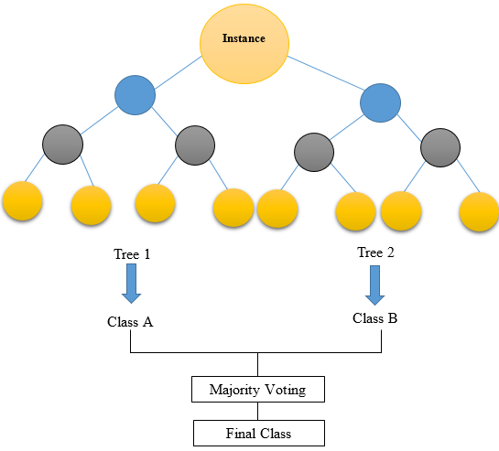

* + **Supplementary materials, if any**

Please submit research instruments (e.g. copies of questionnaires, interview questions, test papers etc.) you used in the research. These will be useful for colleagues who would like to replicate the study. Please also provide the data set if possible.