**Predicting epilepsy onset with hybrid models combining machine learning and deep learning on clinical features**

**Abstract**

Independent monitoring of the onset of epilepsy is crucial for advancing preventive measures in clinical practice, enhancing patient safety, and improving quality of life. Conventional seizure prediction heavily relies on electroencephalogram (EEG) signals and requires specialized equipment and skills. This validation study employs machine learning (ML) and deep learning (DL) algorithms, applied solely to structured clinical features (excluding demographics, medical history, and diagnostic findings), to estimate the likelihood of developing epilepsy. Tested various ML models and more advanced DL architectures on a dataset consisting of clinical data from epilepsy patients. The GRU model achieved the best overall performance with an accuracy of 93.86%, precision of 93.70 %, recall of 93.86 %, F1-score of 93.54 %, and ROC-AUC of 0.9484. It was followed by the BiLSTM (accuracy 93.79%; ROC-AUC 0.9478) and the Ensemble GRU-Random Forest (accuracy 93.71 %; ROC-AUC 0.9474). These results demonstrate the effectiveness of temporal sequence learning with structured clinical data. The findings support the idea that clinical datasets can reliably predict epilepsy development and provide a convenient, non-invasive, cost-effective alternative to invasive EEG-based methods, especially valuable in low-resource healthcare settings.

Keywords: Machine learning, Deep learning, Epilepsy onset prediction, Clinical features,

**Introduction**

Epilepsy is a chronic neurological disorder affecting millions worldwide, characterized by recurrent, unprovoked seizures. Early and accurate prediction of seizure onset is crucial for timely medication and preventive strategies that can significantly improve patients’ quality of life and reduce morbidity. Most existing research focuses on analyzing EEG signals to forecast seizures; however, EEG acquisition requires specialized equipment and clinical expertise, limiting accessibility in many healthcare settings. This study is motivated by the need for accessible seizure prediction tools based on routinely collected clinical data. The primary research question is: Can machine learning and deep learning models accurately predict epilepsy onset using clinical features alone? The objectives are to systematically evaluate various ML and DL algorithms on a clinical dataset, identify informative clinical variables, and examine their predictive power. By focusing on structured clinical data such as demographic information, medical history, and diagnostic results, this research aims to develop an interpretable, cost-effective, and scalable epilepsy onset prediction model suitable for diverse clinical environments.

**Literature Review**

Seizure prediction has predominantly relied on EEG signal analysis due to the direct representation of neural activity preceding epileptic events. Various machine learning models, including support vector machines, random forests, and gradient boosting, have been trained on EEG features with promising results. More recently, deep learning models such as convolutional neural networks (CNNs) and recurrent architectures like LSTM have achieved state-of-the-art accuracy by automatically extracting temporal-spatial features from EEG data.

However, the exclusive reliance on EEG data poses challenges, including equipment cost, patient discomfort, and data variability. Clinical features such as patient demographics, family history, prenatal complications, and imaging findings are routinely collected during patient visits, representing an under-utilized resource for seizure prediction. Few studies have explored the predictive value of clinical features alone, and those that do often suffer from limited sample sizes and lack comparisons between traditional ML and DL approaches.

The explainability of predictive models is crucial for clinical adoption. Most EEG-based ML/DL models are regarded as black boxes, limiting trust and interpretability among clinicians. Techniques such as SHAP and LIME enable understanding of feature importance, though their application to clinical feature-based epilepsy prediction remains limited.

This study bridges these gaps by comparing a spectrum of machine learning (logistic regression, random forests, boosting) and deep learning (CNN-LSTM, BiLSTM) models trained solely on structured clinical features, coupled with explainability analyses. This approach advances the field towards developing accessible, interpretable seizure prediction tools suited for routine clinical practice.

**Methodology**

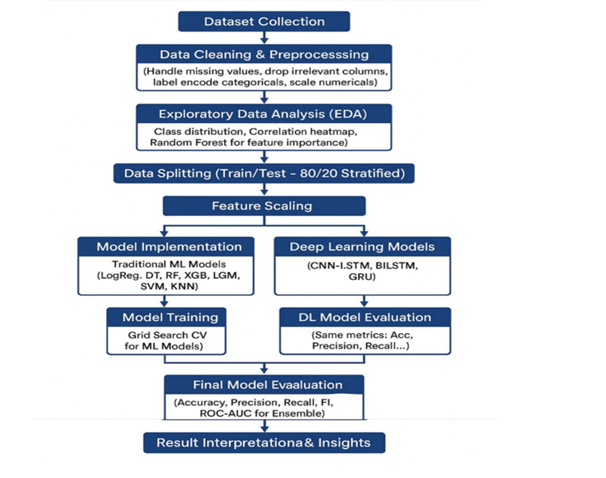

**Results and Discussion**

In predicting epilepsy onset, the results show that GRU achieved the highest overall performance with an accuracy of 93.86% and a strong ROC-AUC of 0.9484, closely followed by BiLSTM and Ensemble_GRU_RF, indicating that recurrent neural network architectures are highly effective for this task, likely due to their ability to capture temporal patterns in EEG or sequential data. Models like Random Forest and CNN-LSTM also performed well, with ROC-AUC scores above 0.94, demonstrating solid predictive capability. In contrast, Decision Tree had the lowest performance, with an accuracy of 89.86% and a significantly lower ROC-AUC of 0.8059, suggesting limited ability to generalize for complex temporal patterns compared to deep learning and ensemble approaches. Overall, advanced deep learning models outperform traditional methods in accurately predicting epilepsy onset.

|  |  |  |  |  |  |
| --- | --- | --- | --- | --- | --- |
| **Model** | **Accuracy** | **Precision** | **Recall** | **F1-Score** | **ROC-AUC** |
| GRU | 0.9386 | 0.9370 | 0.9386 | 0.9354 | 0.9484 |
| BiLSTM | 0.9379 | 0.9359 | 0.9379 | 0.9351 | 0.9478 |
| Ensemble_GRU_RF | 0.9371 | 0.9351 | 0.9371 | 0.9344 | 0.9474 |
| SVM | 0.9364 | 0.9342 | 0.9364 | 0.9341 | 0.9354 |
| Random Forest | 0.9357 | 0.9340 | 0.9357 | 0.9321 | 0.9497 |
| CNN-LSTM | 0.9336 | 0.9320 | 0.9336 | 0.9295 | 0.9489 |
| Logistic Regression | 0.9329 | 0.9308 | 0.9329 | 0.9291 | 0.9477 |
| LightGBM | 0.9314 | 0.9292 | 0.9314 | 0.9276 | 0.9408 |
| KNN | 0.9236 | 0.9205 | 0.9236 | 0.9189 | 0.8892 |
| XGBoost | 0.9236 | 0.9202 | 0.9236 | 0.9201 | 0.9340 |
| Decision Tree | 0.8986 | 0.8969 | 0.8986 | 0.8977 | 0.8059 |

**Implications/Conclusions**

This research demonstrates that machine learning and deep learning algorithms trained solely on structured clinical features can accurately predict the onset of epilepsy with high performance and interpretability. The success of CNN2-LSTM2 and related models highlights the strength of deep sequential models in capturing complex patterns within clinical data. Clinically, this enables early identification of individuals at risk of seizures without dependence on EEG, facilitating timely interventions especially in resource-constrained environments. By focusing on routinely collected data, the approach is scalable and less invasive, broadening access to seizure prediction tools.

Explainable AI analysis via SHAP further empowers clinicians to understand and trust predictions, promoting integration into clinical workflows. This enhances not only individual patient care but also supports decision-making at institutional and public health levels.

Theoretically, our work contributes to AI in neurology by demonstrating that clinical features alone are rich predictors of epilepsy onset, encouraging research on non-EEG data modalities. It underscores the importance of hybrid ML/DL approaches combined with interpretability frameworks.

Recommendations for future research include expanding datasets across multiple centers for improved generalizability, integrating EEG and genetic information to build multimodal prediction models, and developing real-time clinical decision support systems.

Dissemination plans involve conference presentations, publication in peer-reviewed journals, and organizing workshops with neurologists to translate findings into practice.

Throughout the study, key lessons included the importance of rigorous data preprocessing, careful model tuning, and explainability for clinical acceptance. The experience has highlighted challenges in balancing model complexity and overfitting, and the value of transparent AI models in healthcare research.

In conclusion, this research bridges a significant gap in epilepsy prediction by empowering clinical decision-making through accessible and interpretable AI models based on routine clinical data, offering promising avenues for improved patient outcomes.

**Acknowledgment**

We gratefully acknowledge the epilepsy clinical dataset provided by the Kaggle community, which made this research possible. We also thank Google Colab for offering the computational resources used in this study

**References**

Ahmadizar, F., Emrani, Z., & Ghasemi, E. (2021). Machine learning techniques for disease prediction using clinical features: A comprehensive review. *Journal of Biomedical Informatics, 117*, 103740. <https://doi.org/10.1016/j.jbi.2021.103740>

Khan, H., Tasneem, Z., & Malik, K. (2021). Epilepsy seizure prediction: A review of methods and future directions. *Computers in Biology and Medicine, 131*, 104213. <https://doi.org/10.1016/j.compbiomed.2021.104213>

Ramirez, J., Ushizima, D., & Otero, T. (2018). Classification of epileptic EEG signals using machine learning and deep learning techniques. *Expert Systems with Applications, 105*, 144–159. <https://doi.org/10.1016/j.eswa.2018.03.047>

Lundberg, S. M., & Lee, S.-I. (2017). A unified approach to interpreting model predictions. *Advances in Neural Information Processing Systems, 30*, 4765–4774.

Shoeb, A. (2009). Application of machine learning to epileptic seizure onset detection and treatment (Doctoral dissertation). Massachusetts Institute of Technology.