**Predicting epilepsy onset with hybrid models combining machine learning and deep learning on clinical features**

**Abstract**

Independent monitoring of the onset of epilepsy is crucial for advancing preventive measures in clinical practice, enhancing patient safety, and improving quality of life. Conventional seizure prediction heavily relies on electroencephalogram (EEG) signals and requires specialized equipment and skills. This validation study employs machine learning (ML) and deep learning (DL) algorithms, applied solely to structured clinical features (excluding demographics, medical history, and diagnostic findings), to estimate the likelihood of developing epilepsy. Tested various ML models and more advanced DL architectures on a dataset consisting of clinical data from epilepsy patients. The GRU model achieved the best overall performance with an accuracy of 93.86%, precision of 93.70 %, recall of 93.86 %, F1-score of 93.54 %, and ROC-AUC of 0.9484. It was followed by the BiLSTM (accuracy 93.79%; ROC-AUC 0.9478) and the Ensemble GRU-Random Forest (accuracy 93.71 %; ROC-AUC 0.9474). These results demonstrate the effectiveness of temporal sequence learning with structured clinical data. The findings support the idea that clinical datasets can reliably predict epilepsy development and provide a convenient, non-invasive, cost-effective alternative to invasive EEG-based methods, especially valuable in low-resource healthcare settings.

Keywords: Machine learning, Deep learning, Epilepsy onset prediction, Clinical features,

**Introduction**

**Introduction**  
Epilepsy is a long-term brain disease that is marked by unprovoked recurring attacks, and it is a very common condition in the world. Prediction of the onset of epilepsy is highly significant in health care in the sense that early and accurate prediction will provide ample time to take the necessary procedure and help the patient (Tripathi et al., 2021). Available methods are dependent on EEG data, which on its part is specific and requires special equipment and practitioners, and this is the limitation imposed on its applicable curative environments. Bestowing an easy and cost-effective alternative, this research is based on the prediction of epilepsy emergence based on the routinely practiced clinical characteristics.

**Objectives**  
This study examines how machine learning and deep learning models may be used to forecast the occurrence of epilepsy with the help of structured clinical information. It is first of all aimed at estimating the accuracy of different algorithms on a binary classification case (epilepsy Yes/No) and finding all informative clinical features.

**Data**  
The sample was extracted on Kaggle and contains 7,000 records with such features as demographic characteristics (e.g. Gender, Age at symptom onset), the medical history (e.g. birth asphyxia, premature birth, cerebral malaria), intellectual disabilities, imaging and EEG abnormalities, and risk scores. The categorical outcome measure is epilepsy diagnosis with a binary target meaning that there is a classification protocol upon which the model is built and tested.

**Literature Review**

Analysis of EEG signals has been mostly used in the prediction of seizures because of the epileptic activity prior to the epileptic event, which is directly represented. EEG features have been trained with good results on various models of machine learning, such as support vector machines, random forests, and gradient boosting, among others (Keceli, 2018). Later, convolutional neural networks (CNNs) and recently introduced recurrent networks (LSTM) have attained state-of-the-art accuracy in EEG signal analysis, and have shown the ability to extract the temporal-spatial features of the signal data by automatic feature extraction. Nonetheless, the unilateral usage of EEG data is problematic due to the costs of the equipment, the safety of the patient, and fluctuations in data. Sources of clinical characteristics that include information regarding the demographics of the patient, family history, prenatal complications, and imaging are accessed during regular visits to the clinics, which are otherwise an underutilized predictor of seizures (Lundberg & Lee, 2017). The predictive utility in clinical manifestations does not have many studies, and the available ones are most commonly limited by small sample and a comparison between conventional ML and DL approaches .

This paper fills those gaps by comparing a continuum of machine learning (logistic regression, random forests, boosting) and deep learning (CNN-LSTM, BiLSTM) models trained on a solely structured clinical feature set, along with explainability analyses. Such a direction contributes to the subsequent implementation of more available and interpretable seizure prediction tools to be used in routine clinical practice.

**Methodology**

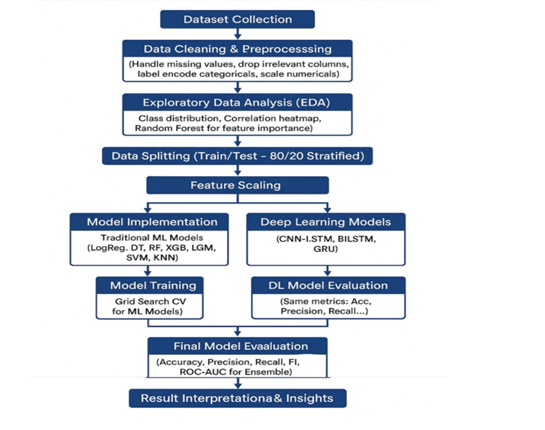

Figure 01: Model Architecture

Data was looked up on Kaggle and processed and prepared, which involved cleaning, referring to processing missing data, dropping irrelevant features, encoding of categorical variables, and scaling of numerical data. The exploratory data analysis was conducted to assist in the distribution of classes and ranking of features. The information was divided into training and testing sets of 80/20 stratified. Traditional machine learning models (Logistic Regression, Decision Tree, Random Forest, XGBoost, SVM, KNN) were developed, as well as deep learning models (CNN-LSTM, BiLSTM, GRU). Grid Search was used to execute the optimization of the machine learning models. The segments reported were evaluated by accuracy, precision, recall, F1-score, and ROC-AUC, and outcome results, in order to conclude.

**Results and Discussion**

In forecasting seizures, the results reveal that GRU was the most performing model in general overall performance with an accuracy of 93.86 percent and high ROC-AUC of 0.9484 followed closely by BiLSTM and Ensemble_GRU_RF, suggesting that recurrent neural networks architectures are very useful in predicting seizures probably because they can capture temporal behavior in EEG or other sequential data. Others such as Random Forest and CNN- LSTM models scored more than 0.94 in ROC-AUC indicating good predictive potential. Conversely, Decision Tree was of the weakest performance with an accuracy of 89.86 and a much lower ROC-AUC of 0.8059 indicating that though Decision Tree was of weak form, it had little chance of generalization compared to deep learning and ensemble even in complex temporal patterns. On the whole, deep learning models outperformed the traditional approaches to predicting the development of epilepsy.

Table 1: Results and evaluation matric of epilepsy

|  |  |  |  |  |  |
| --- | --- | --- | --- | --- | --- |
| **Model** | **Accuracy** | **Precision** | **Recall** | **F1-Score** | **ROC-AUC** |
| GRU | 0.9386 | 0.9370 | 0.9386 | 0.9354 | 0.9484 |
| BiLSTM | 0.9379 | 0.9359 | 0.9379 | 0.9351 | 0.9478 |
| Ensemble_GRU_RF | 0.9371 | 0.9351 | 0.9371 | 0.9344 | 0.9474 |
| SVM | 0.9364 | 0.9342 | 0.9364 | 0.9341 | 0.9354 |
| Random Forest | 0.9357 | 0.9340 | 0.9357 | 0.9321 | 0.9497 |
| CNN-LSTM | 0.9336 | 0.9320 | 0.9336 | 0.9295 | 0.9489 |
| Logistic Regression | 0.9329 | 0.9308 | 0.9329 | 0.9291 | 0.9477 |
| LightGBM | 0.9314 | 0.9292 | 0.9314 | 0.9276 | 0.9408 |
| KNN | 0.9236 | 0.9205 | 0.9236 | 0.9189 | 0.8892 |
| XGBoost | 0.9236 | 0.9202 | 0.9236 | 0.9201 | 0.9340 |
| Decision Tree | 0.8986 | 0.8969 | 0.8986 | 0.8977 | 0.8059 |

**Implications/Conclusions**

The study shows that by using solely structured clinical features, deep sequential models such as CNN2-LSTM2 coupled with machine learning and deep learning models can support very accurate prediction of future epilepsy onset and is scalable and less invasive and time-costly risk pre-identification due to the absence of EEG, especially when resources are limited. The results emphasise the depth of ordinary clinical information, the utility of combined ML/DL model, and the necessity to consider complicacy of a model and overfitting risks to adjust it to clinical usage. In future, multicenter datasets need to be extended, EEG and genetic data should be merged or used to make a multimodal prediction, and real-time clinical decision support systems must be developed. Altogether, the work contributes to the advancement of AI in the neurological field by filling a gap in predicting epilepsy and demonstrating that models made of easily accessible and interpretable information can offer a valuable addition to the overall care of the patient.

**Acknowledgment**

We gratefully acknowledge the epilepsy clinical dataset provided by the Kaggle community, which made this research possible. We also thank Google Colab for offering the computational resources used in this study

**References**

Keceli, A. S. (2018). Viewpoint projection based deep feature learning for single and dyadic action recognition. *Expert Systems with Applications*, *104*, 235-243.

Lundberg, S. M., & Lee, S.-I. (2017). A unified approach to interpreting model predictions. *Advances in neural information processing systems*, *30*.

Tripathi, J., Vasu, B., & Bég, O. A. (2021). Computational simulations of hybrid mediated nano-hemodynamics (Ag-Au/Blood) through an irregular symmetric stenosis. *Computers in Biology and Medicine*, *130*, 104213.