**Luyanda Mncube 59448873 COS1511 Assignment 3**

**Question 1**

#include <iostream>

using namespace std;

int main()

{

int selection; // Fill in the code to define an integer variable called selection

float cost, number;

cout.setf(ios::fixed);

cout.precision(2);

cout << "Please enter the choice of hotdog "

<< "(a number from 1 to 4 or 0 to quit) " << endl;

cout << "Hot Dog Menu " << endl << endl;

cout << "1: Plain hotdog" << '\t' << '\t' << '\t'<< "R15.00" << endl;

cout << "2: Chilli hotdog" << '\t' << '\t' << "R12.50" << endl;

cout << "3: Cheese hotdog" << '\t' << '\t' << "R17.00" << endl;

cout << "4: Russian hotdog" << '\t' << '\t' << "R22.50" << endl;

cout << "0: QUIT " << endl <<endl << endl;

cin >> selection ;

while (selection < 0 || selection > 4 ) //complete the condition

{

cout << "Invalid choice - Please re-enter ";

cin >> selection;

cout << endl;

}

cout << "You have selected option number " << selection;

cout << ", How many hotdogs would you like?" << endl;

cin >> number; // Fill in the code to read in number

// Fill in the code to begin a switch statement

// that is controlled by selection

switch (selection)

{

case 1: cost = number * 15.0;

cout << "The total cost is R " << cost << endl;

break;

// Fill in the code for the case chilli hotdog ( R12.50 each)

case 2: cost = number * 12.50;

cout << "The total cost is R " << cost << endl;

break;

// Fill in the code for the case chesse hotdog (R17.00 each)

case 3: cost = number * 17.0;

cout << "The total cost is R " << cost << endl;

break;

// Fill in the code for the case Russian hotdog (R22.50 each)

case 4: cost = number * 22.50;

cout << "The total cost is R " << cost << endl;

break;

case 0: cout << " Please come again" << endl;

break;

default:

cout << "Invalid selection";

cout << " Try again please" << endl;

}

return 0;

}

**Output**

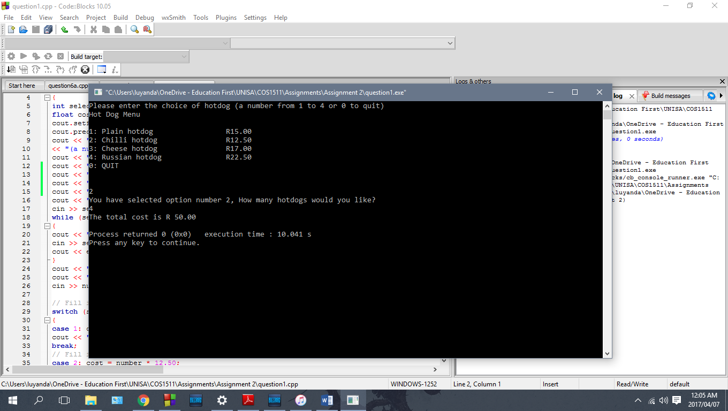

**Question 2b**

#include <iostream>

using namespace std;

int main ()

{

int next = 2, sum = 0; //sum should be initialised to 0

while (next <= 5){

sum = sum + next;

next++; //Loop control variable *next* should only be incremented AFTER the sum of the variables *sum* and *next* are calculated

}

cout << "The sum of 2 through 5 is " << sum << endl;

return 0;

}

**Question 3**

// This program finds the average time spent programming by a student

// each day over a three day period.

#include <iostream>

#include <string>

#include <cstdlib>

using namespace std;

int main(){

int numStudents;

float numHours, total, average, Biologyaverage, Programmingaverage;

int student,day = 0,numdays,subjectflag; //these are the loop counters string subject;

cout << "This program will find the average number of hours a day"

<< " that a student spent programming over a long weekend\n\n";

cout << "How many students are there?" << endl;

cin >> numStudents;

cout << "Enter the number of days in the long weekend" << endl;

cin >> numdays;

cout << "================================================" << endl;

for( student = 1; student <= numStudents; student++)

{

for( subjectflag = 1; subjectflag <= 2; subjectflag++)

{

switch (subjectflag)

{

case 1 :

subject = "Biology";

break;

case 2 :

subject = "Programming";

break;

}

total = 0;

for(day = 1; day <= numdays; day++)

{

cout << "Please enter the number of hours worked by student " << student <<" on day " << day << " for " << subject << endl;

cin >> numHours;

total = total + numHours;

}

average = total / numdays;

cout << "The average number of hours per day spent on " << subject

<< " by student " << student << " is " << average << endl << endl << endl;

if (subjectflag == 1 ) //Seperate each subject average

Biologyaverage = average;

else

Programmingaverage = average;

}

if (Biologyaverage > Programmingaverage)

cout << "Student " << student << " spent the most time on Biology" << endl;

else

cout << "Student " << student << " spent the most time on Programming" << endl;;

cout << "================================================" << endl;

}

return 0;

}

**Output**

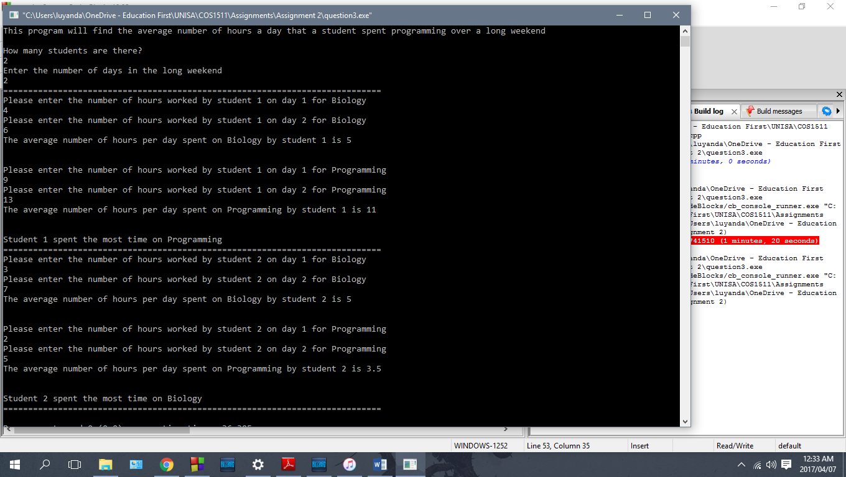

**Question 4**

#include <iostream>

#include <math.h>

using namespace std;

void selTabs (int startVal, int rowVal, int incVal)

{

cout << "NUMBER" << '\t' << "SQUARE" << '\t' << "CUBE" << endl;

int ansSquare, ansCube;

int rowNum,startNum, k;

//Ensures loop repeats according to increment

rowNum = startVal + (rowVal * incVal);

for (k =startVal; k < rowNum ; k += incVal)

{

ansSquare = pow(k,2);

ansCube = pow(k,3);

cout << k << '\t'<< ansSquare << '\t' << ansCube << endl;

}

}

int main()

{

int startIn, rowIn, incIn; //Variables for user input

cout << "Enter the starting value of the table" << endl;

cin >> startIn;

cout << "Enter the number of values to be displayed" << endl;

cin >> rowIn;

cout << "Enter the increment between the values" << endl;

cin >> incIn;

selTabs(startIn,rowIn,incIn);

}

**Output**

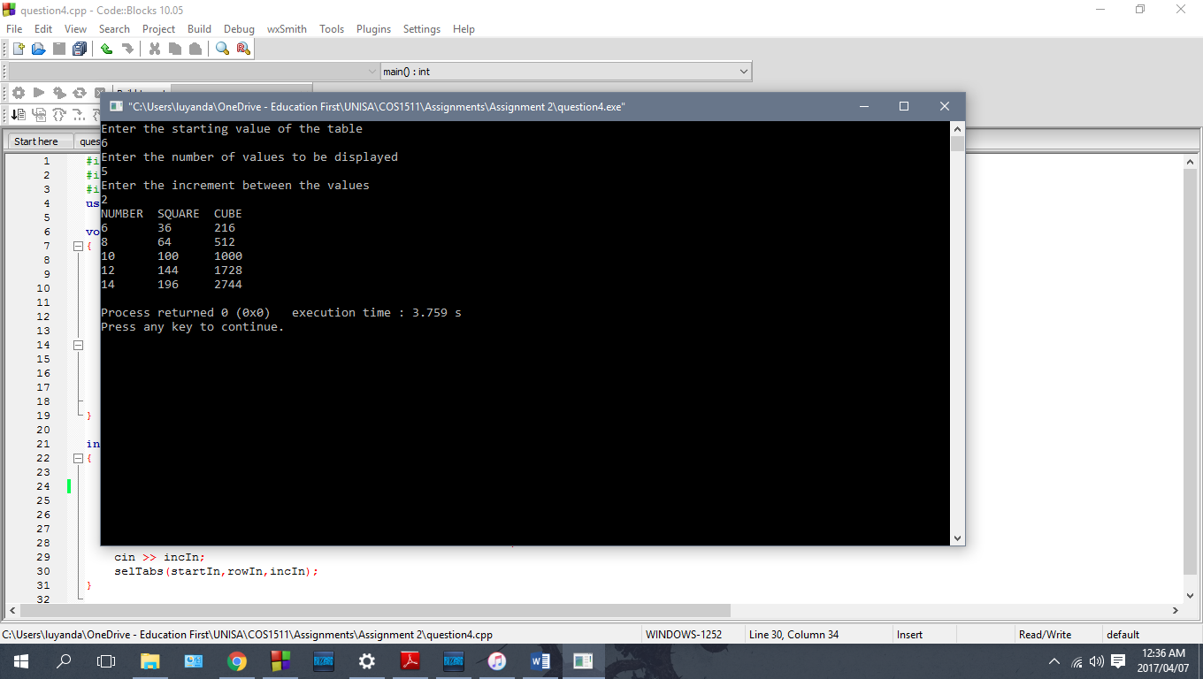

**Question 5**

#include <iostream>

#include <math.h>

#include <cmath>

#include <string>

#include <iomanip>

using namespace std;

//Get customer name

string getCustomerName(string& Customername)

{

cout << "Please enter name of customer:" << endl;

getline(cin, Customername, '\n');

return Customername;

}

//Get customer number

string getCustomerNumber(string& Customernumber)

{

cout << "Please enter customer number:" << endl;

cin >> Customernumber;

return Customernumber;

}

//calculateCarpetSize

int calculateCarpetSize(float roomLengthP, float roomWidthP)

{

cout << "Please enter length of room:" << endl;

cin >> roomLengthP;

cout << "Please enter width of room:" << endl;

cin >> roomWidthP;

return ceil(roomLengthP) * ceil(roomWidthP);

}

//calculateCarpetCost

float calculateCarpetCost(int roomSize, float sellingprice)

{

cout << "Please enter selling price for carpet" << endl;

cin >> sellingprice;

return roomSize * sellingprice;

}

//calculateLabourCost

float calculateLabourCost(int roomSize1)

{

return roomSize1*24;

}

//qualifyForDiscount

bool qualifyForDiscount(string customerNumber)

{

bool ForDiscount;

char discountflag;

discountflag = customerNumber[0];

ForDiscount = (discountflag == '0'); //Error check this

return ForDiscount;

}

//computeDiscount

float computeDiscount(float discountpercentageP, float amountP, bool discountflag)

{

float discountrecieved;

if (discountflag == 1)

{

cout << "Please enter discount to apply (0-100):" << endl;

cin >> discountpercentageP;

discountrecieved = amountP *(discountpercentageP/100);

return discountrecieved;

}

else

return 0;

}

//printCustomerStatement

void printCustomerStatement(string customerName1, string customerNumber1, float CarpetCost1,float LabourCost1, float firstsubtotal1, float discount1,

float secondsubtotal1, float taxamount, float total)

{

cout << setw(45) << "CROSWELL CARPET STORE" << endl;

cout << setw(40) << " STATEMENT" << endl;

cout << setw(40) << "Customer name : " << customerName1 << endl;

cout << setw(40) << "Customer number : " << customerNumber1 << endl;

cout << setw(40) << "Carpet price : " << CarpetCost1 << endl;

cout << setw(40) << "Labour : " << LabourCost1 << endl;

cout << setw(40) << "Subtotal : " << firstsubtotal1 << endl;

cout << setw(40) << "Less discount : " << discount1 << endl;

cout << setw(40) << "Subtotal : " << secondsubtotal1 << endl;

cout << setw(40) << "Plus tax : " << taxamount << endl;

cout << setw(40) << "Total : " << total << endl;

}

int main()

{

float roomLength, roomWidth ;

//Global variables used in function calls

float mCarpetsize, mCarpetCost, mLabourCost, mForDiscount,

mDiscountpercentage, mSellingprice, mDiscountamount, tax, mTotal;

string mCustomerName, mCustomerNumber;

const float TAXRATE = 0.14;

//Variables for subtotals

float firstsubtotal, secondsubtotal;

cout.setf(ios::fixed);

cout.precision(2);

//Call functions for name and number

mCustomerName = getCustomerName(mCustomerName);

mCustomerNumber = getCustomerNumber(mCustomerNumber);

//Assign called functions to global variables

mForDiscount = qualifyForDiscount(mCustomerNumber);

mCarpetsize = calculateCarpetSize(roomLength, roomWidth);

mCarpetCost = calculateCarpetCost(mCarpetsize, mSellingprice);

mLabourCost = calculateLabourCost(mCarpetsize);

firstsubtotal = mCarpetCost + mLabourCost;

mDiscountamount = computeDiscount(mDiscountpercentage, firstsubtotal, mForDiscount);

//Additional calculations

secondsubtotal = firstsubtotal - mDiscountamount;

tax = mCarpetCost * TAXRATE;

mTotal = secondsubtotal + tax;

//Call print function

printCustomerStatement(mCustomerName, mCustomerNumber, mCarpetCost,mLabourCost , firstsubtotal, mDiscountamount, secondsubtotal, tax, mTotal);

return 0;

}

**Output Mr. Wilson**

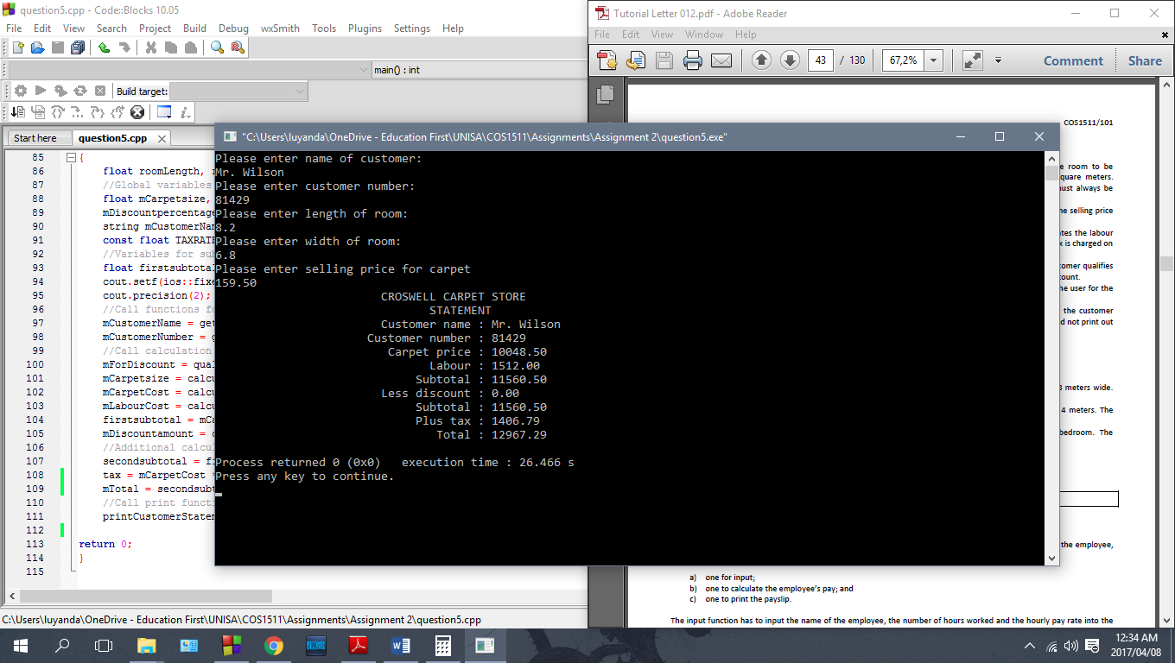

**Output Mr. and Mrs. Adams – discount of 5% given**

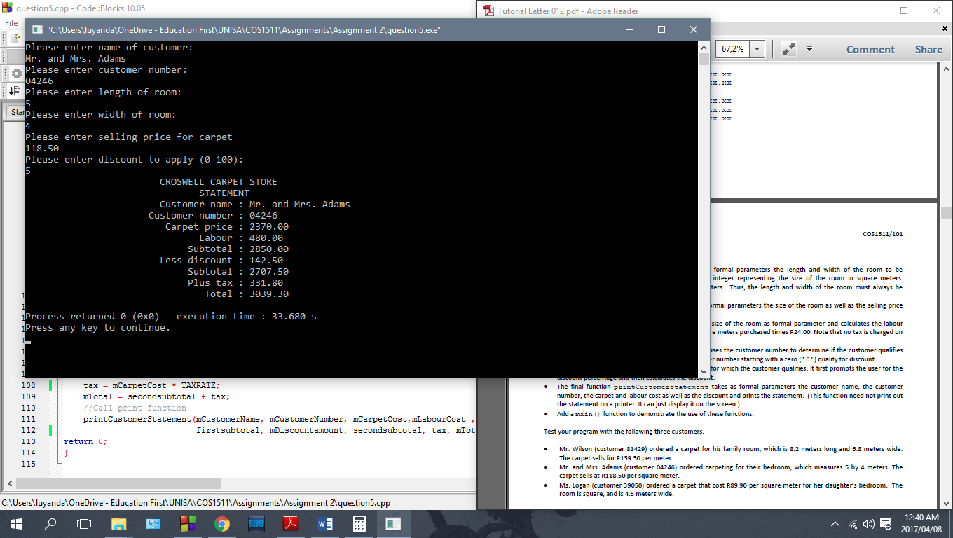

**Output Ms. Logan**

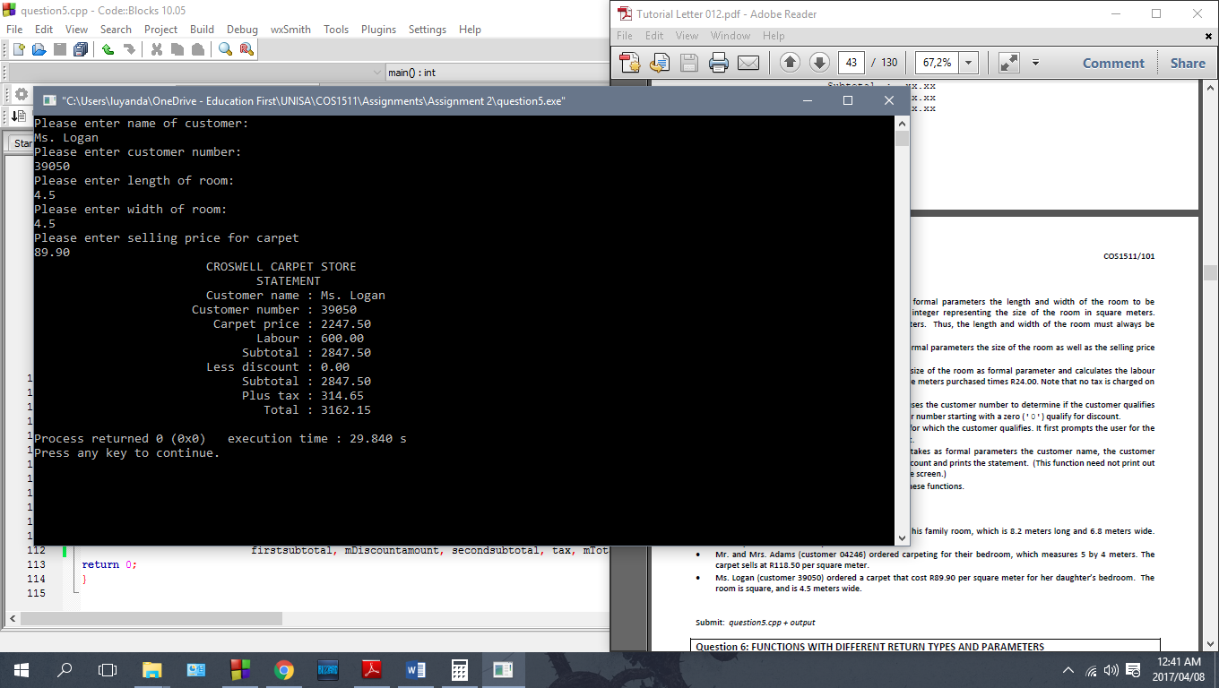

**Question 6a**

#include <iostream>

#include <string>

using namespace std;

//Function 1: Input

void employeeinput (string& theEmployee1, float& theHoursWorked, float& thePayRate)

{

cout << "Please enter employee name: \n";

getline(cin, theEmployee1, '\n');

cout << endl;

cout << "Please enter how many hours the employee worked: " << endl;

cin >> theHoursWorked;

cout << "Please enter employee hourly pay rate: " << endl;

cin >> thePayRate;

cout << endl;

cin.ignore(50,'\n'); //Allows stream manipulation in loops

}

//Function 2: Employee's Pay calculation

float calculatepay (float hoursworked, float payrate)

{

if (hoursworked > 40)

return hoursworked * payrate * 1.5;

else

return hoursworked * payrate;

}

//Function 3: Output

void employeeoutput (string employeename, float hoursworked1, float payrate1, float finalpay)

{

float overtime;

if (hoursworked1 > 40)

overtime = hoursworked1 - 40;

else

overtime = 0;

cout << "Pay slip for " << employeename << endl;

cout << "Hours worked: " << hoursworked1 << " hours" << endl;

cout << "Overtime hours: " << overtime << endl;

cout.setf(ios::fixed);

cout.precision(2);

cout << "Hourly pay rate: " << payrate1 << endl;

cout << "Pay: R" << finalpay << endl;

cout << "==================================" << endl;

}

int main()

{

string mEmployee;

float mHours, mPayrate, mPay;

for (int k =1; k <= 5; k++)

{

employeeinput(mEmployee,mHours,mPayrate);

mPay = calculatepay(mHours, mPayrate);

employeeoutput(mEmployee, mHours,mPayrate, mPay);

}

return 0;

}

**Output**

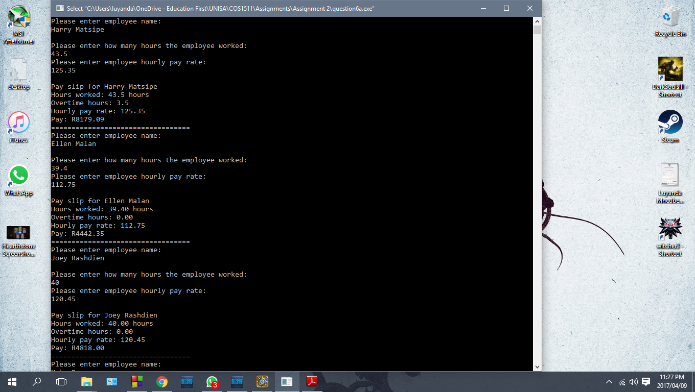

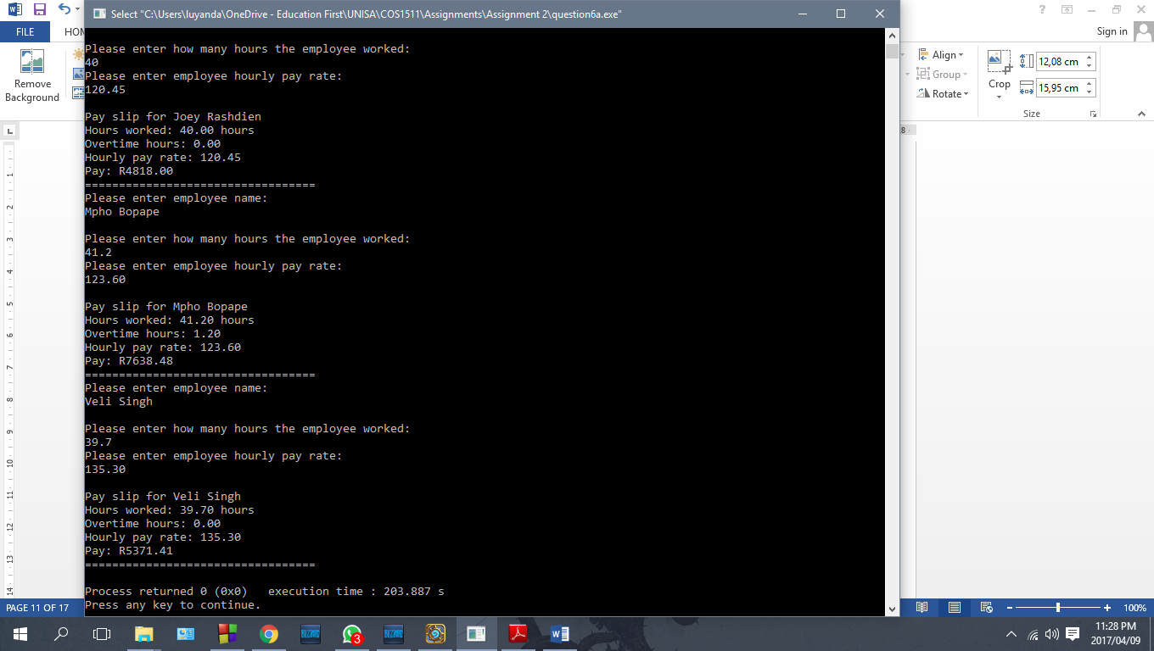

**Question 6b**

#include <iostream>

#include <string>

using namespace std;

//Function 1

float specialdiscount(char popcorn1, float ticketprice)

{

float total;

if (popcorn1 == 'Y')

total = ticketprice*0.80;

else

total = ticketprice*0.90;

return total;

}

//Function 2

float normaldiscount(char popcorn2, float ticketprice1)

{

float total1;

if (popcorn2 == 'Y')

total1 = ticketprice1*0.90;

else

total1 = ticketprice1;

return total1;

}

int main ()

{

const float TICKETPRICE = 80.00;

char entry, popcorn;

float totalprice;

//While loop to ensure correct entry of characters

while (popcorn != 'Y' || popcorn != 'N'|| entry != 'S' || entry != 'P' || entry != 'O')

{

cout << "Please enter p for pensioner, s for student or o for other:" << endl;

cin >> entry;

entry = toupper(entry);

cout << "Did you buy any popcorn? Y/N: " << endl;

cin >> popcorn;

popcorn = toupper(popcorn);

if (entry == 'P' || entry == 'S')

{

totalprice = specialdiscount(popcorn,TICKETPRICE);

cout << "This person will pay " << totalprice << " for their ticket" << endl;

break;

}

else if (entry == 'O')

{

totalprice = normaldiscount(popcorn,TICKETPRICE);

cout << "This person will pay " << totalprice << " for their ticket" << endl;

break;

}

else

cout << "Invalid entry, please try again." << endl;

}

return 0;

}

**Output**

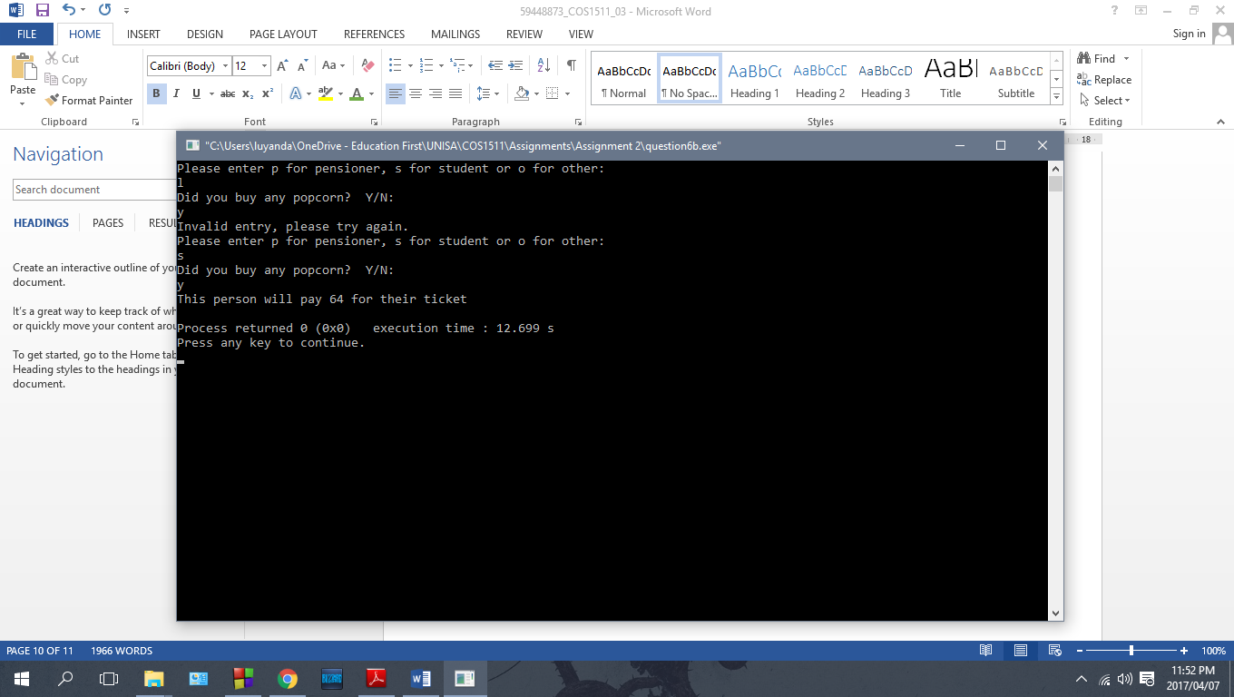

**Question 6c**

#include <iostream>

#include <string>

using namespace std;

string getname(string name, string surname)

{

string joinednames;

cout << "Please enter customer name:" << endl;

getline(cin, name, '\n');

cout << "Please enter surname:" << endl;

getline(cin, surname, '\n');

joinednames = name + " " + surname;

return joinednames;

}

float gethours(string& fullname, float payrate)

{

float total = 0, hoursworked, bonus, salary;

cout << "Please enter payrate per hour for employee: " << endl;

cin >> payrate;

for (int k = 1; k <= 5; k++)

{

cout << "Please enter hours worked for day: " << k << endl;

cin >> hoursworked;

total += hoursworked;

}

cout << "Employee worked " << total << " hours."<< endl ;

if (total > 40)

{

bonus = 1.10;

cout << "Employee recieved 10% bonus." << endl ;

}

else

{

bonus = 0.90;

cout << "Employee recieved 10% reduction." << endl ;

}

salary = total * payrate*bonus;

return salary;

}

int main()

{

string employeename, employeesurname, fullname1;

float payrate1, salary1;

fullname1 = getname(employeename,employeesurname);

salary1 = gethours(fullname1, payrate1);

cout << "The employee " << fullname1 << " salary was: R" << salary1 << endl;

}

**Output**

**Employee worked less than 40 hours – pay reduced**

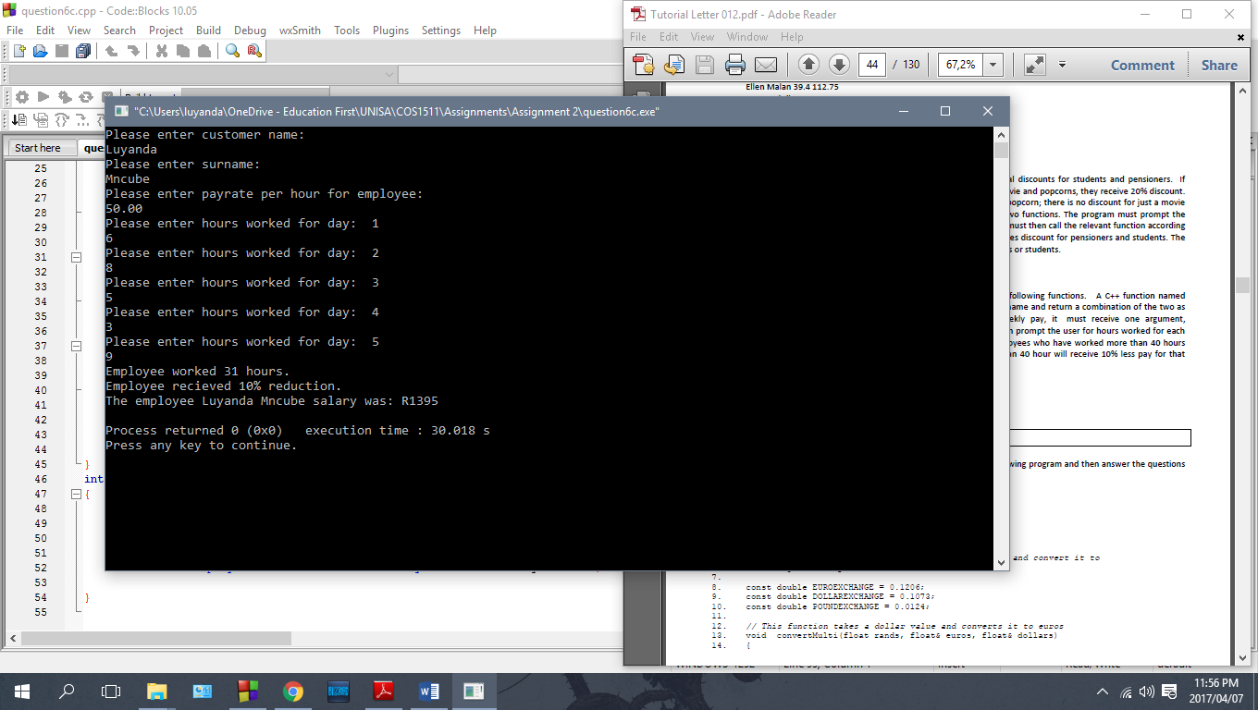

**Employee worked more than 40 hours – bonus recieved**

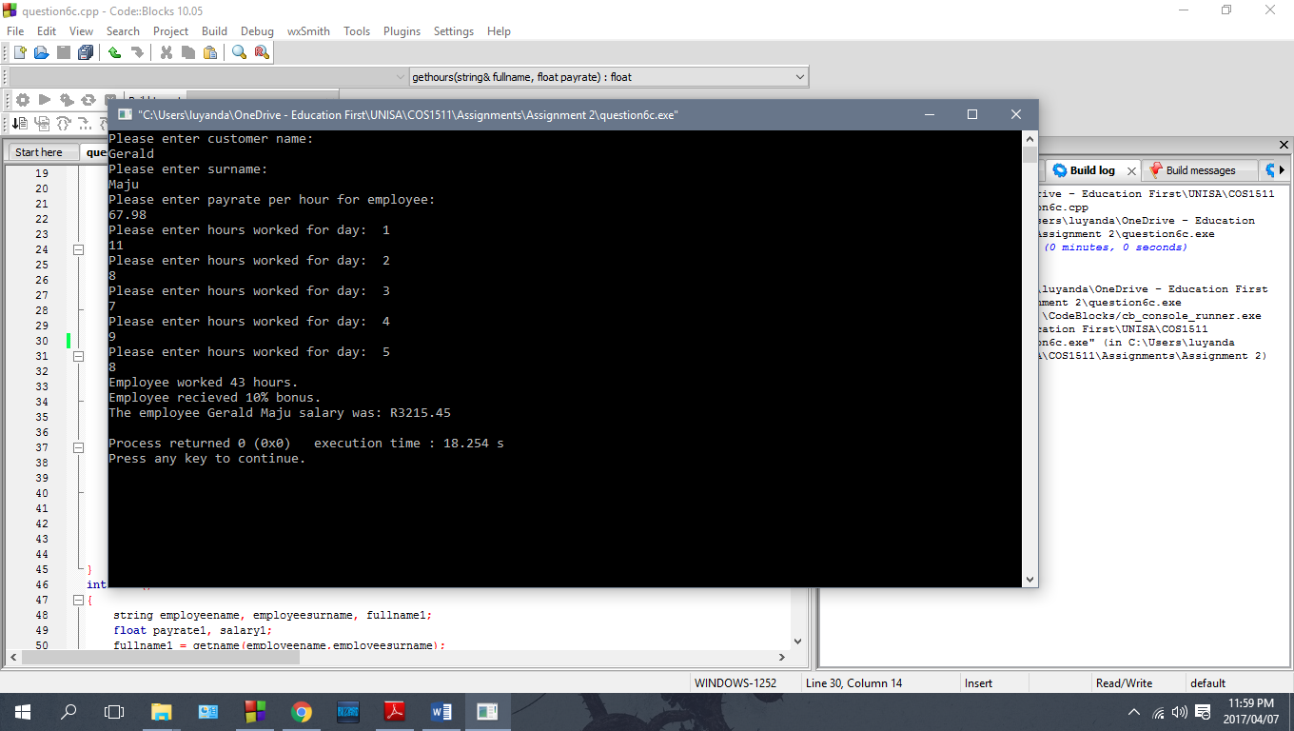

**Question 7a**

The function call is not valid. The function in line 61 does not have enough actual parameters. The function header has four formal parameters, all of the type float while the called function has 3 actual parameters, all of the type float.

**Question 7b**

The function call is valid. Even though in the actual parameters, the variables used have the same name as in the function header. This will not affect how the program works, as long as the syntax and calculations for the program are correct.

**Question 7c**

The function call is not valid. The function in line 86 has too many actual parameters. The function header only has one formal parameter, rands of type float while the called function in line 86 has too many parameters, rands and euros which are both of type float.

**Question 7d**

Function 1: This function is returning two values, balAmnt of type float and amtC of type float. This header is not valid. Functions which return two variables as reference parameters cannot be valid where an actual value is passed through the function call as an actual parameter. The value it receives is 200.53.

Function 2: This function is returning one values, balAmnt of type float. This header is valid. Functions which return one variable as reference parameters are valid where an actual value is passed through the function call as an actual parameter. The value it receives is 200.53.