**Question 1**

Which of the following statements about the function given by $f(x) = x^{4} - 2x^{3}$ is true?

(1) The function has no relative extremum.

(2) the graph of the function has one point of inflection and has two relative extrema

(3) the graph of the function has two points of inflection and has one relative extremum.

(4) The function has a singular point at $x = 0.$

(5) The function has a maximum point at $x =\frac{3}{2}$

**wolframalpha**

extrema x^4-2x^3

$\min\left\{x^{4} - 2x^{3}\right\}= -\frac{27}{16}$, $x=\frac{3}{2}$*global minimum*

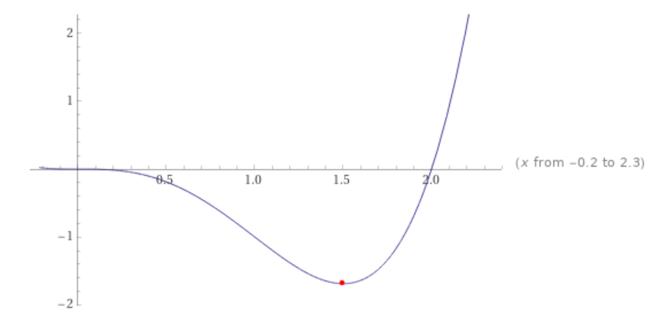

Question 2

To have an idea on whether we should apply the bisection method to determine the root of $f(x) = 0$ in a given interval, we may

(1) check if $f(x)$ and $f'(x)$ are continuous then conclude

(2) draw the graph of $f(x)$ and observe the graphs then conclude

(3) check if $f(x)$ has a critical point in the given interval

(4) apply the function $f(x)$ to the endpoints of the given interval and check the sign of the corresponding outputs.

(5) check if $f(x)$ has a point of inflection in the given interval.

Bisection method: find a root

The Bisection Method will cut the interval into 2 halves and check which half interval contains a root of the function

The Bisection Method will keep cut the interval in halves until the resulting interval is extremely small

The root is then approximately equal to any value in the final (very small) interval.

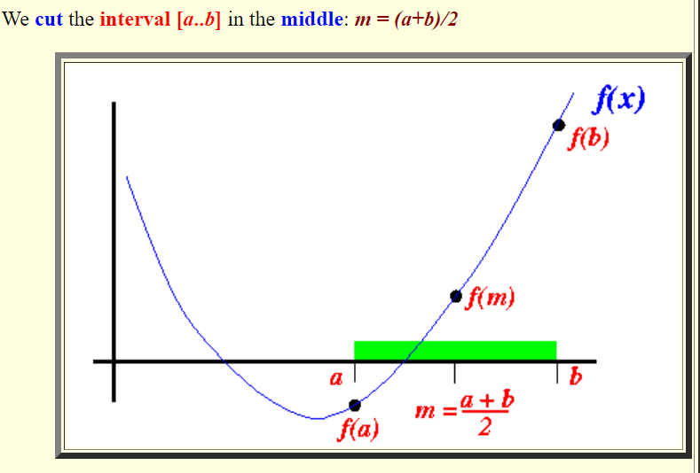

<http://www.mathcs.emory.edu/~cheung/Courses/170/Syllabus/07/bisection.html>

if a function $f(x)$ is continuous on the interval $[a,b]$ and sign of $f\left(a\right)≠$ sign of $f(b)$ then there is a value $c∈[a,b]$ such that $f\left(c\right)=0$

(For Questions 3 to 5)  
<http://web.stanford.edu/class/cs205/homework/hw5_solutions.pdf>

Suppose we wish to develop an iterative method to compute the square

root of a given positive number $y$, i.e., to solve the nonlinear equation $f(x) = x^{2} - y = 0$

given the value of $y$. Each of the functions g1 and g2 gives a fixed-point problem that is equivalent

to the equation $f(x) = 0$:

(a) $g_{1}(x) = y + x - x^{2}$

(b) $g_{2}\left(x\right)= 1 + x -\frac{x^{2}}{y}$

For each of the functions, we want to determine whether the corresponding fixed-point iteration scheme

$$xk+1 = gi(xk)$$

is locally convergent to $\sqrt{y}$ if $y = 3$.

Answer:

$x* =\sqrt{3}$ Thus we need to determine whether each iteration is locally convergent or divergent by examining $|g'(x*)|$. We have

Locally convergent

**Question 3**

Consider $g_{1}\left(x\right)= y + x - x^{2}$

(1) $g_{1}(x)$ is locally convergent

(2) $g_{1}(x)$ would have been locally convergence if $g_{1}(x)$ were continuous and differentiable in an interval that include $\sqrt{3}$.

(3) The interval of convergence where $|g’(x)| < 1$ contains $\sqrt{3}$.

(4) $g'(x)$ is not continuous.

(5) None of the above is true

$g_{1}\left(x\right)= y + x - x^{2}$ is divergent

Is also continuous ( $1-2x$ and $1$)

**Question 4**

Consider $g_{2}(x) = 1 + x -\frac{x^{2}}{y}$

(1) the convergence of $g_{2}(x)$ is not guaranteed because the interval of convergence where $|g_{2}(x)| < 1$ does not contain $\sqrt{3}$.

(2) $g’_{2}(x)$ is not continuous.

(3) the convergence of $g_{2}(x)$ is not guaranteed because $g'(x)$ is not continuous.

(4) the convergence of $g_{2}(x)$ is not guaranteed because $g_{2}(x)$ and $g_{2}(x)$ are continuous but the set of points of intersection of the graphs of $y=g_{2}(x)$ and $y = x$ is empty

$g_{2}(x) = 1 + x -\frac{x^{2}}{y}$ is locally convergent

**Question 5**

The fixed-point function, $g_{3}(x)$ given by Newton’s method for $f(x) = x$

$2 - 3$ is:

(1) $g_{3}(x)$ $= g_{1}(x).$

(2) $g_{3}\left(x\right)= x -\frac{x_{2} -3}{2x}$

(3) $g_{3}(x)= g2(x).$

(4) $g_{3}\left(x\right)= x -\frac{g1\left(x\right)}{g2\left(x\right)}$

(For Questions 6 to 9)

Consider the nonlinear equation $xe^{x} = 2$, which has a root in the interval $[0, 1]$.

Question 6

Which of the following is FALSE.

(1) The fixed-point formula $g(x) = 2e^{-x}$ converges to the approximate solution $p = 0.85260550$ if the initial approximation $p0 > 0.69314$.

(2) The minimum number of iterations required to approximate the root by the bisection method correct to ${10}^{-8}$ is $26$.

(3) Newton’s method with $p_{0} = 0$ will converge to the approximate solution $p = 0.85260550$ after at most 4 iterations.

(4) Newton’s method with $p_{0} = 1$ will converge to the approximate solution $p = 0.85260550$ after exactly 4 iterations

(5) Both (1) and (4) are correct.

**Wolframalpha**

root xe^x=2

Question 7

2

Question 8

5

**Question 9**

Using Muller’s method

(1) (2) (3) (4)

**atozmath**

2e^-x

x_0: 3

x_1: 1

x_2: 2

**atozmath**

2e^-x

x_0: 1.5

x_1: 1

x_2: 1

**atozmath**

2e^-x

x_0: -2.5

x_1: 2

x_2: -3.5

**atozmath**

2e^-x

x_0: -3.5

x_1: -2.5

x_2: -1.5

6.76310209 -5.52113054

**Question 10**

Choose the appropriate option:

(1) The secant method and Muller’s method are similar in the sense that they both start with two points.

(2) The secant method yields a complex root even when the initial approximation is a real number.

(3) Muller’s method determines the next approximation by considering the intersection of a parabola and the x-axis through three given points.

(4) All of the above statements.

(5) none of the above statements

<http://kilyos.ee.bilkent.edu.tr/~microwave/programs/utilities/numeric1/infoMuller.htm>

Secant method starts with two points $x_{0}$ and $x_{1}$

Muller's Method Determines The Next Approximation By Considering The Intersection Of A Parabola

Muller’s method starts with three points $x_{0}$ and $x_{0}$, $x_{1}$ and $x_{2}$

The power of Muller Method comes from the fact that it finds the complex roots of the functions.