Question 1

Build/design a Turing machine (TM) that determines whether a given word contains at least one instance of the substring aab. If it does, then the TM should write a T on the tape after the input word.

Question 2

Build/design a TM that:

· accepts all words that start with an a, and ends with a b,

· loops forever on all words that start with a b, and

· rejects all other words.

Question 3

Build a 2PDA that accepts the language

States :

Alphabet :

Stack Alphabet:

Start State ():

Accepting State ():

Transition function (δ):

δ

δ

δ

δ

δ

δ

δ

δ

Question 4

Build a Turing Machine that:

· accept even number of as,

· loops forever if start with b, and

· rejects all other words.

States :

Alphabet :

Stack Alphabet:

Start State ():

Accepting State ():

Transition function (δ):

δ

δ

δ

δ

δ

δ

δ

δ

Question 5

Convert the following TM into summary table and then into their code words in CWL. What is the language accepted by this TM.

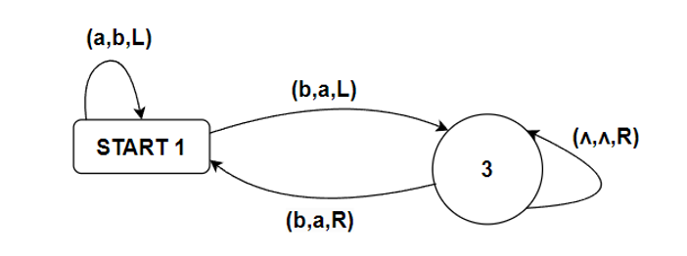

CWL:

(Current State, Input Symbol, Write Symbol, Move Direction, Next State)

1. (START1, a, b, L, START1)

2. (START1, b, a, L, 3)

3. (3, Λ, Λ, R, 3)

Language Accepted:

* Accepts strings ending in b
* Non-empty