Abstract
Fork-based development allows developers to start development from existing software repository by copying the code files. However, when the number of forks grows, contributions are not always visible to others, unless an explicit merge-back attempt is made. To solve this problem, we implemented Forks Insight (http://www.forks-insight.com) to help developers get an overview of forks on GitHub. The current release version focuses on simple analytics for the high level overview which is lightweight, scalable and practical. It has an user-friendly interactive web interface with features like searching and tagging.
Key words: Fork-based development, Open-source, Overview of forks, GitHub

Poster: Forks Insight: Providing an Overview of GitHub Forks
Andrzej Wasowski
IT University of Copenhagen

1 Introduction
Fork-based development allows developers to start development from existing software repository by copying the code files, and gives developers the freedom and independence to make modifications on their own fork [Error: Reference source not found, Error: Reference source not found, Error: Reference source not found, Error: Reference source not found]. Even though it has been widely used in both open source communities and industry, when the number of forks grows, it becomes difficult for programmers to keep track of decentralized development activities in many forks. Some of the developers on GitHub that we have interviewed previously reported problems they faced in terms of losing overview of forks. For example, one said: "I do not have much visibility of the forks. They are too many, and it is overwhelming to keep track of them" [Error: Reference source not found]. Both Duc et al. and Berger et al. found that this problem also appears in industry. It is hard for individual teams to know who is doing what and what code changes are made in other forks [Error: Reference source not found, Error: Reference source not found].
Even though GitHub supports a network view to visualize the commit history across all branches and forks of a repository, it is difficult to gain a straightforward overview of specific activities in forks. As another developer said: "The network view is helpful for seeing how active a fork is, but often you have to scroll back a lot to find the fork point and then you have to go to the end again for seeing what changed since then in the parent and in the fork, by reading the tooltips of each commit." A lack of an overview of forks leads to several additional problems: (1) redundant development: developers may re-implement a functionality that has already been developed elsewhere; (2) lost contributions: the contributions developers made are easily lost to the larger community unless they contribute those changes back to the original repository; (3) suboptimal forking point: developers might not fork from the codebase that is closest to their intended goals [Error: Reference source not found, Error: Reference source not found, Error: Reference source not found]. We therefore argue that it’s necessary to give developers a panoramic view to help them better understand activities among various forks.
Forks Insight (http://www.forks-insight.com) is a more lightweight and accessible solution of our prior academic prototype INFOX [Error: Reference source not found], analyzes and clusters changes in C/C++ code within forks. Forks Insight offers an web service for all GitHub repositories. It provides an overview of each repository in fork-level granularity and delivers insights to developers including repository’s maintainers and other developers who are interested in the repositories.

2 Forks Insight
Forks Insight provides facilities to explore unintegrated changes to find opportunities for reuse, to find inspirations for further development, to potentially connect developers working on similar topics. It analyzes each active fork of a repository by taking the diff between the latest commit of both the upstream and the fork to get the commits that only exist in forks, and extracting keywords from corresponding code changes, comments and commit messages. Besides, Forks Insight presents statistical data of changes such as commits, changed files, lines of code changed, last commit time. The user interface of Forks Insight is shown in Fig. 1.
Users could log in with their GitHub accounts, and subscribe repositories on GitHub that they are interested in. Fork Insight supports importing repositories from user’s public repositories list or searching by a repository url. Forks Insight will start crawling and analyzing data if the repository is not in the database yet and remind the user when finished.
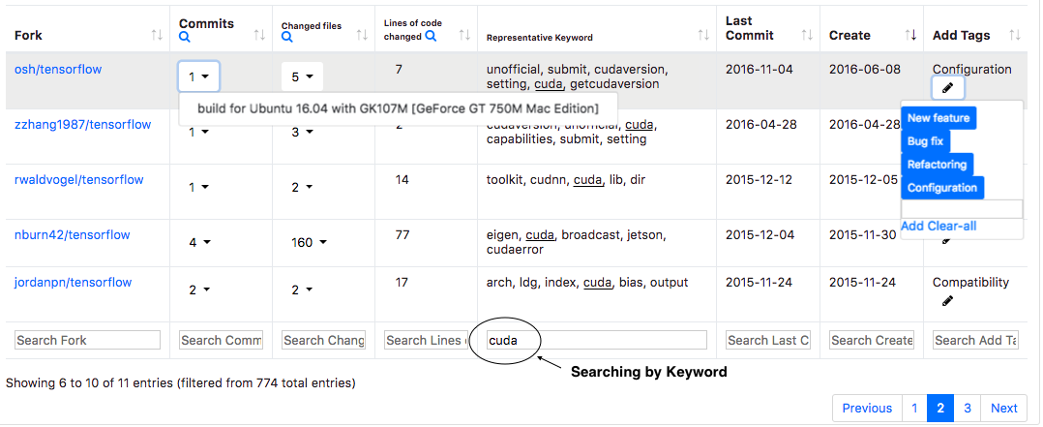
Figure 1: User Interface of Forks Insight. This example shows searching "cuda" in repository of tensorflow/tensorflow.

2.1 Extracting Keywords
To give developers a quick summary of what code changes have been made in each fork, we extract a list of representative keywords from text that are related to the code changes, such as source code, comments, and corresponding commit messages, by using the well-known natural language processing technique TF-IDF [Error: Reference source not found]. Specifically, we first preprocess the text: removing all the numeric strings; splitting word into subtokens for Pascal Case and Camel Case; lemmatizing words into a normal form. Then, we extract keywords from the text by calculating TF-IDF weight of each token. Though TF-IDF could effectively filter out some stop words like "or", "and", there are still some words with high weight like "public", "private" that are meaningless for code summary. To improve the result, we manually add a list of reserved words for different programming languages as stop words.

2.2 Tagging Forks
Developers fork a repository for different reasons: adding new features, fixing bugs, and changing configuration, etc. [Error: Reference source not found, Error: Reference source not found, Error: Reference source not found, Error: Reference source not found], which could help developers of interests(Luyao: developers of interests?) quickly find the fork they want to explore. Thus, Forks Insight allows users to tag each fork based on their understanding of the main activity.(Luyao: check this sentence) (see the last column in Fig. 1). We hope user’s input on tags could not only help themselves maintain and understand each fork, but also help the whole community, especially for the new users who are not familiar with this repository to get a better overview. The tagging result will also be useful for future research.

2.3 Searching Related Forks
The interviews we did for INFOX show that the problem of redundant development exists in forks. For example, a developer found another fork implemented a very simple one-function as they did several years ago, and he said “I think they should use our code, there is great reason to use it.” Another developer said: "I can see multiple forks are working on the similar problem. This one looks like it is adding [...] that I already added" [Error: Reference source not found].
To identify redundant development, we design the functionality of keywords searching, which is a simple and practical way to find code changes that contain the same keyword(Luyao: change to: with the similar changes?). For example, in Fig. 1, if developers search for "cuda", which is a common keyword related to GPU configuration in repository of tensorflow/tensorflow, Forks Insight will return several forks that have made code changes related to “cuda”. This example shows that, by using keyword searching, user could find similar forks and potentially reduce the redundant development.

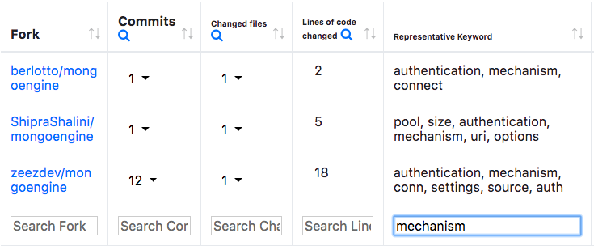
Figure 2: An example of searching for similar forks.

3 Conclusions and Future Work
We implemented Forks Insight to help developers get an overview of forks. The current release version focuses on simple analytics for the high level overview which is lightweight, scalable and practical. It uses the keyword extraction of INFOX and extends it with a user-friendly interactive web interface and features for searching and tagging. In order to improve the usability of Forks Insight, we plan to design a user study to ask for feedback from open source developers. And we would like to add more interactive elements and powerful functions into our tool. There are several directions we are considering to move forward: using more visualization to show meaningful data; identifying features in forks; summarizing the activities of forks by natural language.
[Sorry. Ignored \begin{acks} ... \end{acks}]
References
[Berger, Nair, Rublack, Atlee, Czarnecki, and WasowskiBerger et al.2014]berger2014three Thorsten Berger, Divya Nair, Ralf Rublack, Joanne M Atlee, Krzysztof Czarnecki, and Andrzej Wasowski. 2014. Three cases of feature-based variability modeling in industry. In International Conference on Model Driven Engineering Languages and Systems. Springer, 302–319.
[Bitzer and SchröderBitzer and Schröder2006]bitzer2006impact Jürgen Bitzer and Philipp JH Schröder. 2006. The impact of entry and competition by open source software on innovation activity. The economics of open source software development (2006), 219–245.
[Dubinsky, Rubin, Berger, Duszynski, Becker, and CzarneckiDubinsky et al.2013]dubinsky2013exploratory Yael Dubinsky, Julia Rubin, Theodore Berger, Slawomir Duszynski, Matthias Becker, and Krzysztof Czarnecki. 2013. An exploratory study of cloning in industrial software product lines. In Software Maintenance and Reengineering (CSMR), 2013 17th European Conference on. IEEE, 25–34.
[Duc, Mockus, Hackbarth, and PalframanDuc et al.2014]Duc:2014:FCM:2652524.2652546 Anh Nguyen Duc, Audris Mockus, Randy Hackbarth, and John Palframan. 2014. Forking and Coordination in Multi-platform Development: A Case Study. In Proceedings of the 8th ACM/IEEE International Symposium on Empirical Software Engineering and Measurement (ESEM ’14). ACM, New York, NY, USA, Article 59, 10 pages. 978-1-4503-2774-9
[Ernst, Easterbrook, and MyLOPOULOSErnst et al.2010]ernst2010code Neil A Ernst, Steve Easterbrook, and John MyLOPOULOS. 2010. Code forking in open-source software: a requirements perspective. arXiv preprint arXiv:1004.2889 (2010).
[Mikkonen and NymanMikkonen and Nyman2011]Mikkonen2011 Tommi Mikkonen and Linus Nyman. 2011. To Fork or Not to Fork: Fork Motivations in SourceForge Projects. Int. J. Open Source Softw. Process. 3, 3 (July 2011), 1–9. 1942-3926
[Robles and González-BarahonaRobles and González-Barahona2012]Robles2012 Gregorio Robles and Jesús M. González-Barahona. 2012. A Comprehensive Study of Software Forks: Dates, Reasons and Outcomes. In Open Source Systems: Long-Term Sustainability - 8th IFIP WG 2.13 International Conference, OSS 2012, Hammamet, Tunisia, September 10-13, 2012. Proceedings. 1–14.
[Salton and BuckleySalton and Buckley1988]salton1988term Gerard Salton and Christopher Buckley. 1988 . Term-weighting approaches in automatic text retrieval. Information processing & management 24, 5 ( 1988), 513–523.
[Stănciulescu, Schulze, and WasowskiStănciulescu et al.2015]stanciulescu2015forked Ştefan Stănciulescu, Sandro Schulze, and Andrzej Wasowski. 2015 . Forked and Integrated Variants in an Open-Source Firmware Project. In 31st International Conference on Software Maintenance and Evolution ( ICSME’15).
[VetterVetter2007]vetter2007open Greg R Vetter. 2007. Open Source Licensing and Scattering Opportunism in Software Standards. BCL Rev. 48 (2007), 225.
[Zhou, Stãnciulescu, Leßenich, Xiong, Wasowski, and KästnerZhou et al.2018]ZSLXWK:ICSE18 Shurui Zhou, Ştefan Stãnciulescu, Olaf Leßenich, Yingfei Xiong, Andrzej Wasowski, and Christian Kästner. 2018. Identifying Features in Forks. In Proceedings of the 40th International Conference on Software Engineering (ICSE). ACM Press, New York, NY.

https://github.com/dear-github/dear-github/issues/175

