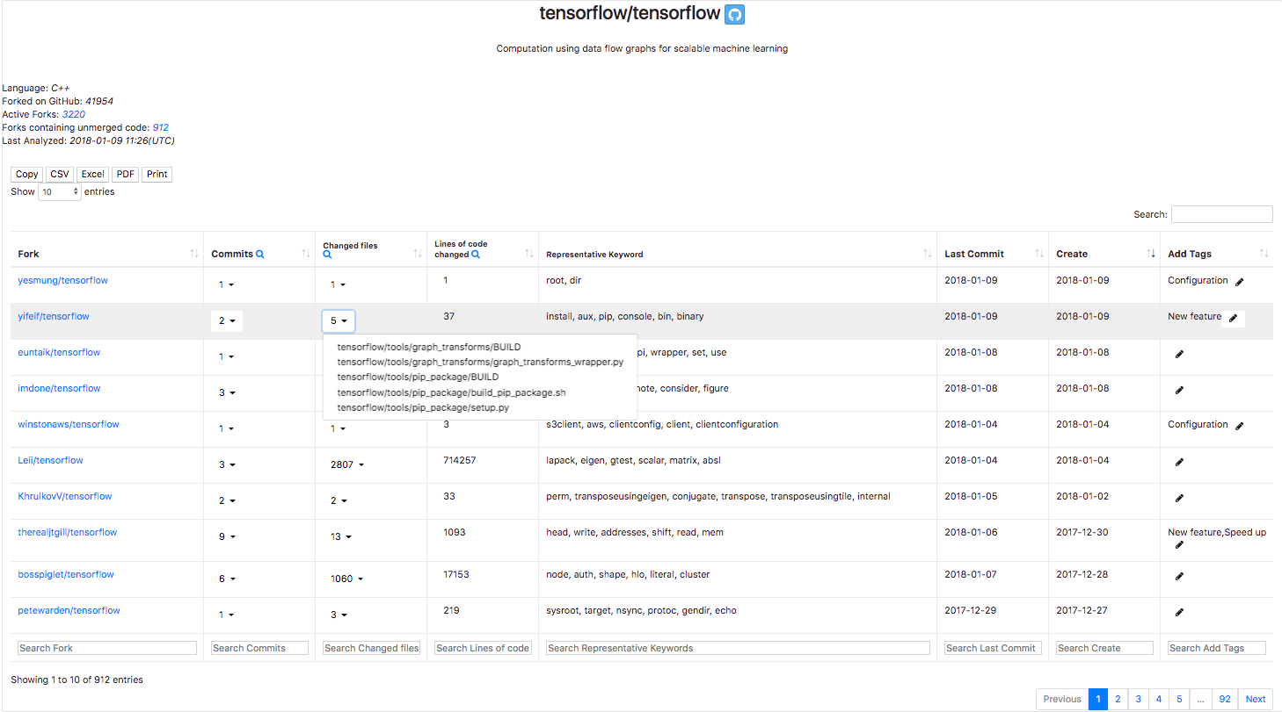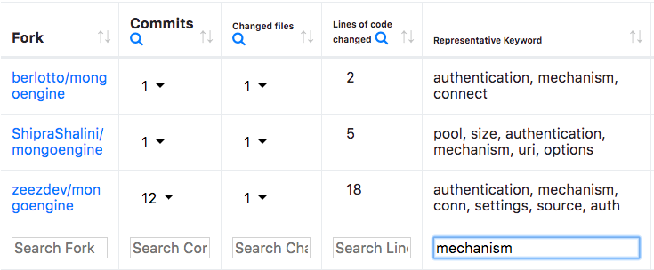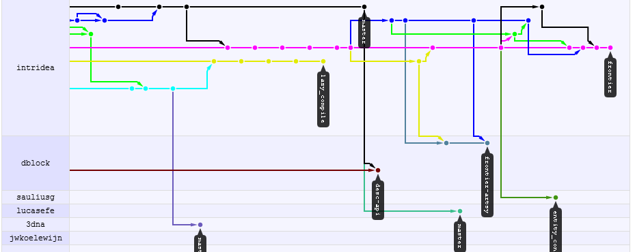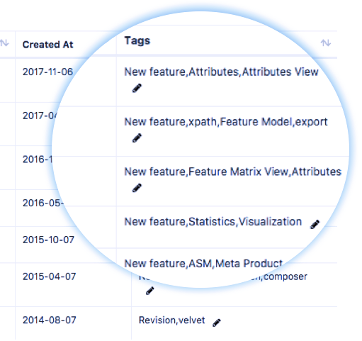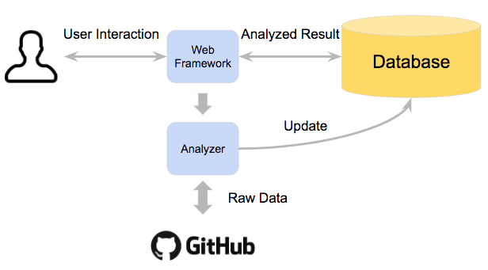

Contact: [fancycoder@pku.edu.cn](mailto:fancycoder@pku.edu.cn)

**Overview a Project's Forks**

**Searching Forks by Keywords**

**Website Architecture**

**Forks Insight: Providing an Overview of GitHub Forks**

Luyao Ren, Shurui Zhou, Christian Kästner

Redundant development

Lost contributions

Suboptimal forking point

**Forks on GitHub**

Key Words Extract using TF-IDF

Basic Information about this project

Tagging on Forks

Click to see more

Similar Forks

Searching by Keyword

Sorting

Click to see data distribution

**Problem**

**Lack of Overview**

**Using [forks-insight.com](http://forks-insight.com) to solve these problems!**