**Task 2.01. Basic SQL**

**Level 1.**

**Exercise1.**

The database *´transactions´* was created from the provided files *´estructura_dades.sql´* and *´dades_introduir.sql´* in MySQL Workbench. Database contains information from a company that sells products online.

**ER diagram**

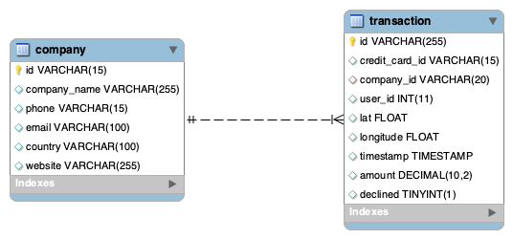

Database has relational structure and consists from two tables:

* *´company´* - corporate information of the companies

All variables are strings of different length

Primary key - ´*id*´ - uniquely identify each company

* *´transaction´* - data related to the transactions performed by companies

Variables *id, credit_card_id* and *company_id* are strings, *user_id* and *declined* have type integer, *lat* and *longitude* are floats, *amount* has decimal format (with up to 10 digits in total and 2 decimal places), and *timestamp* has datetime format.

Primary key - ´*id*´ - uniquely identify each transaction

Foreign key - ´*company_id*´ - links this tabel with table ´*company*´ (column ´*id*´), links each transaction to the company that made the transaction. Also ´*user_id*´ and ´*credit_card_id*´ could be foreign keys for tables like *user* and *credit_card* if existed.

**Tables overview**

***´company´***

There are 100 different companies. All company names are unique.

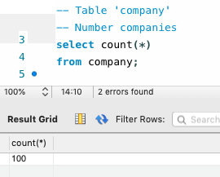

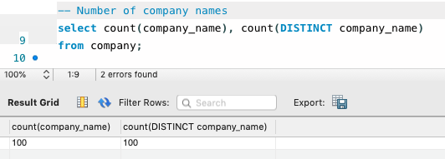

There are no missing values in the corporate information (email, pone, website).

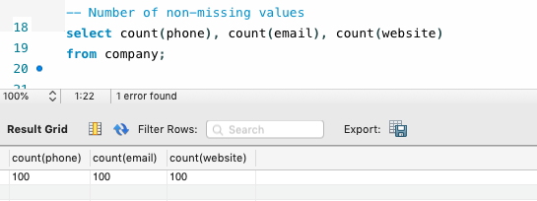

***´transaction´***

During period from ´2021-03-17´ to ´2022-03-16´ 587 transactions were performed, only 87 of them were declined (around 15%).

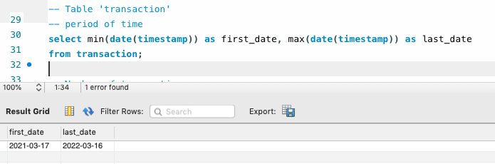

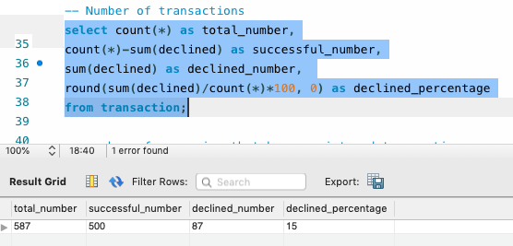

100 companies have registered transactions, what allow to assume that all companies from *‘company’* table may have at least 1 transaction.

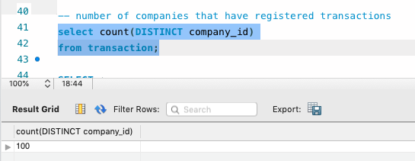

There are no missing values in the information about transactions.

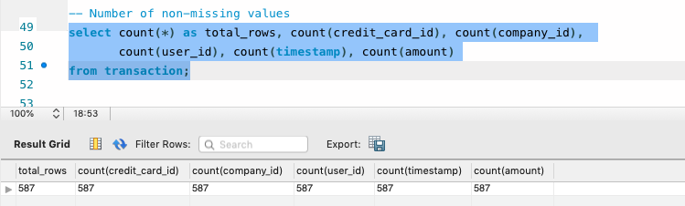

**Exercise 2.**

* List of countries that are shopping (using JOIN)

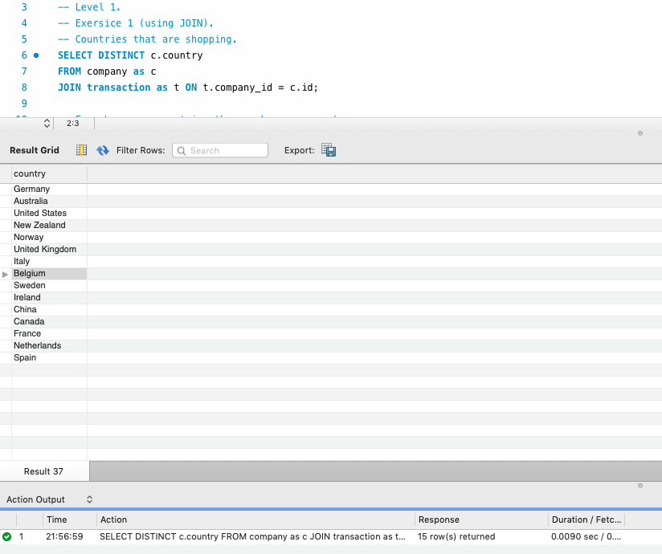

* From how many countries the purchases are made? (using JOIN)

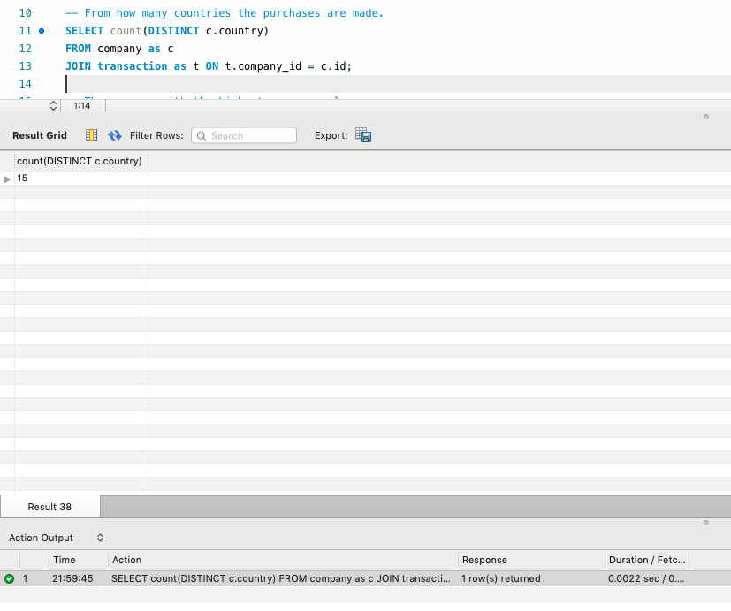

* Company with the highest average sales (using JOIN).

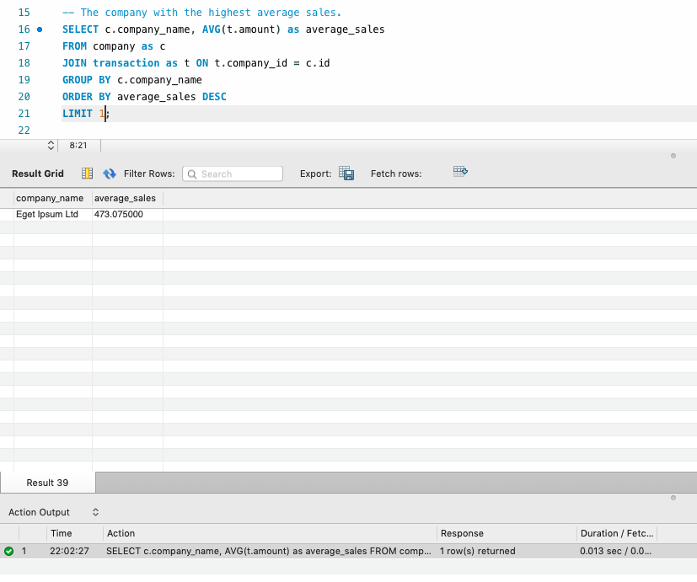

**Exercise 3.**

* All transactions made by companies in Germany

(subqueries without using JOIN).

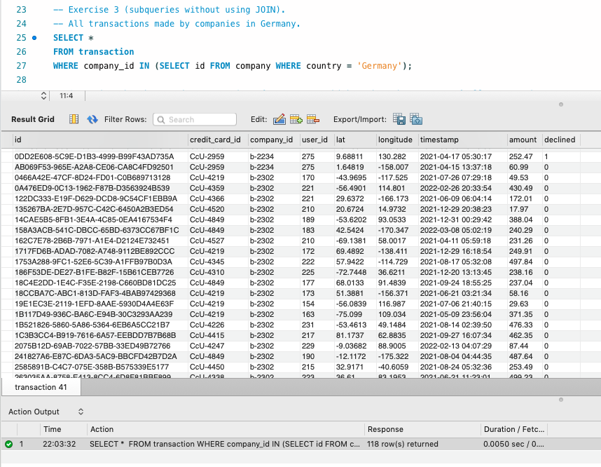

* List of companies that have made transactions for an amount higher than the average of all transactions

(subqueries without using JOIN).

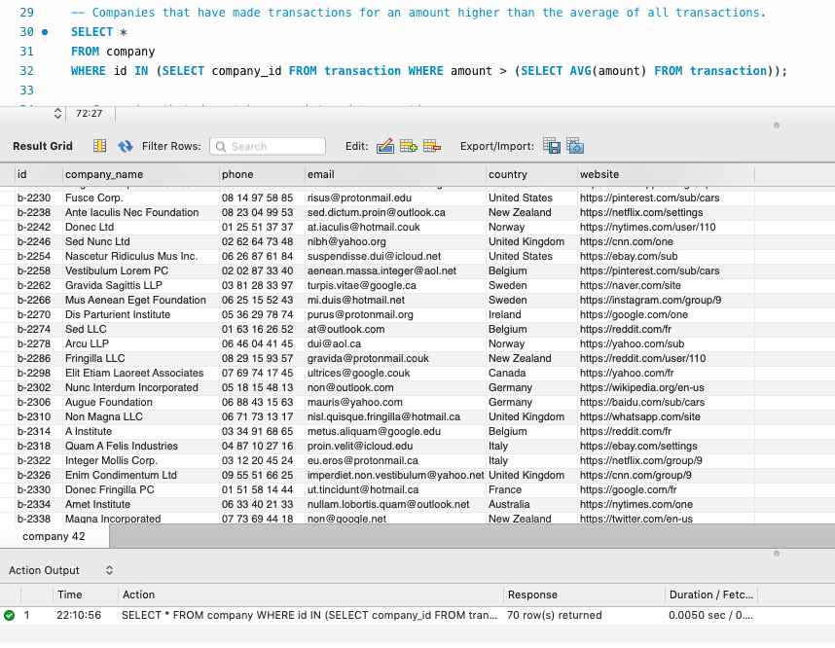

* Companies that do not have registered transactions will be removed from the system, provide the list of these companies

(subqueries without using JOIN).

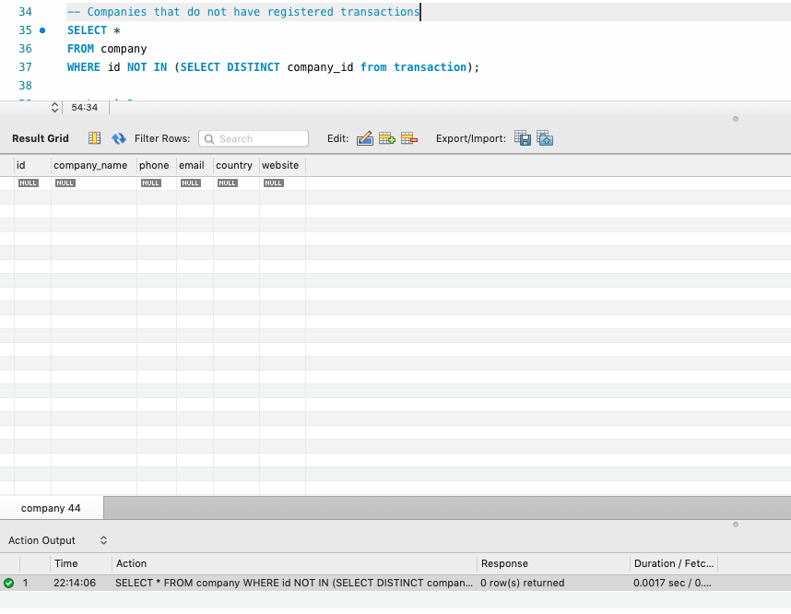

**Level 2.**

**Exercise1.**

Five days that generated the largest amount of revenue for the company (date of each transaction along with the total sales)

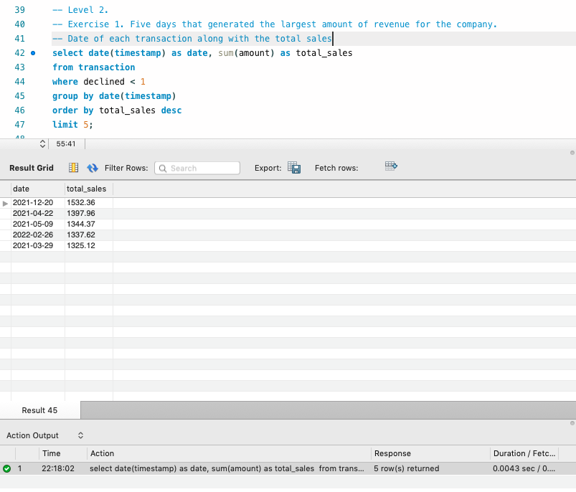

*\*\* Declined transactions were not taking into account because they did not generate any profit for the company.*

**Exercise2.**

Average sales per country. Results are sorted from highest to lowest average sale.

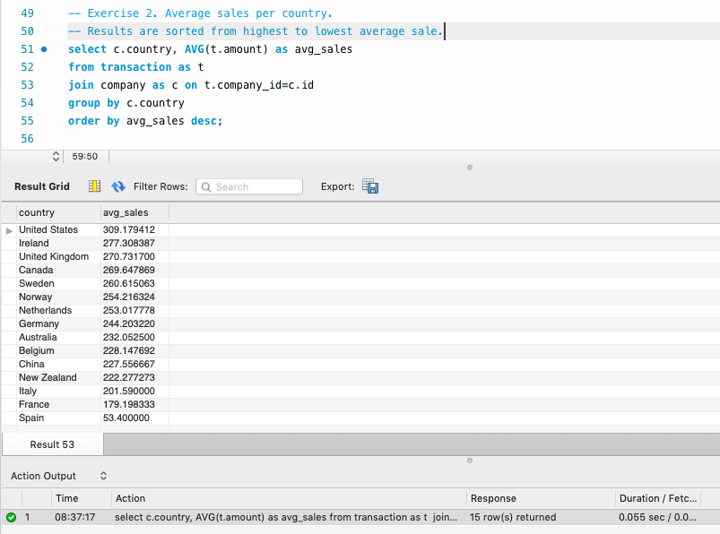

**Exercise3.**

Transactions carried out by companies that are located in the same country as "Non Institute" company.

* using only subqueries

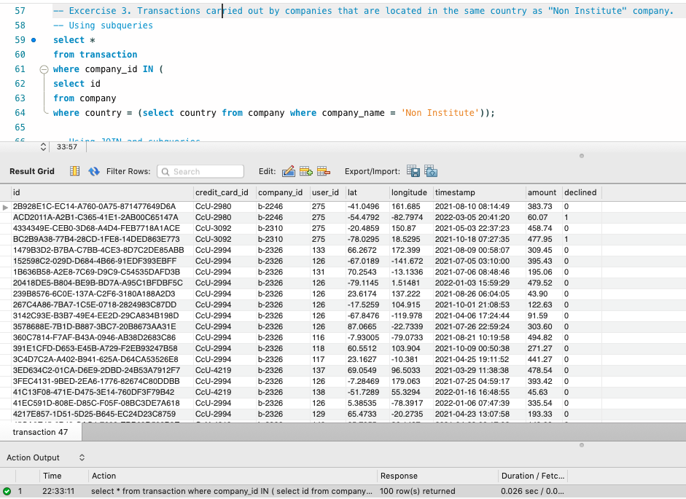

* Using JOIN and Subqueries

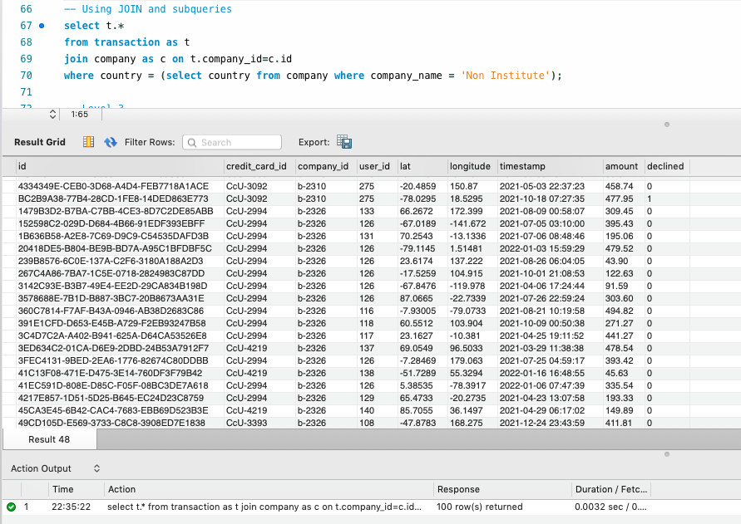

**Level 3.**

**Exercise1.**

List of companies (name, telephone, country, date and amount) that made transactions with a value between 100 and 200 euros and on any of these dates: April 29, 2021, July 20, 2021 and March 13, 2022 (results are sorted from highest to lowest amount).

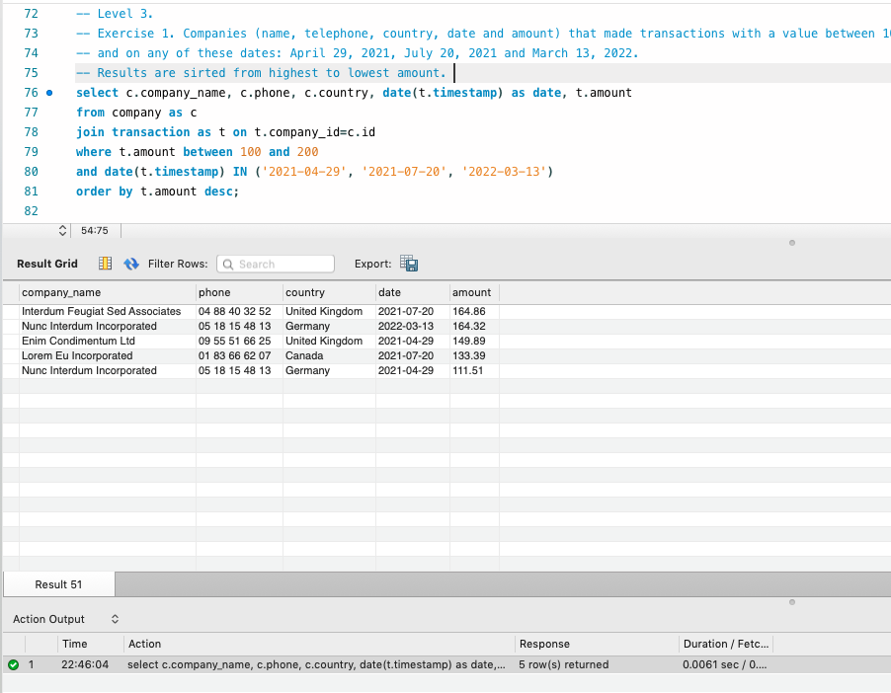

*\*\* Values 100 and 200 are included*

**Exercise2.**

List of companies with the amount of transactions that the companies carry out, specifying whether they have made more than 4 transactions or less.

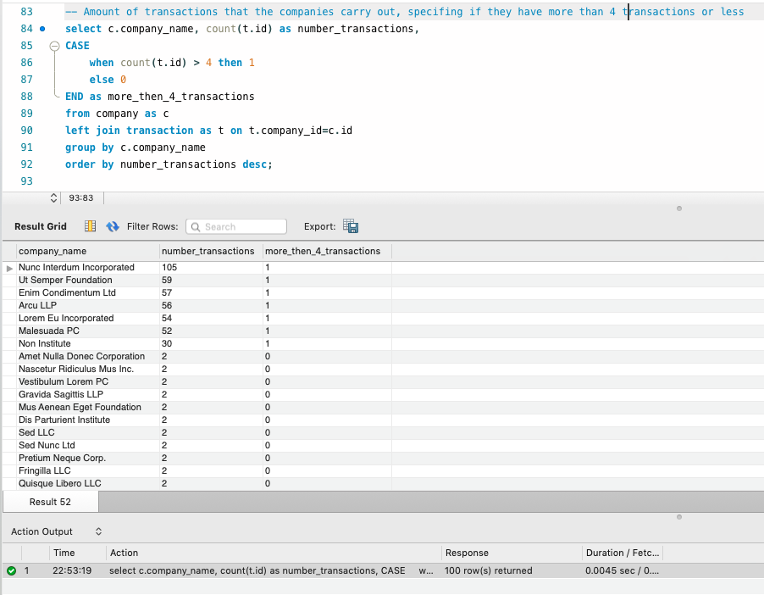

*\*\* Left JOIN was used to provide information about all the companies from the ‘company’ table, regardless of whether they made any transaction.*