Homework3-cs460

Lu Ye

1. List all attributes of the employees from department 5.

Query:

select * from mccann.employee where dno=5;

Answer:

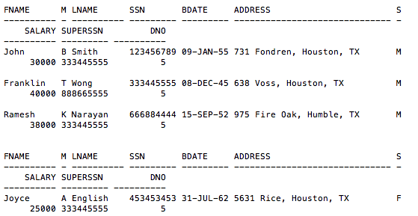

1. What are the SSNs of the employees working on proposal #10? Sort the result in descending order.

Query:

select ssn from mccann.employee, mccann.works_on where works_on.essn = employee.ssn and pno=10 order by ssn desc;

Answer:

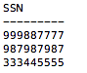

1. What is the Cartesian Product of the employees’ first names and the dependents’ names? List each pair of names only once in the result.

Query:

select distinct fname, dependent_name from mccann.employee, mccann.dependent;

Answer:

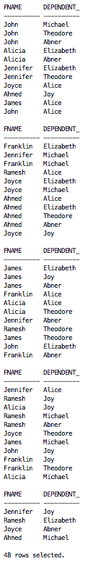

1. At which locations is the research department located?

Query:

select dlocation from mccann.dept_locations where dnumber in (select dnumber from mccann.department where dname='Research');

Answer:

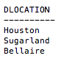

1. What is the full name of the employee who has the largest salary?

Query:

select fname, minit, lname from mccann.employee where salary in (select max(salary) from mccann.employee);

Answer:

luye:Users:kanoutsuyu:Desktop:Screen Shot 2017-03-22 at 8.50.00 PM.png

1. What are the names of the departments with employees who have a dependent named Alice?

Query:

select dname from mccann.department, (select dno from mccann.employee,(select essn from mccann.dependent where dependent_name='Alice') where ssn=essn)

where dnumber = dno;

Answer:

luye:Users:kanoutsuyu:Desktop:Screen Shot 2017-03-22 at 10.19.11 PM.png

1. Retrieve the SSNs of the employees who work in department 5 or who directly supervise an employee in department 5.

Query:

select ssn from mccann.employee where dno='5'

union

select ssn from mccann.employee where ssn in (select superssn from mccann.employee where dno='5');

Answer:

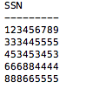

1. What are the birthdates of the managers of the departments with projects from Stafford? (Note the wording change from Homework #2.)

Query:

select bdate from mccann.employee

where ssn in(select mgrssn

from mccann.department

where dnumber in (select dnum from mccann.project where plocation='Stafford'));

Answer:

luye:Users:kanoutsuyu:Desktop:Screen Shot 2017-03-20 at 6.46.30 PM.png

1. For each employee, retrieve his/her full name and the full name of his/her immediate supervisor.

Query:

select distinct fname,minit,lname,t1,t2,t3

from mccann.employee, (select fname as t1, minit as t2,lname as t3, ssn as mssn from mccann.employee)

where mssn=superssn

union select fname,minit,lname,null,null,null from mccann.employee where superssn is null;

Answer:

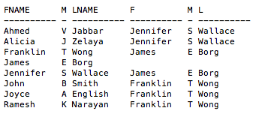

1. What are the names of the male dependents who are dependent on a male employee?

Query:

select dependent_name from mccann.dependent where sex='M' and essn in (select ssn from mccann.employee where sex='M');

Answer:

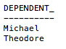

1. What are the salaries of the employees from department 5 who are NOT working on ProductY?

Query:

select salary from mccann.employee where ssn in(select essn from mccann.works_on minus select essn from mccann.works_on where pno in (select pnumber from mccann.project where pname='ProductY')) and dno=5;

Answer:

luye:Users:kanoutsuyu:Desktop:Screen Shot 2017-03-22 at 9.36.14 PM.png

1. For each project on which more than two employees work, retrieve the project number, project name, and the number of employees who work on that project.

Query:

select pnumber,pname,numOfEm from mccann.project,

(select pno, count(*) as numOfEm from mccann.works_on group by pno having count(pno) >2)

where pnumber=pno;

Answer:

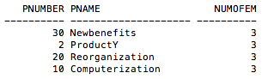

1. What are the names of the departments which employ all genders?

Query:

select dname from mccann.department where dnumber in

(select dno

from mccann.employee,(select sex as s, dno as no from mccann.employee)

where sex='M' and s='F' and dno=no

);

Answer:

