Homework2-CS460

Lu Ye

1. List all attributes of the employees from department 5.

Query:

display(project(select(employee)(dno='5'))(fname,minit,lname,ssn,bdate,address,sex,salary,superssn,dno))

Answer:

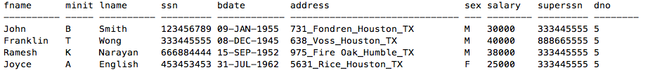5

1. What are the SSNs of the employees working on proposal #10?

Query:

display(project(join(employee)(project(select(works_on)(pno='10'))(empssn))(empssn=employee.ssn))(ssn))

Answer:

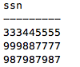

1. What is the Cartesian Product of the employees’ first names and the dependents’ names?

Query:

display((project(employee)(fname))product(project(dependent)(dependent_name)))

Answer:

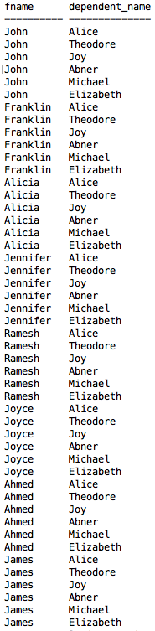

1. (You must not use JOIN for this query) At which locations is the research department located?

Query:

display(project(select(select((department)product(dept_locations))(dname='Research'))(dnumber=d#))(dlocation))

Answer:

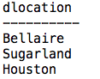

1. (You must use JOIN for this query) At which locations is the research department located?

Query:

display(project(join(dept_locations)(project(select(department)(dname='Research'))(dnumber))(dnumber=dept_locations.d#))(dlocation))

Answer:



1. What are the names of the departments with employees who have a dependent named Alice?

Query:

display(project(join(project(select(dependent)(dependent_name='Alice'))(essn))(department)(department.mgrssn=essn))(dname))

Answer:



1. Retrieve the SSNs of the employees who work in department 5 or who directly supervise an employee in department 5.

Query:

display((project(join(project(select(employee)(dno='5'))(superssn))(employee)(employee.ssn=superssn))(ssn))union(project(select(employee)(dno='5'))(ssn)))

Answer:

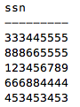

1. What are the birthdates of the managers of the proposals from Stafford?

Query:

display(project(join(employee)(project(join(department)(project(select(proposal)(plocation='Stafford'))(dnum))(department.dnumber=dnum))(mgrssn))(mgrssn=employee.ssn))(bdate))

Answer:



1. What are the names of the departments managed by people who have dependent female spouses?

Query:  
display(project(join(department)(project(select(select(dependent)(relationship='Spouse'))(sex='F'))(essn))(department.mgrssn=essn))(dname))

Answer:



1. What are the names of the male dependents who are also dependent on a male employee? (Use ∩)

Query:

display(project(select(join(project((project(select(employee)(sex='M'))(ssn))intersect(project(select(dependent)(sex='M'))(essn)))(essn))(dependent)(dependent.essn=essn))(sex='M'))(dependent_name))

Answer:

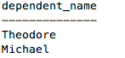

1. What are the salaries of the employees from department 5 who are NOT working on ProductY?

Query:

display(project(select(join(employee)((project(works_on)(empssn))difference(project(join(works_on)(project(select(proposal)(pname='ProductY'))(pnumber))(pnumber=works_on.pno))(empssn)))(empssn=employee.ssn))(dno='5'))(salary))

Answer:



1. What are the names of the departments which employ all genders? (In other words, the departments that have at least one woman and at least one man.) (Yup, this is the ÷ query.)

Query:

a=project(employee)(sex,dno)

b=project(employee)(sex)

dn=project(a)(dno)

pro=(b)product(dn)

dif=(pro)difference(a)

se=project(dif)(dno)

c=(dn)difference(se)

jo=join(c)(department)(c.dno=department.dnumber)

display(project(jo)(dname))

Answer:

