APTECH LIMITED — TECHWIZ 7
THE WORLD TECH CHAMPIONSHIP
SOFTWARE REQUIREMENTS SPECIFICATION (SRS)
FANDOMVERSE
The Centralized Multi-Fandom Information & Community Hub
— Single Page Application (SPA) Web Platform
Project Name | FandomVerse
Theme | Fandom Universe (Anime, Gaming, Movies, TV Shows, K-Pop, Comics, Manga)
Category | Web Innovation Unleashed
Version | 2.1 (SPA Architecture, Admin Management Module & Rule-Based AI Chatbot)
Publisher | © Aptech Limited
Core Technology | HTML5, CSS3, JavaScript (ES6+), Bootstrap/ReactJS, Local/SessionStorage, JSON

Team / Individual Name | [Kinh Of Drinking / Le Tri Phuong]
Members | [Le Trung Kien, Luyen Viet Hao, Nguyen Dinh Hung]
Training Center / Campus | [Trinh Van Bo Aptech Center]
Submission Date | [27/09/2026]

DOCUMENT OVERVIEW
- Part 1: Introduction & Project Background — Background, market problem, the proposed FandomVerse solution, purpose of the document.
- Part 2: Project Scope & Technical Constraints — 7 focus categories, core features, No-Backend constraint and copyright rules.
- Part 3: User Specification & Operating Environment — Target user groups, User Personas, assumptions & dependencies.
- Part 4: System Architecture & Detailed Design — SPA architecture, Data Flow Diagrams (DFD Level 0 & 1), Sequence Diagram, Admin Use Case Diagram, Admin Operational Flow, JSON data model & Web Storage.
- Part 5: Functional Requirements Specification (14 Modules) — Screen-by-screen detail, features, interaction flows, filters, shopping cart, JSON chatbot, and the Admin Management Module.
- Part 6: Non-Functional Requirements — Performance, accessibility, security, compatibility, reliability.
- Part 7: External Interface Requirements — User interface (UI), hardware interface, development technology, API communication.
- Part 8: Delivery Plan & Quality Evaluation — Deliverables list, Google Lighthouse standards, acceptance criteria.
- Part 9: Conclusion — Closing statement on the value and readiness of the FandomVerse platform.

DOCUMENT REVISION HISTORY
Version | Release Date | Author / Team | Main Change Description
1.0 | 15/08/2026 | FandomVerse Development Team | Initial draft of the SRS document for the Fandom information portal.
2.0 | 23/09/2026 | Aptech Project Team | Finalized the No-Backend SPA architecture specification, standardized the static JSON dataset, integrated the Rule-Based Chatbot, the Web Storage cart, and AI usage regulations.
2.1 | 27/09/2026 | Aptech Project Team | Added the Admin actor, Admin Use Case Diagram, Admin Management Module (FR-11) and Admin Operational Flow; full document localized into English.

1. OVERVIEW & PROJECT BACKGROUND

1.1 Background & Necessity
A "fandom" is the term used for a community of enthusiastic fans who share a common passion for a brand, character, work of art, or cultural entertainment phenomenon. In the digital era, fandom communities built around the seven mainstream entertainment domains — Anime, Video Games, Movies, TV Shows, K-Pop, Western Comics, and Japanese Manga — have grown into some of the largest and most active online communities in the world.
Problem Statement: Fans today face serious information fragmentation:
- Users must constantly switch between dozens of platforms (fan wikis, social networks such as Reddit/Twitter, streaming services, ticketing portals, merchandise stores, and online news outlets) just to follow a single topic.
- The experience is disjointed, time-consuming, and exhausting when trying to filter out authoritative sources.
- Content Discovery — finding new fandoms or related content — is difficult without a single platform that brings multiple categories together.

1.2 Proposed Solution: The FandomVerse Portal
FandomVerse is designed as a unified Multi-Fandom Content & Information Hub. The platform delivers a comprehensive lookup experience from a single address, including:
- 7 Dedicated Hubs: full coverage of the seven flagship categories — Anime, Gaming, Movies, TV Shows, K-Pop, Comics, and Manga.
- Rich Multimedia Content: crisp image galleries with a lightbox zoom effect, high-quality video trailers, interview audio/podcast files, in-depth feature articles, character profiles, and an international event calendar.
- Multi-dimensional Filtering & Search: a sub-tag filtering system, media-format filters, and an instant search engine that runs 100% in the browser.
- Merchandise Showcase & Shopping Cart: a display area for figures, apparel, and collectible items with a temporary cart feature and a convenient checkout-total calculator (no real payment gateway integration).
- High Performance & User-Friendly: built as a smooth Single Page Application (SPA) with a page-load time under 1.5 seconds, fully compatible across Mobile, Tablet, and Desktop.
- Local Rule-Based AI Chatbot: an intelligent virtual assistant driven by a keyword rule set over a local JSON dataset, answering questions instantly and guiding users without relying on any paid external API.
- Centralized Admin Management: a dedicated internal Admin panel that lets content managers maintain articles, characters, events, trailers, merchandise, and multi-language translations without touching the source code (see Section 4.3–4.4 and FR-11).

1.3 Purpose of the SRS Document
This Software Requirements Specification (SRS) establishes the comprehensive technical standard for the FandomVerse v2.1 project. The document serves the following stakeholders:
- Project Management & Advisory Board (Stakeholders): to clearly understand product scope, completion criteria, delivery schedule, and the quality benchmark (Google Lighthouse).
- Developers & UI/UX Designers: a direct reference for designing the SPA architecture, the JSON data structure, implementing Web Storage flows, writing CSS/JS, and optimizing the user experience.
- Quality Assurance (QA/QC): the basis for building test cases, responsive-UI testing, and verifying the integrity of sample data.

2. PROJECT SCOPE & SYSTEM CONSTRAINTS

2.1 Project Scope
FandomVerse is a Single Page Application (SPA) web app that runs independently in the user's browser. The project scope focuses on displaying and interacting with content through a standardized static dataset:
- Category Hub Subsystem: seven major categories with a flexible Card UI layout.
- Search & Filter Subsystem: multi-criteria filters (genre, media format, popularity, alphabetical order).
- Multimedia Subsystem: Lightbox/Carousel image viewer, embedded YouTube trailers & open-licence audio.
- Character Profile Subsystem: at least 5 flagship characters per category (35+ characters in total) with full stats, franchise, and biography.
- Event Calendar Subsystem: at least 3 large-scale events per category (21+ events in total) with date/time, location, and detailed description.
- Merchandise Subsystem: a collection of physical products (figures, apparel, posters…) with add/remove-from-cart, quantity update, and total-price calculation.
- Favorites & Notes Management Subsystem: stores a bookmarked-article list in LocalStorage and personal session notes in SessionStorage, with .txt export support.
- AI Chatbot Assistant Subsystem: a floating chat widget that answers FAQs based on a predefined JSON file.
- Admin Management Subsystem: an internal panel (Section 4.3–4.4, FR-11) through which an authorised Admin maintains content, characters, events, trailers, merchandise, user accounts and translations, entirely on the client side.

2.2 Core Technical Constraints
📌 MANDATORY NO-BACKEND ARCHITECTURE CONSTRAINT: This project is built to the standard of the Web Innovation Unleashed competition. The entire platform MUST NOT use a backend database server (no SQL/RDBMS backend) and must not call any paid external AI API. All data must operate independently through static JSON files and Web Storage — including every Admin edit, which is layered on top of the static JSON at runtime rather than written back to a server.

Code | Constraint Name | Detailed Description & Technical Approach
CON-01 | No Server Backend | The system has no server for dynamic data storage (no Node.js/PHP/C#/Java used to write files or a DB). All data is stored as static JSON files (contents.json, characters.json, events.json, trailers.json, merchandise.json).
CON-02 | Valid Content & Copyright | Only royalty-free images, video, and audio — or content that falls under a valid Creative Commons licence — and officially released public trailers may be used.
CON-03 | Internal Chatbot (Rule-Based Dataset) | No direct client-side calls to the OpenAI or Google Gemini API, to avoid exposing an API key and violating the no-backend rule. The chatbot must run a keyword-matching algorithm over the chatbot_faq.json file.
CON-04 | Non-Transactional Cart | The shopping cart is illustrative only (UX simulation). State is kept in LocalStorage, with the total automatically computed by JavaScript; it is never connected to a real bank payment gateway.
CON-05 | Client-Side Security | No passwords or sensitive information are stored. The Login/Register feature (for both regular users and Admin) only produces a simulated UI modal effect (Visual UI Simulation) backed by a session flag, never a real authentication server.

3. USER SPECIFICATION & OPERATING ENVIRONMENT

3.1 Target User Groups
The FandomVerse system targets four main groups of users:
- 1. Hardcore Fans: people with a deep passion for one specific category, who visit frequently to check new trailers, character bios, and upcoming convention schedules.
- 2. Casual Visitors: general users who want general information, ranking articles, analysis pieces, and to discover new anime, games, or TV shows.
- 3. Collectors: users interested in official merchandise, figures, and collectible publications from entertainment brands.
- 4. System Administrator / Content Manager: the internal role responsible for keeping the site's content current — publishing articles, characters and events, curating trailers and merchandise, moderating dummy user accounts, maintaining multi-language translation strings, and monitoring platform usage through the Statistics Dashboard (see Section 4.3–4.4 and FR-11).

3.2 Representative User Personas
Criteria | Persona 1: Otaku & Gamer — Tuan Anh | Persona 2: K-Pop & Movie Enthusiast — Mai Linh | Persona 3: Content Administrator — Minh Anh
Age / Occupation | 21 years old — IT student | 24 years old — Marketing specialist | 26 years old — Community & Content Manager
Main Interests | Action anime, RPG games, Shonen manga | K-Pop idol groups, blockbuster movies, Netflix TV shows | Editorial workflows, community moderation, analytics dashboards
Goals on the site | Watch new game trailers, read favourite character bios, bookmark deep-lore articles to read later. | Check the concert/exhibition event calendar, browse high-quality photo galleries, and check lightstick/T-shirt prices in the cart. | Publish new articles and events on schedule, keep character/trailer/merchandise data accurate, review site statistics and update translation strings without editing code.
Pain Points | Dislikes sites cluttered with ads, slow loading, and messy layouts. | Struggles to find one portal that has both an accurate idol event calendar and accurate movie trailers. | Without a dedicated panel, would otherwise need a developer for every small content change — too slow for a fast-moving fandom calendar.

3.3 Operating Environment & Hardware Requirements
Hardware & software requirements: to ensure smooth development, packaging and testing, the system follows this standard configuration:
Component | Minimum Recommended Configuration | Operating Notes
CPU | Intel Core i5 / AMD Ryzen 5, 8th generation or newer | Ensures smooth rendering of CSS3 effects and a large DOM.
RAM | 8 GB or higher | Ensures smooth multitasking across multiple browser tabs.
Storage | At least 500 MB free space for source code & assets | Includes optimized WebP/PNG images, video links, and scripts.
Display | Minimum resolution 1366×768 (Full HD 1920×1080 recommended) | Compatible with 16:9, 16:10, and 19.5:9 aspect ratios on mobile devices.
Web Browser | Google Chrome 110+, Mozilla Firefox 110+, Microsoft Edge 110+, Safari 16+ | Full support for CSS Grid, Flexbox, Fetch API, LocalStorage, and Web Components.

4. SYSTEM ARCHITECTURE & DATA MODEL

4.0 Single Page Application (SPA) Architecture
FandomVerse is architected as a pure client-side SPA. The site loads only one HTML file (index.html). All page transitions are orchestrated by a client-side router through URL Hash Navigation (#home, #anime, #gaming, #search, #merchandise, #bookmarks, #admin).
Layered module structure: the source code follows a clear layered architecture:
- 1. View Layer (HTML5 Templates): contains the base UI skeleton, the lightbox modal, the navbar, the footer, and the main #app-root container — plus the Admin Login view and Admin Panel views.
- 2. Styling Layer (Vanilla CSS3 & Bootstrap Grid): the Fandom Universe colour scheme with high contrast, a modern Glassmorphism style combined with a mysterious Dark Mode, and smooth CSS transitions.
- 3. Router Controller (app.js / router.js): responsible for capturing hash-change events (window.onhashchange), initializing the matching view, and updating the page title — including guarding the #admin route behind the session flag.
- 4. Data Service Layer (dataService.js): performs asynchronous fetch() calls to load static JSON files, caching data in RAM to avoid repeated reads.
- 5. Storage Service Layer (storageService.js): responsible for synchronizing the cart, bookmarks, and viewing history with the browser's localStorage and sessionStorage.
- 6. Chatbot Rule Engine (chatbot.js): the string-parsing engine that normalizes diacritics and matches keywords against the FAQ knowledge base.
- 7. Admin Service Layer (adminService.js) — NEW: validates the Admin session flag, merges each static JSON dataset with the corresponding "admin_overrides" object stored in LocalStorage at render time, and persists every create/update/delete made from the Admin Panel back into that same override layer (see Section 4.4 and FR-11).

4.1 Data Flow Diagrams (DFD)

4.1.1 DFD Level 0 (Context Diagram)
At the context level, the system receives interactions from two actors — the general User and the Admin (search keywords, category selection, add-to-cart actions, notes, chatbot questions, and Admin content edits) — and retrieves data from two local stores: the static JSON data files and the browser's Web Storage. Admin edits do not create a third store; they are written into the same Web Storage as a dedicated "admin_overrides" namespace, keeping the whole system fully client-side.

4.1.2 DFD Level 1 (Process Breakdown)
Process | Input Data | Data Source / Store | Processing Logic | Output Data
1.0 Global Search & Filtering | Search keyword, category filter, media-format filter | Static JSON (contents, characters, events) | Array traversal, case-insensitive includes()/Regex check | List of matching article/character cards
2.0 Dynamic Content Rendering | Category code (anime, gaming…), sub-tag type | contents.json, characters.json, trailers.json | Pagination, sort by date/A-Z, render HTML template | Category UI with interactive cards and lightbox
3.0 Cart & Billing Engine | Add-to-cart action, quantity change, item removal | merchandise.json & LocalStorage | Update cart array, calculate subtotal, tax, and grand total | Cart badge count and detailed cart breakdown
4.0 Bookmark & Note Manager | Favourite action, note text | LocalStorage (bookmarks) & SessionStorage (notes) | Serialize to a JSON string, write to the browser storage key | Saved list, with .txt export support
5.0 Rule-based Chatbot Engine | Free-text question or quick-reply button | chatbot_faq.json | Keyword token matching, find the highest-similarity answer | Bot reply message with a deep-link
6.0 Admin Content Management — NEW | Admin create/update/delete form submission | adminService.js & LocalStorage (admin_overrides) | Validate the Admin session, merge the override object into the in-memory dataset, persist to LocalStorage | Updated content rendered instantly across the site, success confirmation toast

4.2 Sequence Diagram: Category Loading & Bookmarking
The 7-step process when a user navigates into a category (e.g. #anime) and bookmarks a favourite article:
1. The user clicks the Anime menu item on the navigation bar. The URL hash changes to /#anime.
2. The router.js controller listens for the event, triggers the category-view loading method, and shows a skeleton loader.
3. dataService.js sends an internal HTTP GET request to data/anime_contents.json and data/characters.json.
4. The browser returns the array of JSON objects. The service filters it by default parameters (sorted by newest first).
5. The UI receives the data, dynamically generates the HTML Card elements, and injects them into the main DOM (#content-area).
6. The user clicks the Heart (Bookmark) icon on a specific article card.
7. storageService.js retrieves the article object, checks for duplicates inside the fandomverse_bookmarks array in LocalStorage, pushes the new entry, and shows a success confirmation Toast.

Participants (left to right):
1. User (actor)
2. SPA Router
3. Category View
4. Data Service
5. Static JSON
6. Storage Service
Notation convention: a solid line with a filled arrowhead (→) represents a call/request; a dashed line with an open arrowhead (⇢) represents a returned response.
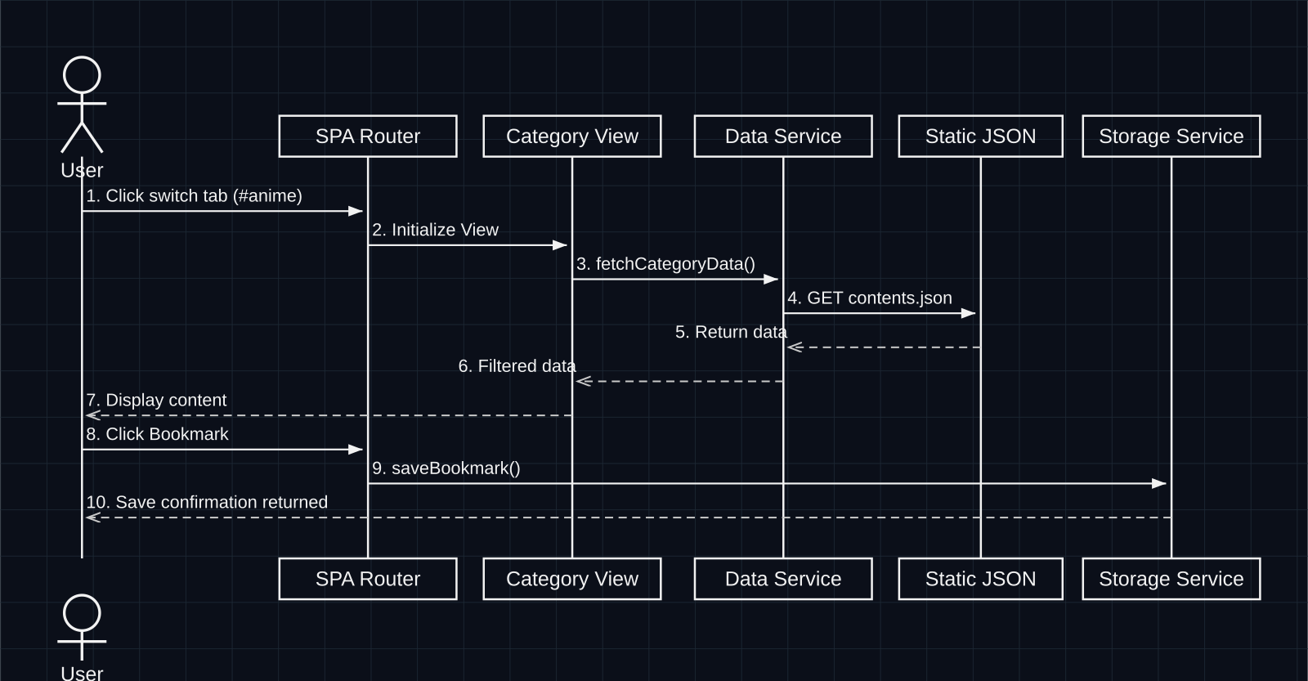
Figure 4.2 — Sequence Diagram: Category Loading & Bookmarking (translated)

4.3 Admin Use Case Diagram
To clearly define every action available to the internal management role, the diagram below maps all interactions between the Admin actor and the FandomVerse system. Each use case corresponds to a sub-feature of the Admin Management Module detailed in FR-11.
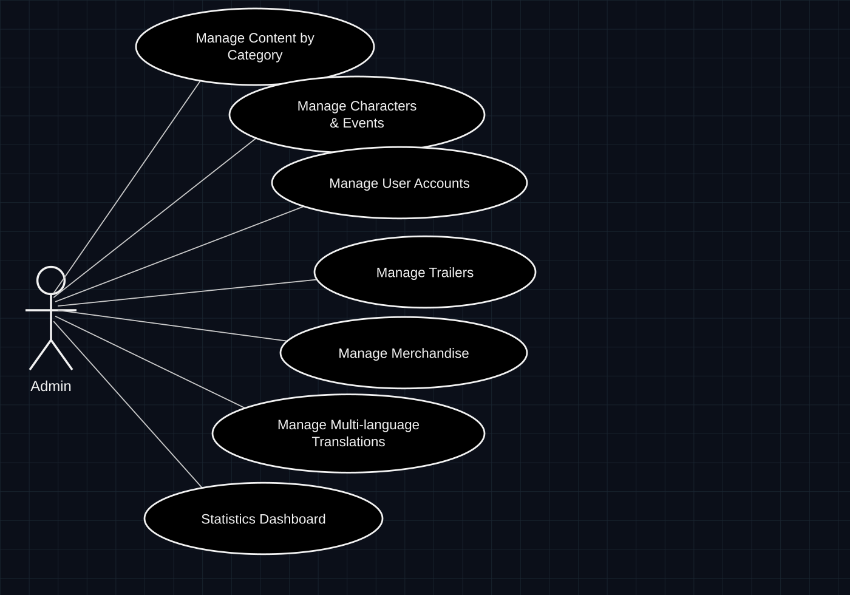
Figure 4.3 — Admin Use Case Diagram
- Manage Content by Category — create, edit, publish, unpublish, or delete articles, image galleries, and feature pieces within any of the 7 category hubs.
- Manage Characters & Events — add or update character profiles and international fandom events, including biography fields, dates, and locations.
- Manage User Accounts — view the list of simulated (dummy) user accounts, and enable/disable an account's access flag for demonstration purposes.
- Manage Trailers — add, edit, or remove trailer entries and switch a trailer's status between Upcoming and Recently Released.
- Manage Merchandise — maintain the merchandise catalogue: product data, pricing, stock status, and imagery.
- Manage Multi-language Translations — edit the key–value translation strings that power the English/Vietnamese language toggle across the interface.
- Statistics Dashboard — review platform-usage metrics: visitor counter, most-viewed content, cart activity, and bookmark totals, computed client-side from JSON and Web Storage.

4.4 Admin Operational Flow (Admin Login & Content Update Sequence)
The 12-step process describing how the Admin authenticates and edits a content record, while the platform remains fully compliant with the No-Backend constraint (CON-01, CON-05):
1. The Admin enters their credentials into the Admin Login view and submits the form.
2. The Admin Login view calls adminService.js → validateAdminSession() to check the credentials against a local configuration.
3. adminService.js returns a session flag stored in SessionStorage, confirming the session is valid.
4. The Admin is redirected to the Admin Panel.
5. The Admin opens a Content or Character record and makes an edit.
6. The Admin Panel requests the base dataset from adminService.js (e.g. GET contents.json).
7. The static JSON file returns the base records.
8. The Admin Panel calls adminService.js → saveAdminOverride(record) with the edited fields.
9. adminService.js writes the change into the admin_overrides key in LocalStorage (the base JSON file itself is never modified, in line with CON-01).
10. adminService.js returns the merged dataset (base record + override) to the Admin Panel.
11. The Admin Panel re-renders the updated table with the new values.
12. A success toast "Content updated" confirms the change to the Admin.
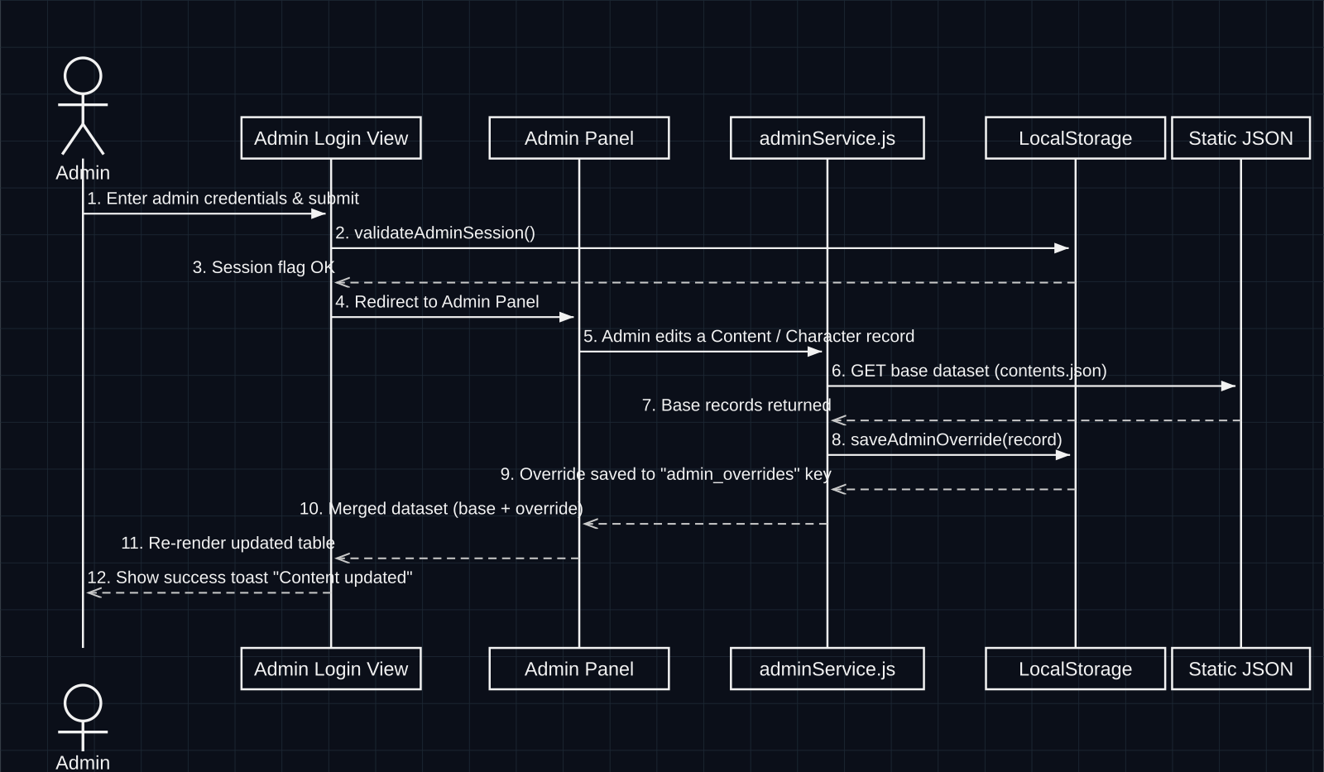
Figure 4.4 — Admin Operational Flow: Login & Content Update
Because every Admin edit is persisted only inside the browser's own LocalStorage as an override layer, the architecture keeps the mandatory No-Backend rule intact: there is no write-capable server, no database, and no risk of exposing credentials, while still giving the Admin a fully functional content-management experience during a live demo session.

4.5 SPA Architecture Diagram (5-Layer Stack)
A vertically stacked 5-layer diagram, connected top-to-bottom by one-directional arrows:
1. User / Browser
2. SPA Router (app.js)
3. View Modules — 5 interface frames:
  - Home View
  - Category Hub View
  - Search Results View
  - Merchandise & Cart View
  - Bookmarks & Notes View
  - Admin Panel View (new)
4. Service Layer — 4 JS services:
  - dataService.js
  - searchService.js
  - storageService.js
  - adminService.js (new)
5. Data & Storage — includes:
  - Static JSON files: contents.json, characters.json, events.json, trailers.json, merchandise.json, chatbot_faq.json
  - Browser Web Storage: LocalStorage (bookmarks, cart, admin_overrides), SessionStorage (notes, admin session flag)

4.6 Static Data Organization Model (Static Data Schema)
Static JSON file structure: all data is structured in standard JSON format:
JSON File Name | Main Fields | Meaning & Data Convention
contents.json | id, category, title, description, content_type, thumbnail, banner, full_text, sub_tags, publish_date, views | Stores every article, news item, photo album, and review for the 7 categories.
characters.json | id, category, name, franchise, avatar, full_image, bio, role, abilities[], first_appearance | Character profiles (at least 5 characters/category, 35+ characters in total).
events.json | id, category, event_name, start_date, end_date, location, map_coordinates, description, ticket_info | Fandom event calendar for the year (at least 3 events/category, 21+ events in total).
trailers.json | id, category, title, youtube_embed_id, duration, status (upcoming/released), release_date | Collection of official trailers and teasers.
merchandise.json | id, category, product_name, price, currency, rating, stock_status, image_url, description | Catalogue of merchandise, collectible figures, and fandom apparel.
chatbot_faq.json | id, keywords[], question, answer, action_link, category_tag | Knowledge base of FAQs, matching keywords, and navigation links.
admin_overrides (LocalStorage key) — new | target_collection, record_id, changed_fields{}, updated_by, updated_at | Client-side override layer written by the Admin Panel; merged with the matching static JSON file at render time so edits appear instantly without a backend write.

5. DETAILED FUNCTIONAL REQUIREMENTS SPECIFICATION (14 MODULES)

FR-01: Home Page Portal
Module objective: The central welcome interface for the whole FandomVerse system.
Technical specification: detailed required functions:
- An impressive animated Hero Banner featuring the slogan 'Web Innovation Unleashed'.
- A navigation grid for the 7 major categories with brand-colour hover effects.
- A featured-article slider/carousel, the week's hottest trailer video, and a countdown to the nearest event.
- An AI Chatbot launch button permanently pinned to the bottom-right corner of the screen.
- A quick-stats panel (article count, virtual visitor count, real-time clock).

FR-02: 7 Category Hubs
Module objective: A dedicated area for each fandom: Anime, Gaming, Movies, TV Shows, K-Pop, Comics, Manga.
Technical specification: detailed required functions:
- Automatically loads and renders the card list from each category's corresponding JSON file.
- Card display: thumbnail image, title, short summary, content-format badge (Article, Gallery, Video, Audio), and sub-tags.
- Quick classification filters: View All, Articles, Characters, Events, Trailers, Merchandise.
- Flexible sorting: Alphabetical (A-Z), Newest, Featured.

FR-03: Global Search & Advanced Filtering
Module objective: An instant search bar present on every screen of the website.
Technical specification: detailed required functions:
- An Instant Search bar (results appear as soon as the user types 2 or more characters).
- Two-level combined filtering: choose a category (one of the 7, or All) and choose a content type.
- A client-side search algorithm that is case-insensitive and strips basic Vietnamese diacritics.
- Displays the number of results found and suggests trending keywords when no matching result is found.

FR-04: Image Galleries & Lightbox Viewer
Module objective: Showcases high-resolution art, cosplay, and concept-art photo sets.
Technical specification: detailed required functions:
- A Masonry or standard Grid layout that respects each image's aspect ratio.
- An integrated Lightbox Modal that zooms an image in-place without navigating away from the page.
- Next/Previous buttons to browse through a photo set using the mouse or keyboard arrow keys.
- Clear display of photographer credit and Creative Commons copyright information.

FR-05: Multimedia Player (Videos & Audio Clips)
Module objective: Embeds video and audio entertainment content directly in the page.
Technical specification: detailed required functions:
- A safely embedded video player via the YouTube IFrame API or the HTML5 <video> tag for local files.
- A custom-styled HTML5 <audio> player for background music tracks and fandom-discussion podcasts.
- Automatically pauses other videos/audio when the user opens a new media file.

FR-06: Featured Articles
Module objective: In-depth review articles, plot analyses, and licensing/transfer news.
Technical specification: detailed required functions:
- Reader-friendly typography: comfortable font size, generous line spacing, and a Table of Contents.
- An integrated Reading Progress Bar fixed to the top of the page.
- A list of 3 related articles from the same category suggested at the end of every article.

FR-07: Character Profiles
Module objective: Deep-dive information on fictional characters and idols.
Technical specification: detailed required functions:
- Guaranteed minimum: at least 5 characters per category (35+ fully completed characters in total).
- Field information: avatar, full name, original work/franchise, role, short biography, ability set/traits.
- Filter profiles by Franchise (e.g. Marvel, DC, Naruto, Genshin Impact…).

FR-08: International Fandom Event Calendar
Module objective: Aggregates Comic-Con conventions, esports tournaments, and music award shows.
Technical specification: detailed required functions:
- Guaranteed minimum: at least 3 events per category (21+ events in total).
- Field information: event name, date/time, venue, content summary, status (Upcoming / Ended).
- An 'Add to Google Calendar' quick-link button using a URL generator.

FR-09: Unified Trailer Hub
Module objective: A page aggregating the newest trailers and teasers from around the world.
Technical specification: detailed required functions:
- Quick status filter: Upcoming or Recently Released.
- An integrated tab filter to quickly switch between the 7 categories.
- A large trailer-playback modal in full HD quality.

FR-10: Merchandise Showcase & Temporary Cart
Module objective: An area presenting official merchandise and simulating a shopping cart.
Technical specification: detailed required functions:
- Product card: product photo, name, listed price (USD/VND), stock status, star rating.
- Shopping Cart feature (drawer/modal): add product, increase/decrease quantity, remove single item, clear cart.
- Automatic price calculation: subtotal, estimated shipping fee, tax, and grand total.
- The cart is stored in LocalStorage (not lost on an F5 page reload).
- A clear disclaimer: 'Simulated showcase system — no real monetary payment is processed'.

FR-11: Admin Management Module (Admin Panel)
Module objective: A protected internal panel that lets the Admin maintain every dataset behind FandomVerse without a real backend, fully aligned with the Use Case Diagram (4.3) and the Operational Flow (4.4) above.
Technical specification: detailed required functions:
- Simulated Admin Authentication: a dedicated Admin Login view checks credentials against a local configuration and sets a session flag in SessionStorage (per CON-05, no real authentication server or stored password is involved).
- Content Management by Category: create, edit, publish/unpublish, and delete articles, galleries, and feature pieces for any of the 7 category hubs, with changes written to the admin_overrides layer described in Section 4.6.
- Character & Event Management: add or update character profiles and international events (biography, dates, venues) through validated forms.
- User Account Management: view the list of simulated user accounts created via the dummy Login/Register modal, and toggle an account's active/disabled flag for demonstration purposes (no real user data is transmitted or stored server-side).
- Trailer Management: add, edit, or remove trailer records, and switch a trailer between Upcoming and Recently Released status.
- Merchandise Management: maintain product listings — pricing, stock status, imagery, and description — that feed directly into FR-10.
- Multi-language Translation Management: edit the key–value pairs of the site's translation dictionary (English/Vietnamese) so that UI copy can be corrected or extended without a code change.
- Statistics Dashboard: a chart-driven summary view of visitor counts, most-viewed content, cart activity, and bookmark totals, computed entirely client-side from the JSON datasets and Web Storage.
- Every write performed in this module respects CON-01 (No-Backend): nothing is persisted to a remote server — all changes live in the browser's LocalStorage override layer and are merged with the static JSON at render time.

FR-12: Favorites & Personal Notes Management
Module objective: Personalizes the user experience using Web Storage technology.
Technical specification: detailed required functions:
- A Bookmark button (Heart / Star icon) on every article and character.
- Saves the Bookmark list permanently in the browser via LocalStorage.
- A Personal Notes feature attached to an article, stored in SessionStorage (auto-cleared when the tab is closed).
- Export function: exports the entire bookmark list and notes to a .txt file for the user to keep.

FR-13: Supplementary UI Features & Static Pages
Module objective: Adds polish and completeness to the product.
Technical specification: detailed required functions:
- A Visitor Counter simulated with LocalStorage, incrementing with every new session.
- A Live Date & Time Clock displayed in 24-hour format.
- Breadcrumb Navigation to help users track their position within the SPA.
- A simulated Login/Register modal (Dummy Auth Modal) with form validation (email/phone regex checks) — shared by both regular users and the Admin Login flow in FR-11.
- An 'About Us' page introducing the project's mission, and a 'Contact Us' page embedding a Google Maps view with GPS coordinates.

FR-14: AI Tool Usage Guidelines
Module objective: Compliance with Aptech's technology-competition ethics standard.
Technical specification: detailed required functions:
- Permits the use of AI tools (ChatGPT, Claude, Gemini, Figma AI, Canva) to assist with ideation, source-code syntax checking, and drafting sample FAQ data.
- Requires students/developers to fully understand 100% of the source code and be able to present and defend it technically.
- Strictly prohibits copying ready-made source-code templates verbatim without genuine improvement and creative integration.

6. NON-FUNCTIONAL REQUIREMENTS

NFR-01: Safety & Security
- Must not contain any malicious code, viruses, spyware, or dangerous page-redirect scripts.
- Encode and sanitize all input entered into the search box to prevent Cross-Site Scripting (XSS) attacks.
- Use the HTTPS protocol when embedding external media files and iframes.

NFR-02: Accessibility (WCAG 2.1)
- Text-to-background contrast ratio must meet at least the AA standard (minimum 4.5:1 for body text).
- Every <img> tag must include a semantically descriptive alt attribute for screen readers.
- Full keyboard-navigation support (Tab, Enter, Escape to close a modal).

NFR-03: Performance & Scalability
- Initial page-load time (First Contentful Paint – FCP) under 1.5 seconds on a standard network connection.
- Google Lighthouse scores for Performance, Accessibility, Best Practices, and SEO of 85/100 or above.
- Apply Lazy Loading for off-screen images to optimize bandwidth.

NFR-04: Compatibility & Responsive Design
- A flexible Responsive Design across every screen size:
  - Mobile (Viewport: 360px – 480px).
  - Tablet (Viewport: 768px – 1024px).
  - Desktop (Viewport: 1200px – 1920px and above).
- Runs smoothly and consistently on modern browsers (Chrome, Edge, Firefox, Safari).

NFR-05: Availability & Reliability
- The client-side application runs reliably 24/7 without depending on the uptime status of any third-party database server.
- If a JSON file is malformed, the system must catch the error with a try...catch block and show a friendly error message instead of crashing the page.

7. EXTERNAL INTERFACE REQUIREMENTS

7.1 User Interface Guidelines
FandomVerse's design language is built around a modern Cyberpunk & Glassmorphism style:
- Color Palette: a mysterious dark background tone (#0B0F19 and #131B2E) combined with neon accent colours for each of the 7 categories (Anime Red, Gaming Green, Movies Metallic Gold, TV Shows Purple, K-Pop Pastel Pink, Comics Orange, Manga Blue).
- Typography: modern Google Fonts typefaces (Inter, Outfit, or Montserrat) with a clear Visual Hierarchy from H1 down to body text.
- Micro-interactions: raised hover effects on article cards (Lift & Glow effect), with smooth page transitions of 0.2s–0.3s.

7.2 Software Interface & Development Technology (Software Stack)
Architecture Layer | Technology Used | Purpose
Core Language | HTML5, CSS3, JavaScript (ES6+) | Ensures compliance with modern web standards and semantic structure.
CSS Framework / Layout | Bootstrap 5 Grid System & Custom Vanilla CSS | Ensures maximum flexibility and a premium, non-templated interface.
UI Support Libraries | FontAwesome 6 Icons, SweetAlert2 / Toastify, Lightbox JS | Displays a rich icon system, notification dialogs, and an image viewer.
Data Storage | Static JSON Files, Window LocalStorage, Window SessionStorage | Manages the static database and user session state, including the Admin override layer.
Testing Tools | Google Chrome DevTools, Google Lighthouse Audit | Tests performance, responsive behaviour, and SEO/PWA compliance.

8. DELIVERY PLAN & QUALITY ACCEPTANCE

8.1 Project Deliverables
No. | Deliverable Name | File Format | Detailed Content Requirements
1 | Technical Project Report | project_report.pdf & .docx | A complete document including: problem definition, the SRS specification, DFD/Sequence/Use Case diagrams, sample test data, and installation instructions.
2 | Complete Source Code Package | FandomVerse_SourceCode.zip | Includes every HTML, CSS, JS, and JSON data file plus the assets folder (images, icons, video links). Includes a ReadMe.doc file.
3 | Operational Demo Video (Mandatory) | fandomverse_demo.mp4 | A narrated screen-recording video demonstrating all 15 functional modules in full (duration 5–10 minutes).
4 | Live Deployment URL | Public URL (GitHub Pages / Vercel / Netlify) | The address of the published public website for the judging panel to access and grade directly.
5 | Quality Audit Report | lighthouse_audit_report.pdf | The Google Lighthouse scoring report proving the platform meets the excellent-quality benchmark.

8.2 Quality Acceptance Criteria Table
Test Standard | Minimum Expected Level | Evaluation Result
SPA Page Load & Navigation | Page transitions with no full-browser reload, response time < 200ms | Pass
Display of the 7 Category Datasets | Full display of articles, at least 35 characters, 21 events from the JSON files | Pass
Shopping Cart Functionality | Add, remove, edit quantity, and update the total with 100% accuracy | Pass
Virtual Assistant Chatbot | Accurately responds to FAQ keywords, with quick-reply button suggestions | Pass
Web Storage (Favorites & Notes) | Data saved to LocalStorage is not lost when the browser is closed | Pass
Admin Management Module | Admin login succeeds, CRUD edits persist via the override layer, and changes render instantly across the site | Pass
Google Lighthouse Performance | Performance: >= 85, Accessibility: >= 90, SEO: >= 90 | Pass

9. CONCLUSION
FandomVerse is proof of a simple but demanding idea: that a rich, multi-role, data-driven web platform can be engineered entirely without a backend server, without a paid API, and without compromising on performance, security, or design ambition. Within a single static JSON dataset and the browser's own storage, the platform delivers seven fully realised fandom universes, a real-time merchandise cart, a rule-based AI assistant, and — with this revision — a complete Admin Management layer that turns FandomVerse from a read-only showcase into a living, maintainable product.
Every constraint in this document was treated as a design opportunity rather than a limitation: the No-Backend rule became an override-layer architecture; the no-paid-API rule became a transparent, explainable keyword engine; and the requirement for a management role became a Use Case Diagram and an Admin flow that any evaluator can trace end to end, screen by screen, call by call. That traceability — from actor, to use case, to sequence, to override, to rendered pixel — is what this SRS is ultimately built to demonstrate.
FandomVerse does not just describe a fandom hub — it proves, requirement by requirement, that it is ready to be built, judged, and used.

