Creation Workshop
SLP Slicing and Control Software
User Manual
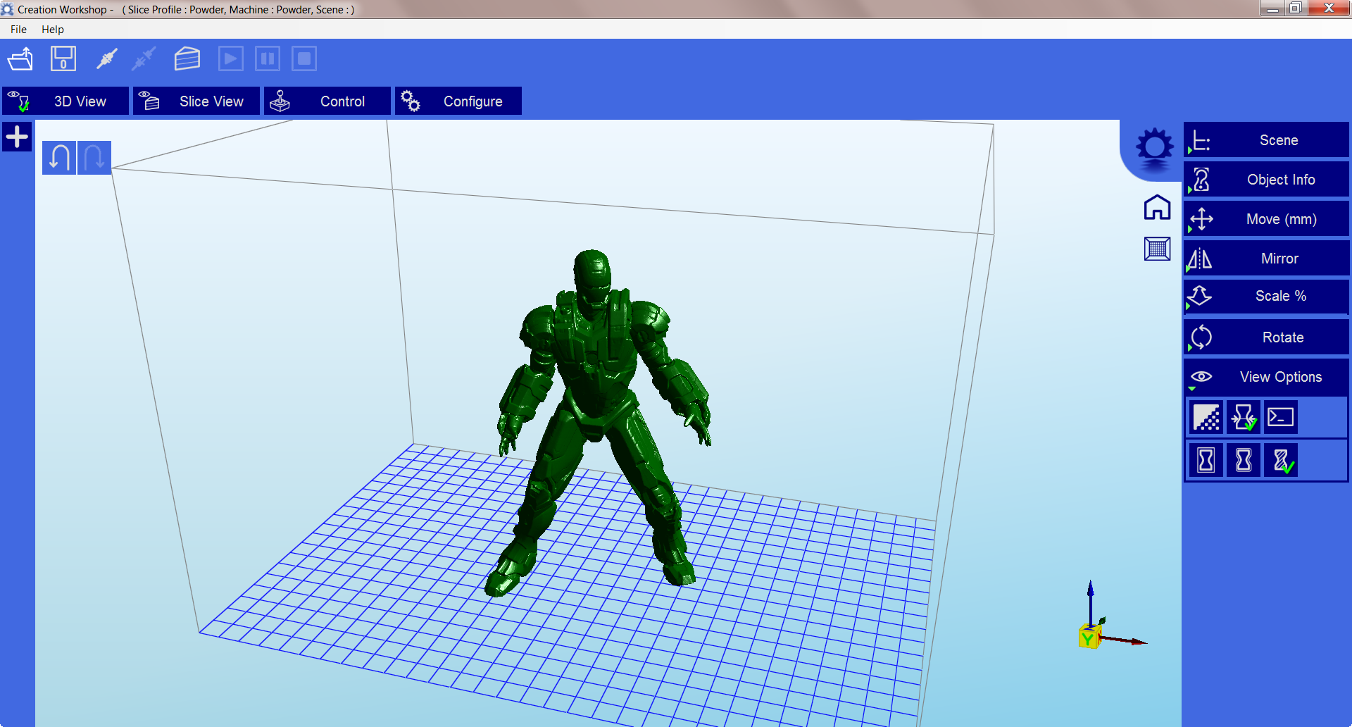

Code Contributors:
Steve Hernandez
Shai Segar
Martin Gugg

Creation Workshop has a new home at www.EnvisionLabs.net
Check out our forums at www.buildyourownsla.com

Revision History:
Date | Version | Author | Description
02/21/13 | Alpha 1 | Steve Hernandez | Initial notes, quick guide, and description
7/31/2013 | Beta 10 | Steve Hernandez | Current screen shots, added more description, re-wrote large portion to reflect current software.
10/22/2013 | Beta 12 | Steve Hernandez | Updated manual to reflect changes for version 12
11/13/2013 | Beta 13 | Steve Hernandez | Updates for version 13
7/24/14 | Release 25 | Steve Hernandez | Numerous updates to pictures and sections

Contents
Installation: 3
Running the application: 4
Loading a Model 4
Scene View 5
Selecting 5
Removing a Model 5
Cloning a model 5
Object Info 6
Move View 6
Mirroring Objects 6
Scaling objects 7
Saving a Scene 9
Move a model 9
Scale a model 9
Rotate a model 10
Setting up a UV Machine for Printing 10
Selecting a display device: 11
Machine Drivers: 11
Selecting a Machine Connection COM Port 11
Setting up a profile for Slicing and Building. 12
Slicing a Model 14
Connecting to a machine 14
Manually controlling your machine. 14
The Build Process 15
Plug-in System 16
Licensing 16
Notes about the license 16
Terminology: 16
Future Efforts: 17
Final Words: 17

Installation:
Installation of the application is fairly straightforward. Simply unzip the contents of the zip file into a directory of your choice. When the application is started for the first time, it will automatically create all necessary subdirectories and default machine and slicing profiles. *Note – be sure unzip into a new directory, and not overtop an old installation. Previous configuration files are usually not compatible.

Running the application:

Loading a Model
You can load a binary or ascii STL, OBJ, AMF, or 3DS model from disk by clicking on the ‘Load’ icon or choosing ‘Load Model from the ‘File’. Multiple models can be loaded and manipulated independently.

Scene View

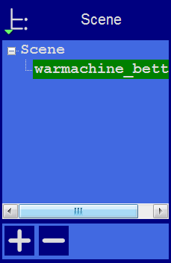
The Scene View allows you to manipulate various aspects of the scene.

Selecting
- Selected models appear in green.
- When a model is loaded, it will be automatically selected.
- You can select a model by double clicking on the model, or selecting it with the scene view

Removing a Model
- You can remove a model by right-clicking on the name in the scene graph and selecting “Remove”.
- The Minus sign “-” will also remove the current model.
- You can also delete a model by selecting it and then pressing the “delete” key on your keyboard.

Cloning a model
You can select a model in the scene and click the “+” sign to clone it. The cloned object will appear in the scene view

Object Info
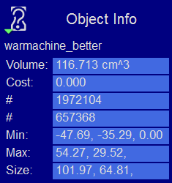
The Object Info view allows you to see various information about the model, including its volume and cost.

Move View
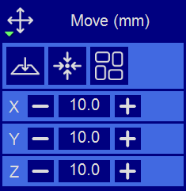
The Move view allows you to move objects on the build platform using the X/Y/Z buttons, the distance can be entered in the middle.
Several other tools are available in this view. From left to right, there are:
- The ‘Place on Platform’ button will position the bottom of the model to rest on the bottom of the build platform.
- The ‘Center’ button will center the model at (0,0,0).
- Auto-Arrange will automatically lay out all models to fit on the build platform. Any model that does not fit within the build platform will be moved outside the build area.
Protip:
- If you hold down the ‘Shift’ key, you can slide the selected model around the ground plane. The model will slide along the ground plane, following the mouse location.

Mirroring Objects
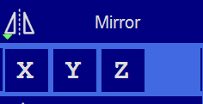
The Mirror view allows you to mirror the selected object on the specified axis.
The three buttons on top from left to right are:
- Place on platform
- Center object
- Auto arrange objects

Scaling objects
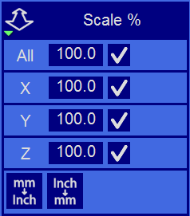
A model can be scaled by selecting it, and using the ‘Scale’ view to enter in a new scaler value. Clicking on the check button will perform the scaling operation. Individual axis of the model can be scaled by entering in a scaler value. Also included are two buttons to convert the model from mm to inches and inches to mm.

Rotating Objects
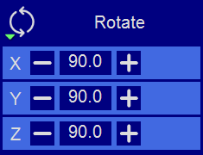
Rotating a model works in a similar way to moving a model. Simply select the model you want to work with, and use the X/Y/Z +/- buttons to rotate the model by the specified degrees.

View Options
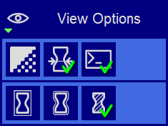
The view options panel allows you to manipulate various options regarding views and models.

Working with Model Support tools
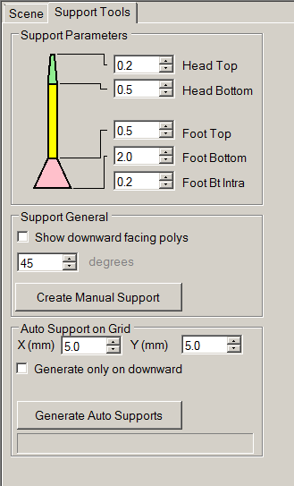

Using Supports
Supports are sometime required to properly attach a model to the build surface. Because of the nature of SLA printing, one layer at a time is printed, and lower layers must be supported directly or indirectly and attached to the build surface.

Support General
Under Support General, you can click ‘show downward facing polys’. This will highlight all polygons in the model that are pointed downward by the specified degree. A single support can be generated for manipulation by clicking the ‘Create Support’ button.

Auto Support on Grid
After a model is loaded into the scene and selected, you can automatically generate a ‘bed of nails’ support for the model. You can specify the grid spacing and the size of the generated supports. If you wish to only generate supports on downward facing polygons, check the boxes under ‘support general’ and ‘generate only on downward’

Moving supports
After a manual or automatic support has been generated, individual supports can be moved around the X/Y plane the same way models can be moved. Select the support by double clicking on it to select it, and hold down the ‘Shift’ key on your keyboard and move the mouse. Supports will automatically scale vertically under the model they support.

Saving a Scene
After one or more models have been loaded and manipulated on the build platform, the entire scene can be saved as an STL model for later use. Simply click on the ‘File->Save Scene STL’ menu item to save the scene model.

Move a model
The position of a model on the build platform can be manipulated. Select the correct model on the scene graph, and use the controls on the ‘Move’ tab. The ‘Center’ button will center the model at (0,0,0). The ‘Place on Platform’ button will position the bottom of the model to rest on the bottom of the build platform. The ‘X,Y,Z’ buttons will allow you to move the model in the scene.
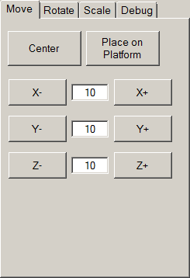
Moving a model with the mouse
You can also move a model manually by selecting it, then holding down the ‘Shift’ key on your keyboard. The model will slide along the X/Y ground plane, following the mouse location.

Scale a model
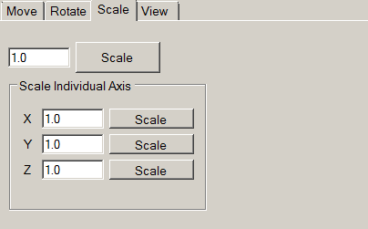

Rotate a model
Rotating a model works in a similar way to moving a model. Simply select the model you want to work with via the Scene Graph, and use the X/Y/Z buttons to rotate the model by the specified degrees.
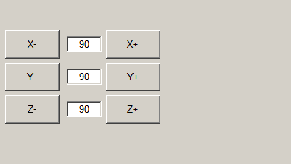

Setting up a UV Machine for Printing
This section covers the basics for setting up a Machine Profile to use with your 3d Printer. For a detailed guide on Hardware and troubleshooting, please refer to the ‘Hardware Guide’ manual.
When you ran ‘Creation Workshop’ for the first time, it created a default 3d UV DLP machine profile. You will need to configure this profile to meet the specifications of your 3d printer. To edit the current machine profile, select ‘Machine Config’ tab in the main window.
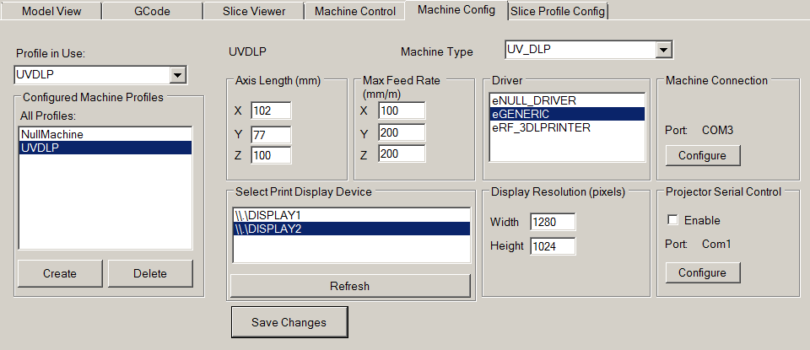
You can create new profiles from the left “Configured Machine Profiles” box. The currently selected profile is indicated in the “Profile in Use” drop-down box. In this display, you can create and configure multiple machines. (UV DLP, FDM, etc..)
For UV Printers, set the platform size for your machine in mm. This X/Y size refers to the projected size of the image on the surface of the build platform. For bottom-up machines, this will be on the surface of the bottom of the VAT, for top-down machines, this will be the surface of the resin. The Z size refers to the maximum Z printing height. This screen also allows you to select a display device the projected images will be displayed upon.

Selecting a display device:
This configuration screen also allows you to select the display device to use for your UV printer. Connected display devices should appear in this area. Clicking on a display device will automatically set the ‘Display Resolution’. If your display device does not appear in this area, please check your display connection and click the ‘Refresh’ button.

Machine Drivers:
You should also select the correct driver for your machine type. Most machines will use the ‘eGeneric’ driver to connect via serial port to a RAMPS-compatible controller board. Also in this screen, you can specify the feed rates to use on your axis’s.
*NOTE- The eNULL_DRIVER can also be useful for testing purposes. This allows you to use a dummy virtual machine to perform a build. This can help you see how your GCode and build sequence performs prior to connecting to a live machine.

Selecting a Machine Connection COM Port
Once a Machine profile has been configured and selected, the ‘Machine Connection’ button can be selected to show the Connection setup screen.
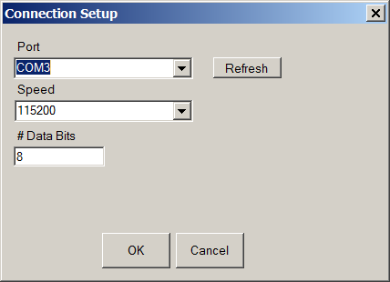
This screen allows you to choose the correct COM port and speed to communicate with the printers’ controller card via serial connection.
*NOTE – The current version of the application will allow connections up to 115200 bps. Please ensure your controller firmware is configured for the speed chosen.
If your UV printer DLP projector has a serial port, you can additionally set up a serial connection to control various projector functions. Please refer to your DLP Projector manual to determine the correct serial port configuration.

Selecting a Projector COM Port (Optional)
Some video projectors have a serial control port. This feature allows you to connect to the serial control port of a projector and send it various commands. You will need to consult your projector’s user manual for a list of commands.

Saving your changes
After you have configured your machine profile, be sure to click the “Save Changes” button to save and apply the changes.

Setting up a profile for Slicing and Building.
In order to slice a model into images, you must first set up a slicing profile. A default profile has been created the first time the application was started. You can create new slicing profiles and manage them in much the same way you can manage machine profiles. The ‘Slice Profiles Config’ tab item will allow you to create, delete, or edit a slicing and building profile.

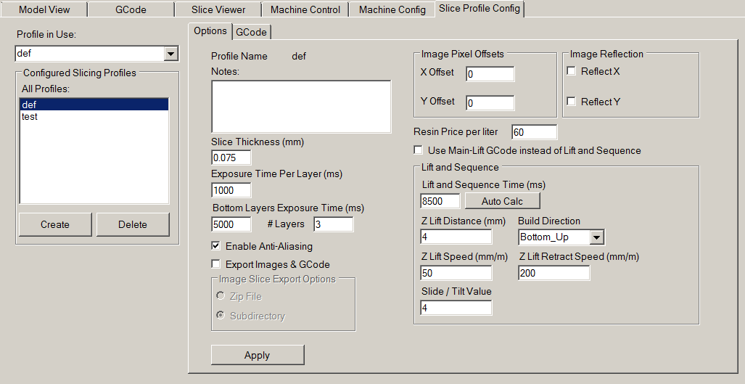
Slice Thickness: This field is to set the thickness of each slice in mm. The default is .05mm (20 slices per mm)
Exposure Time per Layer: This time value specifies how long the projector will display an image slice on a per-layer basis.
Bottom Layer exposure time: In order to ensure the model is properly adhered to the bottom of a vat (for bottom-up machine types), a longer exposure time can be used for a specified number of bottom layers.
# Bottom Layers: This specifies the number of ‘bottom layers’ that receive the longer exposure time.
Blanking time between layers: This is a time delay that allows the machine to perform a ‘Lift/tilt/slide’ . You may have to experiment with this value to determine a proper timing for your machine.

Resin Price per liter
You can specify the cost of the resin used here. This is used to calculate printing costs under the ‘File->Calculate Volume & Costs’ menu item.
Lift and Sequence Time:
This time specifies in milliseconds how long the lift and retract sequence takes. You can use the “Auto Calc” button to generate a time estimate for the lift and retract. This value may need to be modified based on the speed of your machine.
Lift Distance: This is the distance that the printer will raise and lower the Z axis after the exposure has taken place.

Z Lift Speed:
When a layer is printed on a bottom up machine, a large amount of force may be required to separate the slide from the vat. This speed indicates how fast to perform the lift, a slower speed may be required to help vat separation.

Z Lift Retract speed:
After the lift occurs, this speed indicates how fast the z axis should travel back to the initial start position.
Slide/Tilt Value: for machine with a slide or tilt mechanism connected to the X axis, this value specifies how much to more in conjunction with the Lift.
X/Y Pixel Offset: This X/Y value allows you to offset the rendered image by a pixel amount.
Build Direction: Top down or Bottom up. This value determines which direction the Lift occurs. For a bottom up machine, this is used to peel the model from the bottom of the build vat, sometimes in conjunction with a tilt/slide. For a Top-down machine, this makes the lift operation dip into the resin.

Image Slice Export Options
This allows you to control how the generated image slices and gcode files are saved. You have the option of exporting to Zip file or to a subdirectory when the ‘Export Images and GCode’ button is checked. If this is left unchecked, slices and gcode will still be generated, but not saved to disk.

Slicing a Model
Once you have loaded one or more models, configured your machine profile, and configured your build & slicing profile, you can slice a model.
 Choose the Slice Icon from the toolbar to bring up the Slicing Screen.
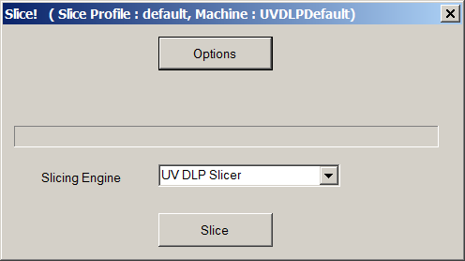
You can click the ‘Options’ button to set the properties of the currently selected build and slicing profile.
For generating images for a UV DLP machine, choose the ‘UV DLP Slicer’ as the slicing engine. If you are slicing a model for FDM, choose the “Slic3r” option.
Click the ‘Slice’ button to begin slicing. You can stop slicing by pressing the ‘Cancel’ button.

Connecting to a machine
You can connect to your 3d printer with the ‘Connect’ toolbar item.

Please ensure that you’re properly configured your machine profile as well as setting up the correct COM port before connecting.

Manually controlling your machine.
Once successfully connected to a machine, you can use the Machine Control screen to control various portions of your machine. Here, you have access to homing, movement, sending arbitrary GCode. You can use the projector controls to show a blank screen, calibration, etc..
FDM based printer can also control the extruder.
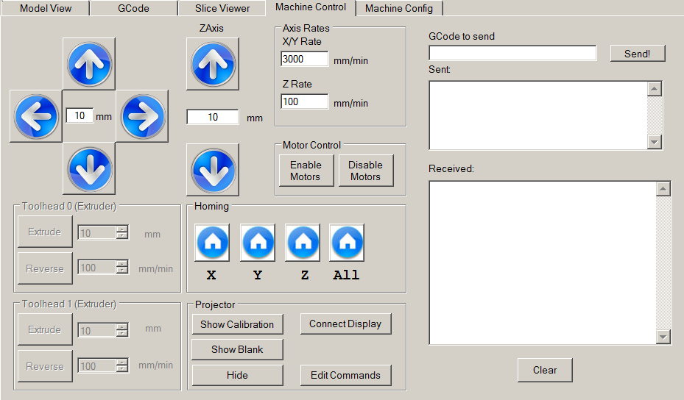

The Build Process
In order to build the model, you need to be connected to a machine (obviously).
Once you have sliced a model and connected to a machine, you can click the “Start Build” button to start the build process. If you have a secondary monitor (or projector) connected to your system, a full-screen window will appear that displays the individual image slices. If you are using only a single monitor, this screen will appear over your primary display (probably not what you want)
For testing purposes and to get an idea of what the build process does, use the null driver in your machine configuration, or set up an additional machine configuration just for testing.
How the build process works
This program uses information from the sliced model, along with generated GCode to control both the printer hardware and projector simultaneously. Special comment lines are generated inside the GCode file that tells the build manager to perform special action:
(Pre-Slice GCode )
(<Slice> 2 )
(<Delay> 5000 )
(<Slice> Blank )
(Pre-lift GCode)
G1 Z5.00000 F100 (Lift)
G1 Z-4.95000 F100 (End Lift)
(Post-lift GCode)
(<Delay> 2000 )

You might recognize the G1 as a movement command. The (<Slice> 2 ) line tells the build manager to display slice 2, and the (<Delay> 5000) line tells the build manager to pause for 5000 milliseconds (5 seconds). The next G1 movement command will not be sent to the machine until AFTER the slice and delay commands have executed. This differs from most G-Code build systems that will send as many commands as possible to the device. You should note that the build process uses relative movement mode instead of absolute mode.

Use of custom G-Code:
When the slicing profile is created, 6 G-Code files are created in a sub-directory of the same name:
start.gcode
preslice.gcode
prelift.gcode
postlift.gcode
end.gcode
mainlift.gcode

The contents of the start.gcode file are inserted at the beginning of the generated gcode file. Likewise, the end.gcode is inserted at the end of file for any shut down commands. You can see the relative insertion positions of the pre-slic, pre-lift and post-lift gcode.

If the G-Code generated does not suit your machines purposes, or if you have specialty custom hardware, you can use the mainlift.gcode file in place of the generate lift sequence.

You can modify the contents of these files to suit your machines individual needs to add additional commands such as a shutter control, or Slide/Tilt mechanism.
If you make changes to any of these files, you will need to re-slice the model.

Plug-in System
Creation Workshop supports a plug-in based system. This allows for a vast array of customizations

Licensing

Notes about the license
Creation Workshop is released under the Creation Commons Attribution-NonCommercial-ShareAlike license. This software and its source code are free for home hobby and academic use. Any commercial re-distribution of the software or any portion of the software requires licensing.

Terminology:
Some common terms used:
3D UV DLP:
This refers to a 3d printer that uses Ultra-Violet cured resin in conjunction with a Digital Light Projector.
VAT: This is the holding tank for UV Resin. For Bottom-up machines, this will have a transparent bottom to allow a DLP to project an image onto the surface.

Future Efforts:
Right now, this software can be used to slice a model and control a 3d UV DLP printer. It can also control FDM printers with the use of Slic3r to generate G-Code. In the near future, the intent is add support for powder-based printers.

Final Words:
This project has taken quite a bit of time and effort. I would love to see this application become a part of the community tools for printer control. Please take the time to report any bugs, give any constructive feedback and design recommendations to:
Pacmanfan321@gmail.com
If you appreciate this program, please also consider donating to me via @ www.paypal.com !

