Creation Workshop

Hardware Guide

Document Version | Date | Author | Notes
1 | 08/05/2013 | Steve Hernandez | Initial Revision

Foreword:
Many people have been asking about the hardware setup that Creation Workshop supports. This document serves to show a few examples from my own 3d printer, as well as giving some useful links to others setups on the web.
Basic Hardware description:
There’s no magic behind anything that I’ve done to create my 3d UV DLP printer. My goal was to use as much existing technology and standards as possible to create the printer.
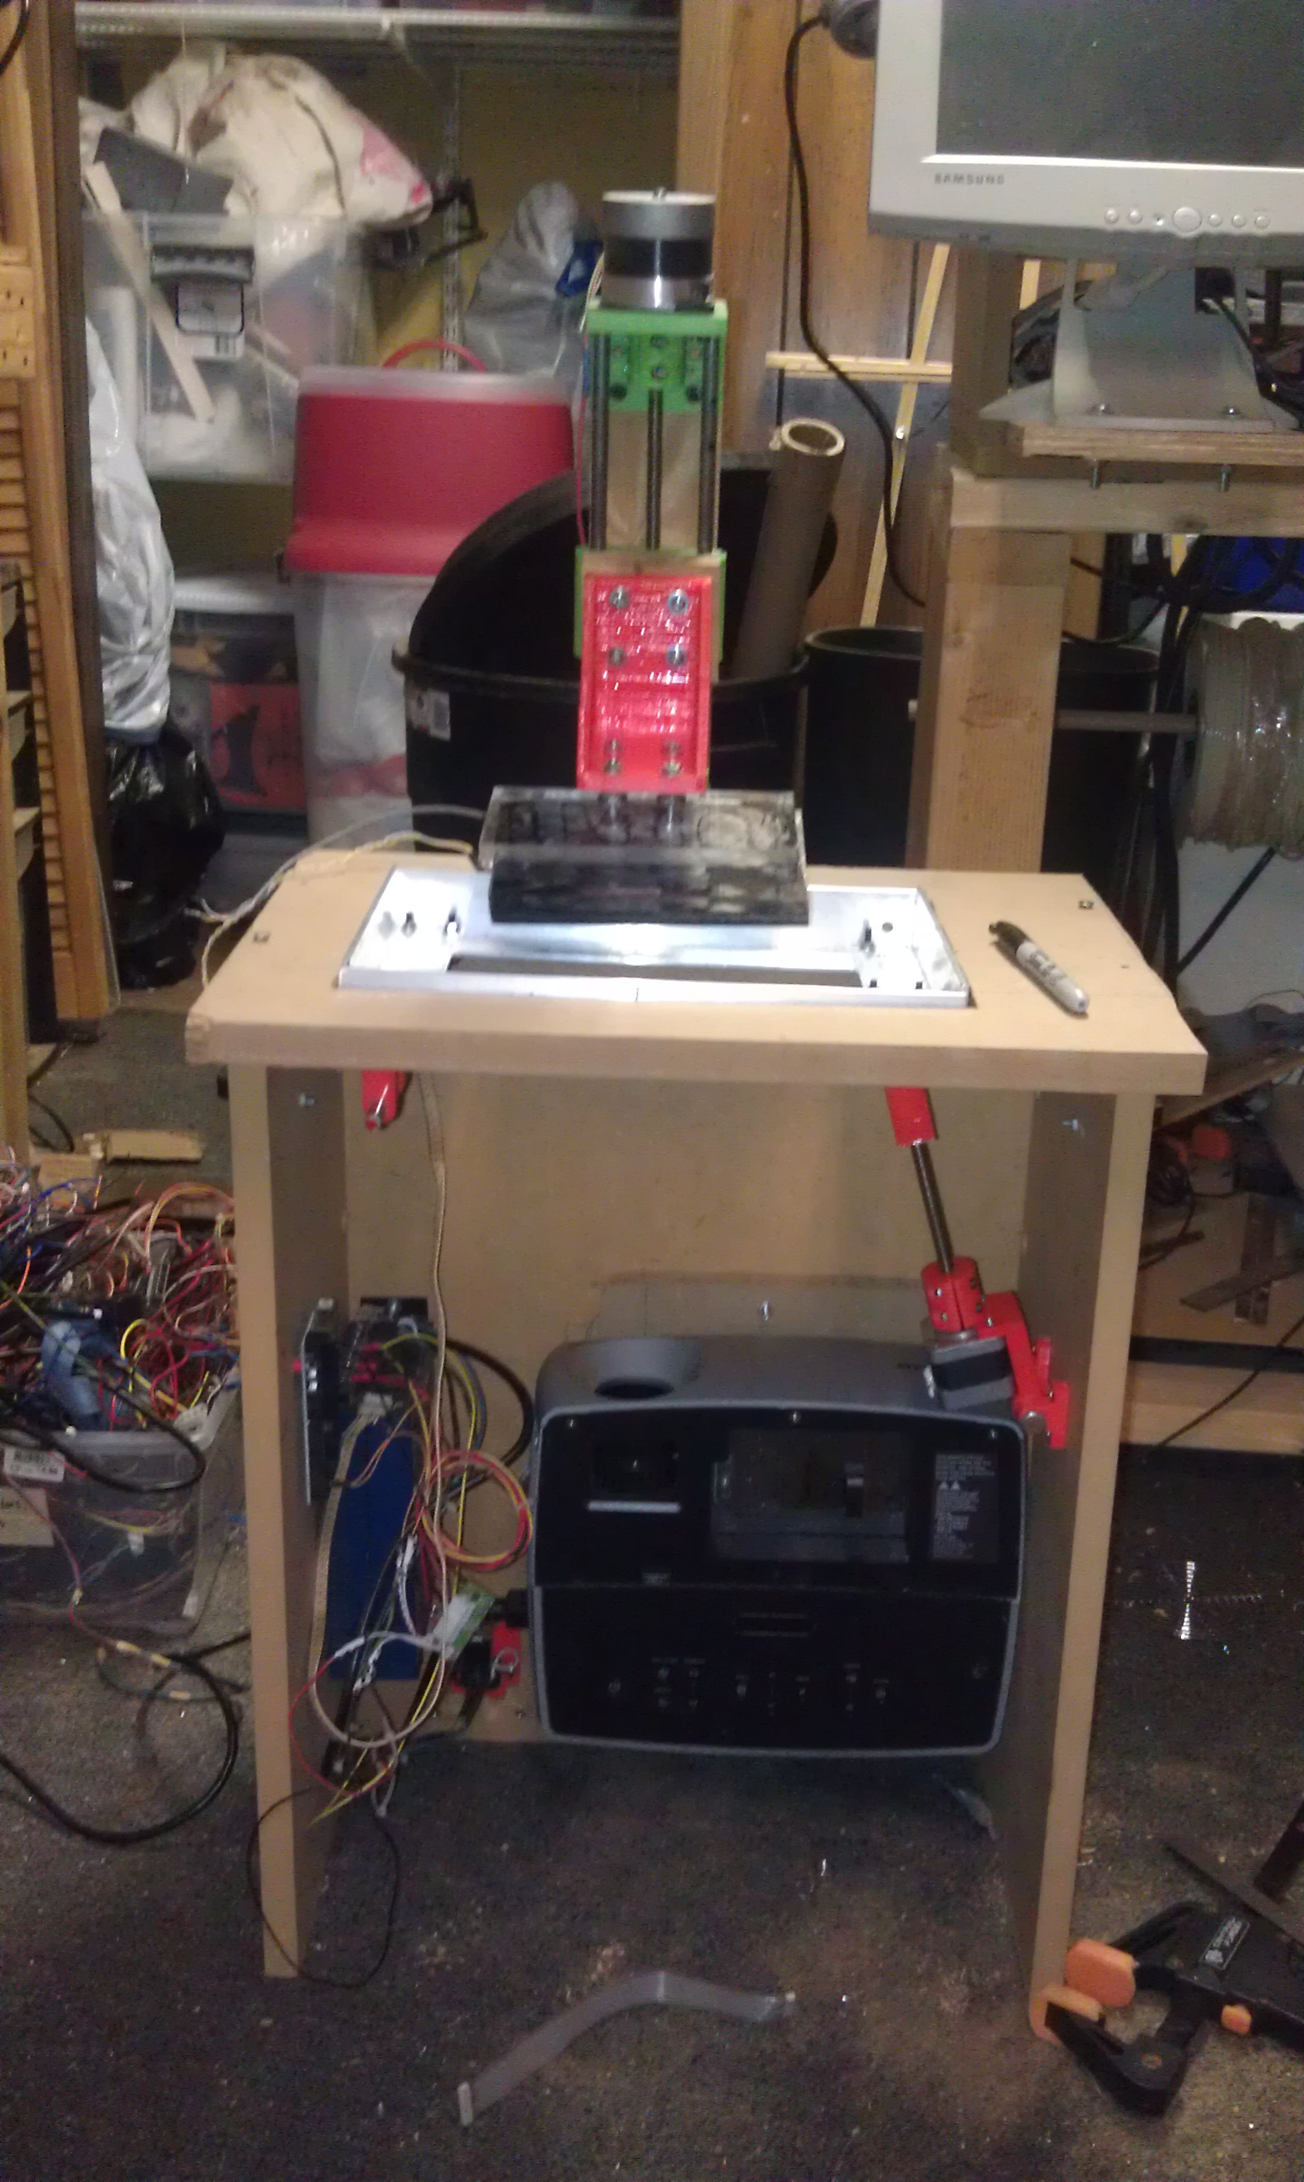
My prototype machine
I used an Arduino Mega 2560 board as the main board (http://arduino.cc/en/Main/arduinoBoardMega2560 ). I also used a few EasyDriver stepper controller boards that I had lying around from Sparkfun (https://www.sparkfun.com/products/10267) to control the Z axis as well as a tilt mechanism wired on the X Axis. All motors used were hi-torque NEMA 17 steppers.
That being said, if I had to do it over again, I would use a RAMPS compatible board so I would have additional stepper controllers to spare for a shutter mechanism and pump for the UV resin. http://reprap.org/wiki/RAMPS_1.4 . There are literally dozens of excellent RAMPS compatible boards on the market used for Fused-Filament-Fabrication machine, and almost any of them would be suitable for the task of controlling a 3d UV DLP printer.
I constructed the Z axis of my machine from my ‘Generic NEMA 17 Axis’ I posted on Thingiverse here http://www.thingiverse.com/thing:14280
You can also use the slightly beefier NEMA 23 version from here: http://www.thingiverse.com/thing:37123
My basic machine has no end-stop switches, so I have to jog the Z axis to the lowest position to start a build. I probably should put a switch in for the z axis so I can automatically home it when beginning a build. Because I don’t have any endstops, and I don’t use homing, my software uses GCode in ‘Relative movement mode’ as opposed to ‘absolute movement mode’.
Tilt Mechanism
I also have a tilt-mechanism that I designed in the second revision of my machine to help separate the model from the bottom of the VAT.
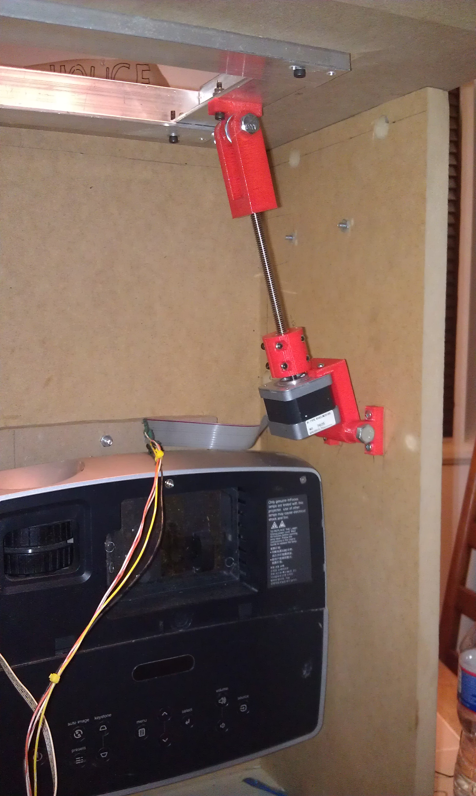
My tilt mechanism
Firmware
I used the Sprinter firmware with no modifications, other than configuring the correct motor pins. https://github.com/kliment/Sprinter . Several other users have noted that they use they Marlin firmware to control the printer: https://github.com/ErikZalm/Marlin
Projector
I used an Infocus 2104 DLP Projector that I bought for cheap on EBay. It has a resolution of 1024x768, which is not great, but does the job. I went ahead and removed the color wheel. From what I understand, the color wheel was blocking the frequencies of light needed to cure the UV resin I have. The picture now looks black and white. I also removed a suspicious pane of glass between the bulb and the DLP chip. It looked coated, and I suspect it filtered UV.
My project blog, along with some detail of my 3d printer (and other projects) can be found here: http://probjectblogs.blogspot.com/
Listed below are many excellent web sites where others have documented their process of creating a 3d UV DLP (or similar) printer.
https://code.google.com/p/lemoncurry/wiki/main - Lemon Curry - an excellent source of information for all things 3d UV DLP

