**Report2**

Lu, Yiwen A0225573A

I have added several functions in lab2.py. This document is intending to specify what these functions do.

* def _learn_node_parameter_w(outputs, inputs=None):

This function is used to calculate weights with Ax=b.

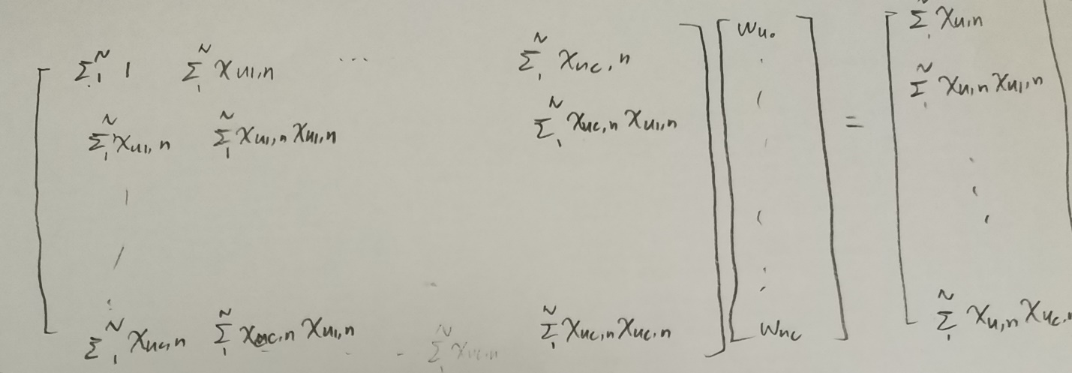

* def _learn_node_parameter_var(outputs, weights, inputs):

This function is used to calculate variance.

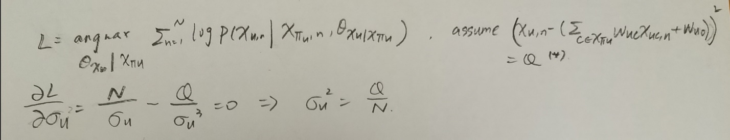

* def _get_learned_parameters(nodes, edges, observations):

This function is used to find the node and its parents. And construct the input parameter of the previous two functions.

Use parameters nodes and edges we can find the inputs and outputs parameters.