Exercises 1

1. ﻿What is the purpose of lithography? What are the basic requirements for lithography?
2. Classification of photoresist? What are the advantages and disadvantages of each photoresist?
3. Composition of photoresist? The role of each part?
4. The basic steps of lithography.
5. What is the standing wave effect? How to reduce the standing wave effect?

Exercises 2

1. Factors that affect exposure quality?
2. List of advanced exposure light source.
3. Why only one wavelength selected from the Mercury lamb and how to select?
4. How to improve the resolution? The relationship between the depth of focus and the resolution?

Exercises 3

1. What is isotropic and anisotropic etching?
2. List of popular etchants and etching gases for silicon dioxide, silicon nitride, silicon and aluminum

﻿ 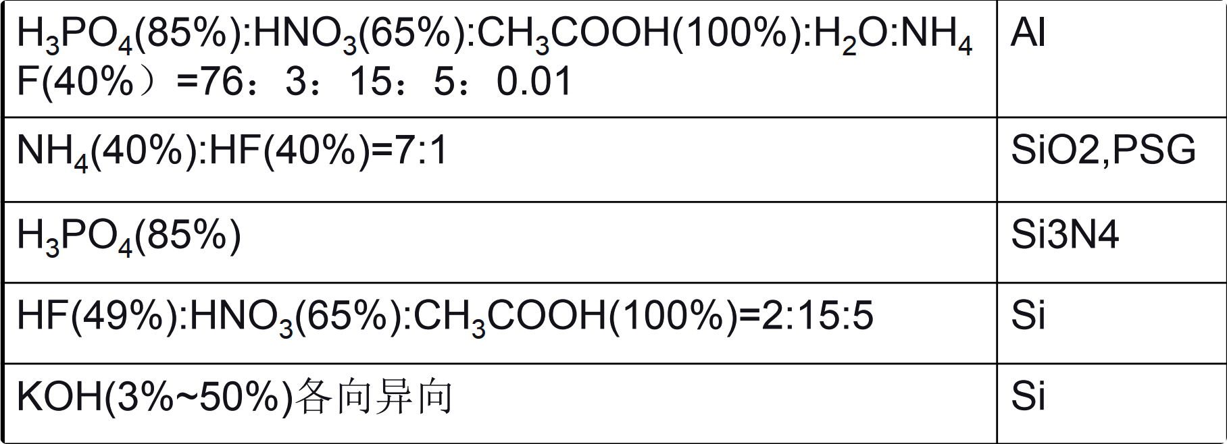

1. What is dry etching, what is wet etching? Describe the advantages and disadvantages of dry etching and wet etching.
2. What are the three types of dry etching What are the principles and characteristics of each?

Exercises 4

1. List popular vacuum pumps, what is the typical pressure and ultimate vacuum pressure can be achieved by different pump?
2. How to use X-ray to tell the film qualities, what is the popular film structure made by thermal evaporators
3. To maintain a 100km 6X5 squares tunnel railway in vacuum of 1~0.1 pa, please try to make estimate on how much power consumption?

Exercises 5

1. Why Inert Gas used for Sputtering, list popular Inert Gas for sputtering.
2. List the major factors may affect the SY
3. Why RF Sputtering and what is the typical frequency been used.
4. What is the advantage of Magnetron sputtering?
5. List 5 ways to check the thin film thickness, and try to make a proposal of an alternative method to measure the film thickness.

Exercises 6

1. What is the most important characteristic of PECVD ?
2. Why do we need epitaxial growth, what is the application
3. How would you deposit Aluminum Nitride ?
4. What is the temperature range used in CVD technology ?
5. What is the advantage of ALD ?
6. How do we do passivation for Solar cells
7. What is the purpose for passivation ?
8. What are the core technology principle of MOCVD ?
9. What is the difference between PECVD and MOCVD ? ﻿

Exercises 7

1. Design an antireflection film for regular Si solar cell, including what material and how much the thickness?
2. List the advantages and disadvantages of thin film solar cell
3. List the advantages and disadvantages of IBC solar cell.
4. Design a completed processing way for the IBC cell.