**Exercises 3**

**List popular vacuum pump?**

以10为底的幂

|  |  |  |
| --- | --- | --- |
| popular vacuum pumps | Maximum operating pressure | Ultimate pressure |
| Rotary vane mechanical pump | 5 | -2 |
| Adsorption pump | 5 | -2 |
| Oil diffusion pump | 0 | -5 |
| Turbo molecular pump | 1 | -8 |
| Sputtering ion pump | 0 | -10 |
| Cryogenic pump 低温泵 | -1 | -11 |

**How to use X-ray to tell the film qualities**

x-ray reflectivity (XRR) determine layer properties

Layer thickness

Layer density

Interface roughness

x-ray diffraction (XRD) determine layer micro structure

crystalline composition

crystallinity

texture.

x-ray Fluorescence (XRF) determine layer composition

elemental composition

Contamination

**what is the popular film structure made by thermal evaporators?**

Island layer island and layer

epitaxial, poly-crystalline, columnar crystal growth

epitaxial disoriented, amorphous columnar, crystal growth with twin boundaries.

**3. To maintain a 100km 6X5 squares tunnel railway in vacuum of 1～0.1 pa, please try to make estimate on how much power consumption?**

To generate

$$E=ωt$$

$$t=\frac{V}{S_{e}}ln\frac{P_{0}}{P_{1}}$$

For a industrial vacuum pump of 1-0.1Pa

S=1m^3/min – 200m^3/min W=1-200kW

W = 200kW S=5 $m^{3}$/s, V=100km×6m×5m, $P_{0}$ =1× ${10}^{5}$ Pa, $P_{1}$ =1-0.1Pa,

then E = ….

to maintain

The main areas for leaks would be the enter and the end stations. The train would have to pass through a series of airlocks that progressively reduce the pressure until the train enters the fully evacuated tunnel.

Assuming Install a vacuum pump station every 1 km

W = 100*2 =200kW

**Exercises 4**

**Why Inert Gas is used for Sputtering?**

Because inert gases do not react with material to be sputtered.

**list popular Inert Gas for sputtering？**

Ne, Ar, Kr and Xe

**List the major factors may affect the SY.**

incident ion (energy and incident angle)

Gas (pressure and flow rate)

Ratio of Mass of Target Atoms to Incident Atoms

Heat of sublimation of material (Surface Binding Energy)

substrate temperature

distance from target to substrate

Crystal Structure and orientation of Target Surface

**Why higher atomic weight of an inert gas will have higher sputtering yield?**

Higher atomic weight results in higher momentum transfer

**Why RF Sputtering and what is the typical frequency been used?**

If sputter insulators using DC, charge on target will accumulate by Ar ions. Ion impingement stops, even arcing occurs in the some area of the target.

13.56MHz.

**What is the advantage of Magnetron sputtering?**

High ionization efficiency (due to more possibility of collisions of elections and gas)

High energy of ion bombardment

High deposition rate

Disadvantage: low target utilization

**List 5 ways to check the thin film thickness, and try to make a proposal of an alternative method to measure the film thickness.**

Electron microscopy

Stylus method

Microbalance method

Quartz crystal oscillation

Resistance method

Optical absorption method

Acoustic wave propagation method

a pulse laser shots on a film, causes thermal expansion, causes an acoustic wave so as echoes. Measure the time between two echoes.

**Exercises 5**

**1. What is the most important characteristic of PECVD?**

the presence of large amounts of high-energy electrons in the plasma, which basically provide the activation energy required for chemical vapor deposition

Plasmas are used to force reactions that would not be possible at low temperature

**The benefits of PECVD which reacts at low temperature?**

Save energy and reduce costs

Increase production capacity

Reducing the minority carrier lifetime decay in high temperature wafers

**After metal lines like Aluminum (Si-Al alloy temperature = 577 °C) are deposited, how would you deposit a dielectric layer to isolate the next layer**

CVD and PECVD depositions of dielectrics

**After all processing, how would you protect the die?**

SiNx deposition at very low temperature

**2.** **Why do we need epitaxial growth, what is the application ?**

epitaxial growth can grow a layer of uniform thickness and accurately controlled electrical properties.

Applications:

provide a perfect substrate for the subsequent device processing

perform Bandgap Engineered Structures

For examples:

epitaxial wafer

MBE: superlattice, heterostructure field effect transistor

**Advantages and disadvantages of Molecular Beam Epitaxy?**

Precisely control the chemical composition and impurity concentration

Best layer control (can deposit atoms layer by layer)

in-situ observation

Large surface

High purity (due to ultrahigh vacuum and pure material)

low substrate temperature

Low growth rate

low substrate temperature

difficult to realize large batch of industrial production

**3. How would you deposit Aluminum Nitride?**

Metal oxidation chemical vapor deposition MOCVD/Atomic Layer Deposition ALD

**4. What is the temperature range used in CVD technology? pdf p30**

APCVD: 700-1000℃

LPCVD:600-800℃

PECVD: 300-450℃

MOCVD: 500-1200℃。

**What is Atomic layer deposition (ALD)?**

the chemical vapor deposition technique based on alternating surface reactions that saturate the surface in each reaction cycle

**steps of ALD?**

Chemisorption saturation process

surface chemical reaction process

**5. What is the** **advantage of ALD ?**

Advantages

Wide operating window

Reagents do not meet in gas phase

Excellent conformality (step coverage)

Best thickness control (deposit atoms layer by layer)

Reproducible

lower temperature

Can modify terminating surface

Disadvantages

Slow growth rate

Narrow temperature window

Low temperature film may require anneal, further oxidation etc.

Still sort of New unrefined technology

**6. How do we do passivation for Solar cells?**

On the surface of polycrystalline silicon solar cells, a layer of silicon nitride film is deposited by PECVD method.

**7. What is the purpose for passivation?**

Protect structure from moisture, acid/alkali, oxidation, ion, external force

﻿improve the presence of grain boundaries (crystal interface), point defects

**8. What are the core technology principle of MOCVD?**

Many materials that we wish to deposit have very low vapor pressures and thus are difficult to transport via gases

Chemically attach the metal (Ga, Al, Cu, etc.) to an organic compound that has a very high vapor pressure

The organic-metal bond is very weak and can be broken via thermal means on wafer. The metal is deposited with the high vapor pressure organic compound being pumped away

**9. What is the difference between PECVD and MOCVD ?**

For PECVD the precursor’s chemical bond is strong and need high energy of plasma to break it so causes deposition, while for MOCVD the precursor’s organic-metal bond is very weak and is easy to break via thermal means on wafer

**Exercises 7**

1. **Design an antireflection film for regular Si solar cell, including what material and how much the thickness?**

silicon nitride

the refractive index of silicon nitride is n = 2.1

the incident light wavelength to be chosen is lambda = 600 nm

the film thickness that minimizes reflection is d = lambda/(4n) = 71 nm

1. **List the advantages and disadvantages of thin film solar cell:**

**Advantages:**

Low material cost

Flexible (Roll-to-Roll)

Large area (large manufacturing unit)

Tunable band gap

High absorption

**Disadvantage:**

Low conversion efficiency

low stability

Large investment

3. **List the advantages and disadvantages of Interdigitated back contact IBC solar cell.**

**Advantages:**

Electrodes are both on the backside which allows more effective area to light illumination

Large electrode area which reduces series resistance

High conversion efficiency

**Disadvantage:**

Complex preparation process

High cost

1. 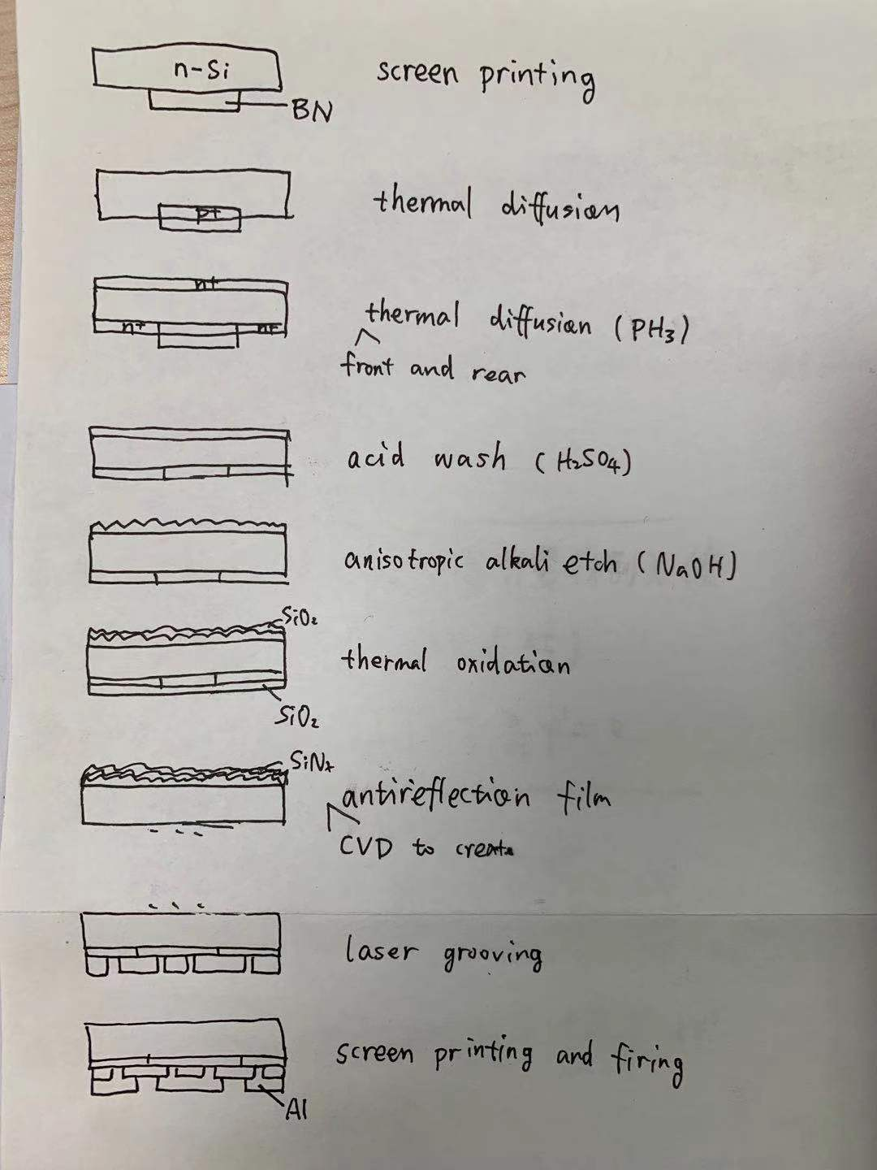**Design a completed processing way for the IBC cell.**