Realistic Real-time Accessibility: Assessing Accessibility Unreliability with High-resolution Real-time Data and Space-time Prisms

Luyu Liu, Adam Porr, Harvey J. Miller

Unreliability of accessibility is a major obstacle to make accessibility measures useful and practical for transit authorities and users. Due to on-time performance variation and schedule’s inaccuracy for representing system performance, the accessibility experienced by transit users can be very different from the one promised by the schedule. However, very few prior accessibility studies addressed this discrepancy explicitly with time geography methods. In this paper, we introduce *realistic real-time accessibility*, which is use a well-established time geography method, space-time prism (STP), to measure the *accessibility unreliability*. Accessibility unreliability is defined as the difference between STP derived from real-time data and STP derived from schedule data. The methods will use two mobility datasets of large volumes: General Transit Feed Specification (GTFS) real-time data, which produce retrospective real-time STP, and GTFS schedule data, which produce scheduled STP. We will also investigate the reliability measure’s connections to social equity factors, such as different social, demographic, and economic factors. The paper will conduct a case study in the Central Ohio Transit Authority (COTA) bus system, a public transit agency in Columbus Ohio. The analysis will focus on the spatial and temporal patterns of the reliability measure from 2018 – 2021 across the city of Columbus, especially the changes before and during the COVID-19 pandemic. This can provide insights about possible impacts of the pandemic on the reliability of the transit accessibility in different communities. All the analyses and results will be visualized in a public web-based platform. This paper provides a scalable time-geography approach to gauge the reliability of transit accessibility with very large datasets; some results can also reveal new empirical patterns of transit accessibility’s impact on social equity.

1. Introduction

Accessibility, or the ability to reach opportunities in an environment, is a fundamental concept in transportation science and human geography (Hansen, 1959; Ingram, 1971)). As the focus of transportation planning shifts to a sustainable mobility paradigm (Banister, 2008), accessibility measures are becoming more crucial as a performance measure to guide policy, planning and decision-making. Advances in mobility and geospatial data technologies and science have enhanced the sophistication and practicality of accessibility measures to point that they are transforming planning and policy (Handy, 2020; Levinson & Wu, 2020; H. Wu & Levinson, 2020). This includes the space-time prism (STP): a core concept in time geography that models accessibility as the envelope of all possible paths with respect to time based on anchoring locations and times, maximum speeds for travel and stationary activity times (Hägerstrand, 1970). New mobility and geospatial data technologies has allowed researchers to greatly increase the analytical power of this basic time geographic concept (Miller, 2017; Neutens, Witlox, & Demaeyer, 2007).

O’Sullivan Morrison and Shearer (2000) pioneered the application of STPs to model public transit accessibility. Since that time, the availability of data on public transit networks and related, supporting infrastructure such as sidewalks afforded the development of public transit network accessibility analysis based on high resolution representation of transit and walking networks. However, this research traditionally still depended on assumptions of average schedule frequency and headways during peak and off-peak times (Tribby & Zandbergen, 2012). This barrier has been shattered by the development of data standards for publishing high resolution schedule and real-time vehicle location data public transit data via the General Transit Feed Specification (GTFS) developed by Google. GTFS allows developers to create navigation apps to support public transit users. It is also allowing researchers to analyze the accessibility generated by public transit systems at high levels of spatial and temporal resolution (Lee & Miller, 2018; Wessel, Allen, & Farber, 2017; Wessel & Farber, 2019).

Transit systems are highly dynamic and time-dependent due to variations in operating conditions, and actual performance can be different from the schedule (Park, Mount, Liu, Xiao, & Miller, 2020). There are several factors that contribute to these deviations from scheduled service: first, many bus systems operate within road networks that are shared with other vehicles. Conditions such as recurrent congestion and non-recurrent disruptions such as construction and crashes can slow transit vehicles, leading to deviations from the schedule service. Second, only travel time at designated timepoint benchmark stops is explicitly defined in the official timetables of many transit systems; travel time at non-timepoint stops is derived from interpolation, which may not be strictly followed in practice.

Wessel, Allen, & Farber (2017) and Wessel & Farber (2019) compared accessibility measures based on public transit schedule data with accessibility measures calculated retrospectively from real-time vehicle location data, finding substantial differences that call into question the use of schedule data alone for public transit accessibility analysis. However, while retrospective real-time accessibility measures recognize that actual operations can deviate from scheduled service, they assume users know *a priori* the actual arrival time of vehicles (Wessel & Farber, 2019); this knowledge is only attainable after the event happens. This makes accessibility measures calculated retrospectively based on real-time vehicle location data is unrealistic in depicting the accessibility realized by the transit system and experienced by public transit users.

This paper introduces an approach based on space-time prism (STP) to understand *accessibility unreliability*, defined as the deviation of a real-time accessibility measure from a static or steady-state accessibility benchmark based on schedules or assumed headways. This measure represents the difference between the expected potential path area (PPA) and the actual or realized PPA based on realized system performance, given the same time budget and departure time. The aggregate version of this measure can also show the consistency and reliability of the transit service; this is vital for administrative and planning purposes. We also introduce the concept and measurement of *realistic real-time accessibility* based on real-time data and users’ ability to act on the conditions when they occurred, not retrospectively. We use schedule and real-time vehicle location data to calculate and compare STPs based on schedule, retrospective and realistic real-time accessibility assumptions. We illustrate these measures using GTFS data from the Central Ohio Transit Authority (COTA) bus system, a public transit agency in Columbus Ohio. The analysis focus on the spatial and temporal patterns in different levels from 2018 – 2021 across Columbus, including during the COVID-19 pandemic. This paper provides a scalable time geography approach to measure the reliability of transit accessibility with very large datasets and investigate its implications on social equity. The next section of the paper will discuss the background of space-time prism, transit accessibility, and the unreliability issue of accessibility measures.

1. Background

This section provides background for the concepts and measures of realistic real-time accessibility and accessibility unreliability. We discuss: i) the evolution of space-time prism; ii) the development of transit accessibility measurements; and 3) the unreliability of schedule-based accessibility measures.

* 1. The evolution of space-time prism

The space-time prism (STP) is a well-established time geography method to measure physical accessibility afforded by transportation systems (Miller, 1991; Y.-H. Wu & Miller, 2001). Since its introduction by Hägerstrand (1970) as a concept, there has been progress in STP analytics based on improving capabilities of computer hardware and software, and the availability of data, allowing the STP to be operationalized and measured more realistically. Lenntorp (1976) provided the first operational implementation of the STP in his computer simulation of possible activity and travel schedules. Burns (1979) provided an analytical foundation for the STP in his formal analysis of the impacts of time, speed and network changes on accessibility. The rising popularity of geographic information system (GIS) software inspired Miller (1991) to develop a generic GIS-based procedure to derive STPs within transportation networks. Refinements in capabilities for calculating shortest paths from and to arbitrary locations within networks allowed Miller (1999) to refine the STP within transportation networks. Increasing availability of dynamic network data allowed (Y.-H. Wu & Miller, 2001) to develop procedures for calculating STPs within networks with time-varying flows and travel times. Kwan (1999) linked STPs to individual-level data using a travel diary dataset.

Improvements in location-aware technologies such as the global positioning system (GPS), automated vehicle location (AVL) devices mobile telephony has also allowed greater refinement and wider application of the STP (M.-P. Kwan, 2000; Tang, Song, Miller, & Zhou, 2016).

* 1. The evolution of transit accessibility measurement

As mentioned in the introduction of this paper, O’Sullivan Morrison and Shearer (2000) pioneered the application of STPs in the analysis of public transit accessibility. However, their analysis assumes travel though planar space outside the transit network. Tribby and Zandbergen (2012) improved transit accessibility by incorporating detailed representations of the sidewalk network for traveling to, from and between transit stops. However, their analysis assumes a static or stead-state transit headway for peak and off-peak hours, based on scheduled service frequency. Lee and Miller (2018) improved this by including publicly available schedule and route data from a local transit agency.

Malekzadeh & Chung (2020) conclude there are two major trends for transit accessibility studies: i) capturing travelers’ behavior and their stochasticity; ii) developing more disaggregated transit accessibility measurements. Both trends exemplify how larger, more detailed, and more accessible datasets impact the formulation of transit accessibility models.

Due to its multimodal and nonlinear nature, early transit accessibility models usually adopt simple assumption based on travel time estimations, which significantly reduces their computational burden (Malekzadeh & Chung, 2020). For example, some early transit accessibility models only consider the proximity to transit stops by walking (Hsiao, Lu, Sterling, & Weatherford, 1997; Zhao, Chow, Li, Ubaka, & Gan, 2003), which is a major simplification. As transit-related datasets become more detailed and accessible, models can better capture the travelers’ behavior and their stochasticity, such as system-facilitated models (Tribby & Zandbergen, 2012) and access-to-destination models (Farber, Bartholomew, Li, Páez, & Habib, 2014; Owen & Levinson, 2015). More detailed models can provide a better understanding of users’ actual travel experience from users’ perspective.

Another trend of transit accessibility is more disaggregated transit accessibility measurements. Larger and detailed datasets, higher computational ability, and better visualization methods help to improve the fidelity of transit accessibility. The rise of standard data format General Transit Feed Specification (GTFS) also marks another boom of accessibility studies (Wessel & Farber, 2019). GTFS data have a well-defined structure for scheduled data and are often released publicly by transit authorities (Barbeau & Antrim, 2013). Therefore, many recent studies use GTFS to derive STP in a larger scale without compromising the fine details of transit systems (Lee & Miller, 2018; Tasic, Zhou, & Zlatkovic, 2014).

* 1. Unreliability of schedule-based accessibility measures

As recent studies focus more on capturing users’ stochasticity, unreliability becomes the center of the discussion: how well can the accessibility measurement capture the actual experience of a user in the system? We define unreliability as an accessibility measurement’s deviation from a standard benchmark, which usually represents the actual or experienced accessibility. Due to the lack of accessible real-time data source, most traditional accessibility measures are calculated based on transit schedule (Wessel & Farber, 2019); therefore, many schedule-based accessibility measures may be very unreliable due to two factors: *uncertainty* and *accuracy*.

*Uncertainty* refers to the stochastic variation of the accessibility measure, due to on-time performance and measuring error. Public transit systems are constantly changing – i.e., early or late time because of unexpected external or internal factors, such as traffic, weather, vehicle conditions, or operator conditions. Hall (1983) was among the first to consider uncertainty when formulating and calculating accessibility. Similar to the development of STP, more studies are dedicated to discussing the unreliability of accessibility measures with better datasets. For example, Kim & Song (2018) discuss an integrated measure of accessibility and reliability for transit systems; Zhang, Dong, Zeng, & Li (2018) introduce a time-dependent reliability modelling approach based on GPS trajectories to address traditional measures’ overestimation problem.

Another factor that can contribute to a schedule-based accessibility measure’s unreliability is *accuracy*. It can be defined as the systematic deviation of an accessibility measure from the standard benchmark. Some papers discuss the topic with empirical evidence: Wessel et al. (2017) constructed a retrospective transit timetable from real-time automatic vehicle location data to better capture the dynamic nature of transit system. The paper also provided a case study in Toronto Transit system and pointed out that real-time based accessibility does have significant deviation from the scheduled, and the pattern of the deviation does not seem random. Wessel & Farber (2019) moreover explore the accuracy of schedule-based accessibility in Toronto, Jacksonville, Massachusetts Bay, and San Francisco. The paper concludes that scheduled-based accessibility measures overestimate on average by 5 to 15 percent or more, and it may not be sufficient to use schedule data alone to access transit accessibility for most transit systems.

Traditional schedule-based accessibility measures have both uncertainty and accuracy issues. In the following sections, we continue the discussion of schedule-based unreliability issue from both perspectives; we also expand the discussion to retrospective-based accessibility’s unreliability issue.

1. Methodology

We introduce the definition of accessibility and unreliability in this section. We first introduce the two main transit datasets we use in this paper. Then, we demonstrate a time-dependent Dijkstra algorithm to calculate the two versions of space-time prisms.

* 1. Data sources

We use General Transit Feed Specification (GTFS) data as the main data source for time geography analyses in this paper. GTFS is a data standard that let transit authorities publish transit data and developers/researchers consume the data (Google Developers, 2020a). GTFS includes two parts: GTFS static and GTFS real-time data, corresponding to scheduled service and real-time vehicle locations, respectively. Several relational database tables comprise the GTFS static data, specifying the transit system’s stops, trips, routes, arrival and departure time, and other schedule information (Google Developers, 2020a). The GTFS real-time data includes two main datasets: *trip update*, which contains the expected arrival/departure time of each trip at each stop in the transit system, and *vehicle position*, which is similar to automatic vehicle location (AVL) data and shows the location of active vehicle in the system (Google, 2021). Transit authorities broadcast GTFS real-time data at regular time intervals from 10 second to 90 seconds to support navigation apps (Liu & Miller, 2020a). We derived the actual arrival time of each trip at each stop from the latest trip update feeds.

We collected both GTFS static and real-time trip update data from the official application programming interface (API) of the Central Ohio Transit Authority (COTA) from February 2018 to July 2020 (Central Ohio Transit Authority, 2021). We update the GTFS static data whenever there are any changes in the schedule data. This can include minor changes on a daily basis, three seasonal adjustments in January, May, and September, and major planned route and schedule changes, such as COTA transit system redesign in May 2017 (Lee & Miller, 2018; Schmitt, 2018) and COVID-19-related schedule adjustments in 2020 (Liu, Miller, & Scheff, 2020). We collected real-time trip update feeds at the interval of 60 seconds; this is a common GTFS real-time update frequency for US transit systems (Liu & Miller, 2020a). The timespan covers February 2018 to July 2021 and the total data volume exceeds 1 terabyte. Due to the large data size, we used a noSQL (unstructured) database technology, MongoDB, to maintain the database and support queries.

* 1. Time-dependent routing

We use the space-time prism (STP), a well-established time geography method, to measure accessibility in public transit systems (Miller, 1991; Y.-H. Wu & Miller, 2001). In practice, we first calculate the shortest travel time between the origin stop to all other stops in the system. We then derive the potential path area (PPA) and STP from the shortest travel time.

It can be challenging to obtain accurate travel times in a transit network, even with a complete archive of retrospective arrival times. A major reason is because transit networks are *discontinuous* and *time-dependent* (Gendreau, Ghiani, & Guerriero, 2015; Wang, Yuan, Ma, & Wang, 2019). Unlike private vehicle or pedestrian network, a user cannot move in the network unless there is an available vehicle, which is scheduled to arrive at only specific time points. Therefore, the network costs of a transit work can vary depending on the passenger’s arrival time at the originating stop of a transit system. This time-dependent variation also applies to other components of public transit travel times, including wait time and in-vehicle time.

There are two approaches to time-dependent routing: deterministic and stochastic (Gendreau et al., 2015). Stochastic models include a random factor to predict the time-varying travel times. They are useful at capturing the randomness caused by congestion, weather, crashes, and road maintenance (Gendreau et al., 2015); however, due to the random nature of these models, the results are non-deterministic, even with retrospective travel time records. Because we collected the arrival times at all the stops and aim for more precise travel time, we use a deterministic approach to address the time-dependent routing problem.

We use a Dijkstra algorithm with dynamic costs to solve the time-dependent routing problem. Dijkstra algorithm is a classic and efficient algorithm to solve the shortest path routing problem (Golden, 1976). It uses a greedy strategy to find the shortest path from the origin node to every other nodes (Xie, Zhu, Yan, Yuan, & Zhang, 2012), which significantly reduces the size of the subproblems and is very useful and efficient to calculate the STPs. However, the Dijkstra algorithm’s correctness is based on non-negative static costs, which time-dependent transit networks do not satisfy. In particular, a vehicle with a later start time may result in an earlier arrival time than another vehicle if the first vehicle *passes* the second (Gendreau et al., 2015). Consequently, the results generated by Dijkstra algorithm with dynamic costs may not be the globally optimal solution. Therefore, many prior studies introduced *no-passing* or *first-in-first-out (FIFO)* rule to make Dijkstra algorithm compatible with the time-dependent requirement (Ahn & Shin, 1991; Ichoua, Gendreau, & Potvin, 2003). FIFO rule assumes a vehicle leaving the origin stop earlier will never arrive later at the destination stop than another vehicle. FIFO rule is a prerequisite to use Dijkstra to calculate routing problem in a transit system. Therefore, we tested if vehicles in the COTA system satisfy the FIFO rule. We calculated whether each bus in the transit system can indeed pass the subsequent bus in the same route. The average ratio of no-passing buses is [ADD NUMBER]; therefore, we conclude that there are very few passing occurrences in the COTA system, and the FIFO rule generally applies to the system.

* 1. Three space-time prisms

After calculating the time-dependent shortest travel time between any stops in the system based on the scheduled and retrospective GTFS data, we derive implicit STP by calculating the number of accessible bus stops. We use a decision variable to represent whether a user starting from stop at time point can arrive at another stop within the time budget :

|  |  |  |
| --- | --- | --- |
|  |  | (1) |

where is the shortest travel time between stop and . Therefore, the number of accessible stops with the time budget can be written as:

|  |  |  |
| --- | --- | --- |
|  |  | (2) |

where represents the number of accessible bus stops from stop at the time point with the time budget , and is the set of all stops. We can then introduce the definition of STP:

|  |  |  |
| --- | --- | --- |
|  |  | (3) |

where represents the implicit STP from stop at a time point , while is the set of all time budgets.

We produce generate three versions of the bus stop-based implicit STPs based on the assumes travel times, namely, scheduled, retrospective real-time, and realistic real-time STPs.

**Scheduled STP.** Scheduled STPs are calculated based on the scheduled time from the GTFS static dataset. It represents the expected accessibility that a passenger can achieve in theory if the transit system operates according to the schedule. However, the actual travel time and accessibility may vary due to on-time performance deviations and schedule is not an unbiased representation of a transit system’s actual performance; therefore, the scheduled STP is typically on overestimate of the actual accessibility experienced by a passenger.

**Retrospective real-time STP**. As we can access all the historical arrival time from GTFS real-time archive, we can calculate a retrospective version of STP with the same algorithm by changing all the scheduled arrival time to corresponding retrospective real-time arrival time (Wessel et al., 2017; Wessel & Farber, 2019). Although this differs from the schedule STP, it is still idealistic. However, when planning trips, the user may not know *a priori* the actual arrival time of each bus (Wessel & Farber, 2019). Although it can be a useful reference for transit agencies and users, *retrospective real-time STP* or more generally *retrospective real-time accessibility* cannot be realized by users. It also overestimates users’ accessibility because it assumes users have omniscient knowledge of the transit system, even events that happen in the future. There are some unnatural and infeasible results caused by this overestimation: in the retrospective model, a user can decide to take a very different combination of trips and routes that will not be possible without predicting the future. For example, a bus can be so delayed that the user can use it to make unexpected transfers that can save significant amount of time. While this is clear in retrospect, it is unknowable to a user during the trip itself.

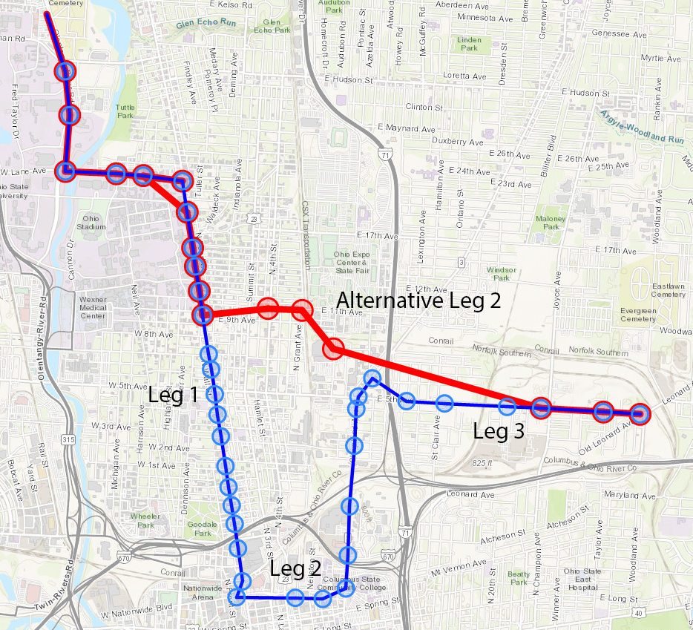

Figure 1: An example of overestimation in retrospective route (red, with 2 legs) compared to scheduled route (blue, with 3 legs). The delayed leg 1 makes the transfer between the leg 1 and alternative leg 2 becomes feasible, which is not possible in the scheduled timetable.

We can moreover deconstruct scheduled and retrospective real-time accessibility from a perspective of a user’s decision-making: these two accessibility systems do not separate the decision-making and the decision implementation process. For a user, the decision-making process typically happens *before* the implementation process since people plan their trips before actually taking the transit. However, both schedule and retrospective real-time accessibility models assume the two processes are happening simultaneously: the user can achieve the same performance the user can always know, board, and finish all the trips without any troubles that can incur extra waiting time or risk of missing a vehicle. Such an assumption is very unrealistic (Liu & Miller, 2020b; Park et al., 2020).

**Realistic real-time STP.** Because of the unrealistic nature of both schedule and retrospective real-time accessibility models, we therefore define *realistic real-time STP* or *realistic real-time accessibility* to better represent transit users’ actual decision-making process and therefore accessibility. A user does not have to experience the event to make the decision and the STP is calculated from only information that is obtained before the event happens, such as the scheduled time or expected time. From the perspective of decision making, the trip planning process happens before the event happens, which makes it possible for a user to implement.

Realistic real-time STP can vary depending on the trip planning strategy the user may take: for example, the user can attempt to reduce waiting time to as close to zero as possible, or take a more cautious approach that include a time buffer that minimized the chance of missing a bus (Liu & Miller, 2020a). In this paper, we will assume the user will plan trips based on the schedule, but implements these trips in the transit system with actual arrival times. Therefore, the trajectories of scheduled and realistic real-time STP are the same but with different travel times.

In practice, the calculation of realistic real-time STP involves two phases to simulate transit users’ two-step transit experience. We first calculate the scheduled STPs and their corresponding trajectories and travel time between stops. Then, we revisit each trajectory and recalculate each synchronization between buses with actual arrival time. For example, in the scheduled STP between two stops, the trajectory is {A, B, C}, where A, B, C represent subsequent stops. The user is scheduled to take bus 1 from stop A to B, then transfer at stop B to another bus 2, and finally arrive at stop C. However, because bus 1 is delayed, the user arrives late at the transfer stop B and misses the scheduled transfer bus 2. We will then find the next bus from stop B to C and record the new arrival time at stop C and travel time between stop A and C. Note that the user will not follow alternative routes, since users plan their route fully based on the schedule.

There are several factors that contribute to differences between the retrospective and realistic real-time STPs. The first factor is the potential delayed or early time at the origin stop and transfer stops, which can result in substantial delay times caused by chain reactions for longer trips that involves multiple transfers. A second factor is the fixed route, which usually is not the same as the optimal shortest route in the retrospective STPs. Realistic real-time STP is a more conservative and practical accessibility measure compared with its scheduled and retrospective real-time counterparts; it can better represent actual users’ transit experience.

* 1. Accessibility unreliability

The difference between expected (scheduled STP and retrospective real-time STP) and the experienced accessibility measures can be defined as the *accessibility unreliability.* Based on the STP definition we give, we define accessibility unreliability as:

|  |  |  |
| --- | --- | --- |
|  |  | (4) |

where: is the expected STP (schedule or retrospective), is the realistic/retrospective real-time STP, is the expected travel time, is the realistic/retrospective real-time travel time. We also introduce another definition of unrealized accessibility normalized by the expected STP:

|  |  |  |
| --- | --- | --- |
|  |  | (5) |

We calculate two versions of accessibility unreliability: scheduled STP’s unreliability and retrospective real-time STP’s unreliability. Scheduled STP is the promise that the transit authorities make with users, while realistic STPs are the actual experience the transit system delivers. The difference between the two represents the part of accessibility the transit system loses during the operation compared with the schedule. Retrospective real-time STP can be conceptualized as an upper bound of users’ physical accessibility in a transit system, while realistic real-time STP can be a lower bound. The unreliability represents the retrospective measures’ overestimation.

Despite we use realistic real-time STP as a benchmark in this study, we do not claim the realistic measure can fully reflect all transit users’ behavior and can be a universally authoritative benchmark. First, the realistic real-time STP uses transit schedule as the basis for users’ decision-making. However, users can follow different strategies and use supplemental navigation sources, such as real-time information. 2) Many other routing algorithms, like open trip planner, adopt different assumptions and conditions, which almost guarantee their results will be different. We view the retrospective and realistic STP as the upper and lower bound of the experienced accessibility, respectively.

1. Analysis

We

* 1. Spatial pattern and time budget

The spatial pattern of accessibility unreliability is highly dependent on the time budget – how much time the person gets to propagate the PPA. Therefore, we present the spatial pattern

We introduce two types of accessibility unreliability – retrospective and realistic unrealized accessibility. We present the spatial patterns of both measures in this section.

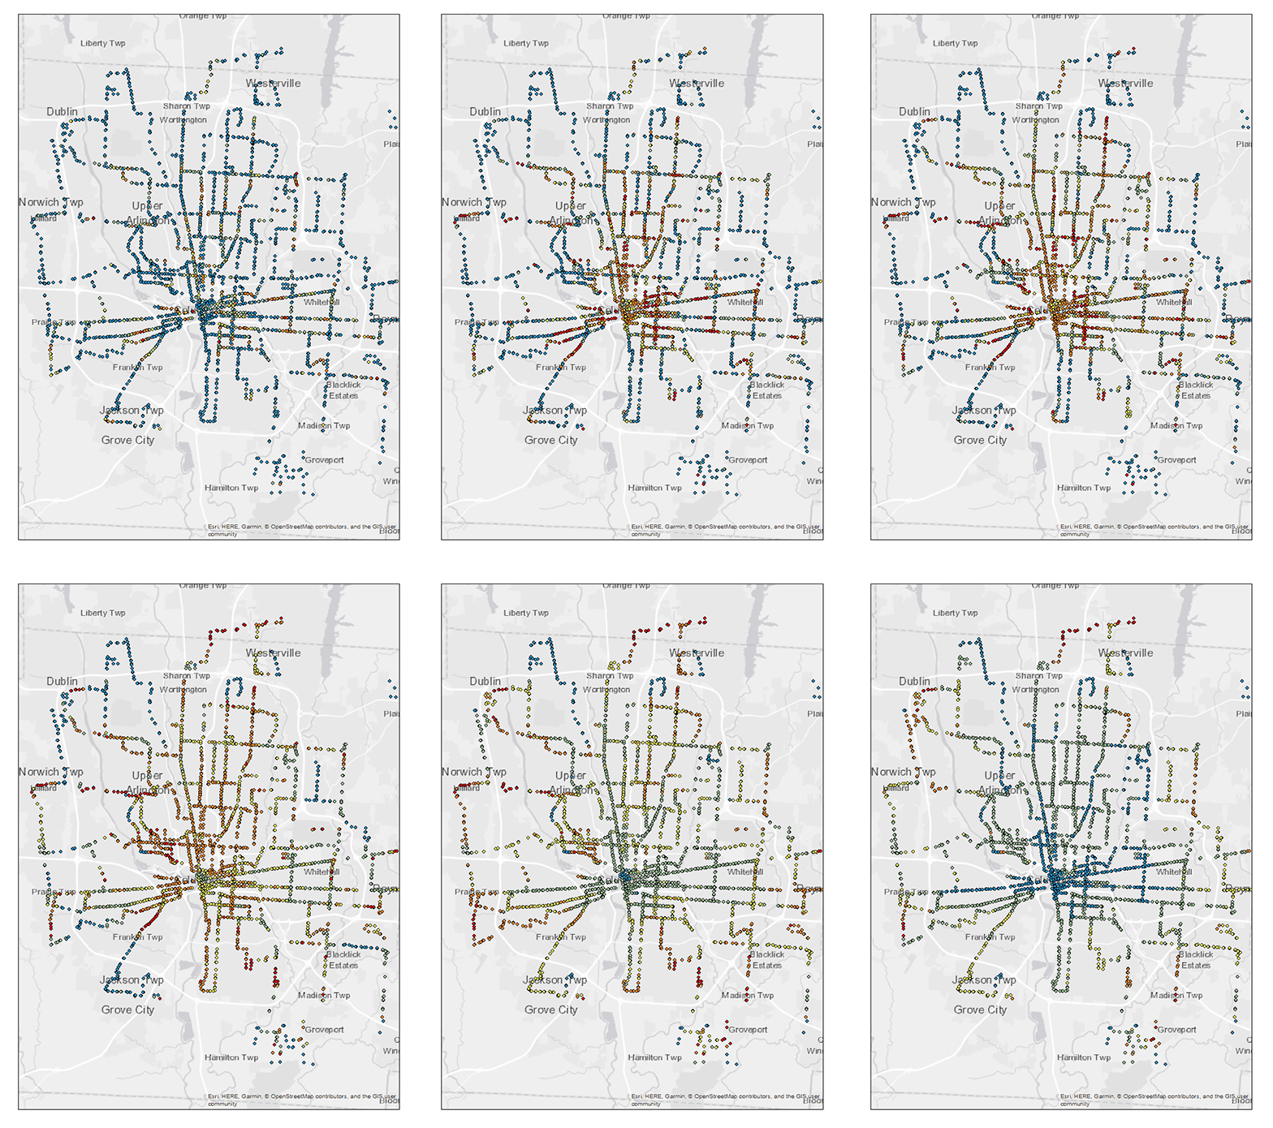

Figure 2: maps of average accessibility unreliability (schedule versus realistic STP) for each stop for time budget of 5, 15, 30, 60, 90, 120 minutes (from top left to bottom right).

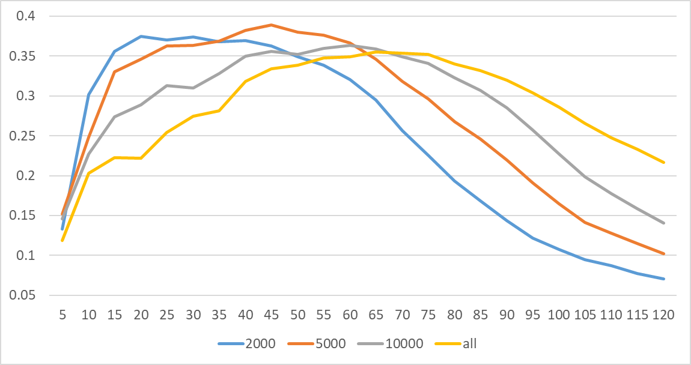

Figure 3: average normalized accessibility unreliability (realistic versus schedule normalized by schedule) for downtown core (radius of 2000 meter from downtown center), inner ring (radius of 2000 - 5000 meters), middle ring (radius of 5000 – 10000 meters), outer ring (outside 10000 meters).

* 1. Temporal pattern

We conduct temporal analysis on several dimensions in terms of the start time: days, seasons, days of week, and hours.

**Daily.** Figure 2 shows the daily pattern of the normalized accessibility unreliability from 2018 - 2019. In terms of different time budgets, larger time budgets larger than 15 minutes show generally similar and heterogenous patterns, while smaller time budgets show more homogeneous pattern. We also observe similar patterns in the spatial and other temporal analysis (discussed below).

We can observe two spikes among different months: February and September to October.

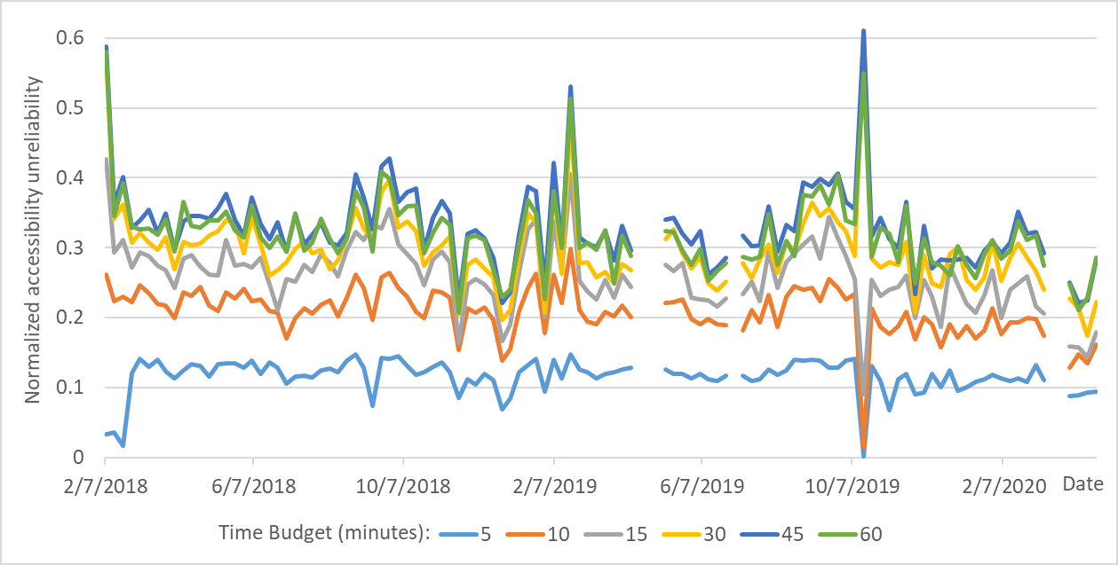

Figure 4: Daily average normalized accessibility unreliability with time budgets of 5 - 60 minutes. Blanks are

**Seasonal.** Figure 1 shows the average normalized accessibility unreliability among all stops for each quadrimester from 2018 to 2020.

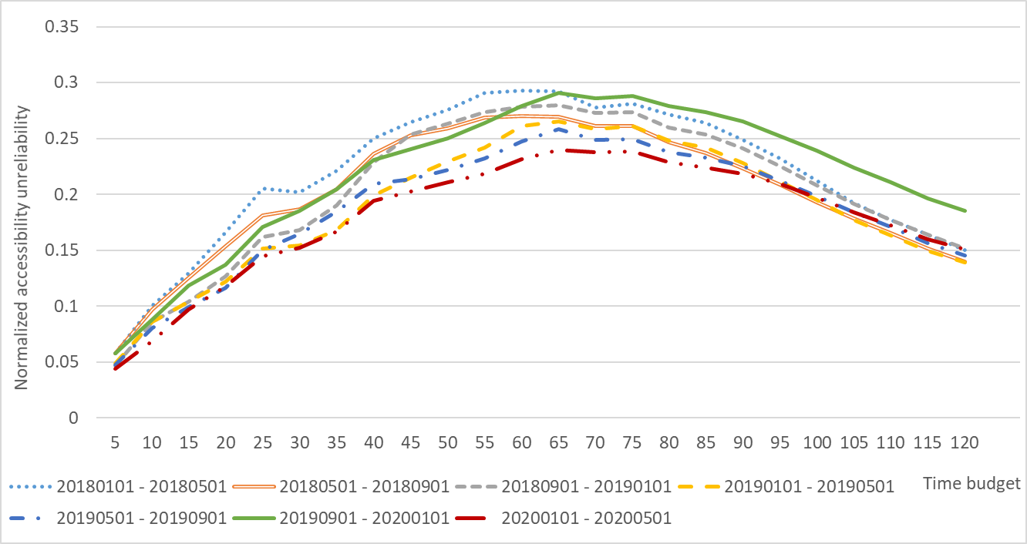

Figure 5 Average normalized accessibility unreliability index for each quadrimester from 2018 to 2020.

Days of week.

Hourly.

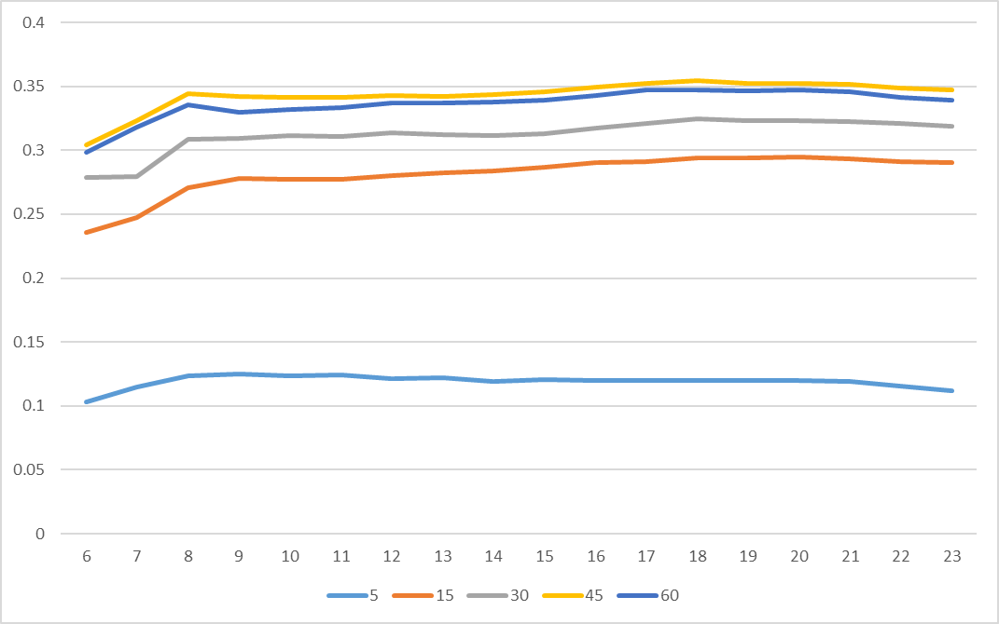

Figure 6: hourly average normalized accessibility unreliability for time budget of 5, 15, 30, 45, and 60 in the day of September 4, 2019.

References:

Ahn, B.-H., & Shin, J.-Y. (1991). Vehicle-routeing with time windows and time-varying congestion. *Journal of the Operational Research Society*, *42*(5), 393–400.

Banister, D. (2008). The sustainable mobility paradigm. *Transport Policy*, *15*(2), 73–80.

Barbeau, S. J., & Antrim, A. (2013). The Many Uses of GTFS Data – Opening the Door to Transit and Multimodal Applications. In *ITS America 2013*. Nashville, Tennessee: Intelligent Transportation Society of America. Retrieved from http://prezi.com/-69luw8sfabp/the-many-uses-of-gtfs-data-its-america-april-2013/

Central Ohio Transit Authority. (2021). Data. Retrieved June 27, 2021, from https://www.cota.com/data/

Farber, S., Bartholomew, K., Li, X., Páez, A., & Habib, K. M. N. (2014). Assessing social equity in distance based transit fares using a model of travel behavior. *Transportation Research Part A: Policy and Practice*, *67*, 291–303.

Gendreau, M., Ghiani, G., & Guerriero, E. (2015). Time-dependent routing problems: A review. *Computers & Operations Research*, *64*, 189–197.

Golden, B. (1976). Shortest-path algorithms: A comparison. *Operations Research*, *24*(6), 1164–1168.

Google Developers. (2020a). GTFS Static Overview | Static Transit | Google Developers. Retrieved May 26, 2021, from https://developers.google.com/transit/gtfs/

Google Developers. (2020b). Trip Updates. Retrieved August 25, 2021, from https://developers.google.com/transit/gtfs-realtime/guides/trip-updates

Hägerstrand, T. (1970). What about people in regional.

Hall, R. W. (1983). Travel outcome and performance: the effect of uncertainty on accessibility. *Transportation Research Part B: Methodological*, *17*(4), 275–290.

Handy, S. (2020). Is accessibility an idea whose time has finally come? *Transportation Research Part D: Transport and Environment*, *83*, 102319.

Hansen, W. G. (1959). How accessibility shapes land use. *Journal of the American Institute of Planners*, *25*(2), 73–76.

Helta, M. (2018). *Trippin’ on MTA with Transit App - A discussion in real-time about real-time information*. Baltimore. Retrieved from https://www.baltometro.org/sites/default/files/bmc_documents/committee/presentations/brtb/BRTB181218pres_Trippin-App-MTA.pdf

Hsiao, S., Lu, J., Sterling, J., & Weatherford, M. (1997). Use of geographic information system for analysis of transit pedestrian access. *Transportation Research Record*, *1604*(1), 50–59.

Ichoua, S., Gendreau, M., & Potvin, J.-Y. (2003). Vehicle dispatching with time-dependent travel times. *European Journal of Operational Research*, *144*(2), 379–396.

Ingram, D. R. (1971). The concept of accessibility: a search for an operational form. *Regional Studies*, *5*(2), 101–107.

Kim, H., & Song, Y. (2018). An integrated measure of accessibility and reliability of mass transit systems. *Transportation*, *45*(4), 1075–1100.

Kwan, M.-P. (2000). *Evaluating gender differences in individual accessibility: A study using trip data collected by the global positioning system*.

Kwan, M. (1999). Gender and individual access to urban opportunities: a study using space–time measures. *The Professional Geographer*, *51*(2), 210–227.

Lee, J., & Miller, H. J. (2018). Measuring the impacts of new public transit services on space-time accessibility: An analysis of transit system redesign and new bus rapid transit in Columbus, Ohio, USA. *Applied Geography*, *93*, 47–63. https://doi.org/10.1016/j.apgeog.2018.02.012

Lenntorp, B. (1976). Paths in space-time environments: a time-geographic sudy of movement possibilities of individuals. *Lund Studies in Geography B,* *44*, 150p.

Levinson, D., & Wu, H. (2020). Towards a general theory of access. *Journal of Transport and Land Use*, *13*(1), 129–158.

Liu, L., & Miller, H. J. (2020a). Does real-time transit information reduce waiting time? An empirical analysis. *Transportation Research Part A: Policy and Practice*, *141*, 167–179.

Liu, L., & Miller, H. J. (2020b). Measuring risk of missing transfers in public transit systems using high-resolution schedule and real-time bus location data. *Urban Studies*, 0042098020919323. https://doi.org/10.1177/0042098020919323

Liu, L., Miller, H. J., & Scheff, J. (2020). The impacts of COVID-19 pandemic on public transit demand in the United States. *PLoS ONE*, *15*(11 November), e0242476. https://doi.org/10.1371/journal.pone.0242476

Malekzadeh, A., & Chung, E. (2020). A review of transit accessibility models: Challenges in developing transit accessibility models. *International Journal of Sustainable Transportation*, *14*(10), 733–748.

Miller, H. J. (1991). Modelling accessibility using space-time prism concepts within geographical information systems. *International Journal of Geographical Information System*, *5*(3), 287–301.

Miller, H. J. (1999). Measuring space‐time accessibility benefits within transportation networks: Basic theory and computational procedures. *Geographical Analysis*, *31*(1), 187–212.

Miller, H. J. (2017). Time geography and space-time prism. *International Encyclopedia of Geography: People, the Earth, Environment and Technology*, 1–19.

Neutens, T., Witlox, F., & Demaeyer, P. (2007). Individual accessibility and travel possibilities: A literature review on time geography. *European Journal of Transport and Infrastructure Research*, *7*(4).

Owen, A., & Levinson, D. M. (2015). Modeling the commute mode share of transit using continuous accessibility to jobs. *Transportation Research Part A: Policy and Practice*, *74*, 110–122.

Park, Y., Mount, J., Liu, L., Xiao, N., & Miller, H. J. (2020). Assessing public transit performance using real-time data: spatiotemporal patterns of bus operation delays in Columbus, Ohio, USA. *International Journal of Geographical Information Science*, *34*(2), 367–392. https://doi.org/10.1080/13658816.2019.1608997

Schmitt, A. (2018). The Columbus Bus Network Redesign Boosted Ridership. Retrieved June 29, 2021, from https://usa.streetsblog.org/2018/08/14/the-columbus-bus-network-redesign-boosted-ridership/

Tang, J., Song, Y., Miller, H. J., & Zhou, X. (2016). Estimating the most likely space–time paths, dwell times and path uncertainties from vehicle trajectory data: A time geographic method. *Transportation Research Part C: Emerging Technologies*, *66*, 176–194.

Tasic, I., Zhou, X., & Zlatkovic, M. (2014). Use of spatiotemporal constraints to quantify transit accessibility: Case study of potential transit-oriented development in West Valley City, Utah. *Transportation Research Record*, *2417*(1), 130–138.

Transit Wiki. (2021). GTFS-realtime. Retrieved August 25, 2021, from https://www.transitwiki.org/TransitWiki/index.php/GTFS-realtime

Tribby, C. P., & Zandbergen, P. A. (2012). High-resolution spatio-temporal modeling of public transit accessibility. *Applied Geography*, *34*, 345–355.

Wang, Y., Yuan, Y., Ma, Y., & Wang, G. (2019). Time-dependent graphs: Definitions, applications, and algorithms. *Data Science and Engineering*, *4*(4), 352–366.

Wessel, N., Allen, J., & Farber, S. (2017). Constructing a routable retrospective transit timetable from a real-time vehicle location feed and GTFS. *Journal of Transport Geography*, *62*, 92–97.

Wessel, N., & Farber, S. (2019). On the accuracy of schedule-based GTFS for measuring accessibility. *Journal of Transport and Land Use*, *12*(1), 475–500.

Wu, H., & Levinson, D. (2020). Unifying access. *Transportation Research Part D: Transport and Environment*, *83*, 102355.

Wu, Y.-H., & Miller, H. J. (2001). Computational tools for measuring space-time accessibility within dynamic flow transportation networks. *Journal of Transportation and Statistics*, *4*(2/3), 1–14.

Xie, D., Zhu, H., Yan, L., Yuan, S., & Zhang, J. (2012). An improved Dijkstra algorithm in GIS application. In *World Automation Congress 2012* (pp. 167–169). IEEE.

Zhang, T., Dong, S., Zeng, Z., & Li, J. (2018). Quantifying multi-modal public transit accessibility for large metropolitan areas: a time-dependent reliability modeling approach. *International Journal of Geographical Information Science*, *32*(8), 1649–1676.

Zhao, F., Chow, L.-F., Li, M.-T., Ubaka, I., & Gan, A. (2003). Forecasting transit walk accessibility: Regression model alternative to buffer method. *Transportation Research Record*, *1835*(1), 34–41.