Measuring the Impact of COVID-19 Pandemic on Public Transit Demand in US

Luyu Liu

1. Introduction

A novel coronavirus disease (COVID-19) has evolved into a global health crisis for its high contagiousness, high fatality rate, and lack of known treatments. To deal with the pandemic, Centers for Disease Control and Prevention (CDCs) and governments in different places recommended social distancing, self-quarantine, and work from home policies to stop the spread of the virus. However, the sudden shutdown also caused recessions in the domain of mobility, economic, and social activities. Different modes of transportation, especially mass transit, suffered considerable loss of passengers due to self-quarantine recommendation and contagion concerns. For example, as countries are closing their borders amidst the fear of transnational spread, the final week of March 2020 witnessed commercial flights dropped by 55% compared to the same date in 2019 (Weber 2020).

This sudden meltdown especially impacted the public transit system across the United States compared with other modes. First, just like other transportation modes, fewer passengers need to take the transit systems due to the suspension of all unessential businesses and work from home orders. Moreover, compared with other transportation modes, public transit systems are perceived to have higher risk. It is natural and common to assume that sharing a narrow and unventilated space with numerous strangers is a bad idea during the pandemic, thus people will generally avoid taking transit trips. According to an online survey (sample of n = 1000 Americans and n = 1000 Canadians), about 48% of Americans and 40% of Canadians feel that riding transit poses a high health risk due to the virus (Yellin 2020). Therefore, most transit systems has witnessed major decrease of transit demand even before the outbreak of the pandemic. For larger transit systems, for example, Washington Metropolitan Area Transit Authority reported that metrorail ridership has been reduced by 90% and bus ridership has been reduced by up to 75% by the end of March (WMATA 2020); for smaller transit system such as El Dorado transit in El Dorado county, California, the ridership also decreased by up to 75% (Christensen 2020). This unprecedented widespread recession has created major economic and stuff health difficulties for all public transit systems across the nation. It is necessary and urgent to measure the impact of the COVID-19 pandemic on the transit systems.

Although it is the first time for the last 30 years that the US society witnesses a total lockdown at the nationwide scale due to a pandemic, there are still sources and experiences about how a pandemic could impact transit systems in different contexts. For example, the severe acute respiratory syndrome (SARS) outbreak in East Asia in 2003 and the Middle East respiratory syndrome (MERS) outbreak in Korea in 2015 all had major impacts on local transit systems in different extent. Wang (2014) used a statistic model to measure the fear of the 2003 SARS pandemic by the ridership decrease of Taipei underground system in the city of Taipei, Taiwan. Based on ridership data from 2001 – 2005, the paper reported that the pandemic resulted in an immediate loss of 1200 ridership per day and 50% of daily ridership compared with ordinary days during the peak of the SARS pandemic. The paper concentrated on the modelling of fear: the total fear is decomposed into the fresh fear, which is generated by the increasing daily confirmed patient’s number, and the residual fear, which propagated and exponentially decays to the following days. Kim et al. (2017) also addressed the fear exposure during the 2015 MERS outbreak in Seoul, South Korea with the transit system smart card transaction data. The paper discussed the variation of trip frequency for different public transit mode, different populations, and different traffic analysis zone in Seoul. The paper also pointed out that fear towards the pandemic had a significant influence on travel behavior; people’s ability to change their daily routine, which is measured by land value in the paper, is relevant when determining the extent of behavioral change. However, the focus of these papers is not transit system per se, but the fear exposure; therefore, the papers did not cover the process of transit ridership recession and its implication. Meanwhile, though the microscope analyses are extremely useful, these results may not apply in other contexts; their special demographic and social-economic status also makes the results exclusive for the East Asia cities. Therefore, it is necessary and urgent to address the impacts of COVID-19 pandemic on the US transit ridership with new measurements and new data; this includes the impacts’ extent, geographic and temporal variation, and its relevance with the development of the pandemic.

However, most transit systems will not or have yet to release their ridership data, and it will take a long time to collect these data for each system. In this paper, we use the transit demand decrease data obtained from the Transit app to infer the change of ridership. We use logistic model to fit the data of each transit system and get the key parameters from the models: **floor value**, which represents the limit of social distancing**; decay rate and half-life**, which represents the speed of the recession; **divergent date**, which represents the initial date when the transit demand began to decrease. We **also calculate the distance between the transit demand decrease curve and the disease cases number curve.**

1. Analysis

In this section, we first introduce our data sources of the transit demand and COVID-19 daily cases statistics. Then, we introduce our theory about the dynamics of transit demand and three key parameters in the model. Then, we investigate the linkage between the transit demand curve and case increase curve.

* 1. **Data sources**

**Transit demand change.** We collected the transit demand change data via the web interface maintained by Transit app. Transit is a popular mobile app providing real-time public transit data and trip planning. The app covers over 200 cities around the world with more than 5 million download on Android platform (Transit app 2020b). Therefore, although the actual ridership data is still largely unknown and inaccessible, the usage of the app can be regarded as a rough measure for the transit demand of these app users (Transit app 2020a). As COVID-19 hit the world and the transit demand decreased consequently, the app website kept updating on the changes of transit demand on an everyday basis. The change values are a set of percentage, calculated by comparing actual usage of the app to projected use of the app based on last year’s numbers. The projected numbers are also adjusted for annual growth (Transit app 2020a). By this adjustment, the values can represent the difference between expected and the actual transit demand.

To valid the authenticity of transit app data, we collected the official ridership decrease report from each system’s website and local news. However, most transit system will not release the full data for each date, instead, many will only release one estimate for one certain day. We collected the reported ridership decrease percent and report date and compared them with the corresponding demand decrease percent from the Transit app dataset in the same date. Figure 1 shows the proximity between the two measures for 40 transit systems that we could trace the actual ridership decrease value. Then we computed the difference of the two measures as the bias for Transit app demand decrease; we moreover calculated the difference’s average value and standard deviation. The average bias is 3.7% and the paired T-test shows that p-value is 0.14>0.05; this means we cannot reject the null hypothesis of no difference between two means, suggesting the conditional unbiasedness for the sampled 40 transit systems. The standard deviation is 15.96%, which may be because of the different definitions of normal ridership level. Generally speaking, the comparison shows that the transit app demand data can be a good indicator despite non-trivial standard deviation.

Although the small-sampled test shows the unbiasedness of the Transit app data, the difference between the behaviors of apps users and other users, the accurate ratio of apps users among all transit users, and other factors affecting the representativeness of the usage statistics are still largely unknown. However, we can still use it as a rough but reasonable proxy to capture the changes of transit demand and ridership caused by the COVID-19 pandemic due to the large user group and popularity of real-time transit apps.

Figure 1: the proximity between actual ridership decrease and demand decrease for 40 transit systems.

The data includes 182 public transit systems across the United States, Canada, Australia, New Zealand, and France. We select all 113 transit systems in 63 metro areas, 52 counties, and 28 states across the United States and conduct analyses based on these areas.

**COVID-19 case numbers.** We collected the daily case numbers for each county from the COVID-19 Surveillance Dashboard produced by University of Virginia (Biocomplexity Institute 2020), COVID-19 Dashboard produced by John Hopkins University (JHU CSSE 2020), and COVID-19 maps and county-level dataset produced by USAFacts (USAFacts 2020). The data includes all counties’ confirmed cases in the US for every day. To find the linkage between the case numbers and the demand decrease, we geocoded each transit system to the corresponding county or county equivalent unit.

* 1. **Logistic model for daily transit demand change**

We first plot the scatter point graph for all systems together as shown in Figure 1 with daily transit demand change data. For all systems during the first few days, the demand generally oscillate around the base line. As the epidemic and quarantines progressed, the demand gradually decreased, until reached a very low level and then stabilized.

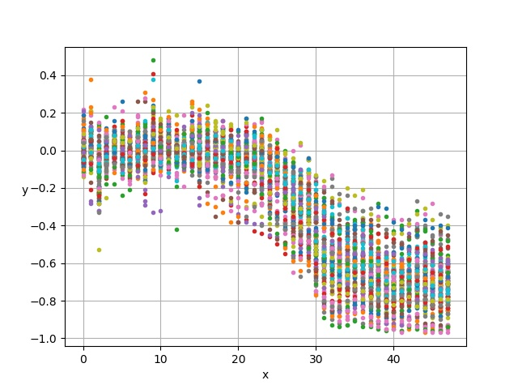Figure 2: the scatter point of all systems' daily demand change.

The shape of the curves can be easily connected with logistic function; therefore, to generalize the change of transit demand, we will use logistic function to fit the data. A logistic or sigmoid function can be expressed into the following form:

|  |  |  |
| --- | --- | --- |
|  |  | (1) |

Where: is the curves’ minimum decreased value, is the curves’ baseline value, k is the logistic growth rate or steepness of the curve; t represent the time (day) and is the day when the function reaches the midpoint. We will fit each transit system’s demand data using logistic model individually and calculate these three parameters. In the next section, we discussed the trend of three parameters for each system.

**Floor value.** In the logistic model, the parameter B represents the range of the logistic curve. The curve will decrease rapidly and then stabilize around the B value, therefore we name it *floor value.* In the practical sense, it represents the ratio of public transit users in this system that still will not or cannot stop using it regardless of the pandemic. For different systems in different metro areas, the floor value is vastly different due to their different social and economic status.

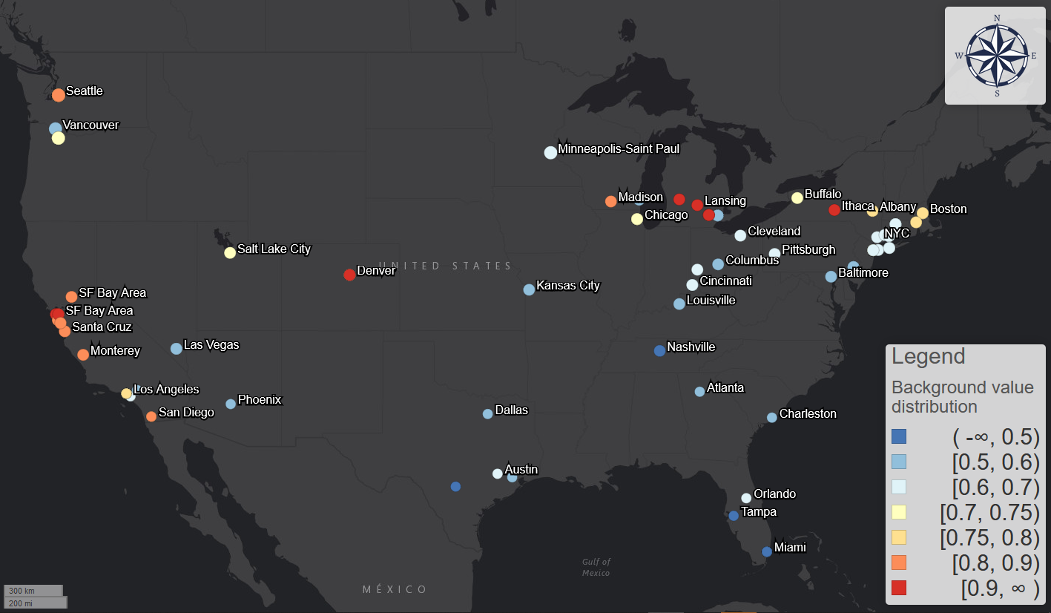

Figure 3: The distribution of floor value across the United States.

The first supposed factor that can have a significant impact on the floor value is the ratio of population with non-physical occupations. Similar to *life fixity* introduced by Kim et al. (2017), which is measured by land price, the ratio of population with non-physical occupations measures the population’s degree of freedom to change the routine of their daily life; it represents how many people can work from home thus avoid regular transit commuting to reduce contagion risk. If an area has higher ratio of non-physical jobs, workers can easily work from home thus the transit demand will decrease further. To test this hypothesis, we use the table “occupation for employed civilian population 16 years and over” from the most recent American Community Survey (ACS) 5-year estimates (2014 – 2018). The table contains the number of employed population in different industries; among these occupation categories, we assign “management, business, and financial operations occupations”, “professional and related occupations”, and “office and administrative support occupations” as the occupations with which people can work from home remotely.

The second supposed factor is the dependency on private vehicles of the area. This can be measured by the ratio of house units that have no vehicles. Supposing more people in the area do not have access to private vehicles, the dependency on the transit system will be higher, thus the decrease of demand can be expected to be less because more people will still rely on transit system. We collected this data from ACS 5-year estimates data (2014 - 2018).

The third supposed factor is the ratio of senior people. We also collected the ratio of age over 55 from the ACS 5-year estimates data. Senior people is the primary susceptible group of the SARS-COVID-2 virus; as of April 21st 2020, people over 55 years old accounted for 91.57% of total deaths reported to the National Center for Health Statistics (Centers for Disease Control and Prevention 2020). Therefore, the ratio of senior population can be a significant factor.

We conducted linear regression analysis between the floor value and the three factors to validate the correlation. The regression results in Table 1 shows that all factors are significant with p-value smaller than 0.05; the F test also shows the model is significant with p-value of . The R-squared value is 0.18, which indicates medium effect size. The residuals assessment moreover shows that the residuals are subject to normal distribution and there are almost no multicollinearity and leverage points.

From the model and the coefficients, we can know that: first, the demand will decrease more if the percentage of people with non-physical occupations is higher. It turns out to be the most significant factor among the three from the R-squared increment. This suggests that occupation, though not directly associate with transportation, is more correlated with transit demand. Meanwhile, the less senior population, the more the demand will decrease; this could be because the information acquiring ability and awareness of the pandemic for young people are generally higher. This is also ironic and alarming: senior people are the most vulnerable population while the area with more senior people generally will have less demand decrease. Last, the dependency on the private vehicles is another significant factor: the more house units with no private vehicles, the more dependent the people are on the transit systems; therefore, people do not have choices but have to stick to transit regardless of the pandemic.

|  |  |  |  |  |  |  |
| --- | --- | --- | --- | --- | --- | --- |
|  | Estimate coefficient | Standard Error | t value | Pr(>|t|) | VIF | R-squared increment |
| Intercept | -0.586 | 0.136 | -4.31 | 3.59E-05 |  |  |
| Ratio of people with non-physical occupation | -0.707 | 0.168 | -4.21 | 5.27E-05 | 1.31 | 0.134 |
| Ratio of no-vehicle house units | 0.158 | 0.0759 | 2.08 | 0.0397 | 1.31 | 0.0331 |
| Population over 55 year old | 0.926 | 0.394 | 2.35 | 0.0204 | 1.00 | 0.0422 |

Table 1: regression results

Floor value is a good measure to demonstrate the potential of transit demand and the regression analysis shows its inherent linkages with different aspects of the social-economic factors. The distribution of floor value can be a good reference for the transit system re-design, funding distribution, and city planning during and after the COVID-19 pandemic. For example, decision-makers can use floor value to measure the degree of ridership recession to assign the relief funding for different public transit systems. For future transit design, COVID-19 provides a bitter but good opportunity to measure the resilience of the local transit system and transit dependency of the local community.

**Divergent point and convergent point.**

As we visualize the curve of the transit demand, the decrease mainly happens during a relatively short period in the middle. Therefore, to measure when the demand started to decrease and finally finished the decreasing process, we introduce two measures: divergent point and convergent point . We apply the confidence interval theory to the definition of the measures by first construct the probability density function of the normalized logistic function F(x):

|  |  |  |
| --- | --- | --- |
|  |  | (2) |
|  | Then: , and | (3) |

Where: P is the probability density function of the normalized logistic function; to normalize the logistic function, we subtract the baseline and divide the result by B to construct the P function so that . is the confidence level. We choose 5% for the confidence level, which is a widely accepted value. The significant level is a useful threshold to decide whether a fitted value changes significantly compared to the baseline value/floor value.

From the formula (3), we can induct that , which means under the confidence level of 0.95, we can make sure most change happen between the divergent point and convergent point. From the formula, we give the direct definition of divergent and convergent point:

|  |  |  |
| --- | --- | --- |
|  | and | (4) |

Moreover, the two measures are not directly calculated from the raw observed data, instead, we obtained the measures from the smoothened curve to remove the stochastic noise. They can be a stable indicator to measure the start and end of the demand decrease.

Beyond its statistical meaning, divergent point represents the first daywhen the demand curve began to diverge from the normality. It also represents when the transit users start to realize they should avoid the transit trips. Convergent point, on the other hands, represents when the decrease finally finishes. After the convergent point, the transit demand will persist at a stable level. In the next section, we will compare the two measures with the development curve of the pandemic cases.

**Decay rate.** Beside the divergent point, the speed of recession is another aspect. The parameter represents the curve’s decreasing speed from the baseline value to the floor value. Therefore, we name it *decay rate*. Decay rate can be an important indicator for the actual response speed of urban residents/public transit users to the pandemic. Figure 3 shows the distribution of the decay rate.

Although the decay rate works well, the rate value per se does not have any physical meaning. Instead, we would like to use a temporal indicator to represent the speed and duration of the decline. From the logistic model, represents the time/days from the day zero to the curve reaches the midpoint of the curve. It reflects two major temporal factors for the pandemic: the initial date of epidemic outbreak, which is measured by the divergent point, and the half-duration of decay. Therefore, we introduce half-life:

|  |  |  |
| --- | --- | --- |
|  |  | (4) |

Half-life is only determined by the decay rate. Half-life indicates the duration of the duration of the demand decrease.

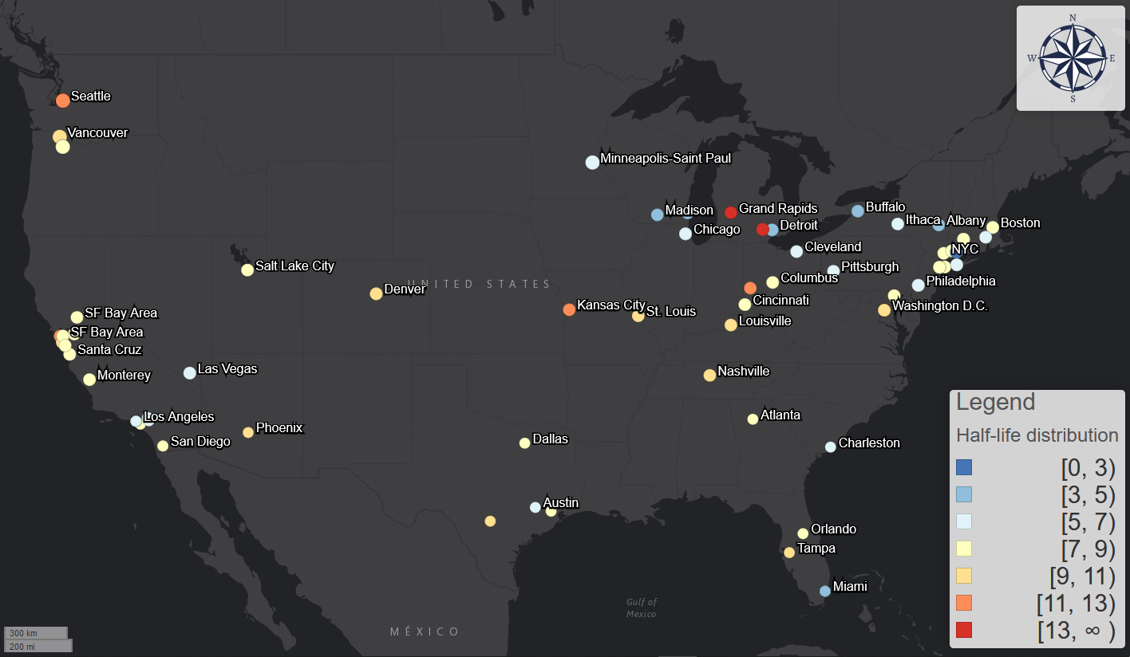

Figure 5: the distribution of half-life

* 1. **Desynchronization between demand decrease and epidemic.**

The process of transit demand decrease is not synchronous with the development of the pandemic. To measure the difference between the two curves, we can compare the divergent point when transit demand decreased and the first day when the pandemic is first confirmed to begin to spread in the local community. This measure also indicates the transit users’ responses compared to the actual development of the pandemic. If the value is smaller than 0, it means most transit users are still using the transit systems as their usual routine; if the value is bigger than 0, it means the transit user community started to make a response, regardless of the speed (decay rate) and the extent (floor value) of the response, prior to the confirmation of the local outbreak. Another similar metric is the difference between the date of first confirmed case and the convergent point, which shows whether the user can totally avoid the transit trips when the actual epidemic arrives.

However, there is another necessary factor that should be taken into consideration beyond the date of first confirmed. The median of incubation period is 5 days and can be as long as 14 days (Lauer et al. 2020). Meanwhile, numerous studies have proven that the virus can spread asymptomatically (Cheng et al. 2020; Dong et al. 2020; Pan et al. 2020). Therefore, the actual initial date when the virus began to spread in the local community can be traced back to 4 - 14 days ago. This lag can be even longer considering the lack of testing kits and slow response for the local authority (Achenbach et al. 2020; Popovich 2020). Therefore, it is necessary to consider this temporal lag ahead of the first confirmed date. Therefore, we can introduce an *incubation lag* parameter in the measures; it measures the temporal delay factors beyond the first case confirmed, such as incubation period and testing delay. Here, we introduce the definition of *response interval* from divergent point and convergent point:

|  |  |  |
| --- | --- | --- |
|  |  | (5) |

Where: is the date of first confirmed case in the county of the transit system; l is the incubation lag; and are the divergent and convergent point. Positive response interval means that the transit users responded earlier than the epidemic spread; the larger the value is, the less risk the transit users are exposed to the virus. For the two versions, the divergent version focuses on the transit users’ awareness while the convergent version focuses on both the awareness and the response speed. Next section we are going to discuss them separately.

Figure 4 shows the distribution of the response interval measures in the US from both divergent and convergent point for incubation lag = 0, 5, 14 days. Figure 5 shows the impact of incubation lag on the ratio of transit systems with positive response intervals (earlier response).

For response intervals from the divergent point: when not considering the incubation lag, the pattern is highly polarized. In some cities with international airports, such as Seattle, Washington State where the first US COVID-19 cases were found, people still used the transit even after the first case emerges. Meanwhile in other cities, such as most cities in Middle West except Chicago, although the cases have not been found in these cities, people already started to avoid transit trips. This can be because the media began to report the severity of this disease and CDC made the prediction that the community spread is inevitable near the end of February 2020 (McLauphlin 2020).

However, after we consider the incubation lag = 5 days, which is the reported average incubation period, many areas with earlier response now have negative response interval. A most noticeable area is the New York City. With lag = 0, out of 13 transit system in the New York City, there are 5 systems that have positive response intervals, such as MTA - Bronx buses, Suffolk County Transit, and Long Island Rail Road; when lag = 5, all of the 13 transit systems all have negative response intervals. This also suggests that New York transit users did not realize the necessity of avoid transit and non-essential trips when the community spread began. On the contrary, most transit systems in the Middle West such as Missouri, Ohio, Michigan, and Kentucky still have positive response intervals. This phenomenon is also supported by the cellphone location data: those places mentioned above had known stay-at-home orders before March 27th and the measured trips are significantly less (Glanz et al. 2020). Due to earlier response, the transit users in these area may be exposed to less risk during the pandemic.

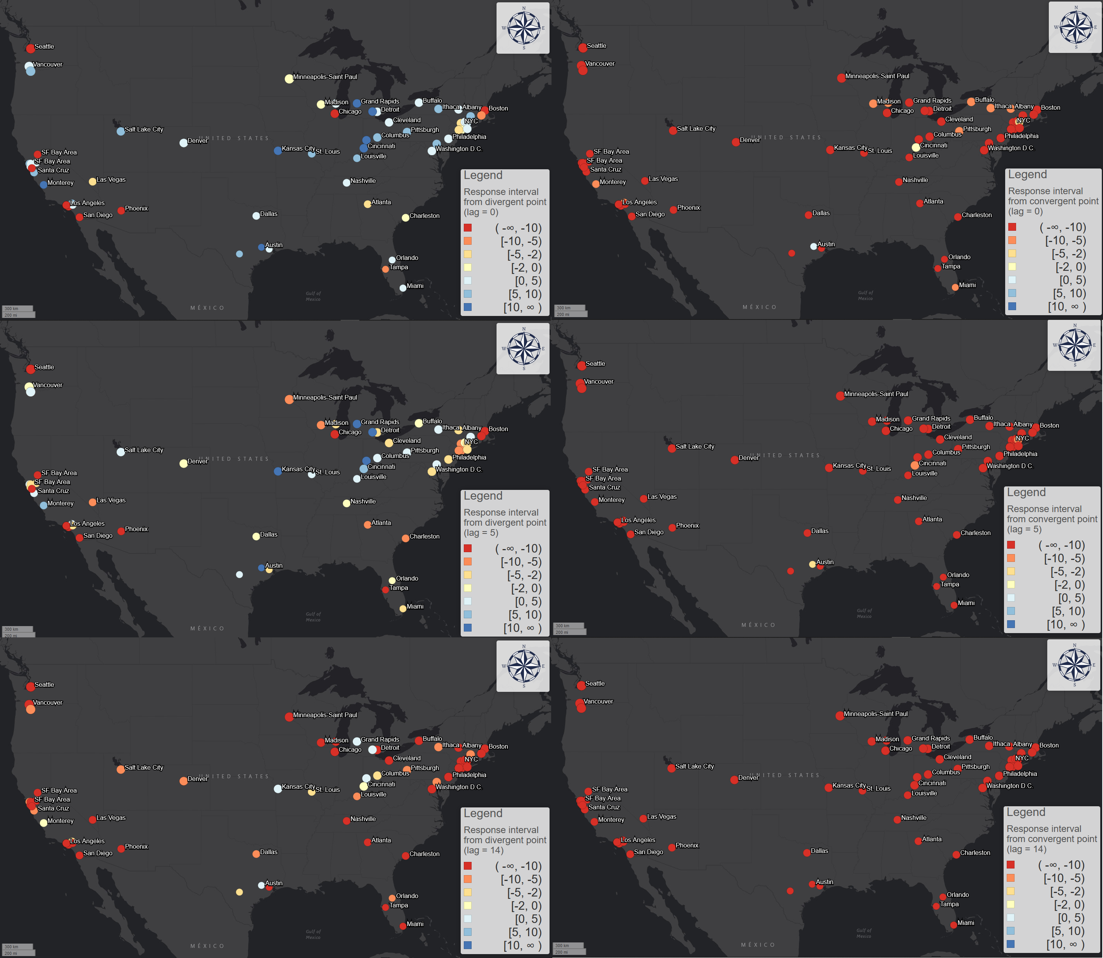

Figure 6: the geographic pattern of response interval with incubation lag = 0, 5, and 14 days for both from divergent and convergent point.

For the scenario of lag = 14 days, which is a highly hypothesis scenario, most transit systems and most cities have negative response.

However, the situation is not going well for the response intervals from convergent point, which represent how earlier is each transit system’s users finished the stay-at-home process. For scenario of lag = 0, only Capital Metro in Austin, Texas and HRT in Hampton, Virginia. For the case of Austin, the demand decrease started at March 6th and finished at March 22nd; the first case was confirmed at March 25th. However, long before the first confirmed case, the city and county authority declared the local state of emergency in March 6th (Evans 2020), which is one of the earliest places to take actions in the South, even in the United States. The divergent point is also the same as the date of local state of emergency, which suggests the effectiveness of the executive order. This can be one reason for the relatively fast and earlier reaction of transit users.

Under the most ideal circumstances, the curve should already finish the declining process before the community spread, which means most transit users can avoid non-essential transit trips after the virus began the local spread. However, for larger lag such as lag = 5 and 14 days, no transit systems and cities have positive response intervals. This suggest that all mentioned US transit systems have not completed the decreasing process when the community spread has started.

Figure 7: Trend of the ratio of transit system with positive response interval for different incubation lag

* 1. Hourly pattern.

The analyses based on the average measures of each day shows the coarse-grained temporal variation of different cities; however, the results do not address the transit demand’s variation within each day. In this section, we analyze and interpret the similarity between the two curves under the normal circumstance without the impact of COVID-19 and the actual circumstance with the impact.

**Similarity.** To conduct the similarity analyses, we use the hourly transit demand change data. Like the daily data, the hourly normal values are also calculated based on the historical data and adjusted with annual growth.

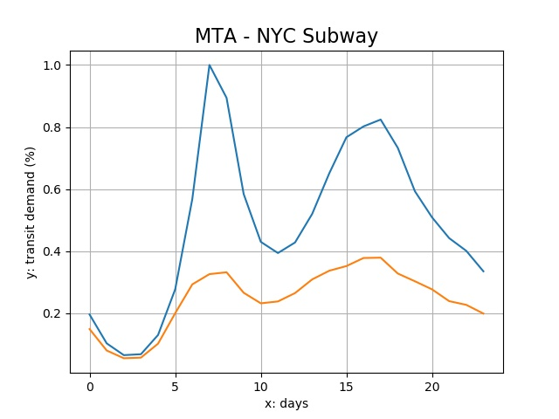

The similarity between the normal and actual curves can generally be decomposed into two factors: the average distance between the curve point and the difference between the shapes of curve point. We utilize an *ordinary Procrustes analysis* approach to measure the two factors. First, we will superimpose the curve of actual curve to the normal curve. For traditional Procrustes analysis for arbitrary shapes, the superimpose process includes panning, scaling, and rotating (Mitteroecker et al. 2013). However, because we know the shift of the demand curves does not contain the panning and rotating process, we will only conduct scaling process in practice. We use a stretch factor as a multiplier on the actual curve to fit the normal curve so that their Procrustes distance is minimized. The process can be denoted as:

|  |  |  |
| --- | --- | --- |
|  | Minimize: | (7) |

Where: is the Procrustes distance, is the stretch factor, is the number of data points in the dataset, is the actual transit demand at time , and is the normal transit demand at time . The solution to this optimization problem is:

|  |  |  |
| --- | --- | --- |
|  |  | (8) |

The optimal stretch factor can be regarded as a measure of average demand decrease, which can be a good complement to the daily transit demand decrease percentage data.

The Procrustes distance with the optimal stretch factor is a good measure of shape similarity without distance and size. It could reflect some very important aspects of the city’s transit mobility patterns, especially for commuting to work: for example, larger Procrustes distance means that the shape of current demand curve changes dramatically from the normal one; it also suggests that commuting decreases more than other transit activities during a day.

Figure 7 shows the geographic distribution of each transit system’s average Procrustes distance between its normal and actual hourly demand curves. It shows a very different pattern for traditional metro areas like New York City and non-physical occupation dominating areas like San Francisco Bay area, and University cities like Ithaca, Madison, and Ann Arbor. The Procrustes distance of traditional metro areas is low, meaning the shape before and during the pandemic did not change much; while the large distance of non-physical occupation dominating areas suggests a major change in their commuting patterns, for most workers will work from home thus most commuting activities will be halted.

Figure 8 shows the temporal distribution of all the transit systems’ average Procrustes distance between its normal and actual hourly demand curves. The temporal analysis shows that the distance between current and expected demand is steadily increasing, which means the shape of the current demand is gradually diverging from the normal shapes. From the week of March 9th to the week of April 6th, the weekly average is 0.299, 0.554, 0.621, 0.631, and 0.633. Like the daily average demand, the distance also rapidly increased and then stabilized around a low value.

The shape of the distance value also shows a very regular periodical pattern for each week and the distance is much higher for weekdays than weekends, which means the shape diverged more for weekdays. This is also due to the halt of commuting activities. In this sense, during the pandemic, weekdays became more like weekends.

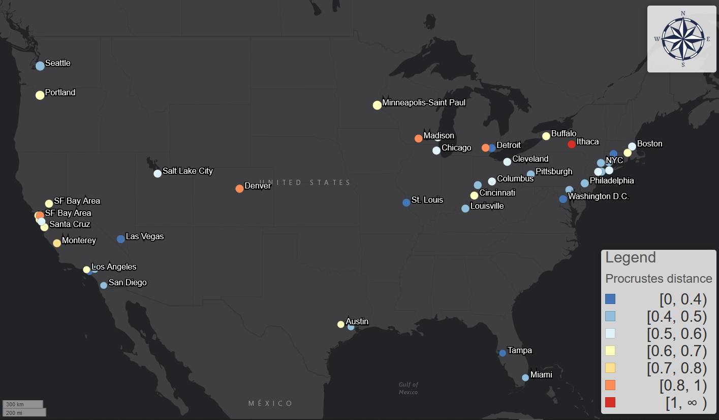

Figure 8: geographic distribution of each transit system's average Procrustes distance between normal and pandemic curves.

Figure 9: temporal distribution of all transit system's average Procrustes distance between normal and pandemic curves.

To moreover demonstrate the distinction between weekdays and weekends, we also calculate the Procrustes distance between the weekdays and the weekends; and we compare the distances before and during the pandemic. This difference of Procrustes distance can inform us that whether the distinction between weekdays and weekends changed by the pandemic. The results demonstrate that all transit system’s Procrustes distance between weekdays and weekends decreased during the pandemic, which moreover suggest that weekdays are more like weekends after the outbreak of the COVID-19 in terms of hourly demand dynamics.

This converging process could be powered by two factors. First one is the disproportional sudden decrease of the morning and afternoon commuting activities in the weekdays. This change will generally flatten the peaks and diminish the contrast between normal hours and rush hours. This process is essentially driven by the privileged population with non-physical occupations: their leave made weekdays more like weekends.

On the other hand, the reduction of unessential activities, such as leisure and shopping trips, also make commuting-relevant trips more prominent during the weekends. This effect is especially obvious in the New York City for its population highly relies on public transit and the non-physical occupation’s rate is not high. For example, for the Metropolitan Transportation Authority (MTA) systems, the curves of Sundays usually have one peak during 2 – 4 pm; however, the shape of the Sunday curves during the pandemic had two peaks, which was similar to the weekdays’ commuting pattern. This process is meanwhile driven by the underprivileged population that still have to work during the weekends: their stay made weekends more like weekdays. These two factors homogenized each day of week and make the boundary between weekends and weekdays less obvious.

**Peaks.** Peak analysis is crucial for the understanding of the mobility dynamics; it can provide demonstrate more detailed patterns for the shift of the curve shape, especially for commuting patterns. Peaks show the maximums in the curves of the hourly pattern in a day; their location and height can be a good measurement of commuting for transit users of the system. The comparison between before and during the pandemic can demonstrate the pandemic’s disruption on the commuting patterns and people’s adaptive behavior change.

Without the impact of COVID-19, most transit systems during weekdays will have two peaks within a day: the morning rush hour usually from 6 to 9 am, when most passengers commute from home to work places; and the afternoon rush hour usually from 4 – 7 pm, when most passenger commute from work places to home. However, this may not hold true after the outbreak of COVID-19. The shifts of peaks, including numbers, position, and height, may vary according to each cities’ demographic and social-economic status.

We first find all the peaks in the curve and find the two highest peaks before and after 12 am within a day, which are corresponded to the morning and the afternoon rush hour; then we will find the peak with largest height as the rush hour peak. We conducted the analysis for both the normal scenario and the pandemic scenario and compare the shift of the peaks. Figure 9 shows the geographic distribution of the morning rush hour shift. The morning rush hour shift varies for different cities and nations. For United States, the average morning shift is -0.13 hours (7.5 minutes) while the shift is -1.04 hours for UK, -1.71 hours for France, and -1.125 hours for Canada. It is very common for morning rush hour to shift earlier across the cities outside the US. A possible explanation is that the workers that cannot work from home usually have earlier working time, especially medical workers. However, not many cities witnessed an earlier morning rush hour in the US. 53 systems out of 93 US systems had a later morning peak. The special medical system could be the reason that US has a different pattern.

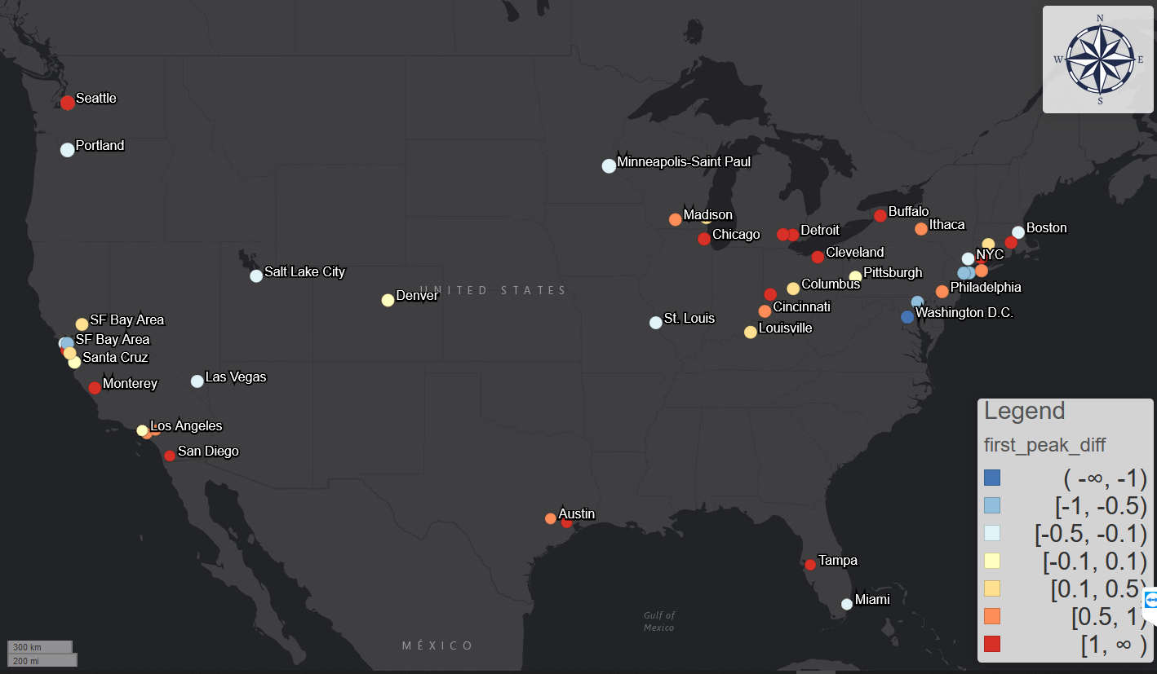

Figure 10: morning rush hour shift for different cities

Meanwhile, the afternoon rush hour generally shifted earlier. This could be due to the decreased relative height of the afternoon rush hour peaks compared to the middle of the day. 83 out of 93 systems witnessed an earlier shift and the average shift is -0.75 hours, while UK’s shift is 0.29 hours, Canada’s shift is -0.42 hours, and France’s shift is -2.29 hours. Moreover, considering the shift of the morning and afternoon peak, the total working hours would also change accordingly. Supposing that the change of working hours is the same as the difference between the morning and afternoon peak shift, the average working hours of the United States shrank by 0.63 hours, while UK’s working hours increased by 1.33 hours, Canada’s increased by 0.71 hours, and France’s decreased by 0.58 hours.

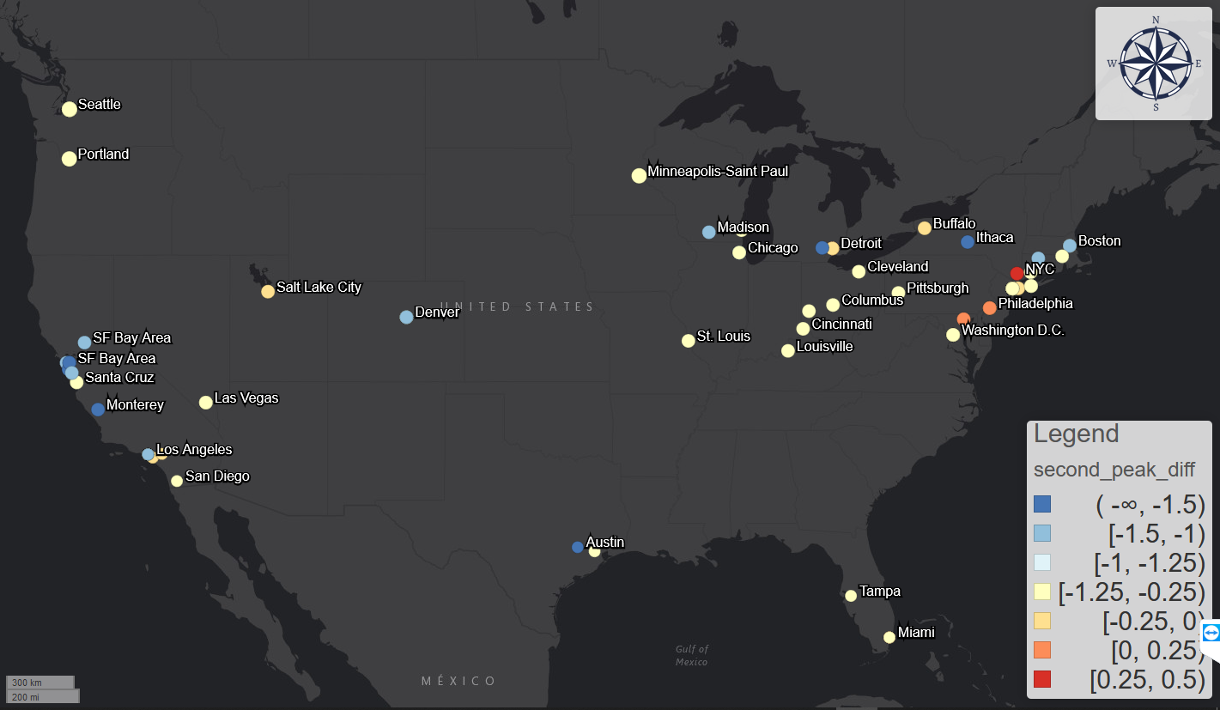

Figure 11: afternoon rush hour shift for different cities

Figure 12: the daily average morning and afternoon peak shift for all systems

1. Discussion