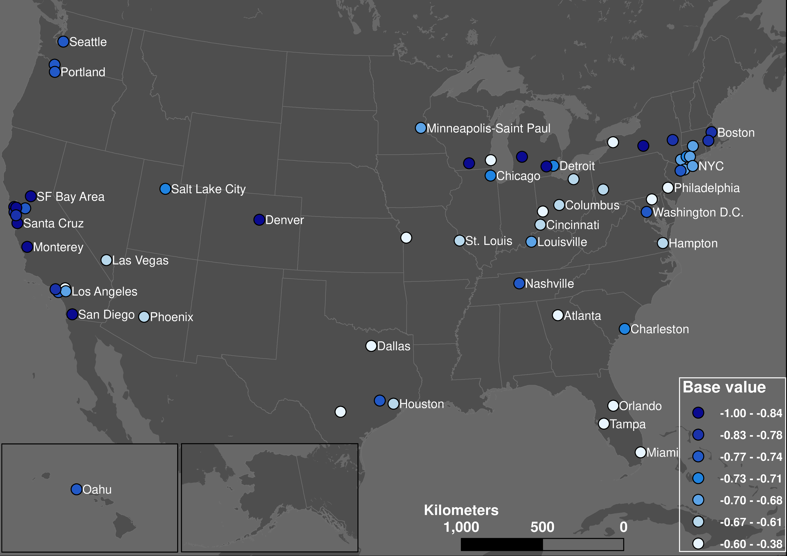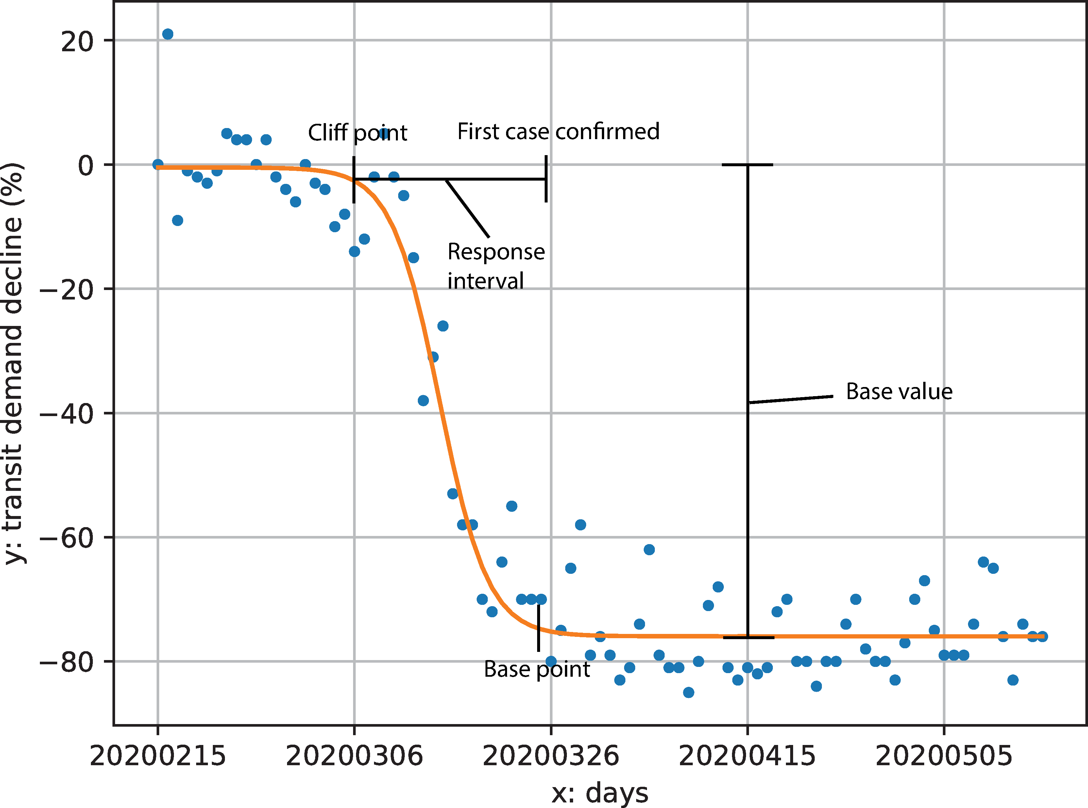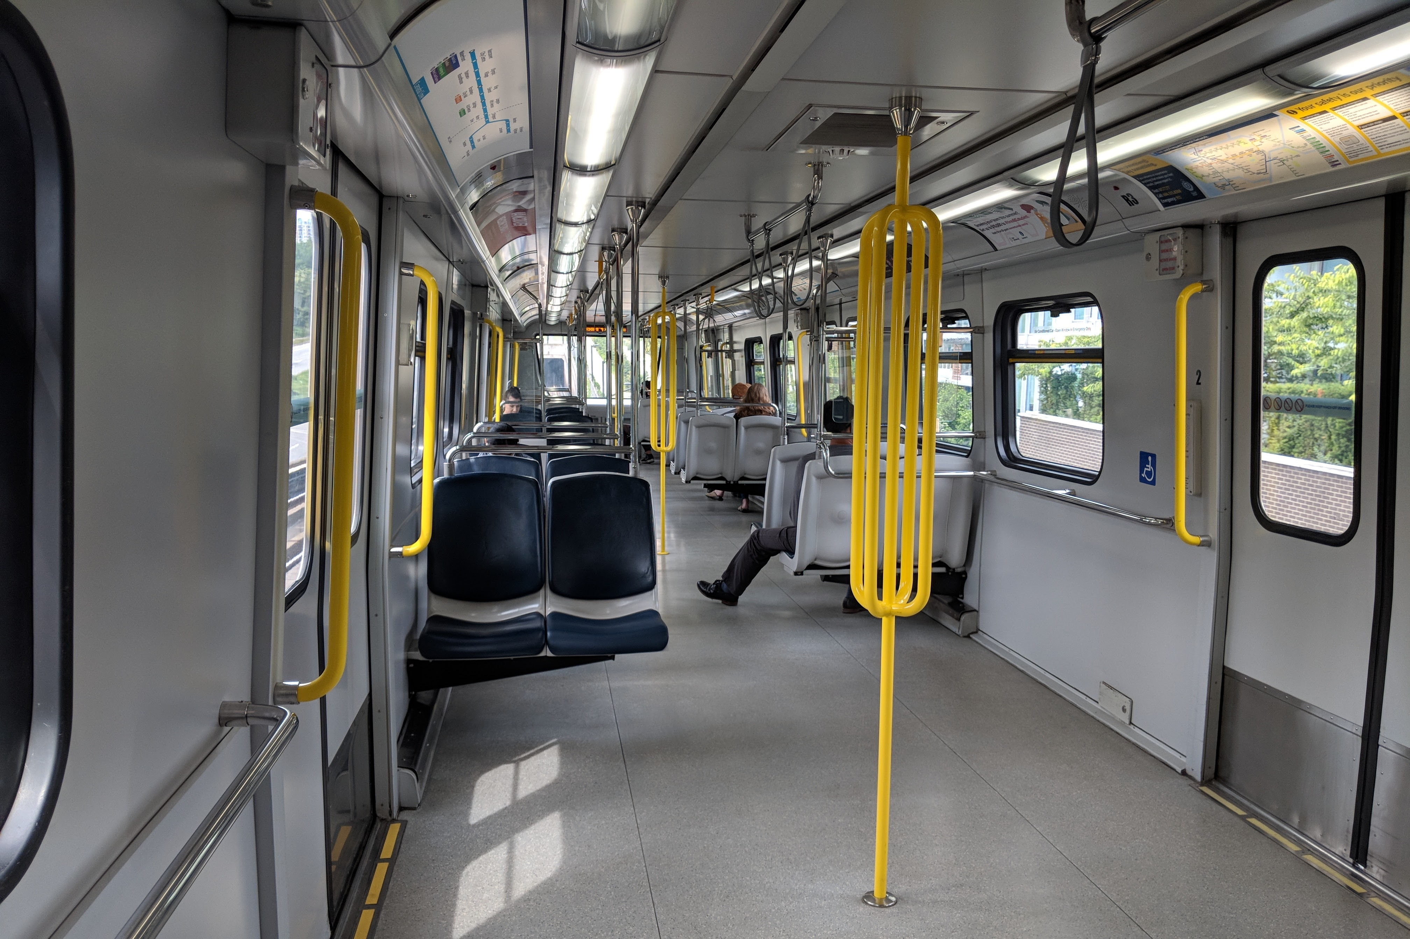

The COVID-19 pandemic led to major transit demand decline for many public transit systems in the United States. We use transit demand data derived from transit navigation app to measure usage during the lockdown and responding time. Regression analyses and online survey provide insights into public transit as an essential service during a pandemic.

Important findings

* Minorities, essential workers, and the senior people contribute to transit usage during the pandemic.
* Very few transit systems could react before the local community spread.
* Mobility routine during the pandemic was significantly different from the pre-COVID time.
* Weekends and weekdays because more alike.

Zoom link: <https://osu.zoom.us/j/95483016042>

Password: 210129

**The impacts of COVID-19 on public transit demand in 113 US transit systems**

Luyu Liu, 4:15 – 5:00pm, Jan 29, 2021

**Department of Geography**