Amendment letter

Luyu Liu and Harvey J. Miller[1]*

Department of Geography and Center for Urban and Regional Analysis

The Ohio State University, Columbus, Ohio, USA

We really appreciate the useful comments from the guest editor and reviewers. In the following paragraphs, we will thoroughly respond each comment and question.

1. Guest Editor Comments
   1. While clearly heading in the right direction, this paper will benefit considerably from further expositional clarity and additional content relating to the underlying themes of the Special Issue to which it is intended to contribute.  
      The need for expositional clarity is raised by both reviewers, but more particularly by reviewer 1. In this vein, our view is that it is not clear the included math is adding much if anything at all – the underlying concepts seem rather intuitively obvious; is the math actually needed rather than just a slightly more considered verbal approach?

**Response**: Thank you for pointing this out. We incorporated formula 1 and 4 (last draft)[2] into the paragraph to avoid confusions. Per reviewer 1’s comments, we simplified the notations for formula 1 and formula 2 (current draft).

* 1. In terms of diagrams, Figure 2 is confusing – again, is it actually needed?

**Response**: It is a very good point. As the guest editor and reviewer pointed out, the definitions of three types of transfer are intuitive and obvious. Therefore, we decided to incorporate the Figure 2 (last draft) into the paragraph and remove the figure.

* 1. Figure 3 is, as reviewer 2 notes, currently hard to read – and will not replicate well in grayscale. In overall terms, more attention to the quality and suitability of the graphics will greatly enhance the approachability of the paper.

**Response**: It is also a good point. We changed the symbology of the map from graduated colors (circles with same size and different colors) to graduated symbols (circles with different sizes and same color). We also rework the maps so that they have smaller scale. Besides, to save words for the strict word limit and make the graph more intuitive, we decide to only keep the results for APC-GTFS data. We believe current version will replicate better in grayscale: Picture 1 is a grayscale version of Figure 1 (current draft). For more clarification and more details about the figures, please refer to our responses to comment 2.1, 2.3, and 3.7.

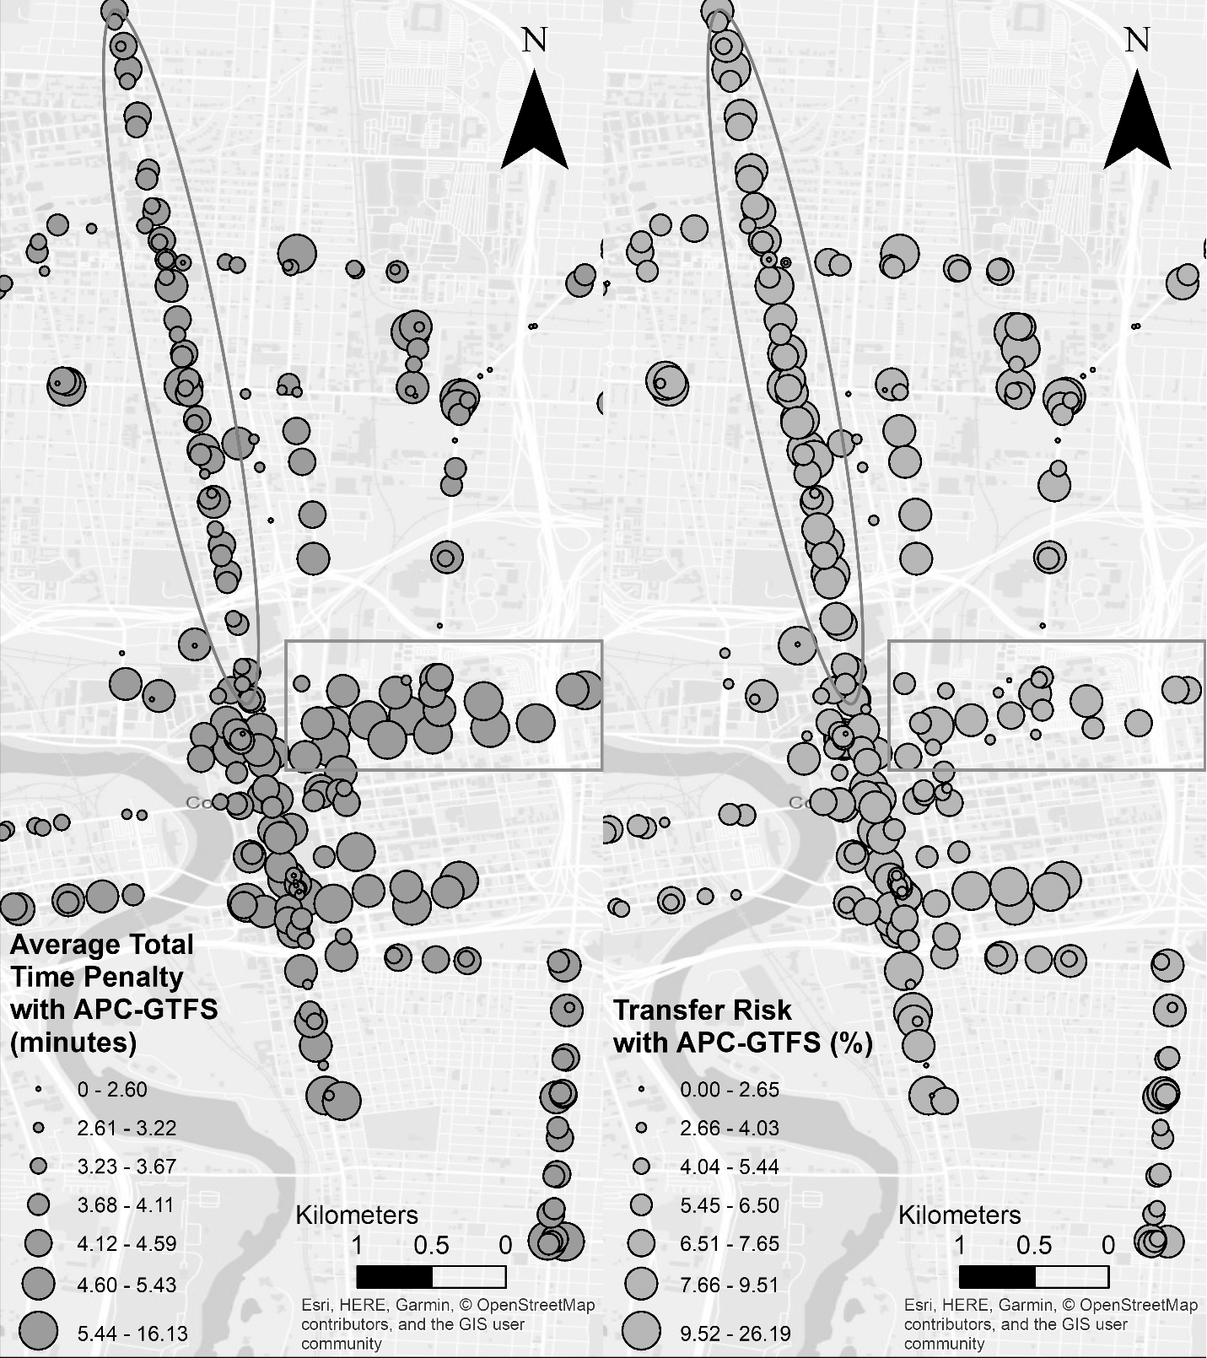

Picture : Grayscale version of Figure 1 (current draft).

* 1. The views of reviewer 2, on a need for the paper to speak more directly and substantively to an Urban Studies audience (and specifically to the special issue themes: Big Data as a tool for advancing our understanding of the urban, and to enhance urban well-being) also merit further emphasis. Attention to this matter has the potential to move the paper from a somewhat specialised contribution that will appeal to a limited cadre of transport experts, into something of much more general value and significance.

**Response**: We added many clarifications so that the paper is more suitable for the special issue theme. Generally, we focused on three parts in terms of emphasizing on the SI theme: the introduction, the literature review, and the conclusion. Please refer to our response to comment 3.1, 3.2, and 3.3 for further details.

In the introduction part, we emphasize the introduction of big data and its implication, both opportunities and challenges, on the transfer studies. To leverage and overcome the complicated nature of big data, we thereby introduce the measures and their advantages over other traditional measures (for more details, please see our response to comment 3.2). We combine the big data and the new measures to demonstrate the main contribution of the paper: high-resolution, real-time, and computationally intensive measures of transfers with big data.

In the literature review part, we start by introducing the history of transfer studies’ data sources. Moreover, we adopt the suggestion of reviewer 2; we changed the “deliberate versus byproduct data” to “small versus big data” to avoid unclear definitions and classifications per comment 3.3 raised by reviewer 2. In the second part, we focus on the development of transfer measures from non-real-time to real-time. We introduce the concept of temporal accuracy and highlight the real-time characteristic of the two measures we are about to introduce; we also connect this concept with later introduction of GTFS and APC. In the last paragraph of the literature review, we briefly compare the results of traditional non-real-time small data research, former big data real-time research, and this paper to emphasize the contribution of the paper. For more details about the literature review, please refer to our responses to comment 3.2 and 3.3.

In the conclusion part, we adopt the reviewer 2’s comment about re-engaging the SI theme. We revisit the vein of the paper from motivation (“real-time big data for transfers”), to the contribution (real-time notification and improved reliability for urban dwellers), then to the vision (more accurate and more abundant big data with ridership support). For more details about the conclusion, please refer to our responses to comment 3.9.

By doing this, we shift the focus of this paper from “study transfers” to “application of transportation big data for transfers”; current draft is not dedicated to transfer or transportation studies alone. Instead, the paper engages more with the big data sources and their application to solve complicated urban transportation questions. We believe the current draft is much more suitable for the SI theme and the broad audience of Urban Studies.

1. Reviewer 1

The paper makes a valuable contribution in public transport research by developing intuitive quality of transfer measures based on scheduled and real-time data. The paper is well written for the most part, however there are some unclear sentences. Some minor comments are listed below:

* 1. Fig 1: x-axis label further away than the legend headers, makes figure a bit hard to read.

**Response**: We adjusted the graph according to the comment (see Figure 1 (current draft)). We indicated x and y to the corresponding label to avoid confusion; we also moved the x-axis label to the middle to keep it consistent with the y-axis label.

* 1. The prime symbol used in the mathematical notation for “actual departure time” is quite difficult to notice. Can you please highlight that you use this symbol in text or alternatively use different symbols for clarity?

**Response**: We simplified the notations in the formula 1 (section 3.2, subsection transfer time penalties) and 2 (same section) in the current version. We now use uppercase T for the actual departure time and lowercase t for the scheduled departure time, which is much more obvious than prime symbols. Moreover, since all the time mentioned in the current formulas are now departure time, we removed the “departure” notations in the subscripts. All these adjustments should make the formulas simpler.

* 1. Fig 2: this is not giving much additional information. It could be changed to depict all the scenarios on page 14. There should also be a scheduled arrival time for the figure to make more sense. Furthermore, the figure text could highlight that the blue line is the chosen option.

**Response**: As the reviewer 1 and editor pointed out, the figure 2 (last draft) was confusing and did not give much additional information. Meanwhile, as the editor commented, the definition of the three types of transfers are inherently intuitive. Therefore, we remove figure 2 (last draft) and add some further explanation to section 3.2, subsection “transfers: the good, the bad, and the ugly” in the definition of each transfer type, especially preemptive transfers according to reviewer 2’s comment.

* 1. Explanations for nonobvious abbreviations could be repeated in analysis section for convenience.

**Response**: We add several explanations in section 4 and especially the start of each subsection. The relevant abbreviations include ATTP (average total time penalty), TR (transfer risk), GTFS (general transit feed specification), APC (automated passenger count), DBL (dedicated bus line), and COTA (Central Ohio Transit Authority).

* 1. Are there large differences in frequency between weekdays and weekends? What are the impacts on the measures? (Similar effects as on the time of day comparison?)

**Response**: We added frequency correlation analysis in Figure 4 and Figure 5.

1. Weekdays

We added the correlation analysis between frequency and daily average measures in section 4.2 (current draft), paragraph 2.

And yes, there are differences. COTA system have three schedules: weekdays, Saturdays, and Sundays. But the difference is rather small for trips that involves transfers. In terms of the transfer trips’ headways, we do not observe a significant difference between the three schedules. However, this could be because the frequency difference between weekdays is too small and there are only seven weekdays and three schedules; therefore, the heterogeneous pattern within a day may be homogenized by this oversimplified aggregation.

1. Time of day

We add the correlation analysis between frequency and hourly average measures in section 4.2 (current draft), paragraph 3. Hourly correlation analysis has more abundant data points and shows the pattern within a day: for TR, frequency has no significant impact for both datasets; for ATTP, frequency has significant negative correlation with it for both datasets. This also suggests that: increasing frequency for both generating and receiving buses can help with reducing the total time penalty, however, it cannot help with the synchronization.

* 1. Page 23, row 50: I think it is fair to assume zero delays for demonstrative purposes, however, it would be good to also highlight that it is a highly speculative assumption that there would be no delays on a BRT line. The only conclusion that can be drawn from this simulation is that improving punctuality even on one route will reduce ATTP.

**Response**: Yes, this is a fair point. We added some clarification in section 4.3, paragraph 2 to highlight the assumption is hypothetical. We also revised the conclusion from “DBL is an effective solution for reducing ATTP” to “improving punctuality even on one route will reduce ATTP”. Besides the overall impact, the DBL simulation moreover pointed out the major differences between DBL’s impact on the generating trips and receiving trips. Although this simulation is hypothetical, the simulation is one of the first to explore DBL’s impact on transfers and it can demonstrate prospective results for future studies.

* 1. Page 17, row 45: unclear sentence: “To investigate the spatial pattern of transfer risk, the first thing is spatial aggregation, since trip patterns (each vehicle trip; the finest level of resolution) are too specific and not representative of broader patterns.”

**Response**: We change the sentence to: “To investigate the spatial pattern of transfer risk, the first thing is to aggregate trips based on their generating stops, since trip patterns (each vehicle trip; the finest level of resolution) are too specific and not representative of broader patterns.”

Different transfer trips with the same transfer stop are not geographically distinguishable: we cannot distinguish these transfer trips on the map since they have the same geographic feature. For example, we have a transfer from route 1 to route 2 from stop A to stop B; we also have a transfer from route 3 to route 4 from stop A to stop B. Since their stops are both A and B, we cannot easily plot their geographic pattern individually on the map. Therefore, before we are investigating the geographic pattern of the transfers, we first need to aggregate trips based on their generating stop.

* 1. Page 19, row 47: unclear sentence: “However, for the APC-GTFS dataset, we observe ATTP on Sundays is second lowest compared to Fridays, which is the lowest for original GTFS dataset.”

**Response**: We change the sentence to: “However, we observe Sundays have the lowest ATTP.” To save words due to strict word limit, we decide to delete the results for original GTFS; current draft only show the results of APC-GTFS, which has higher temporal accuracy.

1. Reviewer 2

The paper presents two measures of transport network performance. It is clearly written, mostly easy to follow and quite technical in nature. The editor may want to take a view to which extent the paper fits the remit of this special issue and the Urban Studies audience more generally. In its current form, the paper seems to be more suited to a transportation-focused journal. Some suggestions:

* 1. The authors could engage more thoroughly with the themes highlighted in the call of the SI. I imagine that an Urban Studies readership would be interested in a discussion of how big data can offer new understanding of urban transport systems. Of course, there are already numerous reviews on this question, but a more focused discussion in view of the SI and the particular specialism of the authors might add to the literature. This would also help readers appreciate the specific contribution of this paper.

**Response:** Thanks for pointing this out for us and we think this is a very good comment. To make the paper fits the SI theme better, we made several major adjustments in the current draft in following different sections, also demonstrated in our responses to the comment 1.4:

* Introduction: we emphasize the introduction of big data and its implication, both opportunities and challenges, on the transfer studies. To leverage and overcome the complicated nature of big data, we thereby introduce the measures and their advantages over other traditional measures. We balance the equilibrium between the SI theme “big data” and the methodological “transfer measures”; moreover, we shift the focus from a transportation study for transfers to an application of transportation big data to understand transfers.
* Literature review: according to the comment: “*a more focused discussion in view of the SI and the particular specialism of the authors*”, we rework the literature review. We made two major adjustments:

First, we changed the “deliberate versus byproduct data” to “small versus big data” to avoid unclear definitions and classifications, according to comment 3.3 by reviewer 2. By doing this, the paper is directly and explicitly connected with the SI theme of “urban big data”.

Second, we focus on the development of transfer measures from non-real-time to real-time. We introduce the concept of temporal accuracy in section 2.2, paragraph 1; then we highlight the real-time characteristic of the two measures we are about to introduce and the challenge and academic gaps.

Combining the two aspects, we also demonstrate the core contribution of the new measures: high-resolution, real-time, and computationally intensive measures of transfers with big data. For more details about the literature review, please refer to our responses to comment 3.2 and 3.3.

* Conclusion: we adopt the reviewer 2’s comment about re-engaging the SI theme. We reorganize the conclusion part so that the motivation (big data for transfer studies), the benefits (real-time notification and improved reliability for urban dwellers), the future (more accurate and more abundant big data with ridership support) can be revisited. We believe the can make the paper more accessible to the audience of Urban Studies and the special issue theme of the journal. For more details about the conclusion, please refer to our responses to comment 3.9.
  1. For the benefit of an Urban Studies audience, I would suggest that the authors dedicate more space to a fuller discussion of the specialist literature, and highlight the different objectives of those studies they cite. What are the pros and cons of existing measures of evaluating transfer effectiveness? In which ways are the measures proposed by authors superior to existing ones?

**Response**:

1. For the benefit of an Urban Studies audience, I would suggest that the authors dedicate more space to a fuller discussion of the specialist literature, and highlight the different objectives of those studies they cite.

Thanks for pointing this out. We adjust numerous wordings and sequence in the literature review so that the objects and detail of the studies can be highlighted. First, we use italic font to highlight each study’s object, as shown in section 2.2, subsection “Non-real-time measures”. Second, we add more clarifications for each objects, as shown in the same paragraph.

We adjust the literature review so that it fits the paper topic and the SI theme. To focus on the real-time nature of the proposed measures, we change the section 2.2 to “non-real-time measures” versus “real-time measure”. We introduce the development of measures. Traditional studies used static measures that are built from non-real-time sources, such as schedules and non-volatile social factors. With the support of more big data sources and corresponding data supports, we now can demonstrate more real-time pattern and analysis.

1. What are the pros and cons of existing measures of evaluating transfer effectiveness?

For each mentioned measure in section 2.1 and 2.2, we conclude their pros and cons:

* For non-real-time measures, though extremely useful in the designing and planning area, we can conclude that they are less effective to measure the actual real-time patterns since they only consider static qualities of transfer or transfer nodes.
* For existing real-time measures, the lack of large-volume real-time big data is the major concern as shown in section 2, last paragraph.
* Most importantly, very few studies consider the transfer’s real-time performance with respect to delay and no study use actual real-time data sources to calculate the performance as shown in section 2, last paragraph. In this sense, TR (transfer risk) and ATTP (average total time penalty) are not measuring the same quality as the existing measures; therefore, the most important negative of the existing measures is simply that they are not measuring the real-time performance.

1. In which ways are the measures proposed by authors superior to existing ones?

Not limited to the literature reviews, as section 1, paragraph 3 (introduction), section 2 (literature), and section 5, paragraph 3 – 5 (conclusion) all pointed out, we can conclude following four major contributions and advantages compared with existing measures:

1. Compared with existing measures, TR and ATTP are the first measures that provide attainable solution to quantify the real-time performance of public transit transfers with respect to the schedules.
2. With this high-velocity and high-volume nature, the results of TR and ATTP are more detailed, more abundant, and more heterogeneous than the traditional measures. TR and ATTP can also be aggregated into different temporal and spatial scales; accordingly, TR and ATTP can provide more abundant and useful real-time information for ordinary passengers, compared with traditional measures dedicated to planning and designing.
3. As the literature review demonstrates in section 2, last paragraph, TR and ATTP are very easy to be implemented to a new public transit system with GTFS or APC-GTFS supports.
4. As the introduction in section 1, paragraph 3 and conclusion demonstrates in section 5, paragraph 3 and 5, TR and ATTP uses common metrics, namely probabilities and time. Compared with traditional composite scores, this feature can not only make them much easier to interpret and understand, but also can make intra-system and inter-system comparison much easier.
   1. How does the commonly made distinction between ‘deliberate data’ and ‘byproduct data’ apply to the datasets used by the authors? I certainly agree that smartcard data are ‘byproduct data’, but datasets such as APC are deliberately collected for the purpose of passenger counts. Similarly, GTFS data are more than just byproduct; they are purposively structured, standardised and documented. The authors should clarify the ways in which their work relates to the SI’s theme of ‘Big Data in the City’, and depending on their focus, offer a fuller discussion of ‘byproduct data’ potentially extending it to issues of bias and computational cost. Alternatively, perhaps an emphasis of ‘small data’ versus ‘Big data’ may be more appropriate for this particular paper.

**Response**: This is a very nice proposal. To avoid further confusions about how to classify “deliberate data” and “byproduct data” and keep the theme of the paper connected to the SI theme, we decided to change the two categories to “small data” versus “big data” as the reviewer 2 proposed. By doing this, we can clearly define GTFS and APC as typical examples of “big data in the city”.

As for the issues of bias and computational cost, we analyze their potential limitation in section 2.1, subsection “Big Data”, paragraph 3; since computational cost is a less important factor considering the advancement of computational technologies and Moore’s law for hardware, we choose to not include this part into the paragraph, also due to the tight word limit. Also, we already present several limits and potential biases in section 3.1, subsection “General Transit Feed Specification (GTFS) data”, paragraph 3 for GTFS data and section 3.1, subsection “Automated Passenger Count (APC) data”, paragraph 1 for APC data. Combining this two analyses on the data sources, we present a comprehensive discussion of the two relevant big data sources and their potential bias and computational cost. In the conclusion part in section 5, last paragraph, we moreover revisit the possible limitations and future direction of the transfer studies with big data: in general, more abundant and more high-resolution big data with ridership support can create more opportunities to understand public transit systems, especially transfers.

* 1. There is a tension between the technical measurement and passengers’ experience, which would warrant further discussion. To which extent are the components of transfer time penalties actually experienced by passengers? On high frequency services, ATP may actually not matter that much. And, if I understand correctly, transfer risk (which would be better called ‘risk of transfer loss’ or something) will increase for high frequency services. If a ‘receiving’ service runs every 5 minutes, the risk is inherently higher than if a service runs every 20 minutes, and yet the impact on the passengers’ experience is higher in the latter case. Of course, this dimension is picked up by the other measures, but I do wonder how meaningful ‘risk of transfer loss’ is without considering frequency.

**Response**: This is a good observation. The best and perhaps the only way to analyze passengers’ experience is to conduct surveys or interviews on the passengers per se. Since we did not do survey on passengers, we cannot have enough solid evidence to support a definite conclusion. This is also what we are conceptualizing in the conclusion part about the future research: more detailed and more abundant big data sources beyond real-time vehicle data. Although we do not have survey results, we can still discuss the questions by following aspects:

1. To which extent are the components of transfer time penalties actually experienced by passengers?

We argue that the user will not experience the components at all, since the user will not see or perceive (the delay of actual receiving bus (the second bus in the transfer)) and (additional time penalty, the sum of receiving bus headways). For example, the nature of ATP determined that it sometimes cannot be physically perceived by the users at all: ATP can be negative. Instead, the user may experience TTP, since it is the “net time loss” for the users’ transfer trip: user can easily calculate or perceive it by comparing with the current time when the receiving bus moves () and the time that the trip planner promised (). However, since we do not have the data on user experience, we cannot conclude the exact threshold of the passengers’ perceived transfer penalty.

1. On high frequency services, ATP may actually not matter that much.

Yes, but this is partially right. On high frequency services, ATP, which is the sum of missed headways of receiving buses, is assumed to have lower value if the frequency increases. However, if the arrival time of the generating bus (the first bus in the transfer) does not change, the ATP will not change even if the headway is smaller, since it will simply miss more buses making the sum of headways stay same. But considering both generating and receiving buses, smaller headway will generally make it easier for transfers to synchronize, thus incur smaller time penalty.

1. Transfer risk (which would be better called ‘risk of transfer loss’ or something) will increase for high frequency services. If a ‘receiving’ service runs every 5 minutes, the risk is inherently higher than if a service runs every 20 minutes, and yet the impact on the passengers’ experience is higher in the latter case. Of course, this dimension is picked up by the other measures, but I do wonder how meaningful ‘risk of transfer loss’ is without considering frequency.

We added the correlation analyses between TR (transfer risk)/ATTP (average total time penalty) and frequency shown in Figure 5 (current draft). We can see that for both datasets, ATTP have significant negative correlation with frequency while TR does not have significant correlation with frequency. Therefore, we can conclude from the data that: among the same system in different hours, frequency/headway does not have a significant impact on transfer risk. This is also intuitive: if the frequency of both generating and receiving buses simultaneously increases, the synchronization result is likely to stay the same. Since frequency does not have significant impact on TR, we can conclude TR can be a good measure to gauge the desynchronization. Therefore, for the large difference of transfer risk between High Street (indicated by a red circle in Figure 2) and the downtown area (indicated by a green rectangle in Figure 2), we do not and cannot say the high risk is due to the high frequency.

Meanwhile, as reviewer 2 commented, TR is only one dimension, which focuses on the synchronization performance on the system side; ATTP is more appropriate for users’ experience, since all that user cares is time penalty, instead of a percentage. The future research can measure the perceived ATTP and compare it with actual ATTP.

* 1. Similarly, I couldn’t follow why ‘ugly, pre-emptive’ transfers would be experienced negatively. ‘Pre-emptive’ suggests that passengers pre-emptively transfer to avoid risk elsewhere; but in this particular context, they simply get on an earlier vehicle without necessarily being aware of this. Except for potential crowding, they may not be any different from ‘good’ transfers.

**Response**: Yes, it is a very good point. The reason why we called it “ugly” is not because preemptive transfers will be experienced negatively, and we added corresponding clarification in the paper about this in section 3.3 (current draft), subsection “Transfers: the good, the bad, and the ugly”, paragraph “The ugly”.

Just like the comment says, compared to the schedule, a preemptive transfer may result in positive, or zero, or negative TTP. This is exactly the reason why we define transfer risk as the proportion of missed transfers alone, instead of missed transfer and preemptive transfers together. We acknowledged that a preemptive transfer can be as “good” as or even better than a normal transfer. However, we have to point out that preemptive transfers are different from the normal transfers. With the metaphor of “ugly”, we intended to describe its random and chaotic nature: although it may be as good, but it is not intended. Even if it may achieve a random better performance, it is not sustainable.

* 1. P.16, last sentence, “Only those combinations with … unique routes are selected”. I couldn’t follow what unique routes means in this context. Does this mean that origin-destination pairs with multiple transfer possibilities have been excluded? More explanation would be helpful.

**Response**: We added some clarification in the section 3.3, paragraph 3. The idea is: for multiple transfers with the same route combinations and the same generating stop (the stop where the user gets off from the first bus), we will only keep the one with closest walking distance to remove some redundancy. This is because the passengers will only walk to the closest stop when she/he gets off the first bus to finish a transfer. For example, if a passenger gets off the first bus at stop A, and she/he has several options (stop B, C, D…) to catch the same second bus. If stop B is the closest one, there is really no point for the passenger to walk further to catch the same bus.

* 1. Figure 3 is hard to read. The authors may want to explore alternative types of visualisations, e.g. heat maps or contour maps.

**Response**: This is a very good point. We adjusted the figure in following several aspects:

1. We changed the extent of the map to the center of the city of Columbus to keep consistent with the geographic pattern described in section 4.1, subsection “spatial patterns”, paragraph 3. The center of city is the area with most ridership in the Central Ohio Transit Authority (COTA) bus system. By doing this, we can not only cover most interesting patterns, but also the symbols are much clearer to see.
2. We did not use heat map or contour map and there are several reasons. First, the two visualization types requires interpolation, which means the visualized symbols does not necessarily represent the actual values. Therefore, it will cause some information loss and homogenize the heterogeneous patterns. We produced an example shown in Picture 2 in quantile classification; we can see heat map cannot show the heterogeneous and microscope patterns between each stops. This is also because the unique feature of bus stops: each stop is extremely close to each other while their ATTP / TR difference can be very large.

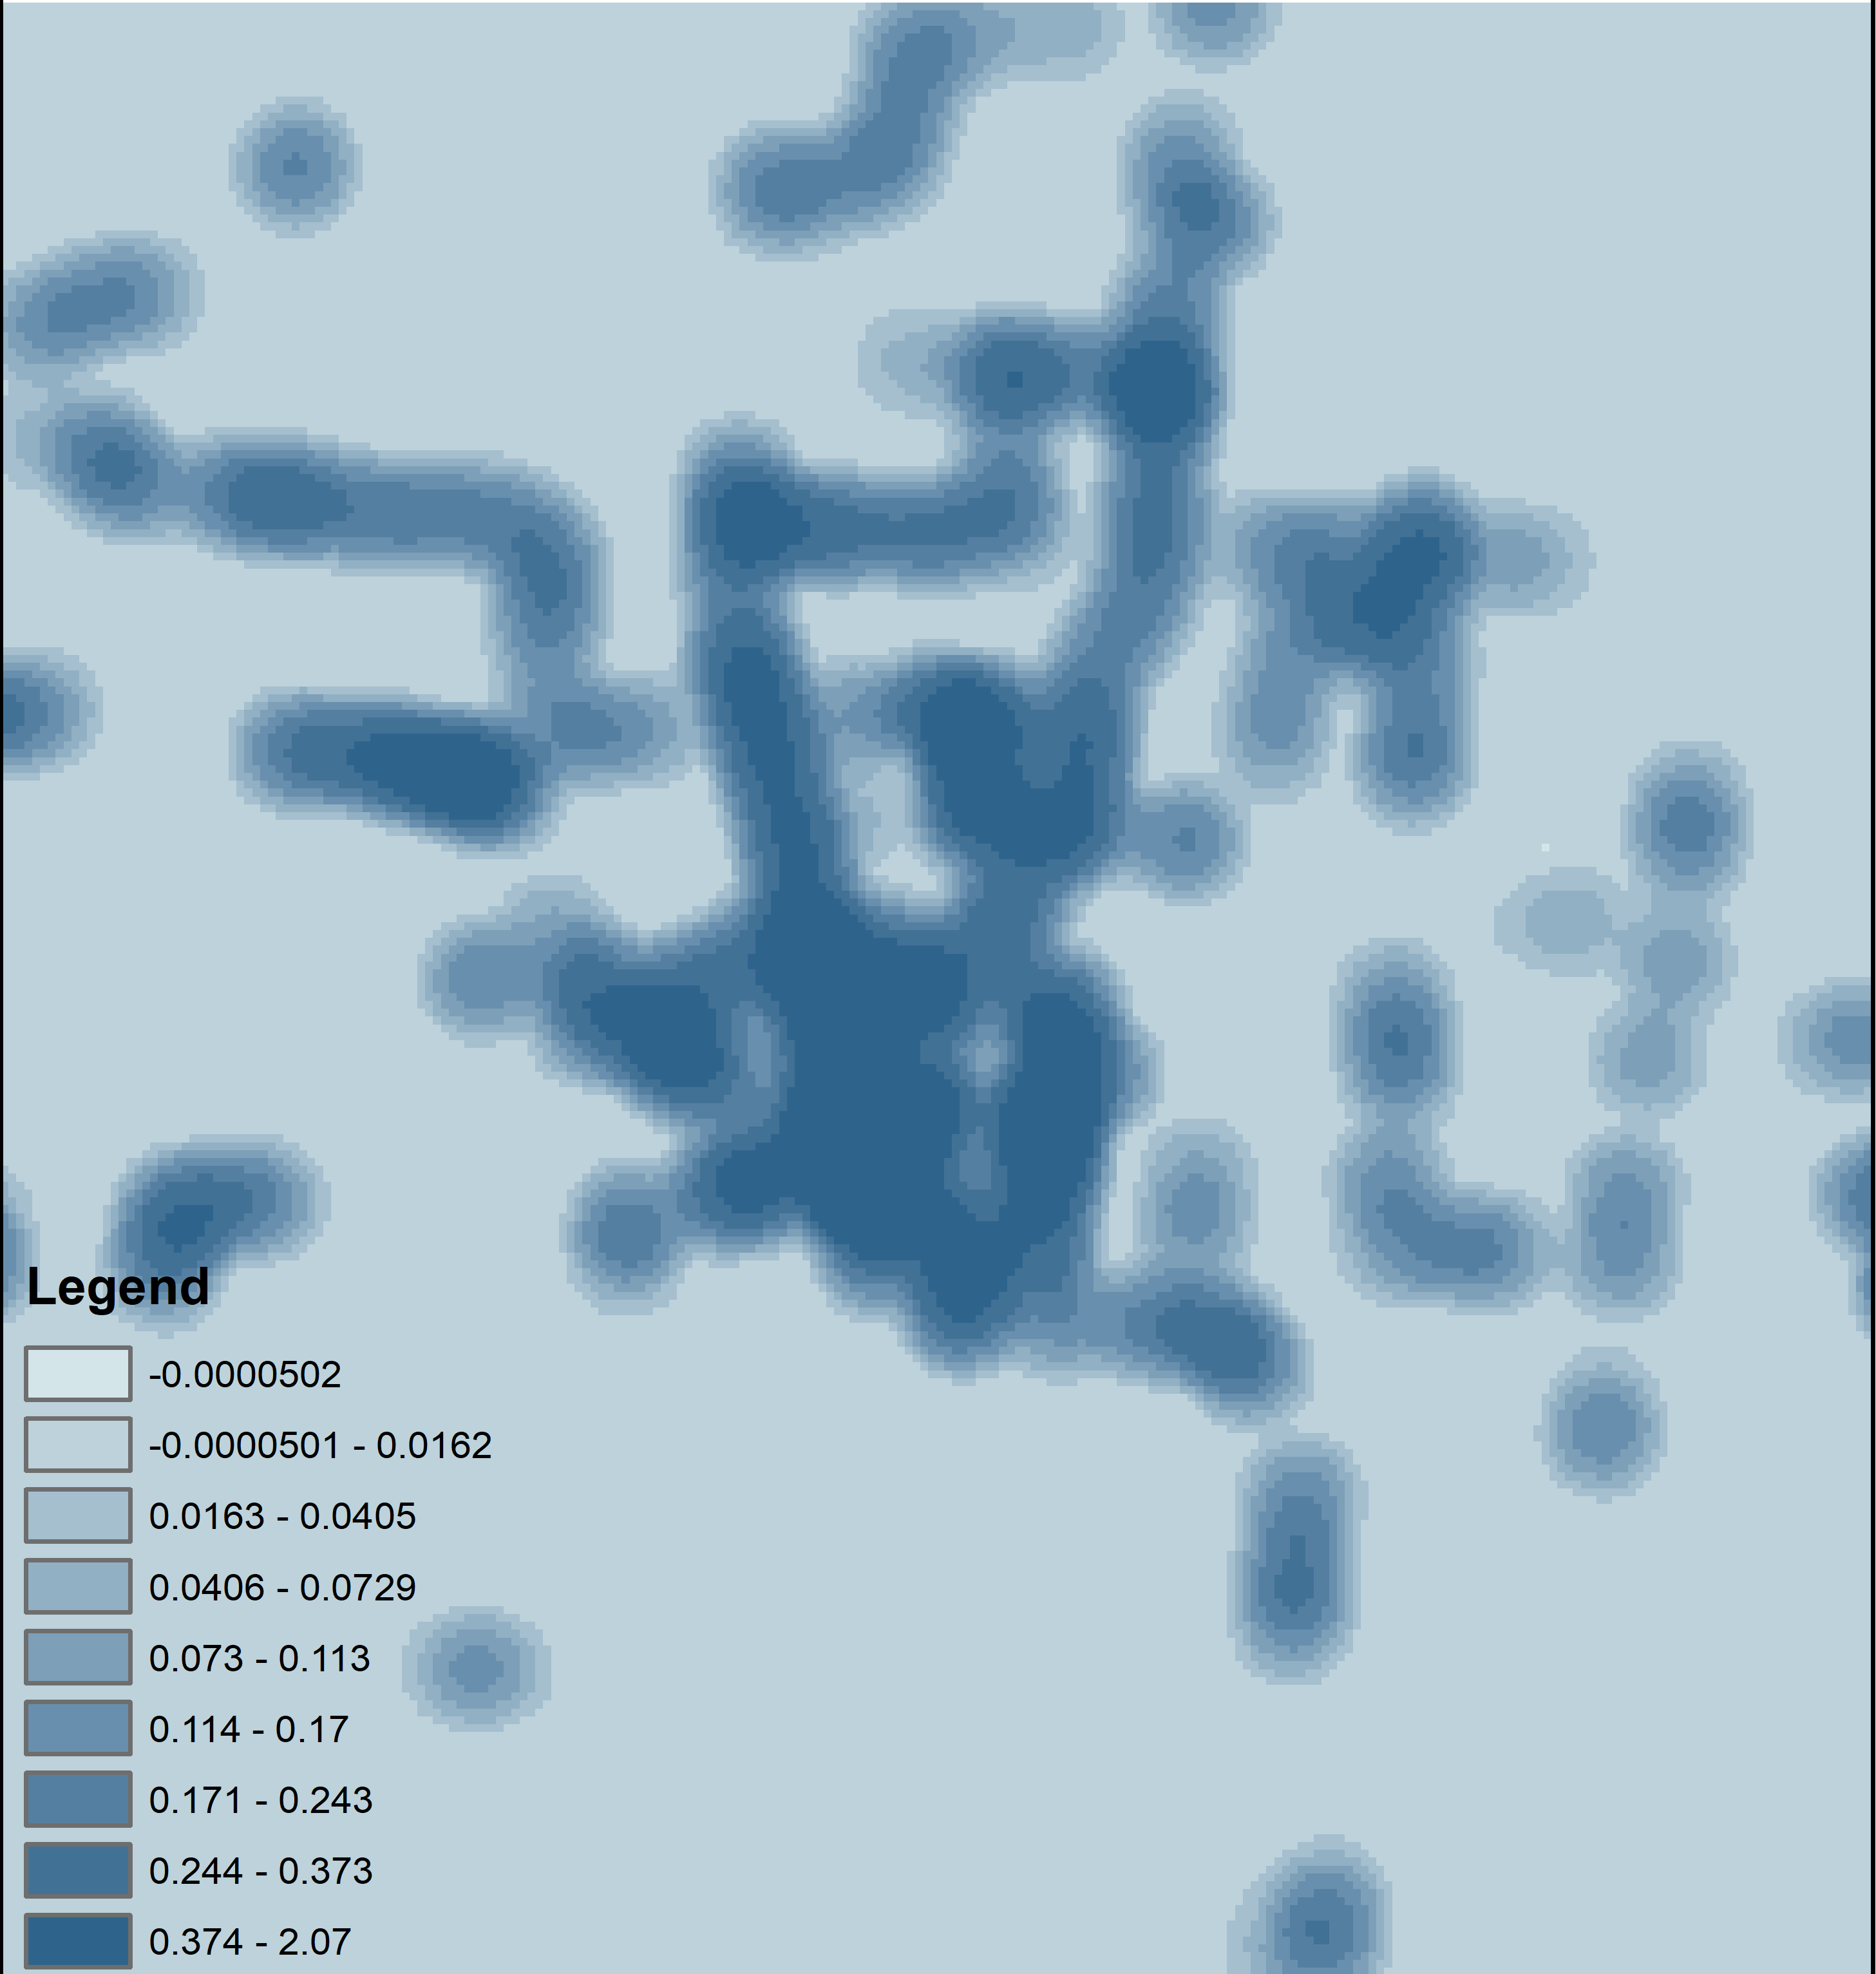

Picture 2: A heat map version of Figure 2 (current draft).

1. Instead, we changed the visualization type from graduated colors (circles with same size and different colors) to graduated symbols (circles with same color and different sizes). The figure also replicates better in grayscale in terms of the editor’s concern, as shown in Picture 1.

Combined with closer zoom, we believe it is easier for readers to distinguish the major patterns in Figure 2 (current draft) on the High street (marked by red circles) and the downtown area (marked by green rectangle).

* 1. P.21 first paragraph, I wonder if statistical tests should be added to assess differences on days with rain or a football match or in the DBL scenario. By the look of the values, I don’t see how they indicate ‘considerable impact’ as the authors conclude. The authors could also focus on connections with larger differences or on those with higher passenger counts.

**Response**: Thanks for pointing this out; we apologize for our neglect. We added corresponding statistical tests to each sections and the results are:

* Football. We did the Kolmogorov–Smirnov (KS) test to see whether the two distributions are the same. For ATTP (average total time penalty), the p-value for original GTFS is 0.036 and the p-value for APC-GTFS is 0.53; for TR (transfer risk), the p-value for original GTFS is smaller than and for APC-GTFS is 0.65. Therefore, for original GTFS, the difference between football game days and ordinary days is significant and for APC-GTFS it is not.
* Precipitation. The results of KS test are all not significant. For ATTP, the p-value for original GTFS is 0.46 and the p-value for APC-GTFS is 0.40; for TR, the p-value for original GTFS is 0.27 and for APC-GTFS is 0.88.

Even if the football days are significantly different from ordinary days for original GTFS data, the results show that the two results in the last draft are not statistically significant under most scenarios. Therefore, as reviewer 2 pointed out, we also would like to put more attention to geographic and temporal patterns; the causality between the introduced measures and other social and environmental factors is not the major research question of this paper. Meanwhile, also because of the strict words limit, we decided to delete it to save space for other more important issues.

* Dedicated bus lane (DBL). The KS test shows very strong significant results for the difference between two scenarios. For ATTP, the p-value for original GTFS is 0.006 and the p-value for APC-GTFS is 0.005. We also add the analysis results to section 4.3 (current draft), paragraph 2.
* However, as we mention in our response to comment 2.8, since we decide to delete original GTFS part to save words, we will not show the test results for original GTFS in the paper.
  1. In view again of the theme of the SI, I would expect authors to re-engage with the theme of Big Data in the conclusions. This may include a discussion of what new insights we may gain with regard to urban dwellers’ experience of their cities.

**Response**: To emphasize the SI theme “Big Data as a tool for advancing our understanding of the urban, and to enhance urban well-being.”, we made several adjustments so that the paper can fit better. As shown in our responses to the comment 1.4 and 3.1, we reorganize the conclusion part so that the motivation (big data for transfer studies), the contribution (real-time notification and improved reliability for urban dwellers), the vision (more accurate and more abundant big data with ridership support) can be revisited:

1. Motivation: Instead of starting with the transfers, we start the conclusion from the perspective of big data sources as shown in section 5, paragraph 1. By doing this, we want to draw more attention to the application of urban and transportation big data in this paper; we can also make the paper more accessible for broader audience of the journal beyond transportation.
2. Contribution: We also reorganize the concluded advantages/utilities of the new measures in section 5, paragraph 3 – 5 so that we can have a comprehensive discussion of their potential impact. As reviewer 2 suggested, we add more content on urban dweller and passengers’ experiences in section 5, paragraph 3; we also merge the management level and administration level to moreover emphasize the urban dwellers’ experience.
3. Vision: In the section 5, last paragraph, we moreover revisit the development of big data and possible improvements in the future.

1. * Corresponding author e-mail: [miller.81@osu.edu](mailto:miller.81@osu.edu)

   First author e-mail: [liu.6544@osu.edu](mailto:liu.6544@osu.edu)
2. To avoid confusion, in this response, we will use brackets + last/current draft to indicate whether the reference is from the last draft or the current draft.