Measuring public transit transfer risk using high-resolution schedule and real-time bus location data

Luyu Liu and Harvey J. Miller *[1]

Department of Geography and Center for Urban and Regional Analysis

The Ohio State University, Columbus, Ohio, USA

**Abstract**

Transfers between routes in a public transit system are important for many users, but few studies assess the risk and consequences of missing transfers based on on-time performance and delays in the real-time context. Leveraging high-resolution schedule and real-time transit big data, we develop two measures to assess transfer risk and time penalties in a public transit system. *Transfer Risk* (TR) measures the proportion of missed transfers and *Average Total Time Penalty* (ATTP) shows overall time loss compared to the schedule. We illustrate these measures using schedule and real-time vehicle data published via the General Transit Feed Specification (GTFS) for the transit authority in Columbus, Ohio. We aggregate, visualize, and analyze each index under different spatial and temporal resolutions. We also simulate the impacts of dedicated bus lanes (DBLs) on the overall transfer performance and different types of transfers. We also conclude that it is more effective to control delay, instead of synchronization, to reduce transit user’s total time penalty. The results demonstrate the potential to apply the TR and ATTP indexes to assess the impacts of delays on transfers and guide planning and decision making to improve on-time performance.

**Keywords**: Transfer; Public transit system; GTFS; Transfer real-time performance.

1. **Introduction**

Transfers between routes are an often necessary component of using public transit (PT). The expansion of city footprints can make long and direct routes difficult and costly (Knoppers & Muller, 1995), making transfers between scheduled public transit routes an important component of the system. However, PT delays, defined as a positive deviation of a transit vehicle’s actual arrival time from the scheduled time, are inevitable due to traffic, malfunctions, and other circumstances. A transit delay causing a user to miss an intended transfer between routes may impose a significant time penalty.

Transfers can be a useful component that improves the usability of PT systems (Walker, 2012). However, transfers have been neglected by many public transportation planners and administrators (Iseki & Taylor, 2009). To make transfers and public transportation more reliable, researchers are assessing, analyzing, and optimizing transfer activities, transfer nodes efficiency, and PT system design and administration. Previous research focuses on the users’ experience and the design of the transfer nodes, using methodologies such as user-based GPS sampling, survey and statistic modeling (Guo & Wilson, 2004, 2011; Han, 1987; Sun, Rong, Ren, & Yao, 2007; Sun, Rong, & Yao, 2010). More recent research expands data sources to include smart card data and real-time feed data (Jang, 2010; Nesheli & Ceder, 2015; Nishiuchi, Todoroki, & Kishi, 2015). However, there are few papers proposing systematic measurement for transfer real-time performance, especially using newly available real-time information data sources such as real-time vehicle locations. It is useful to develop an index and a system to measure the real-time performance of transfers in the PT system for planning and administrating purposes.

In this paper, we develop an analytical system for the evaluation of the transfer performance in an existing PT system. In response to the lack of transfer’s on-time performance measurement, we develop two measures in the context of real-time data and methodology: *Transfer Risk* (TR) measures the proportion of missed transfers and *Average Total Time Penalty* (ATTP) shows overall time loss compared to the schedule. We implement these measures using data collected from Central Ohio Transit Authority bus system in Columbus, Ohio. We explore the patterns of TR and ATTP at different levels of spatial and temporal resolution. We also simulate the impact of dedicated bus lane on transfer risk and penalties. The results demonstrate the potential to apply the TR and ATTP indexes to assess the impacts of delays on transfers and guide planning and decision making to improve on-time performance.

1. **Literature review**

This literature review covers two aspects of measuring and analyzing public transit transfers. We first discuss data sources, including traditional manual-based data sources such as global positioning system (GPS)-based trajectory samples and surveys, and automatically generated data, including General Transit Feed Specification (GTFS) schedule and real-time feeds, and smart card data (Ceder, 2007). Following this, we discuss research that uses these data for two purposes, namely, measurement and system optimization.

* 1. Traditional data versus automatic big data

**Traditional data.** For transfer studies in the domain of the public transit, traditional data are collected deliberately for theory-driven research questions, often using dedicated GPS receivers and survey instruments. While these data have been proven useful, there are several issues that limit the usefulness of studies based on these data sources.

One issue is the lack of universal standards and definitions, making comparison and the generality difficult. Different transfer studies have varying definitions of transfers and their data (Guo & Wilson, 2004), limiting comparability. Studies using traditional data also have heterogeneous, study-specific data sources that may be difficult to reproduce in other settings.

Another issue is that most traditional data are expensive and time-consuming to collect. For example, Guo and Wilson (2011) create and maintain special purpose station inventory, direct enquiry and field survey databases. This requires substantial time and resources, often for relatively small volume of data. Therefore, it can be challenging to cover the whole PT system well, both spatially and temporally, using traditional data sources. On the other hand, sampling strategy with a small dataset works well, while it is also fragile without representativeness (Miller & Goodchild, 2015).

An example for traditional data is stated preference (SP) data. Derived from surveys, SP data is widely used to support mode choice models (Guo & Wilson, 2011). Although many transfer assessment studies use SP data (Wardman, 1998), the choice dimension is typically small, meaning that SP data may not be able to capture the full diversity of transfer situations (Bovy and Stern 2012). Other semi-quantitative data collecting methods, such as on-board questionnaires (Bamford, Carrick, & MacDonald, 1984), can also lack precision and reliability. The result of these imprecise data sources is that most studies provide synoptic assessment for the entire system since it is difficult to have a detailed assessment in a higher spatial or temporal resolution (Guo & Wilson, 2011).

**Big data.** In the past, detailed and real-time data about public transit was difficult to acquire (Dessouky, Hall, Nowroozi, & Mourikas, 1999). However, this has changed due to the development of transportation data collection and sharing technologies. The emergence of *Big Data* and corresponding data-driven methods show a new way to overcome the existing flaws of traditional data. The definition of Big Data is diverse under different circumstances. A universally accepted definition can be generally categorized as “three Vs”: large volume, high variety, fast velocity (Ayed, Halima, & Alimi, 2015; Chen, Mao, & Liu, 2014). The widespread application of advanced transmission, data storage, and computational infrastructure and rapid progress of information and communication technologies (ICTs) provide the technical support for the Big Data (Hilbert, 2016).

In the domain of the public transit, inexpensive GPS receivers and wireless communication allow widespread tracking of vehicle locations in real-time. Meanwhile, the World Wide Web combined with data services allow sharing schedule, real-time vehicle location, and ridership data, such as automatic vehicle location (AVL) and automated passenger counter (APC) data. It makes precise and comprehensive data available. In addition, these data are collected automatically on an ongoing basis by PT authorities, meaning they are readily available without additional and prohibitive cost or effort. This technology revolution allows the possibility of more detailed investigation of transfer performance in a PT system.

However, big data has its own inherent issues. Among the three “Vs”, high variety shows the heterogeneity of the big data: unstructured data, diverse data sources, lack of metadata, and lack of quality control all make automated-generated big data hard to work with (Miller & Goodchild, 2015). Accordingly, standard protocols for transit real-time data were introduced to solve the problems.

General Transit Feed Specification (GTFS) is a combination of two data standards defined by Google: GTFS static and GTFS real-time expansion. GTFS static, also named static transit, reports the schedule data of a public transportation system. GTFS static is now the *de facto* standard for public transportation schedules and associated geographic information (Google Developers, 2016). PT system administrations are encouraged to share their GTFS static publicly, regularly, and precisely. Many of them are sharing their data: this is not limited to large transit authorities such as the Metropolitan Transportation Authority (MTA) in New York City. Already by 2010, almost 85% of transit miles traveled in the U.S were covered by open data published by transit authorities (Antrim & Barbeau, 2013).

Beyond scheduled data, GTFS real-time expansion provides frequently updated vehicle location data. GTFS real-time includes two components: buses’ location real-time data and the trip updates, which contains vehicles’ arrival and departure time at every sequential stop. Moreover, the temporal resolution can be as high as 1 min (Kujala, Weckström, Mladenović, & Saramäki, 2018).

GTFS overcomes the disadvantages of both traditional data and unclean big data: small volume, low velocity, lack of standards, and limited system coverage. However, it is important to realize that GTFS provides data based on the transportation instead of humans: the measured data points to trains, buses or ferries instead of passengers.

Moreover, besides normalized AVL data like GTFS, some studies also used automatically generated user-based data like smart card data to study transfers in the public transit systems (Jang, 2010; Nishiuchi et al., 2015). Jang (2010) attempted to examine the smart card data potential for transportation planning, especially travel and transfer analysis. Nishiuchi et al. (2015) used DESUCA smart cards data to measure the transfer efficiency in Kochi city, Japan. An advantage of smart card data is that it is linked to humans not vehicles. A disadvantage is limited availability compared to GTFS data.

* 1. Measuring and analyzing public transportation transfers

While PT transfer studies are diverse, we can classify them into two general categories, namely, measurement and optimization.

**Measurement.** Many studies concentrated on measuring different aspects of transfers and defined different indices based on one or several transfer attributes. For example, Nishiuchi et al. (2015) used Data Envelop Analysis (DEA) model to reference multiple indices to evaluate the efficiency of user transfers between transportation systems. This study concentrated on the transfer stations’ commuting efficiency using users’ smart card data.

Besides transfer nodes’ efficiency, Hadas & Ranjitkar (2012) combined transfer connectivity and travel time to representing the quality of the transfer. They sorted the transfers by quality standards into several categories and measured the transfer’s effectiveness in terms of travel time and transfer by mode of the two transfer stops.

Guo & Wilson (2011) assessed the cost of transfer in PT system based on both users’ and operators’ perspective. The paper developed an index based on path choice and labeling approach and applied it to the London Underground system in London, UK. In the case study, the paper computed each transfer nodes’ average time and economic cost per capita and their effectiveness in London Underground system. They used four multinomial logit models to measure the effectiveness of each transfer node.

Some research analyzed users’ psychological perception towards transfer (Algers, Hansen, & Tegner, 1975; Guo & Wilson, 2004; Han, 1987; Hunt, 1990; R. Liu, Pendyala, & Polzin, 1997; Planning & Transportation, 1997; Wardman, Hine, & Stradling, 2001). These studies used transfer penalty as the measurement: these penalties encompass a broad range of factors such as transfer walking, transfer’s number, transfer waiting, ticket fare, and other environmental factors. However, insufficient and imprecise data source limits their generalizability and authenticity.

Kujala et al. (2018) analyzed travel time and transfer based on Pareto-optimal theory and conducted a case study in Helsinki, Finland. The paper calculated pre-journey waiting time, journey duration, and number of required transfers for all Pareto-optimal journeys between all origin-destination (OD) pairs to calculate accessibility for Pareto journeys with different number of possible transfers.

**Optimization**. The synchronization of bus timetables is a sub-problem of bus network planning, and it has been proven to be NP-hard, meaning it is difficult to solve exactly (Ibarra-Rojas & Rios-Solis, 2012). Methods have been devoted to developing transfer optimization algorithms for planning and optimization purposes, with the objective of optimization includes minimizing travel and waiting times and maximizing synchronization. For example, Ceder, Golany, & Tal (2001) developed a heuristic algorithm to maximize the synchronization in a PT system. Jang (2010) utilized smart card data to illustrate that transit authorities can improve the service at some critical transfer nodes.

Several studies investigated the real-time optimization in the stage of system operation, which is defined as tactic-based optimization problem (Liu, Ceder, Ma, Nesheli, & Guan, 2015; Nesheli & Ceder, 2014; Nesheli, Ceder, & Liu, 2015; Nesheli, Ceder, & Gonzalez, 2016; Nesheli, Cedera, & Hassold, 2014). For example, Nesheli et al. (2015) developed a system performance-indicator model and built an agent-based model to simulate real-time performance. The study used GTFS schedule and OpenStreet map data, demand data derived from survey, and PT vehicles data to develop a real-time optimization system. However, due to the lack of real-time data, these studies still concentrated on building the statistic models and simulations.

The literature review clearly shows that: due to the lack of real-time data, few papers assess transfer real-time performance and risk of missing transfers due to bus delays, as well as the performance’s variance and spatiotemporal patterns. Progress in data availability, real-time monitoring and other smart city technologies are making this topic an area of active investigation again: researchers can now conduct more detailed analysis and develop more precise measures and models of PT transfers (Hadas & Ranjitkar, 2012; Kujala et al., 2018). In response to the gaps in the transfer’s real-time performance and synchronization theory in the real-time data context, we would like to address the PT transfer’s measuring problems using the high-resolution GTFS datasets.

1. **Methodology**

This section discusses the methodology. We first define PT transfers and the impact of vehicle delays on transfer synchronization. Then, we discuss the methods involved in transfer risk measurement and analysis.

* 1. Transfer definition

All transfers can be divided into several two-stage sub-transfers, which consist of two trips: the *generating trip* and *receiving trip*. Within each two-stage transfer, a user first boards a bus to start the generating trip, then alights to catch the next bus to start the receiving trip until the user arrives her/his final destination. Figure 1 provides an illustration using a time-space diagram. Defined by Hadas and Ranjitkar (2012), two-stage transfers could be categorized by a) street-crossing transfer; b) sidewalk transfer; c) non-walk transfer; d) one-leg trip (Hadas & Ranjitkar, 2012). Based on this categorization, we can generalize the transfers as: a) *non-walking transfer*, which does not require a walking process for the transfer, and b) *walking transfer*, which requires walking from the generating trip’s destination stop (which we label the *generating stop*) to receiving trip’s starting stop (the *receiving stop*).

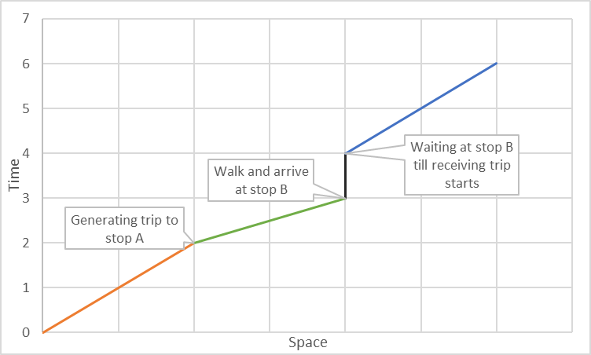

Figure 1 Time-space diagram of a typical two-stage transfer.

We can further conceptualize transfers as a process of synchronization among: i) the generating trip brings passengers to the generating stop; ii) transition of users to receiving stop; iii) the receiving trip picks up passengers at receiving stop.

* 1. Transfer synchronization and real-time measures

**Synchronization.** Due to different factors such as traffic congestion, weather, road construction and unforeseen events such as vehicle crashes, delay is inevitable in a PT system. Delay can result in inconsistent arrival and departure times hence the desynchronization of scheduled generating and receiving trip; Figure 2 provides an illustration. For each transfer, we can measure the time penalty when the receiving bus is leaving; this is the time point when the desynchronization happens. During the synchronizing process between the generating and receiving trip at the receiving stop, the actual transfer can differ from the schedule according to the relative temporal order of the two trips arrival/departure time.

Due to the desynchronization, the actual receiving bus can be different from the scheduled receiving bus. The schedule of all buses running on the same route can be conceptualized as an array of trips (a *trip sequence array*). The passenger will always take the first available bus. If the generating bus is sufficiently late, the passenger will miss the scheduled bus and need to take a later scheduled bus. Likewise, if the receiving buses are sufficiently late, the passenger can catch an earlier receiving bus in the trip sequence array. We developed an integer variable, *desynchronization degree* (DD), to measure a transfer’s desynchronization in the trip sequence array.

|  |  |  |
| --- | --- | --- |
|  |  | (1) |

We calculate two types of potential time penalties for each transfer. The first is total time penalty (TTP):

|  |  |  |
| --- | --- | --- |
|  |  | (2) |

where: is the actual departure time of actual receiving bus (DD = n), is the scheduled departure time of scheduled receiving bus (DD = 0).

**Decomposition.** TTP represents the total time loss compared to the schedule at the receiving stop. The value shows the synoptic delay when the receiving trip starts, which encompass both generating and receiving bus’s time loss. However, since the synchronization process is involved with two actors, it is also important to determine the corresponding time loss caused by each bus. For example, a large TTP could be because of the receiving bus’s large delay but the synchronization is not disturbed; on the other hand, a large TTP could be also because of the first bus’s delay, which results in desynchronization thus long waiting time.

To quantify this two different types of delay, we decompose TTP as follows:

|  |  |  |
| --- | --- | --- |
|  |  | (3) |

where: is the scheduled departure time of the actual receiving bus (DD = n), is the scheduled departure time of the scheduled receiving bus (DD = 0), is the delay of the actual receiving bus at the receiving stop.

The second part of the decomposition is defined as additional time penalty (ATP), which represents the time cost caused by the transfer desynchronization.

The two parts of TTP’s decomposition, ATP and , correspond to the time penalty caused by missing the scheduled bus and normal delay of the actual receiving bus. The value of depends on the passenger’s actual arrival time at receiving stop and the receiving buses’ schedules. If the passenger’s actual arrival time is before the scheduled bus’s departure time (DD = 0), there will be no additional time penalty; if the actual arrival time is after the nth bus’s departure time (DD = n), which can be noted as *n*-th receiving bus, then there is an additional time penalty which is worth sum of *n* receiving buses’ headways.

|  |  |  |
| --- | --- | --- |
|  |  | (4) |

where: n is the transfer’s actual DD, M is the lower bound of DD, and N is the upper bound of DD. is the sum of headways. The index is applied to both schedule-based and headway-based systems; however, due to GTFS data’s schedule-based nature, we focus on the schedule-based systems in this paper.

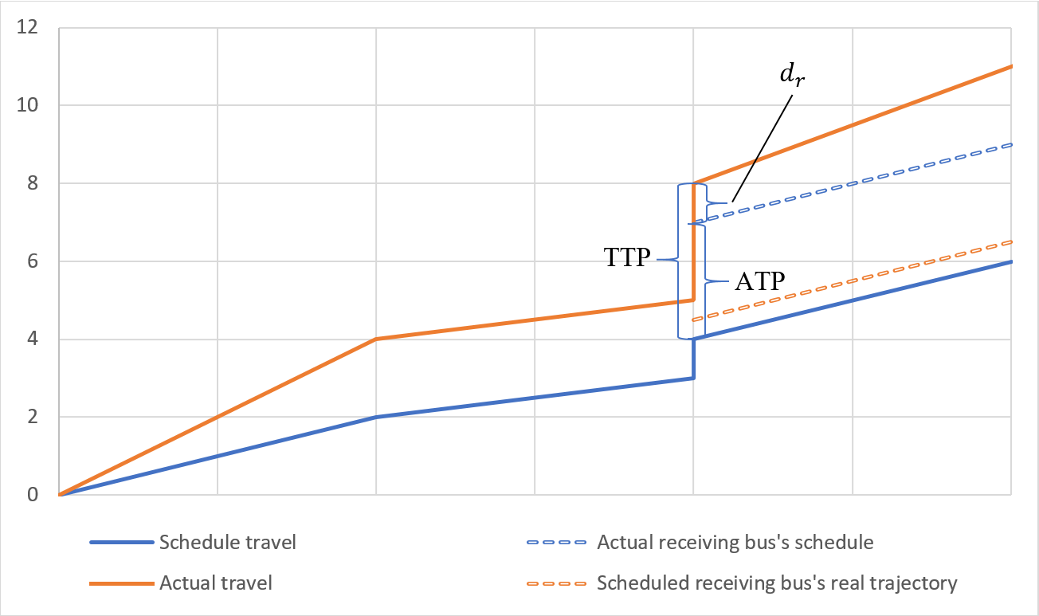

Figure 2 Time-space diagram of a delayed two-stage transfer and the corresponding scheduled transfer

**The good, the bad, and the ugly.** We classify all transfers into three categories according to their real-time synchronization performance. We can distinguish them by the receiving bus’s desynchronization degree.

* *Normal transfers* (DD = 0), as shown in Figure 3 (middle). A passenger getting on a normal transfer will catch the same bus as the scheduled transfer. Under this circumstance, ATP = 0, which means there is no additional time penalty, while the performance can be still different from the schedule due to the normal delay of the receiving trip.
* *Missed transfers* (DD > 0), as shown in Figure 3 (right). Under this circumstance, ATP > 0. The passenger will take a bus after the scheduled bus, hence will suffer from additional time penalty other than normal delay. The missed transfers moreover have several scenarios: 1) generating trip is delayed that the user cannot catch the scheduled receiving bus; 2) the scheduled receiving bus is out of service; 3) the scheduled receiving bus is severely delayed after another receiving bus. Scenario 1 is the most common circumstances. For scenario 2, if the scheduled receiving trip is no longer running, the passenger must take the next bus. Likewise, for scenario 3, a severely delayed bus can be caught up by another bus on the same route scheduled after it. It is natural for users to take the closest bus despite the buses being out of sequence.
* *Preemptive transfers* (DD < 0), as shown in Figure 3 (left). During a preemptive transfer, instead of the scheduled bus, the user will get on a bus which should have arrived earlier than the passenger at the receiving stop. This is due to delays in the receiving buses. The passenger will naturally take the nearest bus regardless of the schedule. The ATP’s value can be negative, zero or positive, however, a negative ATP will not necessarily suggest a better performance since the TTP can be positive meanwhile.

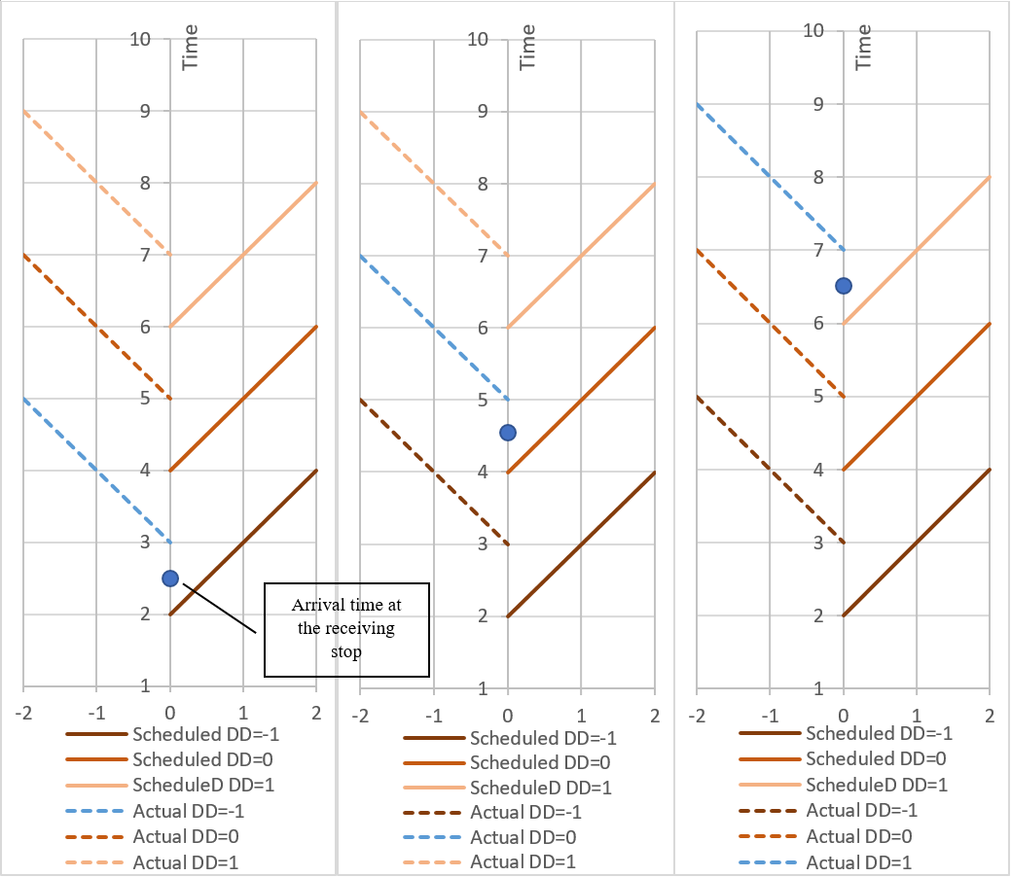

Figure 3 Space-time diagram of three scenarios of a transfer synchronization process (Dash line: actual; solid line: schedule.)

* 1. Defining valid transfers schedule

There are four policies for transfer scheduling in PT systems: 1) Unscheduled transfers; 2) Scheduled transfers without vehicles waiting, 3) Single holding strategy that lower frequency vehicles wait for higher frequency vehicles, 4) Double holding transfer that both vehicles hold for transfers (Ceder, 2007; Knoppers & Muller, 1995). Many PT authorities, especially those that rely on buses, use an unscheduled transfer policy, meaning there are few explicitly scheduled transfers in the GTFS static data. Moreover, in reality, transit users’ transfer behavior and transit real-time apps will not strictly follow the scheduled transfers. Correspondingly, we have to search empirically for possible transfers from the GTFS static data. Theoretically, any two trips at two stops which are proximal enough for users to access can be regarded as a valid transfer. This can be refined with passenger data that shows actual transfers; this is likely to be a subset of the valid transfers. However, the danger with this approach is we may miss a potential transfer if it did not occur in the data.

Based on the data structure in the GTFS data, we define three levels of aggregation: *stop*, *route*, and *trip*. Every trip is run according to a fixed schedule by a bus at a specific time. Trips with a same schedule can be aggregated into a route, and some routes can be bound to a stop. To find transfer schedule from GTFS schedule, we developed a hierarchical searching algorithm in Python and MongoDB environment. Using the algorithm, we derived all possible stops combinations, route combinations, and GTFS trip combinations. Only those combinations with near distance (Euclidean distance < 100 meters) and unique routes are selected into the transfer schedule.

* 1. Measurements

To systematically measure the risk of missing PT transfers, we developed several methods to assess the risk of transfers in a PT system. We measured each transfer using the total time penalty or a binary value that represents whether it has additional time penalty or not. Based on the assessment of single transfer, transfer risk is defined as the empirical possibility of the transfer miss happening in a scheduled transfer. Overall *transfer risk* (TR) in the system is:

|  |  |  |
| --- | --- | --- |
|  |  | (5) |

where: *n* represents the number of transfers, and is the binary measurement variable of each transfer indicating whether the transfer is missed. A missed transfer is defined as: the actual bus’s desynchronization degree is larger than 0. This also means the user takes a different bus *after* the scheduled bus.

We can also measure the *average total transfer time penalty* (ATTP) for the system:

|  |  |  |
| --- | --- | --- |
|  |  | (6) |

where: is the measurement of transfer ’s total time penalty.

TR and ATTP are a further step towards a smart public transit system: Compared with previous indexes and measuring systems, the spectrum of the audience is broad. Thanks to the high-resolution data, we can calculate corresponding performance from a very specific transfer to overall broad patterns.

* In the application level, users can query each transfer’s performance in their real-time transit apps and react real-timely. A major concern for users to use transfers is their instability. However, current mainstream transit apps do not show empirical risk and average time loss on their interfaces. If a proposed transfer’s empirical performance is shown when the apps plan the trip, users can avoid high risk and high penalty route thus save potential waiting time.
* In the operation level, administrators can check the high risk and high time penalty areas and response real-timely. With support of real-time data, the PT authorities can know the indexes’ current geographic pattern; based on the real-time indexes, they can add additional buses and enforce bus’s time table to reduce transfer risk. Moreover, with the real-time ridership data, administrators can identify the ongoing transfers and plan flexible time table adjustment accordingly.
* In the management level, traffic and city planners can gain empirical spatiotemporal patterns and design accordingly. Just like PT system delay’s empirical pattern, TR and ATTP’s pattern can also demonstrate important information about the road design, PT system’s design, and other transport and non-transport factors in the domain of city planning. The information is not limited to geographic pattern, but also temporal. For example, after a major route adjustment, it has been proven that validation and comparison of before and after the change is crucial and informative (Lee & Miller, 2018). Similarly, traffic planners can compare the transfer indexes to validate the efficiency of the change. Both the geographic and temporal empirical pattern can contribute to the improvement of the transit system.
* In the policy-making level, policy makers can compare different PT systems’ transfer real-time performance across the US. Unlike some composite indexes that are hard to compare with each other, transfer risk and total time penalty are all comparable across different systems, since TR is percentage and ATTP is time. Meanwhile, due to the high reusability and expandability of the indexes and the system, they can be easily implemented and applied to any PT system with published GTFS scheduled and real-time data without major modification.

1. **Analysis**

To validate and implement the indexes and the system, we conducted a case study with GTFS data from Central Ohio Transit Authority (COTA) bus system in Columbus, Ohio from February 2018 to February 2019. We acquired these data using the COTA application programming interface and archived these data for analysis in a MongoDB database. The GTFS real-time database and its auxiliary databases are in near Terabyte level in total; the code is optimized and highly parallelized to deal with the subsequent computational difficulties. Using various aggregation methods, we developed different summary measures based on varying spatial or temporal resolutions.

* 1. Spatial patterns

To investigate the spatial pattern of transfer risk, the first thing is spatial aggregation, since *trip patterns* (the finest level of resolution) are too specific and not representative of broader patterns. We can aggregate trip combinations in different ways: Naturally, *route patterns* are useful, which aggregate the trip combinations based on their route schedules, since they measure the empirical performance of the transfers between certain stops and certain routes. *Stop patterns* are also useful since the quality of transfers between stops is assessed and stop combinations are geographically distinguishable, making it especially crucial for visualization. We concentrate on stop patterns in our analysis.

From February 2018 to February 2019, the average transfer risk is 7.14%; average total time penalty for all transfers is 3.74 minutes with standard deviation of 13 minutes. Figure 4 and Figure 5 show the spatial pattern of the average transfer risk and average total time penalty from February 2018 to February 2019. It suggests some differences between TR and ATTP’s spatial distribution, especially on High Street (a major north-south thoroughfare in Columbus, indicated by a red circle in Figure 4 and Figure 5) and downtown area (indicated by a blue circle in Figure 4 and Figure 5).

Stops among High Street has relatively higher transfer risk while they also have relatively lower average total time penalty. This is because the headway between buses is small, although the transfers are frequently missed. Similarly, the high ATTP clusters on some roads in downtown area and some periphery roads do not have higher transfer risk. Although the desynchronization cost is low, the original delay can be high, especially for downtown. If a user misses a bus in these locations, that user must wait for a relatively longer time; but these stops have relatively lower risk of missing a scheduled bus.

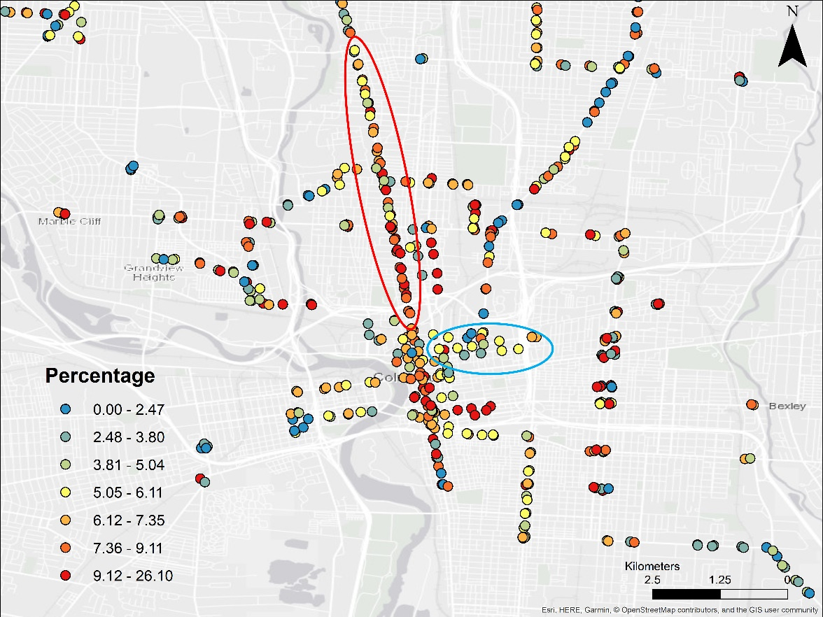

Figure 4 Spatial pattern of TR (in percentage and quantile classification) in 2018

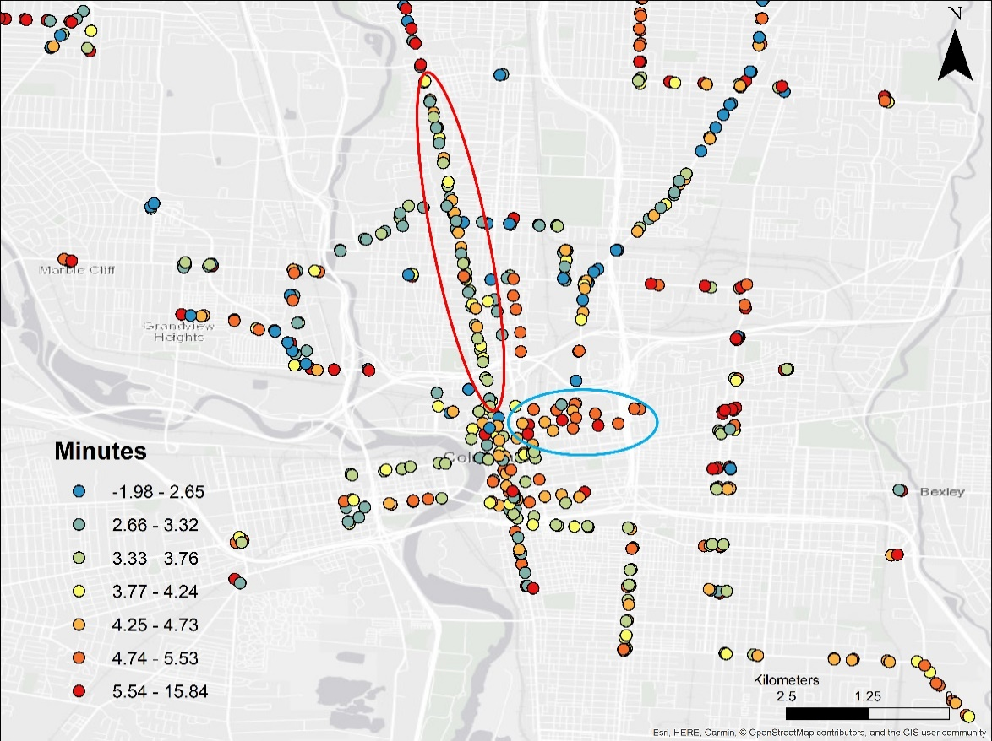

Figure 5 Spatial Pattern of ATTP (in minutes and quantile classification) in 2018

* 1. Temporal patterns.

Every transfer can be aggregated and measured in different time resolution, such as hours, week days, months, seasons and years. Based on different purposes and time periods, we conducted different temporal pattern analysis. For example, during peak hours a transit system can experience more delays and additional time penalty than non-peak hours. Also, transfer performance in some days in a week can be worse than other days based on regular traffic patterns and PT system usage. Therefore, we may wish to compare overall TR and ATTP at each stop for every operating hour and week day.

Besides regular temporal patterns, we chose certain days with special events to see their impact on the transfer real-time performance. Weather, especially extreme weather during winter, is a major factor for PT delays. Special events (such as football games near the Ohio State University in Columbus) can also impact local traffic and public transit. We can select several representative days to measure the TR and ATTP differences due to these events.

Figure 6 provides the monthly trends of TR and ATTP. June, July, and December show an overall low time penalty pattern. This can be due to better overall traffic conditions during summer and holiday season vacation. August is the worst month to take a transfer; this may be due to the start of an academic year in a city with a massive university campus near the city center.

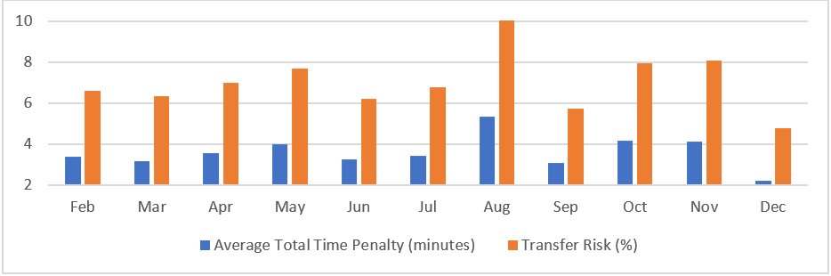

Figure 6 Overall monthly TR and ATTP trend chart in 2018.

Figure 7 provides the trends by day of the week. We can see the overall transfer risk and ATTP peak on Friday, and the core of weekdays (Wednesday, Thursday, Friday) maintains higher levels of risk and penalties due to the overall traffic pattern. Weekends and Monday’s ATTP and TR are relatively low due to flexible working schedule and less commuting activities.

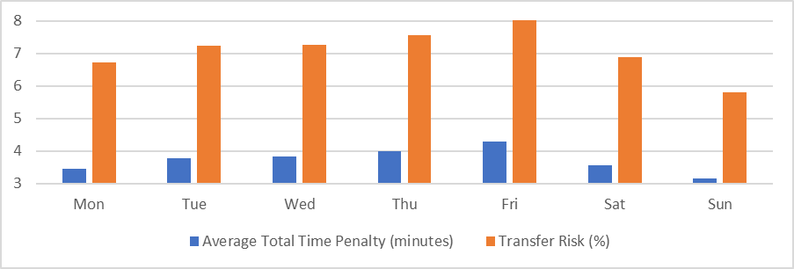

Figure 7 Overall Weekday TR and ATTP Trend Chart in 2018.

Figure 8 illustrates the hourly trend, while Figure 9 maps the spatial patterns during time penalty periods when transfer risk and penalties clusters are high: mornings (8:00 – 9:00 and 9:00 – 10:00), afternoon (17:00 – 18:00 and 18:00 – 19:00), and night hours (22:00 – 23:00 and 23:00 – 24:00). High risk and penalties during the morning and afternoon periods can be explained by overall traffic pattern during these busy hours. However, nighttime with lower traffic also witnesses high transfer risk and high total time penalty. While the risk of missing a transfer does not increase dramatically at night, the consequences (time penalties) are higher due to sparser scheduled services (see Figure 8 and Figure 9).

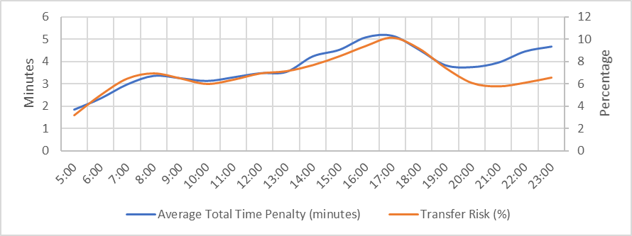

Figure 8 Overall Hourly TR and ATTP Trend Chart.

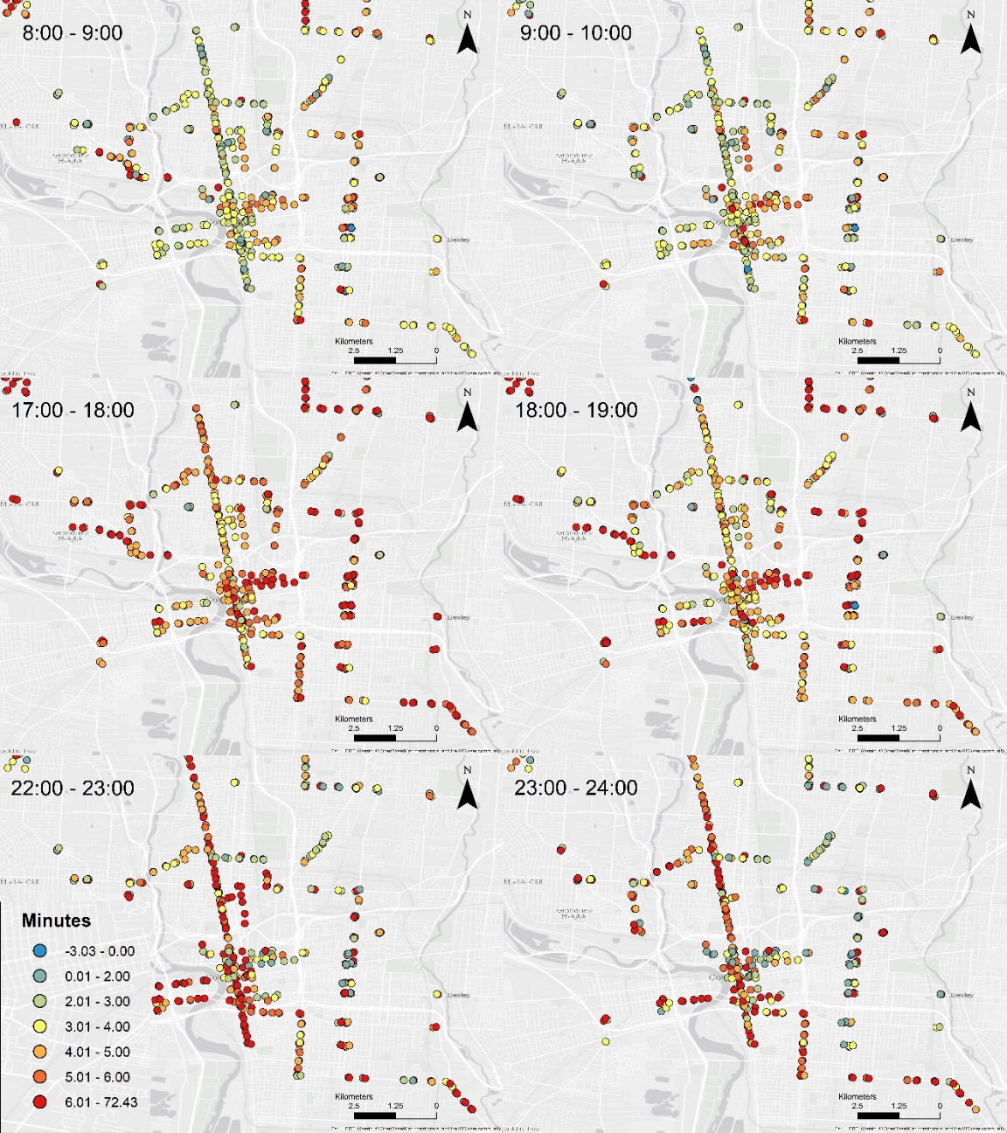

Figure 9 Average Total Time Penalty (ATTP) Hourly Temporal Pattern during three major high time periods.

To examine the impacts of weather and special event days on transfer risk and penalties, we analyzed all days with more than 1.78 centimeters precipitation per day and all days with football games. During days with heavy precipitation, average transfer risk increases to 7.47% and average total time penalty increases to 3.92 minutes. During the football game days, average transfer risk increases to 8.66% and average total time penalty increases to 4.36 minutes. Extreme weather and major events have significant impact on the public transit transfer performance.

* 1. Simulating the impacts of dedicated bus lanes

*Dedicated bus lanes* (DBL) can provide benefits for a bus system by reducing delays due to automobile traffic. Without the disturbance of traffic congestion, bus rapid transit (BRT) systems with separated DBL can achieve rail-like performance (Li, Song, Li, & Zhang, 2009). Basso et al. (2011) investigated several congestion mitigating solutions and conclude that DBL is a good approach to diminish bus delays and increase on-time performance (Basso, Guevara, Gschwender, & Fuster, 2011).

We simulated the impact of DBL on delays, transfer risk and time penalties using the methods in this paper. First, we designated COTA bus route No. 2 as a dedicated bus route with several reasons:

* Frequent transfers: among all the routes, route No. 2 has the most transfers in the COTA system.
* Large spatial coverage: route No. 2 connect North Columbus and East Columbus with the downtown area, which spans a major part of the city.
* One of the busiest routes: Connecting Ohio State University and the downtown area, the ridership statistics show that No. 2 bus is among the routes with the highest ridership. From January 1st 2018 to January 17th 2018, transfers from and to the route 2 take 30.16% of total transfers, which is also the most among all the routes.
* High temporal frequency: route No. 2 is one of the most frequent route (10 – 15 minutes for standard schedule) among the bus routes in COTA system.

Based on these facts, we assume all the buses running on this route behave as the GTFS static scheduled (i.e., no delay). We analyzed TR and ATTP’s changing trend before and after applying the assumption and the difference’s spatial and temporal pattern.

We simulated the impact of a dedicated bus lane (DBL) transfer performance at proximal stops. We specifically inspected proximal stops’ TR and ATTP difference between the scenario without DBL and the scenario with DBL. Figure 10 shows spatial pattern of the TR and ATTP difference between no DBL and DBL on COTA Route 2. For transfer risk, the spatial pattern shows there is a high improvement cluster for part of the route indicated by the red circle in Figure 10. Other route segments show relatively random pattern of transfer risk changes. However, for ATTP, all stops’ performance universally improves but the impact on the downtown is less compared to other outlying stops, especially the cluster with more transfer risk improvement (red circle). Across all stops on the route, the DBL saved on average 1.95 minutes with a standard deviation of 14.58 minutes. Therefore, although the average time savings is modest, the impacts are highly differentiated across stops.

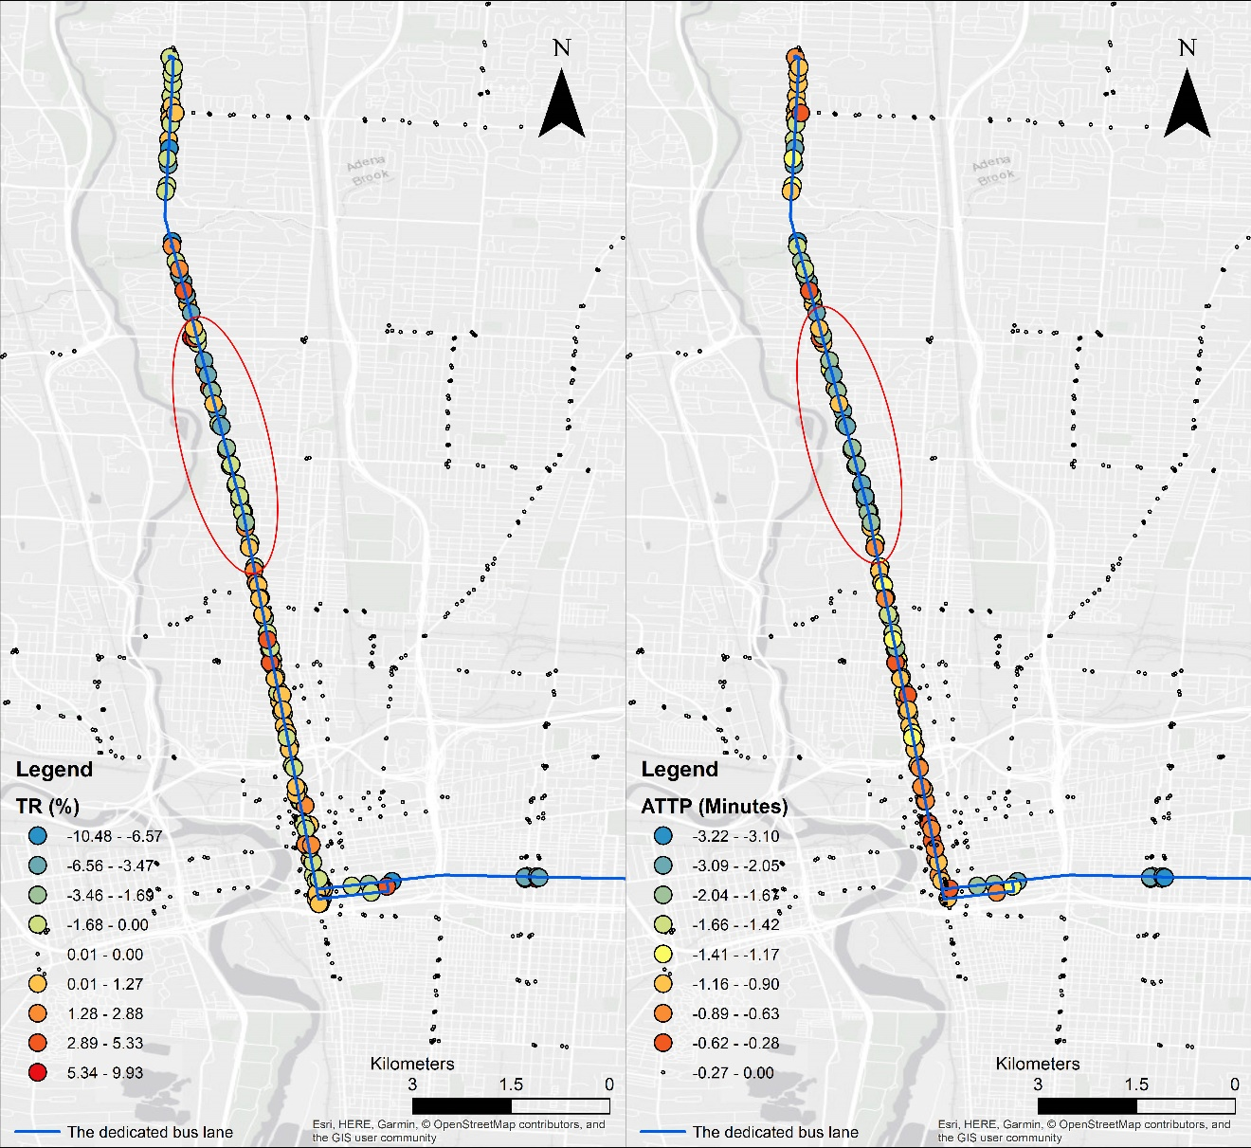

Figure 11 Simulated differences in TR and ATTP after implementation of a dedicated bus lane

Besides DBL’s average impact on all trips, we calculated different impacts on the generating trips and receiving trips. We categorized all affected transfers into two classes: transfers with generating trip on the DBL (*DBL-generating transfers*) and transfers with receiving trip on the DBL (*DBL-receiving transfers*). According to Equation (3), TTP is determined by two factors: *ATP*, which represents the desynchronization penalty; and , which represents normal bus delay. DBL will eliminate delays for all transfers and decrease all transfers’ total time penalty universally. Nevertheless, with DBL removing a generating trip’s delay, it will help reducing desynchronization during the transfer process. However, with DBL eliminating a receiving trip’s delay, it will increase desynchronization, but not necessarily enlarge the time penalty. To measure the two factors’ influence on the saved time, we specifically inspected TR difference and ATTP difference for DBL-generating and DBL-receiving transfers. By comparing the two measures, we investigated how DBL helps save time for the PT users.

Figure 11 shows that DBL will decrease desynchronization for DBL-generating transfers, while it will increase desynchronization for DBL-receiving transfers. The rationale behind this is: for a DBL-generating transfer, there is always a counterpart of DBL-receiving transfer. When DBL improves the performance of the DBL-generating transfer, it will degrade the performance of the DBL-receiving transfer simultaneously. As we combined the two classes of transfers, the graph suggests DBL will not significantly improve the overall TR performance.

However, the ATTP’s spatial and temporal pattern (Figure 10 and Figure 12) suggests the ATTP of stops on the DBL will universally decrease, both for DBL-generating and DBL-receiving transfers. This also suggests that for the average TTP of the COTA system, is the dominating factors after implementing the DBL (see Equation (5)). Also, since DBL-generating transfers benefit from both less desynchronization and less delay, they save more time than the average; since desynchronization increases for DBL-receiving transfers, they still save time but less than the average.

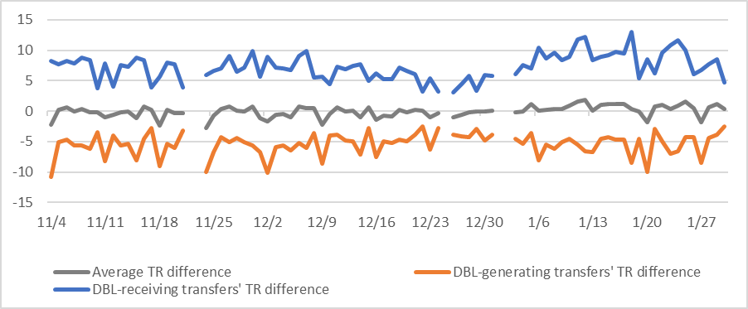

Figure 12 Temporal pattern of simulated changes in TR after implementing a dedicated bus lane (gaps indicate missing data)

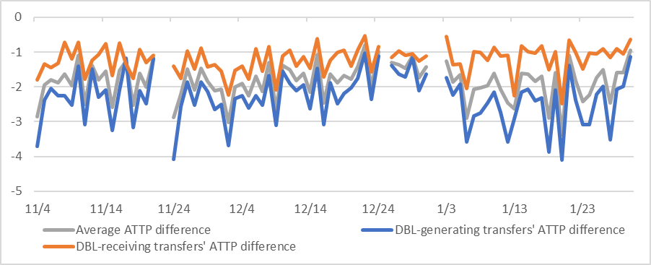

Figure 13 Temporal pattern of simulated changes in ATTP after implementing a dedicated bus lane (gaps correspond to missing data)

Based on this simulation, we conclude that DBL is a good strategy to decrease transfer users’ total time penalty. Figure 11 and Figure 12 also demonstrate that: synchronization is binary and generally complicated to optimize for both transfers. However, delay is single and easy to optimize for both transfers. Although DBL only improves certain transfers’ TR performance, it will universally reduce transit system users’ total transfer time by systematically lessening the receiving buses’ delay. Accordingly, to optimize TTP, it is feasible and effective to reduce delay, such as dedicated bus lane and traffic control. The case study also shows that even if just one route, instead of the whole system, delay control can be efficient to reduce ATTP.

1. **Conclusion**

Transfers between routes are an essential issue for public transit (PT) design and operations. Based on high-resolution GTFS real-time and static data of huge volume, we developed a series of measures, including the transfer risk (TR) and average total time penalty (ATTP), to assess the transfers’ performance. TR and ATTP indicate the systematic quality of transfers and corresponding potential time cost. These measurements provide important information for the PT system planners and administrators concerning the transfers’ feasibility, quality, and user experience. To illustrate this, we applied the index using GTFS static and real-time data from February 2018 to February 2019 in Columbus, Ohio. The spatial and temporal analysis show similar pattern like overall traffic and PT system delay. Moreover, we simulated dedicated bus routes’ impact on the transfer performance. It suggests the dedicated bus lane is a good strategy to reduce ATTP, especially for DBL-generating transfers. We also conclude that it is effective to control delay, instead of synchronization, to reduce ATTP.

Future direction of the transfer studies can also concentrate on the application of both smart and human sensors, generating abundant and high-resolution big data for analysis, administration and prediction. Automatic data from sensors includes GPS stream data from the buses, the smart card data, bus on- and off-boarding information, and the video cameras’ visual recognition. Volunteered data from humans is also a possible strategy for collecting data (Bakillah, Liang, & Zipf, 2012). Based on more precise and abundant data, there are more possibilities for more scientific planning, improvement and knowledge derivation of transfer activities and the PT system.

Appendix A

Ridership-weighted TR and ATTP

We moreover define a weighted version of each index based on the ridership affect, if empirical user ridership data are available:

|  |  |  |
| --- | --- | --- |
|  |  | (7) |

|  |  |  |
| --- | --- | --- |
|  |  | (8) |

where: is the number of people who use this transfer.

**References**

Algers, S., Hansen, S., & Tegner, G. (1975). Role of waiting time, comfort, and convenience in modal choice for work trip. *Transportation Research Record*, *534*, 38–51.

Antrim, A., & Barbeau, S. J. (2013). The many uses of GTFS data–opening the door to transit and multimodal applications. *Location-Aware Information Systems Laboratory at the University of South Florida*, *4*.

Ayed, A. Ben, Halima, M. Ben, & Alimi, A. M. (2015). Big data analytics for logistics and transportation. In *2015 4th International Conference on Advanced Logistics and Transport (ICALT)* (pp. 311–316). IEEE.

Bakillah, M., Liang, S. H. L., & Zipf, A. (2012). Toward coupling sensor data and Volunteered Geographic Information (VGI) with agent-based transport simulation in the context of smart cities. In *Proceedings of the First ACM SIGSPATIAL Workshop on Sensor Web Enablement* (pp. 17–23). ACM.

Bamford, C. G., Carrick, R. J., & MacDonald, R. (1984). Public transport surveys: A new effective technique of data collection. *Traffic Engineering & Control*, *25*(HS-037 547).

Basso, L. J., Guevara, C. A., Gschwender, A., & Fuster, M. (2011). Congestion pricing, transit subsidies and dedicated bus lanes: Efficient and practical solutions to congestion. *Transport Policy*, *18*(5), 676–684.

Ceder, A. (2007). *Public transit planning and operation: Modeling, practice and behavior*. CRC press.

Ceder, A., Golany, B., & Tal, O. (2001). Creating bus timetables with maximal synchronization. *Transportation Research Part A: Policy and Practice*, *35*(10), 913–928.

Chen, M., Mao, S., & Liu, Y. (2014). Big data: A survey. *Mobile Networks and Applications*, *19*(2), 171–209.

Dessouky, M., Hall, R., Nowroozi, A., & Mourikas, K. (1999). Bus dispatching at timed transfer transit stations using bus tracking technology. *Transportation Research Part C: Emerging Technologies*, *7*(4), 187–208.

Google Developers. (2016). GTFS Static Overview | Static Transit | Google Developers. Retrieved March 8, 2018, from https://developers.google.com/transit/gtfs/

Guo, Z., & Wilson, N. (2004). Assessment of the Transfer Penalty for Transit Trips Geographic Information System-Based Disaggregate Modeling Approach. *Transportation Research Record: Journal of the Transportation Research Board*, *1872*(1872), 10–18. https://doi.org/10.3141/1872-02

Guo, Z., & Wilson, N. H. M. (2011). Assessing the cost of transfer inconvenience in public transport systems: A case study of the London Underground. *Transportation Research Part A: Policy and Practice*, *45*(2), 91–104. https://doi.org/10.1016/j.tra.2010.11.002

Hadas, Y., & Ranjitkar, P. (2012). Modeling public-transit connectivity with spatial quality-of-transfer measurements. *Journal of Transport Geography*, *22*, 137–147.

Han, A. F. (1987). Assessment of Transfer Penalty to Bus Riders in Taipei: A Disaggregate Demand Modeling Approach. *Transportation Research Record*, *1139*(Table 1), 8–14.

Hilbert, M. (2016). Big data for development: A review of promises and challenges. *Development Policy Review*, *34*(1), 135–174.

Hunt, J. (1990). *A logit model of public transport route choice* (Vol. 60).

Ibarra-Rojas, O. J., & Rios-Solis, Y. A. (2012). Synchronization of bus timetabling. *Transportation Research Part B: Methodological*, *46*(5), 599–614.

Iseki, H., & Taylor, B. D. (2009). Not all transfers are created equal: Towards a framework relating transfer connectivity to travel behaviour. *Transport Reviews*, *29*(6), 777–800.

Jang, W. (2010). Travel time and transfer analysis using transit smart card data. *Transportation Research Record: Journal of the Transportation Research Board*, (2144), 142–149.

Knoppers, P., & Muller, T. (1995). Optimized transfer opportunities in public transport. *Transportation Science*, *29*(1), 101–105.

Kujala, R., Weckström, C., Mladenović, M. N., & Saramäki, J. (2018). Travel times and transfers in public transport: Comprehensive accessibility analysis based on Pareto-optimal journeys. *Computers, Environment and Urban Systems*, *67*, 41–54.

Lee, J., & Miller, H. J. (2018). Measuring the impacts of new public transit services on space-time accessibility: An analysis of transit system redesign and new bus rapid transit in Columbus, Ohio, USA. *Applied Geography*, *93*, 47–63.

Li, J.-Q., Song, M., Li, M., & Zhang, W.-B. (2009). Planning for bus rapid transit in single dedicated bus lane. *Transportation Research Record: Journal of the Transportation Research Board*, (2111), 76–82.

Liu, R., Pendyala, R., & Polzin, S. (1997). Assessment of intermodal transfer penalties using stated preference data. *Transportation Research Record: Journal of the Transportation Research Board*, (1607), 74–80.

Liu, T., Ceder, A., Ma, J., Nesheli, M. M., & Guan, W. (2015). Optimal synchronized transfers in schedule-based public transport networks using online operational tactics. *Transportation Research Record: Journal of the Transportation Research Board*, (2533), 78–90.

Miller, H. J., & Goodchild, M. F. (2015). Data-driven geography. *GeoJournal*, *80*(4), 449–461.

Nesheli, M. M., & Ceder, A. A. (2014). Optimal combinations of selected tactics for public-transport transfer synchronization. *Transportation Research Part C: Emerging Technologies*, *48*, 491–504.

Nesheli, M. M., & Ceder, A. A. (2015). Improved reliability of public transportation using real-time transfer synchronization. *Transportation Research Part C: Emerging Technologies*, *60*, 525–539.

Nesheli, M. M., Ceder, A. A., & Liu, T. (2015). A robust, tactic-based, real-time framework for public-transport transfer synchronization. *Transportation Research Procedia*, *9*, 246–268.

Nesheli, M. M., Ceder, A., & Gonzalez, V. A. (2016). Real-time public-transport operational tactics using synchronized transfers to eliminate vehicle bunching. *IEEE Transactions on Intelligent Transportation Systems*, *17*(11), 3220–3229.

Nesheli, M. M., Cedera, A. A., & Hassold, S. (2014). *Optimal holding and skip-stop/segment tactics for public-transport transfer synchronization*.

Nishiuchi, H., Todoroki, T., & Kishi, Y. (2015). A Fundamental Study on Evaluation of Public Transport Transfer Nodes by Data Envelop Analysis Approach Using Smart Card Data. *Transportation Research Procedia*, *6*, 391–401.

Planning, C. T., & Transportation, U. S. D. of. (1997). *Transfer penalties in urban mode choice modeling*. US Dept. of Transportation.

Sun, L., Rong, J., Ren, F., & Yao, L. (2007). Evaluation of passenger transfer efficiency of an urban public transportation terminal. In *IEEE Conference on Intelligent Transportation Systems, Proceedings, ITSC* (pp. 436–441). IEEE. https://doi.org/10.1109/ITSC.2007.4357762

Sun, L., Rong, J., & Yao, L. (2010). Measuring Transfer Efficiency of Urban Public Transportation Terminals by Data Envelopment Analysis. *Journal of Urban Planning and Development*, *136*(4), 314–319. https://doi.org/10.1061/(ASCE)UP.1943-5444.0000028

Walker, J. (2012). *Human transit: How clearer thinking about public transit can enrich our communities and our lives*. Island Press.

Wardman, M. (1998). A review of British evidence on the valuations of time and service quality.

Wardman, M., Hine, J., & Stradling, S. (2001). Interchange and Travel Choice Volume 2. *Scottish Executive Central Research Unit*.

1. *Corresponding author e-mail: [miller.81@osu.edu](mailto:miller.81@osu.edu)

   First author e-mail: [liu.6544@osu.edu](mailto:liu.6544@osu.edu)