Measuring public transit transfer risk using high-resolution schedule and real-time bus location data

Luyu Liu and Harvey J. Miller[1]*

Department of Geography and Center for Urban and Regional Analysis

The Ohio State University, Columbus, Ohio, USA

**Abstract**

Transfers between routes in a public transit system are important for many transit users. Missing transfers due to public transit delays can impose substantial time penalties on these users. However, few studies assess the risk and consequences of missing transfers based on on-time performance. Leveraging high-resolution schedule and real-time transit data, we develop two measures to assess transfer risk and time penalties in a public transit system. *Transfer Risk* (TR) measures the empirical probability of missed transfers and *Average Total Time Penalty* (ATTP) shows overall time loss compared to the schedule. We illustrate these measures based on schedule data and two sources of real-time vehicle data from the transit authority in Columbus, Ohio: open General Transit Feed Specification (GTFS) and administrative Automatic Passenger Counter (APC) data. We aggregate, visualize, and analyze each measure under different spatial and temporal resolutions. We also simulate the impacts of dedicated bus lanes reducing transfer risk and time penalties. Results demonstrate the effectiveness of the TR and ATTP measures to assess the impacts of delays on transfers and guide planning and decision making to improve on-time performance.

1. **Introduction**

Transfers between routes are a necessary component of public transit systems. The expansion of city footprints can make long and direct routes difficult and costly (Knoppers and Muller, 1995). Configuring systems that include route transfers can also allow public transit providers to cover more space and time with fewer vehicles (Walker, 2012). However, transit delays, defined as a positive deviation of a transit vehicle’s actual arrival time from the scheduled time, are inevitable due to traffic, equipment malfunctions, external events and other circumstances. Transit delays causing users to miss intended transfers between routes can impose significant time penalties on users, making the system less functional and desirable.

Until recently, the scientific analysis of public transit transfers has been limited (Iseki and Taylor, 2009). Previous research focus on the users’ experience and transfer node design, using methodologies such as tracking a sampling of users and stated preference surveys (Guo and Wilson, 2004, 2011; Sun et al., 2007, 2010). More recent research expands these data sources to include smart card data and real-time data on system (Jang, 2010; Nesheli and Ceder, 2015; Nishiuchi et al., 2015). However, there are few papers proposing systematic measurement for transfer performance using newly available high-resolution data sources such as detailed schedule and real-time vehicle locations. Measures and analytics to help understand the impact of delays on transfers can be useful for operational, planning and administration purposes.

In this paper, we develop measures for the evaluation of the transfer performance in public transit systems using high-resolution schedule and real-time vehicle location data. *Transfer Risk* (TR) measures the empirical probability of missing transfers based on historical data, while the *Average Total Time Penalty* (ATTP) shows overall time loss compared to the schedule. We implement these measures using high-resolution schedule and real-time vehicle location data from the Central Ohio Transit Authority (COTA) bus system in Columbus, Ohio, including both open data published in the General Transit Feed Specification (GTFS) format and administrative data derived from Automated Passenger Counters (APCs). We explore the patterns of TR and ATTP at different levels of spatial and temporal resolution, and simulate the impact of dedicated bus lanes on TR and ATTP. The results demonstrate the effectiveness of the TR and ATTP measures to assess the impacts of delays on transfers and guide planning and decision making to improve on-time performance.

In the next section of this paper, we review previous research on transfers from the perspectives of the data utilized and the analysis conducted. In the subsequent section we introduce our data sources and methods. Following this, we show the results of the spatial and temporal analyses. We conclude this paper with a discussion of the strengths and limitations of this study, and steps for future research.

1. **Background**

This literature review covers two aspects of measuring and analyzing public transit transfers. We first discuss two types of data sources: data collected deliberately for analysis and data generated automatically as a byproduct of operations (Ceder, 2016). Following this, we discuss research that uses these data for the transfer measurement.

* 1. Deliberate versus byproduct data

**Deliberate data.** Traditionally, studies of public transit transfer properties and behaviors use data collected deliberately for specific research questions, often using dedicated Global Positioning System (GPS) receivers and survey instruments. While these data are valuable, there are several issues that limit their usefulness.

One issue is the lack of universal standards and definitions, making comparisons difficult. Different transfer studies have varying definitions of transfers and their data (Guo and Wilson, 2004), limiting comparability. Studies using deliberate data also have study-specific data sources that may be difficult to reproduce in other settings.

Another issue is that most deliberate data are expensive and time-consuming to collect. For example, Guo and Wilson (2011) created and maintained special purpose station inventory and field survey databases. This requires substantial time and resources, often for a relatively small volume of data. Therefore, it can be challenging to cover the entire public transit system well, both spatially and temporally. In addition, sampling frames are fragile, meaning that data collected for one set of questions cannot easily be repurposed for other questions (Miller and Goodchild, 2015).

An example of deliberate data is stated preference (SP) data, used widely to support mode choice models (Guo and Wilson, 2011). Although many transfer assessment studies use SP data (Wardman, 2001), the choice dimension is typically small, meaning that SP data may not be able to capture the full diversity of transfer situations (Bovy and Stern, 2012). Other semi-quantitative data collecting methods, such as on-board questionnaires, can also lack precision and reliability. The result of these imprecise data sources is that most studies provide a partial assessment of the system since it is difficult to have a detailed assessment at high spatial or temporal resolutions across the entire system (Guo and Wilson, 2011).

**Byproduct data.** In the past, detailed, real-time performance data about public transit was difficult to acquire (Dessouky et al., 1999). However, this has changed due to the development of new data collection and sharing technologies, often used to support activities such as operations and customer relations rather than scientific research. The widespread application of new information and communication technologies (ICTs) provide the technical support for what is often labeled *Big Data* (Hilbert, 2016). The definition of Big Data is diverse; a commonly accepted definition encompasses the “three Vs”: large volume, high variety, fast velocity (Chen et al., 2014). However, as Miller and Goodchild (2015) argue, in many applications, especially in urban science, the unique and valuable characteristic of Big Data is ubiquity: its widespread coverage and availability, often as a byproduct of digitally-enable operations and activities.

In public transit, inexpensive GPS receivers and wireless communication allow widespread tracking of vehicle locations in real-time. These data are collected automatically on an ongoing basis by public transit authorities, meaning they are readily available without additional and prohibitive cost or effort. Meanwhile, the World Wide Web combined with data services allow sharing schedule and real-time vehicle location data. This technology revolution allows the possibility of more detailed investigation of transfer performance across an entire transit system.

However, big data also has limitations. As suggested by the characteristic “high variety,” these data are often heterogeneous in terms of structure, quality and support: diverse data sources, lack of metadata, and lack of quality control all make big data challenging from a scientific perspective (Miller and Goodchild, 2015). Accordingly, standard protocols for sharing transit schedule and real-time data, such as General Transit Feed Specification (GTFS) (Google Developers, 2016, 2018), to help solve these problems.

* 1. Measuring public transit transfers

Many studies concentrate on measuring aspects of transfers and define measures based on one or several transfer attributes. For example, Nishiuchi et al. (2015) used Data Envelop Analysis to derive measures to evaluate the efficiency of user transfers between transportation systems. They concentrate on the transfer stations’ commuting efficiency using users’ smart card data. Hadas & Ranjitkar (2012) combine transfer connectivity and travel time to represent the quality of transfers. Guo & Wilson (2011) assess transfer cost based on both users’ and operators’ perspective; they develop an index that measures each transfer node’s effectiveness based on average time and economic cost per capita and apply it to the London Underground system.

Some research analyze users’ perceptions and attitudes about transfers (CTPS, 1997; Guo and Wilson, 2004; Liu et al., 1997; Wardman et al., 2001). These studies focus on measuring transfer penalties; these penalties encompass a broad range of factors such as walking time, number of transfers in a single trip, waiting time, ticket fare, and other environmental factors. Kujala et al. (2018) analyze travel time and transfers in Helsinki, Finland. They calculate pre-journey waiting time, journey duration, and number of required transfers for all Pareto-optimal journeys between all origin-destination pairs to calculate accessibility for journeys with different number of possible transfers.

Due to the lack of real-time data, little research assesses transfers based on real-time performance and the risk of missing transfers due to delays. Progress in data availability, real-time monitoring and other smart city technologies are making this topic an area of active investigation: researchers can now conduct more detailed analysis and develop more precise measures and models of public transit transfer performance (Hadas and Ranjitkar, 2012; Kujala et al., 2018). This paper contributes to this literature by developing measures of transfer risk and transfer time penalties using high-resolution real-time data sources.

1. **Methodology**

This section discusses the methodology in our study. We first describe our data sources; then we define public transit transfers from a space-time perspective and conceptualize the impact of vehicle delays as a problem in transfer synchronization. Then, we discuss the methods involved in transfer risk measurement and analysis.

* 1. Data sources

In this paper, we leverage two datasets for measures and analytics.

**General Transit Feed Specification (GTFS) data.** General Transit Feed Specification (GTFS) is a combination of two data standards: *GTFS static* and *GTFS real-time expansion*. GTFS static reports the schedule data for a public transportation system. GTFS static is now the *de facto* standard for public transportation schedules and associated geographic data (Google Developers, 2016). Public transit system administrations are encouraged to share their GTFS static publicly: by 2010, almost 85% of transit miles traveled in the U.S were covered by open data published by transit authorities (Antrim and Barbeau, 2008).

GTFS real-time expansion provides frequently updated vehicle location data. GTFS real-time includes two components: vehicles’ location and the trip updates, which contains vehicles’ arrival and departure time at every sequential stop. Moreover, the temporal resolution can be as high as 1 min (Kujala et al., 2018). GTFS overcomes the disadvantages of both traditional data and unclean big data: it is high volume, frequently updated, standardized formats, and covers the entire public transit system.

However, despite all the valuable features, GTFS is not perfect. In particular, GTFS’s temporal accuracy can be low compared with other sources such as automated passenger count data (discussed below). This is because GTFS real-time data feed is updated based on a set temporal interval, not based on the actual events of a public transit vehicle entering and leaving a designated stop. Consequently, the actual arrival/departure time may be different from the times recorded in the GTFS data.

**Automated Passenger Count (APC) data.** Due to the temporal uncertainty of GTFS data, we also utilize another data source. Automated Passenger Counting (APC) data is generated by devices that are installed on the vehicles to track and report transit ridership (Chu, 2010; Transit Wiki, 2019). These data often contain arrival time and departure time at each stop.

A major advantage of APC data compared to GTFS data is its higher temporal accuracy: the arrival and departure time is recorded at the stop as the events occur instead of updated according to a specified temporal interval. However, APC data are not open. As administrative data, APC data are not available for the public and transit mobile applications. Moreover, APC data does not have widespread coverage of the whole system. Typically, a subset of public transit vehicles are installed with APC devices rather than blanket coverage as with GTFS data.

To leverage the positive features of both data sources, we merge the raw APC data and the GTFS data into a new combined dataset. We enumerated all GTFS trips while querying the APC database: if the corresponding trip is in the APC database, we override the record in the GTFS database to take advantage of the higher temporal accuracy of the APC data. Below, we will provide results based on both the original GTFS and the merged APC-GTFS dataset.

* 1. Transfer definition

Public transit transfers link *generating trip* and *receiving trip*. A user first boards a bus to start the generating trip, then alights to catch the next bus to start the receiving trip. The transfer itself can be characterized as: i) a street-crossing transfer; ii) a sidewalk-based transfer, and; iii) a non-walk transfer at the same stop (Hadas and Ranjitkar, 2012). Based on this categorization, we can generalize the transfers as: i) *non-walking transfer*, which does not require a walking for the transfer, and; ii) *walking transfer*, which requires walking from the generating trip’s stop (which we label the *generating stop*) to receiving trip’s stop (the *receiving stop*).

* 1. Transfer synchronization, desynchronization and time penalties

**Synchronization and desynchronization.** We further conceptualize transfers as a process of synchronization among: i) the generating trip brings passengers to the generating stop; ii) transition of users to receiving stop; iii) the receiving trip picks up passengers at receiving stop.

Transit delays can result in inconsistent arrival and departure times hence the desynchronization of scheduled generating trip and receiving trip. For each transfer, we can measure the time penalty when the receiving bus is leaving; this is the time point when the desynchronization happens. Due to desynchronization between the generating and receiving trip at the receiving stop, the actual transfer can differ from the schedule according to the relative temporal order of the two trips arrival/departure time. Figure 1 illustrates this process using a time-space diagram.

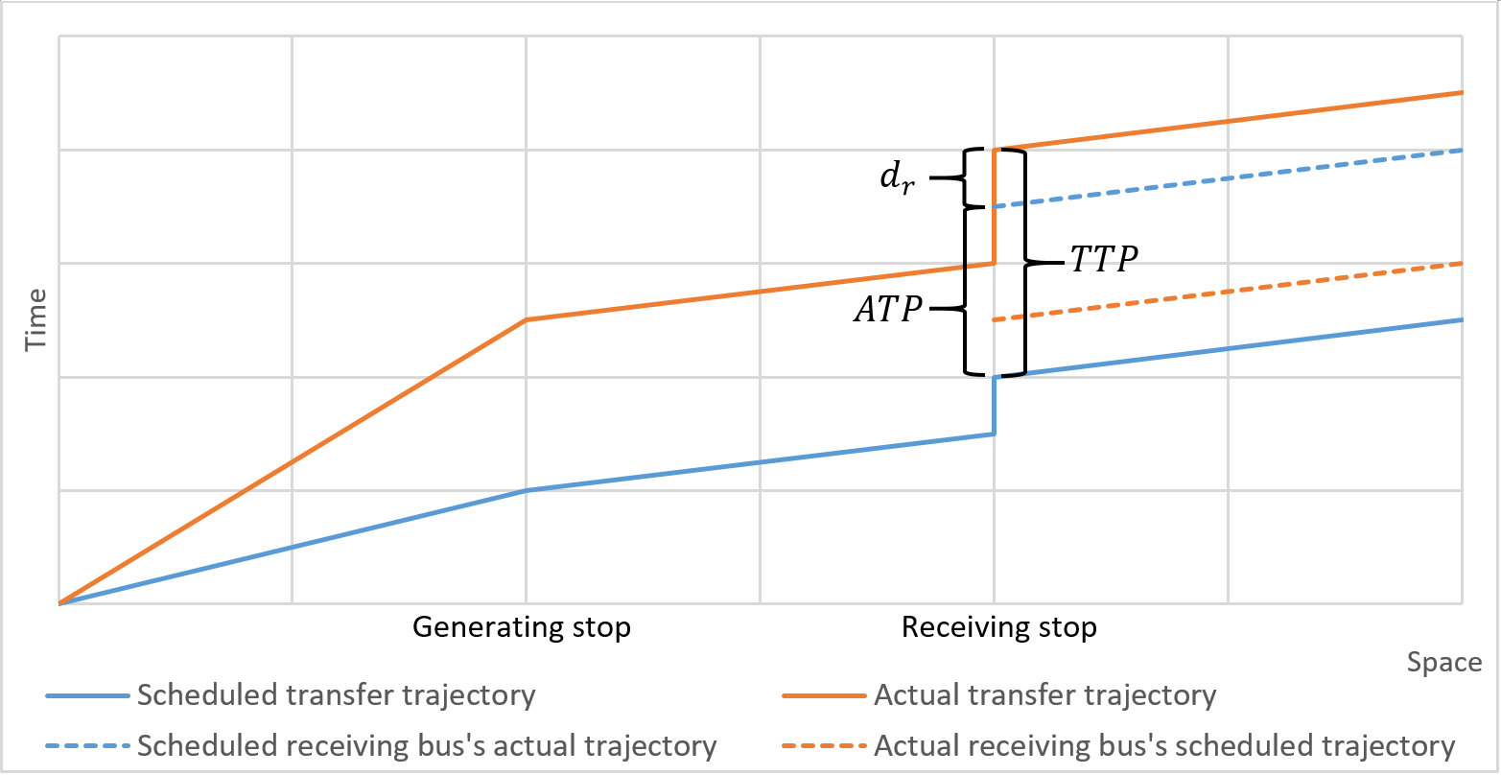

Figure 1 Time-space diagram of a delayed transfer and the corresponding scheduled transfer

Due to the desynchronization, the actual receiving bus can be different from the scheduled receiving bus. We can conceptualize the schedule of all buses running on the same route as an array of trips (a *trip sequence array*). We assume the passenger will always take the first available bus. If the generating bus is sufficiently late, the passenger will miss the scheduled bus and need to take a later scheduled bus. Likewise, if the receiving buses are sufficiently late, the passenger can catch an earlier receiving bus in the trip sequence array. The *desynchronization degree* (DD), an integer variable, measures a transfer’s desynchronization in the trip sequence array:

|  |  |  |
| --- | --- | --- |
|  |  | (1) |

**Transfer time penalties.** We calculate two types of potential time penalties for each transfer. The first is *total time penalty* (TTP):

|  |  |  |
| --- | --- | --- |
|  |  | (2) |

where: is the actual departure time of actual receiving bus (DD = n), is the scheduled departure time of scheduled receiving bus (DD = 0). TTP represents the total time loss compared to the schedule at the receiving stop. The value shows the total delay when the receiving trip starts, which encompass both the generating bus and receiving bus time loss. However, since the synchronization process is involved with two vehicles, it is also important to determine the corresponding time loss caused by each bus. For example, a large TTP could be because of the receiving bus’s large delay but the synchronization is not disturbed; on the other hand, a large TTP could be also because of the first bus’s delay, which results in desynchronization and thus long waiting time.

To quantify this two different types of delay, we decompose TTP as follows:

|  |  |  |
| --- | --- | --- |
|  |  | (3) |

where: is the scheduled departure time of the actual receiving bus (DD = n), is the scheduled departure time of the scheduled receiving bus (DD = 0), is the delay of the actual receiving bus at the receiving stop. The second part of the decomposition is defined as *additional time penalty* (ATP), which represents the time cost caused by the transfer desynchronization.

The two parts of TTP’s decomposition, ATP and , correspond to the time penalty caused by desynchronization and normal delay of the actual receiving bus. The value of depends on the passenger’s actual arrival time at receiving stop and the receiving buses’ schedules. If the passenger’s actual arrival time is before the scheduled bus’s departure time (DD = 0), there will be no additional time penalty; if the actual arrival time is after the nth bus’s departure time (DD = n), which can be noted as *n*-*th* receiving bus, then there is an additional time penalty which is worth sum of *n* receiving buses’ headways.

|  |  |  |
| --- | --- | --- |
|  |  | (4) |

where: n is the transfer’s actual DD, M is the lower bound of DD, and N is the upper bound of DD. is the sum of headways.

Beyond a single transfer’s time penalty, we can expand the measure to a collection of transfers. The collection can have different spatiotemporal definitions depending on different purposes, such as transfers between two routes during an hour every day, or transfers at a stop during a year. We can measure the *average total transfer time penalty* (ATTP) for a collection of transfers :

|  |  |  |
| --- | --- | --- |
|  |  | (5) |

where: is the measurement of transfer ’s total time penalty.

**Transfers: The good, the bad, and the ugly.** We classify all transfers into three types according to their real-time synchronization performance. We can distinguish them by the receiving bus’s desynchronization degree.

* *The good: normal transfers* (DD = 0), as shown in Figure 2 (left). A passenger getting on a normal transfer will catch the same bus as the scheduled transfer. Under this circumstance, ATP = 0, which means there is no additional time penalty, while the performance can be still different from the schedule due to the normal delay of the receiving trip.
* *The bad: missed transfers* (DD > 0), as shown in Figure 2 (middle). Under this circumstance, ATP > 0. The passenger will take a bus after the scheduled bus, hence will suffer from additional time penalty other than normal delay. The missed transfers have several scenarios: 1) generating trip is delayed that the user cannot catch the scheduled receiving bus; 2) the scheduled receiving bus is out of service; 3) the scheduled receiving bus is severely delayed after another receiving bus. Scenario 1 is the most common circumstances. For scenario 2, if the scheduled receiving trip is no longer running, the passenger must take the next bus. Likewise, for scenario 3, a severely delayed bus can be caught up by another bus on the same route scheduled after it. It is natural for users to take the closest bus despite the buses being out of sequence.
* *The ugly: preemptive transfers* (DD < 0), as shown in Figure 2 (right). During a preemptive transfer, instead of the scheduled bus, the user will get on a bus which should have arrived earlier than the passenger at the receiving stop. This is due to delays in the receiving buses. The passenger will naturally take the nearest bus regardless of the schedule. The ATP’s value can be negative, zero or positive, however, a negative ATP will not necessarily suggest a better performance since the TTP can be positive meanwhile.

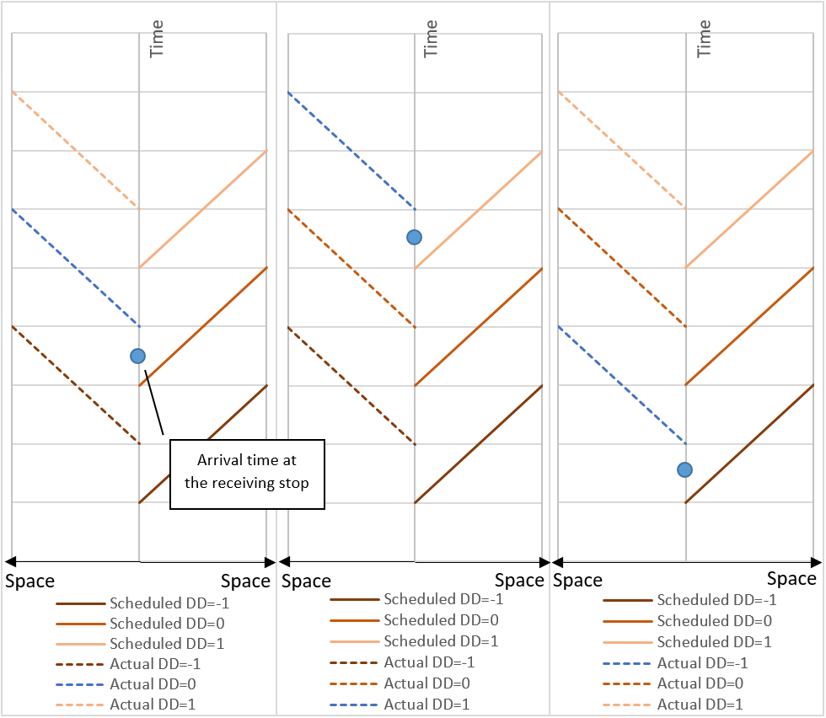

Figure 2 Space-time diagram of three scenarios of a transfer synchronization process (Dash line: actual; solid line: schedule.)

Accordingly, we measure each transfer with a binary value that represents whether it is a missed transfer. Based on the assessment of single transfer, we define *transfer risk*: it is the proportion of missed transfers in a collection of transfers, based on the empirical schedule and real-time vehicle location data; we can interpret this as an empirical probability of a missed transfer in this collection. Mathematically, in a collection , the transfer risk is:

|  |  |  |
| --- | --- | --- |
|  |  | (6) |

where: is the collection of transfers and is the binary measurement variable of each transfer.

* 1. Determining valid transfers

There are four policies for transfer scheduling in public transit systems: 1) Unscheduled transfers; 2) Scheduled transfers without vehicles waiting; 3) Single holding strategy that lower frequency vehicles wait for higher frequency vehicles; 4) Double holding transfer that both vehicles hold for transfers (Ceder, 2016; Knoppers and Muller, 1995). Many transit authorities, especially those that rely on buses, use an unscheduled transfer policy, meaning there are few explicitly scheduled transfers in the GTFS static data. Moreover, in reality, transit users’ transfer behavior and transit real-time apps will not strictly follow the scheduled transfers.

Consequently, we have to search empirically for possible transfers from the GTFS static data. Theoretically, any two trips at two stops which are proximal enough for users to access can be regarded as a valid transfer. This can be refined with passenger data that shows actual transfers; this is likely to be a subset of the valid transfers. However, the danger with this approach is we may miss a potential transfer if it did not occur in the data.

Based on the data structure in the GTFS data, we define three levels of aggregation: *stop*, *route*, and *trip*. Every trip is run according to a fixed schedule by a bus at a specific time. Trips with a same schedule can be aggregated into a route, and some routes can be bound to a stop. To find transfer schedule from GTFS schedule, we developed a hierarchical searching algorithm in the Python and MongoDB environment. Using the algorithm, we derived all possible stops combinations, route combinations, and GTFS trip combinations. Only those combinations with near distance (Euclidean distance < 100 meters) and unique routes are selected for the transfer schedule.

1. **Analysis**

To implement and assess the indexes and the system, we conducted a case study using data from Central Ohio Transit Authority (COTA) bus system in Columbus, Ohio from February 2018 to January 2019. We acquired the GTFS schedule and real-time data via the COTA public application programming interface. COTA shared the APC dataset from May 2018 to January 2019. When merging the APC and GTFS datasets, 45.06% of the total records were matched on average, meaning that roughly half of the GTFS vehicle time data was updated with the more accurate APC time data.

We archived the data using a MongoDB database. The GTFS real-time data, APC data, and their auxiliary databases total nearly one terabyte. Due to this large database size, we optimized and parallelized our code to deal with the computational burden. We also developed different summary measures based on varying spatial or temporal aggregations. To compare the results derived from GTFS and APC data, we present two versions of measures and compare accordingly.

* 1. Spatial patterns

To investigate the spatial pattern of transfer risk, the first thing is spatial aggregation, since *trip patterns* (each vehicle trip; the finest level of resolution) are too specific and not representative of broader patterns. We can aggregate in different ways. Naturally, *route patterns* are useful, which aggregate the trip combinations based on their route schedules. *Stop patterns* are also useful since the quality of transfers between stops is assessed and stop combinations are geographically distinguishable, making it especially crucial for visualization. We concentrate on stop patterns in our analyses.

Based on the GTFS data alone, the average TR over the study period is 7.14% (25.75%) and the ATTP is 3.74 ( 12.97) minutes; based on the merged APC-GTFS, the average TR is 8.55% (27.96%) and the ATTP is 4.57 (15.44) minutes. Although the mean value is relatively small, however, the standard deviation is substantially large, which suggests the temporal and spatial variation is large. We can also observe that calculations of TR and ATTP are higher based on the APC-GTFS data than the GTFS data alone.

Figure 3 show the spatial pattern of the TR and ATTP from February 2018 to January 2019 for both datasets. It shows some differences between TR and ATTP’s spatial distribution, especially on High Street (a major north-south thoroughfare in Columbus, indicated by a red circle in Figure 3) and downtown area (indicated by a blue circle in Figure 3). Stops among High Street has relatively higher transfer risk but also have relatively lower average total time penalty. This is likely due to traffic and other disturbances on this route elevating the risk, although headway between buses is short meaning the time penalty is small. Similarly, the high ATTP clusters on some roads in downtown area and some peripheral roads that do not have higher transfer risk. Although the desynchronization risk is low, the time delay can be high, especially for downtown, due to longer headways.

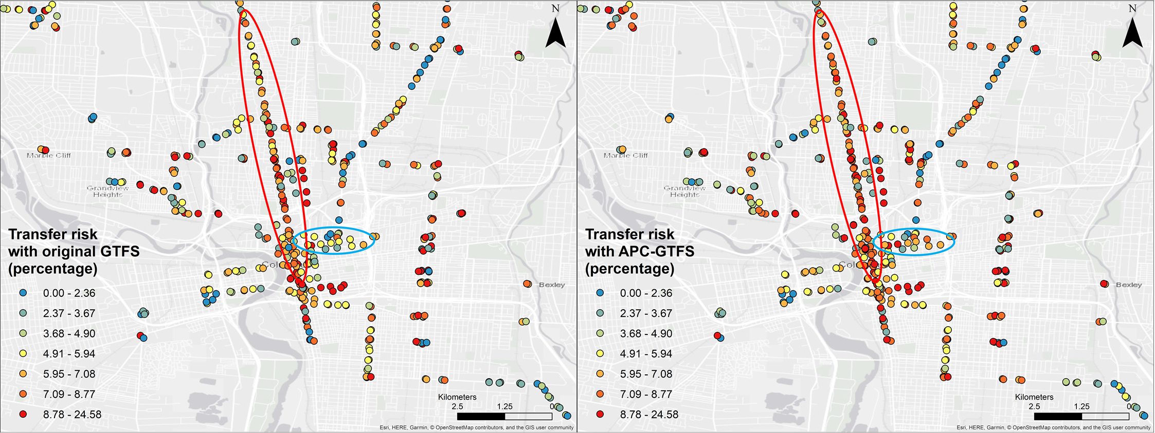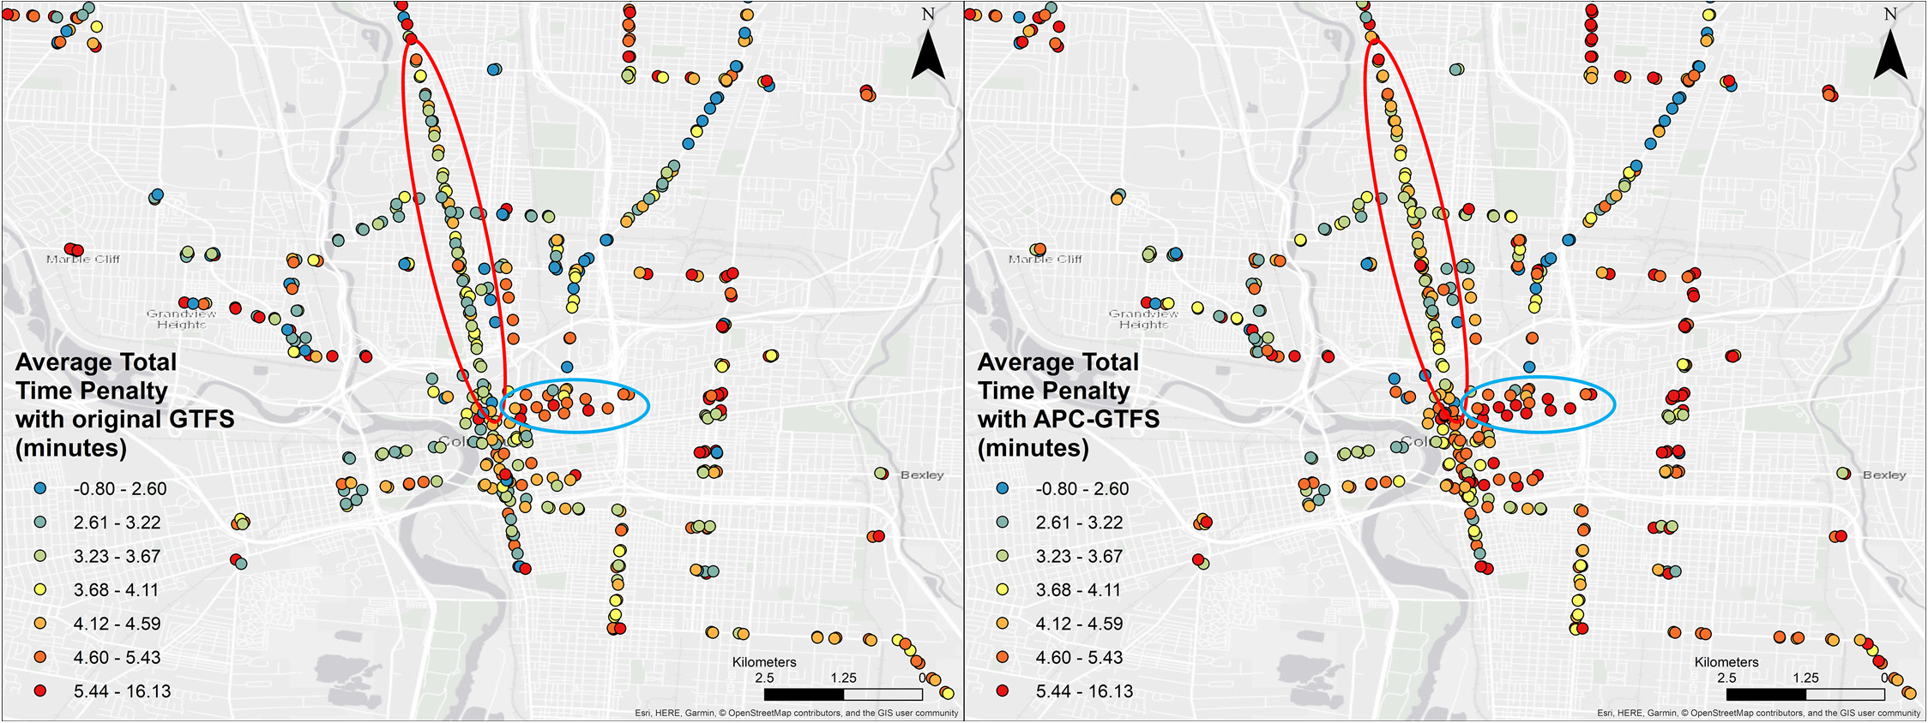

Figure 3 Spatial Pattern of TR and ATTP (in quantile classification)

* 1. Temporal patterns

We now examine aggregate temporal patterns of transfer risk and time penalties. Figure 4 provides the monthly trends of TR and ATTP for both datasets. Although APC-GTFS’s results are larger, both datasets suggest a similar pattern. July, December, and January show an overall low time penalty pattern. This can be due to better overall traffic conditions during summer and holiday season vacation. August is the worst month to take a transfer; this may be due to the start of an academic year in a city with a massive university campus near the city center.

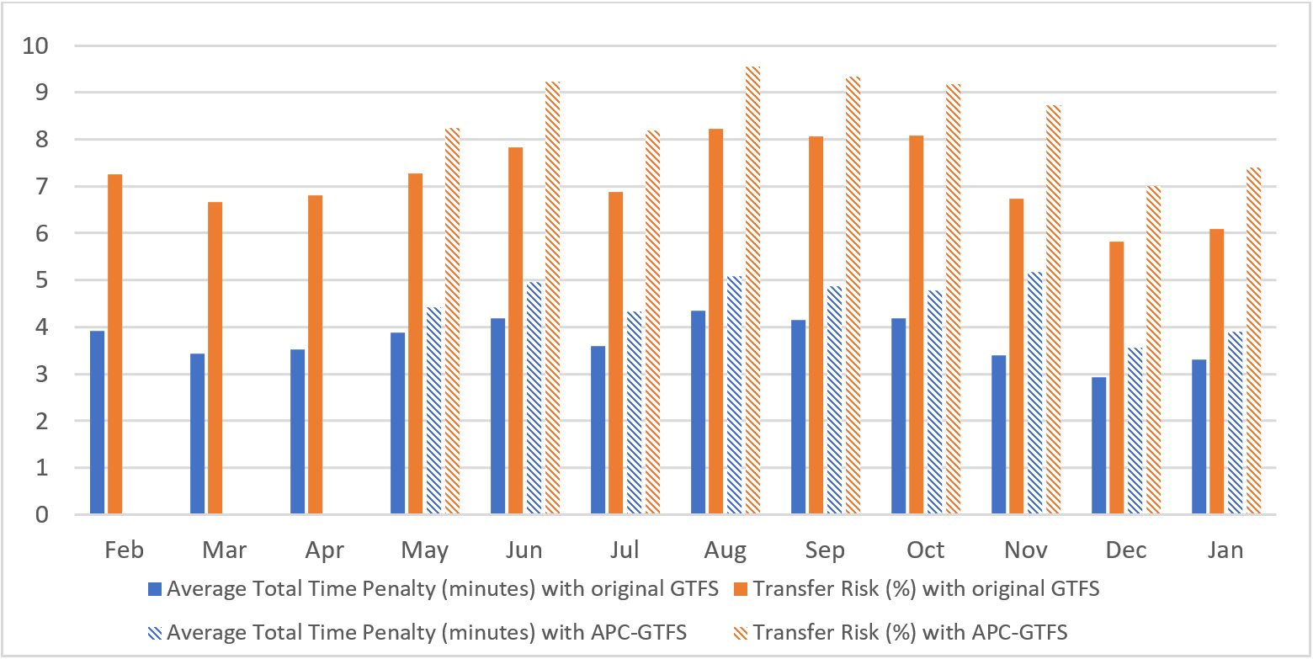

Figure 4 Overall monthly TR and ATTP trend chart.

Figure 5 provides the aggregate trends by day of the week for both datasets. We can see the overall TR and ATTP peak on Friday, and the core of weekdays (Wednesday, Thursday, and Friday) maintains higher levels of risk and time penalties, likely due to the overall traffic pattern in this city. TR and ATTP are relatively low on weekends, as would be expected due to lower traffic congestion. TR and ATTP are relatively low on Mondays, possibly due to flexible working schedule and long weekends for some residents, leading to less commuting. However, for the APC-GTFS dataset, we observe ATTP on Sundays is second lowest compared to Fridays, which is the lowest for original GTFS dataset.

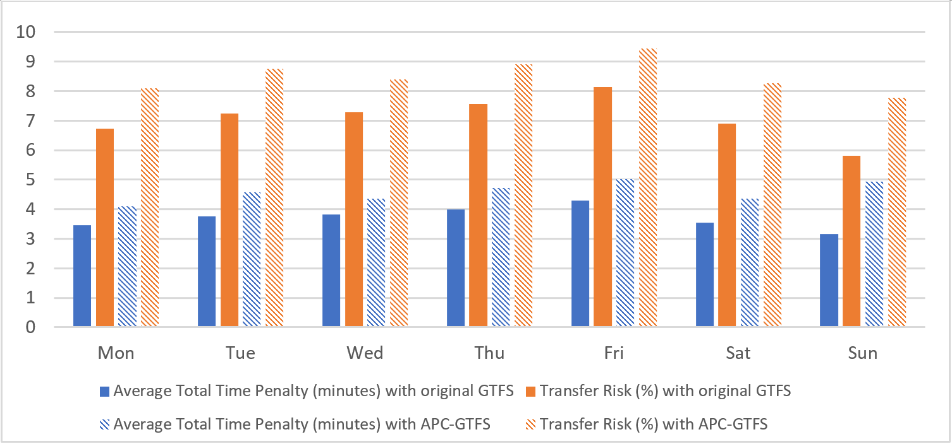

Figure 5 Overall Weekday TR and ATTP Trend Chart.

Figure 6 illustrates the hourly trend and there are three major time clusters when transfer risk and penalties are high: mornings (8:00 – 9:00 and 9:00 – 10:00), afternoon (17:00 – 18:00 and 18:00 – 19:00), and night hours (22:00 – 23:00 and 23:00 – 24:00) for APC-GTFS data. High risk and penalties during the morning and afternoon periods can be explained by overall traffic pattern during these busy hours. However, nighttime with lower traffic also displays high transfer risk and high total time penalty. At night, the time penalties are higher due to sparser scheduled service.

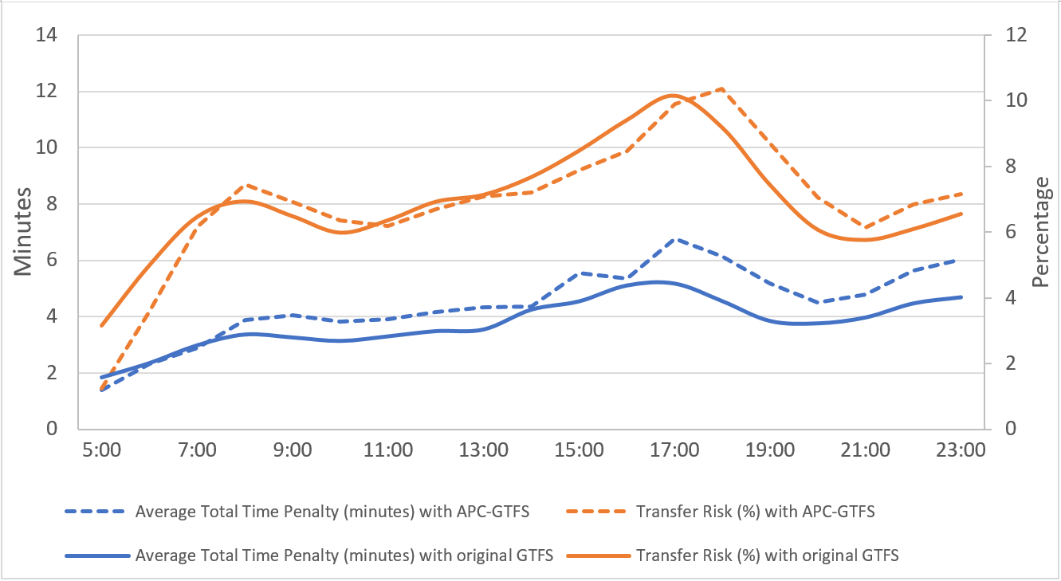

Figure 6 Overall Hourly TR and ATTP Trend Chart.

As for the comparison of original GTFS and APC-GTFS, for most hours, the ATTP based on the APC-GTFS data is larger than the ATTP based on the original GTFS data; while only during rush hours (morning, afternoon) and night is the APC-GTFS transfer risk is larger than GTFS transfer risk estimate. Although both results display similar patterns, the original GTFS data results are smaller compared with APC-GTFS, especially during rush hours. Moreover, the differences between the datasets could have more impact if ridership is included, since rush hours witness most ridership in the system. This demonstrates some risks of using original GTFS as the only data source without any calibration using administrative data.

Besides regular temporal patterns, we chose days with weather events and special events to examine their impact on the transfer real-time performance. Weather, especially extreme weather during winter, is a major factor for public transit delays. Special events (such as football games near The Ohio State University in Columbus) can also impact local traffic and public transit. We selected several representative days to measure the TR and ATTP differences due to these events. We analyzed all days with more than 1.78 centimeters precipitation per day and all days with football games. During days with heavy precipitation, TR increases from 7.14% to 7.47% and ATTP increases from 3.74 to 3.92 minutes for original GTFS data; while TR increases from 8.55% to 9.89% and ATTP increases from 4.57 to 5.14 minutes for APC-GTFS data. During the football game days, TR increases to 8.66% and ATTP increases to 4.36 minutes for original GTFS data; TR increases to 9.06% and ATTP increases to 4.83 minutes for APC-GTFS data. Extreme weather and major events have considerable impact on the public transit transfer performance.

* 1. Simulating the impacts of dedicated bus lanes

*Dedicated bus lanes* (DBL) can provide benefits for a bus system by reducing delays due to automobile traffic. Without the disturbance of traffic congestion, bus rapid transit (BRT) systems with separated DBL can achieve rail-like performance (Li et al., 2009). We simulated the impact of DBL on delays, transfer risk and time penalties using the methods in this paper.

We selected the COTA bus route No.2 as the target, which has the most transfers and most ridership in the system. We simulate the impact of a DBL by assume all the buses running on this route will behave according to the GTFS static schedule data after DBL is in effect (i.e., no delay). This is an upper bound on the actual DBL performance. We analyze TR and ATTP’s changing trend before and after applying the assumption and the difference’s spatial and temporal pattern. Across all stops on the route, the DBL will save 1.69 minutes ( 13.24 minutes) with original GTFS; with APC-GTFS as shown in Figure 7, the DBL will save 1.72 minutes ( 10.09 minutes). Therefore, although the average time savings is modest, the impacts are highly differentiated across stops.

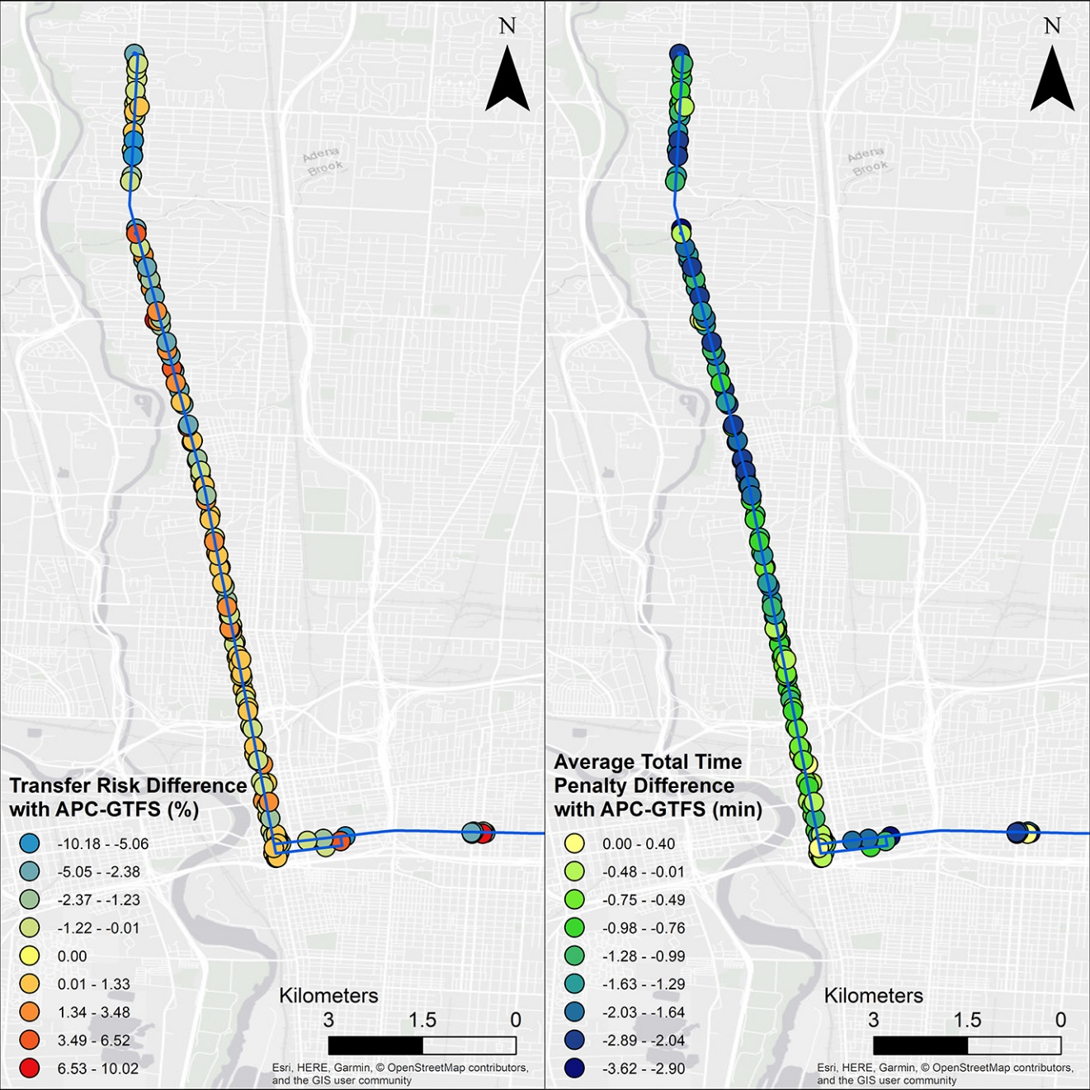

Figure TR and ATTP difference after implementation of a dedicated bus lane for APC-GTFS

Also, we calculated different impacts on the generating trips and receiving trips. We categorized all affected transfers into two classes: transfers with generating trip on the DBL (*DBL-generating transfers*) and transfers with receiving trip on the DBL (*DBL-receiving transfers*). DBL will save DBL-generating transfers 2.25 minutes and 5.25% transfer risk while only save DBL-receiving transfers 0.32 minutes and increase 9.03% transfer risk. This suggest that the DBL will eliminate delays for all transfers thus decrease all transfers’ total time penalty universally; but will simultaneously decrease DBL-generating transfers’ risk while increasing DBL-receiving transfers’ risk, however, it will not necessarily enlarge its time penalty. Based on this simulation, we conclude that DBL is a good strategy to decrease transfer users’ total time penalty, but DBL-generating transfers will benefit more from the DBL.

1. **Conclusion**

Transfers between routes are an essential issue for public transit design and operations, however, few studies focus on the transfers’ on-time performance in the real-time context. Based on high-resolution GTFS and APC real-time and static data of huge volume, we developed a series of measures, including the transfer risk (TR) and average total time penalty (ATTP), to assess the transfers’ performance. TR and ATTP indicate the systematic quality of transfers and corresponding potential time cost. These measurements provide important information for the transit system planners and administrators concerning the transfers’ feasibility, quality, and user experience. To illustrate this, we applied the measures with two datasets in Columbus, Ohio: original GTFS data (February 2018 - January 2019) and merged APC-GTFS data (May 2018 - January 2019) with higher temporal accuracy. The spatial and temporal analysis show similar pattern like overall traffic and transit system delay, while it also shows some unique patterns, such as high time penalty during the nighttime due to larger headway. The comparison between original GTFS and APC-GTFS datasets furthermore demonstrates that it is possible to underestimate transfer risk and time penalties with only original GTFS data. Additionally, we simulated dedicated bus routes’ impact on the transfer performance. It suggests the dedicated bus lane is a good strategy to reduce ATTP, especially for DBL-generating transfers.

The TR and ATTP measures are a further step towards supporting a smarter public transit system. Compared with existing indexes and measuring systems, the spectrum of the proposed measures’ audience is broad: besides academic and administrating purposes, ordinary passengers and open source developers can also be potential users. Thanks to the high-resolution public transit data, we can calculate corresponding performance based on specific transfers as well as overall broad patterns. For example:

* At the application level, users can query each transfer’s performance in their real-time transit apps and react correspondingly. Current mainstream transit apps do not show empirical risk and average time loss, especially for transfers which users have no control. If a proposed transfer’s empirical performance is shown when the apps plan the trip, users can avoid high risk route. This is similar to airlines and air travel apps showing the on-time performance of air routes.
* At the operational level, administrators can check the high risk and high time penalty areas and respond. With support of real-time data and the measures in this paper, the transit authorities can make operational changes such as adding additional buses and enforce bus’s time table to reduce transfer risk. Moreover, with the real-time ridership data, administrators can identify the ongoing transfers and plan flexible time table adjustment accordingly.
* At the management level, city planners can analyze the spatiotemporal patterns of risk and time penalties, and adjust the system accordingly. The patterns of proposed measures can demonstrate important information about the road design, the transit system’s design, and other transport and non-transport factors. For example, after a major route adjustment, traffic planners and managers can assess and justify the adjustment by showing changes in the measures.
* At the policy-making level, policy makers can compare different public transit systems’ transfer real-time performance across the US. Unlike some composite indexes that are hard to compare, transfer risk and total time penalty are all comparable across different systems since they use common metrics, namely probabilities and time. Meanwhile, due to the high reusability and expandability of the indexes and the system, they can be easily implemented and applied to any transit system with published GTFS scheduled and real-time data without major modification.

Future research direction can concentrate on the application of both smart and human sensors, generating abundant and high-resolution big data for analysis. In this paper, we compared datasets of different temporal accuracy, nevertheless, we do not have a good answer for how spatial accuracy will influence the results and how the overall impact of inaccuracy can be decomposed into the two factors. It may be useful to utilize a third-party data to calibrate the GTFS data, so that GTFS data can achieve higher accuracy. Volunteered data from humans is also a possible strategy for collecting data (Bakillah et al., 2012). Based on more precise and abundant data, there are more possibilities for more scientific planning, improvement, and knowledge derivation of transfer activities and the transit system. Moreover, with transfer ridership data, population and rider factors can be incorporated into the system.

**References**

Antrim A and Barbeau S (2008) THE MANY USES OF GTFS DATA – OPENING THE DOOR TO TRANSIT AND MULTIMODAL APPLICATIONS Aaron. *Locationaware.Usf.Edu* 4.

Bakillah M, Liang SHL and Zipf A (2012) Toward coupling sensor data and volunteered geographic information (VGI) with agent-based transport simulation in the context of smart cities. In: *GIS: Proceedings of the ACM International Symposium on Advances in Geographic Information Systems*, 2012, pp. 17–23. ACM.

Bovy PH and Stern E (2012) *Route Choice: Wayfinding in Transport Networks: Wayfinding in Transport Networks*. Springer Science & Business Media.

Ceder A (2016) *Public Transit Planning and Operation: Modeling, Practice and Behavior, Second Edition*. *Public Transit Planning and Operation: Modeling, Practice and Behavior, Second Edition*. CRC press.

Chen M, Mao S and Liu Y (2014) Big data: A survey. *Mobile networks and applications* 19(2). Springer: 171–209.

Chu X (2010) *A Guidebook for Using Automatic Passenger Counter Data for National Transit Database ( NTD ) Reporting*. National Center for Transit Research (US).

CTPS CTPS (1997) *Transfer Penalties in Urban Mode Choice Modeling. Travel Model Improvement Program*. US Dept. of Transportation.

Dessouky M, Hall R, Nowroozi A, et al. (1999) Bus dispatching at timed transfer transit stations using bus tracking technology. *Transportation Research Part C: Emerging Technologies* 7(4). Elsevier: 187–208.

Google Developers (2016) GTFS Static Overview | Static Transit | Google Developers. Available at: https://developers.google.com/transit/gtfs/ (accessed 8 March 2018).

Google Developers (2018) Trip Updates. Available at: https://developers.google.com/transit/gtfs-realtime/guides/trip-updates (accessed 8 April 2019).

Guo Z and Wilson NHM (2004) Assessment of the transfer penalty for transit trips: Geographic information system-based disaggregate modeling approach. *Transportation Research Record* 1872(1872). Transportation Research Board of the National Academies: 10–18. DOI: 10.3141/1872-02.

Guo Z and Wilson NHM (2011) Assessing the cost of transfer inconvenience in public transport systems: A case study of the London Underground. *Transportation Research Part A: Policy and Practice* 45(2). Pergamon: 91–104.

Hadas Y and Ranjitkar P (2012) Modeling public-transit connectivity with spatial quality-of-transfer measurements. *Journal of Transport Geography* 22. Elsevier: 137–147. DOI: 10.1016/j.jtrangeo.2011.12.003.

Hilbert M (2016) Big Data for Development: A Review of Promises and Challenges. *Development Policy Review* 34(1). Wiley Online Library: 135–174.

Iseki H and Taylor BD (2009) Not all transfers are created equal: Towards a framework relating transfer connectivity to travel behaviour. *Transport Reviews* 29(6). Taylor & Francis: 777–800. DOI: 10.1080/01441640902811304.

Jang W (2010) Travel time and transfer analysis using transit smart card data. *Transportation Research Record* (2144). Transportation Research Board of the National Academies: 142–149.

Knoppers P and Muller T (1995) Optimized transfer opportunities in public transport. *Transportation Science* 29(1). INFORMS: 101–105.

Kujala R, Weckström C, Mladenović MN, et al. (2018) Travel times and transfers in public transport: Comprehensive accessibility analysis based on Pareto-optimal journeys. *Computers, Environment and Urban Systems* 67. Elsevier: 41–54.

Li JQ, Song M, Li M, et al. (2009) Planning for bus rapid transit in single dedicated bus lane. *Transportation Research Record* (2111). Transportation Research Board of the National Academies: 76–82.

Liu R, Pendyala RM and Polzin S (1997) Assessment of intermodal transfer penalties using stated preference data. *Transportation Research Record* (1607). Transportation Research Board of the National Academies: 74–80.

Miller HJ and Goodchild MF (2015) Data-driven geography. *GeoJournal* 80(4). Springer: 449–461.

Nesheli MM and Ceder A (2015) Improved reliability of public transportation using real-time transfer synchronization. *Transportation Research Part C: Emerging Technologies* 60. Pergamon: 525–539.

Nishiuchi H, Todoroki T and Kishi Y (2015) A Fundamental Study on Evaluation of Public Transport Transfer Nodes by Data Envelop Analysis Approach Using Smart Card Data. *Transportation Research Procedia* 6. Elsevier: 391–401.

Sun L, Rong J, Ren F, et al. (2007) Evaluation of passenger transfer efficiency of an urban public transportation terminal. In: *IEEE Conference on Intelligent Transportation Systems, Proceedings, ITSC*, 2007, pp. 436–441. IEEE.

Sun L, Rong J and Yao L (2010) Measuring transfer efficiency of urban public transportation terminals by data envelopment analysis. *Journal of Urban Planning and Development* 136(4). American Society of Civil Engineers: 314–319.

Transit Wiki (2019) Automated passenger counter. Available at: https://www.transitwiki.org/TransitWiki/index.php/Automated_passenger_counter (accessed 10 February 2019).

Walker J (2012) *Human Transit: How Clearer Thinking about Public Transit Can Enrich Our Communities and Our Lives*. *Human Transit: How Clearer Thinking About Public Transit can Enrich our Communities and our Lives*. Island Press.

Wardman M (2001) A review of British evidence on time and service quality valuations. *Transportation Research Part E: Logistics and Transportation Review* 37(2–3). Institute of Transport Studies, University of Leeds: 107–128.

Wardman M, Hine J and Stradling S (2001) Interchange and Travel Choice Volume 1. *Edinburgh: Scottish Executive Central Research Unit* 1.

1. * Corresponding author e-mail: [miller.81@osu.edu](mailto:miller.81@osu.edu)

   First author e-mail: [liu.6544@osu.edu](mailto:liu.6544@osu.edu)