**Title of Your Paper**

A. Author1, B. Author2, C. Author3

*1Department, Institution/Company, City, Country*

*2Department, Institution/Company, City, Country*

*3Department, Institution/Company, City, Country*

**Summary (maximum 150 words)**

This is the template for abstracts for E-Textiles 2023. When submitting the abstract, please indicate whether you would like to be considered for an oral presentation or poster presentation.

Please underline the **presenting** author and make sure that the e-mail address, mailing address and telephone number of the corresponding author are provided.

In the first paragraph, please describe your major achievements and present the summary of your contribution.

**Keywords (up to 5)**

Please include any key words/phrase of your choice for your work (e.g. printed sensor, wearables, e-yarn)

**Motivation and Results**

The motivation and results of your research must be clearly identified and the novelty or progress made compared to the state of the art has to be provided.

The **total length of the abstract** including summary and conclusions but excluding references **should not exceed 600 words**. Please present results in the abstract and illustrate your approach and results by referring to figures and/or tables on the second page. To explain the motivation and background of your work, you can refer to previous works by yourselves and/or other researchers to be included on the second page.

**Conclusions (max 100 words)**

This should highlight the most important conclusions of your work.

Please submit your abstract and a short one paragraph biography for the presenting author by **Friday 8th September 2023** here:  <https://www.conftool.org/e-textiles2023/>

Abstracts and biographies should be submitted in **PDF format** and should include your **full name in the file title**.

**References**

1. Author 1, A.B.; Author 2, C.D. Title of the article. Abbreviated Journal Name Year, Volume, page range.

Any figures and/or tables should be included after the main text, only on the second page.

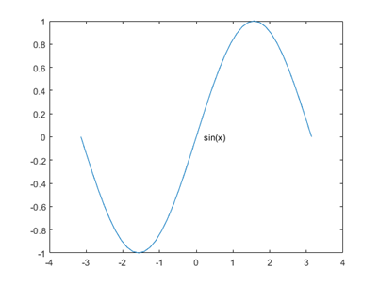

***Fig. 1:***Figures must be placed on the second page.

***Table 1:*** Tables must be placed on the second page.

|  |  |  |  |
| --- | --- | --- | --- |
|  |  |  |  |
|  |  |  |  |
|  |  |  |  |
|  |  |  |  |