This Tool is used to generate weekly report based on data from Salesforce. Two files are required as input, FA and ECAP.

**1. Get FA File:**

Go to salesforce, filter the data as Follows Samples:

Entry Year and Time Frame needs to be changed accordingly to the requirement. For example, report for

2017 Spring week 1 would have Entry Year equals 2017 and time range from __ to 9/03/2016 .

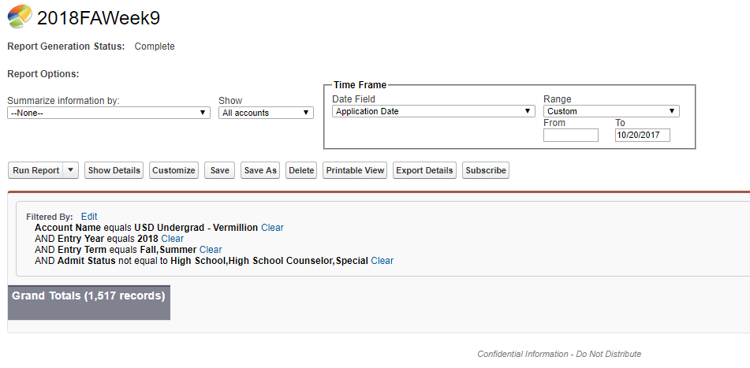

After finished, run the report and Download it as csv File using the Export Details Option. Change the downloaded file name so it is easier to organize later. For example. 2018FAWeek9.csv is a good name for file created by example above.

**2. Get ECAP File**

Similar procedure as FA File, change Entry Year and Time Range Accordingly, Download the File as well.

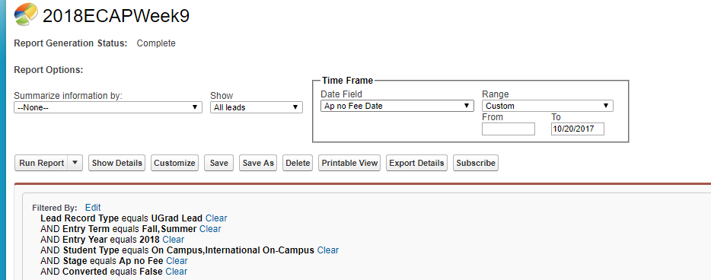

1. **Run the Program**

If Java is installed on your computer. Simply run the program csvDataAnalysis.jar. The program will ask you for a few inputs:

* Choose the FA file downloaded in step 1.
* Choose the ECAP file downloaded in step 2.
* Enter the Entry year for the report. The year you input has to be 4 digits such as 2017, 2018… Wrong input will cause wrong result or crash of program and you will have to run the program again. If you named the file as suggested previously in step 1. The year is in the File Name you just entered.
* Enter the Week Number For this report.
* Program has finished, the report will be in the same folder as your report named according to the week number and Entry Year You input.

**Config Settings (Not Required to Access Every Time):**

In the file EntryYearStartDateConfig.txt. You can set the start date for current entry year. For example. Start Date for 2018 Entry year is 08/26/2017, the line for that looks like 2018,08/26/2017 in the config file. 2017, 2018, 2019 are preset in the file, if this tool is used for other years, start date for that year must be added to this file for the tool to run correctly.

In Location.txt, titles name (Total Applications, Accepted, M…..) and their coordinates in the matrix can be changed (it is not recommended to change the location if you do not understand what the numbers mean, if you are not sure, make a backup before you change them)