why like or don’t like sth (week 8 )

yes/no

what is it

why (内容和形式)

深层原因

What is a tech difficult for you

Which(describe)

Why

What friend like to work with

What is he/i like

Why the pare could be wonderful

What we could achieve

Todays manager should prove what?

1 what + why （+benefits）

2 what + why （+benefits）

……

Which history event you want to know more

What (important)

Why interest

What benefits(meaning)

所以如果能总结的话就是：

是什么

为什么

有什么影响/好处/意义

（需要怎么做）

梦回初中政治。。。

顺便摘录一些比较重要的五四那个回答的关键词句（素材来自CBY版本）

结构参考:

我大概总结了一个套路结构：

先解释这句话(这个概念)(first)

再说在当下历史背景下的意义(in practice)

年轻人该怎么做/overall,……/in conclusion ,young people should ……

详细的版本（by yzh）

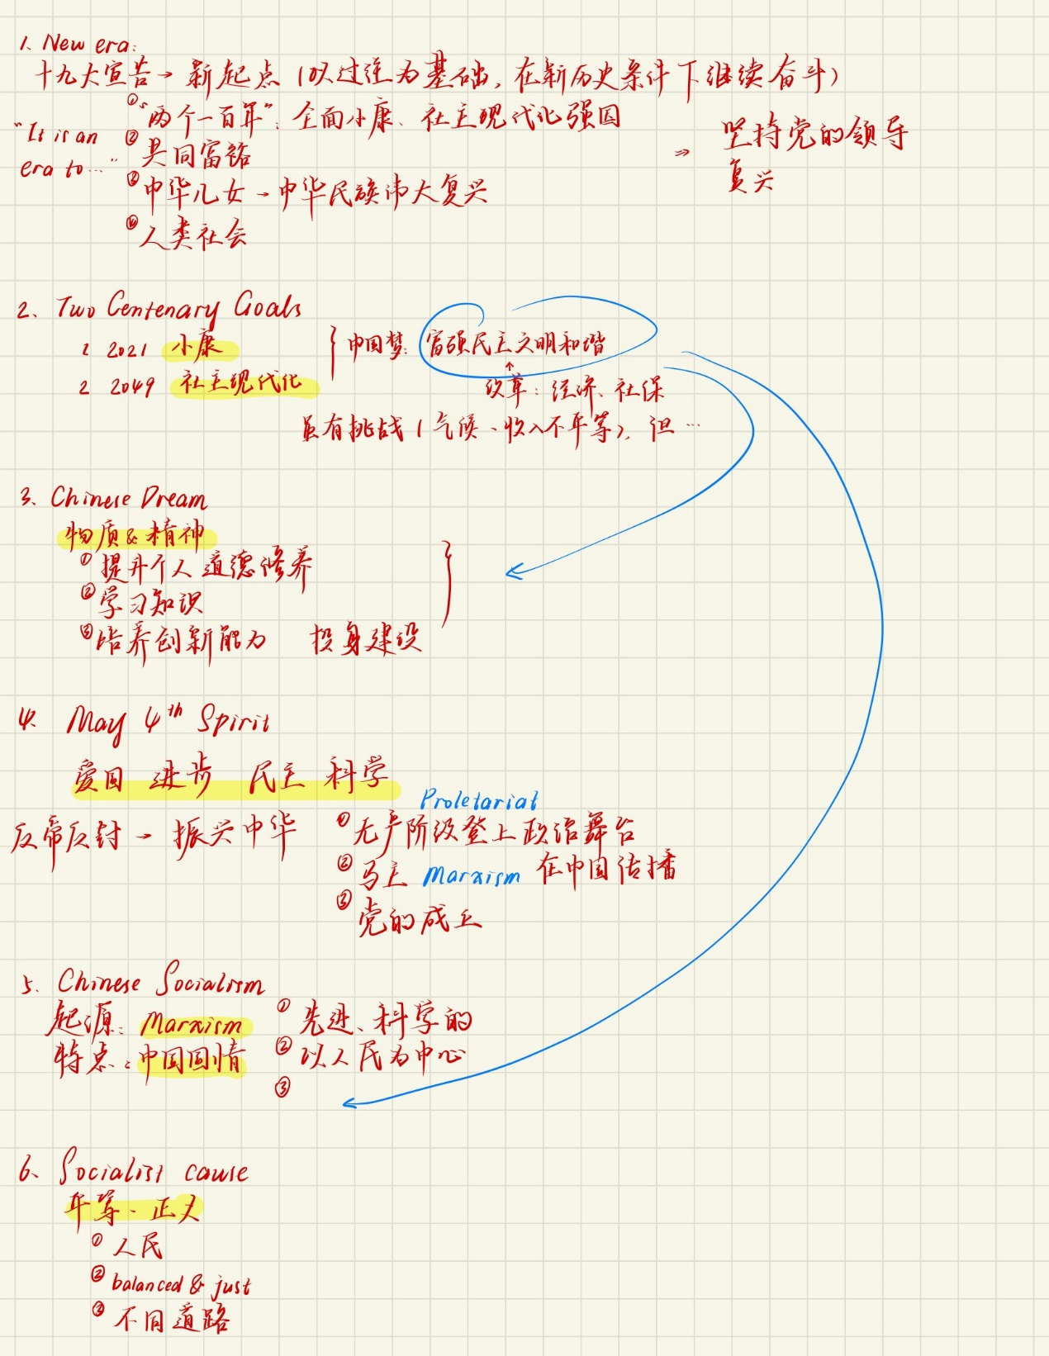

1. New era

unprecedented transformation and growth of China's development under the guidance of the Communist Party of China

confidence in their country's socialist path

realizing the Chinese dream of national rejuvenation.

1. The Two Centenary Goals

The first goal is to build a moderately prosperous society in all aspects by 2021, which

marks the 100th anniversary of the founding of the CPC.

The second goal is to build a modern socialist country that is prosperous, strong,

democratic, culturally advanced, and harmonious by 2049

upholding the leadership of the CPC

patriotism, innovation, and a sense of responsibility among young people

1. The Chinese Dream of national rejuvenation

aims to transform China into a modern and prosperous society

1. The spirit of the May 4th Movement

that emerged in China in 1919 when young Chinese protested against the unequal

treatment of China

embodies the values of patriotism, democracy, science, and social reform

In today's context, the spirit of the May 4th Movement is a call for Chinese youth to

embrace the values of patriotism, knowledge, and innovation while promoting social progress and reform

5. "a person who aspires to be a saint will become a saint; and a person who aspires

to be a sage will become a sage."

our thoughts and beliefs shape our actions, and consequently, our destiny

If young people have positive ideals and beliefs, and they align them with the needs

and aspirations of their country and society,

6.Chinese socialism

It has its roots in Marxist theory

integrates Chinese traditions and values

In practice

7. Dr. Sun Yat-sen said that the biggest thing for a citizen is "knowing how to love one's

country"

the duty and responsibility of every citizen was to love their country

Dr. Sun's words serve as a call to action for all Chinese citizens to consider the needs of the country and prioritize the collective good above individual desires.

8. As Lu Xun the great writer said, young people "have strength to spare; they can turn

a dense forest into flat land, plant trees in the wilderness, and dig wells in the desert".

young people have the ability to accomplish seemingly impossible tasks, such as

9. Socialist cause

The socialist cause aims to establish a society that is more equitable and just, where resources are distributed fairly and everyone is able to benefit from the country's economic and social development.

the socialist cause is intertwined with the "Chinese Dream", a national aspiration to build a thriving and powerful country that provides a better life for its citizens

10. As Mao Zedong said, "Should I have 200 years to spare, I will surely swim for 3,000

li (1,500 km). "

It shows that Mao Zedong was willing to go to great lengths to achieve his goals, even if it was impossible to complete within a normal human lifespan.

national rejuvenation can only be achieved through an arduous popular struggle

11. "If you idle away your youth and achieve nothing, it's no good lamenting in old

age."

the importance of hard work and productivity during youth.

12. historical nihilism

negation or rejection of the historical achievements, values, and traditions of Chinese society

denies the importance of history and undermines the fundamental values of society.

may also involve the rejection of traditions or cultural norms