**Lecture 1 Foundations of SFC Models for Economic Research**

第一讲 经济研究的SFC模型基础

主讲人：Marco Veronese Passarella

整理人:罗迅

目录

第一讲 经济研究的SFC模型基础 1

1. 宏观经济学的现状 1

1.1 DSGE模型存在的问题 1

1.2来自澳大利亚中央银行的评价 2

1.3是否存在更好的模型方法？ 3

2. SFC模型的起源与发展 4

2.1 SFC模型的起源 4

2.2 金融市场与实际生产一体化 5

2.3 与其它学科的联系 6

3. SFC模型的会计准则 8

3.1 基本准则 8

3.2 会计矩阵 9

3.3资产负债表、交易-流量矩阵和完全整合矩阵的示例 9

4. SFC方程与编码 11

4.1恒等式和行为方程 11

4.2理论和政策含义 12

4.3 解决方案和识别 13

4.5编程软件选择 15

5. 参考文献 16

6. 课程提问 16

第一讲 经济研究的SFC模型基础

Lecture 1 Foundations of SFC Models for Economic Research

1. 宏观经济学的现状

1.The State of Macroeconomics

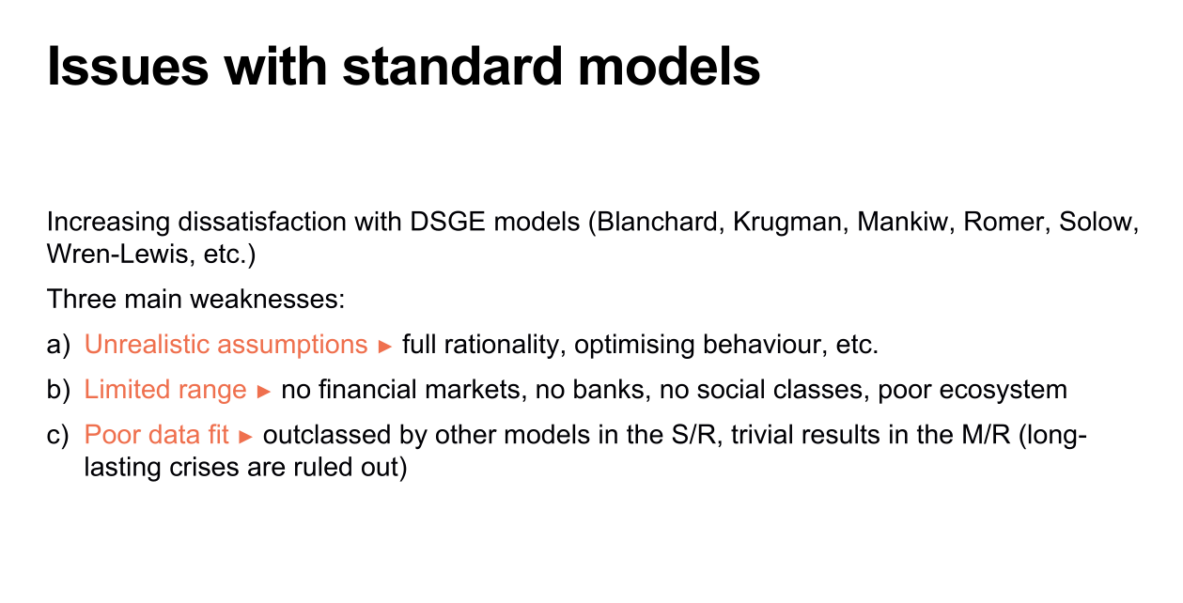

1.1 DSGE模型存在的问题

DSGE模型（动态随机一般均衡模型）存在越来越多的争议，许多经济学家包括Blanchard、Krugman、Mankiw、Romer、Solow、Wren-Lewis等人都对其持有批评态度。这是因为DSGE模型存在三个主要的问题：

第一个问题是众所周知的，因为它与实用主义哲学有关。实用主义哲学认为，我们不应该过分关注假设，只应该关注预测，这导致了假设缺乏现实性。DSGE模型非现实性的假设一直受到批评，特别是在2007年的金融危机之后，因为这些假设（例如完全理性、最优化行为等）很可能是DSGE模型无法预测危机的原因。第二个问题是DSGE模型没有涉及金融市场、银行、社会阶层，没有信贷创造，是对系统的不全面刻画。第三个问题是数据拟合度低。DSGE模型指出经济始终会回到初始点，实际上这对预测一次又一次的危机毫无作用。

1.1 Issues with standard models

There's been an increasing dissatisfaction with DSGE(Dynamic Stochastic General Equilibrium) models, and many were leading economists, including Blanchard, Krugman, Mankiw, Romer, Solow, Wren-Lewis, etc. Because DSGE models have three main weaknesses:

The first issue is well-known because it is associated with the functionalist philosophy. The functionalist philosophy argues that we should not overly focus on assumptions but rather on predictions, which leads to the lack of realism in assumptions. The unrealistic assumptions of DSGE models have been criticized, particularly after the 2007 financial crisis, as these assumptions (such as full rationality, optimizing behavior, etc.) are likely reasons why DSGE models failed to predict the crisis.

The second issue is that DSGE models do not incorporate financial markets, banks, social classes, or credit creation, leading to an incomplete depiction of the system.

The third issue is the poor data fit of DSGE models. DSGE models suggest that the economy will always revert to its initial state, which in reality has proven to be ineffective in predicting recurring crises

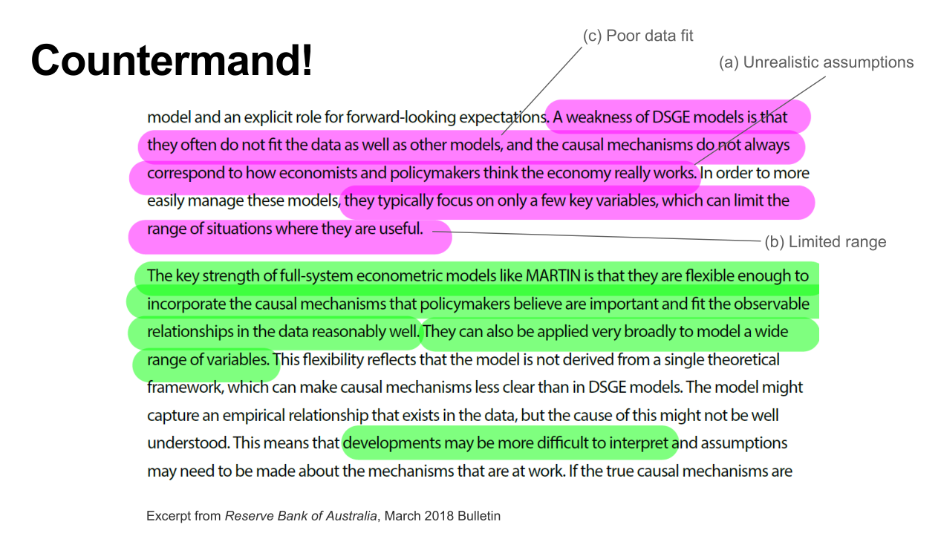

1.2来自澳大利亚中央银行的评价

2018年3月2日，澳大利亚中央银行指出了经典DSGE模型的问题：假设非现实性、有限的范围、数据拟合度低。它不符合我们对经济运作方式的认知，模型中投资没有独立的角色，而在现实世界中，私营企业的投资或政府的投资相当重要，它是我们经济的一大驱动因素。而DSGE模型只关注了少数几个关键变量，这可能限制了它们的适用范围。

1.2 Comments from Australia's central bank

On March 2, 2018, the Reserve Bank of Australia highlighted the issues with classical DSGE models. They pointed out that these models have unrealistic assumptions, limited range, and poor data fit. They do not align with our understanding of how the economy operates. In these models, investment does not have an independent role, whereas in the real world, investment by private firms or the government plays a significant role and serves as a major driver of our economy. Additionally, DSGE models only focus on a few key variables, which can restrict their applicability.

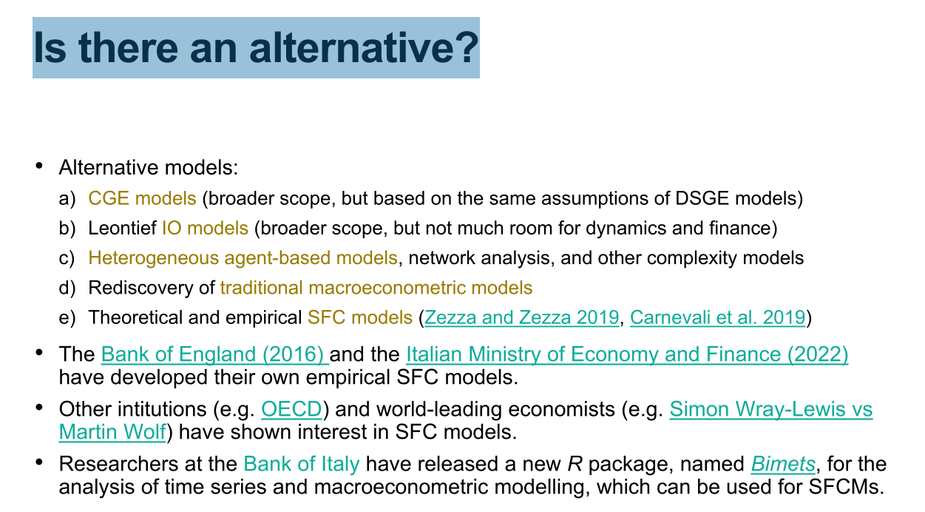

1.3是否存在更好的模型方法？

其它的模型，比如CGE模型适用范围更广，但遵从和DSGE模型相同的假设；Leontief IO 模型适用范围更广，但不涉及动态变化、金融市场和银行系统；第三个选择是基于代理人的模型，如果你需要分析金融市场上的泡沫，则建议使用基于代理人的模型，但实际上我们不需要这个模型里包含的所有随机性。“卢卡斯批评”认为我们不能使用宏观计量模型，因为结构系数或参数是不稳定的，这就是许多央行和其他机构重新评估传统宏观计量模型的原因。

在某种程度上，SFC模型（存量-流量一致性模型）就是替代模型中的一个代表，它具备对于复杂动态的关注。近年来，相当多的机构开发了自己的SFC模型。例如2016年，英格兰银行发布了一篇论文，其中提到他们开发了一个SFC模型；最近，意大利财政部也发布了关于SFC模型的研究论文；此外，像经合组织这样的机构也对SFC模型表现出了兴趣。两三年前，意大利银行的研究人员发布了一个新的R软件包“Bimets”，我推荐给喜欢宏观计量分析的人，这个软件包可以用来开发实证SFC模型。

* 1. Is there an alternative?

Other models, such as CGE models, have a broader scope of application but adhere to the same assumptions as DSGE models. Leontief IO models have a broader scope of application but do not involve dynamic changes, financial markets, and banking systems. The third option is agent-based models, which are recommended if you need to analyze bubbles in financial markets. However, in reality, we do not need all the randomness included in this model. The "Lucas Critique" argues that we cannot use macroeconometric models because the structural coefficients or parameters are unstable, which is why many central banks and other institutions are re-evaluating traditional macroeconometric models.

In a sense, Stock-Flow Consistent (SFC) models are representative of alternative models, as they focus on complex dynamics. In recent years, many institutions have developed their own SFC models. For example, in 2016, the Bank of England published a paper mentioning their development of an SFC model. More recently, the Italian Ministry of Economy and Finance also published a research paper on SFC models. Institutions like the OECD have also shown interest in SFC models. A few years ago, researchers from the Bank of Italy released a new R software package called "Bimets," which I recommend to those interested in macroeconometric analysis. This package allows for the development of empirical SFC models.

2. SFC模型的起源与发展

2. The Inception of SFC Models

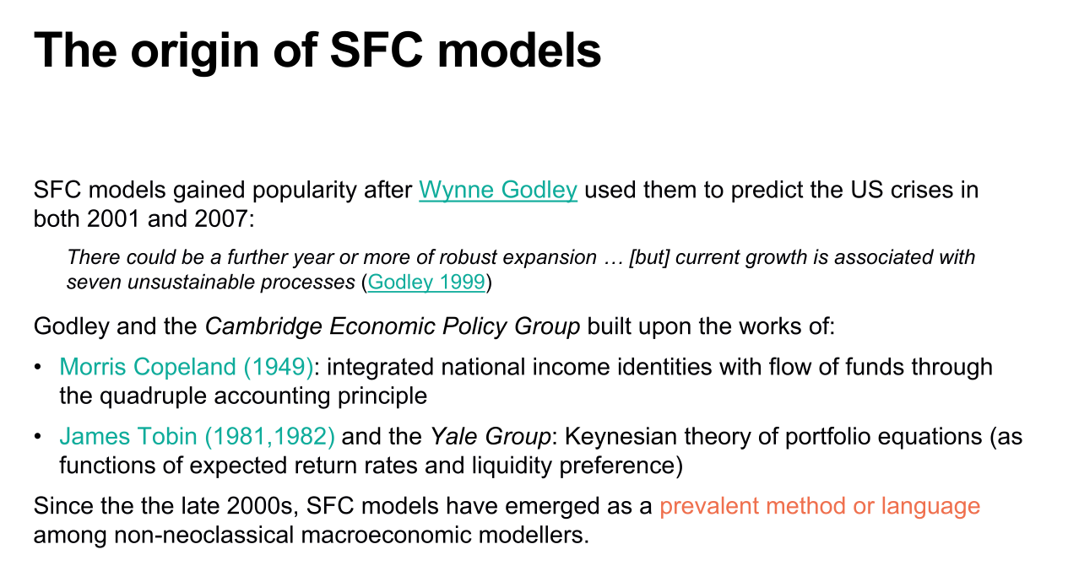

2.1 SFC模型的起源

关于SFC模型的起源或许有一定争议，但我确定是在Wynne Godley之后，SFC模型变得受关注起来，因为他使用SFC模型准确预测了2001年和2007年的经济危机。Godley和剑桥经济政策组织开发了自己的SFC模型,该模型基于Morris Copeland和James Tobin的工作。Copeland在某种程度上是国民核算的鼻祖，他将国民收入等式与资金流动相结合，并发展了四式记账核算原则。Tobin是诺贝尔经济学奖得主，他提出了凯恩斯投资组合方程理论（关于预期收益率和流动性偏好的函数）。到了2000年代后期，对于非新古典宏观经济学派的研究者，SFC模型已成为一种流行的方法或语言。

2.1 The origin of SFC models

There may be some controversy regarding the origin of SFC models, but I can confirm that SFC models gained attention after Wynne Godley, who accurately predicted the economic crises of 2001 and 2007 using SFC models. Godley, along with the Cambridge Economic Policy Group, developed their own SFC models, which were based on the work of Morris Copeland and James Tobin. Copeland, to some extent, can be considered the pioneer of national accounting as he integrated national income identities with flow of funds and developed the quadruple accounting principle. Tobin, a Nobel laureate, proposed the Keynesian investment portfolio equation theory, which relates expected returns and liquidity preference. Since the late 2000s, SFC models have emerged as a prevalent method or language among non-neoclassical macroeconomic modellers.

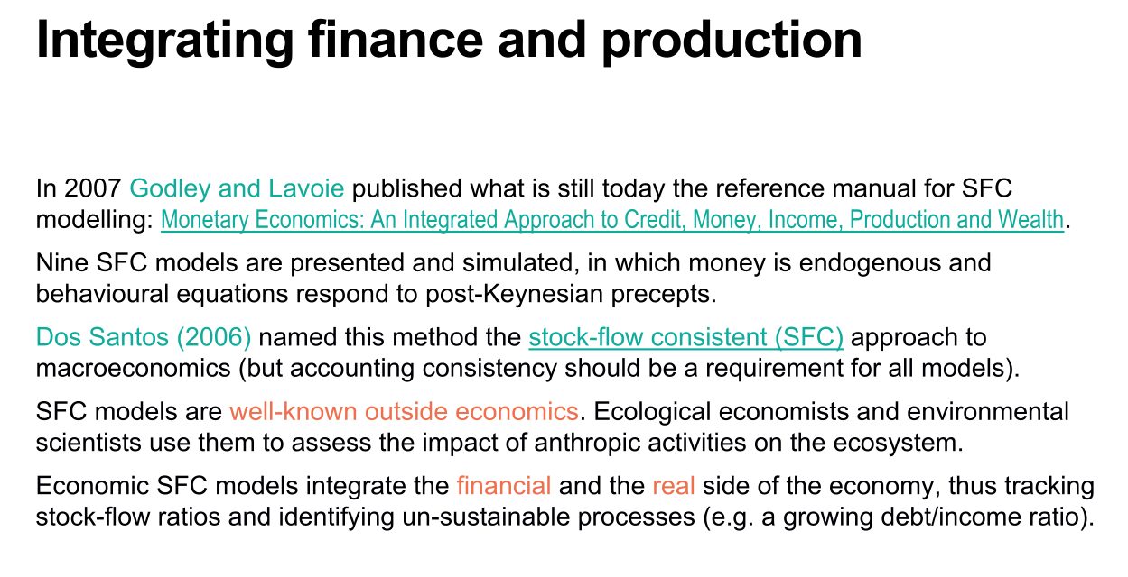

2.2 金融市场与实际生产一体化

2007年，Godley和Lavoie出版了书籍《货币经济学：信用、货币、收入、生产和财富的综合方法》，该书至今仍是SFC建模的参考手册。这本书介绍了九种不同的模型，在这些模型中，货币是内生的，所使用的行为方程遵循的是后凯恩斯主义思想。2006年，Dos Santos将这一方法正式命名为宏观经济学的存量-流量一致性模型（会计一致性其实是所有模型的要求）。

另一方面，存量-流量一致性模型在经济学之外也广为人知，例如许多在生态经济学领域工作的研究者们，自上世纪90年代开始，他们就一直在使用这些模型来评估人类活动对生态系统的影响，而这些SFC模型其实只是姊妹模型或者混合模型的不同应用。

SFC模型的一个重要特征是,它们整合了经济中的金融和实物两方面，这是通过追踪存量流量比率来实现的，并且可以用来识别不可持续的过程。Godley之所以在预测危机方面那样成功，并不是什么秘密，他只是关注了某些特定的存量流量比例，比如美国家庭的负债与净资产比率。

2.2 Integrating finance and production

In 2007, Godley and Lavoie published the book "Monetary Economics: An Integrated Approach to Credit, Money, Income, Production, and Wealth," which is still considered a reference manual for SFC modeling. The book presents nine different models in which money is endogenous, and the behavioral equations used adhere to post-Keynesian principles. In 2006, Dos Santos officially named this approach the Stock-Flow Consistent (SFC) modeling in macroeconomics (but accounting consistency should be a requirement for all models).

On the other hand, the Stock-Flow Consistent (SFC) models are well-known outside the field of economics as well. For example, many researchers working in the field of ecological economics have been using these models since the 1990s to assess the impact of human activities on ecosystems. These SFC models are merely different applications or variations of sister models.

An important characteristic of SFC models is their integration of both the financial and the real side of the economy, achieved through tracking stocks and flows. They can also be used to identify unsustainable processes. Godley's success in predicting crises is not a secret; he simply focused on specific stock-flow ratios, such as the debt-to-net-wealth ratio of American households.

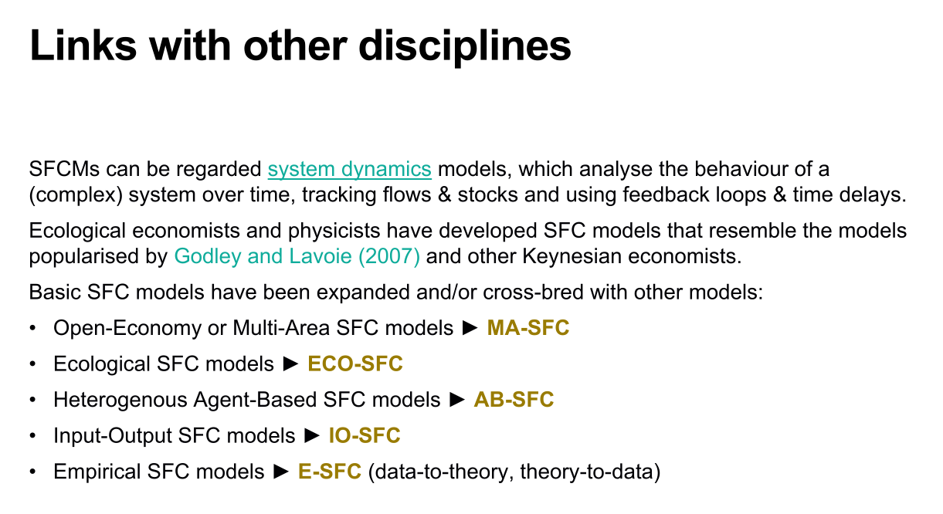

2.3 与其它学科的联系

如前所述，存量-流量一致性模型与其他学科有关联。它们可以被看作是系统动力学模型，用于分析复杂系统随时间的行为，从而可以追踪流量和存量。正是因为交叉借鉴，我们今天拥有了许多不同类型的SFC模型,适用于不同领域。

第一个分支是MA-SFC模型，是一个开放经济或多地区的模型，例如分析循环经济政策和其他绿色政策对经济的影响时，想要追踪所有的效应和跨国家的事实，你需要一个多地区的模型。

第二个分支是ECO-SFC模型，即生态SFC模型，模型中包含各种生态和环境变量、反馈效应、气候变化造成的损害等，还加入关键阈值、非线性和临界点等特征。

第三个分支是AB-SFC模型，即互动代理人SFC模型，在过去几年里，许多基于代理人的模型构建者意识到，他们的模型必须满足微观上的存量-流量一致性关系，因此改变了他们的模型开发方式。

第四个分支是IO-SFC模型，即投入-产出SFC模型，模型中我们拥有多个部门，也就是家庭、企业、银行、中央银行、政府和外国部门，并对行业作出了垂直上的区分，该模型可用于研究技术进步或经济内部的不平衡等问题。

第五个分支是E-SFC模型，即实证SFC模型，这也将是我们最后一堂课的主题。实际上SFC模型是作为实证模型诞生的，上世纪80年代纽约经济学研究所开发的模型主要是实证模型。自从Godley的《货币经济学》出版后，大多数从业人员开始专注于理论模型和数值模拟。今天，我们正在回到经验主义，试图将我们的模型与数据联系起来。

2.3 Links with other disciplines

As mentioned earlier, stock-flow consistent (SFC) models are interconnected with other disciplines. They can be seen as system dynamics models used to analyze the behavior of complex systems over time, allowing for the tracking of flows and stocks. We presented these models at the same conference, where we understood each other and used almost the same symbols and equations. This process of cross-fertilization is very interesting. It is precisely because of this cross-fertilization that we have a variety of SFC models today, suitable for different fields.

The first branch is the MA-SFC model, which is an open economy or multi-region model. For example, when analyzing the effects of circular economy policies and other green policies on the economy and wanting to track all the effects and cross-country facts, a multi-region model is needed.

The second branch is the ECO-SFC model, which stands for ecological SFC model. This model incorporates various ecological and environmental variables, feedback effects, damages caused by climate change, and also includes features such as key thresholds, non-linearity, and critical points.

The third branch is the AB-SFC model, which stands for Agent-Based SFC model. In the past few years, many developers of agent-based models have realized that their models must satisfy micro-level stock-flow consistency relationships, leading to changes in their model development approach.

The fourth branch is the IO-SFC model, which stands for Input-Output SFC model. In this model, we have multiple sectors, including households, firms, banks, central banks, governments, and foreign sectors. Vertical differentiations are made across industries in this model, making it suitable for studying issues such as technical progress or imbalances within the economy.

The fifth branch is the E-SFC model, which stands for Empirical SFC model. This will also be the topic of our final lecture. In fact, SFC models originated as empirical models, with the models developed by the Levy Institute of Economics in New York in the 1980s primarily being empirical models. After the publication of Godley's "Monetary Economics," most practitioners shifted their focus to theoretical models and numerical simulations. Today, we are returning to empiricism, attempting to link our models with data.

3. SFC模型的会计准则

3. SFC Accounting Principles

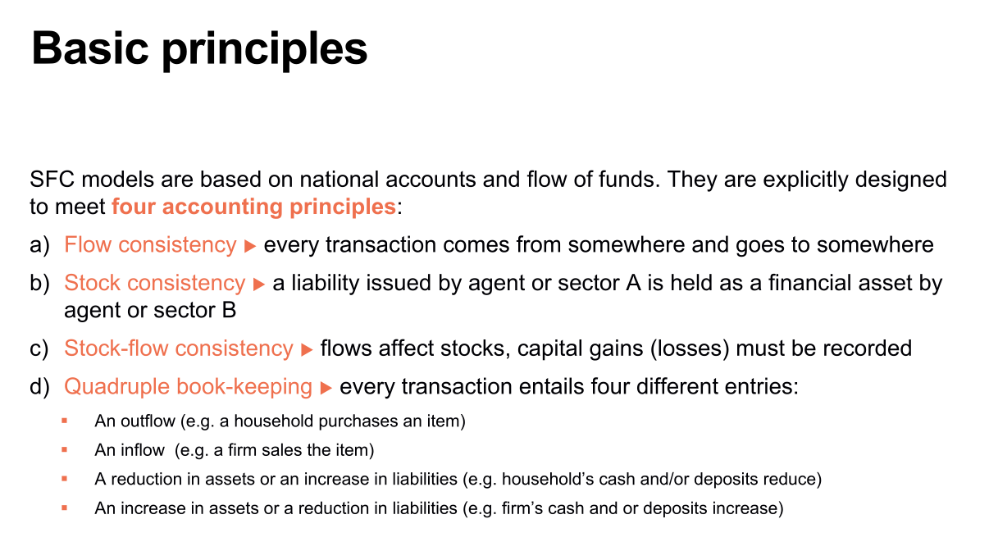

3.1 基本准则

SFC模型基于国民账户和资金流动，所以它们基于国民会计原则。SFC模型符合以下四个会计原则：

一是流量一致性，即每笔交易都有来源和去处；二是存量一致性，一笔负债意味着有另一个部门持有金融资产；三是存量-流量一致性，因为仅有存量一致性和流量一致性是不够的。你还需要跟踪存量和流量之间的联系，因为流量影响存量，存量影响流量，最明显的例子是资本收益和资本损失可以增加或减少你的存量价值。四是四重簿记原则，每笔交易都涉及到四个不同的条目：（1）流出，如果你购买某样东西，你将面临一笔支出。（2）流入，这意味着出售物品给你的公司会从你那里收到一些钱。（3）某些资产的减少，例如，如果你使用现金支付购买物品，你的现金存量会减少；（4）某些资产的增加，比如销售者的现金存量增加或其银行存款增加。

3.1 Basic principles

The SFC models are based on national accounts and fund flows, so they adhere to the principles of national accounting. The SFC models comply with the following four accounting principles:

Flow consistency: Every transaction has a source and a destination.

Stock consistency: A liability implies that another sector holds financial assets.

Stock-flow consistency: It is not sufficient to have only stock consistency and flow consistency. You also need to track the relationship between stocks and flows because flows affect stocks and stocks affect flows. The most obvious example is that capital gains and losses can increase or decrease the value of your stocks.

Quadruple book-keeping principle: Every transaction involves four different entries: (1) outflow - if you purchase something, you incur an expenditure; (2) inflow - selling a product results in receiving money from the buyer; (3) reduction in certain assets - for example, using cash to make a purchase reduces your cash holdings; (4) increase in certain assets - such as an increase in the seller's cash holdings or their bank deposits.

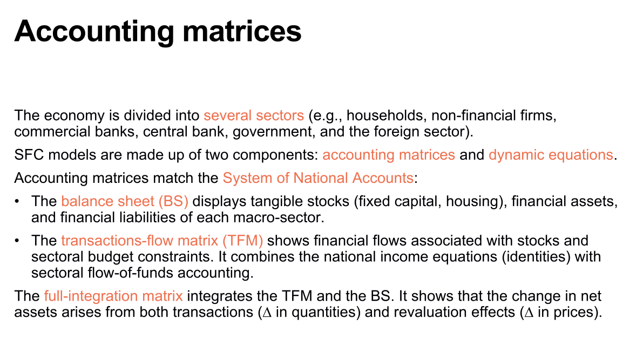

3.2 会计矩阵

整个经济体被分为几个部门，例如家庭、非金融公司、商业银行、中央银行、政府和外国部门。SFC模型由两个部分组成：会计矩阵和动态方程。其中会计矩阵与国民经济核算制度相匹配：资产负债表(BS)显示了每个宏观部门的有形存量 (固定资本、住房)、金融资产和金融负债；交易-流量矩阵展示了与库存和部门预算限制有关的资金流动，它将国民收入方程与部门资金流动会计相结合。完全整合矩阵将交易-流量矩阵（TFM）和资产负债表（BS）进行整合，它显示净资产变动既来自于交易（数量上的变化），也来自于重新估值效应（价格上的变化）。

3.2 Accounting matrices

The entire economy is divided into several sectors, such as households, non-financial corporations, commercial banks, central banks, governments, and foreign sectors. The SFC model consists of two components: accounting matrices and dynamic equations. The accounting matrices align with the system of national accounts: the balance sheet (BS) displays the tangible stocks (fixed capital, housing), financial assets, and financial liabilities of each macroeconomic sector; the transaction-flow matrix (TFM) shows the financial flows associated with stocks and sectoral budget constraints, combining national income equations with sectoral flow-of-funds accounting. The full-integration matrix integrates the TFM and the BS, showing that changes in net assets arise from both transactions (changes in quantities) and revaluation effects (changes in prices).

3.3资产负债表、交易-流量矩阵和完全整合矩阵的示例

3.3 Examples of balance sheet, transaction-flow matrix, and full-integration matrix

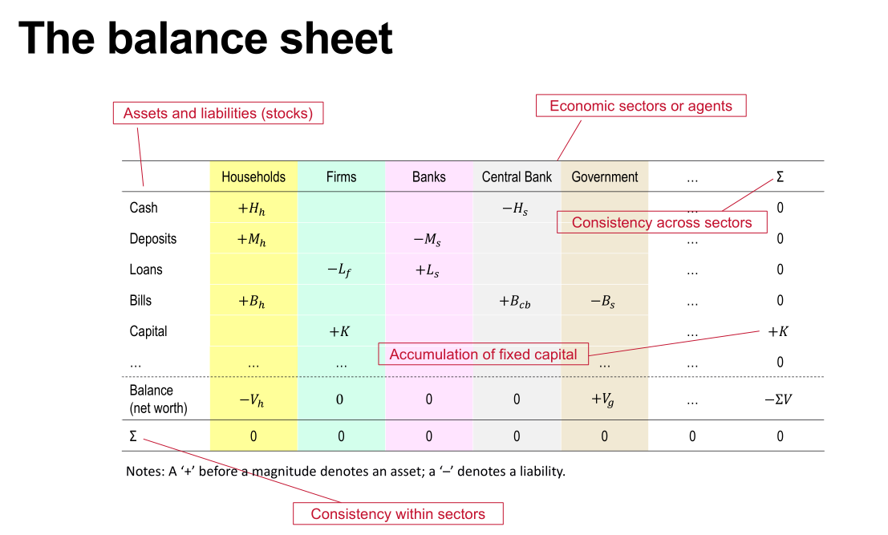

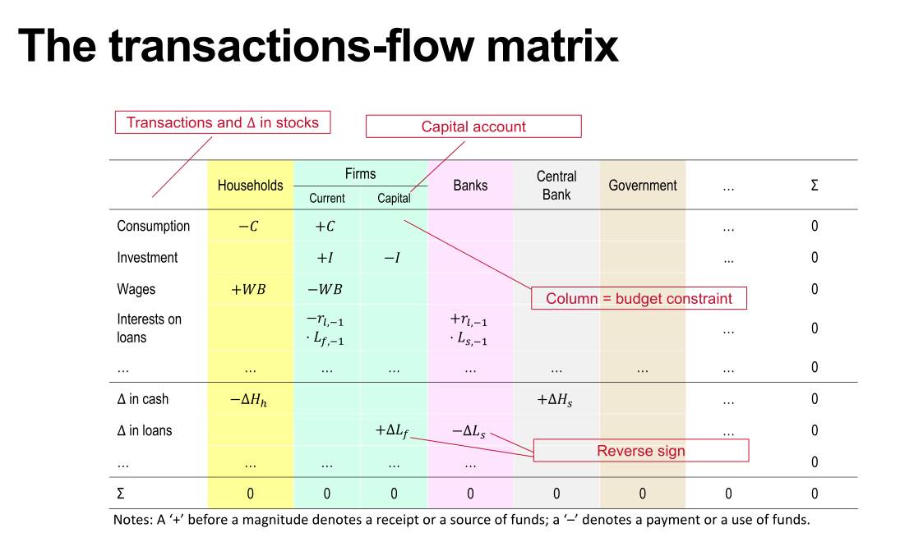

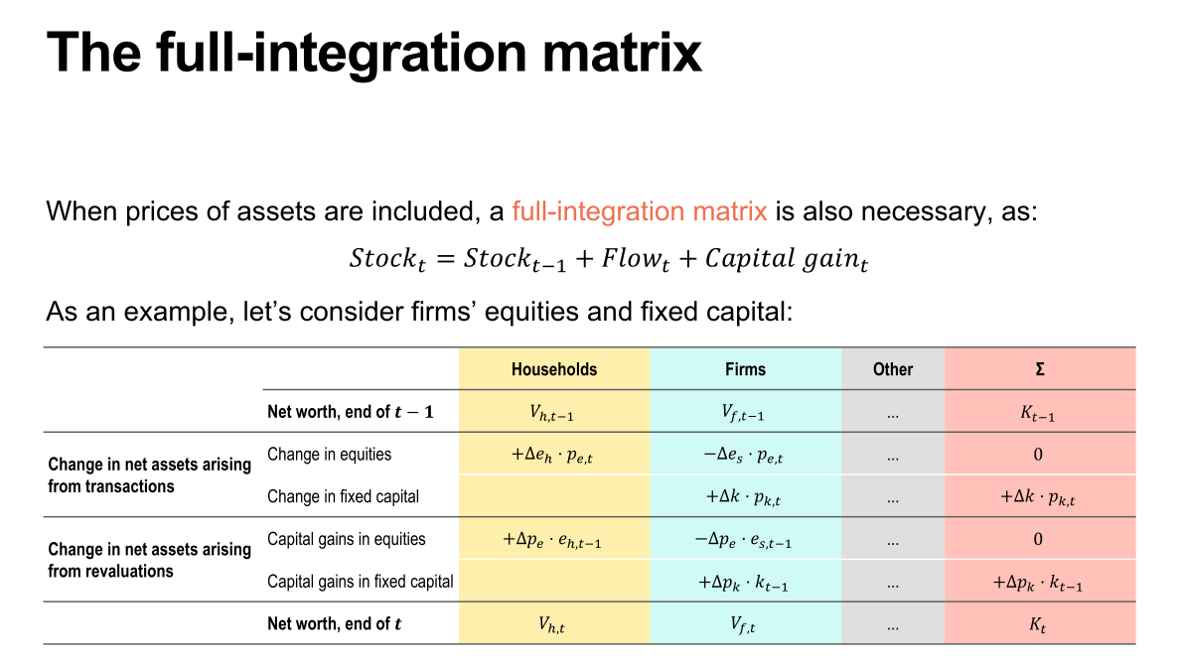

4. SFC方程与编码

4. SFC Equations and Coding

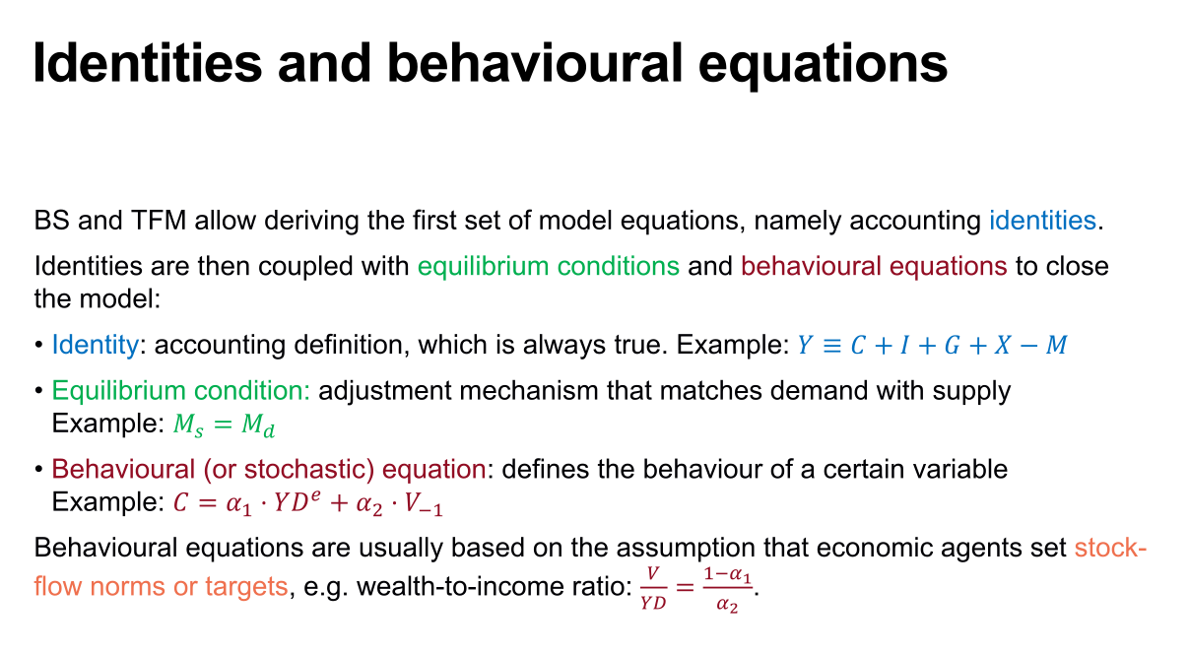

4.1恒等式和行为方程

通过BS和TFM可以导出第一组模型方程，即会计恒等式。然后将恒等式与均衡条件和行为方程相结合，以闭合模型：恒等式是会计上定义的，始终正确，例如;均衡条件是指需求与供给相匹配的调节机制，即；行为（或随机）方程定义了某个变量的行为，例如;行为方程通常基于这样的假设：经济主体设定存量流量规范或目标，例如财富收入比率：。

4.1 Identities and behavioural equations

BS and TFM allow deriving the first set of model equations, namely accounting identities. Identities are then coupled with equilibrium conditions and behavioural equations to close the model:

Identity: accounting definition, which is always true. Example: 

Equilibrium condition: adjustment mechanism that matches demand with supply Example: 

Behavioural (or stochastic) equation: defines the behaviour of a certain variable Example: 

Behavioural equations are usually based on the assumption that economic agents set stock-flow norms or targets, e.g. wealth-to-income ratio: 

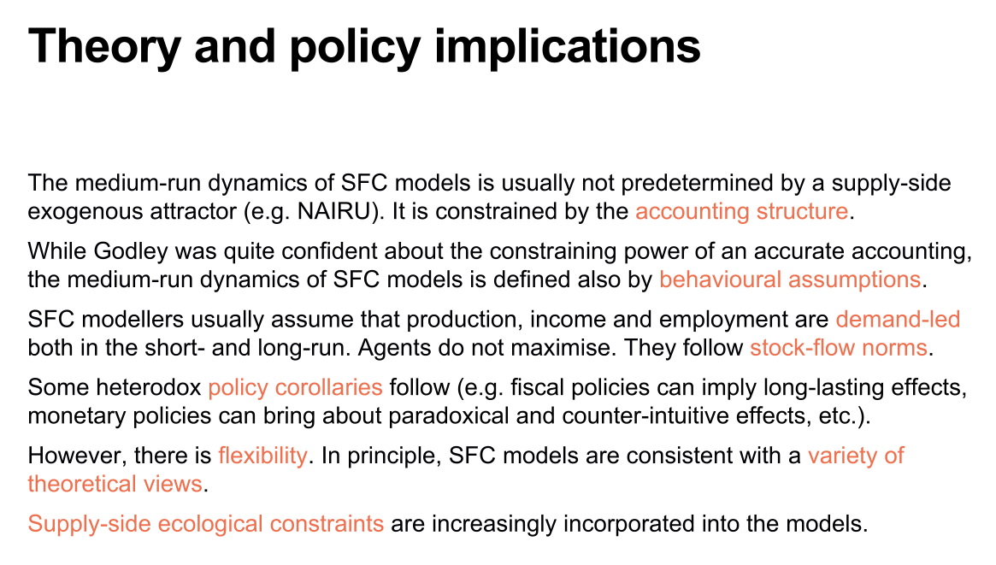

4.2理论和政策含义

SFC模型的中期动态通常不是由供给端外生因素（例如NAIRU）预先确定的，而是受会计结构的限制。尽管Godley对会计约束力非常有信心，但SFC模型的中期动态也由行为假设所决定。SFC模型的建模者通常假设生产、收入和就业在短期和长期都是由需求主导的，经济主体不追求最大化，而是遵循存量-流量规范。这些假设带来了一些非正统的政策推论（例如，财政政策可能产生长期效应，货币政策可能产生悖论和违反直觉的影响等）。然而，SFC模型具有灵活性，原则上，SFC模型与各种理论观点是一致的。同时，SFC模型越来越多地将供给端的生态约束纳入到模型中。

4.2 Theory and policy implications

The medium-run dynamics of SFC models is usually not predetermined by a supply-side exogenous attractor (e.g. NAIRU). It is constrained by the accounting structure. While Godley was quite confident about the constraining power of an accurate accounting, the medium-run dynamics of SFC models is defined also by behavioural assumptions. SFC modellers usually assume that production, income and employment are demand-led both in the short- and long-run. Agents do not maximise. They follow stock-flow norms. Some heterodox policy corollaries follow (e.g. fiscal policies can imply long-lasting effects, monetary policies can bring about paradoxical and counter-intuitive effects, etc.). However, there is flexibility. In principle, SFC models are consistent with a variety of theoretical views. Supply-side ecological constraints are increasingly incorporated into the models.

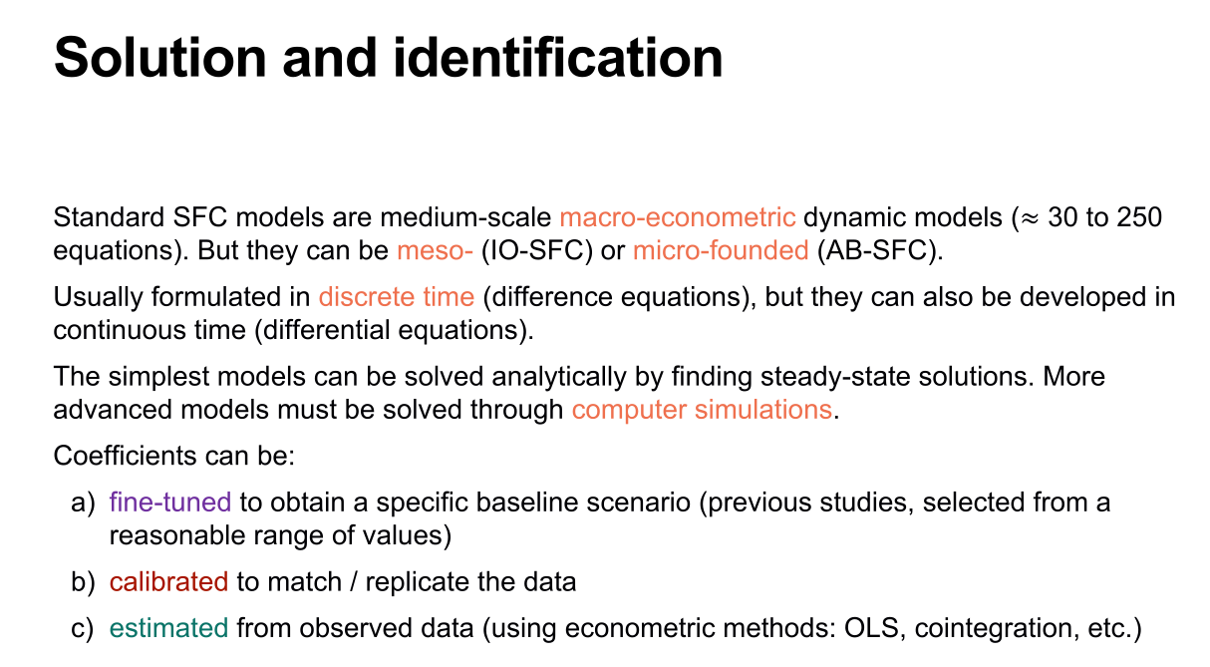

4.3 解决方案和识别

标准SFC模型是中等规模的宏观计量经济动态模型（约30至250个等式），但他们也可以是中观的（IO-SFC模型）或微观的(AB-SFC模型)。通常情况下，标准的SFC模型以离散时间（差分方程）的形式进行构建，但也可以以连续时间（微分方程）的形式进行发展。最简单的模型可以通过寻找稳态解来进行解析求解。更复杂的模型必须通过计算机模拟来求解。模型的系数可以采取以下方法：

a）微调以获得特定的基准情景（以前的研究中选择合理范围内的值）

b）校准以匹配/复制数据

c）从观测数据中估计（使用计量经济学方法：OLS、协整等）

4.3 Solution and identification

Standard SFC models are medium-scale macro-econometric dynamic models(30 to 250 equations）.But they can be meso- (IO-SFC) or micro-founded (AB-SFC). Usually formulated in discrete time (difference equations), but they can also be developed in

continuous time (differential equations). The simplest models can be solved analytically by finding steady-state solutions. More advanced models must be solved through computer simulations.

Coefficients can be:

a) fine-tuned to obtain a specific baseline scenario (previous studies, selected from a

reasonable range of values)

b) calibrated to match / replicate the data

c) estimated from observed data (using econometric methods: OLS, cointegration, etc.)

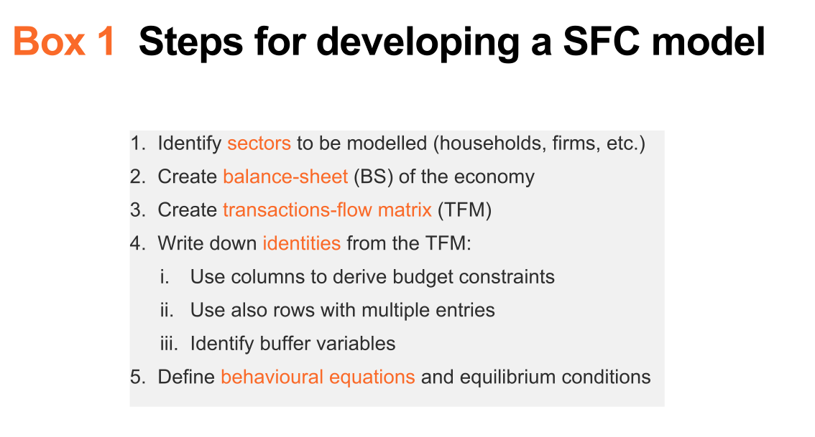4.4 开发SFC模型的步骤

一、确定要建模的部门（家庭、企业等）

二、创建经济的资产负债表（BS）

三、创建交易流量矩阵（TFM）

四、从TFM中写出等式：

i. 使用列来推导预算约束条件

ii. 同样使用具有多个条目的行

iii. 确定缓冲变量

五、定义行为方程和均衡条件

4.4 Steps for developing a SFC model

1）Identify sectors to be modelled (households, firms, etc.)

2） Create balance-sheet (BS) of the economy

3） Create transactions-flow matrix (TFM)

4） Write down identities from the TFM:

i. Use columns to derive budget constraints

ii. Use also rows with multiple entries

iii. Identify buffer variables

5）Define behavioural equations and equilibrium conditions

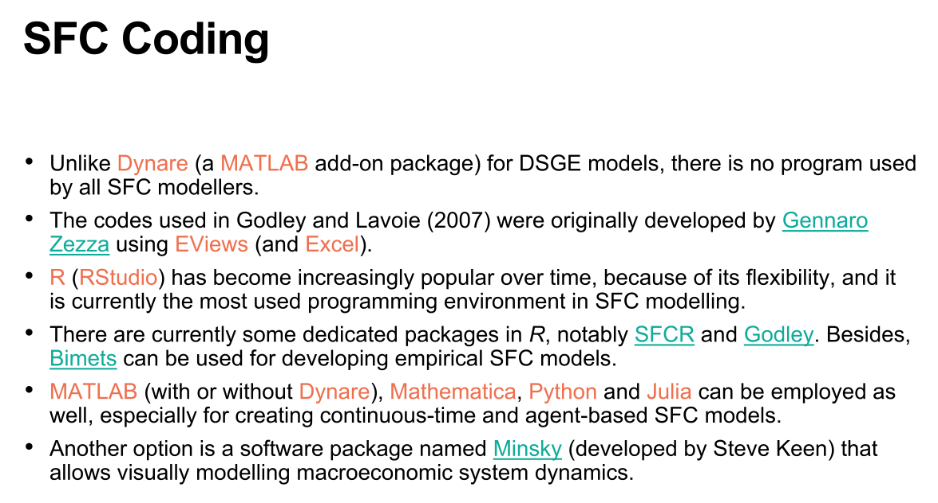

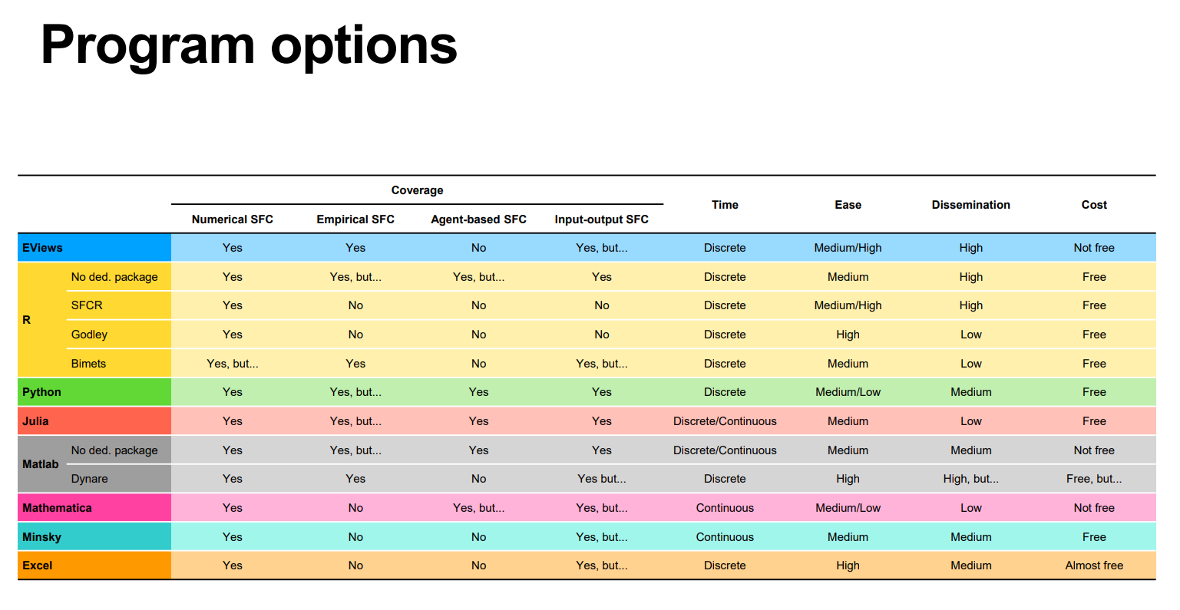

4.5编程软件选择

• 与用于DSGE模型的MATLAB附加包Dynare不同，没有一个程序被所有SFC模型制作者使用。

• Godley和Lavoie（2007）中使用的代码最初由Gennaro Zezza使用EViews（和Excel）开发而来。

• R（RStudio）随着时间的推移越来越受欢迎，因为它具有灵活性，并且目前是SFC建模中使用最广泛的编程环境。

• 目前在R中有一些专门的包，特别是SFCR和Godley。此外，Bimets可用于开发经验性SFC模型。

• MATLAB（带有或不带有Dynare）、Mathematica、Python和Julia也可以使用，尤其是用于创建连续时间和基于代理的SFC模型。

• 另一个选择是名为Minsky的软件包（由Steve Keen开发），它允许可视化建模宏观经济系统动态。

4.5 Choice of programming software

• Unlike Dynare (a MATLAB add-on package) for DSGE models, there is no program used by all SFC modellers.

• The codes used in Godley and Lavoie (2007) were originally developed by Gennaro

Zezza using EViews (and Excel).

• R (RStudio) has become increasingly popular over time, because of its flexibility, and it is currently the most used programming environment in SFC modelling.

• There are currently some dedicated packages in R, notably SFCR and Godley. Besides, Bimets can be used for developing empirical SFC models.

• MATLAB (with or without Dynare), Mathematica, Python and Julia can be employed as well, especially for creating continuous-time and agent-based SFC models.

• Another option is a software package named Minsky (developed by Steve Keen) that allows visually modelling macroeconomic system dynamics.

5. 参考文献

5. References

[1] W. Godley and M. Lavoie (2007). Monetary Economics. An Integrated Approach to Credit, Money, Income, Production and Wealth. Palgrave Macmillan, chapters 1, 2, 3, 4, 7.

[2] W. Godley (1999). Seven Unsustainable Processes. Levy Institute Strategic Analysis, January 1999.

[3] C.H. Dos Santos (2006). Keynesian Theorising During Hard Times: Stock-Flow Consistent Models as an Unexplored ‘Frontier’ of Keynesian Macroeconomics. Cambridge Journal of Economics, 30 (4), 541-565.

[4] M. Nikiforos and G. Zezza (2017). Stock-Flow Consistent macroeconomic Models: A Survey. Journal of Economic Surveys, 31 (5), 1204-1239.

[5] Emilio Carnevali, Matteo Deleidi, Riccardo Pariboni, Marco Veronese Passarella (2019). Stock-Flow Consistent Dynamic Models: Features, Limitations and Developments. In: Philip Arestis, Malcolm Sawyer (eds.): Frontiers of Heterodox Macroeconomics, Palgrave Macmillan, pp. 223-276.

6. 课程提问

Q:教授您好，如果我将社会分为四个部门，分别是家庭、商业银行、中央银行和政府，也就是忽略掉金融公司，这样做是可行的吗？

A:这取决于你要做什么。如果你只是创建一个新的数值模型，你可以忽略它，没有金融资产，没有票据，没有股份股本，这意味着你的金融部门非常简化。但如果你尝试在模型中使用实际数据，就可能会遇到一些问题。那么你必须在某个地方包含金融部门，这样才可以使用时间序列数据来校准你的模型或估计模型的系数。

Q: 教授您好，请问您认为SFC模型在生态经济学领域的前景如何？使用SFC研究生态问题的优势和劣势是什么？

A: 我的观点是，生态经济学家和环境科学家更喜欢SFC模型而不是DSGE模型、HG模型、CG模型、North House模型等等。因为这些模型都预设了社会只有唯一一个的稳定状态和最优均衡，而当你分析环境问题和生态系统时，会立刻意识到不存在所谓的最优均衡，它充满了非线性、临界阈值和锁定效应等。而这些都要求我们使用没有预先定义均衡条件的模型，这是SFC模型第一个优势；第二个优势是我们可以决定所使用的代理人的细化程度，所以可以有部门，可以有产业，如果愿意，我们甚至可以有个体代理人。此外，我们不必优化任何东西，不必最大化或最小化任何内容，这与环境科学家使用的技术是相同的。

关于劣势：首先是规模较大，研究生态系统很容易得到一个有1000个方程的模型，所以我们必须尽可能保持模型不超过100或200个方程。此外，如何建模损失函数尚不明晰，我们知道极端天气会对资本存量、生产力甚至人口造成损害，有害废物可能降低人口的增长率，但目前还缺乏可用的数据。但总的来说，我认为优点远大于缺点，因此我会选择使用SFC进行建模。

6.Q&A

Q: Hello, Professor. If I divide society into four sectors, namely households, commercial banks, central banks, and governments, while ignoring financial firms, is this approach feasible?

A: It depends on what you are trying to accomplish. If you are just creating a new numerical model, you can ignore it and have a simplified financial sector without financial assets, bills, shares, or equity. However, if you attempt to use real data for your model, you may encounter some issues. In that case, you would need to include the financial sector somewhere in order to calibrate your model or estimate the coefficients using time series data.

Q: Hello, Professor. What are your views on the prospects of SFC models in the field of ecological economics? What are the advantages and disadvantages of using SFC to study ecological issues?

A: In my opinion, ecological economists and environmental scientists prefer SFC models over DSG models, HG models, CG models, North House models, and others. This is because these models assume a single stable state and optimal equilibrium for society, but when analyzing environmental issues and ecosystems, we immediately realize that there is no such thing as an optimal equilibrium. It is filled with nonlinearity, critical thresholds, and lock-in effects, among others. This requires us to use models that do not predefine equilibrium conditions, which is the first advantage of SFC models. The second advantage is that we can determine the granularity of the agents we use, so we can have sectors, industries, and even individual agents if desired. Furthermore, we do not have to optimize anything, nor maximize or minimize any variables, which is similar to the techniques used by environmental scientists.

As for the disadvantages: Firstly, the models can become large in scale. When studying ecosystems, it is easy to end up with a model consisting of 1,000 equations. Therefore, we must strive to keep the models as small as possible, preferably not exceeding 100 or 200 equations. Additionally, it is not clear how to model damage functions. We know that extreme weather can cause damage to capital stock, productivity, and even the population. Hazardous waste can potentially reduce population growth rates. However, there is currently a lack of available data on these aspects. Overall, I believe that the advantages outweigh the disadvantages, and therefore, I would choose to use SFC for modeling purposes.