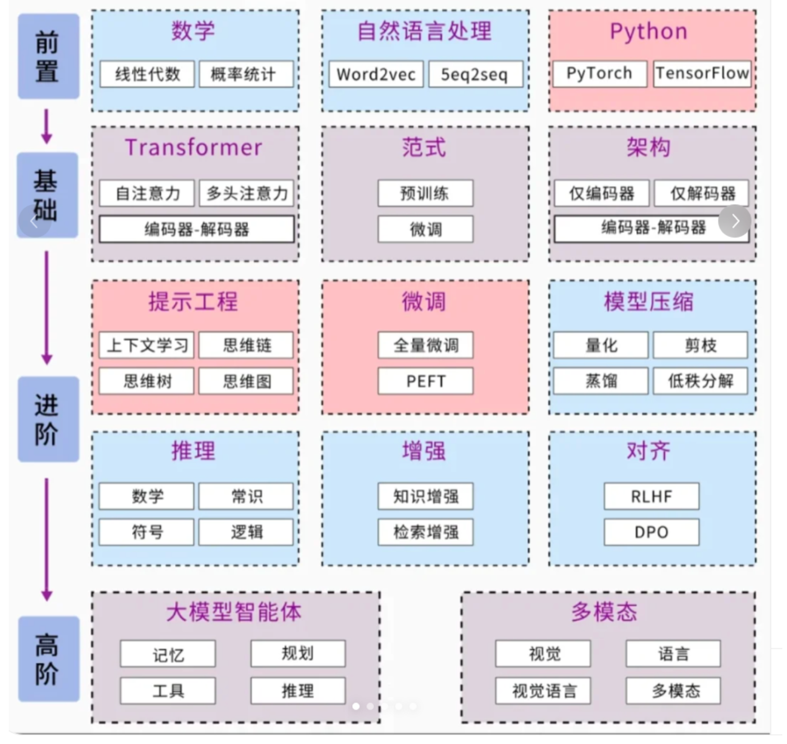

基础transformer知识：<https://www.youtube.com/watch?v=ugWDIIOHtPA&list=PLJV_el3uVTsOK_ZK5L0Iv_EQoL1JefRL4&index=61>

完善的工具说明：https://transformers.run/

微调训练：<https://zhuanlan.zhihu.com/p/695287607>

https://github.com/hiyouga/LLaMA-Factory/blob/main/README_zh.md