Session: Exceptions in Java

..................................................................
Vorname, Name, Matrikelnummer

1. What is wrong with this code?

public void Foo () }
try {
lock() // lock some resource
// open some resource
// try to change some things
// fool around a bit

}
catch (Exception e) {
}
catch (ConcurrentModificationException e) {

System.out.println(„ bad stuff going on today!“)
}
finally {
return;
}
}

→ The code catches all exceptions no matter what type they are of before catching the ConcurrentModificationException

2. What will be the output of the program?

public class TestException
{
public static void badCall()
{
System.out.print("throwing it ");
throw new RuntimeException();
}
public static void main(String [] args)
{
try
{
System.out.print("hello ");
badCall();
}
catch (Exception re )
{
System.out.print("caught ");
}
finally
{
System.out.print("finally ");
}
System.out.println("after ");
}

Output: „hello “ „throwing it “ „caught “ „finally “ „after “
3. Output?
public class TestException1
{
public static void main(String [] args)
{
try
{
badMethod();
System.out.print("A");
}
catch (Exception ex)
{
System.out.print("B");
}
finally
{
System.out.print("C");
}
System.out.print("D");
}
public static void badMethod()
{
throw new Error();
}
}
Output: BCD

4. Make it compile!

public class TestException2
{
class TestException extends Exception {} // inner class
public void runTest() throws TestException {}

public void test()
{
runTest();
}
}
→ UNSOLVED!

5. When should you re-throw a caught exception?

→ An example could be logging:

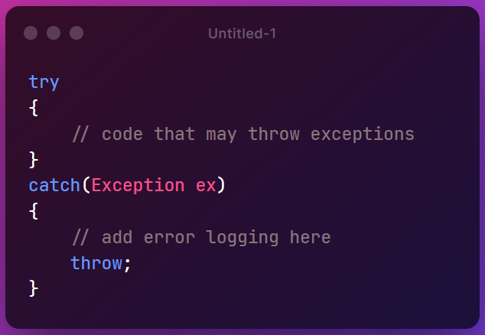

6. A banking software detects, that a certain customer ID is not in the database.
Is this a) a system exception, b) a custom exception, c) no exception.

→ This is either a custom exception or a system exception

7. Was ist der Vorteil von Exceptions gegenüber dem Auswerten von Fehlerwerten im Return?

→ Makes your code way cleaner (Inbuilt java tools for handling)

