<https://www.esri.com/en-us/disaster-response/disasters/wildfires>

Esri’s database of wildfires in their disaster response program that allows the public to access wildfire data, live feeds, and resources.

The Wildfire Aware app is intended to provide information about the current status and potential impact of wildfire incidents in the United States. This app opens with the list of fires sorted by the number of personnel assigned from greatest to least as reported by incident staff. The data included in this application can all be found in ArcGIS Living Atlas and are from authoritative entities.

**GIS use cases for administrators and decision makers-** Can easily identify which areas need safety information broadcast to them via radio stations, text message alerts and other notifications.

**Esri or other source-** Esri

**User interface, tools, or features that I like/ dislike**- overall I very much enjoy the interface, the symbology, basemap, and ability to select an area and obtain demographic information about it.

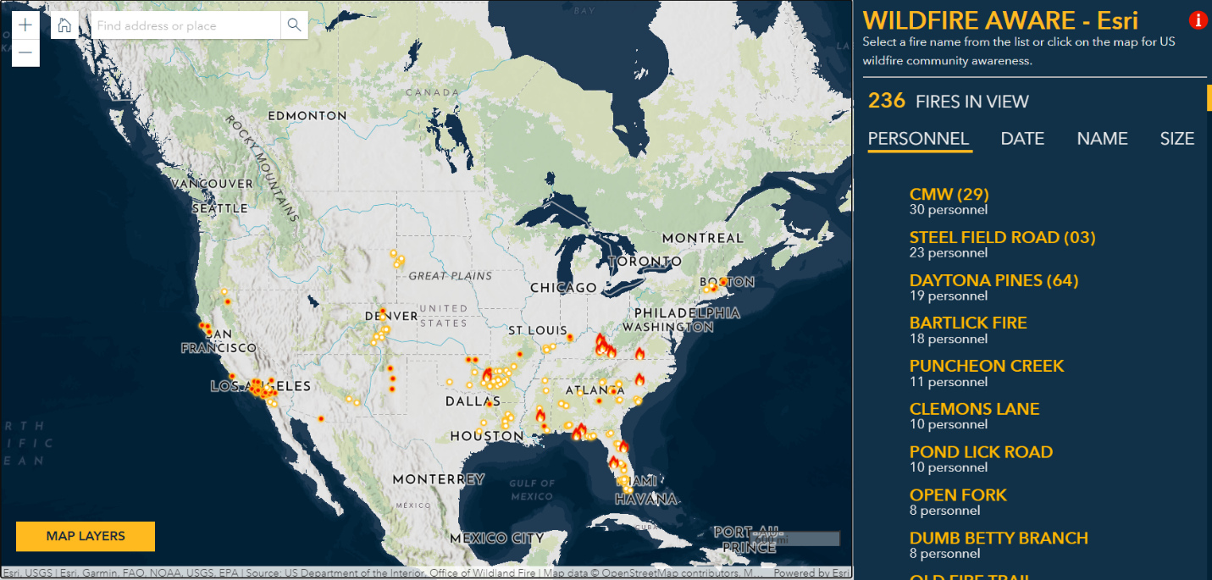

<https://firms.modaps.eosdis.nasa.gov/usfs/map/#d:24hrs;@-87.7,35.9,4z>

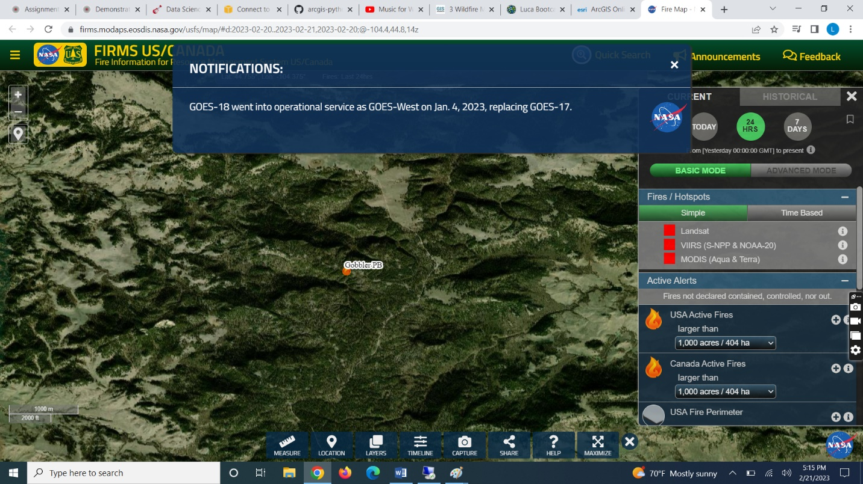

This Fire Information for Resource Management (FIRM) map is a joint effort between NASA and the USDA forest service to provide satellite imagery and science data products from Earth Observation System (EOS) Satellite Assets to identify the location, extent and intensity of wildfire activity and its effects.

**GIS use cases for administrators and decision makers-** provides higher resolution satellite imagery which is useful for anticipating how the fire will spread over terrain, deciding evacuation zones, and nearby infrastructure.

**Esri or other source-** Other source

**User interface, tools, or features that I like/ dislike-** overall I enjoy the satellite imagery basemap and the visualization of wildfire icons by size rather than deployment of personnel like the Esri map.

<https://worldview.earthdata.nasa.gov/?v=-184.37394173306774,-46.546875,18.717691733067724,53.015625&t=2023-02-21-T21%3A26%3A09Z>

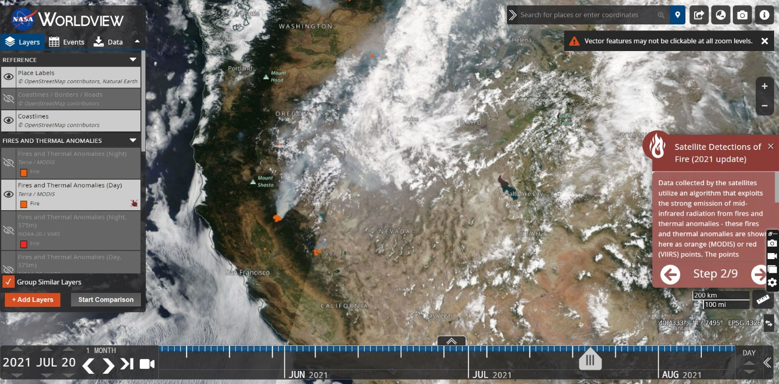

NASA’s daily satellite sensors detect daily fires occurring across the globe. Data collected by the satellites utilize an algorithm that exploits the strong emission of mid-infrared radiation from fires and thermal anomalies - these fires and thermal anomalies are shown here as orange (MODIS) or red (VIIRS) points.

**GIS use cases for administrators and decision makers-** get real time information from satellite imagery to show anomalies in sat data, giving early warning and detection about potential fires before they get out of control.

**Esri or other source-** Other source

**User interface, tools, or features that I like/ dislike-** satellite imagery is low resolution and can’t provide much detail when zoomed in. however I like the way you can view historical imagery such as the wildfires from June 2021 that created a lot of smoke.