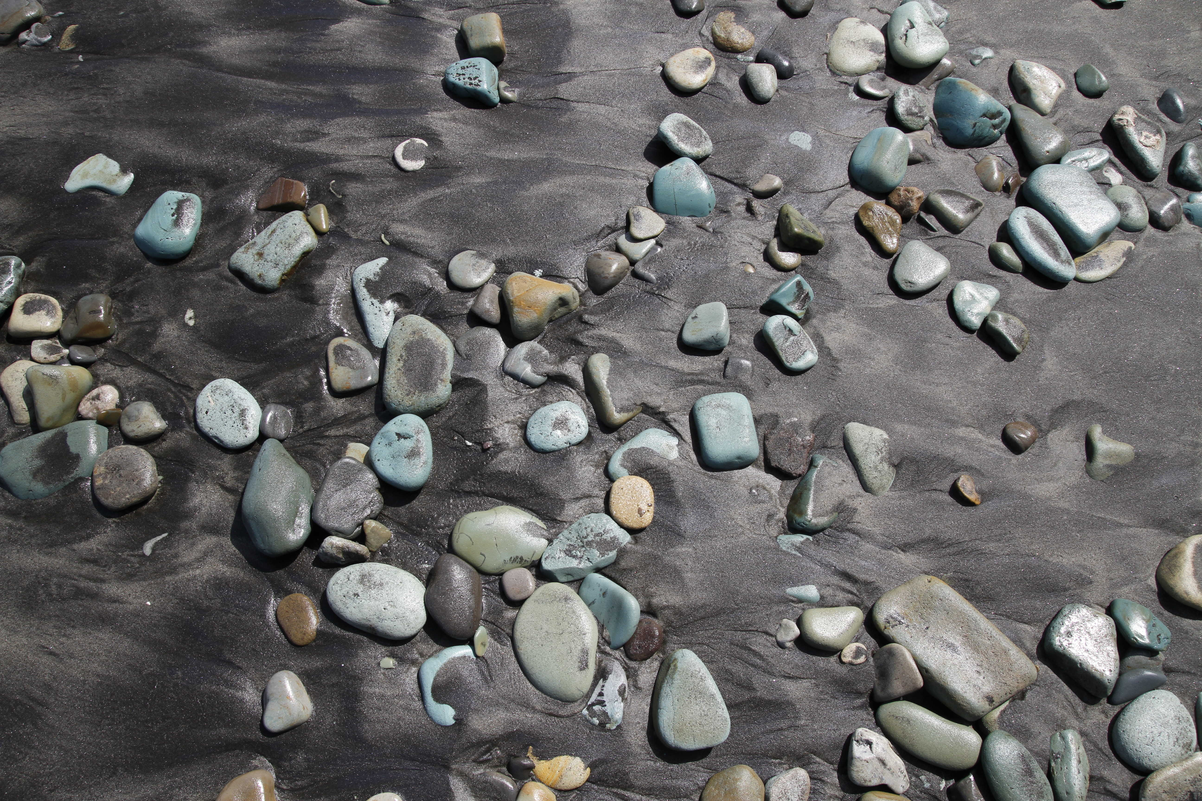

Frequently Asked Questions (FAQ)

1. Q – How can I join the Pickleball Club and what is the cost?
A – The cost is $20.00 for the year. You can see Bonnie Frye, who is treasurer of the club to pay your dues. Membership forms are located at the clubhouse bulletin board.

2. Q – I’ve never played before. Are there lessons for beginners?
A – Yes, there are lessons offered free by Phil Snape. The lessons are every Wednesday from 11:00 until Noon.

3. Q – Do I need my own paddle and balls to play?
A – The balls are provided at the court. Paddles may be borrowed from the Fitness Center. Most players have their own paddles.

4. Q – What are the court times when I can play and when does the Pickleball Club use
the courts?
A – The courts are open for open play every afternoon and the additional times as shown on the Pickleball Court Schedule on the website.

5. Q – Do I need to live in the park to join the club?
A – Yes, as a resident or as a guest staying briefly with a resident.

