Reproduced analysis of FARS data

Lizette van Zyl

October 25, 2017

## Results

Percentages of drivers testing positive by drug type, sex, and year group

|  |  |  |  |  |  |  |
| --- | --- | --- | --- | --- | --- | --- |
| Drug type | F 1999-2002 | F 2003-2006 | F 2007-2010 | M 1999-2002 | M 2003-2006 | M 2007-2010 |
| Alcohol | 26.4 | 24.3 | 27.1 | 43.2 | 42.9 | 43.3 |
| Cannabinoid | 2.8 | 5.7 | 7.3 | 5.8 | 10.3 | 11.8 |
| Depressant | 3.4 | 3.8 | 4.8 | 2.0 | 2.5 | 3.2 |
| Narcotic | 4.2 | 4.9 | 7.0 | 2.2 | 3.4 | 4.0 |
| Other | 5.6 | 6.6 | 7.2 | 4.3 | 4.5 | 4.2 |
| Stimulant | 7.2 | 9.1 | 8.7 | 10.5 | 11.9 | 9.2 |

Figure 1: Prevalence of nonalcohol drugs in fatally injured drivers by year and age group

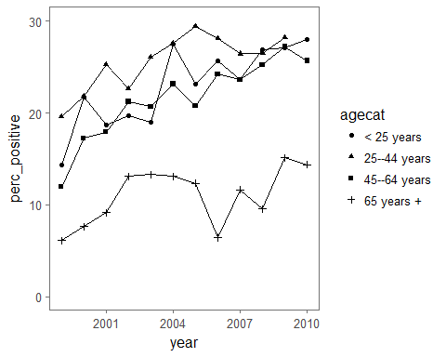

Figure 2: Prevalence of nonalcohol drugs in fatally injured drivers by year and drug type

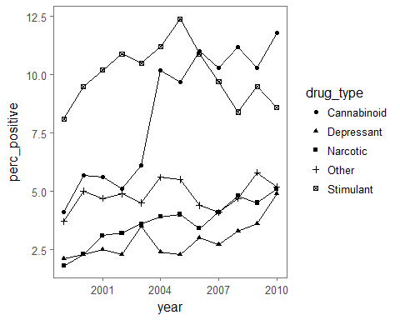

Figure 3: Prevalence of cannabinoid drugs in fatally injured drivers by year and age group

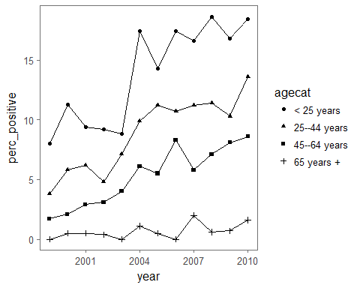

Prevalence of drugs in fatally injured drivers for 1999 and 2010 by drug type

|  |  |  |
| --- | --- | --- |
| Drug type | 1999 | 2010 |
| Alcohol | 38.7% (36.5%, 40.9%) | 39.1% (36.7%, 41.5%) |
| Cannabinoid | 4.1% (3.2%, 5%) | 11.8% (10.2%, 13.4%) |
| Depressant | 2.1% (1.4%, 2.8%) | 4.9% (3.8%, 6%) |
| Narcotic | 1.8% (1.2%, 2.4%) | 5.1% (4%, 6.2%) |
| Other | 3.7% (2.8%, 4.6%) | 5.2% (4.1%, 6.3%) |
| Stimulant | 8.1% (6.8%, 9.4%) | 8.6% (7.2%, 10%) |

Statistics for testing for trend in prevalence of drugs over study years by drug type using Cochran-Armitage trend test

|  |  |  |
| --- | --- | --- |
| drug | Z | p.value |
| Alcohol | 1.2 | 0.228 |
| Nonalcohol | 9.9 | 0.000 |
| Narcotic | 6.7 | 0.000 |
| Depressant | 4.7 | 0.000 |
| Stimulant | 0.5 | 0.604 |
| Cannabinoid | 13.6 | 0.000 |
| Other | 1.4 | 0.157 |

Statistics for testing for trend in prevalence of drugs over study years by drug type using Wald test of logistic regression coefficient for “year”

|  |  |  |
| --- | --- | --- |
| drug | Z | p.value |
| Alcohol | 1.2 | 0.228 |
| Nonalcohol | 9.9 | 0.000 |
| Narcotic | 6.6 | 0.000 |
| Depressant | 4.7 | 0.000 |
| Stimulant | -0.5 | 0.604 |
| Cannabinoid | 13.5 | 0.000 |
| Other | 1.4 | 0.158 |