The Prevalence, Effect, and Transmission of Ranaviruses in Amphibian Communities of Vermont

By Lauren Ash

Second Year Ph.D. Student

Ph.D. Advisors Dr. Nicholas Gotelli

Dr. Brandon Ogbunugafor

Committee Members Dr. Samuel Scarpino, Committee Chair

Dr. Joseph Schall

**Title:**

**Summary/Specific Aims (abstract):**

**Intellectual Merit** (knowledge gaps) adds to the body of emerging infectious diseases, data for a region it has not been previously found in, adds to understanding of this particular disease (perhaps could apply to other systems?), could inform conservation decisions (protect vulnerable populations from disease-related die-offs);

disease killing frogs!! Gaps in knowledge: how virus is being affected; new locations of disease; warmer temperatures influencing disease prevalence?

Our ability to predict the ramifications of these emerging infectious diseases depends on furthering our understanding of how diseases function in novel and changing environments, which are increasingly warming and developing. (Schock et al. 2009).

**Introduction**

Why ranavirus is a good disease system?? It is complex – affects multiple species; ability to cross over classes (potentially useful information for diseases that affect humans)

Describe the virus – mechanisms, effects, factors, everything we know thus far

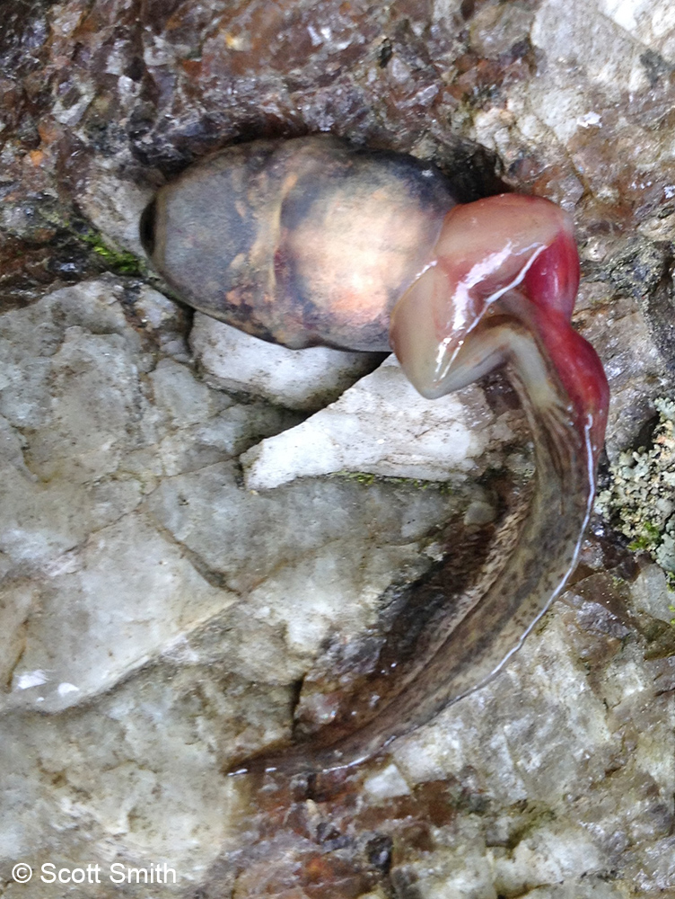Amphibians (Lissamphibia) are part of a diverse and abundant group of organisms that serve as indicators of environmental health, provide biomedicines, and are a vital link in the food web (Wake 1991). However, in recent years, amphibian populations world-wide have been in decline, and studies point to emerging infectious diseases as one of the major contributors (Gray and Chinchar 2015; Harp and Petranka 2006). The genus *Ranavirus* (family Iridoviridae) is a group of emerging pathogens currently wreaking havoc on amphibian communities, occurring in 32 countries on 6 continents. It possesses an extremely wide host range, exhibiting host-switching behavior and the capability of infecting captive and wild fish, amphibians, and reptiles. Ranavirus varies in virulence and timing depending on the virus strain, the life history characteristics of the host, and environmental factors (Hoverman et al. 2011). However, much about the disease is still a mystery. For example, the disease can cause a mass mortality event in a population at one pond and occur sub-lethally in another population nearby. The complexity and mystery of this pathogen make it a unique study system.

Ranavirus infected wood frog larvae

Although the outcome of infection depends on the host, virus strain, and other confounding environmental factors, such as temperature, it is clear that ranaviruses have the potential to impact ectothermic vertebrate populations and can often trigger significant morbidity and mortality, resulting in population declines and local extinctions (Teacher et al. 2010; Earl and Gray 2014; Gray and Chinchar 2015). Ranavirus surveillance and population monitoring of natural communities are severely lacking, with most research concentrating on laboratory experiments (Gray and Chinchar 2015). For example, transmission routes have been tested in the lab, so it is known that ranavirus can be transmitted through direct contact, indirectly (i.e. water or sediment), and ingestion (i.e., cannibalism, predation). However, no published study has focused on the critical roles that host density, behavior, and contact rates play in transmission dynamics (Brunner et al. 2015). Epidemiological models, parameterized to predict the occurrence of this disease, are basically non-existent due to this lack of longitudinal, presence/absence, and wild population dynamics data.

**(3-4) Objectives (Questions?)/Hypotheses/Background/Approach: Think of different chapters as separate papers; could change objectives to questions**

**Objective** Conduct a field survey to elucidate the prevalence and viral load of *Ranavirus* in native amphibian communities of Vermont to a) determine if any of the pathogens are present and affecting Vermont amphibians and b) determine the variety of strains present in communities (phylogenetics); modeling (predictive and epidemiological) determine which factors influence presence absence

Ranavirus book pg226 [MODELING]:

“One strategy would be to create several competing models and test them to data on dynamics in natural populations or in mesocosm studies to identify the most important mechanisms for transmission”

“Other model expansions could be particularly useful for predicting ranavirus dynamics in natural populations; studies could serve as a starting point for determining transmission probabilities in aquatic communities with multiple species”

Vertical transmission hypothesized: a study that controls for in vitro contamination has not been performed. (2009 “Ecology and pathology of amphibian ranaviruses” Gray, Miller, Hoverman)

**Question I: What is the distribution, prevalence, and community structure of ranaviruses in amphibian communities of Vermont?**

**Objective I: a) I aim to evaluate the roles that temporal, spatial, environmental, and anthropogenic factors play in *Ranavirus* distribution and prevalence in natural amphibian populations of Vermont, and b) I aim to determine the diversity and abundance of *Ranavirus* species in the state of Vermont.**

**Hypotheses and Predictions**: a) I hypothesize that ranaviruses are present in the state and that prevalence is affected by anthropogenic and environmental factors. I predictthere will be increased prevalence in sites closer to roads and agricultural areas and sites that have higher human visitation and fishing activity. I also predict that ponds with variable water and soil conditions throughout the season will have increased prevalence. b) I hypothesize that viral diversity mimics the viral diversity of surrounding New England states, and predict Frog-Virus 3 will be the primary species, with potentially multiple sub-strains.

**Background**

The prevalence and diversity (sub-strains FV-3) in the Northeast US and Canada;

Are ranaviruses present in native Vermont amphibian communities, and if so, what is the diversity of strains?

In 1968, a study conducted in New York found ranavirus in the liver of Northern Leopard Frogs bought from a bait shop in Vermont (Clark et al. 1968). Since 2000, ranavirus has been shown to occur in Canada (Greer et al. 2005), Maine (Gahl and Calhoun 2010), New Jersey (Monson-Collar et al. 2013), New York (Brunner et al. 2011), and Massachusetts and New Hampshire (Green et al. 2002); however, it has not been identified in the wild amphibian communities of Vermont.More research is needed to understand why ranaviruses emerge in particular areas (Gray and Chinchar 2015), so the fact that it has not been detected here, as of yet, makes it particularly interesting to study.

**Approach**

*Sampling Design*

In the summer of 2016, I aimed to collect amphibian tissue samples across sites in northwestern Vermont (Figure ). Sampling would occur at each site, once every other week, from mid-May to August in order to increase the probability of witnessing a mass mortality event. The potential sites were chosen with James Andrews, the state herpetologist of Vermont. Sites with predicted high amphibian abundance, estimated from Mr. Andrews’ prior survey experience, ideal amphibian conditions (i.e. shallow water and emergent vegetation), assessed either from prior knowledge or from Google Maps satellite view, and those that could reasonably be visited once every other week were selected as contenders. The consistently high amphibian abundance throughout the summer at these sites was considered because an increase in the amount of samples collected would increase the probability of disease detection. A total of 18 sites met the requirements, were chosen as final sampling locations, and were visited a total of seven sampling periods throughout the summer.

*Sampling Techniques*

Previous estimates indicate that for 95% confidence in disease detection and at 5% disease prevalence, tissue should be collected from at least 20 individuals (REF). Therefore, samples were taken from a maximum of 30 individuals at a particular site or after an allotted amount of time, to standardize sampling effort. To obtain an hour and a half of person hours, the total amphibian search time was for 45 minutes with two people or 30 minutes with three people. All non-endangered species of amphibians at various life stages were collected and placed in either individual plastic bags of distilled water, if a salamander or larval frog, or individual plastic containers, if an adult frog, to limit cross-contamination. Additionally, different pairs of powder-free nitrile gloves were worn while handling each individual. Although lethal methods of sample collection (i.e. liver samples) detect disease more precisely, being able to accurately determine the distribution and prevalence of the disease in Vermont required too large of sample sizes to warrant lethal sampling. Therefore, tail tissue was collected from salamanders and larval frogs, and toe tissue was obtained from adult frogs. Tail collection involved pressing the flat side of a ruler onto the tip of the tail, triggering the natural predator defense of tail autonomy, which minimizes blood loss. Using surgical scissors, one toe was collected from an adult frog per sampling week. If the individual was recaptured, non-adjacent toes were clipped. Forceps and scissors were disinfected between uses with 10% bleach, and waders, boots, and nets were disinfected between sites using 3% bleach, according to the NEPARC disinfection protocol (REF). Tissue was stored in 1.5 mL tubes of 90% ethanol in a -20° freezer. A total of 1,822 tissue samples from a total of 10 amphibian species were collected throughout the summer.

*Testing for virus*

DNA was extracted using the Omega Bio-Tek E.Z.N.A. Tissue DNA kit and protocol. I tested for presence of the virus using real-time quantitative PCR (qPCR) because studies have shown that qPCR methods are more sensitive to virus detection when compared to PCR (REF). Real-time quantitative PCR was performed in MicroAmp optical 96-well reaction plates using StepOnePlus Real-Time PCR Systems (Applied Biosystems). The 10uL reactions consisted of 2 uL of 10ng DNA, 5 uL 1X Sso Advanced SYBR Green Supermix (Bio-Rad Laboratories, Hercules, CA, USA), 0.75 uL of each primer, and 1.5 uL of nuclease-free water. Primers RVMCPKim3_F (5’-TAA- CACGGCATACCTGGACG-3’) and (5’-GATGAGATCGCTG- GTGTTGC-3’) RVMCPKim3_R (Kimble et al*.* 2014) were used to amplify a 97 bp region of the major capsid protein. The thermal profile consisted of 2 minutes at 95°C, then 35 cycles of 95°C for 20 seconds followed by 65.1°C for 20 seconds. Each individual sample was run in duplicate with four serially diluted standards from 10 to 106 viral copies constructed from cultured Frog Virus-3 (FV3), and a negative control using sterile H2O. qPCR standards were created from cultured FV3 from an outbreak in wild adult Northern Leopard Frogs (*Lithobates clamitans*) from Illinois and obtained from Dr. James Julian at the University of Pennsylvania Altoona. Based on the standard curve, a reaction was considered positive when Ct < 32.0.

*Summer 2017*

If ranavirus is present in Vermont and does not show significant variation in prevalence between weeks, I plan on expanding the number of sites I collect samples from, but reducing my sampling periods to three or four times during the summer. The decrease in sampling periods is due to the fact that mass mortality events were not witnessed during the previous summer. Therefore, reduced sampling may still capture representative prevalence throughout the summer. I plan to record environmental data, such as water and soil quality, from sites each time I collect samples. Additionally, I would like to obtain environmental DNA, in which to test for the presence of ranavirus, in order to determine where else the virus is present besides within the individual.

*Data Analysis: Prevalence*

Disease prevalence can be estimated by dividing the number of cases by the population size. In my case, I will estimate prevalence at a given site and time by dividing the number of infected individuals by the total sample size. I will also be able to compare prevalence estimates between species. The change in prevalence between summers: regular ANOVA? Change in prevalence throughout the summer: Repeated measures ANOVA (changes in mean scores over three or more time points): <https://statistics.laerd.com/statistical-guides/repeated-measures-anova-statistical-guide.php>

*Data Analysis: Virus diversity and invasion history*

The amplified ranavirus-positive DNA will also be Sanger sequenced at the Advanced Genome Technologies Core Facilities at the University of Vermont. With the sequenced amplified region of the major capsid protein, I can determine which (and potentially how many) species of the six official viruses are present in the Vermont amphibians I collected. In the future, I would like to use next generation sequencing to sequence the whole genome of positive samples and determine which sub-strains are present, as well. Using that collection of ranavirus sub-strains, and potentially sequences along state borders, I can construct a virus phylogenetic tree. From there, I can use a neighbor-joining tree analysis and haplotype distribution to explore the invasion history of the virus into the state. This method has not been used before (fruit fly, gen. diversity: <http://journals.plos.org/plosone/article?id=10.1371/journal.pone.0036176>; spider spread but human influence: <http://www.sciencedirect.com/science/article/pii/S1055790303003968>) in the ranavirus system and has the potential to allow us to better understand how, or if, it is spanning large areas and the best method of limiting its spread.

*Data Analysis: Potential predictor variables*

In order to attempt to understand what is driving the presence of the virus in certain locations, I can first determine if the means of bioclimatic variables and elevation are different between ponds where ranavirus occurred at some point throughout the summer and those where it did not, using simple one-way analyses of variance (ANOVA). Next, I can use either these coarse BioClim data layers or finer resolution Vermont-specific data layers to predict the presence of the virus in the state. I can start with all 21 predictor layers, determine which are strongly influencing the model, and reduce the number of variables. Since the number of predictor variables may still be more than the number of sites, I can compare the full model to a model that uses a raster PCA of the data layers (how could I interpret this??). If a relatively decent model can be constructed for the small area of Vermont, I can conduct a meta-analysis using latitude and longitude points from other studies to form a model for a larger area. Careful selection of other coordinates will need to be done in order to avoid variance between years and potentially months. Using the driving predictor variables, I can also create a regression tree to see exactly the values that are driving separation between present and absent sites. Additionally, this summer, I plan on collecting environmental information at each site and time point and will be able to compare water and soil quality values to prevalence numbers. With these types of data, a linear regression will be the best method to determine if there is a relationship between those specific environmental conditions and disease prevalence.

**Expected Results and Implications**

**- alternative results; backup plan??**

Show Amphibian abundance graph

2 potential papers: 1) showing that the virus is present in a location not previous found and comparsions of prevalence between sites; predicted distribution

2) Invasion history of the virus

disease ‘hotspots’

**Question II: What are the effects of ranaviruses in these communities?**

H ypothesis II: Disease severity varies between communities

Approach: viral load with qPCR to determine how virulent; estimate host abundance and host community structure; estimate differences in these measurements between present sites and absent sites; look at abiotic factor comparison between present and absent sites

* How sick is it making them? [viral load, host symptoms, ‘virulence’ of pathogen]

**Background**

**Approach**

*Viral load quantification*

Viral load will first be estimated for all samples by comparing the cycle threshold (the crossing point of the amplification curve with the preset threshold of fluorescence detection) of the sample to the standard curve. Using Nanodrop, the amount of DNA in each sample was estimated and then diluted to the same concentration of 5 ng/uL. A dilution factor was applied to samples that had a concentration of less than 5 ng/uL. Using this method, a rough estimate of viral copy number for each positive sample is calculated, and the resulting estimates can then be compared. In the future, to obtain more precise calculations of viral copy number, the positive samples will be run again in duplicate with an internal control in the form of an amphibian gene (yet to be determined).

**Question III: How are ranaviruses being transmitted between among individuals and between sites?**

**Objective III: and b) to identify *Ranavirus* ‘hotspots’ that could be influencing its spread.**

Hypothesis III: A combination of environmental and anthropogenic factors is driving transmission

* Which factors are influencing transmission of the disease between individuals?
* epidemiological models to predict natural ranavirus dynamics [transmission/virulence/host or reservoir species/variation])
* predictive model??? with other data points in specific time frame to determine presence factors [possibly give info on virulence and transmission];
* We can identify disease hotspots (‘potential for high transmission between sites’; high probability of presence; high human contact) in Vermont to target for prioritized conservation efforts
* Investigate a potential vector (leeches): Are leeches potential vectors of the pathogens? (test collected leeches for disease using qPCR; if found, conduct experiment)
* How is it getting around? [Factors; Trade off in virulence and transmission]
* eDNA: see if ranavirus is in soil and water: threshold found for detecting presence at site: correlates with larvae density? Unknown

**Background**:

**Approach**:

**Question IV: Are there host and/or pathogen characteristics that increase or decrease pathogen transmission?**

Hypothesis IV: Host genetic structure influences the effects of the pathogen

Does the host genetic structure influence the effects of the pathogen on the host? (compare population genetic structure of sites that are present vs absent; conduct experiment to obtain genomic data)

* Characteristics of the host that increase transmission? [Genetic structure]
* Characteristics of pathogen [connected with how is it getting around/how sick is it making them]
* gene flow (migration) – landscape genetics (not disease related?)
* Co-infection with chytrid?

**Background**:

**Approach**:

**Conclusions:**  **synthesize predicted results; how do they connect?; how do they answer big question?**

**Broader Impacts**:

**References**: