The Distribution, Prevalence, and Transmission of Ranaviruses and their Effect on Amphibian Communities of Vermont

Lauren Ash

Second Year Ph.D. Student

Ph.D. Advisors Dr. Nicholas Gotelli

Dr. Brandon Ogbunugafor

Committee Members Dr. Samuel Scarpino, Committee Chair

Dr. Joseph Schall

**Project Summary (abstract)** Will write last

**Intellectual Merit**

* adds to the body of emerging infectious diseases, data for a region it has not been previously found in, adds to understanding of this particular disease (perhaps could apply to other systems?)
* could inform conservation decisions (protect vulnerable populations from disease-related die-offs); disease killing frogs
* Gaps in knowledge: how virus is being affected; new locations of disease; warmer temperatures influencing disease prevalence?
* Our ability to predict the ramifications of these emerging infectious diseases depends on furthering our understanding of how diseases function in novel and changing environments, which are increasingly warming and developing (Schock et al. 2009).
* Ranavirus surveillance and population monitoring of natural communities are severely lacking, with most research concentrating on laboratory experiments (Gray and Chinchar 2015). For example, transmission routes have been tested in the lab, so it is known that ranavirus can be transmitted through direct contact, indirectly (i.e. water or sediment), and ingestion (i.e., cannibalism, predation).

**Introduction**

Viruses are considered to be the most ubiquitous and abundant organisms in the world, with an estimated 1031 viruses across the globe (Breitbart and Rohwer 2005). In fact, mathematical models have predicted that the diversity of viruses found in 1 kilogram of marine surface sediment is larger than the diversity of all reptiles on the planet (Breitbart et al. 2004). Not only do they serve as a reservoir for the greatest genetic diversity on Earth, they are important agents of mortality and are central in global geochemical cycles (Suttle 2005). Considering viral abundance, diversity, and ecological importance, surprisingly little is known about their biogeographical distributions, community structure, and ecological dynamics (Breitbart and Rohwer 2005).

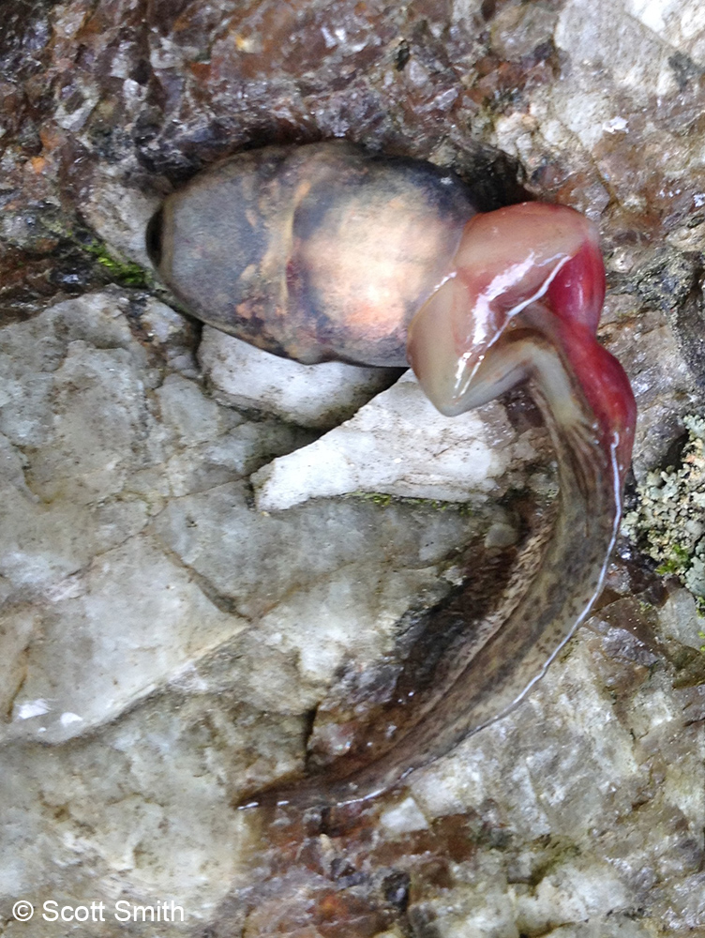 The genus *Ranavirus* encompasses a group of large, double-stranded DNA viruses (family Iridoviridae) and provides an example of the ubiquitous, yet relatively unknown, nature of viruses. These viruses infect a wide range of species, are transmitted through multiple routes, and have large, varying effects between species and populations, making them more general than most viral species, which provides an interesting study system. Ranaviruses are found in 32 countries on 6 continents and possess an extremely large host range, with the capability of infecting multiple species across classes (Chinchar and Waltzek 2014), specifically bony fish (Actinopterygii**)**, reptiles (Reptilia), and amphibians (Amphibia). Amphibians (Lissamphibia) are a diverse and abundant group of organisms that serve as indicators of environmental health and are a vital link in the food web (Wake 1991). However, amphibian populations worldwide have been in decline, and studies point to emerging infectious diseases as one of the major contributors (Gray and Chinchar 2015; Harp and Petranka 2006). Specifically, they have been shown to be particularly susceptible to ranaviral disease: one study reported that the most common cause of amphibian mortality events was infection by ranaviruses (Green et al. 2002). Other studies have reported that ranaviruses are resulting in population declines (Petranka et al. 2003; Teacher et al. 2010; Price et al. 2014; Wheelwright et al. 2014) and have the potential to cause local extinctions (Earl and Gray 2014).

Ranavirus infected wood frog larvae

There are 3 official *Ranavirus* species known to infect amphibians: *Frog virus 3* (FV3), *Ambystoma tigrinum virus* (ATV), and *Bohle iridovirus* (BIV). They have been reported in at least 105 amphibian species in 18 families (Duffus et al. 2015). Transmission of the virus can occur through several routes, including through water and substrate, direct contact, and ingestion of infected individuals. Although the symptoms vary between host and pathogen species, host life stage and transmission route (REF), the viruses generally cause lethargy, internal and external hemorrhaging, swelling of the body and legs, and erratic swimming, with fatal cases involving necrosis in the liver, kidney, and spleen (REF). Additionally, the amphibian ranaviruses have a general trend in the timing of outbreaks, with most die-offs occurring rapidly in the mid to late-summer months (REF). Although these patterns can be observed, there are notable exceptions: the timing of outbreaks in certain species, like Bullfrogs, is much later in the summer (REF) and individuals can be asymptomatic (REF). Unsurprisingly, the mortality rate of infected individuals is also inconsistent.

The outcomes of these outbreaks can vary between species, populations and location, ranging from no apparent mortality to mass die-offs. Factors, such as host life stage, temperature, and anthropogenic influences, have been implicated in this variation. For example, ranavirus outbreaks frequently occur in the mid to late summer months, which coincide with both high temperatures and often the metamorphosis of amphibian larvae. However, studies that tested these influences found conflicting results. Arial et al. (2009) found that multiple amphibian ranavirus species replicated faster with increasing temperature up to a certain optimum, usually between 24°C and 28°C. Contrastingly, another study showed that salamander larvae reared at 10°C or 18°C experienced higher mortality after exposure to ATV compared to larvae reared at 26°C (Rojas et al. 2005), and proposed that the immune system could be suppressed in colder temperatures. Additionally, the process of larval metamorphosis involves natural immunosuppression (Rollins-Smith 1998; Carey et al. 1999); thus, it has been hypothesized that some of the variation in ranavirus outbreak timing could be explained by host life stage. However, although one study found a 1.7-fold increase in mortality of wood frog tadpoles exposed to ranavirus with increasing Gosner (1960) development stages (Warne et al. 2011; Figure 1), another found that metamorphosis was not always the most susceptible stage (Haislip et al. 2011). Finally, further environmental and anthropogenic factors may contribute to the variance in disease prevalence and host mortality, as well. Studies have shown increased probability of outbreaks in areas with cattle access (Gray et al. 2007; Greer and Collins 2008; Hoverman et al. 2012), low elevation (Gray et al. 2009b; Sutton et al. 2014), high elevation (Gahl and Calhoun 2010), and pesticides (Forson and Storfer 2006b; Kerby and Storfer 2009; Kerby et al. 2011).

**Figure 1** shows that the probability of death by ranavirus infection increases with increasing Gosner developmental stage (Warne et al. 2011)

Although there is strong evidence that ranavirus replication and the outcome of infection depend on the host and virus species, as well as other confounding environmental and anthropogenic factors (Speare and Smith 1992; Grant et al. 2003; Rojas et al. 2005; Ariel et al. 2009b), it is clear that ranaviruses have the potential to impact ectothermic vertebrate populations and can often trigger significant morbidity and mortality. Investigating the drivers of outbreak variation would not only further our understanding of generalist viruses and infectious disease ecology in general, but could inform amphibian conservation efforts, as well. Preliminary results from my current research indicate that ranaviruses are indeed present in the state of Vermont. My proposed dissertation research will focus on the ecological and anthropogenic variables associated with disease presence, the effects of these viruses on amphibian communities, how transmission is occurring between ponds and individuals, and the characteristics of both host and pathogen that influence host mortality (Figure 2).

**Question I: What is the distribution, prevalence, and community structure of ranaviruses in amphibian communities of Vermont?**

**Objective I: a) I aim to evaluate the roles that temporal, spatial, environmental, and anthropogenic factors play in *Ranavirus* distribution and prevalence in natural amphibian populations of Vermont, and b) I aim to determine the diversity and abundance of *Ranavirus* species in the state of Vermont.**

**Hypotheses and Predictions**: a) I hypothesize that ranaviruses are present in the state and that prevalence is affected by anthropogenic and environmental factors. I predictthere will be increased prevalence in sites closer to roads and agricultural areas and sites that have higher human visitation and fishing activity. I also predict that ponds with variable water and soil conditions throughout the season will have increased prevalence. b) I hypothesize that viral diversity mimics the viral diversity of surrounding New England states, and predict Frog-Virus 3 will be the primary species, with potentially multiple sub-strains.

**Background**

Surrounding Vermont, ranaviruses and associated mortality events have been found in amphibian communities of Maine (Gahl and Calhoun 2010), Massachusetts and New Hampshire (Green et al. 2002), New York (Brunner et al. 2011), New Jersey (Monson-Collar et al. 2013), and Quebec (Paetow et al. 2011) and Ontario (Greer et al. 2005), Canada. The specific viral species was not reported for most studies, except in New York, which after genetic analysis found FV3-like ranaviruses present, and Ontario and Quebec, where sequences were a 98 and 100 percent match to FV3, respectively. Additionally, prevalence has not been reported for most studies. Quebec found ranavirus prevalence at 85 percent (Paetow et al. 2011), but another study found in 2012 that 100 percent of 18 ponds across 10 states on the United States eastern coast had ranavirus-infected frogs (Crespi et al. 2015).

Although a 1968 New York study found ranavirus in the liver of Northern Leopard Frogs (*Lithobates pipiens*) purchased from a business in Vermont (Clark et al. 1968), no ranavirus surveys have been conducted in the natural amphibian communities of the state. Therefore, ranavirus distribution, prevalence, and its associated factors are virtually unknown. More research is needed to understand why ranaviruses emerge in particular areas (Gray and Chinchar 2015), so the fact that it has not been detected here, as of yet, makes it particularly interesting to study.

Phylogenetics background: 3 official amphibian ranaviral species, however, there are dozens of unofficial sub-species, implying a relatively high evolution rate.

**Approach**

*Sampling Design*

In the summer of 2016, I aimed to collect amphibian tissue samples across sites in northwestern Vermont (Figure 1). Sampling would occur at each site, once every other week, from mid-May to August in order to increase the probability of witnessing a mass mortality event and because the sensitivity of PCR using non-lethal tissue samples peaks around 12 days post-virus exposure (Greer and Collins 2007). The potential sites were chosen with James Andrews, the state herpetologist of Vermont. Sites with predicted high amphibian abundance, estimated from Mr. Andrews’ prior survey experience, ideal amphibian conditions (i.e. shallow water and emergent vegetation), assessed either from prior knowledge or from Google Maps satellite view, and those that could reasonably be visited once every other week were selected as contenders. The consistently high amphibian abundance throughout the summer at these sites was considered because an increase in the amount of samples collected would increase the probability of disease detection. A total of 18 sites met the requirements, were chosen as final sampling locations, and were visited a total of seven sampling periods throughout the summer.

*Sampling Techniques*

Previous estimates indicate that for 95% confidence in disease detection and at 5% disease prevalence, tissue should be collected from a sample size of at least 20 individuals (Gray et al. 2015). Therefore, samples were taken from a maximum of 30 individuals at a particular site or after an allotted amount of time, to standardize sampling effort. To obtain a total amphibian search time of an hour and a half ‘person hours’, either two people searched for 45 minutes or three people searched for 30 minutes. All non-endangered species of amphibians at various life stages were collected and placed in either individual plastic bags of distilled water, if a salamander or larval frog, or individual plastic containers, if an adult frog, to limit cross-contamination. Additionally, different pairs of powder-free nitrile gloves were worn while handling each individual. Although lethal methods of sample collection (i.e. liver samples) detect disease more precisely, being able to accurately determine the distribution and prevalence of the disease in Vermont required too large of sample sizes to warrant lethal sampling. Therefore, tail tissue was collected from salamanders and larval frogs, and toe tissue was obtained from adult frogs. Tail collection involved pressing the flat side of a ruler onto the tip of the tail, triggering the natural predator defense of tail autonomy, which minimizes blood loss. Using surgical scissors, one toe was collected from an adult frog per sampling week. If the individual was recaptured, non-adjacent toes were clipped. Forceps and scissors were disinfected between uses with 10% bleach, and waders, boots, and nets were disinfected between sites using 3% bleach, according to the Northeast Partners in Amphibian and Reptile Conservation disinfection protocol (NEPARC 2014). Tissue was stored in 1.5 mL tubes of 90% ethanol in a -20° freezer. A total of 1,822 tissue samples from a total of 10 amphibian species were collected throughout the summer.

*Testing for virus*

DNA was extracted using the Omega Bio-Tek E.Z.N.A. Tissue DNA kit and protocol. I tested for presence of the virus using real-time quantitative PCR (qPCR) because studies have shown that qPCR methods are more sensitive to virus detection when compared to PCR, especially when pathogen concentration is low (Monson-Collar et al. 2013). Real-time quantitative PCR was performed in MicroAmp optical 96-well reaction plates using StepOnePlus Real-Time PCR Systems (Applied Biosystems). The 10uL reactions consisted of 2 uL of 10ng DNA, 5 uL 1X Sso Advanced SYBR Green Supermix (Bio-Rad Laboratories, Hercules, CA, USA), 0.25 uL of forward and reverse primers, and 2.75 uL of nuclease-free water. Primers RVMCPKim3_F (5’-TAA- CACGGCATACCTGGACG-3’) and (5’-GATGAGATCGCTG- GTGTTGC-3’) RVMCPKim3_R (Kimble et al*.* 2014) were used to amplify a 97 bp region of the major capsid protein. The thermal profile consisted of 2 minutes at 95°C, then 35 cycles of 95°C for 20 seconds followed by 65.1°C for 20 seconds. Each individual sample was run in duplicate with four serially diluted standards from 10 to 106 viral copies constructed from cultured Frog Virus-3 (FV3), and a negative control using sterile H2O. qPCR standards were created from cultured FV3 from an outbreak in wild adult Northern Leopard Frogs (*Lithobates clamitans*) from Illinois and obtained from Dr. James Julian at the University of Pennsylvania Altoona. Based on the standard curve, a reaction was considered positive when Ct < 32.0.

*Summer 2017*

If ranavirus is present in Vermont and does not show significant variation in prevalence between weeks, I plan on expanding the number of sites I collect samples from, but reducing my sampling periods to three or four times during the summer. The decrease in sampling periods is due to the fact that mass mortality events were not witnessed during the previous summer. Therefore, reduced sampling may still capture representative prevalence throughout the summer. I plan to record environmental data, such as water and soil quality, from sites each time I collect samples. Additionally, I would like to obtain environmental DNA, in which to test for the presence of ranavirus, in order to determine where else the virus is present besides within the individual.

*Data Analysis: Prevalence*

To address my first hypothesis, virus prevalence can be estimated by dividing the number of cases by the population size. In my case, I will estimate prevalence at a given site and time by dividing the number of infected individuals by the total sample size. I will also be able to compare prevalence estimates between species. Difference in prevalence between sites: chi-squared test (p217; <http://fwf.ag.utk.edu/mgray/RanavirusBook/Chap8/SampleCode_8.5.html>); The change in prevalence between summers: regular ANOVA (ANCOVA?)? Change in prevalence throughout the summer at a site: Repeated measures ANOVA? (changes in mean scores over three or more time points): <https://statistics.laerd.com/statistical-guides/repeated-measures-anova-statistical-guide.php>; Logistic regression can also be used to estimate the risk factors associated with ranavirus occurrence among populations (Ranavirus Book p218; <http://fwf.ag.utk.edu/mgray/RanavirusBook/Chap8/SampleCode_8.5.html>) *Bayesian methods; R package for repeated observations (not mark recapture) – “unmarked”; better

Randomized block design – each study site is a block; can’t test for block*time interaction

Across all sites – general seasonal pattern; randomization test? Regression line to 7 data points for each site (randomize ordering of 7 sites – factorial orderings; is ordering non-random; bootstrap? Fit slope (get distribution of slopes; is my distribution steeper slope than random); logistic regression?

Hierarchical Bayesian model? Look at human epi or other organism literature that use bigger sample sizes? Jim Clark; Bayesian models (light uptake by plants; seedling survival; has book about Bayesian modeling in R) Bryan Beckage – look at notes; sampling is binomial? Model parameter and credibility; increase attractiveness of paper

*Data Analysis: Predicted distribution and potential predictor variables*

In order to attempt to understand what is driving the presence of the virus in certain locations, I can first determine if the means of bioclimatic variables and elevation are different between ponds where ranavirus occurred at some point throughout the summer and those where it did not, using simple one-way analyses of variance (ANOVA). Next, I can use either these coarse BioClim data layers or finer resolution Vermont-specific data layers to create a predicted distribution of the presence of ranavirus in the state. I can start with all 21 predictor layers, determine which are strongly influencing the model, and reduce the number of variables. Since the number of predictor variables may still be more than the number of sites, I can compare the full model to a model that uses a raster PCA of the data layers (how could I interpret this??). Using AIC model evaluation, I can determine the best predictive model and identify potential disease ‘hotspots,’ or areas with a high probability of presence. Next, if a relatively decent model can be constructed for the small area of Vermont, I can conduct a meta-analysis using latitude and longitude points from other studies to form a model for a larger area. Careful selection of other coordinates will need to be made, in order to avoid variance between years and potentially months. Using the driving predictor variables, I can also create a regression tree to see exactly the values that are driving separation between present and absent sites. Additionally, because I plan on collecting environmental information at each site and time point this summer, I will be able to compare water and soil quality values to prevalence numbers. With these types of data, a linear regression will be the best method to determine if there is a relationship between those specific environmental conditions and disease prevalence.

*Data Analysis: Virus diversity and invasion history*

The amplified ranavirus-positive DNA will also be Sanger sequenced at the Advanced Genome Technologies Core Facilities at the University of Vermont. With the sequenced amplified region of the major capsid protein, I can address my second hypothesis and determine which (and potentially how many) species of the six official viruses are present in the Vermont amphibians I collected. In the future, I would like to use next generation sequencing to sequence the whole genome of positive samples and determine which sub-strains are present, as well. Using that collection of ranavirus sub-strains, and potentially sequences along state borders, I can construct a virus phylogenetic tree. From there, I can use a neighbor-joining tree analysis and haplotype distribution to explore the invasion history of the virus into the state. These particular methods have not been used before in the ranavirus system (fly, gen. diversity: <http://journals.plos.org/plosone/article?id=10.1371/journal.pone.0036176>; spider, human infl.: <http://www.sciencedirect.com/science/article/pii/S1055790303003968>) yet have the potential to allow us to better understand how, or if, the virus is spanning large areas and the best method of limiting its spread. [Mention spatial analysis and phylogenetic study of ranavirus in UK (Price et al. 2016)? They used “twinstim, a function in the R package Surveillance v. 1.7 [38 – 40], to analyse the UK spread of ranavirus-consistent mortality events”]

**Expected Results and Implications**

I expect to obtain two main results from this first question. Firstly, ranavirus has not been documented in natural communities of Vermont, and this is the first large survey of the state. I will be able to present the first instance of the virus, its predicted distribution and potential disease ‘hotspots’ in Vermont, as well as its prevalence and diversity in the sites I sampled. Furthermore, to the best of my knowledge, the predicted distribution of the virus has not been published. For my second main result, I can use a combination of spatial and phylogenetic analyses to present an invasion history of the disease, first locally in the state and then broader-scaled. This method has not been used in this disease system, but has the potential indicate if expansion is human-mediated.

**Question II: What are the effects of ranaviruses in amphibian communities of Vermont?**

**Objective II: I aim to determine a) whether there is a relationship between species diversity and disease presence and b) if disease severity varies across sites.**

**Hypotheses and Predictions:**

a) I hypothesize that ranavirus reduces species and genetic diversity. I predict the virus will cause mortality in susceptible species, which will reduce species richness, evenness, and genetic diversity in ranavirus present sites after periods of high disease prevalence. b) I hypothesize that host community and genetic structure cause variation in disease severity between amphibian populations and communities and predict that communities and populations with low genetic diversity, richness, and evenness will have increased ranavirus severity. Additionally, I predict communities that have reservoir species will have increased ranavirus severity.

**Background:**

- community stability/equilibrium

- species diversity metrics in general/ in system

- genetic diversity in general? In system?

- disease severity/mortality and viral load are correlated (find reference)

- reservoir species (in general, and in ranavirus system)

- Not too many community analyses in this system (make sure)

- Variance in virulence

- Most susceptible species (wood frogs)?

**Approach**

*Viral load quantification*

Viral load will be used as an estimate of disease severity. It will first be estimated for all samples by comparing the cycle threshold (the crossing point of the amplification curve with the preset threshold of fluorescence detection) of the sample to the standard curve. Using Nanodrop, the amount of DNA in each sample was estimated and then diluted to a concentration within an order of magnitude to each other (less than 100 ng/uL). Using this method, a rough estimate of viral copy number for each positive sample is calculated, and the resulting estimates can then be compared. In the future, to obtain more precise calculations of viral copy number, the positive samples will be run again in triplicate with an amphibian reference gene. This allows for the amount of host DNA in the reaction to normalize the qPCR data. Amphibian genes such as ribosomal protein L7 (RPL-7), and 18S ribosomal RNA have been used as reference genes in the past (Zhang and Hu 2006), but I will have to perform tests to determine which gene would work best with my qPCR assay.

*Calculating species and genetic diversity*

To measure species diversity, a diversity index that summarizes the number of species and their relative abundances in a community will be calculated. Simpson's diversity index (*D*) is often used as an estimate of species diversity (Equation 1; Simpson 1949).

$D= \frac{1}{\sum_{i=1}^{S}{p_{i}^{2}}}$ (*Equation 1*)

In addition, the uniformity of species abundances, or evenness, can be estimated with the Probability of Interspecific Encounter (PIE; Equation 2; Hurlbert 1971).

$PIE=\frac{N}{N-1} (1-\sum_{i=1}^{S}{p_{i}^{2})}$ (*Equation 2*)

To calculate genetic diversity within a host population, ideally I would like to use next generation sequencing to obtain whole genome diversity estimates. However, another less expensive option to obtain genetic diversity would be to use microsatellite markers. A previous study have determined genetic diversity for populations of one host that were infected with ranavirus. I would like to estimate genetic diversity and structure for multiple host populations, or each species that was infected with ranavirus at some point throughout the summer. Common ways of estimating genetic diversity are using heterozygosity and allelic richness and diversity at certain loci or SNPs (Allendorf 1986). Heterozygosity can be used as a measure of the capability of a population to respond to selection immediately after a bottleneck (i.e. disease), while allelic diversity determines the capacity of a population to respond to long-term selection over numerous generations (REF). In addition, I would like to compare genetic variability within and between populations using FST.

*Analyses*

To determine whether there is a difference in species diversity between sites that have ranavirus infected species and those that do not I will perform t-tests. I can also use hierarchical clustering analyses and non-metric multidimensional scaling (NMDS) to further explore the data. To determine whether there is a relationship between virus prevalence/severity and diversity, I will use generalized linear models to perform regressions. With this method, I can determine how much of the variance in the species and genetic diversity can be explained by disease prevalence and viral load, and vice versa. Additionally, I would like to perform a regression on disease prevalence/viral load and abiotic measurements to see if disease severity can be explained by these abiotic factors (i.e. water pH). To determine whether there is a relationship between genetic differentiation and disease severity, I can apply the same method using FST.

**Expected Results and Implications**

If no change in species richness, evenness, or abundance is observed, perhaps ranavirus is not causing severe mortality (further studies of fitness effects?)

Not too many community analyses in this system (make sure)

Abundance data – if mortality affecting all species the same or the most common species more, may see decrease in total abundance;

There are, however, several reports of ranavirus being present in larval and post-metamorphic amphibians without notable disease or mortality (Duffus et al. 2015), although most studies do not collect longitudinal data and are liable to miss mortality events (Gray et al. 2015). It is worth noting that sublethal infections by ranavirus can impact fitness-related traits such as growth and development (Echaubard et al. 2010).

“Greer et al. (2009), for instance, found that ATV infection in tiger salamanders (*A. m. nebulosum*) increased to a peak of ~50 % prevalence in three ponds in northern Arizona, but no morbidity or mortality was observed” and “Duffus et al. (2008) found that 20–32 % of wood frog tadpoles were infected in early summer, but none showed clinical signs of disease.”

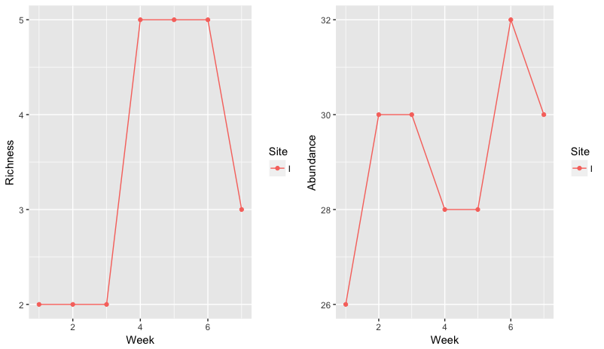

**Question III: How are ranaviruses being transmitted among individuals and between sites?**

H1: Transmission between communities varies due to the environment, human influence, and disease prevalence

P1: Transmission between communities will increase with increasing human visitation, increasing virions in the environment, and increasing statewide and within-community disease prevalence.

H2: Transmission within communities varies due to different species interaction strengths and contact rates.

P2: Individuals and species will interact with each other non-randomly, which will influence disease transmission

P2: Increased density of conspecifics and heterospecifics will increase transmission; increased predation by amphibians on amphibians will increase transmission; increased mating will increase transmission

H3: The number of hosts influences pathogen fitness and transmission.

P3: Pathogen fitness will decrease with increasing number of hosts, so transmission mode will expand.

How does pathogen host switching influence transmission (come up with probabilities of ranavirus infection across species due to interactions: does ranavirus have the same efficiency across species?) – use bacteriophages as model; “efficiency” = fitness?

expose bacteriophage to multiple hosts vs single host – trade offs? Does primary transmission mode shift? “Evolutionary Reversals During Viral Adaptation to Alternating Hosts” - W. D. Crill, H. A. Wichman and J. J. Bull

Background:

- how is it transmitted between individuals? (more detail; which has bigger dose)

- how do humans influence transmission (other ways to go between sites)?

- Previous eDNA research

- Host-switching behavior (general/ranavirus)

- Experimental evolution: viruses dominate our planet and their evolution is a broad and applied field that can be studied in the real time

Approach 1: **use transmission network analyses to make SIR models - how different interactions (and hypotheses of these interactions) influence disease prevalence**

Approach 2: Predict the probability of being transmitted to another site using environmental data (eDNA), anthropogenic influences (visitation estimates), and ranavirus prevalence

Approach 3: experimental evolution

Expected results:

First transmission network/SIR model in system

**Question IV: Are there host and/or pathogen characteristics that increase or decrease pathogen fitness? Are there environmental stressors that increase susceptibility, resilience, or tolerance?**

* Does mortality/fitness change with multiple stressors and at different life stages?
* If there are any that are asymptomatic – are they differentially expressing genes?
* Are the survivors differentially expressing genes?
* There are adaptive alleles: allelic shifts as summer passes/infection prevalence increases?
* Characteristics of the host that increase transmission? [Genetic structure] (QII?)
* Characteristics of pathogen [connected with how is it getting around/how sick is it making them] (QIII)
* gene flow (migration) – landscape genetics (not disease related?); estimate migration; high migration could be introducing the disease at a higher rate but could also add to genetic diversity which could buffer effects of disease (QII)
* Co-infection with chytrid?

H: Multiple stressors increase host susceptibility to ranavirus and the susceptibility to these stressors varies between life stages.

P:

H: There are adaptive alleles and differences in gene expression in asymptomatic and surviving individuals, which signal increased host tolerance

P:

Background

- Multiple stressors

- Define host susceptibility, tolerance, and resistance

- has differential gene expression been done in this system?

- what is known about ranavirus genomics

Approach:

Experiment: full factorial design

Genomics

add timing of pesticide to experiment? (pesticide first then disease, disease first then pesticide)

Expected Results:

- the only expression studies deal with immune response (check); not asymptomatic or surviving individuals

- multiple stressors have not taken life stage into consideration or exposed individuals to pesticide before the disease

**Conclusions:**

* Synthesize predicted results
* How do they connect?
* How do they answer big question?

**Broader Impacts**:

* Conservation
* Working with the State Parks;
* Vermont Herp Atlas;
* Other database that woman emailed me about

**References**:

Bergh, Ø. et al. (1989) High abundance of viruses found in aquatic environments. Nature 340, 467–468

Breitbart, M. et al. (2004) Diversity and population structure of a nearshore marine sediment viral community. Proc. R. Soc. Lond. B. Biol. Sci. 271, 565–574

Brunner JL, Barnet KE, Gosier CJ et al (2011) Ranavirus infection in die-offs of vernal pool amphibians in New York, USA. Herpetol Rev 42:76–79

Crespi EJ, LJ Rissler, NM Mattheus, K Engbrecht, SI Duncan, T Seaborn, EM Hall, JD Peterson, JL Brunner. 2015. Integr Comp Biol. **55**: 602-617.

Gahl MK, Calhoun AJK (2010) The role of multiple stressors in ranavirus-caused amphibian mor-

talities in Acadia national park wetlands. Can J Zool 88:108–121

Gosner KL (1960) A simplified table for staging anuran embryos and larvae with notes on identi- fication. Herpetologica 16:183–190

Gray et al. 2015: Ranavirus Book - Design and Analysis of Ranavirus Studies: Surveillance and Assessing Risk

Green DE, Converse KA, Schrader AK (2002) Epizootiology of sixty-four amphibian morbidity and mortality events in the USA, 1996-2001. Ann N Y Acad Sci 969:323–339

Greer A.L., J.P. Collins. 2007. Sensitivity of a diagnostic test for amphibian ranavirus varies with sampling protocol. Journal of Wildlife Diseases **43**:525-532

Hurlbert, S.H., 1971, The nonconcept of species diversity: a critique and alternative

parameters. Ecology, v. 52, p. 577-586. (On explicit calculation of rarefaction

richness and derivation of Hurlbert’s PIE measure of evenness.)

Monson-Collar K, Hazard L, Dolcemascolo P (2013) A Ranavirus-related mortality recent and the first report of Ranavirus in New Jersey. Herpetol Rev 44:263–265

Northeast Partners in Amphibian and Reptile Conservation. 2015. Disinfection of Field Equipment to Minimize Risk of Spread of Chytridiomycosis and Ranavirus. http://www.northeastparc.org/products/pdfs/NEPARC_Pub_2014-02_Disinfection_Protocol.pdf

Paetow LJ, Pauli BD, McLaughlin JD et al (2011) First detection of ranavirus in *Lithobates pipiens* in Quebec. Herpetol Rev 42:211–214

Price SJ, Garner TWJ, Cunningham AA, Langton TES, Nichols RA. 2016 Reconstructing the emergence of a lethal infectious disease of wildlife supports a key role for spread through translocations by humans. Proc. R. Soc. B 283: 20160952. <http://dx.doi.org/10.1098/rspb.2016.0952>

Simpson, E.H., 1949, Measurement of diversity. Nature, v. 163, p. 688. (Measurement and error bars for dominance, which is the complement of evenness.)

van Regenmortel, M. (1990) Virus species, a much overlooked but essential concept in virus classification. Intervirology 31, 241–254