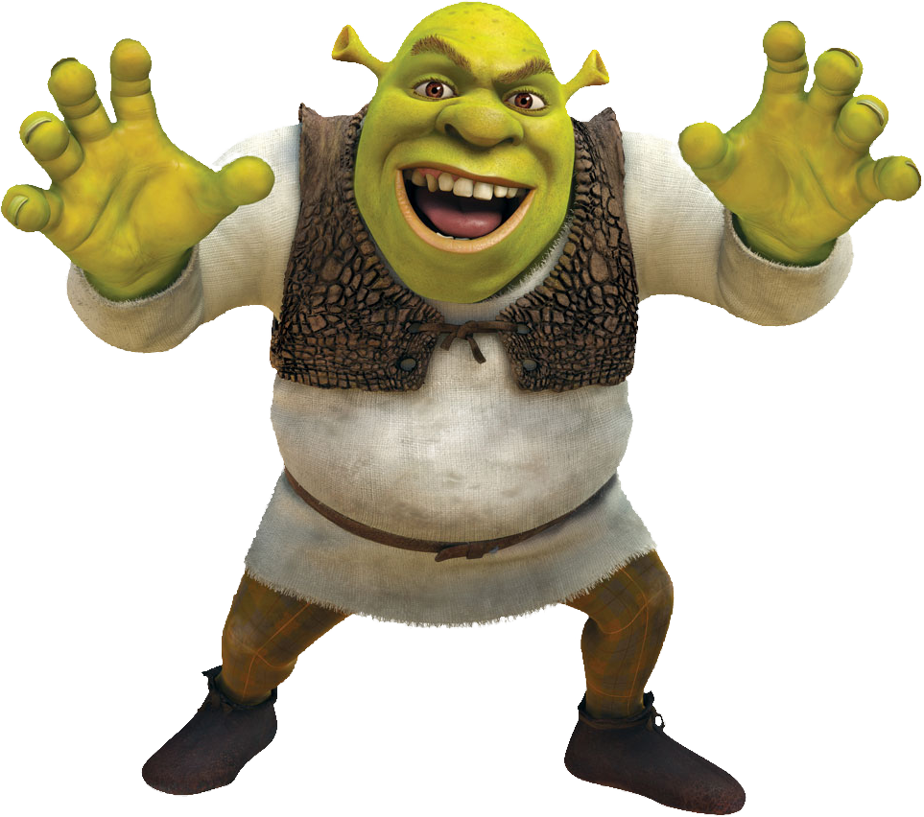

Rules of the Swamp

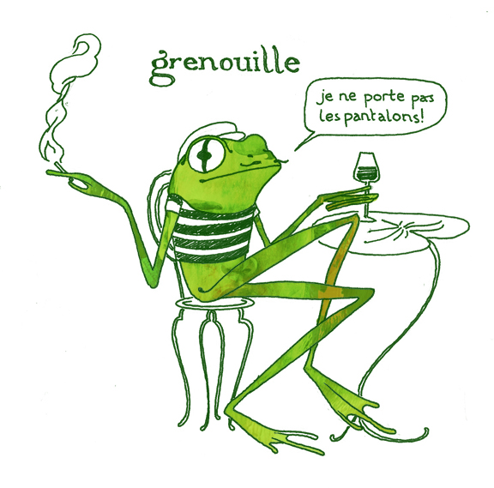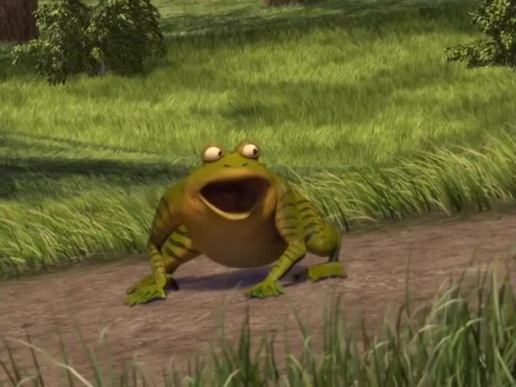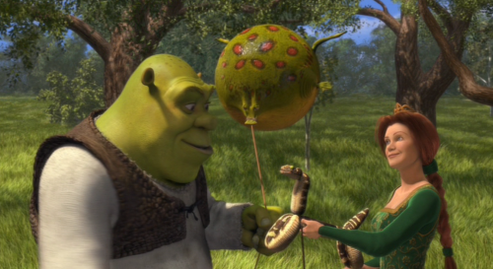

1. Please keep the door closed   
**(**[ l[ke my swamp chilly**)**

2. No food or dr[nk past this point

3. Do not change the l[ght or temperature settings