ACE Inhibitors and Diuretics Among Hypertensive patients: A Randomized Parallel Clinical Trial
Lizbeth Vasquez
10 May 2022

Abstract

There is insufficient literature differentiating the short-term effects of Angiotensin-converting enzyme (ACE) inhibitors and Thiazide diuretics within patients newly diagnosed with hypertension. To increase the literature, data were obtained from Houston Methodist Hospital to estimate the risk of continued high blood pressure in men and women aged 30-65 in Houston, Texas prescribed an ACE inhibitor compared to a diuretic. Regression models were used to evaluate the outcome and the risk of experiencing multiple side effects. No difference was found between both medications, however the risk of having one or more side effects was .25 in the group who received the ACE inhibitor compared to those prescribed the thiazide diuretic. This study highlights the need to increase research of severity of side effects within this population, to aid in the prescription of hypertensive medications.

Introduction

High blood pressure is a non-communicable disease that is one of the main risk factors for cardiovascular diseases within the United States. In 2017, new guidelines were published defining high hypertension as a blood pressure result at or above 130/90. According to the CDC, there are two stages of hypertension, the first stage has systolic blood pressure (SBP) between 130-139 mmHg or a diastolic blood pressure (DPB) of 80-89 mmHg. The second stage rises with a SBP ≥ 140 mmHg or ≥ 90 mmHg.¹ SBP measures the force used of the mechanism of the heart contracting to release blood into the body, DBP is measured by the force of the heart while the heart is relaxed to allow the arterial chambers to fill with blood. There is an increase in SBP as age increases, showing an increase in hypertensive diagnosis and treatments.²
Treatments recommended by physicians for high blood pressure mostly include lifestyle change and the introduction of a hypertensive medication. There are multiple blood pressure medications available to lower high blood pressure and prevent development of heart diseases. Medications include Angiotensin-converting enzyme (ACE) inhibitors and angiotensin II receptor blockers (ARBs), Calcium channel blockers, Diuretics, and Beta Blockers. It has been noted that Diuretics and Calcium channel blockers have increased effectiveness in lowering the SBP in the elderly population. In a study comparing multiple hypertensive therapies in elderly patients, ACE inhibitors did not significantly alter the SBP or DBP of the participants.³
ACE Inhibitors aid in hypertension by dilating the arteries in the body, therefore decreasing the pressure within the heart. Additionally, the medication will also decrease the force of the left ventricle which can unfortunately also cause the cardiac thickness and mass to shrink.⁴ Some common adverse reactions of ACE inhibitors are syncope, hyperkalemia, and dry cough.⁵ Diuretics are treatments that aid to remove excess urine and sodium from the body. Thiazide diuretics are effective in young adults to reduce sodium reabsorption as well as a long-term hypertensive treatment.⁶ Common side effects include hypokalemia, hyponatremia, and hyperglycemia.
While both ACE inhibitors and Diuretics are both common first lines of defense of hypertension, there are different studies showing differing effects in different populations. In populations with chronic kidney diseases, coronary artery disease, and ST elevated myocardial infarction along with hypertension, ACE inhibitors are recommended to be the initial treatment. Those with history of diabetes are then recommended thiazide diuretics in place of an ACE inhibitor.⁵ This study will aim to conduct a parallel randomized controlled trial to evaluate the timely effectiveness of ACE inhibitors reducing high blood pressure compared to patients prescribed a thiazide diuretic.

Methods
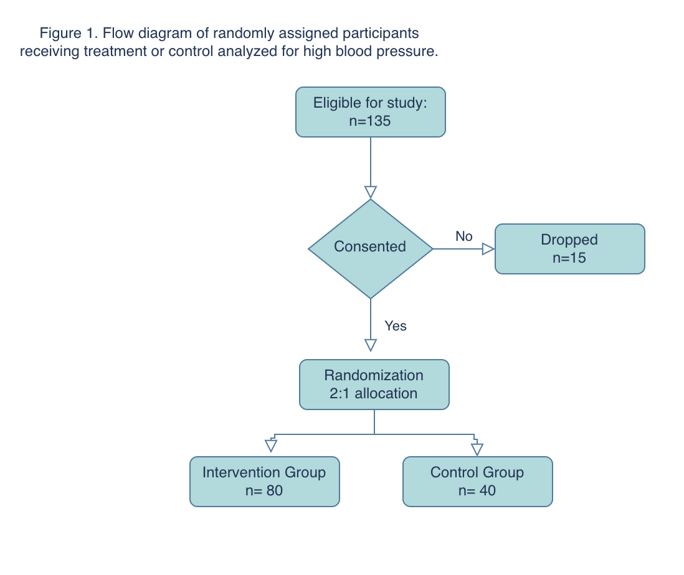
This superiority study will measure the high blood pressure outcome after a high blood pressure diagnosis along with the prescription of an ACE inhibitor or diuretic at risk. This is a parallel randomized controlled trial based in the state of Texas within the United States, as an intention-to-treat-analysis. Patients were selected from Houston Methodist Hospital in Houston, Texas. Total population of this city was 2.31 million in 2019, Houston Methodist Hospital care group employs 76 doctors addressing hypertension within the Houston metropolitan area. The participants eligible were identified as those receiving primary care from the Houston medical center who had been diagnosed with hypertension (SBP >120 mm Hg, and/or DBP >90 mm Hg) for the first time in their lives. The trial included participants from the age 30 and above, not including patients on antihypertensive medication. Within day of intake, the physician must have recorded BMI, demographics and referred the patient to study. Heart & Vascular Specialist working on the study based in a Texas Medical Center where participants completed follow-up clinical measurements a month after treatment. Additional exclusions included pregnant women, visually impaired or person with hearing loss, any bed-ridden patients, participants diagnosed with kidney disease, cancer, heart disease, chronic obstructive pulmonary disease, and mental illness. A week after intake and baseline data were obtained, the participants completed a consent form, then were blinded, and allocated to receiving an ACEs inhibitor as a treatment for hypertension (n=40) or to the control group prescribed the standard diuretic (n=80). The Heart & Vascular Specialist distributed the supply of medication to each patient. A 30-day supply of a phosphorus-containing ACE inhibitor, Fosinopril, of 25mg was given for the intervention participants to split orally into two equal doses during the day to control blood pressure. A thiazide diuretic would also be administered as a 30-day supply, chlorthalidone of 35mg, which should be taken orally in the morning with food. Prescribed medications were formed to look the identical (Figure 2). The primary outcome of this study evaluated the final BP reading at follow up one month after baseline data was obtained. The primary outcome was coded as “yes” if the patient remained at a hypertensive level. The secondary outcomes were evaluated if the patient had experienced any adverse side effects including syncope, hypokalemia, hyponatremia, and hyperglycemia.
The initial study population contained 135 participants with a 2:1 allocation ratio. Assuming the power is .90, having an alpha of 0.05 and the no be loss to follow up, the projected study population was about 100 participants. However, after additional revision, the decision was made to conduct the study at a 2:1 ratio to reduce bias and confounding effects. A statistician who was also blinded to the study, randomly assigned a deidentified dataset of (2:1) participants to an intervention or control group using the SAS software. This software was also used at the end of the follow up period to evaluate the risk ratio of the outcome and run a log linear regression using a GEE mixed model (Table 2). The additional covariates include age, baseline BMI, follow up BMI, baseline systolic blood pressure, baseline diastolic blood pressure, follow up systolic blood pressure, and follow up diastolic blood pressure (Table 1).

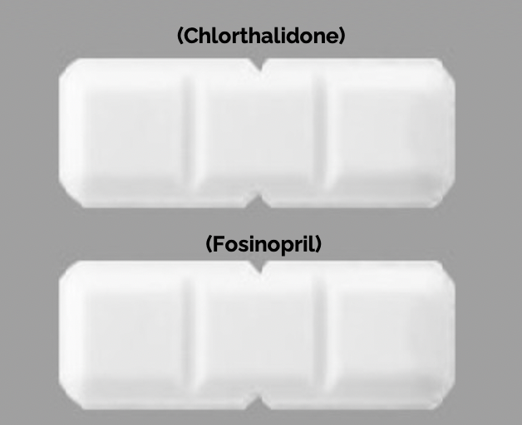
Figure 2. Both medications formed to seem visually identical to each other.

Table 1. Unweighted DISTRIBUTION OF SAMPLE CHARACTERISTICS (n=120) | Intervention (n = 80)  Mean S.D.* |  | Control (n=40)  Mean s.d
Age | 48.46 10.88 | 47.13 |  | 11.21
Baseline Systolic Blood Pressure | 155.76 16.31 | 151.65 |  | 13.42
Baseline Diastolic Blood Pressure | 99.28 14.55 | 100.38 |  | 12.66
Baseline BMI | 25.09 4.24 | 25.97 |  | 3.54
male | N(%)  40 (50%) | N (%)  26 (65%)

*S.D.= Standard deviation

Table 2. results from regression models Comparing Interventions and high blood PRESSURE (n=120) |  |  | RR (95% CI) | RD (95% CI)
Model 1: received Ace Inhibitor (Intervention) | N (Cases) | N
Yes | 69 | 11 | 1.08 (0.90, 1.29) | 1.06 (0.92, 1.23)
No | 32 | 8 | ref | ref
MODEL 2: SENSITIVITY ANALYSIS BETWEEN SIDE EFFECTS WITHIN INTERVENION STATUS  Received ACE Intervention  Yes | Experienced Side Effects (1+)  8 | No Side Effects  72 | 0.24 (0.11,0.50) | 0.72 (0.62, 0.85)
No | 17 | 23 | ref | ref

*CI: Confidence interval

Results
The sample eligible for the study included 135 participants prior to completing a consent form to begin the randomization process. The final analytic sample was obtained following a consent form provided using the Qualtrics software where 15 participants declined to participate in the study (n=120).. Of those who declined to participate, they returned to their primary physician to begin a plan of treatment recommended by the physician. The total sample of participants randomized in the intervention group receiving the ACE inhibitors was (n=80) and control group receiving the thiazide diuretic was (n=40) (Figure 1). The time when baseline data was obtained from a primary physician referred to the study began July 23rd-27th of 2018. Follow up data occurred approximately a month after the patients had been provided with their respective medications beginning August 23rd-29th of 2018.
The baseline and follow up data provided to the researchers included blood pressure, BMI, age, and sex of the patient (Table 1). The average age of the entire sample at baseline was 48, with an average blood pressure of 154/100, and BMI of 25.4. At follow up, physicians measured vital statistics, as well as the side effects experienced during the one-month period. Participants with a follow up blood pressure reading above 130/90 were referred to their primary physician to continue treatment of hypertension.
The risk of hypertension was 1.08 in participants prescribed an ACE inhibitor (Fosinopril 25mg,) as compared to participants prescribed a Diuretic (Chlorthalidone of 35mg) (95% CI: 0.90, 1.29. Results for the log linear regression done for those receiving the ACE inhibitor resulting in continued high blood pressure indicated a risk difference of 1.06 (95% CI: 0.92, 1.23). This primary analysis indicates that there was no difference in the reduction of hypertension in both groups. While was no difference in the effectiveness of an ACE inhibitor or thiazide diuretic one month, our secondary analysis regarded the major unintended side effects that participants experienced during the study of high potassium blood levels, temporary loss of consciousness, high blood sugar, and low sodium levels which are all taken at the follow up curb appointment. Syncope was the only side effect reported by the patient themselves and the rest were confirmed by blood test. The intervention group who received the ACE inhibitor had .25 the risk of having side effects compared to those taking the Diuretic (95% CI: 0.11,0.50).

Discussion:
The baseline characteristics were between all participants which show the effectiveness of the randomization process. The design of the trial itself was a strength as we were able to control for unknown variables, confounding, and had the ability to reduce other biases. With this, the ability to measure multiple outcomes was beneficial for future uses of the data collected within this trial. One of the difficulties faced was the possible lack of adherence that could have risen with the increase of side effects faced during the one-month period. In multiple studies, it has been found that about 50-80% of patients prescribed hypertensive medications are nonadherent.⁷ While recruitment included those with first time high blood pressure diagnosis, it is unknown how long patients had been living with untreated hypertension and the long-term physiological effects that may have an impact on body function and the medications effect. AN additional limitation is the use of the 2:1 ratio, as it may restrict the internal validity of a study, and the possibility of equipoise.
While the primary outcome of this study was to evaluate if an ACE inhibitor would have a greater effect on hypertension as compared to a standard diuretic in men and women aged 30-65, we found a greater effect in the secondary analysis. Based on the results of this study, there should be additional studies analyzing the side effects affecting different populations including race, age groups, and sex as there have been risks associated with each medication.^{8,9} Additional tests should be included in future studies at baseline including kidney function and renal impairment prior to treatment.⁵ We infer that ACE inhibitors are appropriate to use as the first line of treatment against hypertension in the Houston population aged 30-65 for individuals with healthy renal functions to experience less side effects of treatment.

References

- Facts About Hypertension. Centers for Disease Control and Prevention. https://www.cdc.gov/bloodpressure/facts.htm. Published September 27, 2021. Accessed May 9, 2022.
- Gurven M, Blackwell AD, Rodríguez DE, Stieglitz J, Kaplan H. Does blood pressure inevitably rise with age?: longitudinal evidence among forager-horticulturalists. Hypertension. 2012;60(1):25-33. doi:10.1161/HYPERTENSIONAHA.111.189100
- Trefor Owen Morgan, Adrianne I.E. Anderson, Robert Jeffrey MacInnis, Ace inhibitors, beta-blockers, calcium blockers, and diuretics for the control of systolic hypertension, American Journal of Hypertension, Volume 14, Issue 3, March 2001, Pages 241–247, https://doi.org/10.1016/S0895-7061(00)01266-8
- Frohlich ED. Angiotensin converting enzyme inhibitors. Present and future. Hypertension. 1989;13(5 Suppl):I125-I130. doi:10.1161/01.hyp.13.5_suppl.i125
- Goyal A, Cusick AS, Thielemier B. ACE Inhibitors. [Updated 2021 Jul 8]. In: StatPearls [Internet]. Treasure Island (FL): StatPearls Publishing; 2022 Jan-. Available from: https://www.ncbi.nlm.nih.gov/books/NBK430896/
- Ernst ME, PharmD., & Moser M, M.D. (2009). Use of diuretics in patients with HypertensionDrug therapy:N Engl J Med. 2009;361(22):2153-64. doi: http://dx.doi.org/10.1056/NEJMra0907219
- Brown MT, Bussell JK. Medication adherence: WHO cares?. Mayo Clin Proc. 2011;86(4):304-314. doi:10.4065/mcp.2010.0575
- Laube G.F., Kemper M.J., Schubiger G., and Neuhaus T.J.: Angiotensin-converting enzyme inhibitor fetopathy: long-term outcome. Arch Dis Child Fetal Neonatal Ed 2007; 92: pp. F402-F403
- Bowen M.E., Ray W.A., Arbogast P.G., Ding H., and Cooper W.O.: Increasing exposure to angiotensin-converting enzyme inhibitors in pregnancy. Am J Obstet Gynecol 2008; 198: pp. 291-295

