Enterprise Integration





LBW Insurance

- Group Project -

|  |  |
| --- | --- |
| **Team** | G4T4 |
| **Members** | Chan Siang Yong, Lyu Bowen, Jovin Ng, Xu Jia Wen, Wang Yechun, Sarah Tay |

TABLE OF CONTENTS

1. Overview of business scenario

1.1 Business Assumptions

1.2 Involved IT Systems

1.3 Business Scenario Process

2. Technological Aspects

2.1 Technical Diagram

2.2 Process Definition Diagram

2.3 Electronic Messaging System (TIBCO EMS)

2.4 XML & XSD Documents

2.5 MySQL Databases

2.6 Web Services

2.7 Integration Middleware (Tibco Businessworks)

3. Beyond The Labs

4. Systems Walkthrough

## 1. Overview of business scenario

LBW Insurance is a car insurance company that provides the option for a premium reduction upon nearing the expiry of the current insurance plan. The systems query for clients that have insurance that are about to expire. Next, the system will come to a conclusion if the client is eligible or ineligible for the reduction. On completion, we will:

1. Emails will be sent to clients to notify them about the result.

2. Respective databases will be updated

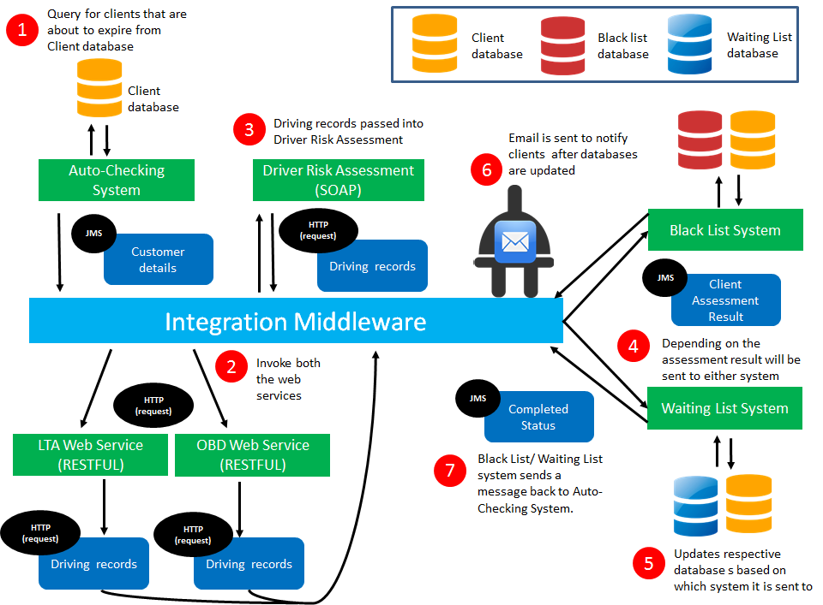

### 1.1 Business Assumptions

* This premium reduction is only for existing clients, as they would need to have their OBD devices already stored in their car for such an evaluation to happen.
* The administrator would be the one to review each application and provide the reason explicitly into the database as to why the client had failed their application.
* A different system would be in place to await the customer response on the acceptance of their new/current premium, and update both the Waiting List Database and Client Insurance Database respectively
* The OBD devices only records dangerous driving incidents

### 1.2 Involved IT Systems

|  |  |
| --- | --- |
| **Name** | **Description** |
| Auto-checking System | This is a web-based application that checks the current clients that are about to expire in a month, using tibco the client’s details(application.xml) would be sent using a queue(q.start). |
| Waiting List System | The Waiting List system processes each and every application passed unto eligible.queue, and updates both the Waiting List database and Insurance Client database, and sends an email towards the client containing the status of their application with their details, including a link that references our company’s website. |
| Black List System | The BlackList system processes each and every application that is passed unto uneligible.queue, and updates both the Waiting List database and Insurance Client database, and sends an email towards the client containing the status of their application with their details, including a link that references our company’s website. |

### 1.3 Business Scenario Process

1. Applicants that are about to expire would be evaluated to ascertain whether they are eligible for insurance premium reduction through a series of systems/web services, first of which would be the client management system apply via Customer System Application (CSA).
2. An administrator using the client management System would retrieve all records of clients that are about to expire for that current month, thereafter these information would be processed into an xml output(application.xml) and would be sent towards the q.start queue.
3. The IM(listening on q.start) would receive the message and parse the xml application, using the information extracted to be serve as input for the invocation of both the LTA web service and On-Board device web service
4. The LTA web service would check the amount of offense records that the applicant have for that year based on his license plate number, and retrieve the result in a json format.
5. At the same time, the On-Board Device web service using the client’s License Plate number would retrieve the number of dangerous logs stored within the OBD database, and return the ouput in a json format.
6. These inputs would be passed unto the Driver’s Risk Assessment, based on a fixed criteria, the Risk Assessment Web Service would return the client’s risk assessment status that could either be (Pass, Average, Fail)
7. The status of the client would then be rendered into a XML format(Modified.xml).
   1. The output of the modified.xml would vary depending on the status, should the status be eligible, the 5 content headers would be Name, Nric , VehicleType, Email & NewPremium. If not, the content headers would be Name, Nric, Vehicle Type, Email & Reason for failure.
8. The Modified XML would be passed unto one of two queues depending on the status of the risk assessment level, namely q,eligible & q.uneligible.
9. The invocation of either the Waiting List System or the Black list System would happen here:
   1. In the waiting List System, the waiting list system would process each application received from eligible.queue, each application would be updated in the Waiting List database. This database would temporarily store the information of the client information while waiting for their response.
   2. Likewise in the Black List System, the Blacklist system would process each application received from eligible.queue, each application would be updated in the Black List database
   3. Consequently, in both systems the updating of the client’s insurance database by temporarily removing the client based on his license plate number, in order to prevent a while loop from happening.
10. Simultaneously, an email would be sent to the corresponding client’s email to update him/her on the results of their evaluation for the current year, that could be a insurance renewal(current premium), insurance reduction(lower premium) or to annul/reject their insurance renewal. A URL of the company website would be provided to accept their new/old premium or to reason for rejection.

2. Technological Aspects

### 2.1 Technical Diagram

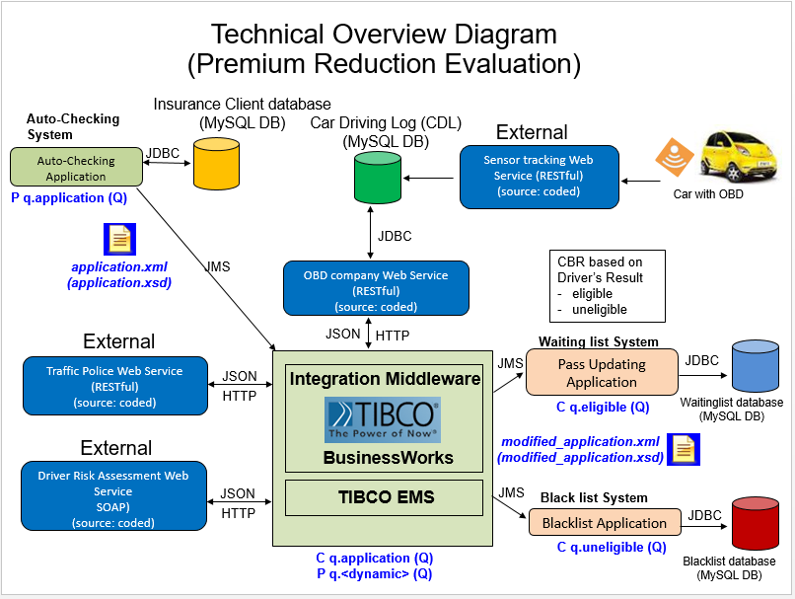

### 2.2 Process Definition Diagram

1. Auto-checking system

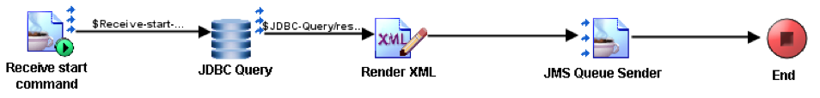

1. Main process

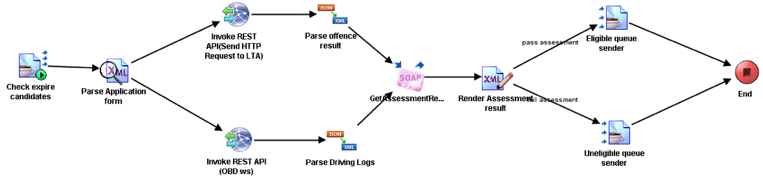

1. Waiting list system

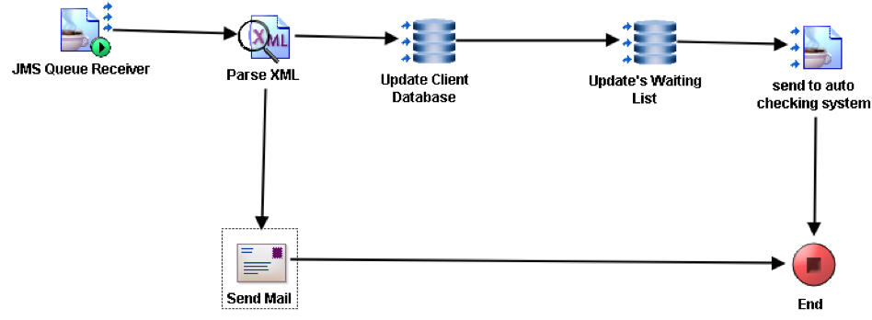

1. Blacklisting system

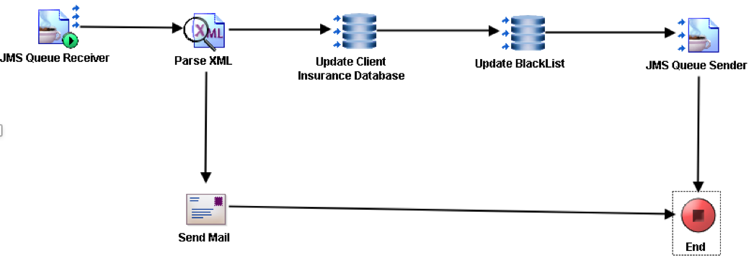

Process sequence: 1 > 2 > 3 or 4 > 1

### 2.3 Electronic Messaging System (TIBCO EMS)

JMS is used to send data between our internal systems. We use JMS to pass user credits within our systems. By using queues to forward messages internally, we will be able to process a high amount of update requests reliably and quickly.

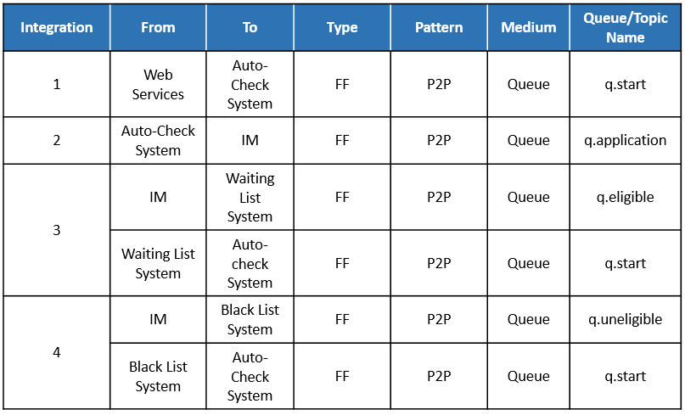

**Integration 1 (q.start)**

Once the admin user clicked ‘check update’ on the webpage, the auto-check system will receive a JMS text ‘approved’ through q.start and then the process will start.

**Integration 2 (q.application)**

Once the process has started, the auto-checking system will send application.xml in XML formatted text to IM through q.application.

**Integration 3 (q.eligible / q.start)**

IM will send modified_application.xml in XML formatted text to waiting list system through q.eligible.

After proceeding with modified_application.xml, waiting list system will send a JMS text message ‘approved’ to Auto-checking system to restart the whole process for the next user.

**Integration 4 (q.uneligible / q.start)**

IM will send modified_application.xml in XML formatted text to blacklisting system through q.eligible.

After proceeding with modified_application.xml, blacklist system will send a JMS text message ‘approved’ to Auto-checking system to restart the whole process for the next user.

### 2.4 XML & XSD Documents

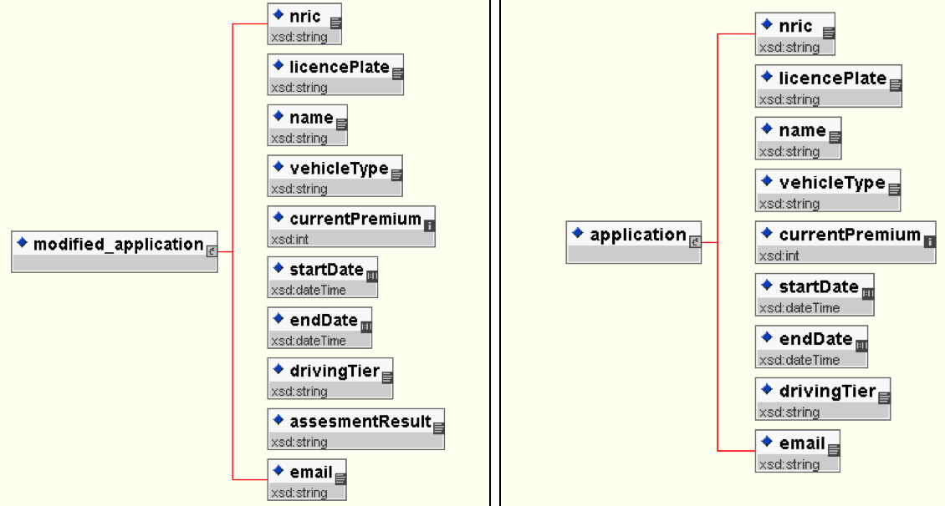

Fig 1. Modified_application XML schema Fig 2. Application XML schema

### 2.5 MySQL Databases

|  |  |
| --- | --- |
| **Name** | **Description** |
| client | This DB stores the details of all clients from the insurer’s database. It contains their **nric**, **licence plate**, **name**, **vehicle type (class)**, **current premium**, **start date(coverage period)**, **end date(coverage period)**, **driving tier**, **email**. The auto-check system will retrieve from the database clients with an expiry date that are expiring in a month’s time. |
| drivinglog | The On-board-device (IOT) placed in the car sends an alert containing the details of that current situation whenever it identifies a **dangerous driving** situation, to a sensor tracking web service. The web service stores the data in this drivinglog database. The database contains the following information : **licence plate, timestamp (of the incident), average speed(during the incident), acceleration(during the incident).** |
| ltalog | This DB which belongs to LTA, contains the details of incidents on offences committed by road users. The informations includes: **license plate**, **timestamp**, **description**, **severity** |
| waitinglist | The waitinglist stores temporary information about clients who are eligible for the insurance premium reduction and would be waiting in line to be further processed to continue on the premium reduction process by the insurer. It contains the following information; **nric, licence plate, name, vehicle type** and **new premium.** |
| blacklist | The blacklist stores the permanent details on clients who are ineligible for the insurance premium reduction due to some reasons that the insurer is unable to insure. This DB stores the following information: **nric, licence plate, name, vehicle type** and **reasons** (for being blacklisted - updated by an administrator upon reviewing the client) |

### 2.6 Web Services

|  |  |  |  |
| --- | --- | --- | --- |
| **Name** | **Input** | **Output** | **Description** |
| Traffic police web services | licencePlate | StatusCode  Msg | This ws will take in licence plate number of a car, and return the status code and msg (number of offenses) |
| On-board device company web services | licencePlate | StatusCode  Msg | This ws will take in licence plate number of a car, and return the status code and msg (number of offenses) |
| Driver risk assessment web services | Msg (from Traffic police ws)  Msg (from OBD ws) | StatusCode  Msg | This ws will take in both msg from the above two ws, and return a status code and msg (total number of offenses) |
| Sensor tracking web services | licencePlate,  avgspeed, acceleration, | - | Collect licence plate number, average speed and acceleration from the car data, and generate a timestamp of current time. Then write these data into database table ‘drivinglog’. |

### 2.7 Integration Middleware (Tibco Businessworks)

Tibco BusinessWorks is used as the integration platform, which involves data transformation, content based routing, plugins and automation.

**Data transformation**

|  |  |  |
| --- | --- | --- |
| **From** | **To** | **Description** |
| Auto-Checking System  (application.xml) | Integration Middleware | Extract the application details such as the license plate, email and the nric of the client for use in subsequent web service (lta, driving log, driver risk assesment) queries as well as storing into waitinglist and blacklist DB. Which would be subsequently used in the modified_application.xml and sent to the email through SMTP. |
| Driver Risk Assessment Web Service | Integration Middleware | Add the extracted application details together with the driver assessment result into a new XML schema and form modified_application.xml |
| Parse XML in wait listing system | SMTP (email) | Concat string "Dear Customer", "Your Insurance Premium Reduction Application result:", "Should you choose to accept the NEW current premium please visit out website.” and name, nric, assesmentResult from modified_application.xml into an email. |
| Parse XML in blacklisting system | SMTP (email) | Concat string "Dear Customer;", "Your Insurance Premium Reduction Application result:", "Should you choose to accept the NEW current premium please visit out website.” and name, nric, assesmentResult from modified_application.xml into an email. |

**Content based routing**

From the process 2 diagram above, based on the driver’s risk assessment results (pass, average, fail), we route the modified_application.xml to the respective application queues (eligible and uneligible)

**Plugins**

Email plugin under tibco businessworks to send business process related information (results of driver’s risk assessment) to the client.

## 3. Beyond The Labs

|  |  |
| --- | --- |
| **Feature** | **Description** |
| AXIS2 | Use POJO method to deploy web service to AXIS2 server. |
| Loop Function | With a single click of the Client Management System.In the auto checking system: for each of the clients retrieved in the database that are about to expire, we would initiate the whole process till each client is either admitted within the waiting List database or the blacklist database A message would be send back a queue that auto-checking system is listening unto, the auto checking system would kickstart the process again till there is no more clients that are about to expire for that month. |
| Email (TIBCO plugin) | Whenever a client’s assessment result is obtained(modified_application.xml), upon parsing the xml file, an email would be sent to the client’s email address that is obtained previously from application.xml. The contents of the email would contain the Client’s details(Name, Nric , License Plate and Status of assessment result) and a link(ghost link) of the insurance website that the client may proceed to accept/reject the application. |
| Github | All of us use Git as repository to share code and updates.  Our Git repository can be accessed athttp://green.smu.edu.sg/jovin-ng-2014/EI |

## 4. Systems Walkthrough

This is the home page of the web application, the administrator clicks on the ‘Check Expire’ to begin the process of checking the database for clients with an ‘End Date’ that expires within a month. The evaluation process then begins.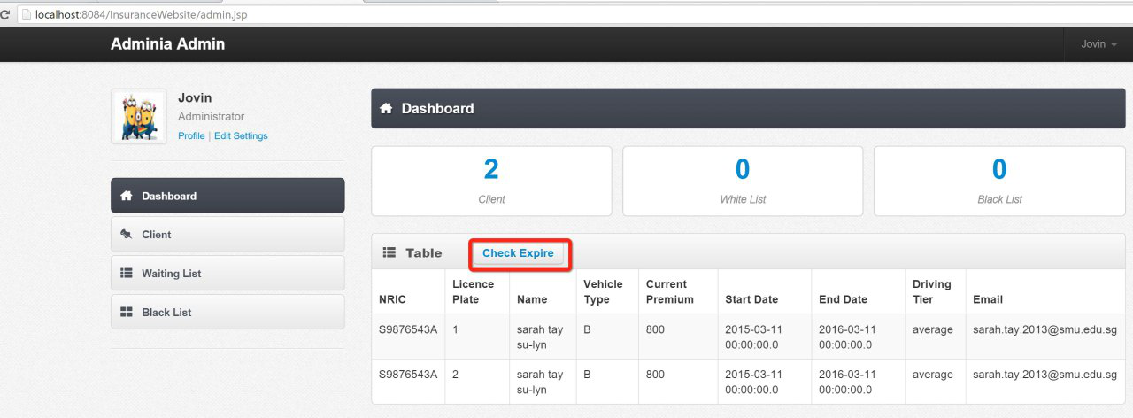

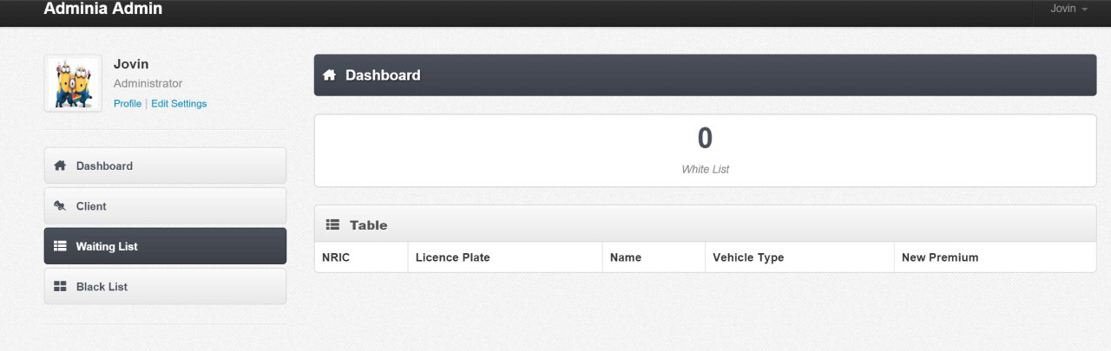

**Waiting List**

1. Before the evaluation of the client’s application is being done , the waiting list could have records present or not. In this case it is empty.

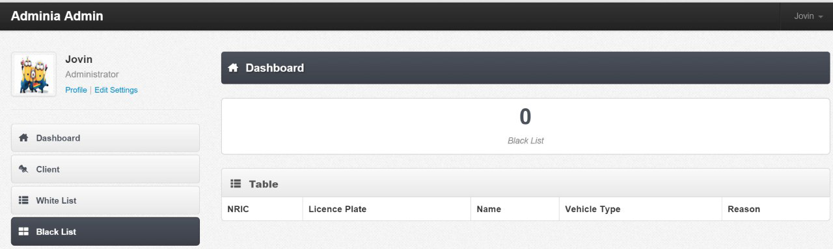

**Black List**

1. Before the evaluation of the client’s application is being done , the black list could have records presents or not. In this case it is empty.

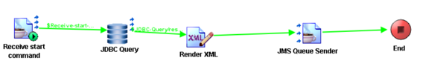

**Auto-checking system**

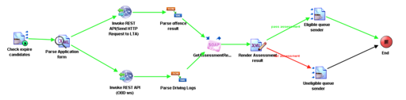

**Integration Middleware**

3. The Integration Middleware receives client application from auto-checking system, then send licence plate to LTA web service and OBD web service to retrieve the client offence record within a year. The offence record will be send to assessment web service to calculate final score. Based on the final score, IM will determine whether the client belong to waiting list or blacklist.

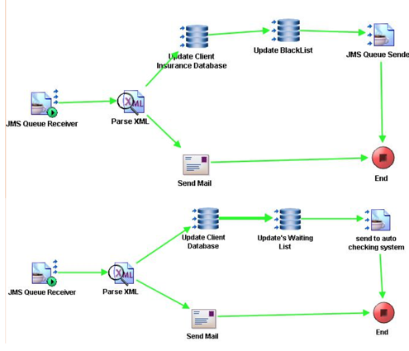

**Waiting list system / Blacklist system**

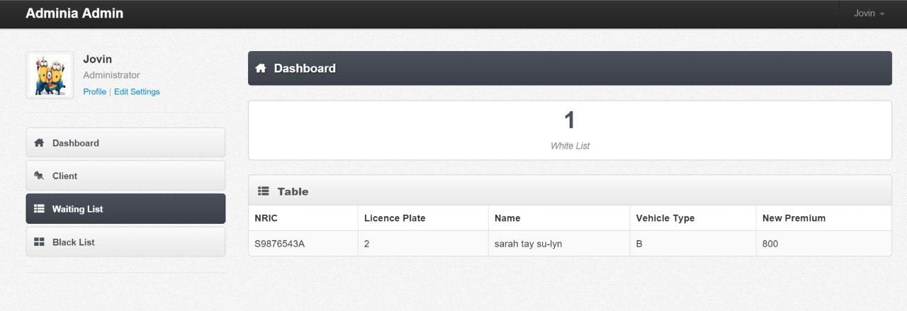

**Waiting list**

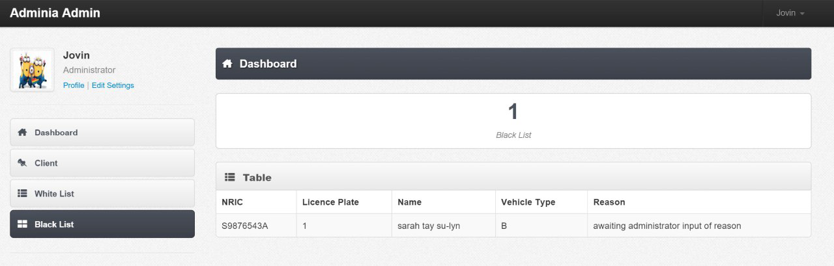

**Blacklist**

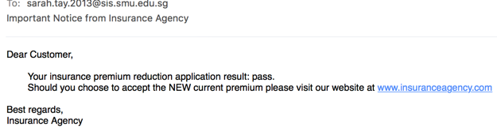

**The Email being send to client**

4.Thereafter when the process has started, the client would be updated into either the Waiting List database or the Blacklist database, this is based on the client’s assessment result and remove the client from client database and send result email to the client. Then the JMS queue sender will send a message to q.start at the very beginning, the process run again.

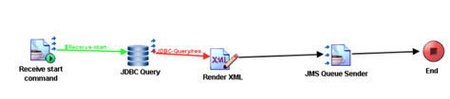

5. When there is no more client expire in one month, the process will stop. So the line from JDBC query to Render XML become red that means, no more client expire in one month.