Project – Ethereum Dapp for Tracking Items through Supply Chain

This document includes all the required documentation that was required. This is the work performed by Luke Vella Critien in fulfilment for the Blockchain Architecture course.

Part 1 – Plan the project with write-ups

Requirement 1 – UML
- Activity Diagram
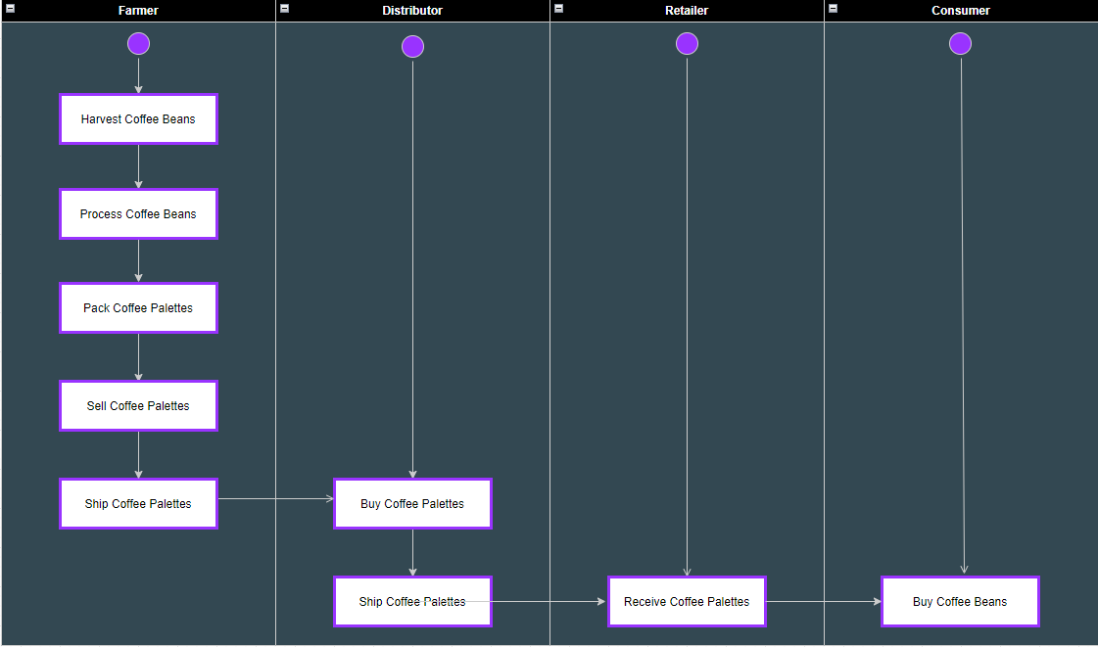
- Sequence Diagram
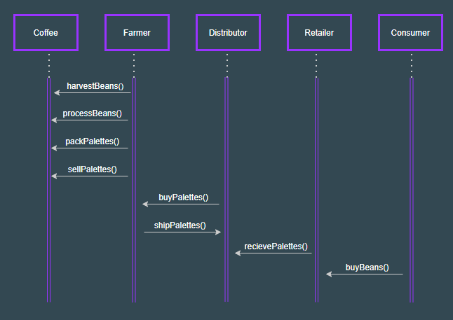
- State Diagram
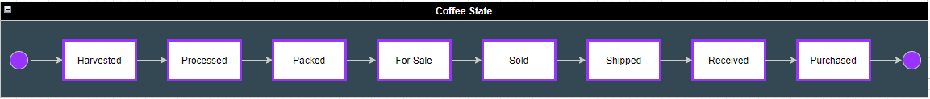

- Classes (Data Model)
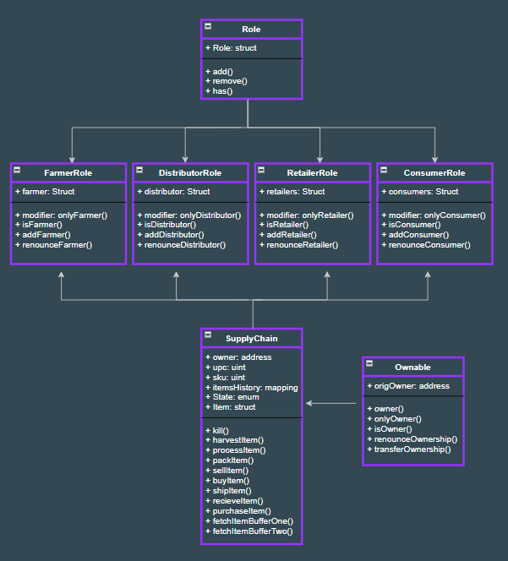

Requirement 2 – Libraries
Below is a list of libraries that were used in this project
- Web3.js – this is a collection of libraries that provides the possibility to interact to an Ethereum node. This is important as we used the Meta Mask which is an Ethereum supported browser. The version used was 0.20.6.
- Solidity – this is the Ethereum smart contract language. Without solidity we would not have been able to write the contracts included in this project. The version used was 0.4.24
- Truffle – this is a development environment which allowed us to compile and test the smart contracts on the EVM. This library made the development process much easier. The version used was 4.1.14
- Node – this is used to be able to handle asynchronous activities. It is important to be able to perform the contractual tasks on the blockchain. The version used was 10.13.0
- Npm – this is a package manager for node.js which helps in installing and configuring the required libraries for the project. The version used was 6.4.1

Requirement 3 – IPFS
No IPFS was used to implement this project.

Part 2 – Write Smart Contracts

All the code related to the smart contracts can be found in the contracts folder which has three sub directories
- Coffee access control
  - This subfolder has a collection of 4 contracts Roles, FarmerRole, DistributorRole, RetailerRole and ConsumerRole
- Coffee base
  - This folder has one contract named SupplyChain which contains the core functionality related to data storage, constants, data types and functions
- Coffee core
  - This includes a single contract named Ownable which controls ownership and its transfer

Part 3 – Test smart contract code coverage

In this section 10 different tests were included to ensure that every function that was implemented in the smart contracts is correct. All the code related to the tests can be found in the TestSupplychain.js file which resides in the Test folder.
Below is a screen shot which shows the Truffle Development environment running successfully
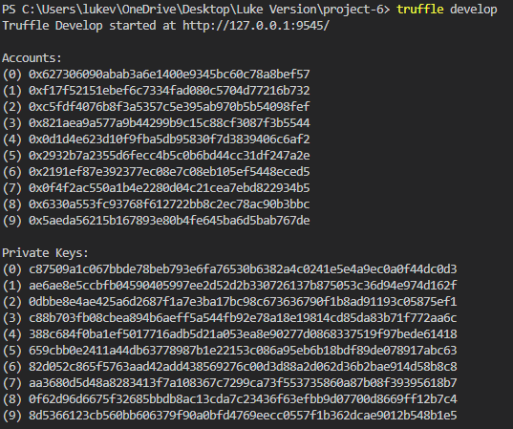
Following this is a screenshot showing that all the 10 test have been executed successfully
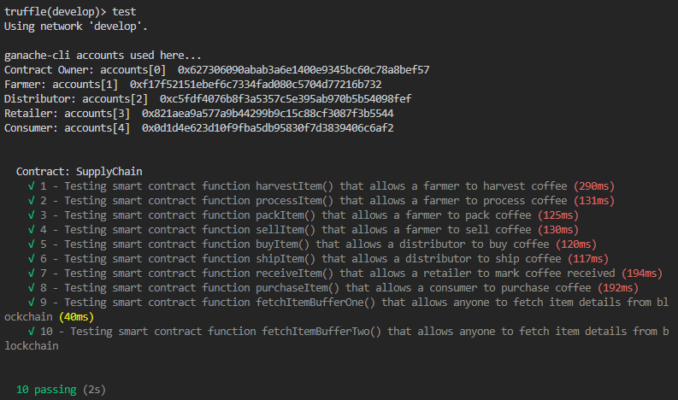

Part 4 – Deploy smart contracts on a public test network

After compiling all the smart contracts and executing all the test correctly, the next phase was to deploy it on a Rinkeby test network. Below is a screenshot from the CLI, generated on deployment which shows the addresses per contract including the Supply Chain address
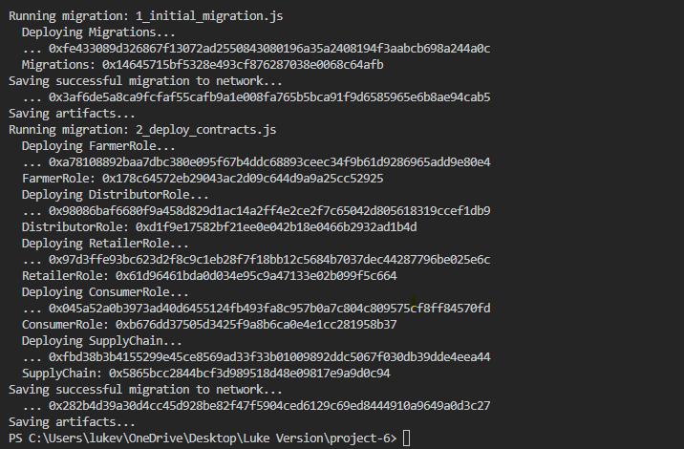
Below you can find:
- Supply Chain Contract Address: 0x5865bcc2844bcf3d989518d48e09817e9a9d0c94
- Proof from the blockchain explorer
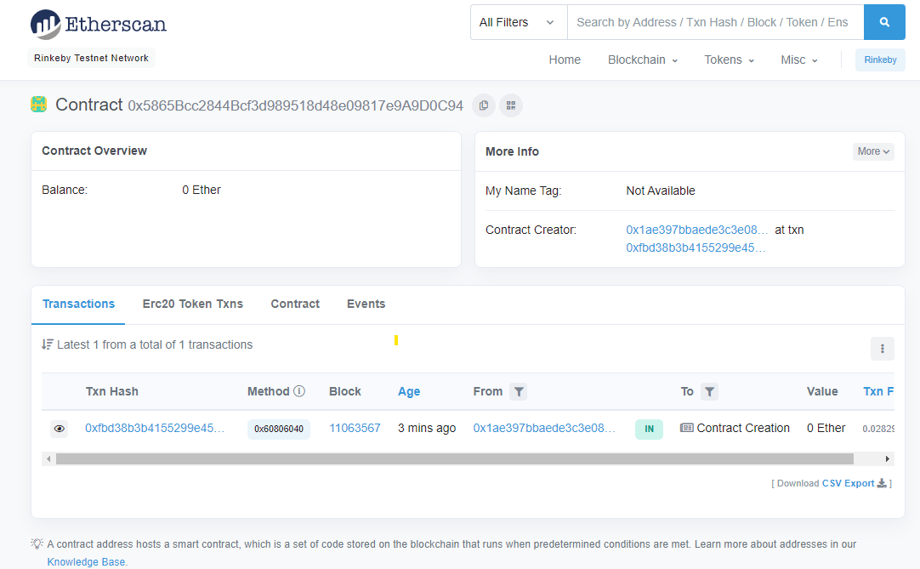

Below you can find:
- Transaction URL: https://rinkeby.etherscan.io/tx/0x282b4d39a30d4cc45d928be82f47f5904ced6129c69ed8444910a9649a0d3c27
- Transaction Hash: 0x282b4d39a30d4cc45d928be82f47f5904ced6129c69ed8444910a9649a0d3c27
- Contract Address: 0x14645715bf5328e493cf876287038e0068c64afb
- Proof from the blockchain explorer

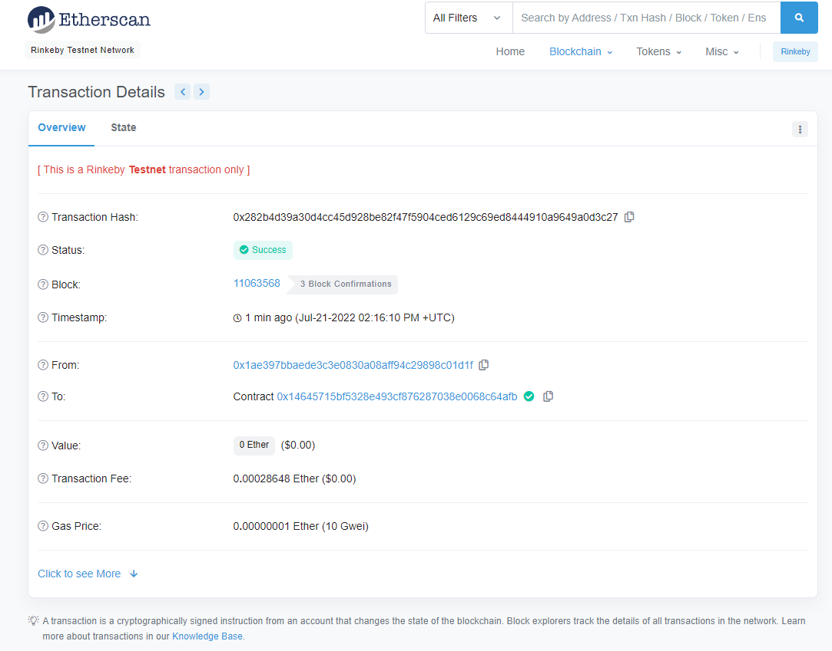

Part 5 – Modify client code to interact with smart contracts

All the requirements for the front end operations to go through the whole lifecycle were tested and no issues were encountered

