# Home Assignment 2&3:

# *How to build Eclipse project for Caffe*

Boris Ginsburg [boris.ginsburg@gmail.com](mailto:boris.ginsburg@gmail.com)

Assume that caffe root directory is called caffe-master

1. $ cd ~/caffe-workspace/caffe-master
2. open Eclipse
3. goto File→New→Project→C/C++ →Makefile Project with Existing Code.

You should see the following window:



1. Create a new **Makefile Project from existing code**:

Project name:   
 caffe-master  
Existing code location  
 /home/user/caffe-workspace/caffe-master  
Language:   
 choose C and C++  
Toolchain:  
 choose Linux GCC



1. Then click on caffe-master in Project Explorer ( set Window→Open Perspective → C/C++). You will see this window:



1. Now go File → Properties → Run/Debug settings. Click New.., and choose C/C++ application  
     
   
2. Fill launch configuration properties

* Main sub-menu:

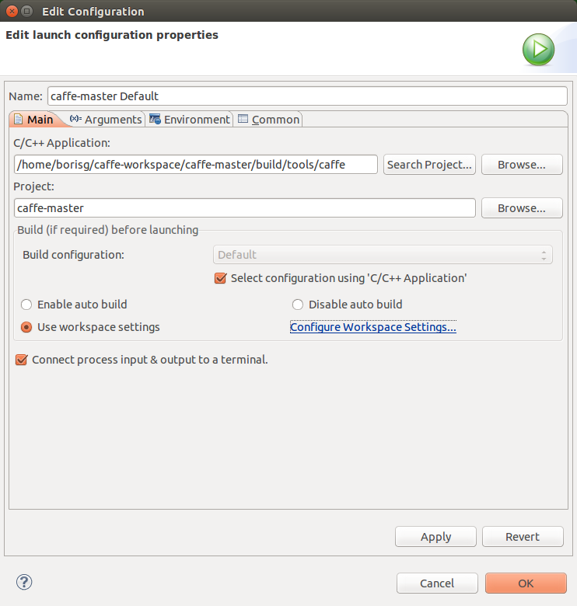

* Arguments:  
  fill train --solver=examples/mnist/lenet_solver.prototxt  
  and change working directory from default to /home/user/caffe-workspace/caffe-master



1. To build just click Projects → Build all.   
   To speed up building process, right click on caffe-master → Properties → C/C++ Build, and change Build command: make -j This will make compiling much faster.  
     
   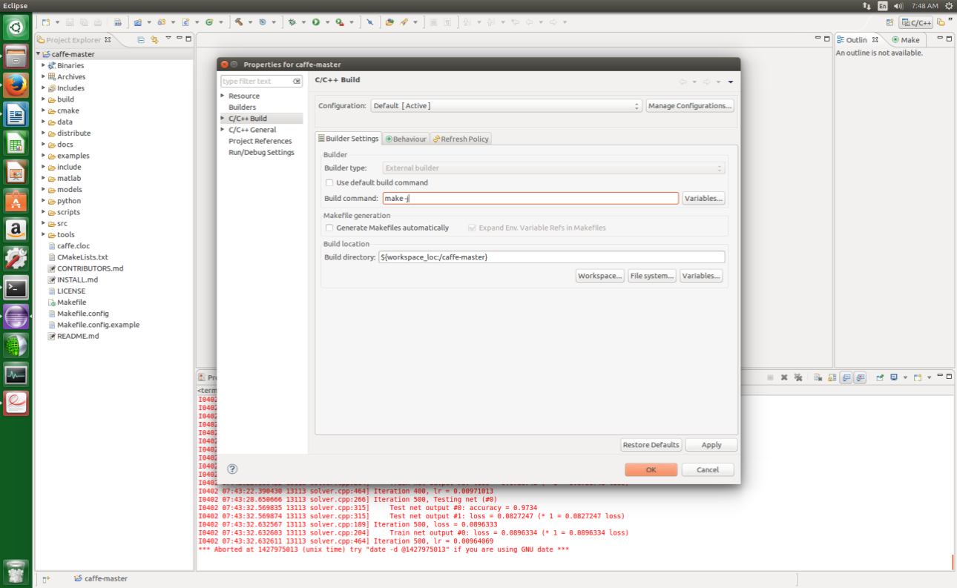
2. To run code Run → run. You will see caffe running in the Eclipse Console:

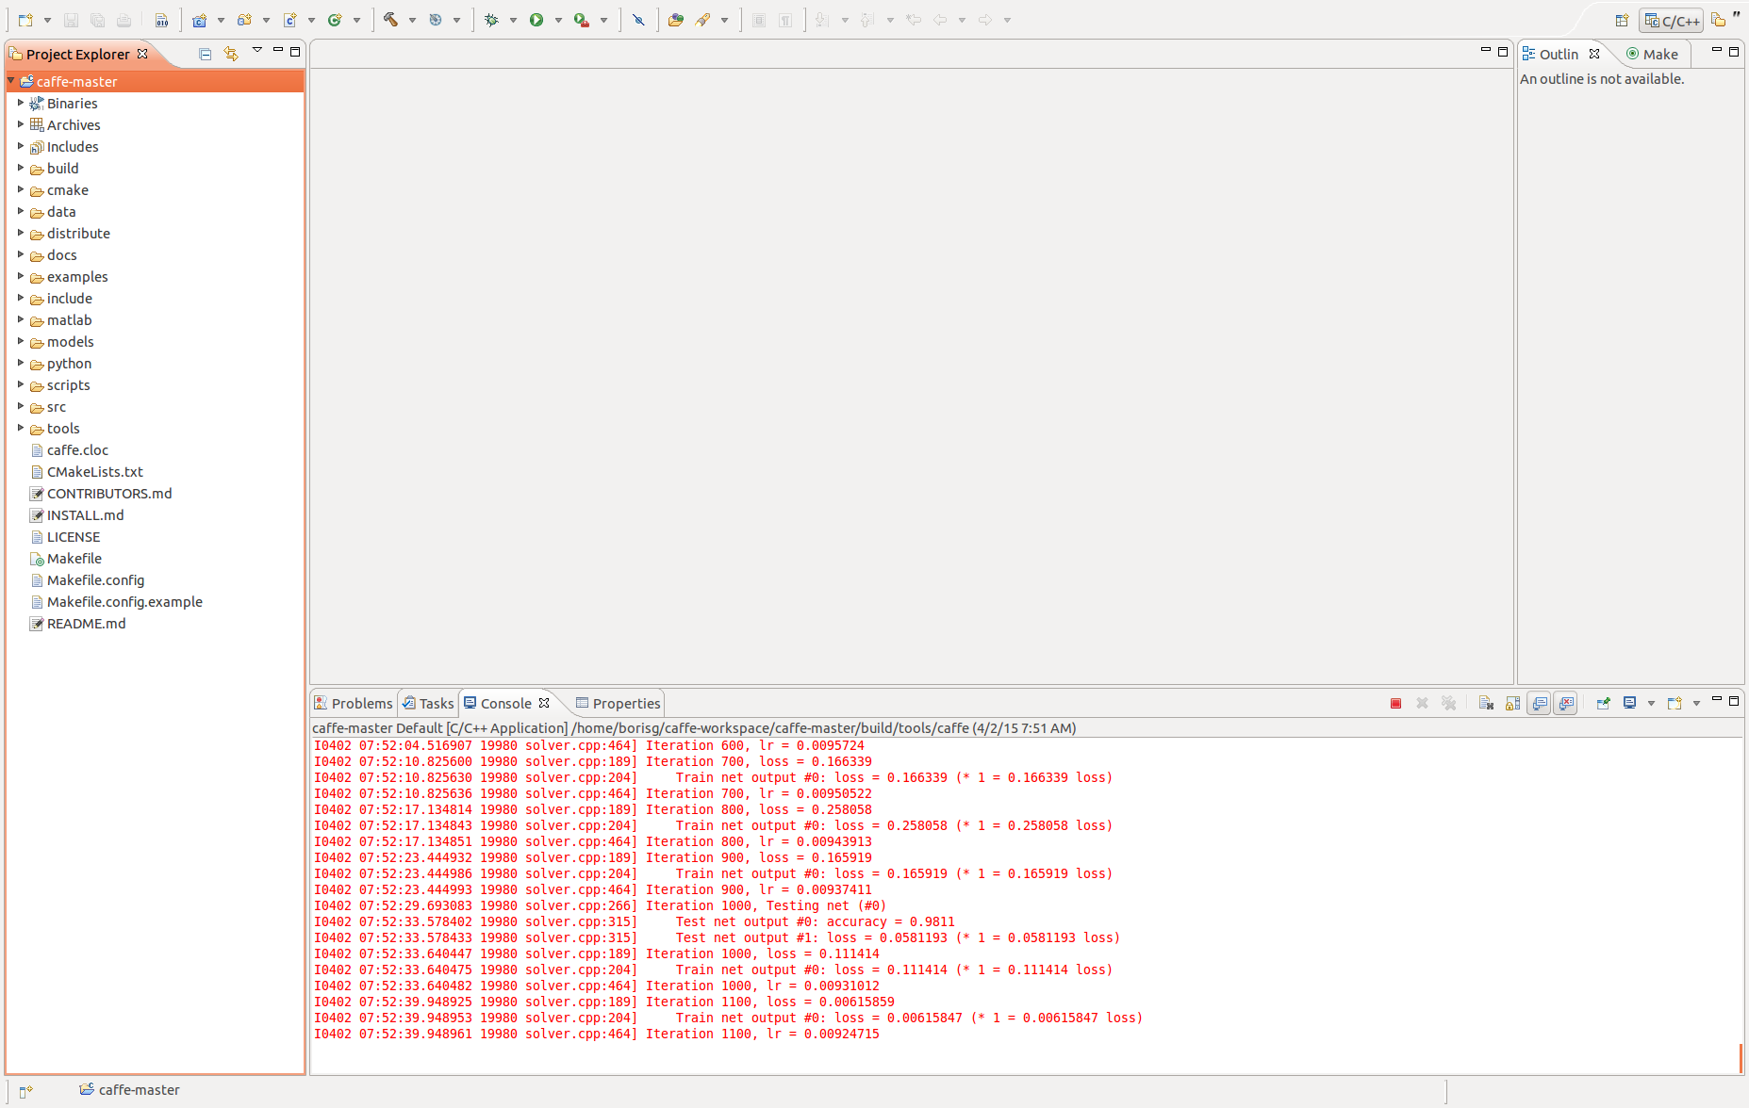

1. To debug caffe, you should open Makefile.config and uncomment DEBUG :=1 .   
   This will add to gcc flag -g -O0 which turn on debug information and switch off optimization  
   Then Project → Clean..., and Project → Build All.
2. Now you can use debug caffe code: Run-> Debug:   
     
   