ZX Evolution
(version 04.01.2016)
www.nedopc.com
«Test&Service» firmware/configuration

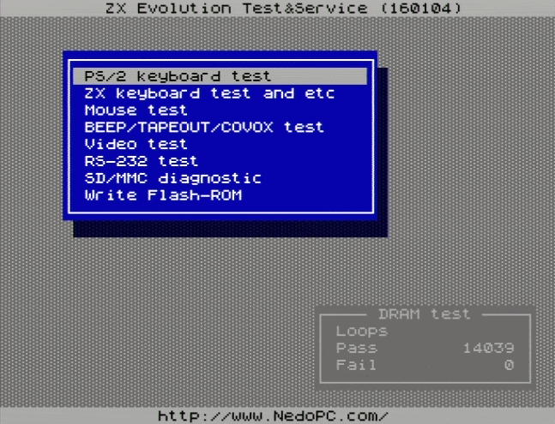

Content
1 Description 2
2 Install 2
3 Start 2
4 Control 3
5 DRAM test 3
6 “PS/2 keyboard” test 4
7 “ZX-keyboard end etc” test 4
8 “Mouse” test 5
9 “BEEP/TAPEOUT/COVOX” test 5
10 “Video” test 6
11 “RS-232” test 6
12 “SD/MMC diagnostic” 6
13 “Write Flash-ROM” 7
13.1 Additional. 8
13.2 Example 1. 8
13.3 Example 2. 8

Description
This firmware/configuration intend for checking proper functionality of ZXEvolution hardware components.
T&S configuration use resource of ATMEGA128 (D4) and EP1K50 (D2) chips. Information view on screen (TV or VGA) and output to RS-232 port (115200 bps, 8 bit, without parity, without transmission control). Control by PS/2 keyboard.
Configuration adapted for default ZXEvolution boards settings (Q2 is 11,0592 MHz, and ICS501 [D9] set 28 MHz output frequency [J2 and J3 opened]).

Install
Test&Service (T&S) configuration install like other configurations via ZXEvolution bootloader.

Start
1) T&S started at power switch on without wait to press any keys like SoftReset.
Output message to RS-232 port on start:
ZX Evolution Test&Service (YYMMDD)
2) On first T&S configurstion try to check pins state of ATMEGA128. Not all pins can to checked. Please not press ZX-Keyboards keys and not use joystick (if they plugged).
Output message to RS-232 port:
ATMEGA128 pins check... No problems found.
3) Switch on main power, if not switched on yet (using ATX power supply).
Output message to RS-232 port:
Status of POWERGOOD=0, VCC5=0
ATX power up...
After switched on main power of ATX power unit:
Status of POWERGOOD=1, VCC5=1
4) Load and configure FPGA
Output message to RS-232 port:
Set FPGA configuration... Done.
On this step synchronization signals come to screen, but information not view on screen.
5) Check exchanging data with FPGA
Output message to RS-232 port:
FPGA data exchange test... Ok.
6) Detect and initialize PS/2 keyboard
Output message to RS-232 port:
PS/2 keyboard check...
FF FA AA F2 FA AB 83 F0 FA 02 FA F3 FA 00 FA
7) Main menu show on screen. You can select tests via PS/2 keyboard.

Control
Main menu and some other testes control by next keys:
<Up>, <Down> - select items;
<Enter> - select or confirm «Yes»;
<ESC> - cancel, exit or confirm «No».
Keys, whose work only on main menu:
<ScrollLock> - switch screen mode «TV/VGA» (Led ScrollLock light on «VGA» mode);
<CapsLock> - select interface language (russian/english).
<F1> - help.
Video mode and interface language saved in eeprom ATMEGA128 and stored till next firmware loading.
On default: video mode - «TV», language — english (for eng version of firmware).

DRAM test
After showing main menu and later started dynamic memory test. It work independently from other test. All dynamic memory filled by quasyrandom sequence and compare with them on every loop. Result showed on DRAM test frame on main menu..
Counter hold on 65535 (after approximately 11 hour). But testing DRAM not stopped.

“PS/2 keyboard” test
Press keyboards keys and them codes show on screen.
Bytes from PS/2 keyboard view on “RAW data” output string. Same data duplicate to RS-232 port.
You must to press ESC key three times for exit from this test.

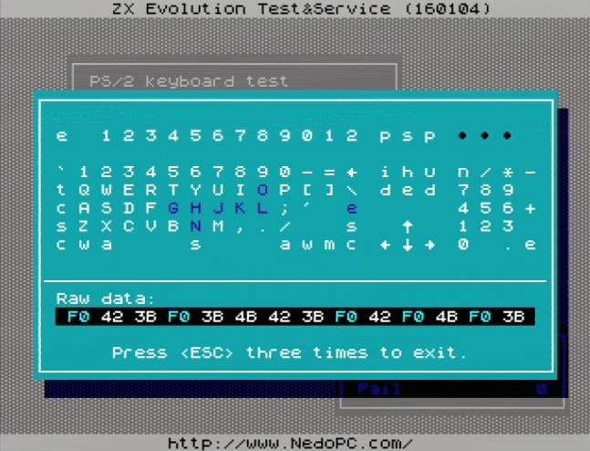
“ZX-keyboard end etc” test
If you plug ZX-keyboard (mechanical keyboard), then you can test it by using this menu item.
Also you can test joystick and system buttons (SoftReset, NMI[TurboKey]).
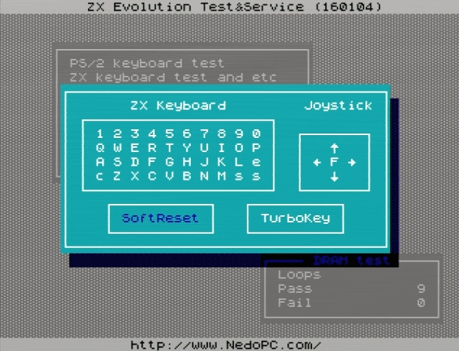

“Mouse” test
PS/2 mouse test support three-buttons with wheel PS/2 mouses. Received data from mouses duplicate to RS-232 port.
View next sequences:
- Detecting mouse sequence;
- Customization sequence (set mouse resolution or other parameters);
- Lets go! - last sequence got from mouse.

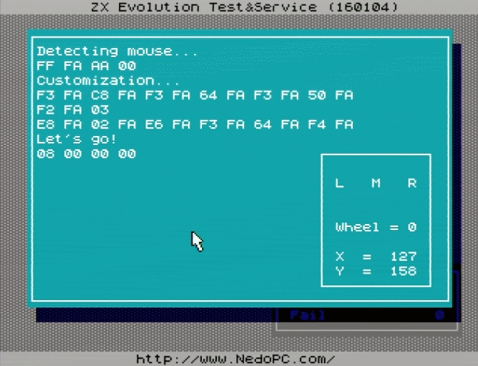
“BEEP/TAPEOUT/COVOX” test
Test generate frequency on sound output.
<Up> - increase frequency, <Down> - decrease frequency.
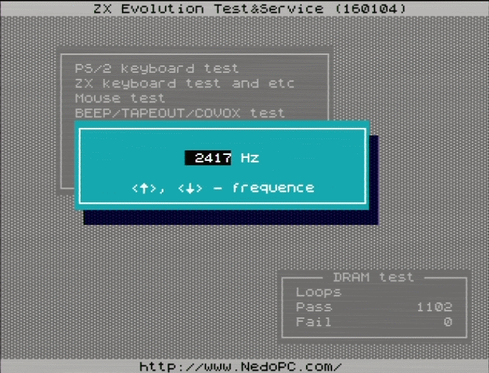

“Video” test
This test content some static images/tables for tuning video out.
<ESC> - exit from test, any other – next image.
- Pixelwide chessboard.
- Chessboard
- “Classic” PAL-tuning table
- Base-colors bars
- Mixed base-colors bars
- Base-colors pixelwide crosses

“RS-232” test
RS-232 loopback test (all received data send back).
Connect ZX Evolution to other computer by null-modem cable. Start on host diagnostic software (for example - http://www.zelax.ru/bfiles/soft/testcom.zip).
Test show on screen next information:
Last sec – bytes per last second (on right – seconds after test starts and speed for this time);
RxBuff and TxBuff – state of receive and transmit buffers;
RTS and CTS – state of transmission control signals.
<Space> key– reset buffers and information.
Null-modem cable scheme (5-wired):

Signal RTS set on 20 bytes before receive buffer end. If receive buffer full then received bytes lost.
Seconds counter reset on 65535 (18 hours 12 minutes) and reset statistic information.

“SD/MMC diagnostic”
Show information about SD (or MMC) memory card on screen and duplicate it to RS-232 port.
If memory card formatted FAT12/16/32 and file TESTFILE.BIN has in root directory, then calculated CRC for them.
You can get detailed report of your memory card if you set checkbox «Detailed log to RS-232».

“Write Flash-ROM”
Flash-ROM utility. Here you can write or update flash-ROM.
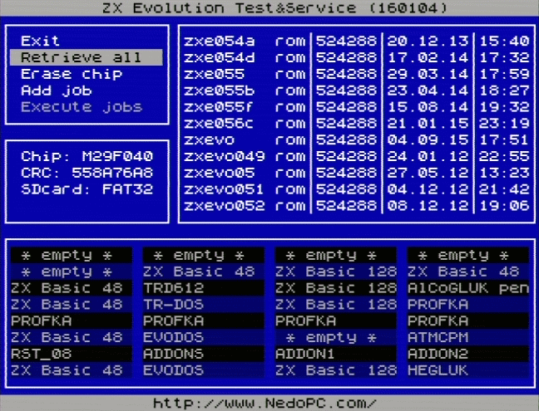
Frame «A»: Main menu of Flash-ROM utility.
A
B
C
D
«Retrieve all» - reset jobs, re-read content of Flash-ROM, init SD card and read root directory.
«Erase chip» - add “Erase chip” job. Flash-ROM will cleaned before any other jobs.
«Add job» - select file and part of Flash-ROM to write.
«Execute jobs» - start to write Flash-ROM.
Frame «B»: information about Flash-ROM type, control sum of chips data (CRC), type of FAT on SD card. Also messages about writing shown here.
Frame «C»: map of content Flash-ROM splits on 16kb pages.
Page 0 (#00000...#03FFF) | Page 1 (#04000...#07FFF) | Page 2 (#08000...#0BFFF) | Page 3 (#0C000...#0FFFF)
Page 4 (#10000...#13FFF) | Page 5 (#14000...#17FFF) | Page 6 (#18000...#1BFFF) | Page 7 (#1C000...#1FFFF)
Page 8 (#20000...#23FFF) | Page 9 (#24000...#27FFF) | Page 10 (#28000...#2BFFF) | Page 11 (#2C000...#2FFFF)
Page 12 (#30000...#33FFF) | Page 13 (#34000...#37FFF) | Page 14 (#38000...#3BFFF) | Page 15 (#3C000...#3FFFF)
Page 16 (#40000...#43FFF) | Page 17 (#44000...#47FFF) | Page 18 (#48000...#4BFFF) | Page 19 (#4C000...#4FFFF)
Page 20 (#50000...#53FFF) | Page 21 (#54000...#57FFF) | Page 22 (#58000...#5BFFF) | Page 23 (#5C000...#5FFFF)
Page 24 (#60000...#63FFF) | Page 25 (#64000...#67FFF) | Page 26 (#68000...#6BFFF) | Page 27 (#6C000...#6FFFF)
Page 28 (#70000...#73FFF) | Page 29 (#74000...#77FFF) | Page 30 (#78000...#7BFFF) | Page 31 (#7C000...#7FFFF)
Status of pages:
«empty» - empty, page filled by #FF.
«????» - non-empty, but utility can't detect type of content.
Frame «D»: SD files viewer. Shown directories and files with .rom/.bin extension and size from 1 to 524288 bytes. Only short names (8.3).

Additional.
SD (or MMC) memory card must formatted to FAT12, FAT16 or FAT32.
Files must had extension .rom or .bin and size from 1 to 524288 bytes. Writing gone by 512 bytes blocks. If file not align to 512 bytes, then writed data fill by SD cards sectors data.
Supported Flash-ROM chips: M29F040, AM29F040 (and compatible). Flash-ROM data erased by 64Kb blocks or full chip erasing.
Writes without erase data is not support.

Example 1.
Flash-ROM already content some data. Try to write data from small file (<=16Kb).
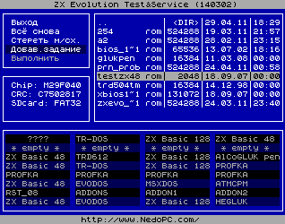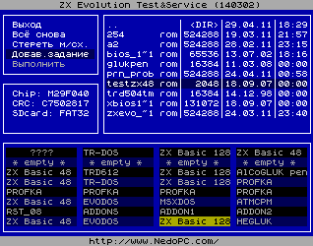
Select «Add job». Select file. Select page.
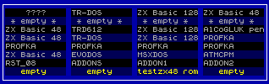
Sets next job:
1) erase pages 28...31;
2) write Flash-ROM on internal address #78000 2048 bytes from file TESTZX48.ROM.

Example 2.
Write set of four pages, but to second page write data from other file.
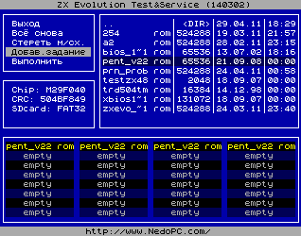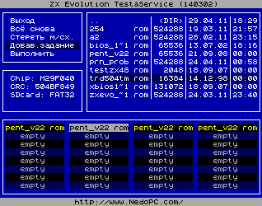
Select «Add job». Select file PENT_V22.ROM. Select pages 0...3.
Select «Add job». Select file TRD504TM.ROM. Select page 1.
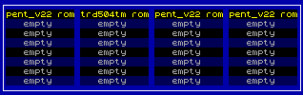
Sets next job:
1) erase pages 0...3;
2) write Flash-ROM on internal address #00000 16384 bytes from file PENT_V22.ROM (from position #00000).
3) write Flash-ROM on internal address #04000 16384 bytes from file TRD504TM.ROM (from position #00000).
4) write Flash-ROM on internal address #08000 16384 bytes from file PENT_V22.ROM (from position #08000).
5) write Flash-ROM on internal address #0C000 16384 bytes from file PENT_V22.ROM (from position #0C000).

