**20CYS311 – Cyber Forensics**

**LAB – 3**

**Exp :3 Email forensics(i) -Gmail Header Analysis**

1. Show original of an email

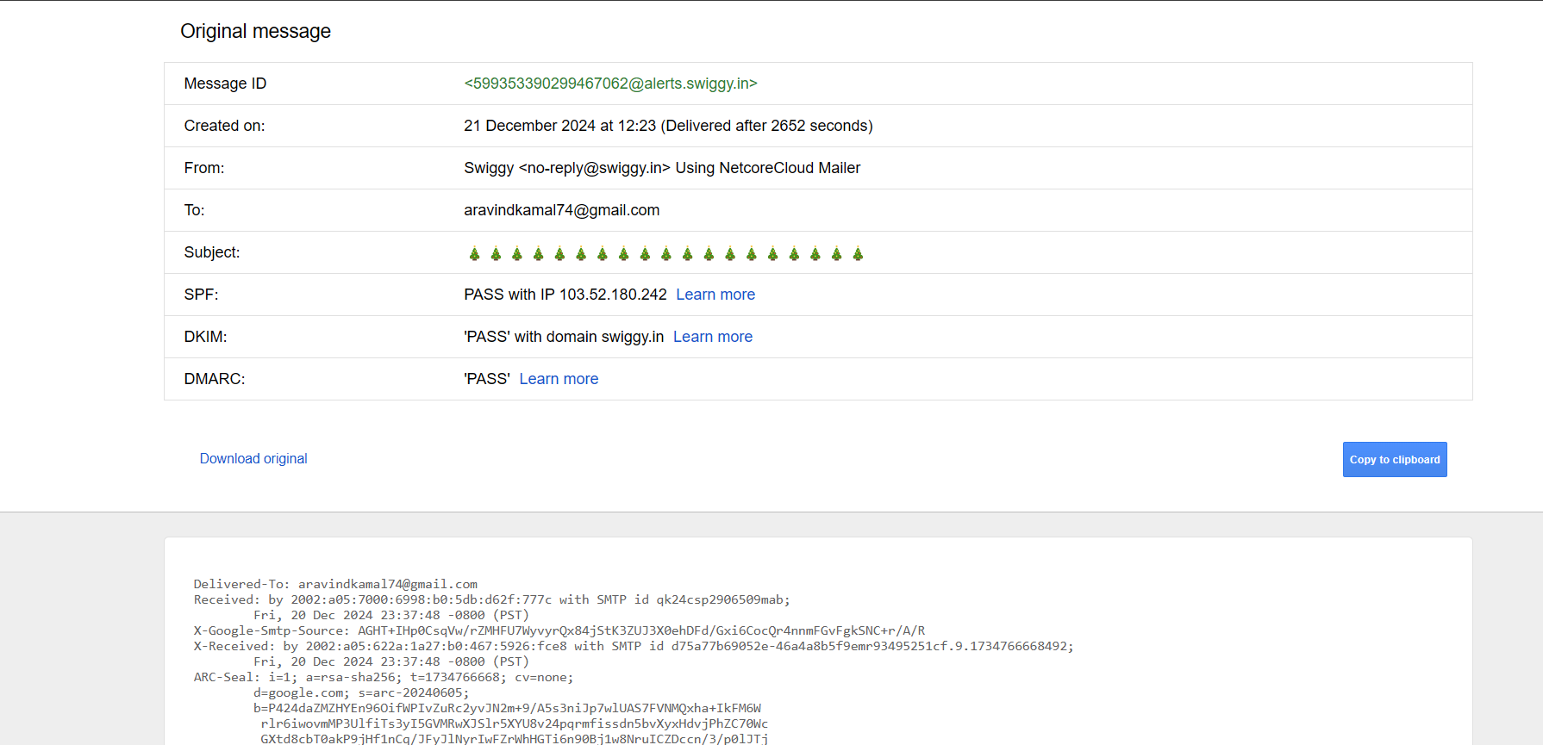

1. Use any online tool to do the analysis of header

<https://mha.azurewebsites.net/>

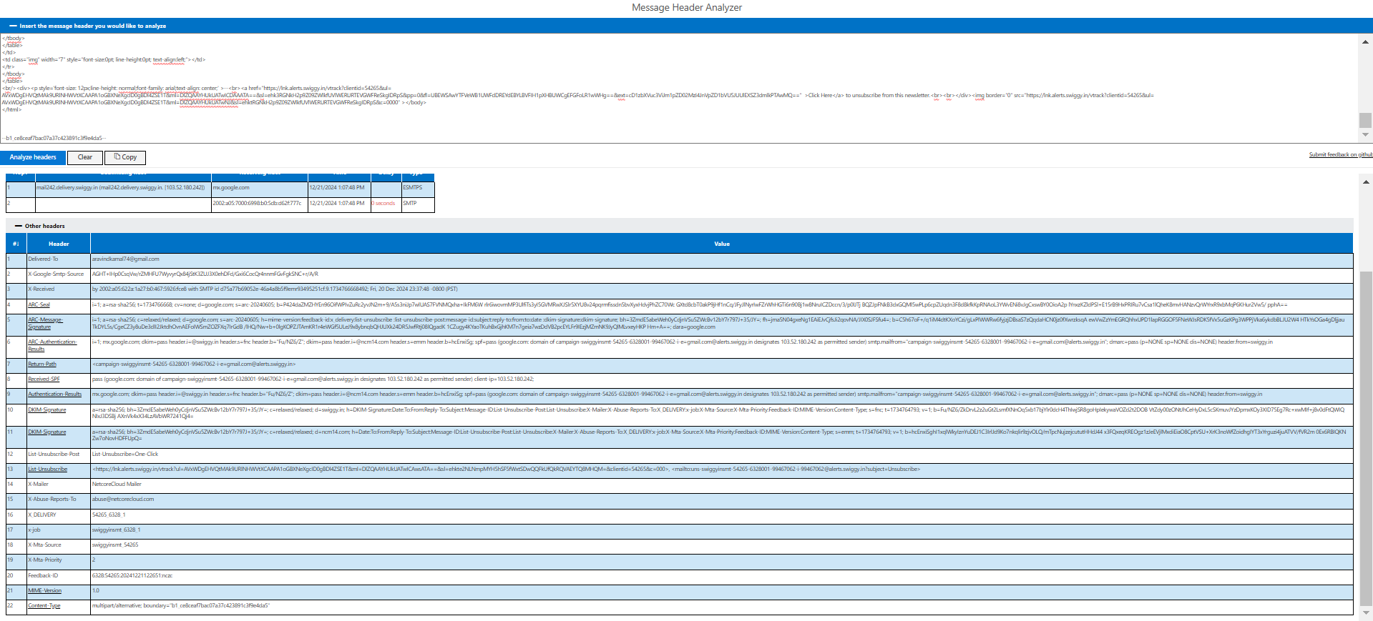

<https://toolbox.googleapps.com/apps/messageheader/>

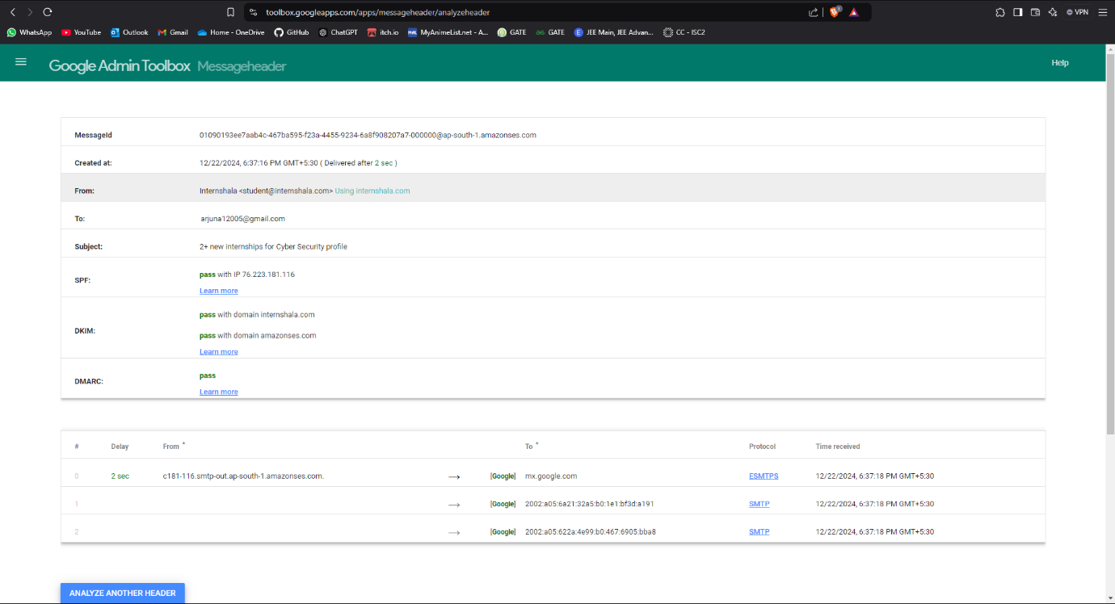

1. Compare two mails…… a mail from your friend and another mail which is a business mail (say from linked in or from any organization)

**Friend**

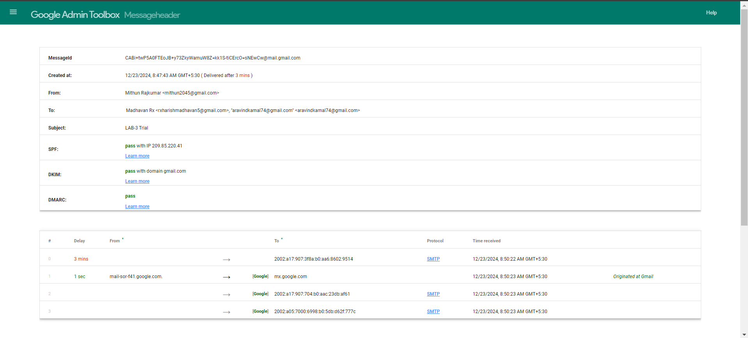

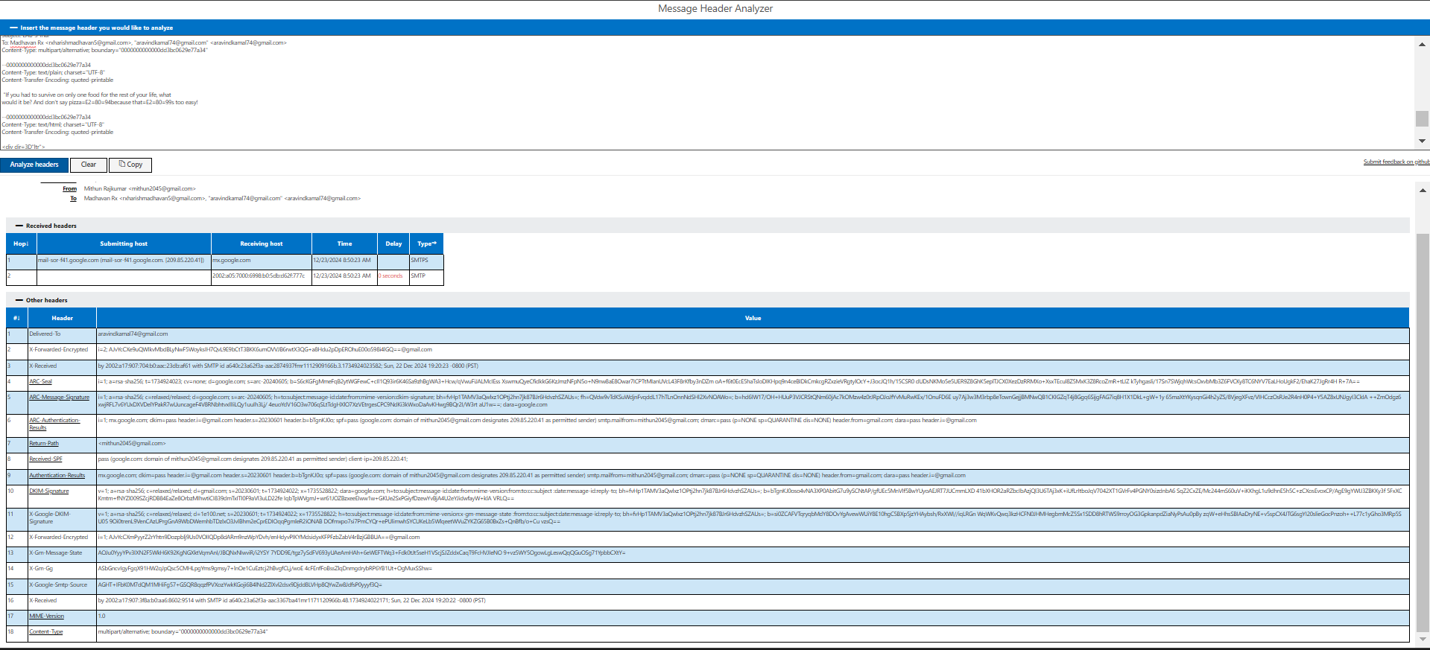

**Business**

# Google Admin Toolbox

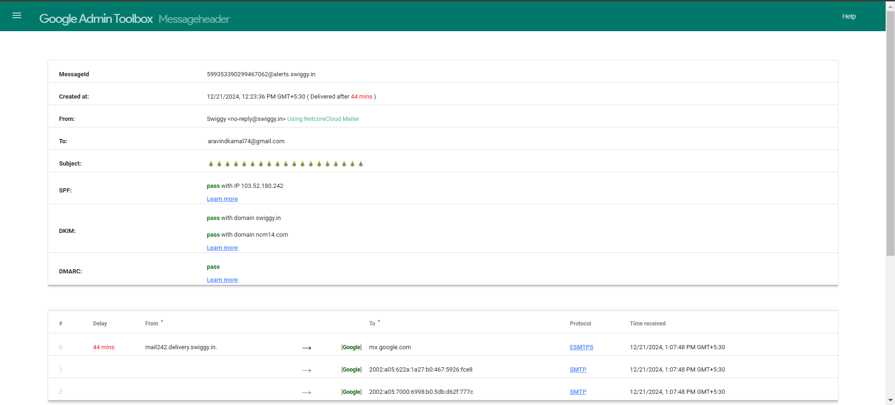

Message Header Analyzer



Exp -4 Email Forensics(ii) -Email Forensics tools to extract and Analysis

1.Download a backup of your gmail or outlook mail

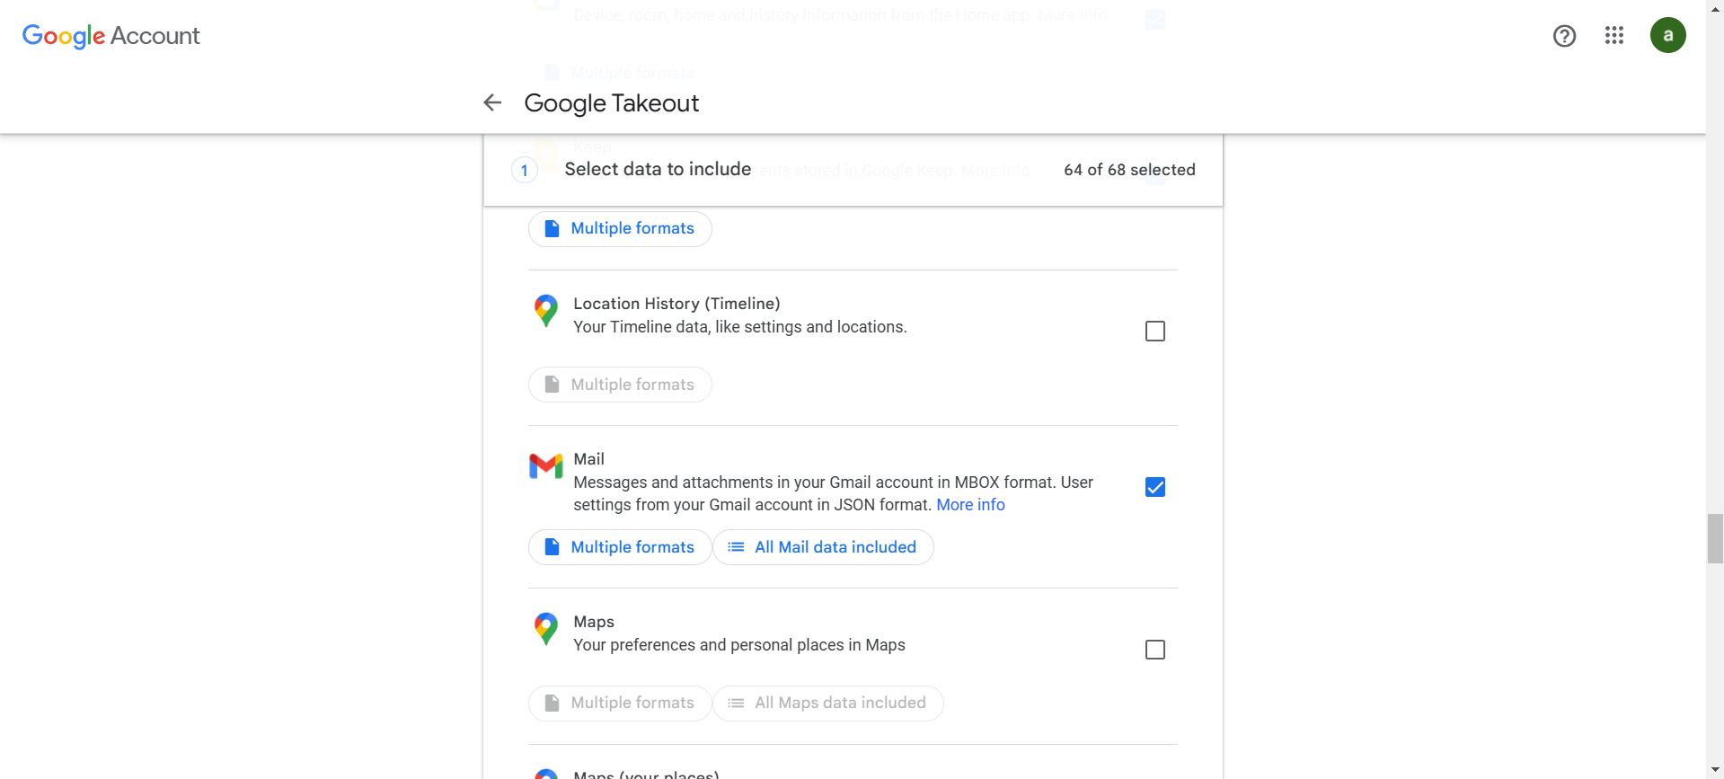

Select the mail and click next

2. Give the backup file as input to your forensics tools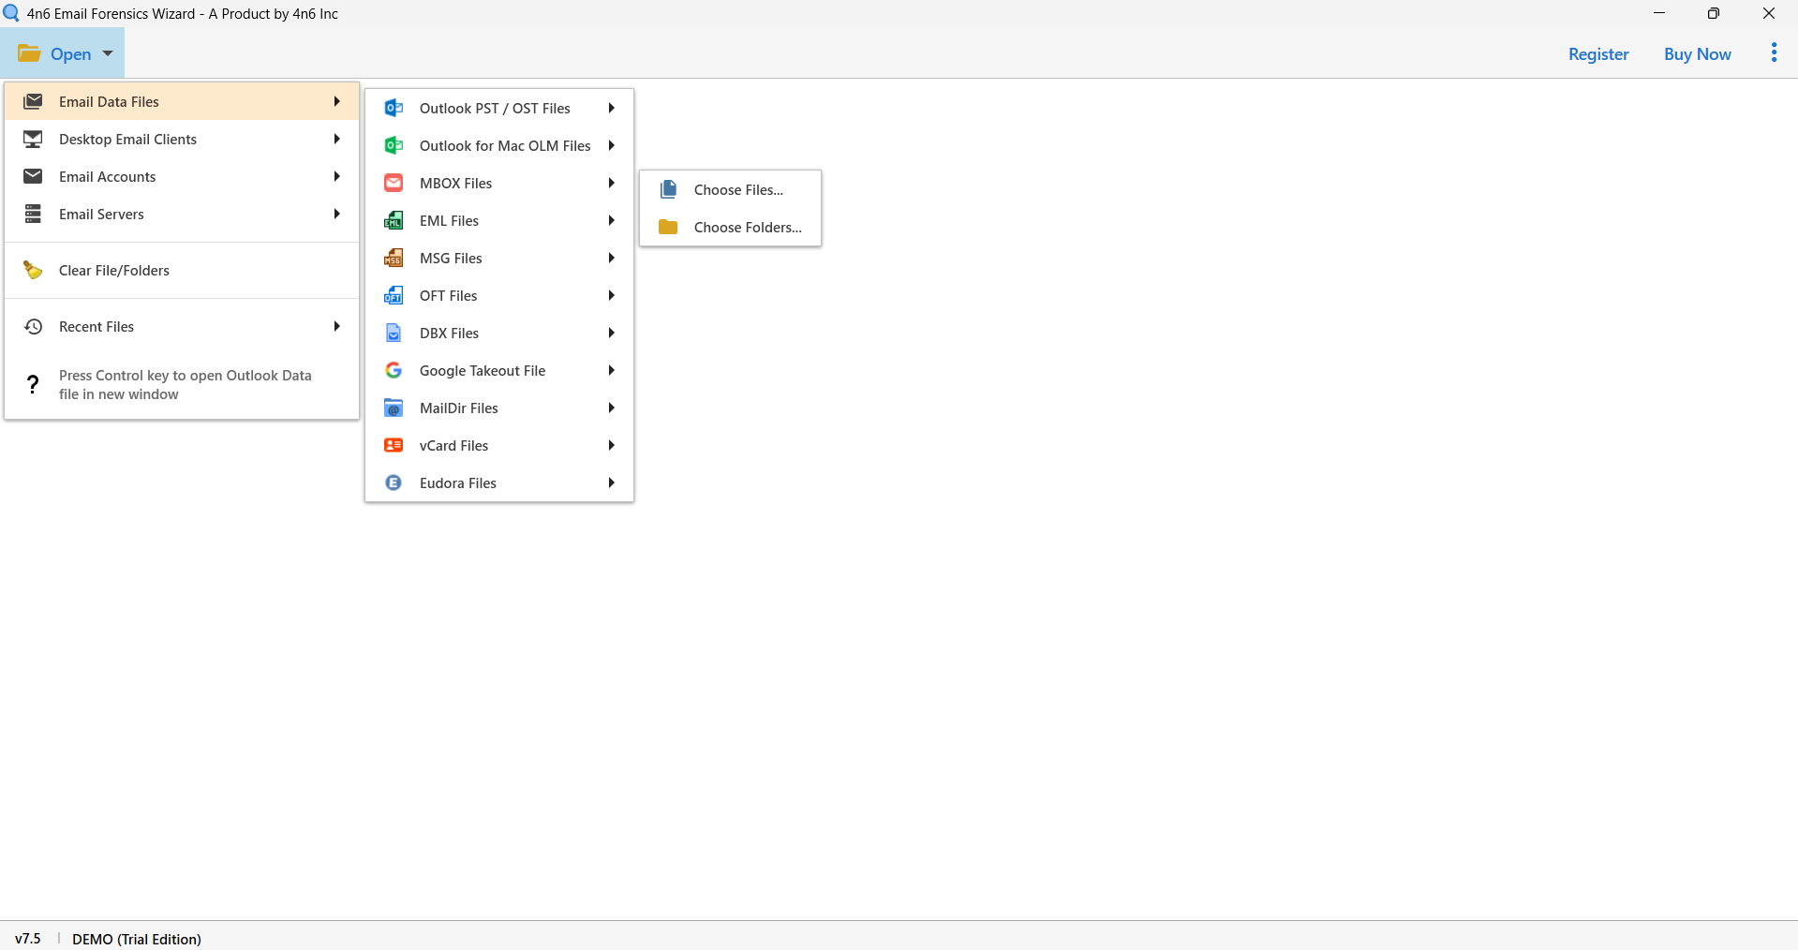

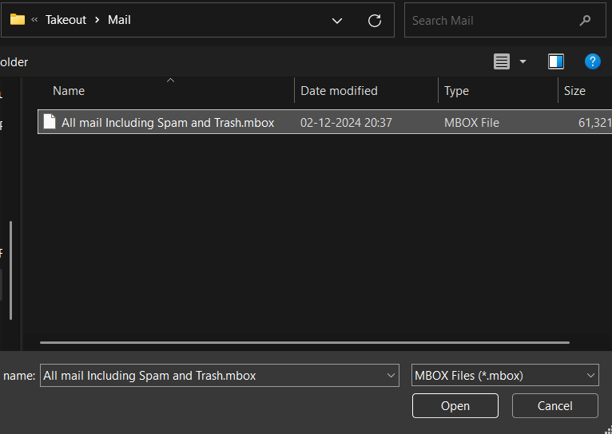

3. perform extraction of mails, phone numbers, attachments etc..

**Attachments**

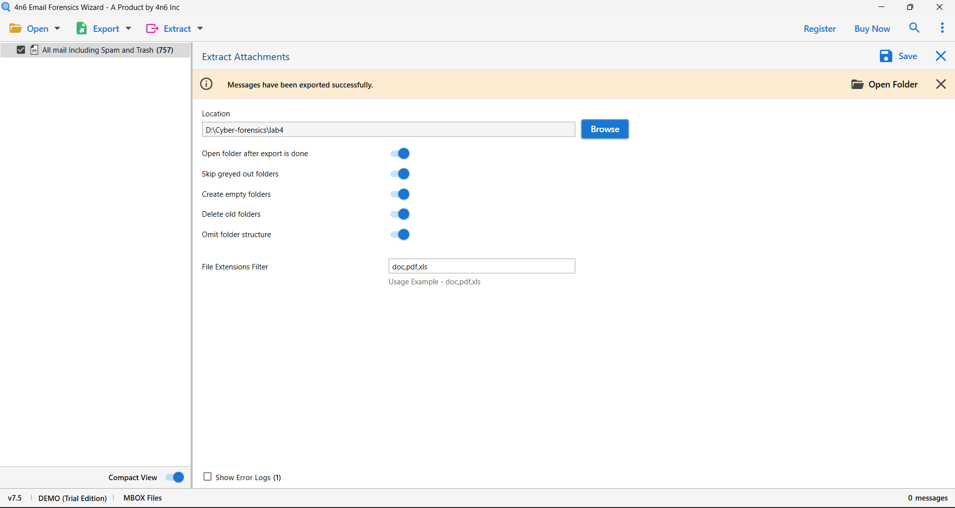

**Emails.**

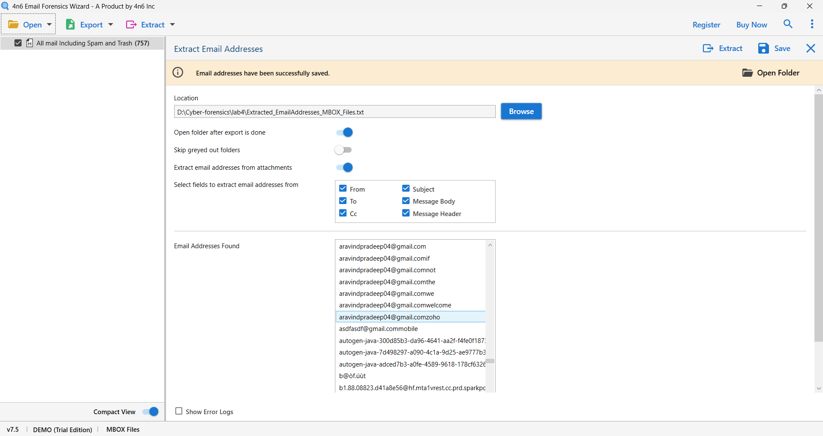

**Phone numbers**

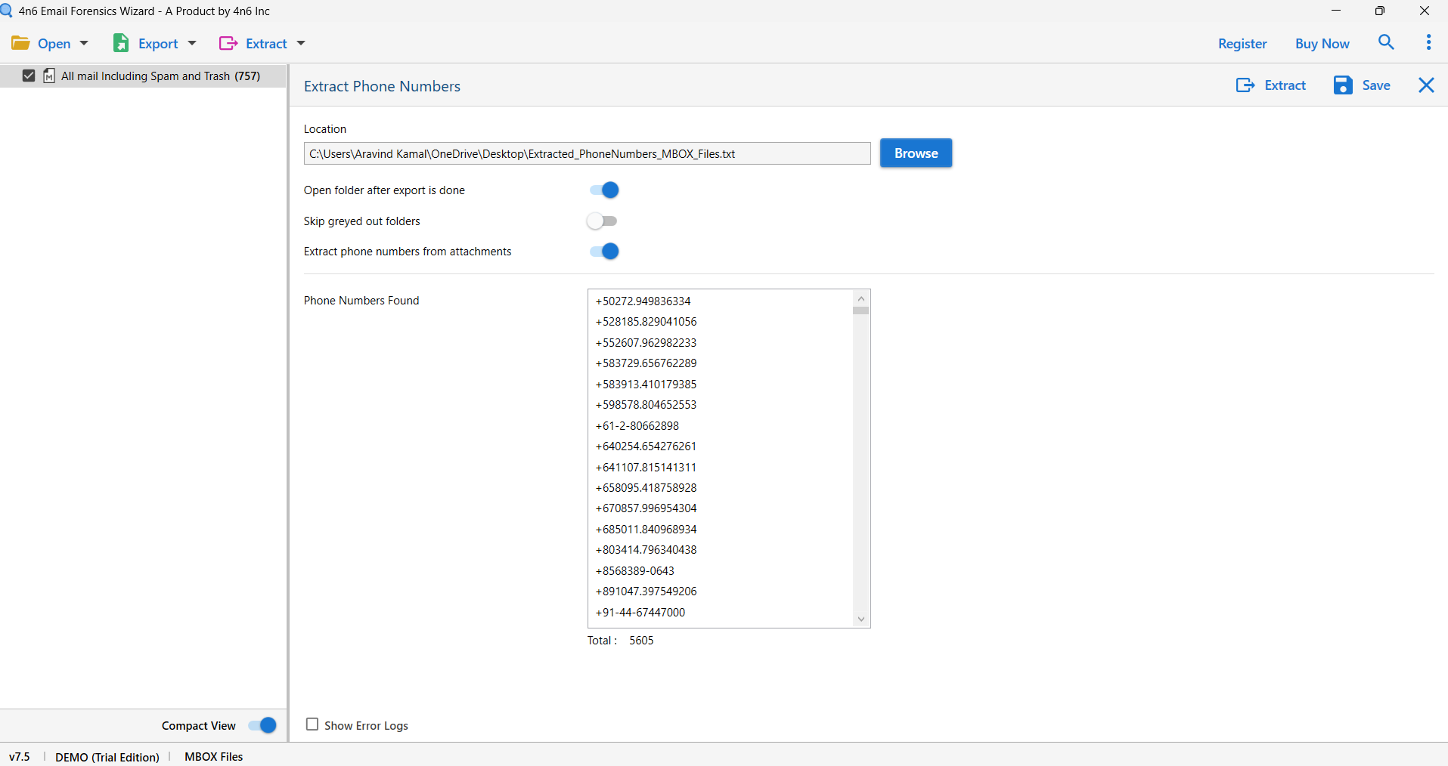

**Both email and mail.**

