|  |
| --- |
| TS006 - TC111_Validation of Concern Email Notification |

|  |
| --- |
| TC001_Validation of CAN field_Account has 1 CAN with Single Service |

|  |
| --- |
| Step 1 - Validate if CAN field is visible and enabled |
| CAN field should be visible and auto-populated  Note: For Guest User, field should be visible and not populated |

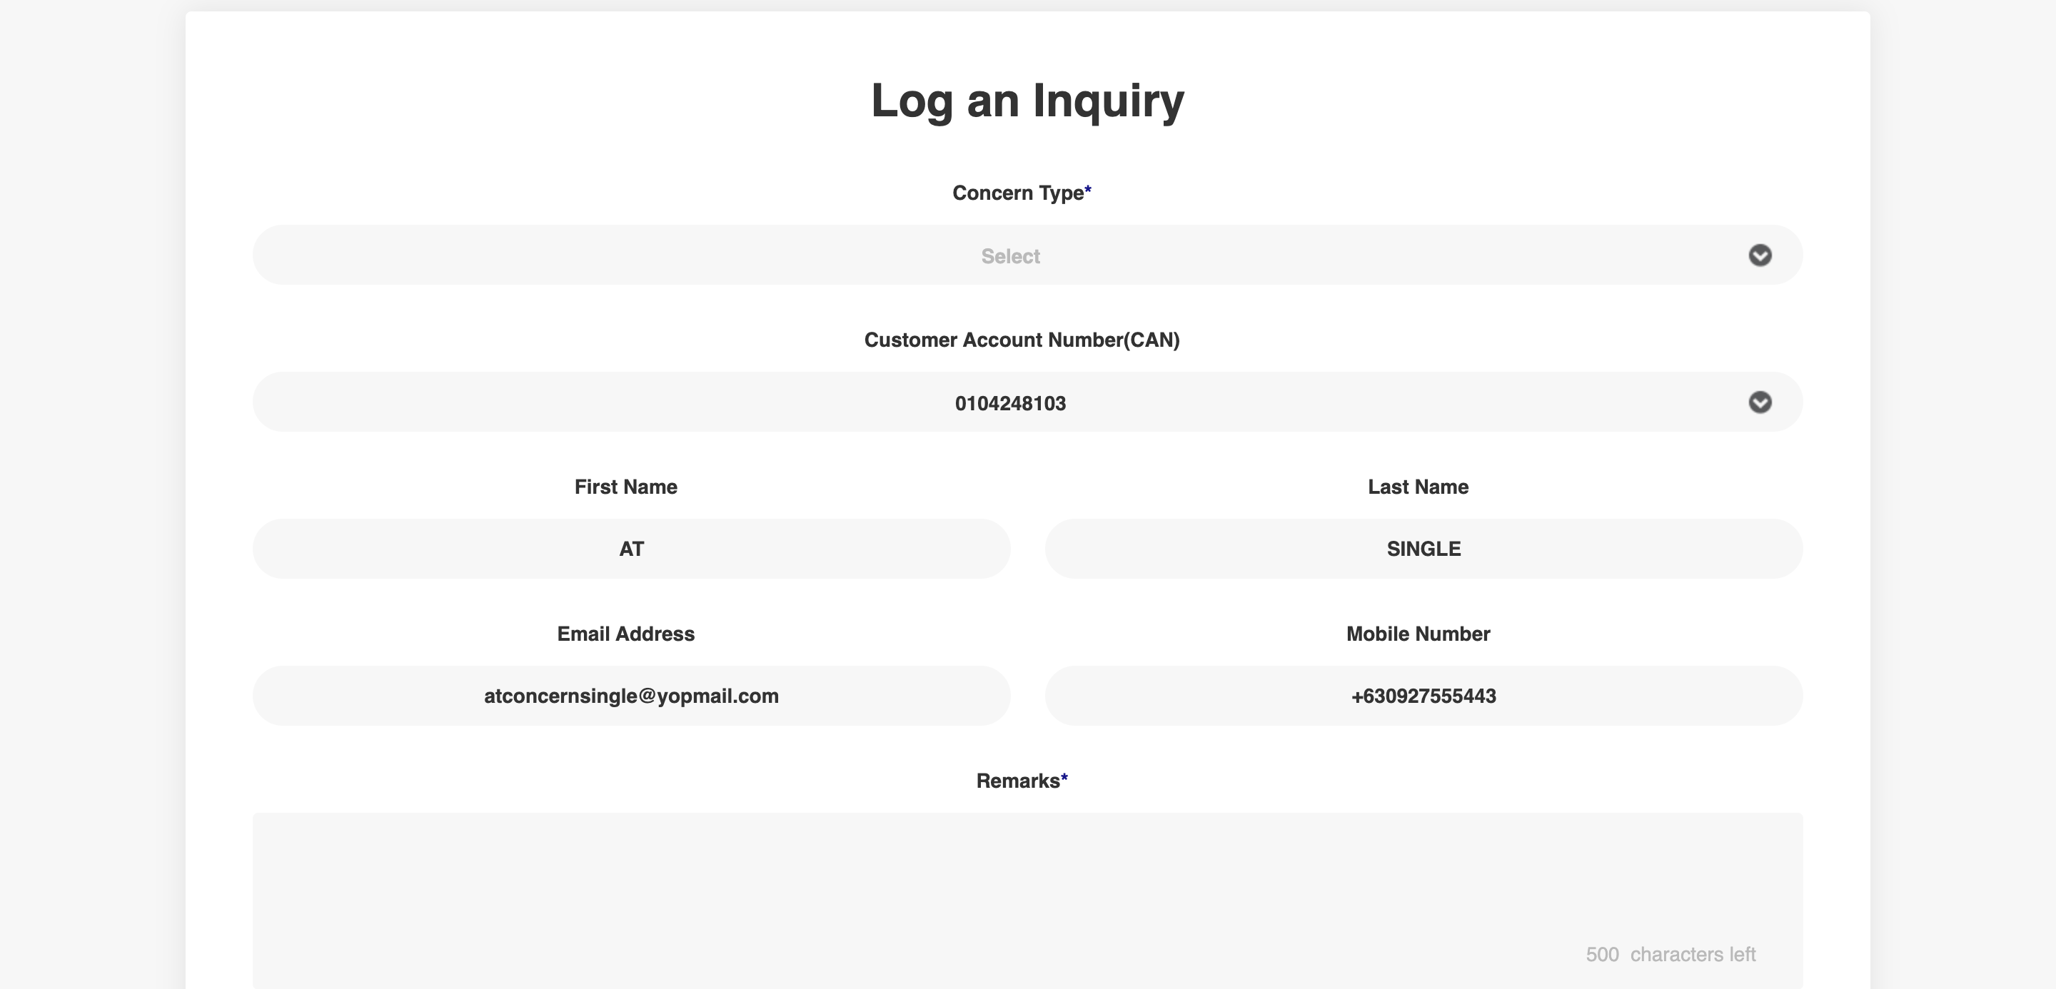

|  |
| --- |
| TC005_Create Concern |

|  |
| --- |
| Step 1 - Populate the following fields:  Concern Type  CAN  SIN (if multiple Service)  First Name  Last Name  Email Address  Mobile Number  Remarks |
| Fields should be populated |

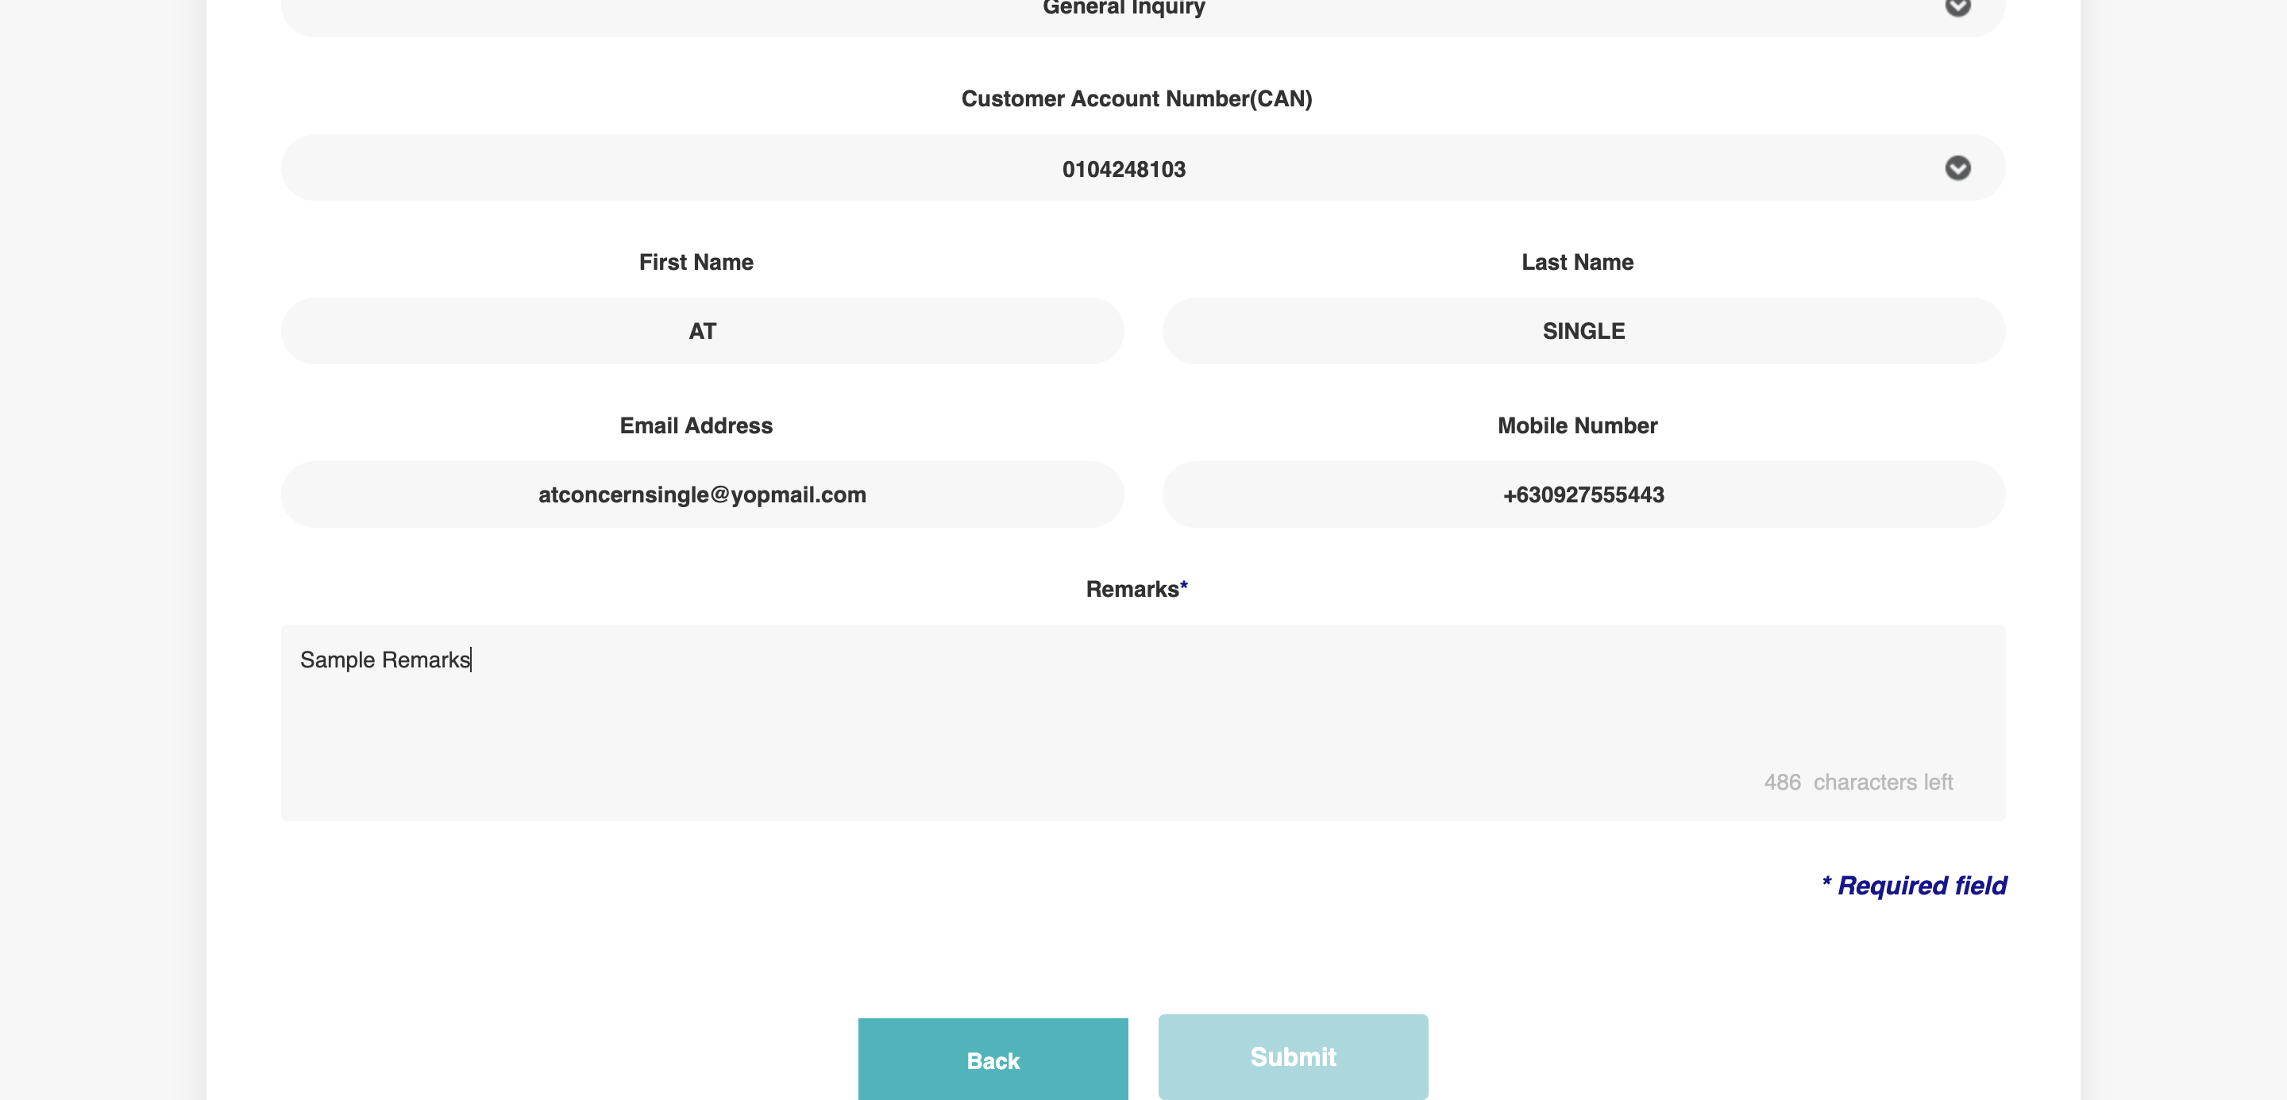

|  |
| --- |
| Step 2 - Click Submit |
| Concern should be successfully created. Case # should be generated. |

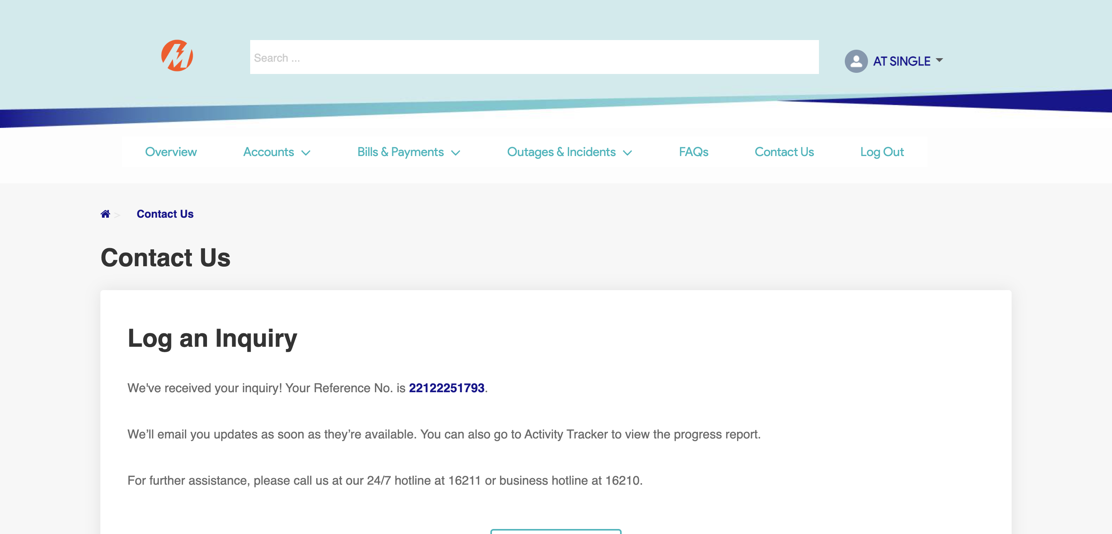

|  |
| --- |
| TC006_Validation of CAN in Activity Tracker page |

|  |
| --- |
| Step 1- Go to Activity Tracker page |
| Activity Tracker page should be displayed;  Activity Tracker columns should be as follows:  Reference No.  Customer Account Number  Service ID Number  Date Received  Concern Type  Specific Concern  Status  Remarks |

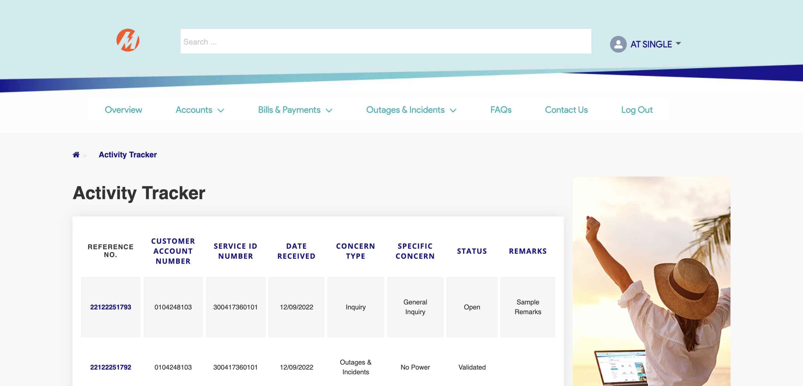

|  |
| --- |
| Step 1- Check if created concern is included in activity tracker page |
| Created concern should be in Activity Tracker page |

|  |
| --- |
| TC111_Validation of Concern Email Notification |

|  |
| --- |
| Step 1- Validate Email Notification received |
| CAN should be included in email notification  Note: See reference tab for Concern Email Notification |

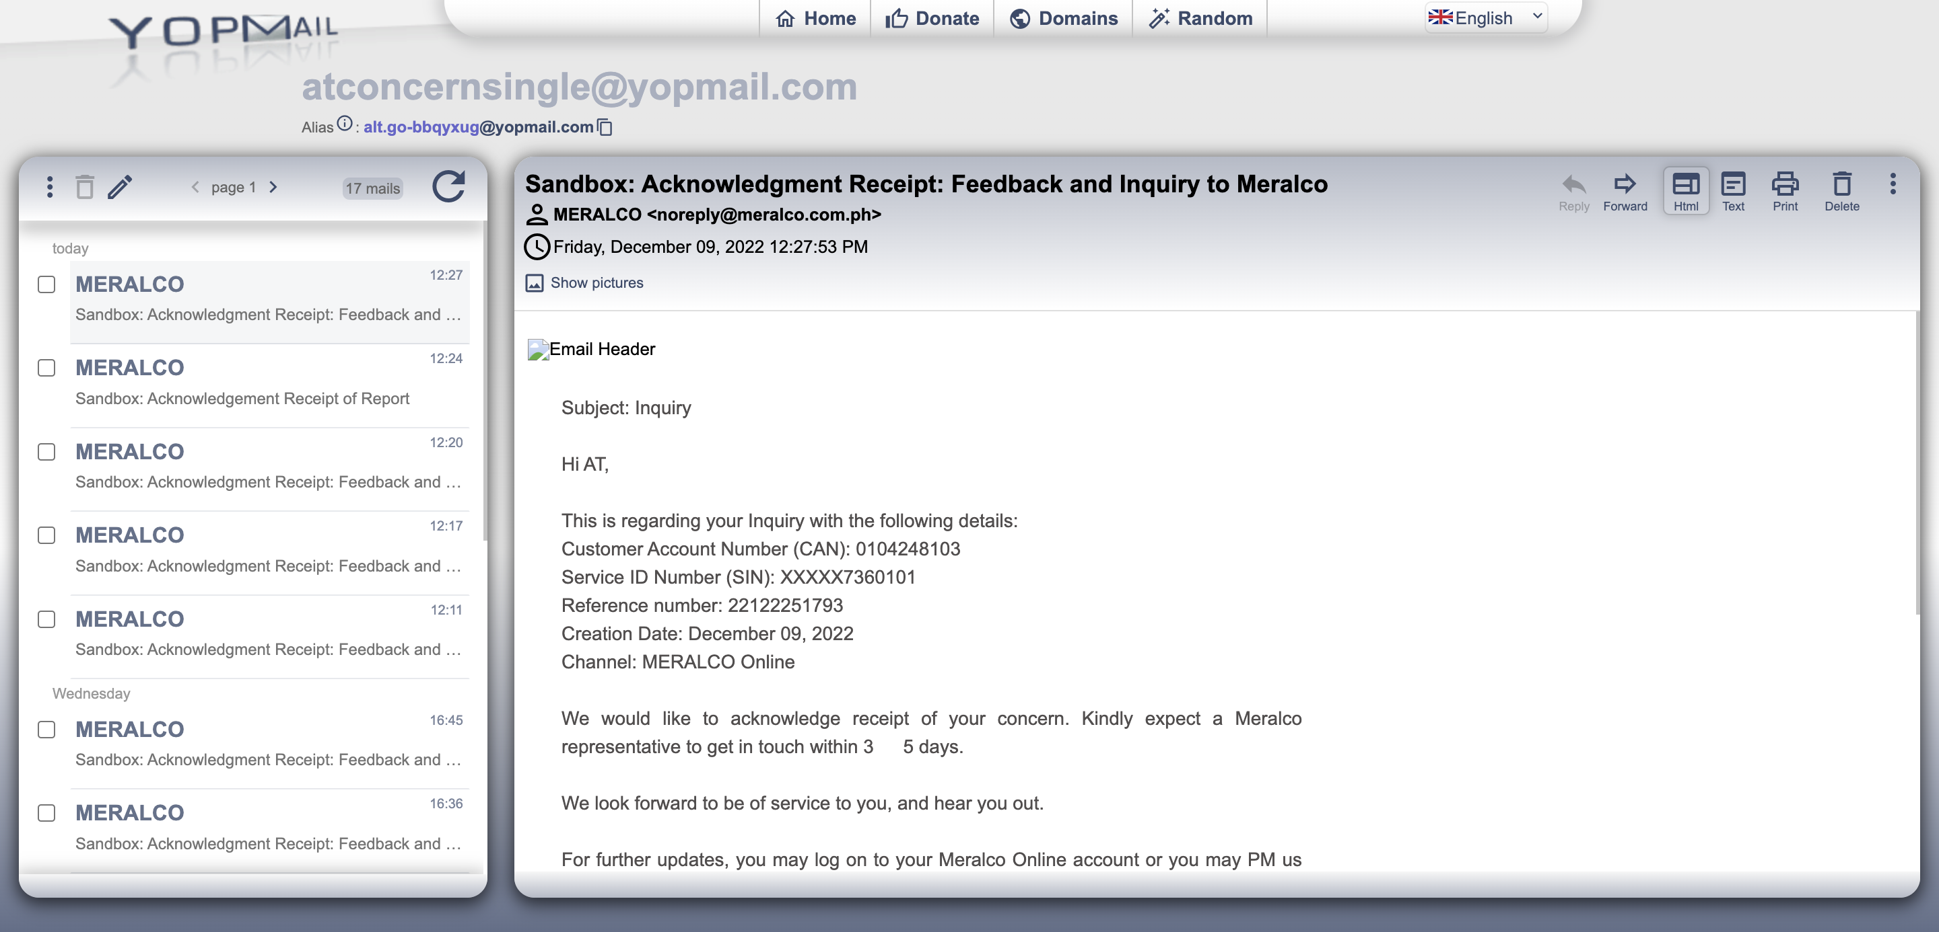

Passed